
The Lived and Living Experience Workforces Data Project
Report

The Lived and Living Experience Workforces Data Project
Report

To receive this document in another format, email the Mental Health Workforce Strategy and Reform Unit < MentalHealthWorkforce@health.vic.gov.au>.
Authorised and published by the Victorian Government, 1 Treasury Place, Melbourne.
© State of Victoria, Australia, Department of Health, December 2022.
In this document, ‘Aboriginal’ refers to both Aboriginal and Torres Strait Islander people. ‘Indigenous’ or ‘Koori/Koorie’ is retained when part of the title of a report, program or quotation.
ISBN 978-1-76131-073-7 (pdf/online/MS word)
Available at <https://www.health.vic.gov.au/workforce-and-training/lived-experience-workforce-initiatives>

Acknowledgements
This work was commissioned by the Mental Health and Wellbeing Division at the Victorian Department of Health and completed in collaboration with lived and living experience researchers and the project’s Advisory Committee.
The Department of Health would like to thank the many lived and living experience workers and representatives of mental health, alcohol and other drug and harm reduction services who completed the surveys. The time and insights generously offered are greatly appreciated and care has been taken to ensure that these views are represented in this report.

Lived and living experience researchers
Kirsty Rosie, Eila Lyon, Tamika O’Brien, Bliss Jackman, Anna Bendell, Nadia Gavin and William Lau.

Advisory Committee members
The Advisory Committee was made up of lived and living experience leaders from across the mental health and wellbeing, alcohol and other drug and wellbeing sectors. This group collaborated across the lifespan of the project, and the project would not have been possible without their generosity and valuable input.

Acknowledgement of country
The Department of Health acknowledges the Traditional Owners of Country throughout Victoria and pay respects to their Elders past and present. We acknowledge that Aboriginal self-determination is a human right and recognise the hard work of many generations of Aboriginal people.

Recognition of lived experience
The Department of Health recognise people with lived and living experiences and thank you for your commitment to working in partnership to achieve system transformation.

Contents

Executive summary 7
Lived and living experiences workforces project 7
Next steps 8
Background 10
Lived and living experience roles in Victoria 10
The policy context 10
Royal Commission into Victoria’s Mental Health System 10
Royal Commission’s Recommendations for lived and living experience workforces 11
The Lived and Living Experience Workforces Data Project 12
Purpose 12
Approach and timing 12
Scope and focus 13
Definitions 14
Methods 14
Individual survey 14
Organisation survey 15
Confidence in the findings 16
Lived and living experience workforces and organisation profiles 17
Workforce profile of individuals 17
Demographic profile of individuals 18
Organisation survey 19
Key findings by domain 20
Employment 20
Contracts and working hours 20
Recruitment and retention 21
Employment conditions 22
Qualifications 23
Training and support 24
Leadership and management 25
Workplace culture 26
Workplace treatment of consumers/service users 27
Workplace safety and wellbeing 27
Key differences in responses 28
Factors driving responses to the individual survey 29
Suggested changes to the survey 31
Individual survey 31
Organisation survey 32
Suggested actions for the future 33
Appendix 1: Plain text infographics 35
Appendix 2: Definitions 45
Appendix 3: Specific changes to individual survey 48
Appendix 4: Short survey – individual 51
Appendix 5: Mini survey – Individual 53
Appendix 6: Organisation survey – updated and short versions 54
Appendix 7: Key Performance Indicator example 58

Executive summary

Lived and living experiences workforces project
The Victorian Department of Health (the department) has conducted the Lived and Living Experience Workforces Data Project as part of the implementation of recommendation 6 of the Royal Commission into Victoria’s Mental Health System interim report. The report calls on the department to collect information about the experience of lived and living experience workers in Victoria and the attitudes of organisations to these workforces. The intent of the recommendation is that the surveys would act as benchmarks to create accountability for positive change in the experience of the lived and living experience workforces.
The department engaged ARTD Consultants and Taylor Fry to collaboratively design the project with lived or living experience researchers and an Advisory Committee made up of representatives from key mental health, alcohol and other drugs and harm reduction organisations and committees.
The surveys were distributed in May 2022. A total of 342 individuals responded to the lived and living experience workforces survey; it is not possible to calculate an accurate response rate for this survey, but it was reported in 2019 that there were 457 lived and living experience workers in Victoria, indicating that the survey achieved a strong response rate of approximately 75% of this figure. Of the 175 mental health, alcohol and other drugs and harm reduction organisations funded by the department who employ (or are not or not yet employing) lived and living experience workers (the ‘organisation survey’), 42 responded.
The findings provide a baseline against which the department and organisations that employ lived and living experience workers can measure change over time.

Key findings
Overall, there is a substantial proportion of lived and living experience workers who report having positive and rewarding experiences in their jobs, and who feel valued and supported. However, there are also many who have faced barriers in using their lived and living experience to make a difference (72 per cent), have both experienced (43 per cent) and witnessed (61 per cent) stigma and discrimination, have experienced burnout (58 per cent) and have working conditions that do not meet their needs (for example, 38 per cent do not have their ideal contract type). This was particularly true for some groups. People living with a disability, those who identified as LGBTQIA+ and/or culturally or linguistically diverse tended to be more negative in their responses to questions about their experiences than those who were not part of those groups. This emphasises that there is still much work to be done to ensure a safe and supportive environment in which the lived and living experience workforces can grow and flourish.
A principal components analysis was conducted to identify concepts or ‘factors’ that explain and summarise the results. This statistical method can provide insight into the factors that, if worked on, can support substantial change to the experience of the lived and living experience workforces. The six key factors that account for most of the variation in responses from individual lived and living experience workers are the extent to which:
- Leaders and staff in the employing organisation recognise and value the role of lived and living experience workers.
- Employing organisations have positive and empowering attitudes to consumers/service users and treat them with respect.
- Employing organisations facilitate connections to other lived and living experience workers and to professional development.
- Lived and living experience workers are satisfied with access to support and supervision from external lived and living experience workers.
- Employing organisations proactively address stigma and power imbalances experienced by lived and living experience workers.
- Lived and living experience workers are satisfied with access to support from internal lived and living experience workers and to professional development.

The six factors highlight areas in which the department and employing organisations can further target efforts to improve the experience of lived and living experience workers.
Insights from the organisation survey reveal that organisations have plans to grow their workforce in response to an understanding of the importance of the lived and living experience workforces in meeting the needs of consumers/service users and families, carers and supporters. However, their responses also tended to be out of step with individuals, since organisations tended to be more positive than individuals on a range of issues. This variance was particularly apparent for questions about whether organisations were actively facilitating connections between lived and living experience workers (23 per cent difference in the proportion of agree/strongly agree), whether lived and living experience workers experience stigma and discrimination (15 per cent difference) or face power imbalances (7 per cent difference) and if organisations are actively addressing these issues (31 per cent difference for stigma and discrimination, and a 41 per cent difference for power imbalances), and the access that lived and living experience workers have to support and professional development (21 per cent difference on average across a range of questions). This points to a mismatch in understanding of the issues faced by lived and living experience workers, and the extent to which organisations are currently proactively supporting their employees in this area.

Next steps
While having this opportunity to deeply understand the current state is an important first step, continued implementation of both surveys is important to track progress. Consideration should be given to developing shorter versions of the survey (based on the 6 key factors) that could be used as pulse checks.
At a state level, to support continued practice improvement, alongside other reforms, it is suggested that the department:
- Hold findings forums with organisations and individuals to share survey findings each time the survey is administered – and explore factors contributing to results, so that good practice can be widely shared.
- Share findings with other reform teams in the department, so that their actions can be informed by the experiences of lived and living experience workers.
- Set state-wide benchmarks for ongoing improvement, likely focused on targets that measure change aligned to the six factors identified as key to variation in survey responses, as well as other factors understood to be key to the experience of lived and living experience workers.
A minimum response size is needed before lived and living experience workers’ experience at an organisational level can be shared with organisations, to protect the identity of individual responders. Without the ability to use comparisons at an organisational level, considering other approaches to creating accountability is recommended, such as including actions to address key issues in funding contracts. This could include delivering education and training around the role and value of lived and living experience workers, facilitating connections between lived and living experience workers and improving access to professional development for lived and living experience workers. Actions should be developed collaboratively with the sector.

Background

Lived and living experience roles in Victoria
Lived or living experience is the expertise one gains through life experiences rather than from formal learning, although formal learning can support LLEW’s professional development. In the context of mental health, alcohol and other drug and harm reduction, lived or living experience relates to the experience of:
- being a consumer/ service user of mental health services
- being a family member, carer or supporter who is supporting a person with mental health issues
- alcohol and drug use and engagement in recovery and treatment services and/or harm reduction services
- supporting a family member or friend in their experience of and/or recovery from addiction.
Lived and living experience workers are employed on the basis of their lived or living experience, which is an essential criterion of their job. They are also expected to have knowledge of lived and living experience perspectives. They are employed across a range of mental health services in direct practice and support and through operational management, leadership, consultation, education, training, research, advocacy and representation.
The lived and living experience workforces have emerged as the most rapidly expanding discipline in mental health services since the first positions were created in 1996. More history of lived experience positions in mental health services can be found in the Our Future report <https://www.sharc.org.au/about-sharc/sharc-publications/>, the Lived experience workforce positions report 2017 <https://www.health.vic.gov.au/workforce-and-training/lived-experience-workforce-initiatives>, and via the Centre for Mental Health Learning (CMHL) Peer Inside resource hub <https://cmhl.org.au/resource-hub>.

The policy context

The Royal Commission into Victoria’s Mental Health System
The Victorian Government initiated a Royal Commission into Victoria’s Mental Health System (the Royal Commission) in February 2019 with the aim of reporting on how Victoria’s mental health system can ‘most effectively prevent mental illness, and deliver treatment, care and support so that those in the Victorian community can experience their best mental health, now and into the future’.
In November 2019, the Royal Commission published its interim report with nine recommendations to lay the foundations for a new approach to mental health.
In March 2021, the final report provided 65 additional recommendations aligned with four key features of the future mental health and wellbeing system.
The Victorian Government has committed to implementing all recommendations made by the Royal Commission.

Royal Commission’s Recommendations for lived and living experience workforces
Recommendation 6 from the Royal Commission’s interim report identified that the lived and living experience workforces across the mental health sector face a range of challenges – including that many feel under-utilised, isolated and poorly supported by their organisations.
The interim report recommended that the Victorian Government expand the consumer and family-carer lived and living experience workforces and enhance workplace supports for their practice through:
- the development and implementation of continuing learning and development pathways, educational and training opportunities and optional qualifications for lived and living experience workers, including adding the Certificate IV in Mental Health Peer Work to the free TAFE course list
- new organisational structures, capability and programs within services to enable practice supports, including coaching and supervision for lived and living experience workers
- delivery of a mandatory, organisational readiness and training program for senior leaders, and induction materials for new staff that focus on building shared understanding of the value and expertise of lived and living experience workers
- implementation of ongoing accountability mechanisms for measuring organisational attitudes and the experiences of lived and living experience workers, including establishing a benchmark in 2020 of the experience of lived and living experience workers.
This program of work is being co-produced with people with lived or living experience and representatives of lived and living experience workforces, and implemented across area mental health services and identified non-government organisations (NGOs).

The Lived and Living Experience Workforces Data Project

Purpose
The Lived and Living Experience Workforces Data Project emerged in response to the interim report recommendation that the department undertake the: ‘Implementation of ongoing accountability mechanisms for measuring organisational attitudes and the experiences of lived experience workers, including establishing a benchmark in 2020 of the experience of lived experience workers.’
This project is designed to implement this recommendation by:
- Collaboratively designing and implementing a survey of mental health, alcohol and other drugs and harm reduction organisations funded by the department who employ lived and living experience workers (and organisations who are not employing lived and living experience workers).
- Collaboratively designing and implementing a survey of lived and living experience workers who work at these organisations.
- Using the findings of the surveys to establish a baseline against which the department and organisations that employ lived and living experience workers can measure change over time.
- Providing the department with advice about using the findings to create accountability and benchmarking to support continuous improvement.

Approach and timing
The department engaged ARTD Consultants and Taylor Fry to collaboratively deliver this project with representatives from the department and the Victorian lived and living experience workforces from August 2021 to November 2022, including:
- Lived and living experience researchers (people with lived or living experience employed as part of the evaluation team)
  - 2 consumer lived experience workers
  - 2 family-carer lived experience workers
  - 2 alcohol and other drugs or harm reduction lived/living experience workers
- an Advisory Committee made up of representatives from key lived experience mental health, alcohol and other drugs and harm reduction organisations and committees
  - Victorian Mental Illness Awareness Council <https://www.vmiac.org.au>
  - Tandem <https://www.tandemcarers.org.au>
  - Carer Lived Experience Workforce <https://tandemcarers.org.au/ >
  - Centre for Mental Health Learning <https://cmhl.org.au>
  - Self Help Addiction Resource Centre <https://www.sharc.org.au>
  - Harm Reduction Victoria <https://www.hrvic.org.au>
  - State-wide Consumer Consultants Committee (Department of Health)
  - Area Mental Health Services
  - Mental Health Victoria
  - Department of Health.
The project team collaborated with these groups through a series of workshops and meetings to advise on survey distribution and recruitment, design the survey domains and questions – noting some questions were drawn from existing department surveys to enable comparison.
Both lived or living experience researchers and Advisory Committee members were presented the survey findings.

Scope and focus
The surveys focused on the experience of lived and living experience workers in Victoria and the organisational practices and attitudes of organisations who employ these workforces or could employ these workforces in future.
The individual survey was designed to be completed by people with lived or living experience who:
- are over 18 years old
- work in mental health and/or alcohol and other drugs/harm reduction
- work in Victoria or support people living in Victoria
- are employed in a designated lived and living experience role or have been employed in a designated role in the last 2 years.
The reasons for including only those who are currently employed or have been employed within the last 2 years were:
- As a baseline for future surveys, it was important to ensure that the results capture a current snapshot of the workforce rather than including more historical perspectives, which would make it harder to interpret any differences over time.
- The survey requests quite precise information and it could become difficult to recall details of a job held more than 2 years ago.
The organisation survey was designed to be completed by representatives of organisations who:
- deliver mental health, alcohol and other drugs and/or harm reduction services
- deliver these services in Victoria
- organisations that do or do not employ lived and living experience workers.
The survey was distributed to all organisations that receive mental health, alcohol and other drugs or harm reduction funding from the department even if delivering these services is not their core business.

Definitions
There is significant variation in the way terms are used in this sector. For a list of terminology used in this report, and their meanings in this report, see Appendix 2.

Methods

Individual survey

Dissemination
The survey was sent to organisations to share with lived and living experience workers within their organisation, and also promoted through peak bodies.

Timeframe
May – June 2022.

Response
- Responses: 420 people responded to at least one question in the survey.
- Inclusions: 342 met the inclusion criteria.
- Exclusions: 78 people did not meet the inclusion criteria and were exited from the survey.
  - 2 people who don’t work in Victoria
  - 29 people who indicated that they don’t work in mental health or alcohol and other drugs
  - 9 people who don’t and have never worked as a lived and living experience workers
  - 7 people who had previously worked in a lived or living experience role, but more than 2 years ago
  - 31 people who have lived or living experience, but work in a non-lived or living experience role (and had never previously had a lived or living experience role).
It was not possible to calculate the exact response rate; however, according to The Lived Experience Workforce Positions Report, there were 457 reported lived or living experience positions within Victorian state-funded mental health and alcohol and other drugs services in 2019. This indicates that a high response rate was achieved.

Organisation survey

Dissemination
The survey was sent by the department directly to all organisations (n=175) that receive relevant funding from the department (executive to executive).

Timeframe
May – June 2022.

Response
- Responses: 44 organisations responded – 39 completed 100 per cent of the survey, 5 completed a shorter version of the survey (for those who do not currently employ lived and living experience workers and either intend or don’t intend to); 3 organisations were exited from the survey because they didn’t provide mental health, alcohol and other drugs or harm reduction services in Victoria.
- Organisations were advised to have a small team of people representing different parts of the organisation complete the survey. Below are the main types of roles organisations chose as part of the survey team to complete the survey:
  - 26 per cent involved executive team members
  - 22 per cent involved lived and living experience workforce coordinators/leaders/most senior people
  - 18 per cent involved HR representatives or operations managers
  - 13 per cent involved clinical managers.
The overall response rate, 44/175 (25 per cent), is not as high as the individual survey. The survey was disseminated to all organisations that receive funding from the department, including those that receive a small amount of state government funding and do not deliver mental health, alcohol and other drugs or harm reduction services as a key part of their service offerings. This was to allow collection of information from services that don't employ lived and living experience workers but may be considering it. There are 92 organisations that deliver mental health, alcohol and other drugs or harm reduction services as a core component of their services and the response rate for these organisations was 33 per cent, giving reasonable confidence in these findings.

Confidence in the findings
Overall, there is sufficient data from individuals to confidently report on the experiences of lived and living experience workers in mental health, alcohol and other drugs and harm reduction services in Victoria. There is sufficient data to compare differences between groups (including differences between lived and living experience workers working at different types of organisations). See the next section for further information about the representativeness of the individual survey sample.
The organisational response rate was lower but the findings capture well the views of organisations that offer mental health, alcohol and other drugs and/or harm reduction as a core service. However, responses to the organisation survey were too limited to make comparisons between the different types of organisations who responded.
Additionally, when considering the findings from the organisations survey, it is worth keeping in mind that organisations were asked to provide their name, and this may have meant that responses are more positive than they would be in a fully anonymous survey.
Finally, this was a pilot of the surveys and, while designed in collaboration with lived or living experience researchers and advisors, this process has identified some weaknesses in both language and structure that should be refined for future iterations.

Lived and living experience workforces and organisation profiles

Workforce profile of individuals
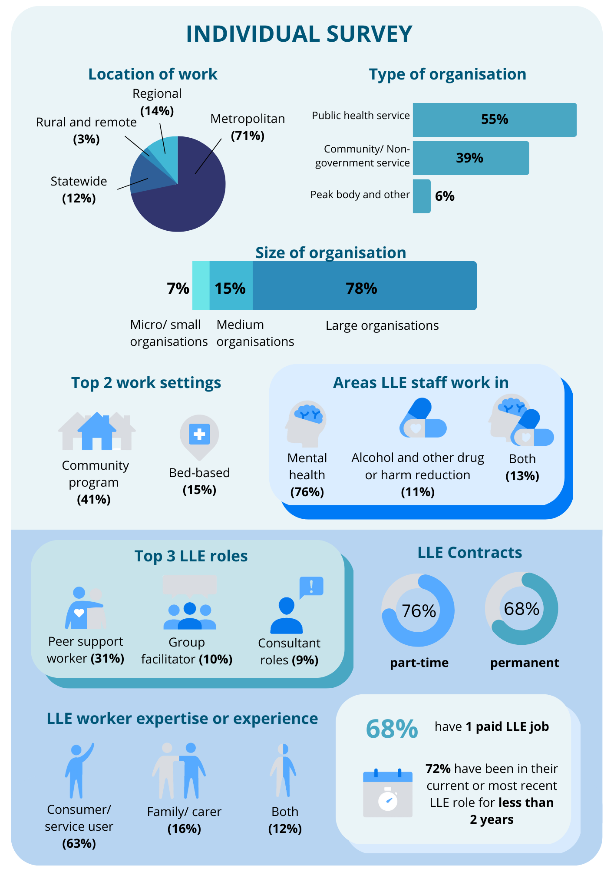
Source: Lived and living experience individual survey (May – June 2022). Note: Percentages may not add up to 100 due to rounding and not all response options being included in this figure.

Demographic profile of individuals
The majority of respondents were female, age between 25 and 54, and university educated.
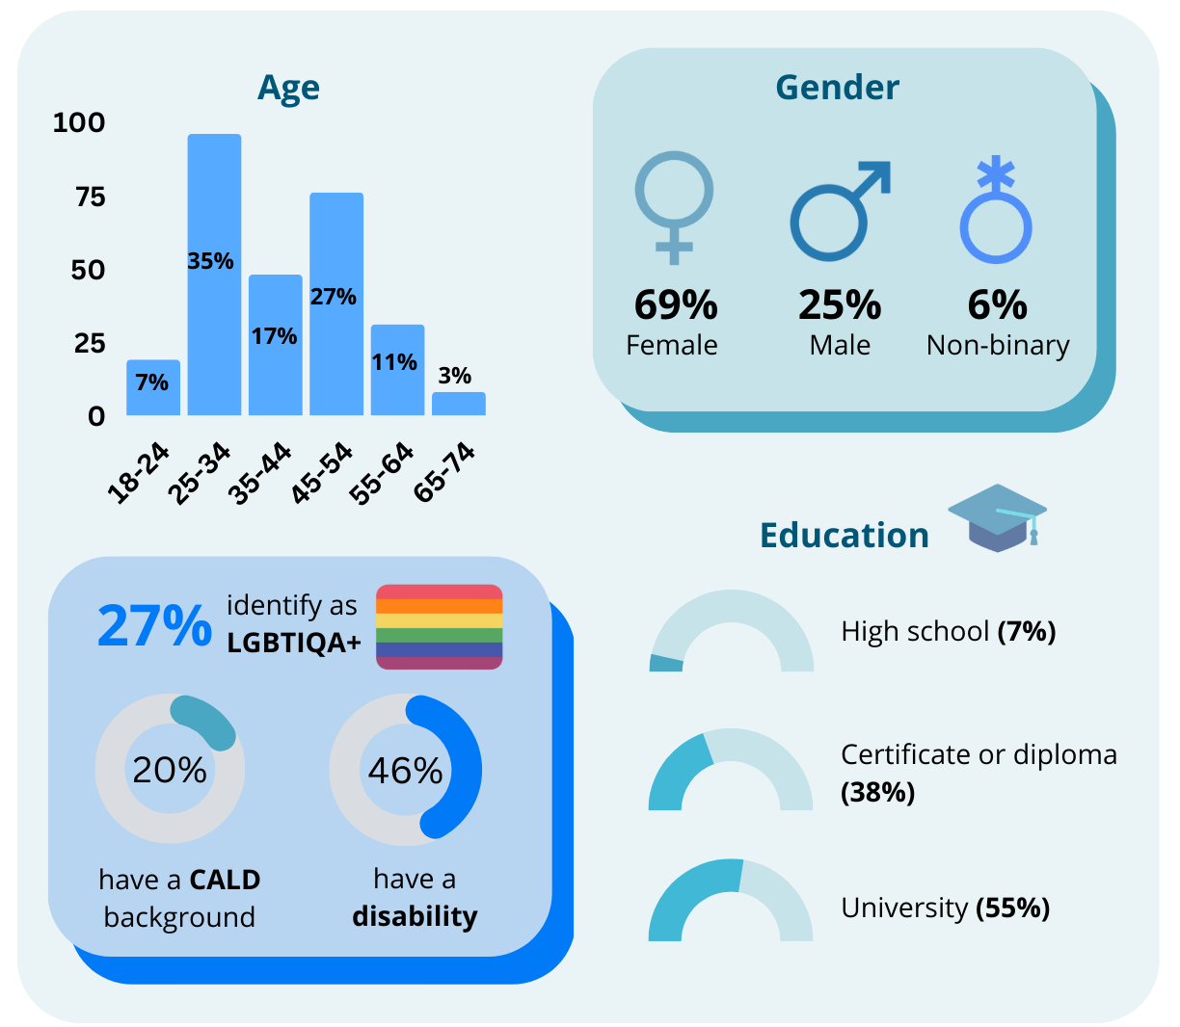
Source: Lived and living experience individual survey (May – June 2022). Note: Percentages may not add up to 100 due to rounding and not all response options being included in this figure. Note: organisation size is based on the ABS definitions, micro – fewer than 5 employees; small – 5-19 employees; medium – 20-199 employees; large – 200 or more employees.

Organisation survey
Community, public and private organisations across all locations were represented in the organisational survey. The majority of respondents were large organisations, but medium and micro/ small organisations were also represented.
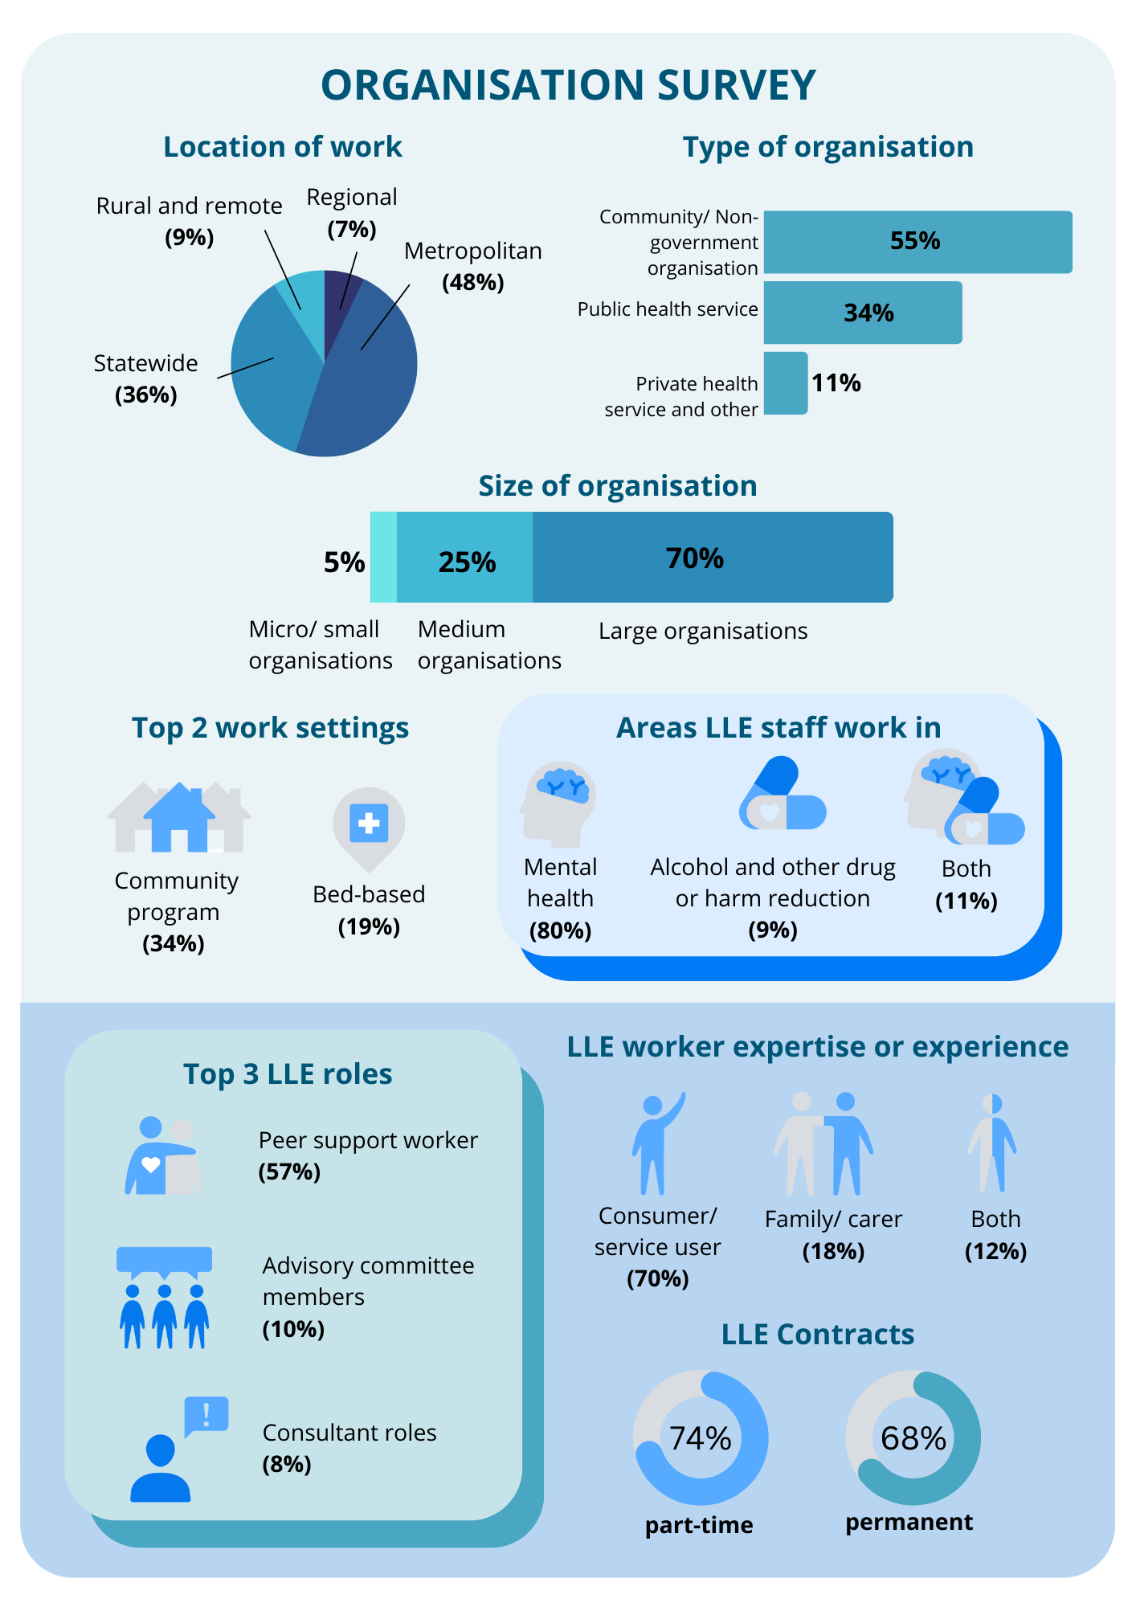
Source: Lived and living experience organisation survey (May – June 2022). Note: organisation size is based on the ABS definitions, micro – fewer than 5 employees; small – 5-19 employees; medium – 20-199 employees; large – 200 or more employees.

Key findings by domain
This chapter covers the key findings by survey domain. Most domains were included in both surveys (except team and management structures and workplace treatment of service users, which were only captured in the individual survey). A description of these figures is available under Key findings by domain in Appendix 1: Plain text infographics.

Employment
- Length of employment
  - Individuals tended to be employed in their current or most recent lived or living experience role for less than 2 years (72 per cent).
- Number of current jobs
  - 32 per cent of respondents to the individual survey had more than one paid lived or living experience job. The most common reasons were that it enabled them to work in a variety of lived or living experience roles (25 per cent), for financial reasons (22 per cent), due to a lack of full-time positions (19 per cent) and because they like doing consulting outside of their current role (18 per cent).
- Previous employment
  - Half of the individuals who are currently employed in a lived or living experience role had previously worked in a different lived or living experience role (49 per cent).

Contracts and working hours
- Contract types
  - The largest proportion of lived and living experience workers had part time (permanent and fixed term) contracts in both surveys (76 per cent in the individual survey and 74 per cent in the organisation survey).
  - Most individuals (62 per cent) indicated that they had their ideal contract type.
- Contracted hours
  - Individuals were most commonly contracted to work 21–30 hours per week (40 per cent) in the lived or living experience role in which they spend the most time.
  - Roughly half (52 per cent) of respondents worked their contracted hours, with 33 per cent working a little more and 12 per cent working a lot more.

Recruitment and retention
- Plans to leave current position
  - 30 per cent of individuals planned to leave their role in the next 12 months, and another 29 per cent were unsure. Reasons for leaving were highly varied, and included insufficient income/salary, career prospects, end of contract, lack of advancement (progression) opportunities and dissatisfaction with management or leadership.
- Career progression
  - Half of individual survey respondents (50 per cent) said that there are roles in their current organisation that would provide career progression. A higher proportion said there were roles that would do this in other organisations (59 per cent).
  - Most organisations agreed that it is important to provide pathways for career progression for lived and living experience workers (83 per cent agreed or strongly agreed). However, only 7 per cent agreed or strongly agreed that their organisation was providing these.
- Turnover
  - The average turnover rate for lived and living experience workers for the last 2 years is 17 per cent.
- Number of lived and living experience workers (Full-time equivalent)
  - Individuals and organisations reported a similar average number of people working in lived or living experience roles in their organisation – 25 (individual survey) and 21 (organisation survey). These numbers are highly variable across organisations.
  - The majority of individuals and organisations reported that there were insufficient lived and living experience worker leadership or supervisory positions to meet the needs of the lived and living experience workforces (76 per cent of individuals, 73 per cent of organisations) and not enough lived and living experience worker positions to meet the needs of consumers/service users (74 per cent of individuals, 79 per cent of organisations) and families, carers and supporters (80 per cent of individuals, 82 per cent of organisations).
  - Individuals reported that a shortage of lived and living experience workers had a number of negative implications for lived and living experience workers and, in turn, client outcomes.
- Workforce growth
  - Most organisations had plans to increase both the number of lived or living experience positions (87 per cent) and the number of hours for existing positions (70 per cent) over the next 12 months.
  - 87 per cent of organisations reported barriers to growing the lived and living experience workforces. Almost all (96 per cent) saw the availability of funding as the most critical barrier and change required to grow the workforces. Both individuals and organisations also saw this as the most critical change required to support lived and living experience workers (85 per cent of individuals and 93 per cent of organisations saw this as critical).

Employment conditions
- Position descriptions and orientation
  - Almost all individual survey respondents (94 per cent) said they have a position description, and 63 per cent felt it accurately described their role (12 per cent were neutral on whether their position description accurately described their role and 25 per cent felt it did not).
  - Roughly half (46 per cent) agreed or strongly agreed that when they started their job they received an orientation that helped them clearly understand their role, while 13 per cent neither agreed nor disagreed and 41 per cent strongly disagreed or disagreed.
- Workplace adjustments
  - Of the 60 per cent of individuals who had workplace adjustments, most (86 per cent) agreed or strongly agreed they were sufficient to do their job. 19 per cent did not have workplace adjustments but felt they needed them.
- Understanding of lived and living experience worker role
  - Individuals were less positive than organisations that staff at their organisation understand how the role of lived and living experience workers differs from other roles. 40 per cent of individuals agreed or strongly agreed, 21 per cent neither agreed nor disagreed and 40 per cent disagreed or strongly disagreed. 60 per cent of organisations agreed or strongly agreed, 23 per cent neither agreed nor disagreed and 17 per cent disagreed or strongly disagreed. Individuals were also less positive than organisations that staff understand the role of lived and living experience workers; why it is important; and the values, ethics, principles and approaches of lived and living experience workers.
  - Individuals and organisations were slightly more positive about the understanding of leaders and managers at their organisation than they were about staff. For example, 60 per cent of individuals agreed or strongly agreed that leaders and managers at their organisation understand how lived and living experience roles differ from other roles, 16 per cent neither agreed nor disagreed and 24 per cent disagreed or strongly disagreed. 69 per cent of organisations agreed or strongly agreed that leaders and managers understand how lived and living experience roles differ from other roles, 24 per cent neither agreed nor disagreed and 7 per cent disagreed or strongly disagreed. Individuals and organisations had similar levels of agreement for each of the corresponding statements about leaders' and managers' understanding of the lived and living experience worker role.
  - Most organisations agreed or strongly agreed that the organisation is actively working to improve the understanding of staff (79 per cent) and leaders and managers (73 per cent).

Qualifications
- Qualifications held by respondents
  - 49 per cent of individual respondents had completed Intentional Peer Support training and 14 per cent had completed a Cert IV in Mental Health Peer Work.
  - 77 per cent of individuals indicated they also had other qualifications that assist them in their role (mostly health specific qualifications, other mental health training and courses and non-health specific tertiary qualifications), and 83 per cent said there are others they would like to have (such as workplace or career training, service delivery training and Intentional Peer Support).
- Essential or desirable qualifications
  - Most organisations and individuals indicated that qualifications were not required. Depending on the qualification, 43-65 per cent of individuals said it was not required, while 23-52 per cent of organisations said it was not required. However, organisations were more likely to report that some qualifications were required or desirable (e.g. 13 per cent of organisations said Intentional Peer Support was required and 65 per cent said it was desirable, compared to 17 per cent and 40 per cent respectively for individuals).

Training and support
- Support from other lived and living experience workers
  - Most individuals agreed or strongly agreed that they are able to access support from lived and living experience workers in their organisation (74 per cent), while 11 per cent neither agreed nor disagreed and 14 per cent disagreed or strongly disagreed.
  - Approximately half (51 per cent) of individuals either agreed or strongly agreed that they are able to access support from lived and living experience workers external to their organisation, while 17 per cent neither agreed nor disagreed and 31 per cent disagreed or strongly disagreed.
  - Organisations were substantially more likely to agree or strongly agree (82 per cent) than individuals (17 per cent) that they actively facilitate connections between lived and living experience workers within their organisation. 11 per cent of organisations neither agreed nor disagreed that they do this, while 7 per cent agreed or strongly agreed that they do. 17 per cent of individuals neither agreed nor disagreed that their organisation does this, while 17 per cent agreed or strongly agreed that they do.
  - Organisations were also more positive about the degree to which they facilitate connections between the lived and living experience workers they employ and those working for other organisations (54 per cent agreed or strongly agreed compared to 35 per cent of individuals). 11 per cent of organisations neither agreed nor disagreed that they do this, while 7 per cent agreed or strongly agree that they do. 17 per cent of individuals neither agreed nor disagreed that their organisation does this, while 17 per cent agreed or strongly agreed that they do.
- Professional development
  - Most organisation survey respondents (83 per cent) agreed or strongly agreed that lived and living experience workers are provided with in-house training opportunities, but only 59 per cent agreed or strongly agreed that they are provided with a budget for external professional development.
  - Around half of individual survey respondents were satisfied with the level of support and professional development opportunities they receive both internally (51 per cent agreed or strongly agreed, 20 per cent neither agreed nor disagreed, 26 per cent disagreed or strongly disagreed) and externally (52 per cent agreed or strongly agreed, 20 per cent neither agreed nor disagreed, 29 per cent disagreed or strongly disagreed).
  - Both sets of respondents tended to agree that the following aspects of support and professional development were available for lived and living experience workers, although organisations were more positive than individuals:
- lived and living experience workers’ access to lived or living experience-led training
- allocated time for professional development
- lived or living experience-specific supervision
- coaching or mentoring by someone with lived or living experience.

Leadership and management
- Line management
  - Most individuals (68 per cent) said their line managers are not in lived and living experience roles. However, 75 per cent would prefer having a lived and living experience worker or one lived and living experience worker and one non-lived and living experience worker as their line manager.
- Leadership
  - Most individual survey respondents said that there are lived and living experience workers in leadership, management or supervisory roles in their organisation (78 per cent).
  - Most organisations agreed or strongly agreed that their organisation encourages people with lived or living experience to take on leadership roles (70 per cent) and has good ways of responding to the views of lived and living experience workers (67 per cent).
- Influence on organisation
  - Individuals were less positive than organisations that lived and living experience workers had influenced changes in their organisation’s structure, systems or policies (63 per cent of individuals agreed or strongly agreed compared to 75 per cent of organisations); and that staff at their organisation had changed their approaches as a result of working with lived and living experience workers (52 per cent of individuals agreed or strongly agreed compared to 79 per cent of organisations).
  - Some changes lived and living experience workers had influenced in their organisations included: more supports for lived and living experience workers, more integration of lived and living experience workers into the company’s structure and leadership roles, improvements to service delivery, and changes to the company’s hiring practices and training policies.
  - Some barriers to lived and living experience workers influencing changes in their organisations included: the organisation’s structure preventing lived and living experience workers’ voices being heard, lived and living experience workers not having enough resources, insufficient numbers of lived and living experience workers in senior roles, and stigma or tokenistic engagement with lived and living experience workers.

Workplace culture
- Individual experiences
  - Individuals (72 per cent) agreed or strongly agreed that staff in non-lived and living experience roles generally have positive attitudes towards lived and living experience workers, although they were less positive than organisations (87 per cent agreed or strongly agreed).
  - Most individuals agreed or strongly agreed that they: speak up at their organisation (77 per cent agreed or strongly agreed, 16 per cent neither agreed nor disagreed, 8 per cent disagreed or strongly disagreed), feel valued by their organisation (66 per cent agreed or strongly agreed, 15 per cent neither agreed nor disagreed, 20 per cent disagreed or strongly disagreed), and are recognised for their contributions (50 per cent agreed or strongly agreed, 23 per cent neither agreed nor disagreed, 17 per cent disagreed or strongly disagreed).
  - Most individuals said they know how to report workplace incidents (78 per cent) and feel confident to do so (71 per cent).
  - Roughly half of individuals agreed or strongly agreed that they feel listened to by their organisation (55 per cent agreed or strongly agreed, 22 per cent neither agreed nor disagreed, 22 per cent disagreed or strongly disagreed) and that their organisation responds constructively to feedback from lived and living experience workers about unsafe, unethical or unhelpful practices (50 per cent agreed or strongly agreed, 27 per cent neither agreed nor disagreed, 23 per cent disagreed or strongly disagreed).
  - 23 per cent of individuals agreed or strongly agreed that they feel pressure to work in opposition to lived and living experience worker values, ethics and approaches (22 per cent neither agreed nor disagreed, 55 per cent disagreed or strongly disagreed).
- Challenges and barriers
  - The main challenges faced by individuals in their role include insufficient numbers of lived and living experience workers (72 per cent) and a lack of time (67 per cent).
  - 58 per cent of individuals said they had experienced burnout, 13 per cent neither agreed nor disagreed that they had, and 29 per cent said they had not.
- Organisational views
  - 80 per cent of organisations reported that they actively seek the expertise of lived and living experience workers. They do this through feedback processes, advisory groups or committees, staff meetings, co-design processes and community consultation.

Workplace treatment of consumers/service users
- Observed treatment of consumers/service users
  - Most individual survey respondents agreed or strongly agreed that their organisation is inclusive (72 per cent), but fewer agreed their organisation is consumer/service user centred (63 per cent), family inclusive (59 per cent) or empowers the consumers/ service users and/or families, carers and supporters it supports (56 per cent).
  - The majority of respondents reported that, in the last 2 years, they had observed some form of stigmatisation or discrimination towards consumers/service users and/or families, carers and supporters. For each form of discrimination or stigmatisation, between 30 and 61 per cent of respondents had seen it often or sometimes.
  - The most common form of stigmatisation individuals had observed towards consumers/service users and/or families, carers and supporters at their organisation was pathologising (attributing behaviour to illness rather than unmet needs) – 61 per cent had observed this often or sometimes.
- Impact of this on respondents
  - Most individuals disagreed or strongly disagreed that they are negatively impacted by the way their organisation interacts with consumers/service users and/or families, carers and supporters (61 per cent disagreed or strongly disagreed, 19 per cent neither agreed nor disagreed, 21 per cent agreed or strongly agreed).

Workplace safety and wellbeing
- Stigma and discrimination
  - 47 per cent of individuals and 32 per cent of organisations reported that lived and living experience staff experience stigma and discrimination.
  - A significant proportion of individuals reported having personally experienced stigma and discrimination in the last two years.
  - The most commonly reported types of stigmatisation or discrimination personally experienced by individuals in the last 2 years were ‘other’ (43 per cent), being treated differently to other lived or living experience staff (36 per cent), negative perceptions of their competency to do their job (35 per cent), and poor response to complaints they have made (32 per cent).
  - Individuals (25 per cent) were less likely than organisations (56 per cent) to agree that their organisation is actively seeking to address stigma and discrimination.
- Power imbalances
  - Similar proportions of individuals (62 per cent) and organisations (55 per cent) agreed there is a power imbalance between lived and living experience workers and other staff at their organisation.
  - Individuals (26 per cent) were less likely than organisations (67 per cent) to agree or strongly agree their organisation is actively seeking to address the power imbalance.

Key differences in responses
All individual surveys were analysed by key groups to see if there were any differences in the way these groups responded. Key differences were:
- Context
  - People working in mental health were generally less positive than those working in alcohol and other drugs or harm reduction
- Expertise/experience
  - Family/carer living and lived experience workers were generally less positive than consumer/service user living and lived experience workers
- Contract type
  - People who are casual or have contract were generally less positive than those who have permanent contracts.
- Previous employment in a lived and living experience role
  - People who had previously worked in a lived and living experience role were generally less positive than those who had not.
- Organisation size
  - People who work in large organisations were generally less positive than those who work in micro, small and medium organisations
- Organisation type
  - People working for public health services were generally less positive than those working in NGOs and other types of organisations.
- Location
  - People working in metropolitan areas tended to be less positive than those working in regional or remote areas or in statewide services.
- Culturally and linguistically diverse
  - There weren’t many substantial differences; however, when there were, culturally and linguistically diverse people were less positive.
- Gender
  - There were very few substantial differences in sentiment between males and females.
- Sexuality
  - People who identify as being from the LGBTIQA+ community are less positive than those who do not.
- Disability
  - People with disability tended to be less positive than those who do not have a disability.

Factors driving responses to the individual survey
A principal components analysis was conducted on 61 items in the individual survey to identify higher order concepts or ‘factors’ that explain and summarise the results. This statistical method can identify ‘unobserved’ factors, represented by a set of questions and responses that, when viewed in combination, provide insight into higher order factors that go beyond any one question. These factors provide insights into the core concepts that people answering the survey are thinking about when they answer individual survey items.
Six key factors were identified that account for more than 50 per cent of the variation in responses to the 61 survey items included in the analysis. That is, the way that individuals felt about these six factors directly influenced how they answered the questions and can explain about half of their responses. The table below identifies each factor and indicates what percentage of variation that factor accounts for. The factors are listed in order of importance, with each one progressively explaining a smaller proportion of the variation.
This analysis serves two core functions. First, it identifies the core concepts that, if improved, would have the biggest impact on the workforce. Second, it provides a data-driven means of reducing the survey size while still capturing the most important and relevant information about lived and living experience workers’ experiences.
Key factors driving responses
Factor | Per cent of variation (individual)
- The extent to which leaders and staff in the employing organisation recognise and value the role of lived and living experience workers | 16.8 per cent
- The extent to which employing organisations have positive and empowering attitudes to consumers/services users and treat them with respect | 11.0 per cent
- The extent to which employing organisations facilitate connections to other lived and living experience workers and to professional development | 7.0 per cent
- The extent to which lived and living experience workers are satisfied with access to support and supervision from external lived and living experience workers | 6.8 per cent
- The extent to which employing organisations proactively address stigma and power imbalances experienced by lived and living experience workers | 6.6 per cent
- The extent to which lived and living experience workers are satisfied with access to support from internal lived and living experience worker and to professional development | 6.0 per cent
The two most important factors relate to the attitudes of leaders and managers towards lived and living experience workers, and how the organisation treats consumers and service users. These two factors account for over 25 per cent of the variation in all 61 survey items.
The remaining four key factors are relatively equal in importance and relate to access to support (from both internal lived and living experience workers and external lived and living experience workers) and professional development, and to the extent to which the organisation proactively addresses issues such as stigma and power imbalances.
These factors are useful in providing a set of priorities that could be leveraged to create positive changes in the experience of lived and living experience workers, although they need to be understood in the broader context of the more detailed findings. It's important to keep in mind that only things that were specifically asked about in the survey can be identified through factor analysis and that other things may also be important – for example, salary and wages.
Each of the factors is associated with a set of questions that most closely align with that factor and the analysis can be used to develop shorter surveys that capture these most critical factors. In this case it seems a survey of 12 items may be sufficient for a quick ‘pulse check’ (between more intensive data collections) about the views of lived and living experience workers (see next section). While it was not possible to undertake a factor analysis on the organisational survey because of the small number of responses, the factor analysis undertaken on the individual survey provides insights into what is most important to measure through the organisation survey, since several of the factors relate to actions and attitudes relating to the employing organisation. This will be explored in more depth in the next two sections.

Suggested changes to the survey

Individual survey
When asked to give feedback on the survey most respondents had no feedback (n=35) or positive feedback (n=30). Other feedback was about specific questions. The responses to survey questions also provided indications of questions that could be clarified or removed. In general, these changes included refining some response options for clarity, and removing some questions that have not provided useful insights. Specific feedback about changes to the individual survey can be found in Appendix 3.
Given the length of the individual survey, it is sensible to consider shorter versions of the survey. Two aspects of our analysis can provide insight into which questions should be included in shorter versions:
- The factor analysis provides insight into the questions that most closely measure the six key factors that drive most of the variation in responses.
- The cross tabulations provide insight into particular demographic groups that tend to respond differently to the survey and, therefore, which demographic questions should be included to track whether changes are occurring for those groups.

Two survey options have been developed:
- A short survey that includes all of the questions that most directly measure the key factors. There are two survey options – if the survey is sent by the department to all lived and living experience workers in Victoria, the inclusion of overarching and demographic questions would be useful to ensure that the right people complete the survey and enable cross tabulations to compare changes between groups. If the survey is used by organisations, they would not need to include the overarching questions or the demographic questions (since the number of responses would not allow for any crosstabulations). This survey can be found in Appendix 4.
- The second is a mini survey (see Appendix 5) that contains only those questions that most directly measure the six key factors. The same overarching and demographic questions could be used.

These shorter surveys could be used by the department for pulse checks, saving the longer survey for a more comprehensive data collection every two years. The versions of the survey should be finalised collaboratively with the sector.

Organisation survey
The organisation survey required significant efforts on the part of the department to generate an acceptable number of responses and this level of engagement is not sustainable over multiple data collections.
While the survey provided useful insights as a baseline against which to measure change, repeating the organisational survey as it is currently constructed would likely be difficult because it would require significant department resources, may not generate accurate responses (because of the reputation risk of providing non-desired responses), and some components duplicate other data collection or could be captured through other data collection. Instead, questions about:
- the number of lived and living experience workers, the nature of their roles and their employment conditions could be gathered through the census of mental health workers in Victoria, particularly if this also included suicide prevention and alcohol and other drugs workers
- plans to change numbers of lived and living experience workers and lived and living experience worker turnover could potentially be included in performance reporting for funding.

If an organisation survey was continued, there were a number of questions or question types that didn’t work well and could be dropped in future iterations of the survey.
- Questions about barriers and enablers to supporting and growing the workforce: As with the individual survey, because responses were distributed across most of the responses, there wasn’t sufficient differentiation to analyse the responses in a meaningful way. This is likely because all of the response options are important. It is likely more useful to infer what these factors are from responses to other questions.
- Questions that asked organisations to provide links or upload evidence to support their responses to questions: Most organisations didn’t do this and it is hard to interpret why they didn’t. It may be because that evidence doesn’t exist, or it could just be that it was technically difficult, overly burdensome or contained confidential information.

In future, an organisation survey could focus on fewer items that provide useful insights, particularly when compared to individual responses, such as:
- the questions about required or desirable qualifications – these can be compared to individual responses
- the Likert scale questions – particularly those aligned to the key factors identified through the individual survey and those paired with individual questions.
A suggested shorter version of the organisation survey is included in Appendix 6, as well as a short and mini survey of the organisation survey, to match the short and mini versions of the individual survey.

Suggested actions for the future
The Royal Commission intended for the survey of ‘organisational attitudes’ to have two functions – to establish a benchmark and to be an ongoing accountability mechanism. This first round of the survey was designed to test the survey and to provide a baseline to accurately describe the current experiences of lived and living experience workers and organisational attitudes towards lived and living experience workers.
Benchmarking is not just about the collection of comparative information. It is a continuous self-improvement tool to seek out and learn about best practice. Benchmarking is expected to stimulate positive change by showing organisations how to do things better through systematic comparisons of service practices. Benchmarking should show an organisation not only how it is performing but how much better it could perform. Information about relative performance may be a catalyst for improvement for organisations, while information at a state level might be a catalyst for improvement where gaps between current and desired levels of practice are identified. Ideally, to support accountability for continuous improvement at an organisational level, it would be possible for organisations to benchmark their performance against like organisations and the state level. It would also be possible to identify discrepancies between the perspectives of organisations and lived and living experience workers in their workforce.
However, given the small numbers of lived and living experience workers in most organisations and the personal nature of the data collection, it is not currently possible to conduct benchmarking in this way. So different approaches need to be considered to support accountability for improvements.

State level
Repeating modified versions of the surveys over regular time periods will allow for comparison at a state level to see if things are changing as relevant reforms are implemented. Given its length, the full individual survey could be repeated every two years, paired with the repetition of the shortened version of the organisational survey. This would minimise the burden on respondents, particularly because some aspects of experience will take time to change. The short or mini versions of the individual and organisation surveys could be used annually (between the more substantive data collections), as a pulse check on changes at a state level, particularly to identify if improvements are occurring in specific areas targeted by reform actions.
The department could explore setting targets for improvements on key items to support system change. In setting targets, the department could consider the potential for different targets for different sub sectors, for example, metro and regional locations might have different targets; as could public health services and NGOs; mental health, alcohol and other drugs and harm reduction; and large and small/medium sized organisations.
To support action at this level, the following strategies are recommended:
- Holding findings forums with organisations and individuals to share survey findings each time the survey is administered – and explore factors contributing to results, so that good practice can be widely shared.
- The department sharing findings with other reform teams, so that their actions can be informed by the experiences of lived and living experience workers.
- Setting state-wide benchmarks for ongoing improvement, likely focused on targets that measure change aligned to the six factors identified as key to variation in survey responses, as well as other factors understood to be key to the experience of lived and living experience workers. (See, for example, the key performance indicators related to the People Matter survey in performance agreements for New South Wales Health organisations – Appendix 6).

Organisational level
A minimum response size is needed before lived and living experience workers’ experiences at an organisational level can be shared with organisations to protect the identity of individual responders. For example, with the People Matter’s survey in New South Wales, a minimum response size of 10 is required before an organisation can see the results. With the sensitivity of the lived and living experience workers survey, a higher minimum response size (of at least 15) is preferable to protect the responses of individuals. There were only six organisations that had 15 or more responses to the individual survey in this round of data collection.
It would be less meaningful for organisations to compare based on the organisational survey responses given the self-report nature of this data and the difference between individual and organisational survey responses at the state level – suggesting a gap between what organisations perceive and what lived and living experience workers experience.
Without the ability to use comparisons at an organisational level to drive improvement actions, it may then be necessary to consider other approaches to creating accountability, such as including actions to address key issues identified through the surveys in funding contracts where these are not already included. For example, some actions that organisations could undertake that would likely drive improvements would be:
- delivering education or training around the role and value of lived and living experience workers, designed to shift individual knowledge and attitudes (with associated outcome measures for those who complete the education or training)
- proactively facilitating connections between lived and living experience workers within and outside of their organisation
- improving access to professional development for lived and living experience workers.
The focus would be on ensuring that organisations make changes that will contribute improvements at a state level. It will be important for actions to be developed collaboratively with the sector.

Appendix 1: Plain text infographics

Workforce profile of individuals (from page 17)
- Location of work: 71 per cent metropolitan. 14 per cent regional. 3 per cent rural and remote. 11 per cent statewide.
- Type of organisation: 55 per cent public health service. 39 per cent community/non-government service. 6 per cent peak body and other.
- Size of organisation: 78 per cent large organisations. 15 per cent medium organisations. 7 per cent micro/small organisations.
- Top 2 work settings: 41 per cent community program. 15 per cent bed-based.
- Areas lived and living experience staff work in: 76 per cent mental health. 11 per cent alcohol and other drug or harm reduction. 13 per cent both.
- Top 3 lived and living experience roles: 31 per cent peer support worker. 10 per cent group facilitator. 9 per cent consultant roles.
- Lived and living experience contracts: 76 per cent work part-time. 68 per cent have permanent jobs.
- Lived and living experience worker expertise or experience: 63 per cent consumer/ service user. 16 per cent family/carer. 12 per cent both.
- 68 per cent of respondents have 1 paid lived and living experience job. 72 per cent of respondents have been in their current or most recent lived and living experience role for less than 2 years.

Demographic profile of individuals (from page 18)
- Age: 7 per cent 18-24 years old. 35 per cent 25-34 years old. 17 per cent 35-44 years old. 27 per cent 45-54 years old. 11 per cent 55-64 years old. 3 per cent 65-74 years old.
- Gender: 69 per cent female. 25 per cent male. 5 per cent non-binary.
- Education: 53 per cent University. 37 per cent Certificate or diploma. 4 per cent High school.
- 27 per cent identify as LGBTIQA+. 20 per cent have a culturally and linguistically diverse background. 46 per cent have a disability.

Organisation survey (from page 19)
- Location of work: 48 per cent metropolitan. 36 per cent statewide. 9 per cent rural and remote. 7 per cent regional.
- Type of organisation: 55 per cent community/non-government organisation. 34 per cent public health service. 11 per cent private health service and other.
- Size of organisation: 70 per cent large organisations. 25 per cent medium organisations. 5 per cent micro/small organisations.
- Top 2 work settings: 34 per cent community program. 19 per cent bed-based.
- Areas lived and living experience staff work in: 80 per cent mental health. 9 per cent alcohol and other drug or harm reduction. 11 per cent both.
- Top 3 lived and living experience roles: 57 per cent peer support worker. 10 per cent advisory committee members. 8 per cent consultant roles.
- Lived and living experience contracts: 74 per cent part-time. 68 per cent permanent.
- Lived and living experience worker expertise or experience: 70 per cent consumer/service user. 18 per cent family/Carer. 12 per cent both.

Appendix 2: Definitions
Term | Definition
Adjustments | Changes to a work process, procedure or environment that allows people with mental health conditions to:  - perform to the best of their ability  - work productively  - work in a safe environment  - feel included in the workplace  - increase their engagement and motivation to improve performance.  Workplace adjustments can range from changes to workplace practices and environments to assistive technology and equipment.
Career prospects | Opportunities to progress career elsewhere
Consultant (lived and living experience role) | This must be as a staff member, not an external consultant
Disability | The definition of disability includes sensory, intellectual, neuro-diverse, physical and mental illness
Diversity for living and lived experience roles | Employing a diverse range of lived and living experience workers (for example, ethnicity, age, experience, etc.)
Education level – Year 11 or below | Includes certificate 1/2/Not further defined
Job | Role for which one has an employment contract
Lived and living experience | People with lived and living experience of mental health challenges, trauma, neurodiversity, psychological or emotional distress, suicidal thoughts and behaviours, substance use or addiction, those experiencing bereavement, grief and loss; and families, carers and supporters of people with these experiences.
Lived and living experience workers | Lived or living experience is an essential criterion for the position.
Non-government service | A service that is not part of the government and doesn't seek to make a profit
Organisation size | Micro – Fewer than 5 employees; Small – 5-19 employees; Medium – 20-199 employees; Large – 200 or more employees
Pathologising | Attributing behaviour to illness rather than unmet needs
Prior living and lived experience workers role | Working in the same type of role as the person is currently in but in a different organisation, a different role in their current organisation or a different role in a different organisation
Public health service | Includes area or designated mental health service
Stigmatisation | The negative and often unfair social attitude attached to a person or group, often placing shame on them for a perceived deficiency or difference to their existence.
Stress/ pressure of the work environment | Hours, deadlines, inadequate resourcing

Lived experience roles in mental health and AOD/Harm reduction settings
Term | Definition
Peer support work | Peer support work focuses on building mutual and reciprocal relationships where understanding and emotional, social, spiritual and physical wellbeing and recovery are possible. Peer support workers may work with individuals or groups. This is highly skilled and specialised work that requires training and ongoing supervision from experienced peer support workers.
Consumer peer support workers | Peer support workers who use their personal lived experience of mental illness and recovery to support other consumers.
Carer peer support workers | Peer support workers who use their experience of supporting a family member or friend who has experienced mental illness to support family members and friends of consumers.
AOD peer workers | Peer support workers who use their personal lived experience of AOD use or of supporting a family member or friend in recovery, plus skills used in formal training, to deliver services in support of others.
Consultants | Provide opinions and recommendations, based on their own expertise.
Consumer consultants | Consultants who collate information and feedback from consumers about their views and experiences of a service and use this information to make recommendations for service improvement.
Carer consultants | Consultants who collate information and feedback from families and carers about their views and experiences of a service and use this information to make recommendations for service improvement.  Many consultants also have responsibilities in education, policy, workforce development and peer support.
Managers
Lived experience managers | Experienced consumer or family/carer workers who support and develop other lived experience workers. They may or may not line-manage staff or provide practice supervision for, or mentor, other workers.
AOD lived experience managers | Experienced AOD peer workers who support and develop other AOD peer workers. They may or may not line-manage staff or provide practice supervision for, or mentor, other workers.
Consumer and family/carer educators | Educators who ensure consumer and family/carer perspectives, participation and involvement are included in all aspects of education and training provided in services. They also facilitate or co-facilitate education and training for staff, consumers and carers.
Advocates | Advocates support an individual or group to speak on their own behalf and in their own interests, or they may speak for and/or on behalf of an individual or group under instruction.
Consumer advocates | Advocates who support consumers to have a voice and be involved in issues that affect them.
Carer advocates | Advocates who support family/carers to be heard in relation to issues that affect them.
Policy advisors | Policy Advisors are responsible for providing advice on regulatory and policy issues.
Consumer policy advisors | Policy advisors who draw on collective consumer knowledge and research (both published and in grey literature) to inform change to systems and bring about change to laws, policy, procedures and bureaucracy that cause or perpetuate injustice or inequity.
Carer policy advisors | Policy advisors who draw on the body of collective carer knowledge and research to inform changes to those aspects of the mental health system that affect families and carers and to promote family/carer sensitive practice.
Consumer and carer researchers | Researchers who draw on their lived experience to promote and enable the engagement of consumers and carers at all stages of research. Consumer and carer researchers may be involved as advisors in others’ research, as partners in collaborative research, or as leaders – initiating, directing and driving research.

Appendix 3: Specific changes to individual survey
Question | Suggested change | Updated question
What expertise or experience do you work from?  Consumer/service user lived and lived experience worker (Yes/No/N/A)  Family/ carer lived and living experience worker (Yes/No/N/A) | Update response options to be clearer about responses – at the moment there are a larger than expected number of people who ticked both (given most living and lived experience workers work in one or the other area even if they have experience of both). | What expertise or experience do you work from?  Consumer/service user lived and lived experience worker  Family/carer lived and living experience worker  Both  Other (please specify)
What area do you work in? Please select one option.  Mental health  Alcohol and other drug or harm reduction  Both  Other (please specify) | A few people who ticked ‘other’ wrote suicide prevention. They were excluded from the survey because they didn’t choose either mental health or AOD, but it would have been good to include them. | What area do you work in? Please select the option that best fits.  Mental health and/or suicide prevention  Alcohol and other drug or harm reduction  Both  Other (please specify)
Do you have plans to leave your current role in your current primary workplace setting within the next 12months? | Suggest that a new question is added for those who indicate they have plans to leave to ascertain if they plan to stay within the mental health, suicide prevention or AOD sector. | Do you plan to continue to work in the mental health, suicide prevention or AOD sectors?  Yes  No  Not sure  N/A
What are the main reasons you left your most recent lived and living experience role? Please select up to 3 options.  (Options not included here) | The responses to this question were difficult to answer because they were highly distributed across all response options. Suggest that the response options are reduced significantly by categorising them into high level groups. Suggest that people are asked to select the main reason. | What is the main reason you left your most recent lived and living experience role? (Please select one option)  - Role no longer available  - To take up more desirable position  - For personal reasons (for example, illness or study)  - Issues with the job or the employing organisation (please specify)
What would encourage you to stay in your current role? Please select up to 3 options.  (Options not included here) | The responses to this question were difficult to answer because they were highly distributed across all response options. Suggest that the response options are reduced significantly by categorising them into high level groups and ensuring they are closely matched to the question about what motivates people to stay in order to allow for comparison. Suggest that people are asked to select the main reason. | What would encourage you to stay in your current role? (Please select the most important factor that would influence your decision)  - Income/salary  - Opportunities for career progression  - More job security (for example, a permanent contract)  - More learning and training opportunities  - More support from leaders, managers and staff  - More appreciation and value of the work I do  - More opportunities to use my lived experience  - More learning and training opportunities  - More independence or autonomy in my work  - More flexibility in hours/shifts
What motivates you to stay in your current role and/or in the mental health system? Please select up to 3 options. | The responses to this question were difficult to answer because they were highly distributed across all response options. Suggest that the response options are reduced significantly by categorising them into high level groups closely matched to the question about what motivates people to stay in order to allow for comparison. Suggest that people are asked to select the main reason. | What motivates you to stay in your current role and/or in the mental health system? (Please select the most important factor that influences your decision)  - Income/salary  - Opportunities for career progression  - Job security (for example, a permanent contract)  - Learning and training opportunities  - Support from leaders and managers  - Appreciation and value of the work I do  - Opportunities to use my lived experience  - Learning and training opportunities  - Desire to help people with their mental health or AOD needs  - Independence or autonomy in my work  - Flexibility in hours/shifts
Is the organisation you work for lived and living experience or peer led? | Most organisations are not peer led, and this was confirmed by the survey. Because there are so few, it is not possible to do any cross-tabulations to see if this drives variation in responses. For this reason, it’s one question that could be removed to reduce the overall length of the survey. | Delete
How many other people work in lived and living experience roles (leave it blank if you don't know): | This question aims to get a sense of the size of the workforce and would probably be better answered by including specific questions about living and lived experience workers in the regular mental health census survey. | Delete
What changes would help support the lived and living experience workforces? | Responses to this question were too distributed across response options to provide a clear picture of what is most important. The factors that help support lived and living experience workers are likely more useful when inferred from direct questions about individual experiences and therefore this question can be deleted. | Delete
Questions about qualifications | Add in other qualification options more related to carer living and lived experience workers. | Add response options as required
What ethnic group(s) do you belong to or identify with? | The open question was time consuming to analyse and not recommended for an ongoing survey. Suggest rewording this to get to the heart of this issue. | Do you belong to or identify with a cultural or ethnic group that is a minority group in Australia? This includes people whose parents or families have migrated to Australia and/or who are part of a cultural or ethnic group who speak a language other than English. It includes people of colour and people who are indigenous.  Yes  No  I’d prefer not to answer

Appendix 4: Short survey – individual
ITEM | Factor
Overarching questions (state-wide only)
- Are you 18 or over?
- Do you work in Victoria or support people living in Victoria?
- What is your organisation name?
- What type of organisation do you work for? Please select the one that best applies.
- What size is the organisation you work for?
- What expertise or experience do you work from?
- What area do you work in?
- Are you currently employed as a lived or living experience worker?
Likert scale questions (strongly disagree, disagree, neither agree nor disagree, agree, strongly agree, N/A)
- I am recognised by my organisation for my unique contribution as a lived and living experience worker | 1
- Leaders and managers in my organisation understand the values, ethics, principles and approaches of lived and living experience workers | 1
- In general, staff in my organisation understand what the role of lived and living experience workers is | 5
- I feel valued by my organisation | 1
- I am satisfied with my access to internal professional development opportunities | 3
- My organisation is consumer/service user centred | 2
- My organisation facilitates connections to lived and living experience workers outside my organisation | 3
- I am happy with the level of support I am able to access from external lived and living experience workers | 4
- My organisation facilitates connections to lived and living experience workers within my organisation | 3
- I am happy with the level of support I receive from internal lived and living experience workers | 6
- At my organisation there are enough lived and living experience leadership/supervisory positions to meet the needs of our lived and living experience workforces | 5
- I have lived and living experience specific supervision (separate to my line manager) | 4
- Over the last two years, have you observed any of the following types of stigmatisation or discrimination towards consumers/service users and/or family carers that your service supports?  - Pathologising/attributing behaviour to illness rather than unmet needs | 2
- Turning a blind eye to stigma and discrimination | 2
- Lived and living experience staff experience stigma and discrimination | 5
Demographic questions (state-wide only)
- Do you identify as part of the LGBTIQA+ community?
- Do you identify as Aboriginal and/or Torres Strait Islander?
- Do you belong to or identify with a cultural or ethnic group that is a minority group in Australia?
- Do you have a disability? (please note the definition of disability includes sensory, intellectual, neuro-diverse, physical and mental illness – where the disability is permanent or is likely to be permanent)

Appendix 5: Mini survey – Individual
ITEM | Factor
Likert scale questions (strongly disagree, disagree, neither agree nor disagree, agree, strongly agree, N/A)
- I am recognised by my organisation for my unique contribution as a lived and living experience worker | 1
- Over the last two years, I have observed stigmatisation or discrimination towards consumers/service users and/or family carers that my service supports | 2
- I am satisfied with my access to professional development opportunities | 3
- My organisation facilitates connections to other lived and living experience workers | 3
- I am happy with the level of support I am able to access from external lived and living experience workers | 4
- My organisation actively seeks to address power imbalances experienced by lived and living experience workers | 5
- My organisation actively seeks to address stigma and discrimination experienced by lived and living experience workers | 5
- I am happy with the level of support I receive from internal lived and living experience workers | 6

Appendix 6: Organisation survey – updated and short versions

Updated survey
Question
Overarching
- Does your organisation provide mental health, alcohol and other drug or harm reduction services in Victoria?
- What is your organisation name?
- What is your organisation type? Please select one option.
- What size is the organisation currently?
- Does your organisation currently employ people in lived or living experience roles?
Specific questions
- What, if any, qualifications are required or desirable to be employed in a lived and living experience position?
- What, if any, qualifications are lived and living experience workers required or encouraged to complete once they commence in a role?
Likert scale questions
- This organisation has enough lived and living experience positions to meet consumer needs
- This organisation has enough lived and living experience positions to meet family/carer needs
- This organisation has enough lived and living experience leadership/supervisory positions to meet the needs of our lived and living experience workforces
- This organisation believes it is important to provide pathways for career progression for lived and living experience workers
- This organisation has clear pathways for career progression for lived and living experience staff in designated roles
- In general, staff in this organisation understand: What the role of lived and living experience workers is
- In general, staff in this organisation understand: Why the role of lived and living experience workers is important
- In general, staff in this organisation understand: How the role of lived and living experience workers differs from other roles
- In general, staff in this organisation understand: The values, ethics, principles and approaches of lived and living experience workers
- Staff in non lived and living experience roles generally have positive attitudes toward lived and living experience workers
- The organisation is actively working to improve staff understanding of lived and living experience workforces
- Leaders and managers in this organisation understand: What the role of lived and living experience workers is
- Leaders and managers in this organisation understand: The values, ethics, principles and approaches of lived and living experience workers
- Leaders and managers in this organisation understand: Why the role of lived and living experience workers is important
- Leaders and managers in this organisation understand: How the role of lived and living experience workers differs from other roles
- The organisation is actively working to improve leaders' and managers' understanding of lived and living experience workers
- Lived and living experience workers have allocated time for professional development
- Lived and living experience workers are provided with a budget for external professional development
- Lived and living experience workers are provided with in-house training opportunities
- Lived and living experience have access to lived and living experience led training
- Lived and living experience workers are provided with coaching/mentoring by someone with lived and living experience
- Lived and living experience workers are provided with lived and living experience specific supervision (separate to line management)
- This organisation actively facilitates connections between the lived and living experience workers it employs
- This organisation actively facilitates connections between the lived and living experience workers it employs and lived and living experience workers outside the organisation
- Lived and living experience workers have influenced changes in the organisation's structures, systems or policies
- Staff at the organisation have changed their approaches as a result of working with lived and living experience workers
- This organisation actively seeks the expertise of lived and living experience workers
- This organisation has good ways of responding to the views of lived and living experience workers
- This organisation actively encourages people with lived and living experience to take on leadership roles
- There is a power imbalance between lived and living experience workers and other staff who are not in lived and living experience roles in this organisation
- Lived and living experience staff experience stigma and discrimination
- This organisation actively seeks to address these power imbalances
- This organisation actively addresses stigma and discrimination faced by lived and living experience staff

Short survey for organisations
Question | Factor
Overarching (state-wide only)
- Does your organisation provide mental health, alcohol and other drug or harm reduction services in Victoria?
- What is your organisation name?
- What is your organisation type? Please select one option.
- What size is the organisation currently?
- Does your organisation currently employ people in lived or living experience roles?
Likert scale questions
- This organisation has enough lived and living experience leadership/supervisory positions to meet the needs of our lived and living experience workforces | 5
- In general, staff in this organisation understand: What the role of lived and living experience workers is | 5
- Leaders and managers in this organisation understand: The values, ethics, principles and approaches of lived and living experience workers | 1
- Lived and living experience workers have allocated time for professional development | 3
- Lived and living experience workers are provided with in-house training opportunities | 3
- Lived and living experience workers are provided with lived and living experience specific supervision (separate to line management) | 4
- This organisation actively facilitates connections between the lived and living experience workers it employs | 6
- This organisation actively facilitates connections between the lived and living experience workers it employs and lived and living experience workers outside the organisation | 3
- Lived and living experience staff experience stigma and discrimination | 5
- This organisation actively addresses stigma and discrimination faced by lived and living experience staff | 5
- There is a power imbalance between lived and living experience workers and other staff who are not in lived and living experience roles in this organisation | 5
- This organisation actively seeks to address these power imbalances | 5

Mini survey for organisations
Question | Factor
Likert scale questions
- Lived and living experience workers have allocated time for professional development | 3
- This organisation actively facilitates connections between the lived and living experience workers it employs | 3
- This organisation actively facilitates connections between the lived and living experience workers it employs and lived and living experience workers outside the organisation | 3
- This organisation actively addresses stigma and discrimination faced by lived and living experience staff | 5
- This organisation actively seeks to address these power imbalances faced by lived and living experience staff | 5

Appendix 7: Key Performance Indicator example
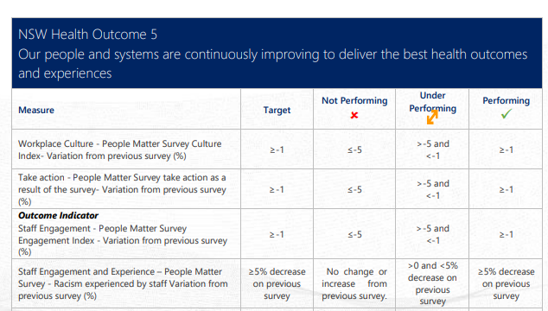
NSW Health Outcome 5
Our people and systems are continuously improving to deliver the best health outcomes and experiences.

Workplace Culture – People Matter Survey Culture Index – Variation from previous survey (per cent). Target: equal or greater than 1. Not performing: equal or less than 5. Under performing: greater than 5 and less than 1. Performing: equal or greater than 1.

Take action – People Matter Survey take action as a result of the survey – Variation from previous survey (per cent). Target: equal or greater than 1. Not performing equal or less than 5. Under performing: greater than 5 and less than 1. Performing: equal or greater than 1.
Outcome Indicator
Staff Engagement – People Matter Survey Engagement Index – Variation from previous survey (per cent). Target: equal or greater than 1. Not performing: equal or less than 5. Under performing: greater than 5 and less than 1. Performing: equal or greater than 1.

Staff Engagement and Experience – People Matter Survey – Racism experienced by staff – Variation from previous survey (per cent). Target: equal or greater than 5 per cent decrease on previous survey. Not performing: No change or increase from previous survey. Under performing: greater than 0 and less than 5 per cent decrease on previous survey. Performing: equal or less than 5 per cent decrease on previous survey.

Victorian Department of Health (2019). Lived experience workforce positions report. Retrieved 7 December 2022: https://www.health.vic.gov.au/workforce-and-training/lived-experience-workforce-initiatives
Victorian Department of Health (October 2021). Lived experience workforce positions report: Victorian mental health and alcohol and other drug services 2019–20. http://www.health.vic.gov.au/sites/default/files/migrated/files/collections/research-and-reports/l/lived-experience-workforce-positions-report.docx
Lived and living experience refers to people with lived and living experience of mental health challenges, trauma, neurodiversity, psychological or emotional distress, suicidal thoughts and behaviours, substance use or addiction, those experiencing bereavement, grief and loss, and families, carers and supporters of people with these experiences.
Designated lived and living experience roles are those in which lived or living experience is an essential criteria for the position.
People who were employed over 2 years ago were asked why they had left their previous job and then exited from the survey.
Victorian Department of Health (2019). Lived experience workforce positions report. Retrieved 7 December 2022: https://www.health.vic.gov.au/workforce-and-training/lived-experience-workforce-initiatives.
Only groups with a sufficiently large number of responses to ensure anonymity of data were analysed.
The 61 items included any question with at least three response options, excluding any that allowed respondents to pick all that applied.
Technically a principal components analysis with varimax rotation was conducted on the individual survey responses. The analysis could not be conducted on the organisation survey because there were not enough responses.
CIPFA (2013). Better Benchmarking. An Executive Guide to Continuous Performance Improvement.

