
User Guide
Outcome Measure Tasks
A guide for creating concurrent episodes maintaining one stream of outcome measure tasks v0.2
OFFICIAL

To receive this document in another format email:
MHDReporting@health.vic.gov.au <MHDReporting@health.vic.gov.au>.

Authorised and published by the Victorian Government, 1 Treasury Place, Melbourne.
© State of Victoria, Australia, Department of Health, April 2023
In this document, ‘Aboriginal’ refers to both Aboriginal and Torres Strait Islander people. ‘Indigenous’ or ‘Koori/Koorie’ is retained when part of the title of a report, program or quotation.
ISBN 978-1-76131-134-5 (pdf/online/MS word)

Table of Contents
Release Versions 4

Introduction 4

Key Message 4

Purpose of this document 4

What is the data used for by the Department of Health 4

Concurrent episodes and outcome measure tasks 5

Client has an episode open: 5
Opening a second episode (concurrent) 6

Maintain one stream of tasks when opening new episode 8
To continue with the same stream of tasks 9

Definitions 12

Release Versions
Table caption
Version | Date | Author | Changes
V0.1 | 27/4/2023 | Glenda Wyatt | - Documentation on how to open concurrent episodes and manage tasks.
V0.2 | 04/05/2023 | Glenda Wyatt | - Update terminology to make consistent throughout document.  - Add additional screen shots

Introduction

Key Message
It is possible to create concurrent ambulatory episodes within CMI/ODS and not generate additional tasks to complete.

Purpose of this document
- To outline the process for creating concurrent episodes without generating more outcome measure tasks
- To outline how to allocate the existing outcome measure tasks to the new ambulatory team.

What is the data used for by the Department of Health
Outcome measures are expected to play an integral role in the activity-based funding model at both Commonwealth and State levels. It is therefore essential that services know how to open concurrent ambulatory episodes without CMI/ODS generating additional outcome measures if they are not required. If the Phase of Care has changed for the consumer, then a new set of outcome measures should be generated by using a Discretionary task.

Concurrent episodes and outcome measure tasks
Client has an episode open:
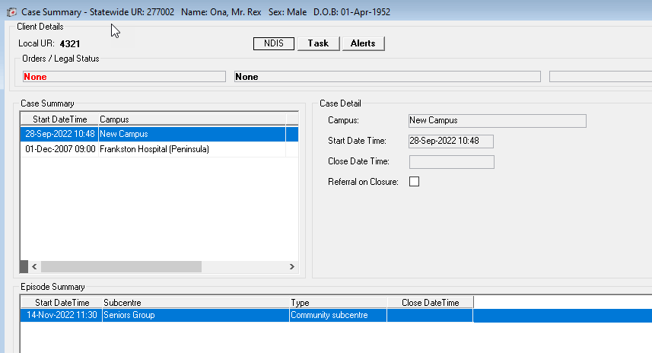
Task is generated.
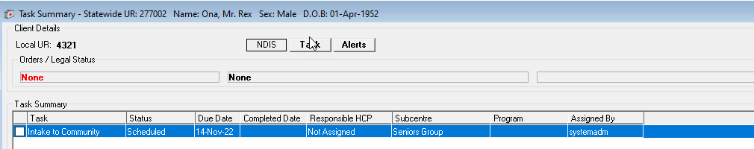
And partially completed
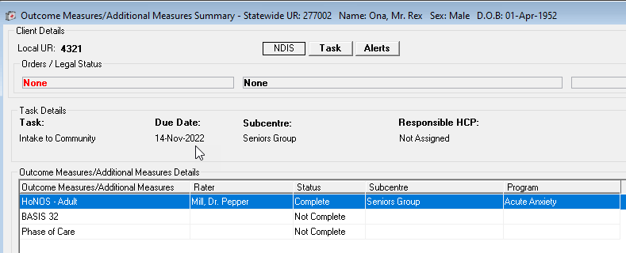

A 91-day review is generated
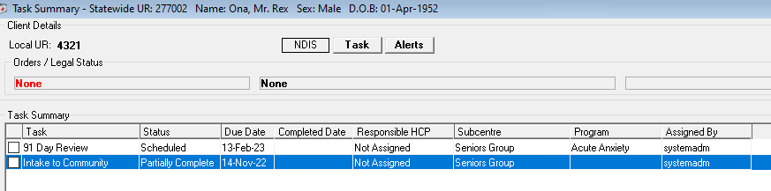

Opening a second episode (concurrent)
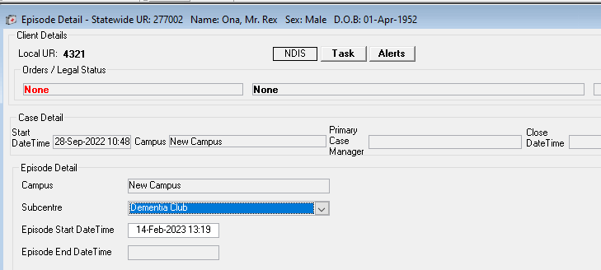
Case summary showing concurrent episodes
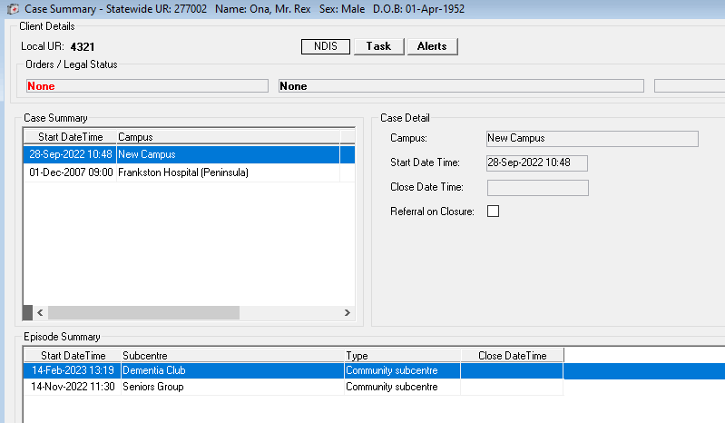

Open the task summary window and click on Edit. Assign the task to the second subcentre
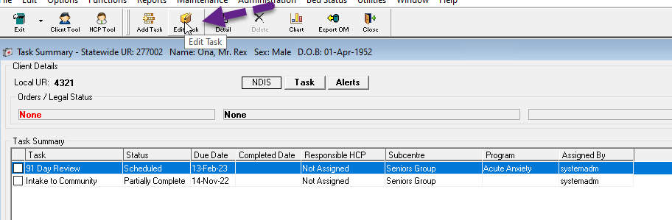
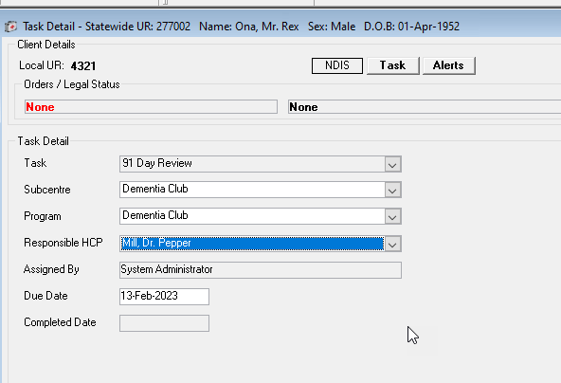
A task is completed, or partially completed, to generate the next 91-day review.
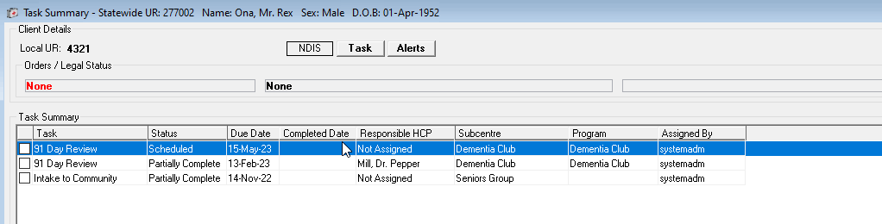
The task can be edited as before and continue alternating between the two teams or make one team the primary team responsible for the tasks.
In this instance, the second team can add their tasks and measures as Additional Measures.
**Discretionary Review tasks must not be used, unless the 91-day review cycle has lapsed and needs to be restarted or the phase of care has changed for the consumer outside of the 91 day review cycle.

Maintain one stream of tasks when opening new episode
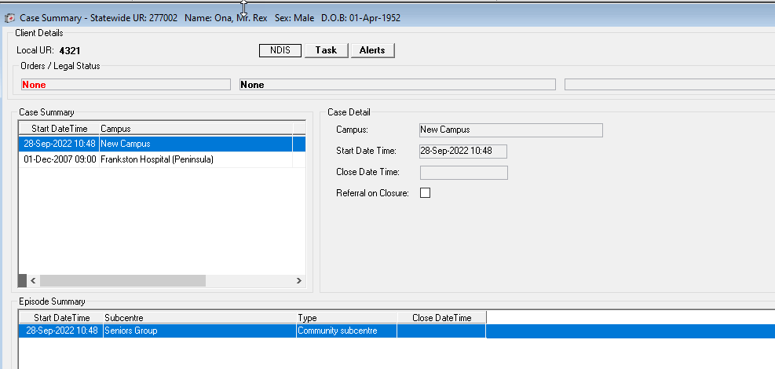
Task is completed - 91-day review is generated.
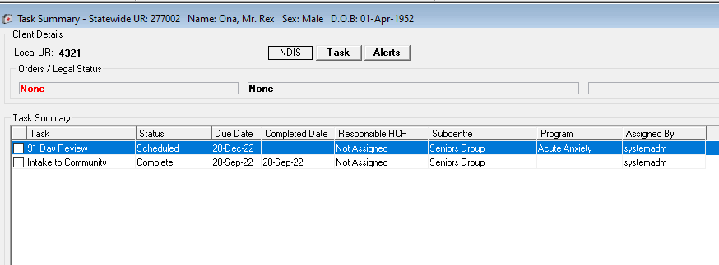

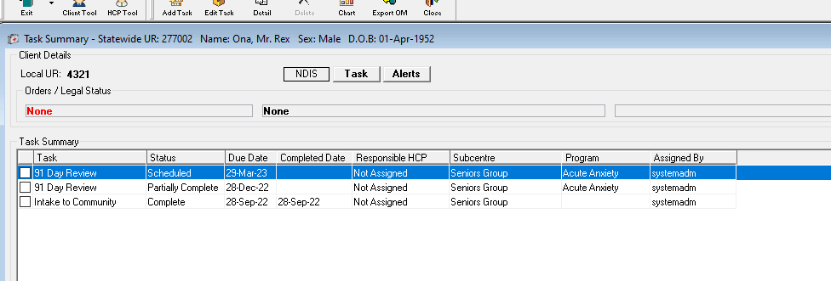

The first team have completed their time with the consumer and have referred them on to the Dementia Club team to start 30/03/2023.

To continue with the same stream of tasks
Open the Dementia Club episode for 30/03/2023 at 9:59 (at this point both episodes are open)
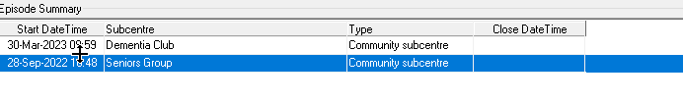
Now close the first episode (Seniors Group) on 30/03/2023 10:00.
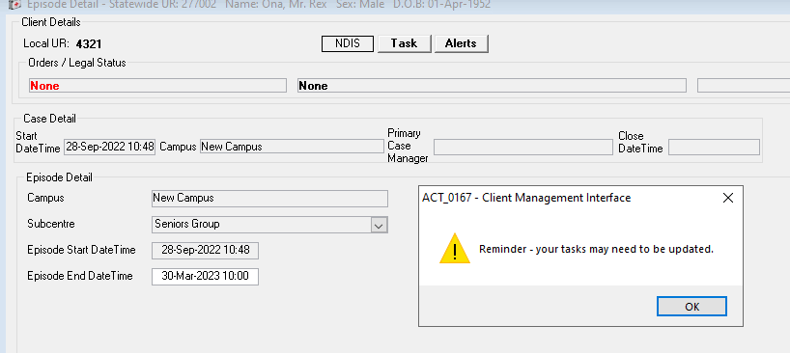
** It is important to close the first episode one minute AFTER opening the new episode – if this is not followed then a new set of outcome measures will be generated.
When saving, this message will appear prompting you to update the tasks, i.e., change the subcentre to the new team, which in this case is the Dementia Club

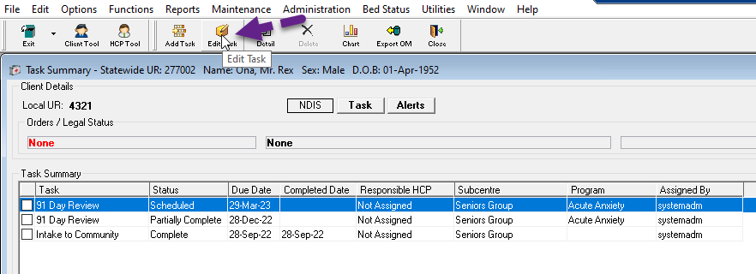

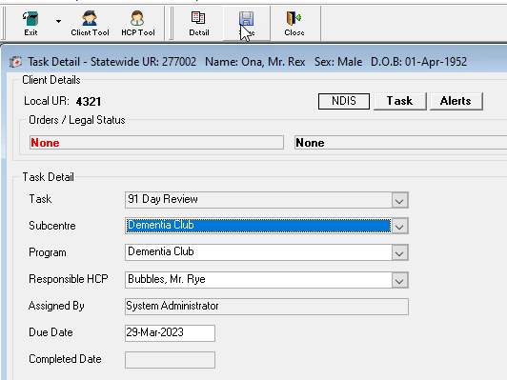

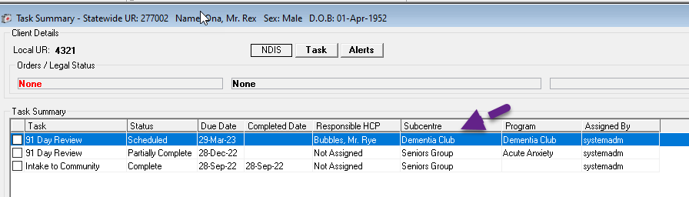
The Dementia Club team are now reponsible for the tasks.
The Seniors team may complete the ‘partially complete’ task for their 91 day review as shown above and can add any other outcome measures as Additional Measures if they would like to.
The scenario above can be ongoing provided the teams looking after the consumer are of the same program class and same outcome measure setting.

NOTE:
- When editing tasks to reflect a change of teams, the program class and outcome measure setting of both subcentres must be the same.
Note: In this instance, the Seniors Group and Dementia Club are both ‘Community’ and both required aged outcome measures.

- If the new subcentre is a different age group, for example if the referring subcentre is an adult subcentre referring to an aged subcentre, then the first episode would need to closed and the second episode opened at least a minute after the close date/time of the first team.

NOTE: Discharge tasks would be generated for the first team and Intake tasks would be generated to the later team in this scenario.
NOTE: If you attempt to edit a task where the program class or outcome measure setting are different (e.g. from adult to aged subcentre)
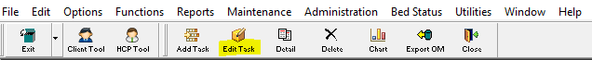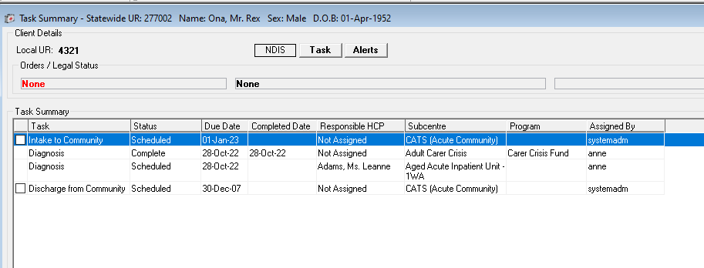
then this message will appear and the record cannot be saved:
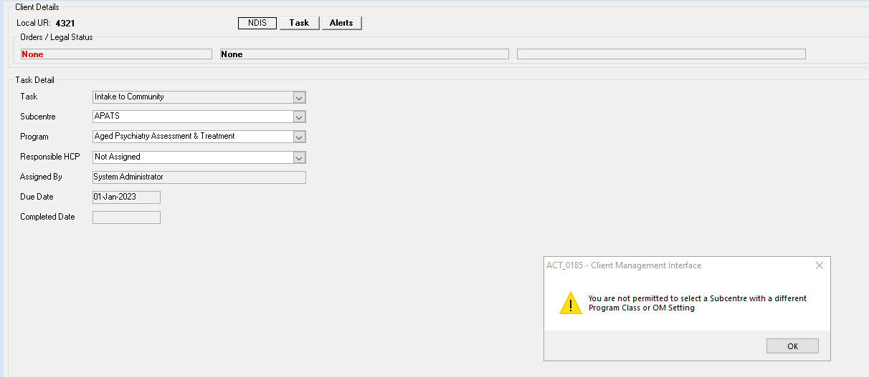

Click ok and continue as described above.

Definitions

OM setting Field available in CMI/ODS to identify the relevant outcome measures applicable to a subcentre based on age group, e.g. CAMHS, Adult, Aged

Program Class A specialised program classification describing the target population and funding source for both episodes and contacts that occur with the subcentre

Program The organisational service unit attached to a subcentre. Each program identifies a clinical function or service intervention performed by a team that relates directly to a funded activity.

Program Type Identifies the mental health setting and applicable age-based category relating to the program team providing the service.

Subcentre Identifies an organisational setting or location from which programs are delivered. A subcentre will comprise of one or more programs. The subcentre provides the setting for inpatient, community residential and community activity for child & adolescent, adult, older persons or generalist client populations.

