
Community Health Demand Management Toolkit
May 2023
OFFICIAL

Community Health Demand Management Toolkit
May 2023

To receive this document in another format, email Primary, Community and Oral Health <Partnerships.Primary@health.vic.gov.au>.
Authorised and published by the Victorian Government, 1 Treasury Place, Melbourne.
© State of Victoria, Australia, Department of Health, May 2023.
ISBN 978-1-76131-171-0 (pdf/online/MS word)
Available at Managing demand for community health services <https://www.health.vic.gov.au/community-health/managing-demand-for-community-health-services>.

Contents
Acknowledgments 7
Introduction 8
Purpose and use of this Toolkit 8
How was this Toolkit developed? 8
Who is this Toolkit for? 9
What principles guide this Toolkit? 9
Demand management overview 10
What is demand management? 10
How do we measure demand? 10
What factors influence demand management? 10
How can we improve demand management? 11
Managing demand across the consumer journey 13
Organisational readiness 14
Access 15
Initial assessment 21
Service delivery 23
Transition and exit 27
Getting your organisation ready 29
Governance and review 32
Governance 32
Review 32
Appendix A: Community Health Program access policy 33
Community Health Program eligibility criteria 33
Principles 33
Appendix B: Frequently asked questions 35
Appendix C: Text-equivalent descriptions of figures 40

Acknowledgments
The Victorian Government acknowledges the Traditional Owners of the lands on which we all work and live. We recognise that Aboriginal people in Victoria practice their lore, customs and languages, and nurture Country through their deep spiritual and cultural connections and practices to land and water.
The Victorian Government is committed to a future based on equality, truth, and justice, and acknowledge that the entrenched systemic injustices experienced by Aboriginal people endure.
We pay our deepest respect and gratitude to ancestors, Elders, and leaders—past and present. They have paved the way, with strength and courage, for our future generations.
The Victorian Government recognises the strength of people with a lived or living experience of trauma, victim survivors, people with disabilities, chronic disease, mental health challenges and substance use or addiction, including their families, carers and supporters.
This Toolkit was developed in consultation with the community health sector from July to December 2022. We acknowledge the time and input of members of the Project Advisory Group and Clinical Working Groups throughout the process. The insights provided by all of the contributors supported the development of a practical and flexible resource, designed to meet the needs of the sector.

Introduction
Community Health Services (CHSs) play an integral role in Victoria’s broader health system, providing holistic and equitable healthcare across the lifespan through an early intervention and prevention perspective. The role of CHSs is to provide accessible healthcare, deliver services across a variety of disciplines and support consumers to access and receive care for various health needs. CHSs are embedded in local communities and are in a unique position to deliver targeted, integrated, and person-centred services for vulnerable and disadvantaged Victorians.
CHSs are evolving together with the broader health system. Major changes such as aged care reforms and the implementation of the National Disability Insurance Scheme (NDIS), alongside the ongoing COVID-19 pandemic, are influencing the role of CHSs. These pressures mean that integrated and connected health and wellbeing responses are more important than ever.
Service demand for CHSs is continuing to increase and are being influenced by factors such as an ageing population, workforce supply and increases in chronic disease prevalence. Demand management is critical to ensuring consumers get access to the right care at the right time. In CHSs, demand management is particularly important to ensure that services are available for vulnerable and disadvantaged populations who may not be able to access other health services.

Purpose and use of this Toolkit
This Toolkit provides guidance that will support CHSs manage demand consistently across the state. The Toolkit provides a level of flexibility that allows each service to adapt demand management practices to best support their service delivery and population needs. It outlines key considerations across the consumer journey for demand management and is not intended to be a prescriptive model due to the diversity of CHSs. The purpose of this Toolkit is to ensure that consumers have:
- Timely access to treatment for better health outcomes
- Equity of access and service delivery across the state
- Priority access for those with the greatest need
The aim of the Toolkit is to support CHSs to deliver services effectively through considering service access and demand management across the consumer journey.

How was this Toolkit developed?
This Toolkit was developed by the Department of Health (the department) in consultation with the community health sector. The approach included a rapid review of the current demand management landscape in Victoria and better practice in demand management in health contexts across jurisdictions. From this, an understanding of the current challenges and opportunities for managing demand in CHSs was gained. It was found that the sector required flexible guidelines for managing demand that could be tailored to each service, allowing them to respond appropriately to local community need.
More than 60 stakeholders across the Community Health sector were consulted. Members from across seven different disciplines, including clinicians, workers, executive staff, researchers, and consumers, engaged in a review process and feedback sessions, with insights embedded throughout the Toolkit.

Who is this Toolkit for?
This Toolkit provides guidance for all CHSs for activity funded under the Community Health Program (CHP). It is recognised that services have several different funding streams, however where practicable, this Toolkit should be applicable to all funding streams to enable an integrated approach to service delivery.

What principles guide this Toolkit?
Demand management involves shaping the capacity of services so that the health needs of communities can be supported with the resources available.
Demand management needs to be grounded in consumer-centred care and aligned with appropriate service delivery within the scope of community health.
The underlying principles for managing demand used in the development of this Toolkit have been derived from themes gathered throughout consultations with the community health sector and evidence from research and demand management literature. These principles should be considered when developing and implementing demand management strategies.
Eight principles underpin the Toolkit including:
 | Equity: Providing support to consumers based on their circumstances and supporting greater equity in health outcomes across the community.
 | Innovation: Trialling and implementing different service delivery models and finding ways to improve or change services when things are not working.
 | Collaboration: Working with consumers, across disciplines and with the broader health and wellbeing sector in a seamless and streamlined manner to provide the best outcomes.
 | Communication: Providing information to consumers in a clear and transparent way that supports informed decision making, including through the provision of language services when required.
 | Impact: Delivering benefit and impact to as many consumers as possible within the capacity and resources available in each service.
 | Empowerment: Equipping consumers with the information and tools needed to self-manage and prioritising improved health literacy.
 | Flexibility: Understanding how demand occurs, how it fluctuates, and being adaptive and responsive to support better demand management.
 | Diversity: Supporting consumers by understanding diverse backgrounds, needs and identities, and delivering services in a culturally safe and responsive way.

Demand management overview

What is demand management?
In the context of community health, demand relates to the number of consumers with health concerns who present for services and the number of services they require. Demand management is an organisational approach to manage capacity and resourcing particularly during times of high demand.
Demand management requires CHSs to:
- Continue to address the broader health needs of the community through early intervention and health promotion across the lifespan
- Regularly review internal processes, ensuring services are efficient, high quality and targeted to consumer needs.
Without an effective demand management process, the capacity of services to respond and deliver both initial appointments and services can be impacted.

How do we measure demand?
Measuring demand requires access to data on the number of people requiring access to a service, and the intensity of the services likely to be required to address the needs of these people.
Methods of measuring demand typically include counting the number of people on waiting lists, monitoring the number of new referrals to a service and understanding the number of people who will require ongoing periodic service (due to a chronic condition for example). Organisations should also consider how demand from population groups who may benefit but are not regularly accessing the service is measured.
A plan for demand management needs to consider the relationship between the amount of supply available, and the amount of demand. Waiting lists that continue to grow over time suggest an imbalance between supply and demand. Waiting lists that remain stable for long periods suggest that supply and demand are balanced. However, for some CHSs, longstanding waiting lists are leading to ongoing delays in service provision.
When demand exceeds supply, CHSs should employ strategies outlined in this Toolkit to bring supply and demand into better balance. The Department is currently working towards developing measurement and benchmarking tools which will be incorporated into a future version of this Toolkit.

What factors influence demand management?
Demand management is influenced by a range of factors.

Workforce supply
The number, discipline, and scope of practice of the workforce will influence what CHSs are able to deliver. CHSs should have clear understanding at all times of the impact of workforce on their services, and ensure they clearly communicate changes to the types of services available to consumers. Where workforce supply restricts what services a CHS can provide, alternative pathway options should be developed to ensure that a consumer’s needs are met. Supply should also be managed where possible during known periods of fluctuations such as school holidays and predictable disruptions such as parental leave.

Service (and funding) model
Not all CHSs provide the same services. Some CHSs may offer different programs and have different approaches to delivering services based on community need and workforce availability. This may also include referrals, partnerships, and/or collaboration with the broader service system to meet a need. Where possible, CHSs should look to offer a variety of pathways to meet individual health needs.

Services available in hospitals and other organisations
For CHSs located in regional areas, access to a broader service system may be limited. Some regional services are the only access point for most of the community. Understanding the existing service landscape and shifting service provision to complement health services in the region will be important to managing demand. This may mean that the model of service delivery will change to reflect local population needs and ensure that the services can work together to respond to need.

Local priority groups
Different geographic areas can have different priority population groups which CHSs need to respond to. These may also change over time. CHSs should identify the priority populations, those who have inequitable access to care and poor health outcomes, and local needs (by using local LGA population data, population needs assessments etc.), ensuring they are developing plans to service local needs. CHSs should regularly review their priority population groups and align service delivery that best responds to local consumers.

Accommodating fluctuations in demand
CHSs should be operating a flexible service delivery approach in times of fluctuations in demand such as emergencies and demographic changes in the population. Emergencies can include natural disasters such as floods and bushfires or pandemics such as COVID-19. Emergencies can lead to rapidly changing medical, economic and social landscapes and CHSs will need to adjust service priorities and service models to keep up with identified and changing community needs.
Changes in demand can also be gradual, resulting from demographic changes over time. Rapid demographic changes can also impact demand, such as highly localised refugee settlement when Australia responds to international humanitarian crises.
Service providers should continually review approaches and be flexible in responses based on changing circumstances.

Funding
The available funding will influence the supply of services, and in turn the management of demand. For Community Health Program funding, where hours are provided for allied health and nursing, understanding demand for each discipline and appropriately planning to meet this need will support the attainment of community health outcomes. Service providers need to ensure that consumers are directed to the most suitable funding stream if they are eligible for Aged Care, NDIS or other services. This will ensure Community Health Program funded services are offered to consumers not eligible for other funded service streams.

How can we improve demand management?
Demand management is comprised of different elements that contribute to resource utilisation. This ensures services can appropriately respond to communities accessing support.
There are several factors that support better demand management, including:
- Enabling timely access
- Providing information to consumers
- Maintaining partnerships with the local community and services to enable service provision
- Waitlist management.
To ensure a consistent approach across all CHSs, the following factors should be considered when managing demand.

Enabling timely access
Timely access to appointments ensures that all appropriate referrals are screened by a worker as soon as possible. This helps reduce the risk of consumers’ conditions deteriorating and of consumers disengaging from services while waiting for treatment or therapy. Workers are then able to develop a plan for service, if required. This may include support through the CHS or a referral to a more appropriate treatment or therapy option within the broader service system.
This approach shifts the focus from prioritising for triage to prioritising for service delivery, with a worker using their knowledge and understanding of the social determinants of healthcare to make an informed decision.

Providing information to consumers
When consumers understand wait times, services, and options available, they can make an informed decision about managing their health and wellbeing. Consumers can also be provided with information about how they can self-manage their condition whilst awaiting support from a suitably qualified health worker. Services should have accessible information available about the services they provide in various formats and languages.

Developing and maintaining partnerships
It should be clear what is and is not provided at each CHS. CHSs should look to create partnerships, where possible, across primary, acute and social sectors in local settings. Consumers will be able to access other services that will meet their health outcomes.
Partnerships also support understanding and awareness of the services that Community Health provide. This enables the sector more broadly to provide consumers with appropriate referrals.

Waitlist management
Where possible, consumers should be provided an appointment upon referral or initial contact, and within an appropriate timeframe.
Services must keep a waitlist that accurately captures the number of clients waiting for a service at any given time, including clients who have been allocated an appointment, but are waiting for service. Actively managing the waitlist and looking to reduce wait times, can support flow through.

Managing demand across the consumer journey
CHSs need to manage demand at all stages of a consumer’s journey. The consumer journey can be described in four key stages, including:
- Access: Initial entry to CHSs which involves determining eligibility and priority and understanding need.
- Initial assessment: Conducted by a suitably trained worker to identify broader consumer need, triaging, and determining service need. The term “worker” is used throughout this document and may include clinicians or other suitably qualified and trained health staff.
- Service delivery: Activities provided by CHSs to improve health outcomes.
- Exit and transition: Supported exit and transition to alternative supports, or referrals to broader service systems, or consumer to appropriately self-manage following the care they have received.
To support the demand management process, organisations will need to consider organisational readiness, including service planning, data collection and continuous improvement.
Figure 1 provides an overview of demand management activities across the four key stages, outlining factors that can support better demand management. A consumer’s journey may not be linear.
Several evidence-based strategies have been identified to support consumers at each stage. The following sections provide approaches to support better demand management across the consumer journey.

Organisational readiness
Demand management is supported by strong organisational processes including service planning, data collection and continuous improvement.
Figure 1: Overview of demand management across the consumer journey
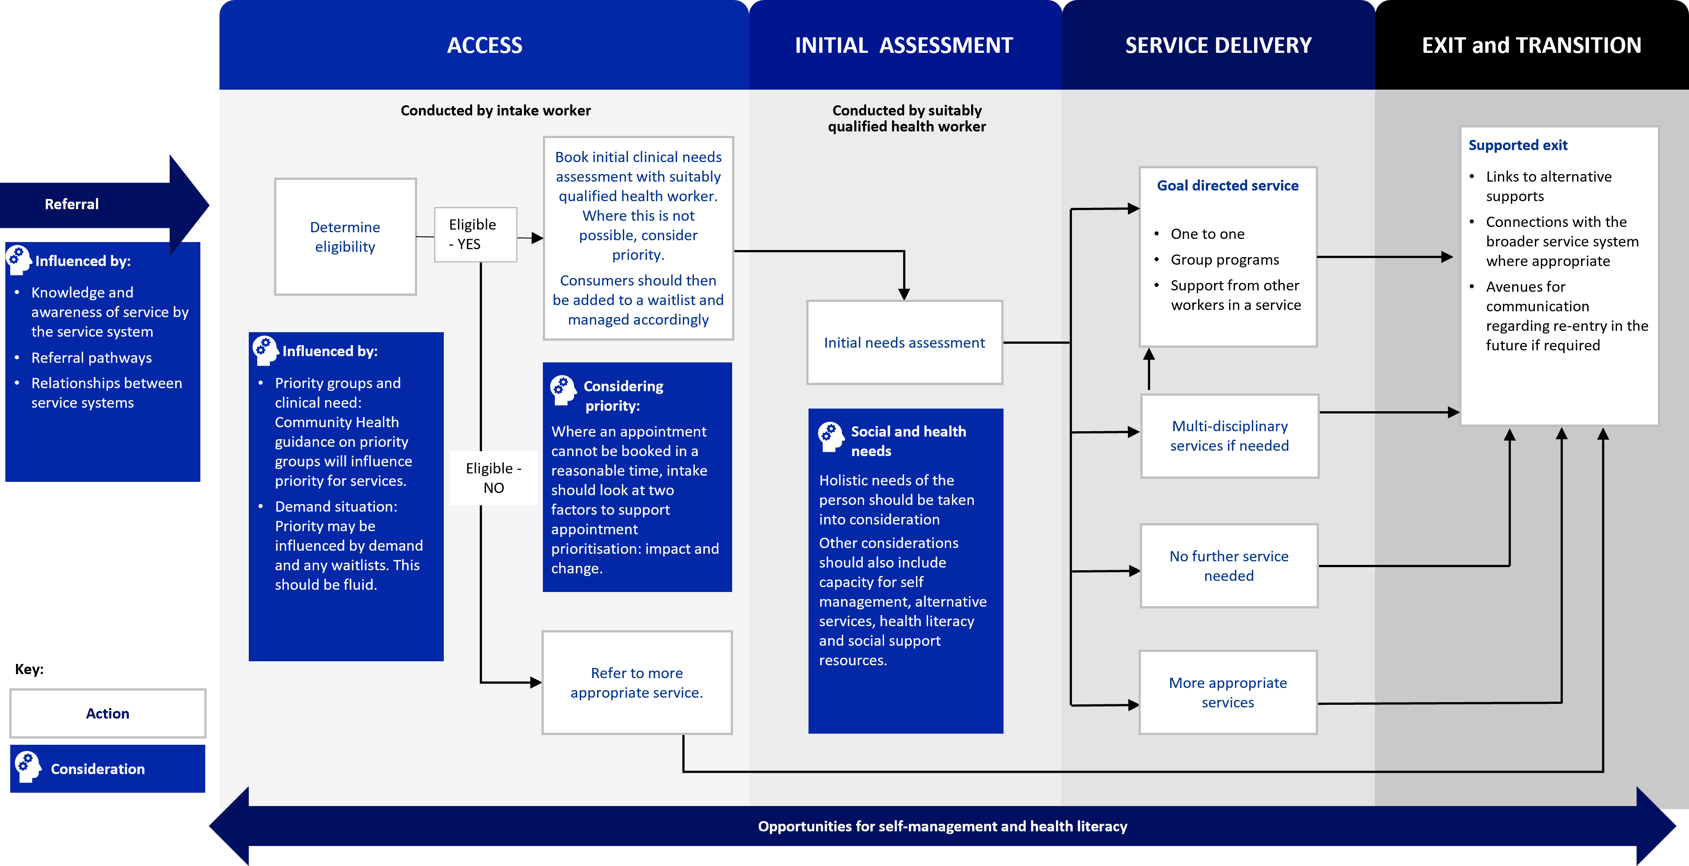

Access
Access refers to the initial entry point to CHSs and involves intake workers reviewing referrals and supporting a streamlined entry point into services. Access should occur in line with the community health focus of providing care to vulnerable and disadvantaged populations; this is enabled by having clear access pathways.
The key aim of managing demand is to provide timely access, as early intervention may prevent a consumer’s condition from worsening. This can also reduce pressure on health services providing acute care.
Access is comprised of three key stages:
- Determining eligibility and priority for services
- Understanding needs
- Booking initial assessment
When demand fluctuates, criteria around each of these elements may need to change to enable flow through, ensuring that resources are focused on priority populations.
It is acknowledged that demand and access to services can vary greatly between disciplines. CHSs should aim to employ a flexible, adaptive, and innovative approach that reflects a diverse professional workforce, is responsive to local community needs, and utilises external services where appropriate to strengthen supports.

Determining eligibility and priority for services
There are no overarching state-wide eligibility criteria for CHSs, although eligibility criteria exist for some funded programs within the CHS sector. The eligibility criteria for the Community Health Program are included at Appendix A. Once eligibility for the service has been identified, CHSs should work to understand priority for access. These steps can be conducted face to face or via phone depending on consumer preference.
Whilst CHSs are one part of a broader healthcare system, they may be the only accessible health service for some segments of the population and this needs to be considered. CHSs should understand their community profile to support decision-making about access where an initial appointment is not made within a reasonable timeframe. This does not need to be a static decision, and elements that can be considered include:
- CHSs not accepting referrals for specific health concerns/issues where there is a dedicated and similar service available in proximity. In this instance, ‘similar’ refers to both the service provided as well as the cost for service.
- Available workforce and capability may mean that CHSs cannot appropriately service all population groups or specific health conditions.
- Encouraging and supporting population groups to access other health and disability services, for example, Commonwealth Home Support Program (CHSP), HACC PYP, My Aged Care or NDIS supports, where eligible.

Priority groups
CHSs in Victoria prioritise access for consumers with the greatest risk of poor health outcomes and with the greatest economic and social need. Priority groups are reflected in the eligibility criteria for the Community Health Program (Appendix A), and include:
- Aboriginal and Torres Strait Islander people, including children and young people
- Refugees and people seeking asylum
- People, including children and young people, who are homeless or at risk of homelessness
- Children in care, child protection, Orange Door and ChildFIRST clients

Intersectionality as a lens to identify priority
CHSs should take a holistic approach when considering the complexity of a consumer’s situation. This requires understanding intersecting aspects of a consumer’s identity and social characteristics. Intersectionality refers to the ways in which different parts of a consumer’s identity and experiences can expose them to overlapping forms of discrimination and marginalisation.
Figure 2: Elements of intersectionality
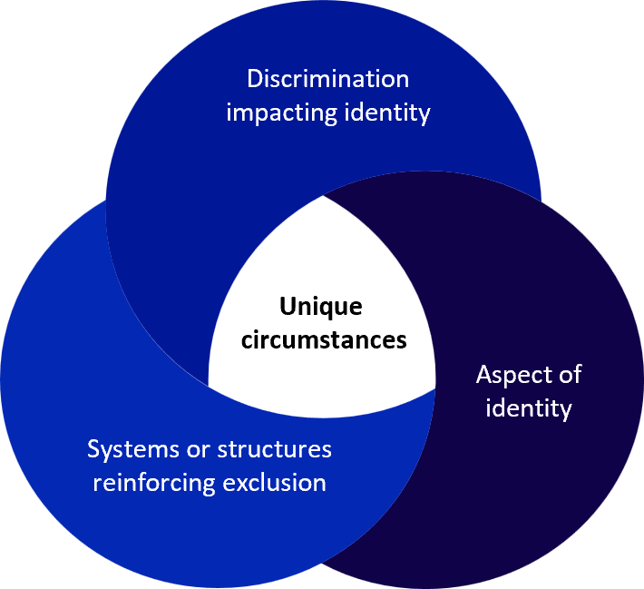

Figure 2 demonstrates how different intersecting identities and structures can reinforce various forms of discrimination and influence health outcomes. These should be considered when thinking about access for CHSs, and can include:
- Unique circumstances: Consumers can be impacted by their own unique circumstances and can include what opportunities they had access to or where they were born.
- Aspects of identity: Factors such as cultural and linguistic diversity, education level, disability, sexuality, gender or gender identity.
- Discrimination impacting identity: The types of discrimination people experience due to the aspects of their identity, such as racism, sexism, homophobia, transphobia, or ableism, and how this may influence accessibility of broader healthcare services.
- Systems or structures reinforcing exclusion: Structural issues that perpetuate systemic inequality, displacement, and exclusion, such as people seeking asylum who are ineligible for certain supports (e.g. Medicare and income support) or people with disability who cannot physically access services or public transport.

To support understanding intersectionality, workers can:
- Ask gentle, open ended, exploratory questions. For example, “How can I help you today?”, “What is influencing your health needs?”, “Is there a reason you haven’t sought help with this health need before now?”
- Listen without judgment and show curiosity and compassion
- Understand it might take some time for consumers to build trust and feel comfortable sharing certain information
- Recognise different aspects of a person’s identity and how these can interact to create barriers to accessing support.
- Ensure information is recorded appropriately to ensure that consumers don’t have to retell their stories or provide information multiple times.
Designing for Diversity is the Department’s framework for embedding responsiveness to diversity at the outset of any policy reform or service design process.
It provides an approach and suite of resources that CHSs can use to address diversity and identify gaps in the design process where diversity may not be adequately addressed.
See the Designing for Diversity for more information <https://www.health.vic.gov.au/populations/designing-for-diversity>.

Managing referrals
Referral management systems should be designed to ensure the right consumers are gaining access to the right services at the right time. This enables transparent engagement about their eligibility, priority and wait times and is driven by evidence-informed decision making. Redirecting referrals that are not eligible means resources can be more effectively used to support vulnerable and disadvantaged populations achieve better health outcomes.
Ideally, all eligible consumers should see a worker within an acceptable timeframe (which organisations need to define based on their operating context). Where this is not possible, the following steps should be considered:

Monitoring service demand
Having an evidence-informed understanding of demand for CHSs and specific disciplines will enable clear organisational communication about the service response. Activity data that captures referrals, wait lists and wait times for CHSs generally, as well as discipline-specific data, should be monitored regularly to understand real time demand.

Referral processes
Streamlining referral processes can support better demand management. This can be achieved by:
- Ensuring that eligibility criteria are transparent and clearly communicated to the community and service providers. This might include communication channels to the broader service system, or information sessions to build awareness. Collecting and reviewing referral data to understand trends. Where referral trends show inappropriate or incomplete referrals, proactive engagement with referrers should occur to support ongoing improvement and reduce effort to manage incorrect referrals.
- Reviewing and updating promotional material and referral documentation with clear advice for community and referrers.
- Creating strong referral pathways within the CHS and broader service system to ensure consumers are getting the most appropriate available service. This can be supported by region-specific communities of practice.

Specific Timely Appointments of Triage (STAT) model is an evidence-based model aimed at reducing healthcare waiting times. Services can explore the STAT model to support effective demand management. This includes:
- Calculating demand and protecting the required number of appointments to book consumers in an appropriate timeframe.
- Combining triage and initial assessment at the first appointment. This may be conducted via telehealth or face to face depending on circumstances.
- Treating and promptly discharging consumers with minor needs.
More information about STAT can be found at The STAT Model <https://stat.trekeducation.org/>.

Providing information to consumers:
Having clear information about expected wait times, and what may influence those wait times, ensures consumers can make an informed choice about accessing other services to manage their health.
To do this in an informed way, CHSs should set up a network of services and provide clear options if unable to see consumers in an acceptable timeframe.
CHSs can provide information to consumers by:
- An initial phone conversation with consumers, where the current capacity of the service is explained, the factors influencing the consumer’s priority is explained, and other options are outlined
- Newsletters or e-bulletins
- Email or SMS
- Social media
- Groups and drop-in sessions.

Referrals to other services
Where it is identified through the access process that a consumer is not suitable for a CHS, or that another service is more appropriate, the intake team should support warm referrals and transition consumers out of the service. Warm referrals can include contacting services on behalf of consumers and passing on relevant information with their consent to better support system navigation. The key is to ensure that consumers are not being left without a response to their identified need.

Understanding clinical and social needs
Where demand pressures within organisations arise, and timely access to an appointment with a worker is not available for all consumers, CHSs should consider two elements to prioritise access:
- Impact: the extent to which the issue/challenge is impacting the consumer’s daily life and functioning.
- Change: whether there has been a recent change in the consumer’s health experience.
These elements should be considered together, and in addition to clinical and social risk. The aim of this step is to ensure CHSs have the information required to determine eligibility and priority, with the initial assessment collecting more complete information. This should be a timebound exercise and should not divert resourcing away from service delivery. It is acknowledged that some populations may not experience any change in their condition but may still be considered a priority for access due to clinical and social risk. CHSs may wish to consider appropriate elements to monitor based on discipline specific priorities.

Impact Assessment Matrix
Services can use an Impact assessment matrix (see Figure 3) to formulate an approach for access based on impact and change. The matrix provides the response parameters for different groupings and enables CHSs to use a consistent method to make decisions. This also provides transparency to consumers, as well as staff.
Figure 3: Impact assessment matrix
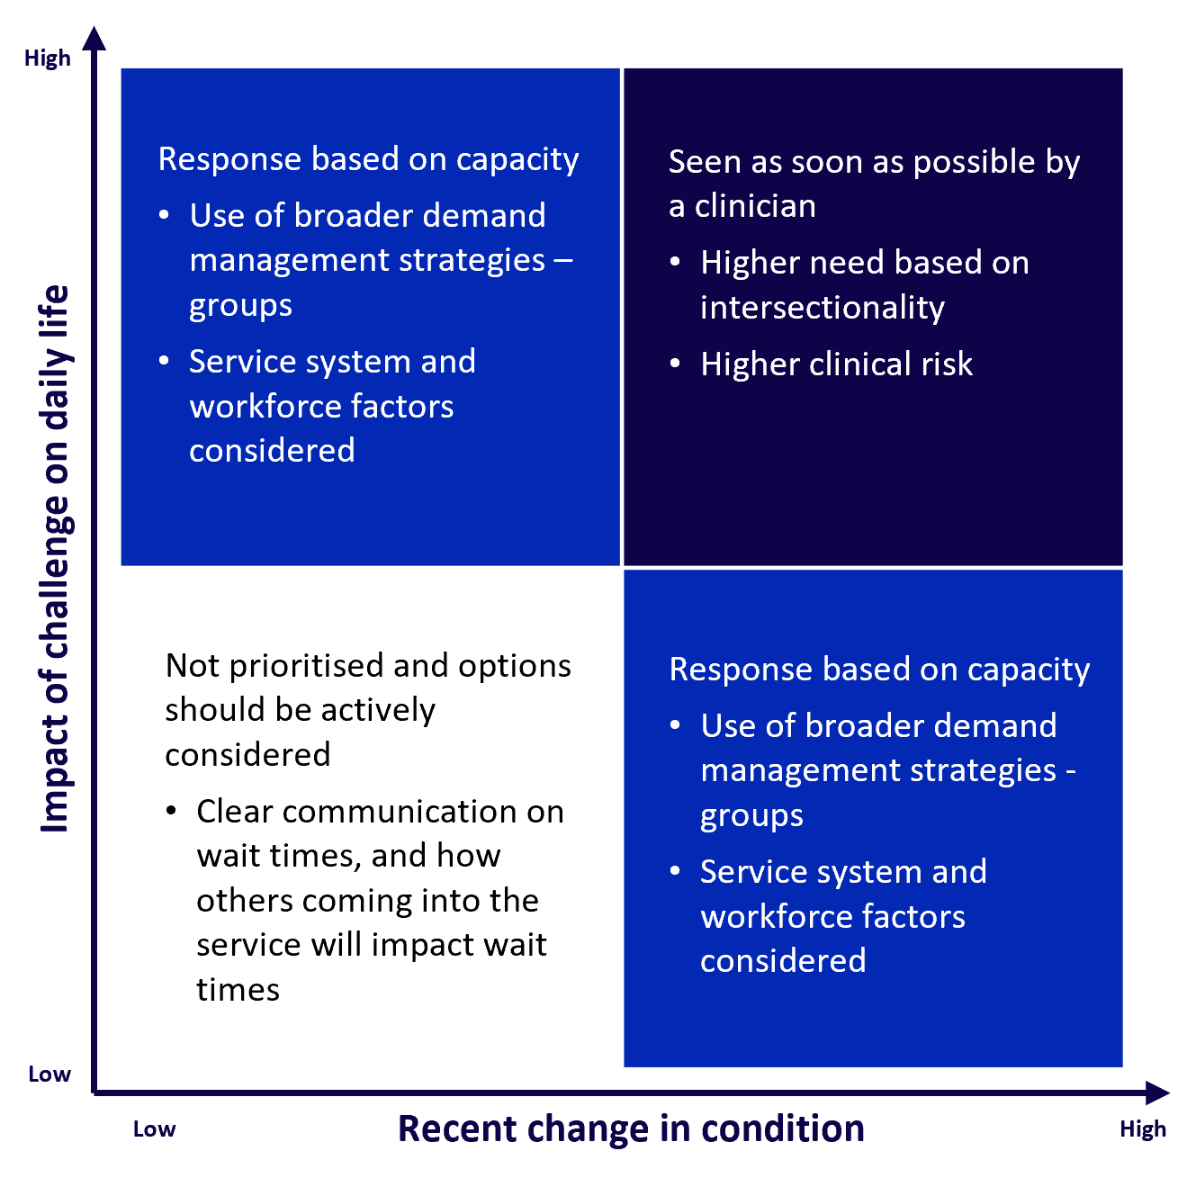

Booking initial assessment
Once priority has been determined, CHSs can move to scheduling an initial assessment with a worker. The aim is for consumers to be offered an appointment in a timely manner. This ensures that decision making and understanding broader social needs occurs as early as possible.
There are some strategies that CHSs can employ when scheduling appointments, including:

Timely access
Holding timeslots in a worker’s schedule for timely access to triage appointments ensures eligible referrals are screened as soon as possible. Timely access means vulnerable and disadvantaged populations achieve better health outcomes, avoid hospital admissions, manage activities of daily living, and participate fully in society.

Decision making and triage
CHSs should consider using clear and transparent decision making and triage processes in line with their service and organisation priorities. Communicating the amount of time before a consumer can see a worker should also be clear and transparent for consumers.

Top tips for access
- Not everyone who is referred to a CHS is a priority, and for some funding streams, not everyone is eligible – some referrals may need to be redirected. Priority should be a fluid concept and follow the eligibility criteria. Where there is greater demand, priority may need to be reassessed, shifted and updated as necessary to ensure service throughput.
- Think about the broader service system – utilising other services for non-urgent referrals can support better demand management.
- Consider implementing strategies that promote timely access, for example, holding timeslots in workers’ schedules for urgent referrals, and holding a certain number of initial assessment appointments.
- Adopt flexible strategies that can be tailored to reflect local practice and community needs.
- Ensure transparent and clear communication with consumers to support decision making and provide information to support the management of their health needs.

Initial assessment
The aim of the initial assessment is to identify the broader social needs of a consumer. From this, workers can develop an approach to service provision in partnership with the consumer to meet identified goals. Initial assessments are intended to be flexible and can be conducted via telehealth or face to face depending on consumer preferences.
Workers should collaborate with consumers to understand their current and underlying issues, determine their needs, and apply the most appropriate response. This approach supports formulating the most suitable service offerings or pathways while also considering the urgency of the situation.
Where possible, workers should be supported to use their full scope of practice and knowledge of other allied health offerings to ensure a holistic assessment. Providing multi (and trans/inter) disciplinary responses supports better health outcomes, particularly for more complex and chronic conditions.

Clearly defining specific treatment goals in partnership with consumers following the initial assessment can enable better outcomes and is regarded as best practice. This can be achieved through:
- Gathering a holistic overview of a consumer’s health and social needs and what they want to achieve
- Embedding clear and targeted goals, communicating associated timelines and review dates into all treatment plans
- Engaging and coordinating support with multidisciplinary teams and/or external services.

What are some options that can be provided after an initial assessment?
Some consumers may only require a once-off appointment to address their needs and can then be immediately treated and discharged with self-management tools, advice, and connections to the broader system. This also avoids re-presentation. For consumers requiring multiple appointments for treatment, workers can determine clinical and social risk, need and priority based on a thorough assessment. It is acknowledged that there may also be a need for ongoing review and assessment as disclosure of information may change over time while trust and rapport is developed. Workers, including managers and other senior staff where applicable, can then decide based on current levels of demand, a consumer’s priority for service and the most appropriate response for treatment/therapy. Some options may include:
- Providing advice or self-management options for consumers while they wait for treatment.
- Referring to more appropriate services, including consulting with other services to identify the most appropriate service response.
- Triaging/delaying treatment commencement due to priority.
- Commencing a defined period of treatment, either in a 1:1 or group model.
At this stage, the care needs of the consumer will be clearer. If acute service is required, this may require clear pathways and coordinated referrals. Workers can exercise their best judgment when deciding treatment options based on clinical and social risk, need, priority and demand.

Top tips for initial assessment
- Collaborate with consumers to understand current and underlying issues and formulate treatment goals.
- Workers can decide priority and treatment options based on their best judgment in the context of clinical and social risk, need, priority and demand.
- Engage and leverage relationships with professionals in other disciplines as well as managers and senior staff to coordinate support and manage demand.
- Set clear expectations and avoid offering care without a defined end or review point. For example, offer therapies in defined blocks of time.

Service delivery
Service delivery is the activities CHSs provide to consumers to support health outcomes identified through an initial assessment. A core principle of service delivery is to have the greatest impact on the greatest number, which means that not all consumers will be provided with the same service.
A key element of managing demand at this stage is to support workers to make active decisions about who is most in need of their support. This includes how they can use the breadth of options available within their service, such as groups, home intervention and support workforces to direct greatest impact. This shifts from a model where one-to-one or immediate service provision is the initial response, to considering a variety of responses and the broader service system, to meet need.
Alongside this, CHS service delivery models and referral pathways may be influenced by broader factors such as workforce availability and external service provider options.
There are many ways that services can be delivered. Where possible, having several intervention options based on best available evidence should be used to support demand management.

When considering how service delivery options can support demand management, CHSs should consider the needs of the community, the broader service system and the resources available.

What are the needs of the community?
Having an understanding of community need, as well as what is available in the broader service system, can help CHSs design their service delivery models. As part of a healthcare sector, CHSs do not have to be everything for everyone, however in some areas of the state, this may be the case. These contextual factors should be considered through decision making.
For example, in an area where the CHS is the only organisation providing physiotherapy services, can partnering with a local gym, and developing an ongoing treatment plan, delivered by a personal trainer, be considered?

What are the options for service delivery?
CHSs should develop flexible models of care in line with the social model of health that acknowledges the social, environmental, and economic factors that affect health. CHSs should offer treatment and care based on consumer needs. This means that CHSs should individualise responses and provide different numbers and types of sessions based on the consumer’s individual needs and care goals.
This can include:
- Information provision
- Individual intervention – single or multiple
- Multidisciplinary/interdisciplinary care
- Groups
- Telehealth
- Support workforce including Allied Health Assistants
- Self-management.

Multidisciplinary teams and case conferencing are important when providing effective care for chronic conditions. Consumers with chronic disease should have access to a comprehensive chronic care program. Where possible, care should be coordinated to support health outcomes and reduce the exacerbation of any health challenges through self-management, health literacy and proactive and preventative supports.

How can self-management be embedded across service delivery?
A key element of service delivery in CHSs is self-management and health literacy. Effective self-management supports consumers, their family and/or carers to take an active role in improving their health and addressing health problems. The aim of self-management is to develop a consumer’s capacity to manage the risk or impact of their condition over time. Being actively engaged in self-management practices better equips consumers to maintain optimal health and wellbeing.
Self-management can be supported through:
- Health education and building a consumer’s knowledge about their condition and understanding what can exacerbate and/or support it.
- Setting clear, targeted health goals and developing clear action plans for success. These plans should include actions for consumers, as well as any broader professionals, with clear indicators of success to support motivation.
- Motivating behaviour change and building confidence. This may be supported through participation in groups sessions.
- Social prescribing and linking consumers to wellbeing initiatives that support connection.

How can workforces be better utilised?
CHSs have varying workforce profiles, reflecting a range in levels of experience, scopes of practice and roles and responsibilities. Taking these elements into consideration when designing a service model and identifying service delivery options can support demand management. This can include:

Scope of practice
Understanding and supporting staff to utilise their full scope of practice is important. This enables ongoing learning and development, as well as concentrating resources where they can make the most impact. For example, where workers conduct the initial assessment, it may be appropriate for support workforces, such as AHAs, to conduct any service delivery in line with the developed intervention plan (with applicable supervision). This will support the worker to practice at the top of their scope.

Delivering group sessions
Where there is volume, and a key element is sharing information or delivering therapy/treatment, group service delivery can support a workforce (particularly those that may be at capacity) to have more impact for more consumers.

Blitz days
Services can have success grouping similar needs into a day of service, which can support flow through. For example, where consumers require rails in their homes, organising the required staff to do this together in a day can support CHSs to immediately respond to the care needs of multiple consumers in one day.

Community of practice
Consider setting up a community of practice to support integrated care and collaborative workforces.

How can services support better flow through?
There are a range of strategies that can be used to support flow through, create capacity and manage waitlists. This can include:

Attendance policies
It is important to recognise that some consumers who have experienced trauma may have challenges with attendance for a range of reasons. CHSs should consider developing a compassionate response to wait list management and having an engagement policy that takes into consideration consumers’ needs and circumstances, This should be dome while balancing throughput, ensuring that consumers are informed of their options and supported to attend their appointments so that they can reach their health and wellbeing goals.

Group appointments
Grouping consumers with similar needs and servicing them concurrently (if willing to participate and if clinically appropriate). For example, where a CHS offers podiatry, services could consider utilising AHAs to deliver a group nail clinic.

Telehealth
Utilising telehealth to access services where there are none available locally with additional assistance from support workforces. This can drive efficiencies while also addressing consumer need.

Evidence based practice
Supporting staff to implement evidence-based practices and regularly updating knowledge as required.

Evidence-informed benchmarks
Building expected timeframes in goal directed care plans for time-bound treatment/therapy pathways to support continuous improvement.

Diversifying skill mix and role profiles
Using workers’ full scope of practice and working with support workforce options such as AHAs or wound care nurses to manage flow through.

Dedicating resources to consumers waiting the longest
Ensuring that consumers who have been on the waitlist for the longest period of time do not get continually pushed out. CHSs can consider setting maximum clinical wait times, as well as using multidisciplinary team models for consumers with complex health and social needs.

Senior support to review caseloads
Supporting more junior staff with caseload management to ensure that practice is enabling flow through the service.

Set a maximum limit for number of sessions
Ensuring that the service can have impact for more consumers, rather than more intense care for a select few.

Implementing recall and review processes
Managing consumers who have long-term needs and/or chronic disease aims to reduce exacerbations and crisis interventions.

Treatment breaks
Offering treatment breaks can alleviate treatment fatigue and assist consumers with skills consolidation learned in treatment/therapy sessions.

Ongoing review of priority
Utilising discipline specific priorities to determine who is most in need of intervention.

Top tips for service delivery
- Maximise service delivery by offering group sessions, telehealth options or utilising support workforces to reach as many consumers as possible.
- Service models that offer the same amount of service to everyone should be avoided - CHSs should be providing the right level of service based on individual need.
- Have clear attendance policies to discourage 'no shows'.
- Self-management should be encouraged throughout service delivery to build consumer capacity.

Transition and exit
Transition and exit focus on the sustainability of health outcomes, ensuring consumers have been supported to a point where they and/or their carers can manage their own ongoing health needs. This includes being linked to broader services that continue to support their goals. A planned approach will ensure a smooth, coordinated transition.
Transition and exit from CHSs can occur at a point where:
- a consumer’s treatment goals have been met and their issues are resolved,
- Consumers can manage their current and ongoing care needs, or
- it is determined that the complexity of their needs would be better managed by another service provider.
Transition and exit may include a combination of additional informal or formal supports from another service or discipline, and/or self-management strategies.

Utilising connections with external services and coordinating exits can support effective management of ongoing care needs and can improve access for new consumers who require support. This can support better demand management through ensuring the sustainability of health gains.

When should a consumer transition and exit from services?
Transition and exit can occur when:
- The consumer has achieved their targeted care goals
- The identified intervention has been completed and there is a plan for ongoing, external support in place
- The consumer no longer wishes to take part in the program
- The consumer has moved from their place of residence and referred to services closer to their new home
- It is decided following a review that there will be no more benefit from continuing the service
- The consumer has been referred to a service that is more appropriate to meet their needs.
Consumers who exit a service may access supports again if their needs change. If this change is the result of a new issue or a change in circumstances, the consumer should be considered as a new referral. The consumer’s level of priority should be determined based on their new presentation. If issues arise because of poor management of the exit process, the consumer’s needs should be addressed immediately based on clinical and social risk.

How can you support consumers exiting your service?
To ensure good consumer outcomes, CHSs should discuss the expected course of management during the initial assessment. Exit from services should be linked to consumer needs, targeted goals, and progress as well as service capacity and demand. Consumers’ expectations regarding the length and type of services they receive should be discussed when they first access the service. Consumers should be involved in the process of planning for exit from the service. This may include referral to other services, programs, or self-support groups.

Top tips for transition and exit
- Clearly communicate the expected course of treatment with consumers.
- Always refer to consumer needs, targeted goals, and progress before initiating exit procedures.
- Keep consumers fully informed about the exit and transition process and what they should expect.
- Provide a comprehensive summary to receiving services via warm referral to ensure a seamless transition.

Getting your organisation ready
Several enablers will support successful and effective demand management. It is acknowledged that this process may take time to implement, and some organisations may require more time due to the scale of change or other influencing factors. Although change may seem challenging at first, better demand management can have positive impacts on capacity and service delivery in the longer term. Maintaining a flexible approach means CHSs can design their own demand management journey, however these enablers will support organisations regardless of which strategies they choose.

Data
Collecting and reviewing referral and wait list data supports organisations and government to understand demand trends and peak periods. This should be coupled with historic activity where appropriate. Data supports the allocation of additional resources when required which will support flow through.
Internal data required to support evidence-informed demand management includes:
- Average number of new referrals by discipline per week that align to the CHSs’ profile. This should consider any known fluctuation over time
- Capturing wait time data and tracking the time between initial contact and service delivery
- Tracking new referral sources
- Number of consumers who fail to attend or miss appointments
- Expectations of management to review and understand service opportunities and challenges, including through the lens of consumer insights, resource allocation and staffing configurations.
- The CHSs’ full time equivalent staff by discipline and the number of appointments available based on this.
Where organisations do not have access to baseline data sources, work should be conducted in this space, ensuring that data is gathered to support evidence-informed planning.
Services should look at whether there is a mismatch between the staff available and the number of referrals. The STAT model provides clear guidance in their handbook for understanding and calculating demand in CHSs.
CHSs must maintain accurate waitlists and ensure that data related to wait times is submitted through the Community Health Minimum Data Set (CHMDS). The Department is currently exploring opportunities to improve the measurement and benchmarking of demand in CHSs. This work may be embedded in future reviews of this Toolkit.

Roles and responsibilities
Having clearly defined roles and responsibilities aligned to models of care for each service ensures there is a consistent and coordinated approach to consumer care. This should include multi-disciplinary responses for more complex needs and chronic conditions, as well as:
- Clarity around the number of appointments for full time and part time staff
- Clear expectations for assessment and planning across the organisation, including by discipline, where appropriate.

Fee policies
CHSs should ensure that they have appropriate systems and practices in place to collect fees in line with fee policies. Collecting fees from consumers with the capacity to pay, in line with the Community Health Program fee policy <https://www.health.vic.gov.au/community-health/community-health-fees-policy> (or other relevant policy), supports demand management by generating revenue that can be directed to providing more services.

Processes and policies
CHSs should ensure processes and policies are regularly reviewed and updated as demand evolves with external system reforms. This includes having a clear and objective escalation process as it is essential to minimise risks for consumers. The overall aim is to have policies that support equitable health access.

Clinical governance and oversight
Intervention and treatment should be based on contemporary evidence. Board, CEOs, and program managers should utilise clinical governance structures to ensure that infrastructure supports this, ensuring greatest impact for the greatest number of consumers.

Change management
Clearly communicating changes to staff will require a robust change management strategy. It is important for staff to understand the impact of demand management changes and how it affects them. This should include:

Clearly articulating the ‘why’
To effectively embed change, those affected must be on board and motivated to facilitate the change and understand why it is needed. Any change to demand management processes within a CHS may create some upheaval in current ways of working.
Co-designing changes in demand management processes with teams ensures they are motivated and on board with the change journey. Most importantly, communicating what is trying to be achieved and the problem it is solving is critical to achieving success. Consideration should also be given to include referrers due to their role in demand management at the access point.
Key messages that may support this include:
- Using an intersectionality lens to support priority decisions, and shifting who is given priority based on set eligibility criteria to enable timely access to those most in need
- Thinking more strategically about the ongoing intervention pathways. This will enable the organisation to have the greatest impact for the greatest number of consumers.

Updating systems to support change
Core systems should be up to date and appropriately integrated to support staff.
Innovative features and decision-making processes can also be built into systems. This encourages staff to embed new ways of working into their daily practices.

Behaviour change
Influencing and changing staff behaviours by encouraging the use of systems and adjusting to new requirements.
It is important to think about how performance may support change management. This includes key performance indicators for intake staff and workers to incentivise new behaviours.

Change champions
Nominating change champions to help facilitate upcoming changes and provide support to other staff.

Governance and review
Community Health in Victoria is currently undergoing reform in response to the VAGO report of the Community Health Program. Alongside this, the COVID-19 pandemic and subsequent pressure on the healthcare system has meant that there is an ongoing period of change across the sector.
As such, it is important that a robust governance framework is established for this Toolkit. This should include a clear review process which is embedded within the ownership of the document to ensure it remains relevant to CHSs across Victoria.

Governance
This Toolkit will be owned by the Community Based Health Services Branch at the Department of Health. The Department will engage the Community Health sector, including consumers, to support Toolkit governance. Representatives across the breadth of CHSs, including metropolitan and regional services, and smaller and larger organisations, will be engaged to provide advice to the Community Based Health Services Branch to support the ongoing review and revision of the Toolkit, with the Executive Director of Community Based Health Services being the decision maker.

Review
The Toolkit will initially be reviewed after two years following its release. The review will focus on:
- The current challenges in relation to demand impacting community health including priority populations and eligibility
- The overarching messages of the Toolkit
- The approach to the consumer journey and whether it still aligns with consumer needs
- The broader factors within the reform process that may influence demand management.
A continuous improvement lens will be applied to the Toolkit review process, with clear implementation planning to support any capability uplift.

Appendix A: Community Health Program access policy
The Community Health Program is funded by the Victorian Government and provides nursing, allied health and counselling services to the Victorian community. Access to the Community Health Program is targeted to those with the greatest risk of poor health and the greatest economic and social need, who may face barriers to accessing care through other services and in other settings.

Community Health Program eligibility criteria
The following people, including children and young people, are eligible to receive services through the Community Health Program:
- People who hold a healthcare or pensioner concession card, or who are a dependent of a concession card holder
- People with a low or medium income
- Aboriginal and Torres Strait Islander people
- Refugees and people seeking asylum
- People who are homeless or at risk of homelessness
- Children in care, child protection, Orange Door and ChildFIRST clients

Principles
When making decisions about access to services through the Community Health Program (CHP), CHSs must apply the following principles:
- CHSs must waive eligibility criteria where, due to factors related to intersectionality and/or individual circumstances, an individual faces barriers to accessing alternative safe, inclusive and/or accessible services.
- CHSs must waive eligibility criteria where the CHSs is the only local provider of a particular service.
- CHSs may restrict access to the CHP where an individual is also receiving funding for the same service through another funding source, e.g., NDIS, My Aged Care etc.
- CHSs must not restrict access to the CHP based on a person’s eligibility for another funding stream or program, where that person is not in receipt of a service or funding. Community health services should support people to access appropriate funding streams and programs, and where practicable and required, provide interim services.
- CHSs must not restrict access to the CHP based on where people live or work, however, may prioritise access for people who live or work in the local area. In determining priority, CHSs should seek to understand an individual’s motivation for travelling outside of their local area, and whether a closer service exists. CHSs may apply geographical restrictions where services are provided outside of the CHS setting, such as home-based and outreach services.
- CHSs should ensure that fees are collected from all CHP clients with the ability to pay, in accordance with the Community Health fees policy <https://www.health.vic.gov.au/community-health/community-health-fees-policy>. CHSs must not deny anyone a service because of their inability to pay.
- CHSs must maintain an open waitlist for eligible CHP clients. People placed on a waitlist must be provided with clear guidance on expected wait times, as well as alternative service options, to ensure that they can make an informed choice about whether or not to wait. CHSs must actively manage waitlists, checking-in on clients at regular intervals to provide updates on wait times and identify any change in the client’s condition that might necessitate a higher priority for service.
- CHSs that accept fee-paying clients outside of the CHP, must ensure that adequate resources are directed to service CHP clients, in line with CHP funding and target hours. Private clients must be billed appropriately to ensure that one hundred percent of CHP funding is directed to CHP clients and target hours.
- Once eligibility is confirmed, CHSs should consider an individual’s clinical and social needs to prioritise access for services using the guidance provided in the Demand Management Toolkit.

Appendix B: Frequently asked questions
- Do community health services have to use this toolkit?
This toolkit can be used as a guide, however the principles outlined should underpin decision making for community health services (CHSs). CHSs can choose to implement some elements of this toolkit into their ways of working. Some services may already be implementing components of this toolkit in their organisations.
- There are no longer clinical priority tools. How do we make clinical prioritisation decisions?
The updated Demand Management Toolkit has not provided clinical priority tools. This is in response to consultation with the community health sector which indicated a diversity of expertise and clinical need, and that a one size fits all approach to clinical prioritisation was not always effective. Through consultation, it was determined that CHSs should develop their own processes to make clinical priority decisions based on the expertise they have within their team, the needs of their community (including clinical risk, priority groups and social determinants), and the principles of the Community Health Program.
- Why have eligibility criteria been introduced?
Eligibility criteria are an important factor in demand management. They ensure equitable access to community health services, and concentrated support to those who will most benefit through the appropriate level and type of care. The eligibility criteria relate to services delivered through the Community Health Program only and aim to direct resources to those with the greatest risk of poor health outcomes and the greatest economic and social need.
- What does the eligibility criteria mean for different funding streams?
Eligibility criteria apply to services funded through the Community Health Program (CHP) and do not affect fee for service, or other funding streams your organisation may be delivering. Consumers ineligible for the CHP may still be able to access services and pay for them out of pocket or through their funding package (e.g., MyAgedCare or NDIS) where there is capacity to provide services.
- How can we support our clinicians and intake staff to understand and respond to the needs of multicultural communities?
Clinicians, suitably qualified health workers and intake workers may require additional support when working with consumers from culturally, linguistically, ethnically and religiously diverse backgrounds with multiple and/or complex needs. Challenges may include language barriers, different cultural understandings, experiences of trauma and deprivation, and factors related to social determinants of health. Services should invest in cultural competency training and community engagement approaches to ensure they can provide accessible, safe and equitable care for consumers. There should also be policies and processes available which clearly outline how to engage interpreters and translation services, as well as partnerships with broader organisations to support specific cultural needs as appropriate.
See the Language Services Policy <https://www.health.vic.gov.au/publications/language-services-policy> and the Refugee and Asylum Seeker Health Services Guidelines for the Community Health Program <https://www.health.vic.gov.au/community-health/community-health-integrated-program-chip-guidelines>.

- There is a lot of flexibility within the toolkit. How do we know our service models are fit for purpose?
Your service model is fit for purpose if it is meeting the needs of your community. A continuous improvement cycle should be embedded in your ways of working, and clinicians/suitably qualified health workers and the broader workforce should be supported through any change. There are a number of ways to embed innovative solutions into your service model to support demand management. This can include the use of allied health assistants and a clearly defined scope of practice, dedicated clinics for particular health needs, fast track model options for those who have identified, short-term and/or contained needs, social prescribing and educative and capacity building responses.
- Are people without a health care card eligible for services?
People without a healthcare card may be eligible for services delivered through the Community Health Program, if they meet one or more of the other eligibility criteria. Consumers may also access support through a community health service under a fee for service model, in line with the demand management principles.
- Are people without a Medicare card eligible for services?
A Medicare card is not required to access services through the Community Health Program. People without a Medicare card are eligible for services delivered through the Community Health Program, if they meet one or more of the eligibility criteria.
- There is a consumer with a number of competing challenges. How do I know what to do?
It is important that consumers coming to community health services are seen by the right service at the right time. In each clinical group, organisations should have clear referral pathways to support decision making at entry but also throughout their engagement with the service. Services should only be provided within the workforce’s scope of practice, and where services are not available, warm referrals should be made. For example, if health professionals are not equipped to respond to alcohol and other drug, family violence and/or sexual assault, these should be referred onto the appropriate team or service provider.
- There is a child for whom I am concerned, what should I do?
Please follow your organisation’s policies and procedures in relation to mandatory reporting. These policies should be in line with the Child Safety Standards and the Children, Youth and Families Act (2005).
- We are having trouble ensuring flow through in our organisation. What should we do?
Ensuring that you are moving people through your service is vital to delivering equitable health responses. Ensuring your organisation is guided by goal-directed care, and where other issues are identified during treatment, consumers are supported back through the intake process, including prioritisation. Your service model can also support flow through, providing clarity on the number of sessions for particular issues.
- We have a request for counselling for someone who is acutely unwell, what should we do?
Community health is not an acute service. Warm referrals (contacting a service on a client’s behalf and facilitating connection) should be made to acute mental health services, ensuring the person gets the right support when needed.

- What do we do if someone is deemed ineligible for our service?
If someone is deemed ineligible, information should be provided to that person about other services and supports that will meet their identified needs. Where required, this should be a warm referral to a known provider to the extent that this is possible in order to facilitate appropriate introduction and handover.
Consumers should understand why they are not eligible for your services, using the policies and information provided by the Department of Health to deliver this information.
- Intersectionality is an important part of the toolkit; how do we ensure equitable access?
Each community in Victoria has diverse and intersecting needs, identities and experiences, as well as different access options depending on their local service system.
Organisations should consider clinical risk, priority groups and social determinants of health to help make decisions to support equitable access and inclusive practice to respond to intersectional needs of communities.
- How can intake teams determine the impact and change of a consumer’s condition? Doesn’t that sit with clinicians/suitably qualified health workers?
Intake teams should be able to collect minimum information from consumers to determine their eligibility and priority. The impact/change matrix can be a useful tool to determine how urgently a consumer needs to be seen. This includes asking consumers how their condition is impacting their daily living and if they have noticed any changes in their condition. If intake workers are unsure how to proceed, clinical expertise may be required if not held within the intake team. In line with the principles of the toolkit, organisations should seek to provide timely access to all consumers.
- How can intake workers collect all the necessary information needed to determine priority in an intake call?
The composition of intake teams across the community health sector can differ, meaning some intake teams may not have the required clinical expertise necessary to determine clinical and social risk. However, services should be providing timely access to appointments with suitably qualified health workers to prevent any complications. Where this is not possible, services should develop clear and transparent decision making and triage processes in line with their service and organisation priorities
- We have consumers who have been with us for several months, some even years. Do they need to exit our service?
Organisations should design a service model that enables flow through. This can include offering treatment breaks, focusing on goal directed care, reviewing caseloads, and implementing recall and review processes. This may assist with freeing up resources and managing consumers with long-term/chronic conditions. For new consumers entering the service, maximum limits can also be applied to the number of sessions and frequency of sessions/review appointments.
- We have a referral for an older person who has been approved for My Aged Care but is still awaiting allocation of a package. Are they eligible for the Community Health Program (CHP)?
Someone awaiting allocation of a funding package, who otherwise meets the CHP eligibility criteria, is eligible for services through the CHP until the package is funded. CHSs must not restrict access to the CHP based on a person’s eligibility for other funding.

- Is a child with a NDIS plan eligible to receive a service through the Community Health Program (CHP) if there are no other providers in the region?
Where the CHS is the only provider of a particular service in the region, it may be necessary for the CHS to accept referrals for NDIS participants. However, these services should not be funded through the CHP. CHS must ensure that they have the capacity to charge fees, including being NDIS registered where necessary, so that NDIS participants can use their NDIS plan funding to pay for the service.
- Is someone on a high income eligible to receive services through the Community Health Program?
Someone with a high income may be eligible to receive a service through the Community Health Program, if they meet another of the eligibility criteria, but would be required to pay for the service in line with the Community Health Program fees policy <https://www.health.vic.gov.au/community-health/community-health-fees-policy>.
- A consumer who has a high income is claiming that they are unable to pay for a service. What do I do?
There are many reasons why a person may not be able to pay for a service despite reporting a high income. This could include family violence situations where a person may not have access to their money or may need to conceal the fact that they have accessed a service, as well as situations of financial stress from the significant burden of managing a chronic condition. CHSs must not deny or restrict access due to a person’s inability to pay and should seek to understand the individual's circumstances. In some instances, a referral to additional services for financial, social and/or legal assistance may be required.
- Why aren’t priority groups included in the Community Health Program access policy?
The priority groups included in the Demand Management Toolkit, have been reflected in the new eligibility criteria for the Community Health Program (CHP). The intent of the eligibility criteria is to ensure that CHP services are directed towards those with the greatest risk of poor health outcomes and the greatest social and economic need. Once eligibility has been confirmed, CHSs should consider an individual’s clinical and social needs, including how belonging to a priority group may impact on an individual’s need for service, to prioritise access using the guidance provided in the Demand Management Toolkit.
- How can we support exit and transition strategies for consumers, especially for chronic conditions that require ongoing and enduring support?
Services should focus on developing a clear and comprehensive transition plan that outlines the goals, timelines, and actions required to support consumers to feel more empowered during the exit and transition process. The transition plan should include ongoing communication with the consumer to ensure they have the support they need to navigate the transition and address any challenges that may arise. Additionally, CHSs should work collaboratively with the consumer and other service providers where appropriate to ensure a smooth transition between services and enable continuity of care. Services should aim to focus on providing equitable access to services, which may mean less active engagement with consumers and more ongoing monitoring through clinically appropriate methods.
- Do we turn people away who are ineligible for the Community Health Program even if we have capacity?
If a consumer is deemed ineligible for the Community Health Program but has the financial means to pay for services, and there is available capacity, CHSs should provide them with the necessary services. The consumer should then be billed for the service in line with the Community health fees policy <https://www.health.vic.gov.au/community-health/community-health-fees-policy>.
- Should readiness be considered for consumers in community health, particularly for services such as counselling?
Readiness may influence a consumers’ engagement with community health services. Readiness can be influenced by a number of factors, and where possible, support should be provided to support readiness to engage. For services such as counselling, readiness is vital in consumers benefitting from the service. Once on the waitlist, CHSs may wish to articulate a time period or a number of sessions to allow consumers time to consider whether they wish to engage in counselling. If the consumer is not yet ready to engage after this timeframe, they should be discharged from services and suggest they re-refer when they feel ready. This approach ensures that services respect the consumer's autonomy while enabling them to engage with services at a time that is right for them.
- We have a high volume of referrals for people who don’t live or work in the area and need to prioritise access for our local community. How should we define ‘local’?
Although CHSs can’t restrict access to CHP services based on where a person lives or works, CHSs may prioritise access for people who live or work in the local area. ‘Local area’ can be broadly defined as the Local Government Area (LGA) in which a CHS is situated, and in some instances may need to include neighbouring areas. CHSs should apply a common-sense approach to determining what ‘local’ means in the context of their service and community.
- How do we manage waitlists and ensure that there have been no changes to consumers’ health condition or capacity to engage that need to be considered?
Managing waitlists can be challenging, especially when dealing with large volumes of referrals. To manage waitlists effectively, services may wish to consider implementing an active waitlist management system, which includes outreach to consumers on the waitlist. Some systems include regular automated texts to keep consumers informed of their waitlist status and to check if their needs (including the impact of their condition) have changed. Reaching out to consumers ensures CHSs have up to date information on their needs and priorities, allowing them to manage resources more effectively, and provide timely services to those who need them.

Appendix C: Text-equivalent descriptions of figures

Figure 1: Overview of demand management across the consumer journey
- Referral
    - Influenced by
      - Knowledge and awareness of service by the service system
      - Referral pathways
      - Relationship between service systems
- Access
    - Conducted by intake worker
    - Determine eligibility
    - Yes, eligible
      - Book initial clinical needs assessment with suitably qualified health worker.
      - Where this is not possible, consider priority
      - Consumers should then be added to a waitlist and managed accordingly
    - No, not eligible
      - Refer to more appropriate service
    - Influenced by:
      - Priority groups and clinical need: Community health guidance on priority groups will influence priority for services
      - Demand situation: Priority may be influenced by demand and waitlists. This should be fluid.
    - Considering priority:
      - Where an appointment cannot be booked in a reasonable time, intake should look at two factors to support appointment prioritisation: impact and change
- Initial assessment
    - Conducted by a suitably qualified health worker
    - Initial needs assessment
    - Social and health needs
      - Holistic needs of the person should be taken into consideration
      - Other considerations should also include capacity for self-management, alternative services, health literacy and social support resources
- Service delivery
    - Goal directed service
      - One to one
      - Group programs
      - Support from other workers in a service
    - Multi-disciplinary services if needed
    - No further service needed
    - More appropriate services
- Exit and transition
    - Supported exit
      - Links to alternative supports
      - Connections with the broader service system where appropriate
      - Avenues for communication regarding re-entry in the future if required

Figure 2: Elements of intersectionality
- Discrimination impacting identity
- Systems or structures reinforcing exclusion
- Aspect of identity
- Unique circumstances

Figure 3: Impact assessment matrix
- Vertical axis – Impact of challenge on daily life
- Horizontal axis – Recent change in condition
- When the impact of challenge on daily life is low and the recent change in condition is low
  - Not prioritised and options should be actively considered
  - Clear communication on wait-times, and how others coming into the services will impact wait-times
- When the impact of challenge on daily life is high and the recent change in condition is low
  - Response based on capacity
  - Use of broader demand management strategies – groups
  - Service system and workforce factors considered
- When the impact of challenge on daily life is low and the recent change in condition is high
  - Response based on capacity
  - Use of broader demand management strategies – groups
  - Service system and workforce factors considered
- When the impact of challenge on daily life is high and the recent change in condition is high
  - Seen as soon as possible by a clinician
  - Higher need based on intersectionality
  - High clinical risk

Harding, K.E., Leggat, S.G., Watts, J.J. et al. A model of access combining triage with initial management reduced waiting time for community outpatient services: a stepped wedge cluster randomised controlled trial. BMC Med 16, 182 (2018)
Understanding intersectionality. Victorian Government (2021) <https://www.vic.gov.au/understanding-intersectionality>
K. E. Harding, A. K. Lewis, D. A. Snowdon, N. F. Taylor & the STAT Research Group. (2018) Specific and Timely Appointments for Triage (STAT) Handbook Melbourne, Victoria: Eastern Health & La Trobe University
Passalent. L, Landry. M, Cott. C, (2010) Exploring wait list prioritisation and management strategies for publicly funded ambulatory rehabilitation services in Ontario, Canada Healthcare Policy 5 (4)
PERN (2017) Toolbox of wait list management strategies in rehabilitation
K. E. Harding, A. K. Lewis, D. A. Snowdon, N. F. Taylor & the STAT Research Group. (2018) Specific and Timely Appointments for Triage (STAT) Handbook Melbourne, Victoria: Eastern Health & La Trobe University
Community Health Program. Victorian Auditor-General's Office (2018) <https://www.audit.vic.gov.au/report/community-health-program?section=>
Refer to the Community health fees policy for income levels <https://www.health.vic.gov.au/community-health/community-health-fees-policy>

