
Guide to healthy and more sustainable food procurement

To receive this document in another format, phone 1300 761 874, using the National Relay Service 13 36 77 if required, or email <GoodFoodPolicy@health.vic.gov.au>.
Authorised and published by the Victorian Government, 1 Treasury Place, Melbourne.
© State of Victoria, Australia, Department of Health, July 2023.
Except where otherwise indicated, the images in this document show models and illustrative settings only, and do not necessarily depict actual services, facilities or recipients of services. This document may contain images of deceased Aboriginal and Torres Strait Islander peoples.
In this document, ‘Aboriginal’ refers to both Aboriginal and Torres Strait Islander people. ‘Indigenous’ or ‘Koori/Koorie’ is retained when part of the title of a report, program or quotation.
This work, Guide to healthy and more sustainable food procurement, is licensed under a Creative Commons Attribution 4.0 licence [http://creativecommons.org/licenses/by/4.0/]. You are free to re-use the work under that licence, on the condition that you credit the State of Victoria, Australia (Department of Health) as the author, indicate if any changes have been made to the work and comply with the other licence terms.
This license does not apply to any images, photographs or branding (including, but not limited to the Victorian Government logo or the Department of Health logo). All images, photographs and branding (including, but not limited to the Victorian Government logo or the Department of Health logo) must be removed prior to any use and distribution of this work.
ISBN/ISSN 978-1-76131-195-6 (pdf/online/MS word)
Available at the department’s healthy and more sustainable food procurement webpage <https://www.health.vic.gov.au/public-health/healthy-and-more-sustainable-food-procurement>

Contents
Introduction 4
Healthy and more sustainable food procurement policy: Application and requirements 5
Requirements for procuring healthy food and drinks 5
Requirements for delivering social and environmental outcomes when procuring food and drinks 5
Policy implementation checklist 6
Procuring healthy foods and drinks 6
Delivering social and environmental outcomes when procuring food and drinks 6
Guidance for procuring healthy food and drinks 7
GREEN and AMBER – always order food and drinks from these categories 7
RED – avoid ordering food and drinks from this category 7
Food and drink quick reference tables 8
Sample menus 11
Healthy Eating Advisory Service 13
Other considerations 14
Guidance for delivering social and environmental outcomes when procuring food and drinks 15
Platforms to identify food suppliers that deliver social outcomes 16
List of sustainable business practices 17
Other considerations 18
Further information and contacts 19

Introduction
Victorian Government departments have committed to delivering health, social and environmental outcomes through food and drink procurement for meetings, functions and events. Organisations across Victoria are encouraged to do the same.
This Guide to healthy and more sustainable food procurement is a resource to support Victorian organisations wanting to adopt food and drink procurement practices that not only support and promote healthy eating, but also benefit the environment and the wider Victorian community.
By adopting the Healthy and more sustainable food procurement policy, organisations can shift the way food and drinks are ordered for staff meetings, functions, and events by ensuring staff:
- select healthy food and drink options, in line with the Victorian Government’s Healthy Choices Framework <https://www.health.vic.gov.au/preventive-health/healthy-choices>, and
- consider opportunities to deliver social and environmental outcomes
This is a template guide which organisations can choose to adapt accordingly. The template has been prepared with all elements of the model policy mandated as the default.

Healthy and more sustainable food procurement policy: Application and requirements
The policy applies to staff purchasing food and drinks with [organisational] funds for meetings, functions, and events.
This includes occasions such as workshops, conferences, community events, launches, celebrations and ceremonies, as well as client or community education, information, or training programs.
Refer to [your organisation’s] healthy and more sustainable food procurement policy for details on policy application and requirements.

Requirements for procuring healthy food and drinks
To support and encourage healthy eating, when procuring food and drinks for [organisation]-funded meetings, functions and events, staff must:
- ensure that the food and drink options available are GREEN or AMBER
- ensure that RED food and drink options are avoided wherever possible

Requirements for delivering social and environmental outcomes when procuring food and drinks
To support and encourage the delivery of social and environmental outcomes when procuring food and drinks for [organisation]-funded meetings, functions and events, staff must:
- consider opportunities to deliver social and environmental outcomes and pursue identified opportunities
- adopt sustainable business practices when ordering and serving food and drinks

Policy implementation checklist

Procuring healthy foods and drinks
All food and drink options available are GREEN and AMBER
For guidance, see pp.8-9.

RED food and drinks have been avoided wherever possible
For guidance, see pp.10.

Delivering social and environmental outcomes when procuring food and drinks
Opportunities to order from catering suppliers that deliver social and environmental outcomes have been considered, and identified opportunities pursued
For guidance, see pp.15-17

Sustainable business practices have been adopted when ordering and serving food and drinks.
For guidance, see pp.17-18

Guidance for procuring healthy food and drinks
The Victorian Government’s Healthy choices: food and drink classification guide <https://www.health.vic.gov.au/preventive-health/healthy-choices> categorises food and drinks as GREEN, AMBER or RED based on nutritional value.
Food and drinks commonly provided through workplace catering have been classified as GREEN, AMBER or RED and are listed in the food and drink quick reference tables on pp. 8-10.

GREEN and AMBER – always order food and drinks from these categories
Procured food and drinks are to be healthier GREEN and AMBER options, because they:
- are essential for good health and vitality
- are sources of important nutrients
- contain low-moderate amounts of saturated fat, added sugar and/or salt.
Examples of GREEN and AMBER foods and drinks commonly available through workplace catering include sandwiches, wraps, frittatas, sushi, fresh fruit, water, coffee and tea. More examples of GREEN and AMBER catering options are listed in the food and drink quick reference tables on pp. 8-9. The eight sample menus on pp. 11-12 demonstrate how GREEN and AMBER food and drink items can be mixed and matched for a meeting, function, or event.

RED – avoid ordering food and drinks from this category
RED food and drink options should be avoided wherever possible. In general, RED options are:
- high in saturated fat, added sugars and/or salt
- high in energy (kilojoules)
- lacking in important nutrients such as fibre.
Examples of RED foods and drinks commonly available through workplace catering include mini-pies, sausage rolls, Danish pastries, sweet biscuits, cakes and slices, large muffins, sports drinks and soft drinks. More examples of RED food and drink catering options, as well as commonly used RED ingredients are listed in the food and drink quick reference table on p. 10.

Food and drink quick reference tables
The following tables list foods and drinks commonly provided at catered meetings, functions and events. Items are classified as GREEN, AMBER or RED according to the Healthy choices: food and drink classification guide. Use the tables to select GREEN or AMBER items from catering menus.
Classifications of items listed in the quick reference tables are of a general nature only. For specific information about classifying a menu item, contact the Healthy Eating Advisory Service (HEAS) <https://heas.health.vic.gov.au>.

Table 1: GREEN and AMBER foods and drinks
This table lists commonly procured foods and drinks generally classified as GREEN or AMBER.
Suggested maximum quantities to order per person are provided in brackets against some items to encourage healthy serve sizes and avoid over catering and food waste.


Drinks
- Water should always be available
- Coffee and teas
- >99% fruit juices (250 mL)
Breakfast
- Fresh seasonal fruit (whole, sliced, skewers)
- Muesli, yoghurt and fruit cups
- Porridge with fresh or stewed fruit and cinnamon (1 cup)
- Fruit or raisin toast
- Pikelets, pancakes or crepes with fruit
- Toast or English muffins with toppings such as avocado, tomato, baked beans, eggs,
- or lean ham and salmon¹
- Frittatas, omelettes or baked eggs with vegetables, lean meats and/or fish

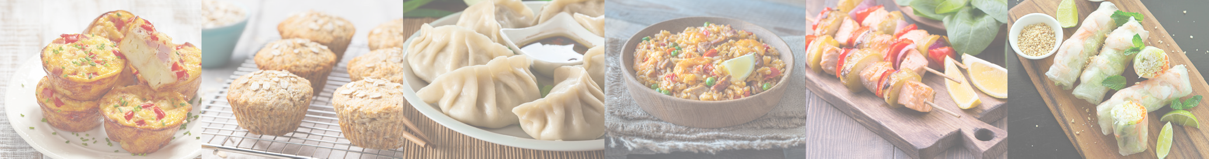

Morning or afternoon tea
- Fresh seasonal fruit (whole, sliced, skewers)
- Dried fruit (30 grams)
- Nuts and seeds (raw, dry roasted or lightly salted) (30 grams)
- Wholemeal, mini fruit-based muffins (up to 80 grams)
- Scones (plain, fruit or vegetable-based e.g. pumpkin)
- Fruit buns, loaves or breads (e.g. banana bread or date loaf) (un-iced)
- Popcorn (plain, lightly flavoured or lightly salted)
- Savoury platters with:
  - Olives, grilled marinated vegetables, sun dried tomatoes
  - Cheeses (40 grams)
  - Hummus, tzatziki, babaganoush, salsa, guacamole and other vegetable dips
  - Crudites or raw vegetables
  - Rice crackers, water crackers (plain or lightly salted)
  - Breads, flatbread, lavosh, mini toasts
- Sushi with vegetables, lean meat and/or fish2 (1 whole roll or three pieces)
- Rice paper rolls (1 whole roll)
- Falafels (pan fried or baked) (2)
- Grilled skewers with vegetables, and/or lean meat or fish2
- Mini vegetable filo pastries (2)
- Mini vegetable frittatas or zucchini slice (2)
- Steamed dumplings or gyoza (6)
- Bruschetta
- Mini pizzas and focaccias with vegetables and/or lean meats
Lunch or dinner
- Sandwiches, wraps, bagels, rolls and baguettes filled with salad, vegetables, cheese and/or lean meats or fish (include mostly wholemeal or multigrain breads) (1 whole sandwich, wrap or roll)
- Soft tacos
- Sushi (2–3 whole rolls)
- Rice paper rolls (3 whole rolls)
- Salads, buddha bowls and poke bowls (2 cups)
- Soups served with bread, preferably wholemeal or multigrain (2 cups)
- Curries, casseroles, stews with lentils, legumes, vegetables and/or lean meats (2 cups)
- Pasta dishes (avoid sauces based on cream)
- Risotto, paella and other rice dishes
- Stir fries and noodle dishes
- Roasted or grilled vegetables and/or lean meats

Table 2: RED foods and drinks
This table lists foods and drinks generally classified as RED. Avoid ordering RED foods and drinks or meals containing large quantities of RED ingredients wherever possible.


Foods and drinks
- Sugar sweetened drinks such as soft drinks, cordials, fruit drinks and iced teas
- Confectionary such as lollies, mints and chocolates, including choc-coated fruit and nuts
- Pastries such as croissants and Danishes
- Biscuits, cakes, donuts, large muffins, buns and slices
- Crackers, crisps and chips that are high in fat and salt
- Savoury pastries such as party pies, sausage rolls and pasties
- Salami, kabana, bacon and other processed or cured meats
- Deep-fried foods such as spring rolls, dim sims and battered meats/vegetables, as well as foods containing deep-fried items (for example, sushi or sandwiches with fried chicken)
Ingredients
- Sweet spreads and toppings such as honey, jam and chocolate
- Cream, coconut cream, aioli, hollandaise and other creamy dressings and sauces

Sample menus
The following sample menus contain GREEN and AMBER food and drinks that are commonly available through workplace catering.
Water should be available at all mealtimes. Tea and coffee including decaffeinated varieties can also be served with meals and accompanied by milk including reduced fat and plant-based options.
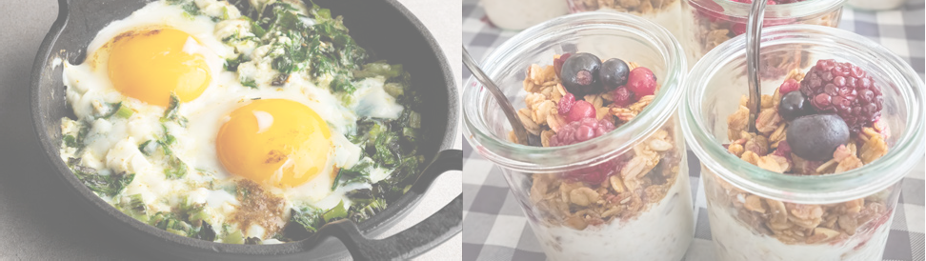
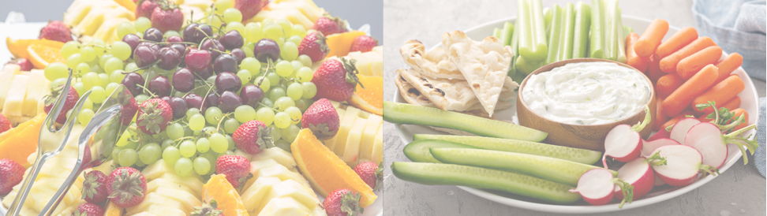

Breakfast

Sample Menu 1
- Breakfast cups with muesli, yoghurt and fruit
- Baked egg pots with crusty bread
- >99% fruit juice

Morning or Afternoon Tea

Sample Menu 1
- Platter of fresh seasonal fruit
- Mini vegetable frittatas
- Mini wholemeal mixed berry and apple cinnamon muffins

Sample Menu 2
- Porridge with stewed fruit and cinnamon
- English muffins with eggs, salmon and mushrooms
- >99% fruit juice

Sample Menu 2
- Platter of crudites (raw vegetables) such as carrots and radishes, with falafel balls, hummus, olives and flatbread
- Fruit buns, un-iced

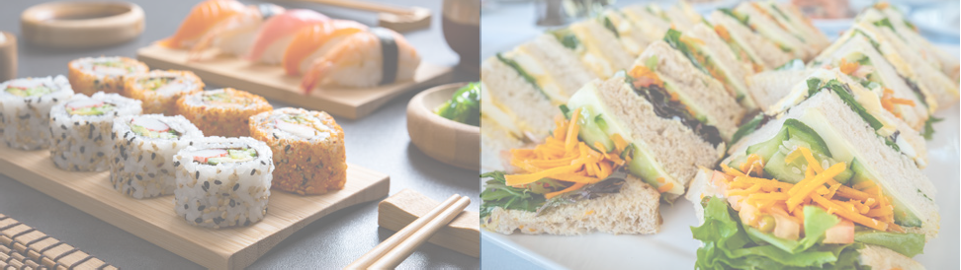

Lunch

Sample Menu 1
- Poke bowls with options such as tofu, salmon or chicken, with Asian-style slaw and rice
- Sushi rolls with fillings such as avocado, fish⁵ and tofu
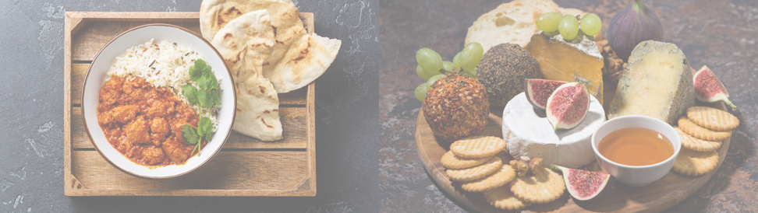

Dinner

Sample Menu 1
- Curries served with yoghurt, rice and flat bread with options such as:
  - spinach and lentil dahl
  - chicken madras
- Platter of fresh seasonal fruit

Sample Menu 2
- Selection of sandwiches, wraps, rolls or baguettes with options such as:
  - roasted vegetables, hummus and rocket
  - salmon⁵, red onion, capers and spinach
  - roast chicken, avocado and salad
- Fruit skewers with yoghurt

Sample Menu 2
- Roasted vegetables and/or grilled meat skewers
- Vegetable risotto
- Platter of cheeses with nuts and dried fruit

Healthy Eating Advisory Service
The Healthy Eating Advisory Service (HEAS) is a free, Victorian Government-supported service that supports a wide range of organisations to provide healthier foods and drinks.
Through HEAS, workplace staff and food businesses can:
- receive free phone and email support to make healthy changes to their menus
- use Food Checker <https://foodchecker.heas.health.vic.gov.au> to do free recipe, product and menu assessments and receive instant feedback on whether foods and drinks are classified as GREEN, AMBER or RED, as well as healthier alternatives
- explore online resources including training, fact sheets and recipes, as well as
- access the Catering for Good Directory.
The Catering for Good Directory has been developed to help Victorian organisations access healthier and more sustainable catering options.
Organisation staff can search the Directory map to find catering businesses that have:
- assessed their menu options using FoodChecker – allowing for green and amber menu items to be displayed on the Directory
- identified their social benefit supplier status, where relevant
- identified their sustainable business practices.
Access the Catering for Good Directory https://heas.health.vic.gov.au/catering-for-good through the HEAS website.

Other considerations

Will alcohol be served?
All alcoholic drinks are categorised as RED. [Refer to your organisation’s policy on provision of alcohol or include details here].

Allergies, intolerances and dietary requirements
When hosting a meeting, function or event where catering is provided, it is important to obtain information from attendees about food allergies, intolerances and/or dietary requirements, and to provide appropriate alternative options as required.
Catering providers should be able to identify menu items that include common allergens or foods that trigger intolerance, for example nuts, wheat, gluten, soy, fish and shellfish, and milk and milk products, or that meet common dietary requirements, for example vegetarian, vegan, halal and kosher.
Many allergies, intolerances and dietary requirements are simple to cater for, for example, by offering milk alternatives (such as soy or almond milk) with hot drinks, ordering gluten free sandwiches or wraps for people with coeliac disease or a gluten intolerance and choosing options without meat or animal products for vegetarians and vegans.
It is important to note that food and drinks provided for catering generally cannot be guaranteed allergen free. While allergies, intolerances and dietary requirements should be considered and catered for as much as possible, ultimately it remains the responsibility of the individual with the allergy, intolerance or dietary requirement to decide what they consume, or to provide their own food.

Guidance for delivering social and environmental outcomes when procuring food and drinks
Food procurement presents a significant opportunity for organisations to use their buying power to generate social value above and beyond the value of the food, drinks and catering service being procured.
Organisations can contribute to delivering a range of positive social and environmental outcomes by procuring healthy food and drinks from, for example:
- Victorian social enterprises certified by Social Traders
- Victorian Aboriginal and/or Torres Strait Islander businesses certified by Kinaway
- suppliers that adopt sustainable business practices such as sourcing ingredients locally and minimising food waste.
To provide a few examples, organisations may order food and drinks from a:
- certified Victorian Aboriginal business
- certified social enterprise providing vocational hospitality training for neurodiverse young people
- supplier that has adopted sustainable business practices such as sourcing ingredients locally, minimising food waste, and reducing carbon emissions
- a certified social enterprise that creates empowering employment opportunities for people seeking asylum and refugees and has also adopted sustainable business practices.
Procuring food and drinks from suppliers that adopt sustainable business practices will help to tackle climate change, reduce waste, and deliver broader environmental outcomes.
An organisation can generate further social value still by adopting its own sustainable business practices when procuring food and drinks (see page 18).

Platforms to identify food suppliers that deliver social outcomes
The following platforms can be used to identify certified social enterprises and certified Victorian Aboriginal and/or Torres Strait Islander businesses that supply food and drinks and deliver social outcomes.

Social Traders’ Social Enterprise Finder
Social Traders <https://www.socialtraders.com.au> is an organisation that certifies social enterprises. It also connects Certified Social Enterprises with businesses and governments to support social enterprise procurement.
Social Traders provides a national directory of certified social enterprises, called Social Enterprise Finder <https://www.socialtraders.com.au/find-a-social-enterprise>. You can search for social enterprises by category, including ‘Catering and hospitality’, and by location and key word. You can display search results as a list or map view.

Kinaway
Kinaway Chamber of Commerce <https://kinaway.com.au> helps to improve the visibility and networks of Aboriginal and Torres Strait Islander businesses in Victoria, and to promote procurement opportunities.
Kinaway provide a Business Directory <https://kinaway.com.au/search> of certified Victorian based Aboriginal and Torres Strait Islander businesses. You can search by category, including ‘Food and hospitality’ as well as by location.

Catering for Good Directory
Refer also to information about the Catering for Good Directory on p.13.

List of sustainable business practices
When procuring food and drinks staff must consider opportunities to deliver environmental outcomes and pursue identified opportunities.
Staff can deliver on this requirement by procuring healthy food and drinks from suppliers that adopt sustainable business practices.
Ask suppliers these questions to identify sustainable business practices:
- Do you consider your environmental impact by considering the sustainability of your processes? For example, through implementing an organisational sustainability policy, plan, strategy or circular business model.
- Do you provide food on or in reusable or returnable, non-disposable serving platters or containers?
- Do you recycle to the maximum extent possible?
- Do you provide vegetarian and/or vegan options?
- Do you implement strategies to reduce food waste and compost any remaining organic waste, ideally on-site?
- Do you donate food from cancelled orders, unused products and excess food to local charities or food rescue organisations and/or implement other food waste minimisation strategies?
- Do you preference locally grown produce where possible?
- Do you vary the menu based on the use of seasonal produce?
- Do you use renewable energy or implement other practices to reduce greenhouse gas emissions?

Banned single-use plastics and alternatives
The following single-use plastics are now banned in Victoria: single-use plastic drinking straws, cutlery, plates, drink stirrers and cotton bud sticks made from conventional, degradable and compostable plastics, including bioplastic and oxo-degradable materials. The ban also applies to food service items and drink containers made from expanded polystyrene.
There are readily available alternatives to these single-use plastic items. If you cannot use reusable items, then choose single-use items made from alternative materials such as Forest Stewardship Council (FSC) certified paper, wood or bamboo.
Single-use plastic drinking straws can be purchased and used for people who need them due to a disability or for medical reasons.
For more information, visit the Victorian Government’s single-use plastics ban website <https://www.vic.gov.au/single-use-plastics>.

Organisation staff should also adopt sustainable practices when procuring and serving food and drinks by:
- including a variety of vegetarian and/or vegan options when procuring food, and making these available for all attendees
- encouraging appropriate waste management by attendees, including providing advice on items which can be recycled or composted, so that waste can be disposed of properly
- avoiding over ordering (see below ‘How much to order’)
- avoiding providing bottled water where reticulated (mains) drinking water is available, and instead using reusable jugs and glasses
- avoiding individually wrapped or packaged foods
- providing food on or in reusable or returnable non-disposable serving platters or containers
- procuring food from suppliers that are close to the venue to reduce emissions associated with transport, where possible.

Other considerations

How much to order?
When procuring food and drinks, ordering too much can lead to excess consumption, food waste and increased costs. Determining the right amount of food and drinks to order can be difficult. The following tips can assist to avoid over ordering:
- Use the suggested maximum quantities provided in Table 1 as a guide to avoid over ordering and waste.
- Order food and drinks as close to the event as possible when estimates of attendance numbers are more likely to be accurate.
- Consider the time of the day and the duration of the meeting, function or event when choosing how much to order.
- Whole fruit stays fresh longer than cut fruit, so consider providing a bowl of whole fruits instead of a fruit platter.
- After each meal, refrigerate leftovers to preserve the freshness of the food.

Further information and contacts
More information on:
- Healthy food and drinks:
  - Contact the Good Food Policy team <GoodFoodPolicy@health.vic.gov.au>
  - Healthy Eating Advisory Service <heas@nutritionaustralia.org.au>

- Social procurement: Buying for Victoria website <https://www.buyingfor.vic.gov.au/implementing-social-procurement-buyers>

- Single-use plastics ban <https://www.vic.gov.au/single-use-plastics>

- Environmental sustainability: The Sustainability Victoria website <https://www.sustainability.vic.gov.au>

Sustainability Victoria’s shop sustainably for food website <https://www.sustainability.vic.gov.au/recycling-and-reducing-waste/at-home/avoid-waste/shop-sustainably/food> has information about sustainable fishing and directs to look for Marine Stewardship Council (MSC) <https://www.msc.org/what-you-can-do/eat-sustainable-seafood/fish-to-eat> certified fish, as certified fisheries meet sustainability standards. The Sustainable Seafood Guide <https://goodfish.org.au> will help you avoid endangered fish and choose fish species with healthier population numbers.
See footnote 1.
The majority of catering options that feature jam (e.g. jam tarts, Danishes, jam donuts) are classified as RED, however, when paired with a healthier base jam can also be an ingredient in AMBER options (e.g. a plain scone served with margarine and jam).
See footnote 1.
See footnote 1.
Food waste accounts for more than 5 per cent of Australia’s greenhouse gas emissions. Refer to the Commonwealth Government’s food waste website <https://www.environment.gov.au/protection/waste/food-waste> for further information. Efforts to reduce food waste are in line with Victoria’s plan to halve food waste by 2030 <https://www.sustainability.vic.gov.au/about-us/our-mission/our-strategies/victorias-plan-to-halve-food-waste>.
Make sure you store food safely. For food safety and storage advice, you can refer to the Better Health Channel <https://www.betterhealth.vic.gov.au/health/healthyliving/food-safety-and-storage>.

