
Victorian Integrated Non-Admitted Health Minimum Data Set (VINAH MDS) manual 2023-24
Section 7 – Validation reports
18th edition, July 2023
Version 1.0
OFFICIAL

To receive this publication in an accessible format email HDSS helpdesk <hdss.helpdesk@health.vic.gov.au>.
Authorised and published by the Victorian Government, 1 Treasury Place, Melbourne.
© State of Victoria, Australia, Department of Health, July 2023.
Except where otherwise indicated, the images in this document show models and illustrative settings only, and do not necessarily depict actual services, facilities or recipients of services. This document may contain images of deceased Aboriginal and Torres Strait Islander peoples.
In this document, ‘Aboriginal’ refers to both Aboriginal and Torres Strait Islander people. ‘Indigenous’ or ‘Koori/Koorie’ is retained when part of the title of a report, program or quotation.

ISBN 978-1-76131-150-5 (pdf/online/MS word)
Available at VINAH minimum data set <https://www.health.vic.gov.au/data-reporting/victorian-integrated-non-admitted-health-vinah-dataset>

Contents
Introduction 1
Control reports 1
File receipt acknowledgement report 2
Figure 1: File receipt acknowledgement sample output 3
File submission acceptance and validation report 3
Figure 2: File submission acceptance and validation report – validations node 4
Figure 3: File submission acceptance and validation report – submission node 5
Figure 4: File submission acceptance and validation report – validations totals node 6
Figure 5: File submission acceptance and validation report – acceptance node 7
Figure 6a: File submission acceptance and validation report – sample output – submission with no validation events 8
Figure 6b: File submission acceptance and validation report – sample output – submission with a validation events 9

Introduction
Control reports in the context of the VINAH MDS are used primarily to manage the lifecycle of transmissions and to maintain data quality. Once a VINAH MDS submission file is processed by the VINAH validation engine, one or more control reports are returned to the sending user containing:
- Validation messages
- Data acceptance indicators
- Submission metadata.
This section of the VINAH MDS manual documents the control reports including their contents, layout and use.

Control reports
The control reports returned as part of the VINAH MDS submission process are listed below:
- File receipt acknowledgement report (Text) - acknowledges receipt of a file by the VINAH repository – returned for all submissions
- File submission and validation report (XML) - the main control report used to manage the VINAH MDS lifecycle – returned for all submissions

File receipt acknowledgement report
File Processing Directive: |  | None – automatically returned.
Returned When: |  | A file of any specification is received by the VINAH repository. With normal operation, files are acknowledged within 1-5 minutes. Where an acknowledgement is not received within 30 minutes, users should consult any HealthCollect portal outage advice, or contact the HDSS Helpdesk.
Purpose: |  | To allow sending users to confirm that the VINAH repository has received the file.  The receipt does not indicate that the file has been processed or validated in any way.
Report Contents: |  | The content of the report is semi-structured text meant for viewing by the sending user and is not designed for automated consumption by the sending system.
Report Name: |  | The report will be named exactly the same as the request file with an additional extension of ‘.ack.txt’.
Period Covered: |  | Immediate VINAH MDS submission.
Report Parameters: |  | None.
Report Sequence: |  | N/A
Fields Reported: |  | Content/Element | Data Element Name
 |  | (System Message) | A variable message from the VINAH system indicating any information that may affect the normal processing of submissions
 |  | (Header) | “Department of Health VINAH - submission receipt”
 |  | Environment | The type of system that processed the file
 |  | Filename | File name
 |  | Uploaded On | File submission date/time
 |  | Received On | The date/time the file was received by the VINAH repository from the HealthCollect portal
 |  | Username | File submission user ID
 |  | HL7 Batches | File HL7 batch count
 |  | HL7 Messages | File HL7 message count
 |  | Size (bytes) | File size
 |  | Est. Job Run | A variable string indicating the amount of time the VINAH repository is predicted to take to perform processing
 |  | Queue Wait | A variable string indicating the amount of time predicted before the processing will be completed, including the amount of time waiting for other files in the submission queue to complete. This value may indicate the numbers of files, if any, ahead of this file in the queue

Figure 1: File receipt acknowledgement sample output
----------------------------------------------------------------------------------------------------
Department of Health - VINAH - Submission Receipt
----------------------------------------------------------------------------------------------------
Environment: live
Filename: VDMO_20170701090807_001.hl7
Uploaded on: 2017-07-01 09:15:24
Received on: 2017-07-01 09:16:00
Username: abcd1234
HL7 Batches: 1
HL7 Messages: 1
Size (bytes): 540
Est. Job Run: 4 seconds
Queue Wait: 8 hours, 34 minutes, 58 seconds (12 files ahead in queue)
----------------------------------------------------------------------------------------------------
Submission file has been received by the VINAH Processing System and is in a queue to be processed. Once the operation completes, reports will be generated outlining any errors, and indicating if batches or messages have been accepted. These reports will be returned via the HealthCollect Portal. If you do not receive any reports within 24 hours, please contact the HDSS Helpdesk.

File submission acceptance and validation report
File Processing Directive: | None – automatically returned.
Purpose: | The main control report used to manage the VINAH MDS lifecycle. Returned for all submissions, this report is designed for use by the software which generated the HL7 submission file. The acceptance flags in the report allow the sending software to know if the VINAH repository has accepted a message.
 | For more information see Section 5b – VINAH MDS transaction implementation guide.
Report Contents: | An XML data structure consisting of file and processing metadata, validation messages (if any) and batch/message acceptance flags.
Report Name: | The report will be named exactly the same as the request file, with an additional extension of ‘.xml’.
Period Covered: | Immediate VINAH MDS submission.
Report Parameters: | None.
Report Sequence: | The validation messages (if any) are sorted in the order in which they were triggered. The acceptance details are ordered by the order in which the batches and messages were included in the submission file.
Fields Reported: | Listed in Figure 5 – File submission acceptance and validation report – acceptance node.

Figure 2: File submission acceptance and validation report – validations node
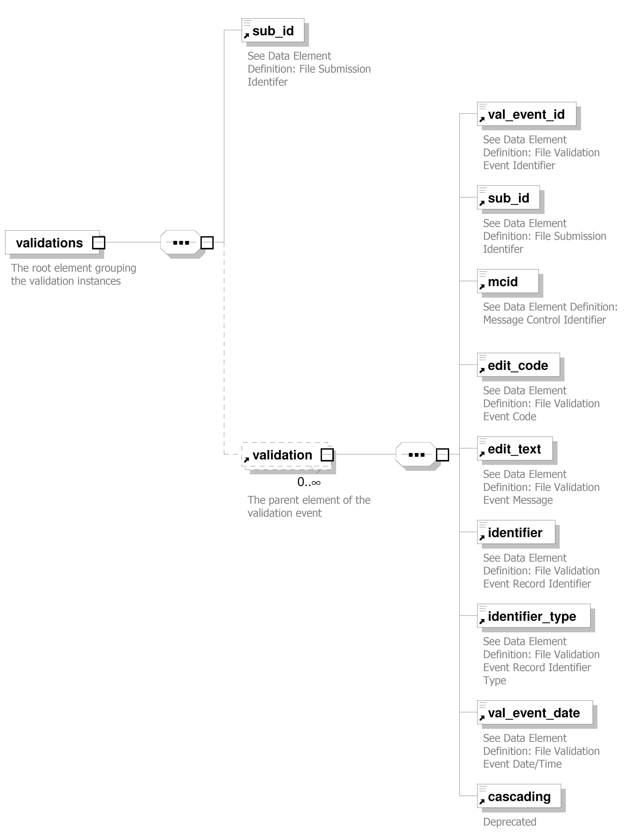

Figure 3: File submission acceptance and validation report – submission node

Figure 4: File submission acceptance and validation report – validations totals node

Figure 5: File submission acceptance and validation report – acceptance node
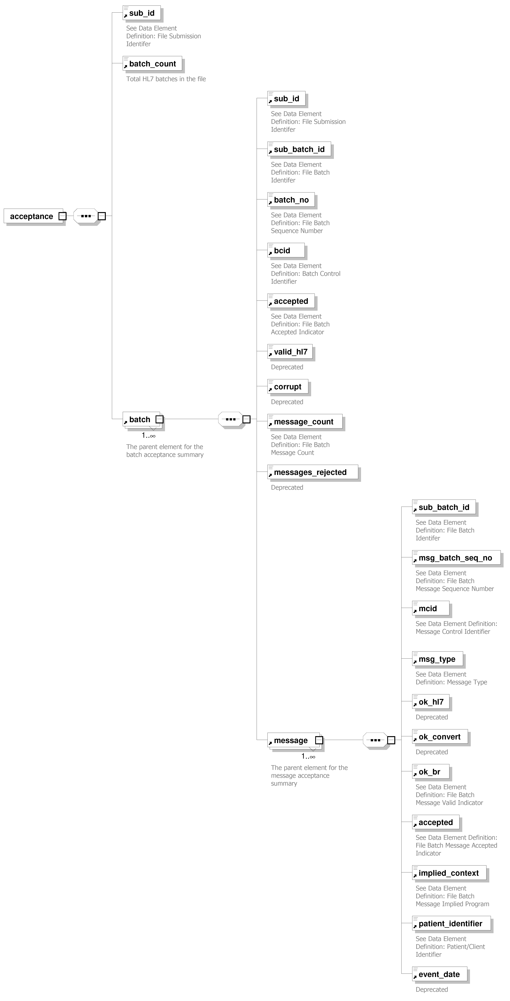

Figure 6a: File submission acceptance and validation report – sample output – submission with no validation events
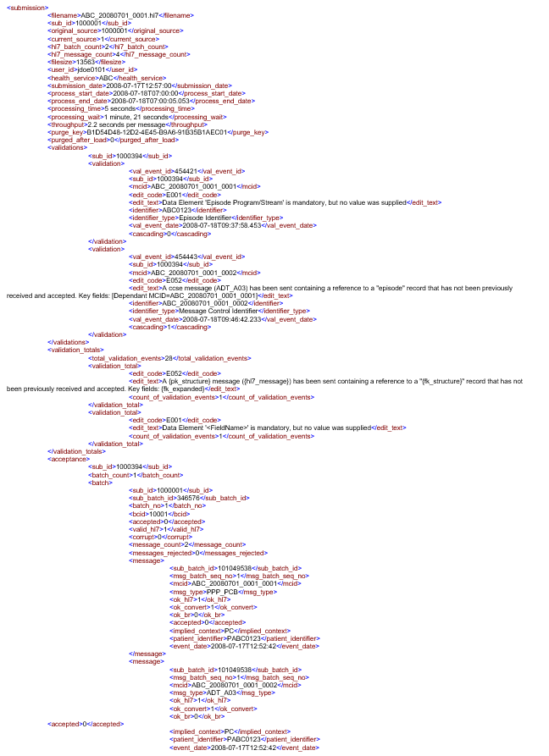

Figure 6b: File submission acceptance and validation report – sample output – submission with a validation events
