
A recipe for food safety
A food safety management tool for food businesses
OFFICIAL

To receive this document in another format, phone 1300 344 727, using the National Relay Service 13 36 77 if required, or email the Food Safety Unit <foodsafety@health.vic.gov.au>.
Authorised and published by the Victorian Government, 1 Treasury Place, Melbourne.
© State of Victoria, Australia, Department of Health, September 2023.
Except where otherwise indicated, the images in this document show models and illustrative settings only, and do not necessarily depict actual services, facilities.
ISBN 978-1-76131-112-3 (pdf/online/MS word).
Available at health.vic <Food businesses (health.vic.gov.au)>

Contents
Introduction 4
Target audience 4
Purpose 4
Legal obligations 4
How does this resource help me? 5
What are the benefits of using this resource and engaging in the local council food safety assessment process? 5
Food safety risk-based assessments 6
What should I do for an assessment? 7
Food safety assessment and your business 7
Appendix 1: High-risk foods 11
Appendix 2: How to identify your food process steps 12
List of food process steps 12
Food process flow chart 12
Appendix 3: About temperature control 13
Appendix 4: About time control 14
How does the rule work? 14
Appendix 5: Date marking 15
Production labelling 15
Dry food store labelling 15
Appendix 6: Top tips for storing food safely 16
Appendix 7: Cleaning and sanitising 17
What is cleaning? 17
What is sanitising? 17
Appendix 8: An example of a food safety management review check list 19
Appendix 9: Business resources 22
Allergens 22
Food recalls 22
Food safety posters 22
Food Standards Australia New Zealand – InfoBites 22
Safe Food Australia 23

Introduction
The development of this resource is one of several initiatives the Victorian Department of Health (the department) is undertaking to reduce the regulatory burden on businesses whilst supporting public health and food safety.
This resource was created through consultation with business peak bodies and individual food business owners. A draft version was trialled by several food business owners and their experiences and advice were used to further develop and refine it.
‘A recipe for food safety’ is designed to assist class 2, 3 and 3A food business owners’ understanding of the local council process of assessing their business for compliance with the Victorian Food Act 1984 and the Australia New Zealand Food Standards Code.
The appendix tools are provided for general information purposes for food businesses, not as templates that must be followed.

Target audience
This resource has been developed for:
- class 2 food service and food retail businesses who are exempt from the requirement to have a food safety program (FSP) for their food business
- class 3 and 3A food service and food retail businesses who are exempt from the requirement to keep minimum records.

Purpose
The purpose of this resource is to provide food business proprietors and their staff with tools and advice that can help them ensure that the food they sell is safe and suitable. It will also support the active engagement and involvement of proprietors and their staff in a food safety assessment of their food business by a local council environmental health officer (EHO). A shared focus on food safety by proprietors and local council is good for business and good for the community.

Legal obligations
The Victorian Food Act 1984 (the Act) sets out the legal obligations for both proprietors and for local councils.
- Proprietors are legally responsible for ensuring food sold from their business is safe and suitable for human consumption.
- Food safety supervisors, employed by food businesses, are legally responsible for ensuring safe food handling in the business.
- Local councils are the registering authority for food businesses and are required to assess businesses to determine compliance by proprietors, food safety supervisors, and food handlers with their legal responsibilities for food safety.

How does this resource help me?
A recipe for food safety can help you to engage with your local council EHO when they undertake a food safety assessment at your premises. It outlines the steps involved in an assessment, and how you can have an impact on the results by demonstrating your knowledge of food safety and your management of food hazards in your business.
There are a range of ideas and tools you can use to demonstrate how you manage food safety; these include showing the EHO that you:
- Understand the food safety hazards in your business, have controls in place and take corrective action when something goes wrong.
- Monitor food safety practices in your business through photographs, logbooks, or diary notes.
- Have food safety management procedures that you and your staff follow, such as good personal hygiene, cleaning and sanitising, and allergen procedures.
- Use posters in your business or information sheets that display important food safety information to remind staff of key food safety measures, such as for hand hygiene, cleaning and sanitising instructions, allergen procedures.
- Ensure staff complete food handler training, such as DoFoodSafely, the department’s free online, food handler’s course.
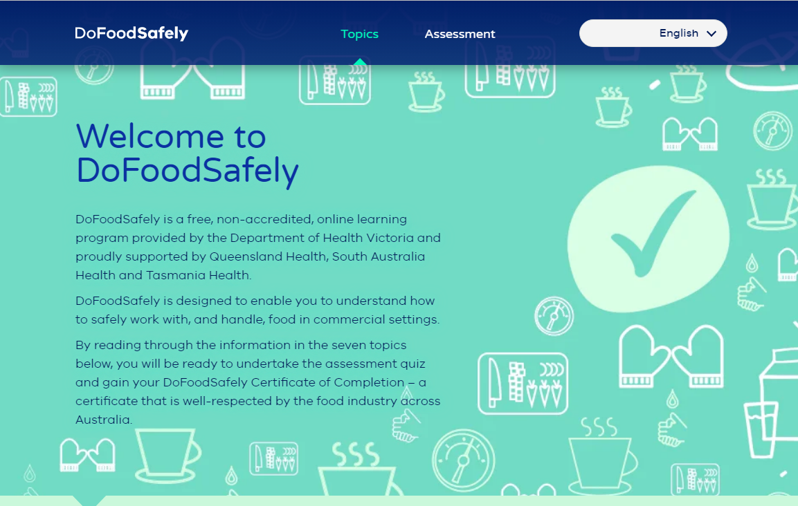

What are the benefits of using this resource and engaging in the local council food safety assessment process?
Your active engagement with the food safety assessment process will mean:
- accurate information is obtained by the EHO about your business operations and the effectiveness of your food safety management procedures and activities
- a focus on food safety priorities for your business
- a more efficient assessment process - it will be quicker
- a more consistent assessment process
- the establishment of a more respectful and constructive relationship between you and the EHO.
Remember that your local council EHO can provide you with advice and information to help you to participate in the food safety assessment of your premises. They have access to a wide range of food safety resources that are suitable for your business needs.

Food safety risk-based assessments
The department and local councils across Victoria have developed and implemented a risk-based approach to food safety assessments. The aim of this approach is to focus on the high-risk processes undertaken at your premises to prioritise that the food you sell is safe and suitable for consumption. This is achieved by assessing the effectiveness of the food safety controls used at your premises.
At the beginning of the EHO’s visit to your food premises, there will be a need to confirm the name of the proprietor and the name of the nominated food safety supervisor (if class 2 or class 3A) prior to the commencement of the assessment.
Food safety assessments are conducted using four steps, as shown in Table 1 below.
Table 1: How local council EHOs assess food safety
Assessment step | EHO assessment activities
1. Preparation | - identify foods and food processes at the premises  - check food safety history and compliance of the business  - research relevant standards, technologies, and legislative classifications  - organise scheduling.
2. Onsite assessment | - introduction to, and engagement with, business owner/manager/person in charge/food safety supervisor  - determine scope and nature of the business  - confirm menu and review  - identify food safety hazards for processes  - gather evidence on effectiveness of hazard controls  - record evidence.
3. Risk analysis | - evaluation of:  - specific process controls – critical control points (CCPs) and critical limits (CLs)  - general hygiene controls  - food handler practices  - corrective actions  - determination of food safety priorities for the business.
4. Communication | - verbal discussion:  - effective controls and practices observed  - deficiencies or failures of specific hazard controls at CCPs or other control points  - improvements in general hygiene controls  - food safety priorities  - rectification actions if required and timeframes  - written assessment:  - documentation of assessment and outcomes  - priorities for any rectification and timeframes.

What should I do for an assessment?
You are encouraged to take an active part in the assessment. Here are three steps you can take to make sure your assessment is accurate and efficient – see Figure 1.
Figure 1: Business and local council assessment steps
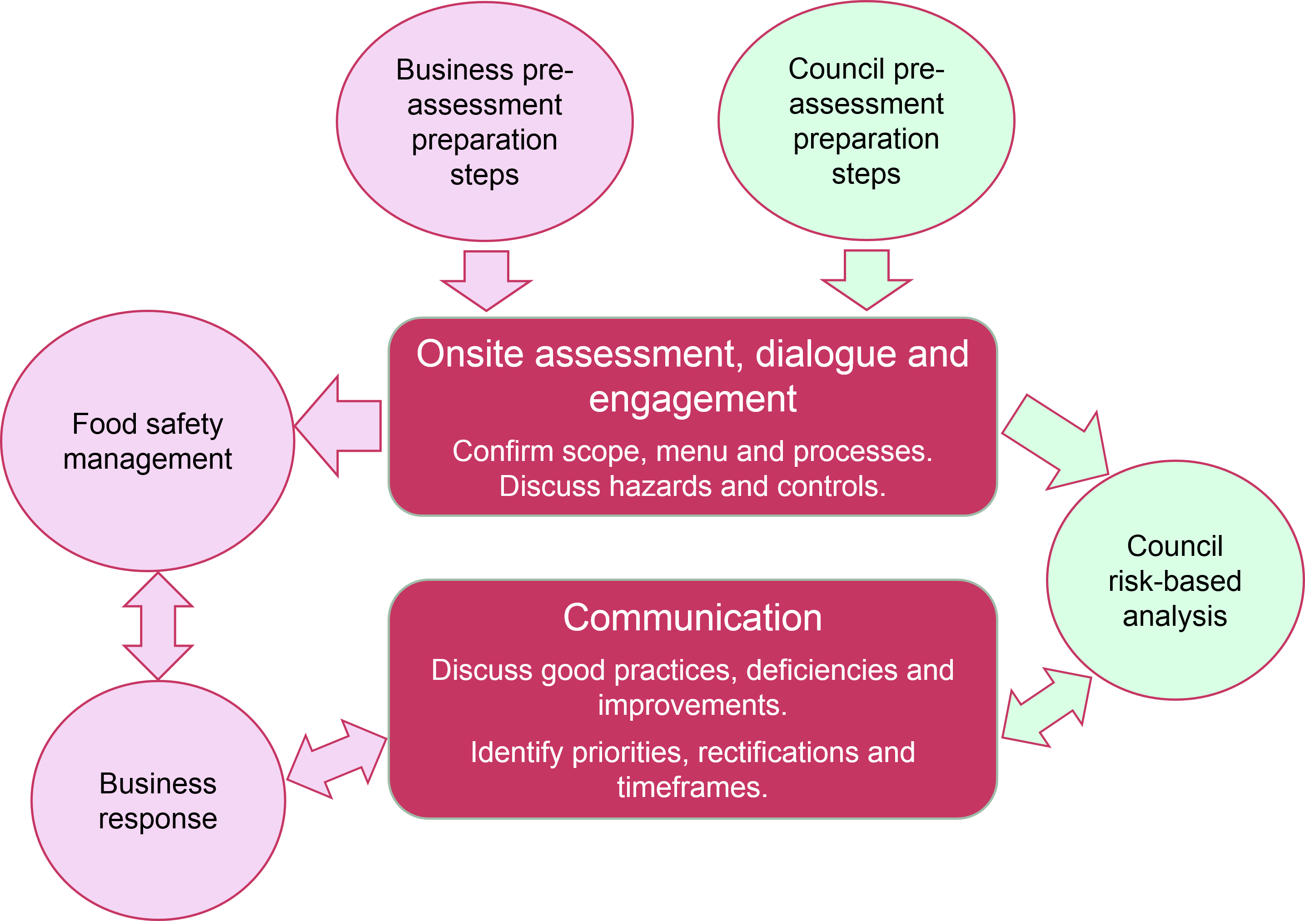

Food safety assessment and your business
The following information steps you through the different ways you can engage in the three-step assessment process.

Step 1: Preparation before an assessment
This step is about being prepared for a food safety assessment which can occur at any time. Being prepared means:
- knowing your food offering/menu and your food preparation and handling processes
- knowing which foods you sell are high-risk
- being ready to discuss and show how you prepare and handle food safely.

Objective: What are you trying to achieve in preparing for an assessment?
Your preparation will ensure that you are ready to demonstrate your knowledge of what foods and food services you provide to consumers, and which food and processes you undertake are high-risk.

How do I show evidence of my knowledge?

Menu/food offering
- If you don’t have a menu or food listing, make one.
- Identify the high-risk foods on your menu/offering (see a list of high-risk foods in Appendix 1).

Food processes
- List the food process steps you have in your business. You can do this using a process flow chart (see a list of food process steps in Appendix 2).
- Determine which of your processes are high-risk.
You can now use this information for your food safety assessment discussions with the EHO as they will want this information too.

Step 2: Food safety management
This step is about discussing with the EHO the procedures and actions you take to ensure that you and your staff are managing:
- food safety hazards associated with specific processes, including receiving, storing, cooking, cooling, reheating, and displaying food
- food temperature controls
- hygiene controls
- training of staff.

Objective: What are you trying to achieve in food safety management?
You are demonstrating that you have correct procedures and checks in place to ensure your food is safe and suitable for consumption.
There are three food safety management areas – controls for high-risk foods, hygiene controls and management procedures – that will be assessed by the EHO. Suggestions on how you can demonstrate effective food safety management in your business are below.

2.1 Specific controls required at each of your process steps for high-risk foods

What do I need to show?
You will need to show that at each of the process steps high-risk foods have been kept safe.
This means that the food is:
- kept at the correct temperatures (see Appendix 3 for temperature control information)
- not kept out of temperature control for more than four hours (see Appendix 4 for time control information)
- within use-by dates (see Appendix 5 for more detailed information)
- protected from contamination by storing in clean containers or packaging (see Appendix 6 for information on how to store food safely).

How can I show food is at the correct temperatures?
- demonstrate to the EHO how you use a digital probe thermometer to check the internal temperature of high-risk foods
- take photographs of a digital probe thermometer in the food showing the food temperatures at specific times and dates
- document your high-risk food temperatures in a diary or develop your own record sheet for staff to use
- if you use a data logger show a reading on your mobile device.

How can I show food is within the right dates and is protected?
- date all containers when food is transferred into them
- take photographs of your dated containers/trays:
  - on your cool room/fridge shelves, in your dry store, and in your freezer
  - in your bain-marie
  - in cold display
  - in bulk storage of containers and packaging
- explain to the EHO how you check and rotate stock (see Appendix 5 for more information on date marking of containers).

2.2 General hygiene controls

What do I need to show?
You need to show that the environment in which you prepare and handle food is free from sources of contamination, such as allergens, pests (insects, rodents) and other food ingredients.
This means that you:
- make sure you and your staff are educated on health and hygiene responsibilities including correct hand washing practices, personal hygiene standards, and not working when unwell
- make sure you and your staff understand correct cleaning and sanitising practices for your premises (see Appendix 7)
- make sure your premises is free from pests.

How can I show this?
- Ensure all staff complete DoFoodSafely (<www.dofoodsafely.health.vic.gov.au>), a free, non-accredited, online learning program provided by the department and show the ‘Certificates of completion’ to the EHO.
- Explain your cleaning and sanitising procedures. You may have a written procedure on display in the food premises that you can use to show the processes you follow (see Appendix 8 for cleaning and sanitising information).
- Explain your dilution procedure for sanitiser. For example, have a large photo/photocopy of the directions from the sanitiser container on the wall in the cleaning area that staff can easily refer to.
- Check for pests regularly – you can record pest checks in a diary or create your own checklist. If you use a professional pest company, you can show the recent pest service report.
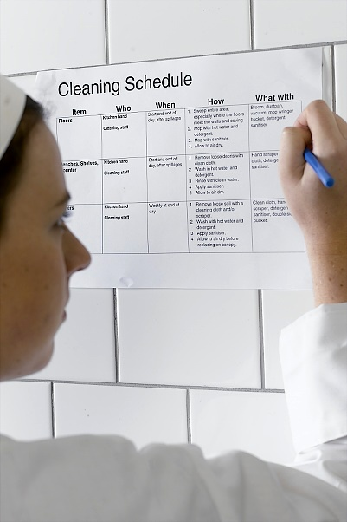

2.3 Management procedures

What do I need to show?
You need to show that you have procedures in place to review your operations and take corrective action when a problem is identified.
This means that you:
- check staff are following your procedures correctly
- correct any food safety issues immediately
- effectively manage customer complaints.

How can I show this?
- Explain your review procedure and show the results of these checks including notes on any corrections you have made.
- Explain your staff induction/training procedure and show the results of these. For example, you could use an induction/training card for each staff member.
- Explain how you manage customer complaints. For example, you could record customers complaints in a diary or create your own log.

Step 3: Response
This step is about receiving, discussing, and understanding the results of the food safety assessment and any future actions that you may need to take.

Objective: What are you trying to achieve in responding to food safety issues?
You need to demonstrate your ability to correct any food safety issues that may have been identified during the food safety assessment.

What do I need to show?
You need to show evidence of correcting food safety issues arising from a food safety assessment and any improvements you have made.

How can I show this?
- You could use a food safety management review list included in (see Appendix 8).
- You could take before and after photos of the improvements you have made and show them to the EHO.
The following appendices are provided for information and are not intended to be seen as templates that must be followed.

Appendix 1: High-risk foods
- High-risk foods (also known as ‘potentially hazardous foods’) are foods that require special care and must be kept at certain temperatures to minimise the growth of food poisoning bacteria that may cause illness.
- Examples of high-risk foods include :
  - raw and cooked meat/poultry or foods containing raw or cooked meat/poultry; for example, burgers, curries, kebabs, pâté, meat pies
  - foods containing eggs (cooked or raw), beans, nuts, or other protein-rich food, for example batter, mousse, quiche, and tofu
  - dairy products and foods containing dairy products, for example milk, dairy-based desserts, bakery products filled with fresh cream or with fresh custard (yoghurt is not included here as it is an acidified product)
  - seafood (excluding live seafood) and foods containing seafood, for example sushi
  - sprouted seeds, for example of beans and alfalfa
  - prepared fruits and vegetables, for example cut melons, salads, and unpasteurised juices
  - cooked rice and both fresh and cooked pasta
  - foods that contain any of the above foods, for example sandwiches, pizzas, and rice-paper rolls.
Not managing high-risk foods may cause a range of illnesses to your customers. More information about preventing food poisoning can be found on the department’s website, health.vic at: <https://www.health.vic.gov.au/food-safety/preventing-food-poisoning>.

Appendix 2: How to identify your food process steps
You can identify your food process steps by simply listing them or use a process flow chart, see examples below.

List of food process steps
- purchase
- receive food deliveries
- cold storage (cold and frozen)
- dry storage
- thaw
- preparation
- cook
- cool
- reheat
- display/hot hold
- allergens
- transport (to another place)
- serve.

Food process flow chart
After considering the chart below, identify the food handling activities you have at your premises.
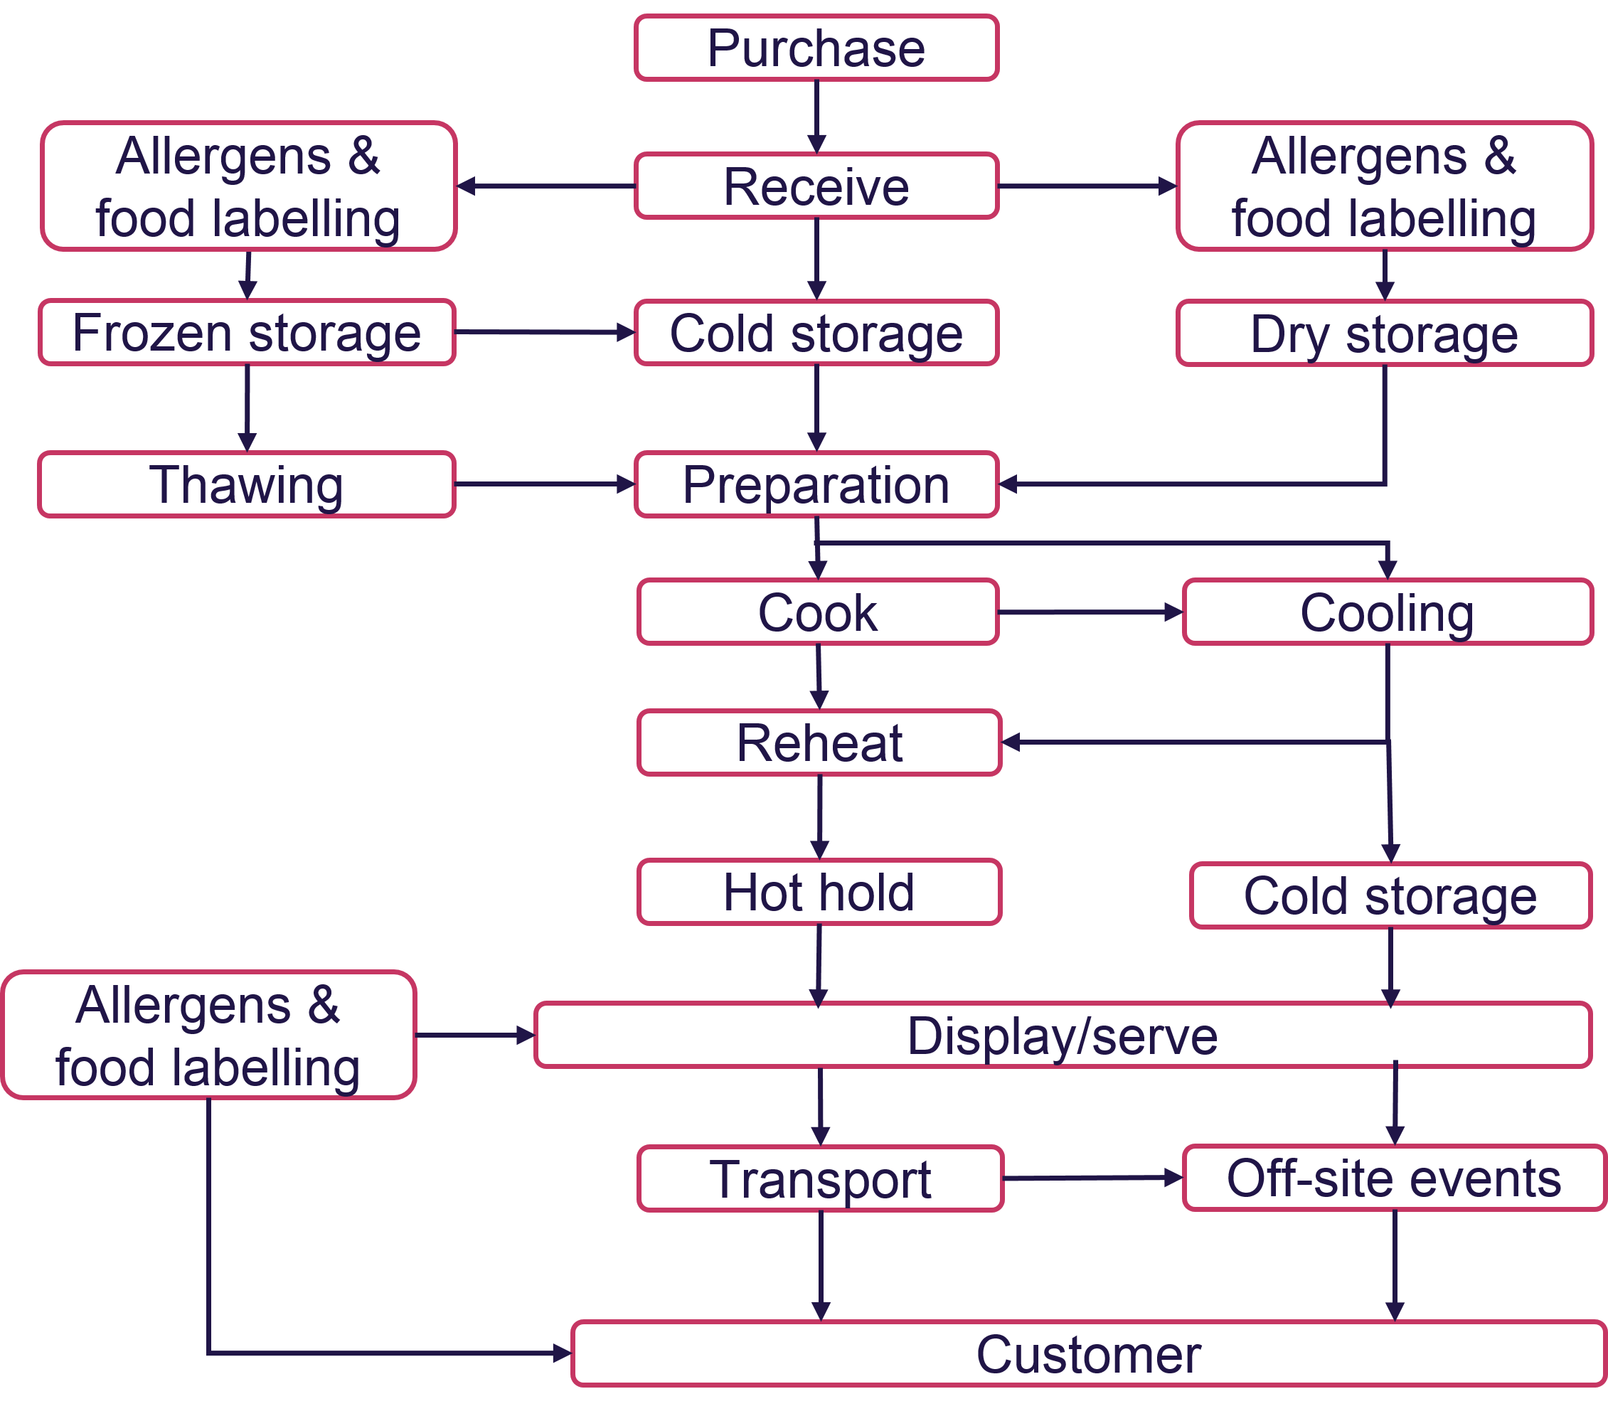

Appendix 3: About temperature control
It is important to check your high-risk food temperatures daily using a digital probe thermometer and limit the time food is in the danger zone as shown in the diagram below.
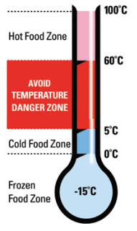
- Limit the time high-risk food is in the temperature danger zone of 5 °C to 60 °C.
- Return high-risk food to the refrigerator during delays.
- If a high-risk food is left in the temperature danger zone of 5 °C to 60 °C for a total time of four hours or more, throw it out.
- When cooking a high-risk food, a process step is needed to reduce to safe levels any pathogens that may be present in the food. Such a process must be reasonably known to achieve the microbiological safety of the food. One common process used to ensure high-risk food microbial safety is to cook to an internal temperature that reaches 75 °C.
- Hot food must be kept at 60 °C or hotter when on display or under hot holding.
- High-risk food, if cooled, must cool from 60 °C to 21 °C in the first 2 hours and then to 5 °C or cooler in the next 4 hours.
Examples of templates for documenting cooling food and recording temperatures of food on display can be found in Appendix 8 of Safe Food Australia – Safe Food Australia - A guide to the Food Safety Standards (foodstandards.gov.au) <Safe Food Australia - A guide to the Food Safety Standards (foodstandards.gov.au)>
More information about temperature control can be found on health.vic at: <https://www.health.vic.gov.au/food-safety/food-businesses-safe-food-preparation-storage-and-display>

Appendix 4: About time control
To ensure high-risk food is safe when it is out of temperature control, use the 2-hour/4-hour rule. The 2-hour/4-hour rule is based on how quickly microorganisms grow in food at temperatures between 5 °C and 60 °C.
The time between 5 °C and 60 °C is cumulative. This means you need to add up every time the food has been out of the refrigerator/coolroom, including during preparation, storage, transport, and display.

How does the rule work?
- Food held between 5 °C and 60 °C for less than 2 hours can be used, sold, or put back in the refrigerator to use later.
- Food held between 5 °C and 60 °C for 2-4 hours can still be used or sold but can’t be put back in the refrigerator.
- Food held between 5 °C and 60 °C for 4 hours or more must be thrown away.
If you follow this, you can be confident your food is safe.
Figure 2: Bacteria growth at different temperatures
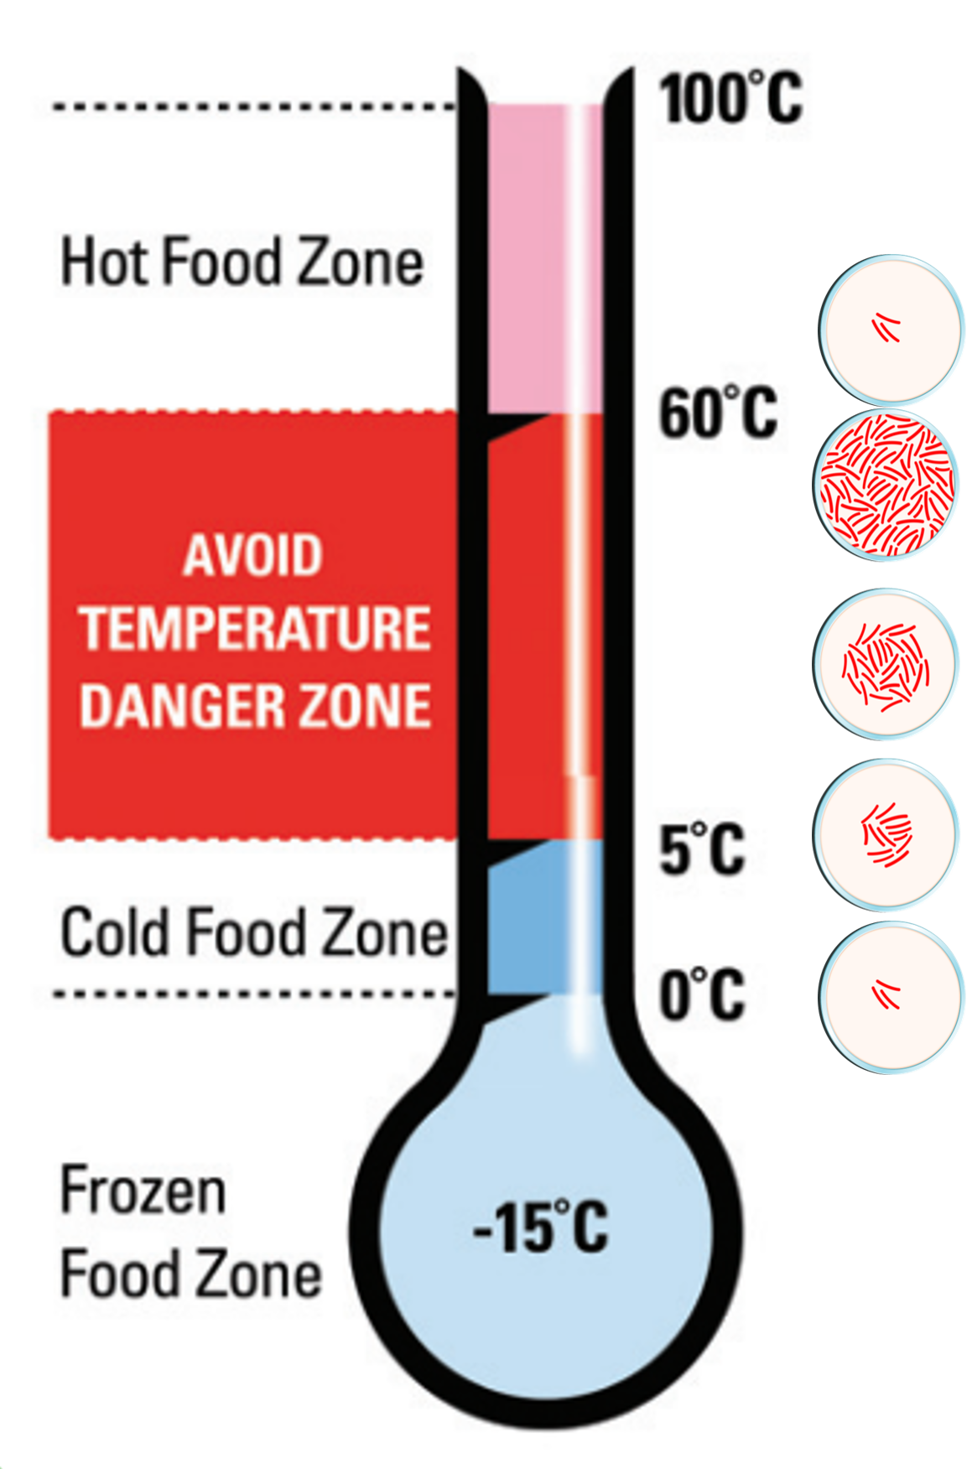

Appendix 5: Date marking
Date marking is an important food safety control as it assists with stock rotation and using foods/ingredients within their use-by/best-before dates, or times. It is important that staff are adequately trained to ensure they follow the rules below for date marking foods.

Production labelling
Ensure all prepared, refrigerated, and ready-to-eat foods:
- are labelled with the name of the food and production dates
- all pre-packaged food is labelled with the date and time when opened and retains the original manufacturer’s use‐by date information
- all allergen‐free food is clearly labelled to distinguish it from foods containing the allergen
- are labelled with a date indicating when the food should be consumed, sold, or thrown away.
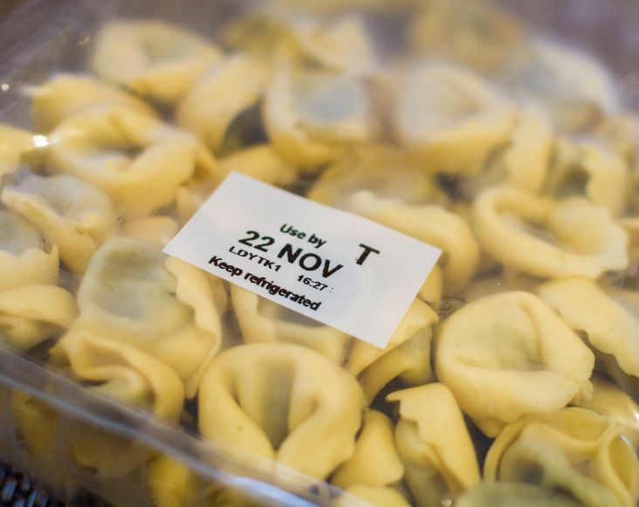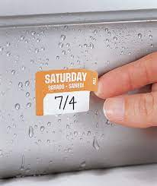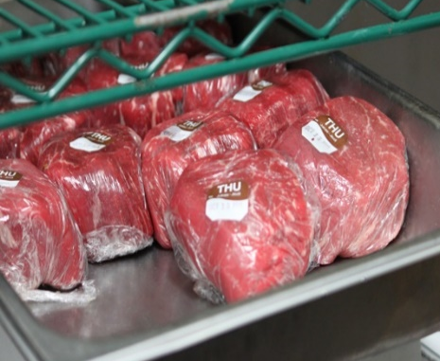

Dry food store labelling
- Make sure labels on unopened food packets clearly state the use‐by, best-before or production date.
- Ensure decanted foods are clearly labelled with the food name, date opened, and the use‐by, best-before or production date (as per packaging). Either cut the label off the packaging and stick it to the outside of the container or write a label and put it on the container.
- If removing bulk food items (for example, multiple packs) from a box ensure the batch‐date or code from the box is retained.
- Allergen‐free food, for example, gluten‐free) must be clearly labelled so you can distinguish it from foods containing the allergen.
- Ensure labels are updated as containers are re‐filled.
- Ensure that containers are checked before re‐filling to ensure allergen‐free products are only refilled into the allergen‐free containers.

Appendix 6: Top tips for storing food safely
To safely store and display food, you should follow these tips.
- Keep raw foods and ready-to-eat foods separate, to avoid contamination.
- Store food in clean, food-grade storage containers.
- Don’t store food in opened cans.
- Make sure food storage containers have not been used to store things other than food and clean and sanitise them before use.
- Don’t reuse containers that are only meant to be used once.
- If a reusable container is in poor condition, throw it out.
- Cover food with tight-fitting lids, foil, or plastic film to protect the food from dust, pests, and cross-contamination.
- Store food in areas specially designed for food storage, such as refrigerators, cool rooms, pantries, and food storerooms.
- Never store food on the floor or on pallets, or in areas containing chemicals, cleaning equipment, clothing, or personal belongings.
- Remove and avoid using foods that are past their use-by dates, spoilt, or are in damaged containers or packaging.
- Know about and avoid the temperature danger zone - bacteria grow quickly in high-risk foods that are kept at temperatures between 5 °C and 60 °C.
- Undertake training in safe food handling.

Appendix 7: Cleaning and sanitising
It is important that you are effectively and carefully clean and sanitise of your food premises to prevent food poisoning bacteria and other pollutants from contaminating your food and protect your customers from illness.

What is cleaning?
Cleaning is the process of using detergent and water to remove dust, grease, dirt, stains and odours from surfaces, fixtures (such as benches and sinks), utensils and equipment.

What is sanitising?
Sanitising is the process of killing food poisoning bacteria, such as Salmonella, E. coli, by using heat and/or chemicals. Sanitising can destroy microorganisms that cause foodborne illness.
A surface needs to be thoroughly cleaned before it is sanitised as sanitisers are unlikely to be effective in the presence of food residues, grease, and detergents.

Different ways to sanitise
There are different ways to sanitise, such as using hot water, chemicals (such as bleach or a food-grade sanitiser) or using a dishwasher on the longest hottest cycle. If using a chemical solution make sure you follow the maker’s instructions on how to prepare the solution as this may vary between products. Diluted solutions, such as bleach and water, should be discarded after 24 hours after it has been mixed as it loses its effectiveness.

What needs to be cleaned and sanitised?
Anything coming into contact with food must be cleaned and sanitised. Items which do not come into contact with food only need to be cleaned. Table 2 below provides examples:
Table 2: Some examples of items for cleaning and sanitising
Items to be cleaned and sanitised | Items to be cleaned
Plates, bowls, glasses, cups & mugs | Floors
Cutlery | Walls
Food processor, mixer, stick-blender | Ceilings
Utensils for preparing and serving food | Rubbish bins
Cutting boards | Windows
Preparation benches | Refrigerators
Storage containers and trays | Coolroom and freezer room
Food display units | Light fittings
Food preparation sinks | Cupboards and shelves

Six steps to effective cleaning and sanitising
- Pre-clean: scrape, wipe or sweep away food scraps and rinse with water.
- Wash: use hot water and detergent to take off any grease and dirt. Soak if needed.
- Rinse-off: any loose dirt or detergent foam.
- Sanitise: use a sanitiser to kill any remaining germs.
- Final rinse: wash off sanitiser (read the sanitiser instructions to see if you need to do this).
- Dry: if possible, allow to air dry, or dry with a clean tea-towel.

What is a cleaning procedure?
A cleaning procedure sets out the tasks of cleaning and sanitising – how often each task needs to be done, how it should be done, and who should do it – so your food contact surfaces are safe, and the premises is maintained in a clean condition.

What does a cleaning procedure look like?
- Begin at the back of your food premises, write down every piece of equipment that needs to be cleaned as you walk towards the front.
- Write down how you will clean each piece of equipment and surface, how often you will clean it, what materials and/or chemicals will be used, and who will do the cleaning.
A cleaning and sanitising procedure template can be found in Appendix 8 of Safe Food Australia – A guide to the Food Safety Standards <www.foodstandards.gov.au/code/pages/default.aspx>
More information on cleaning and sanitising can be found here <https://www.foodstandards.gov.au/foodsafety/standards/Pages/Cleaning-and-sanitising.aspx>
The Department of Health’s animation, called ‘Cleaning and sanitising for food businesses’, is a great tool to help educate staff and is available to be viewed in a range of languages including Arabic, Farsi, Hindi, Nepali, Punjabi, Sinhalese, Simplified Chinese, Spanish, Tagalog, and Vietnamese. You can access the animation at <https://www.health.vic.gov.au/food-safety/food-businesses>
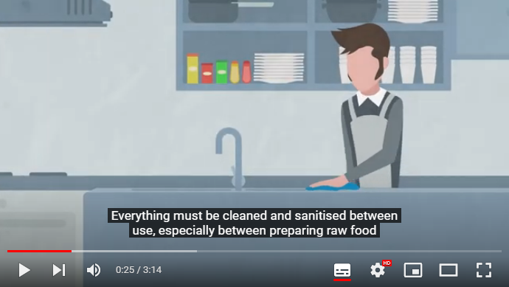

Appendix 8: An example of a food safety management review check list
Regular food safety reviews can help you focus on areas that need attention in your business, as well as monitoring staff hygiene, food processes, cleaning practices and maintenance. Below is an example of a checklist you could use or modify to suit your food business needs.
Food safety management review checklist
Date of review:
Reviewed by:
Food safety practice | Tasks | Yes | No | Observation/corrective action
Staff induction/training | Have all staff been inducted/trained so they have the skills they need to handle food safely?
Staff induction/training | Do staff understand their food safety responsibilities?
Staff induction/training | Has the induction/training been recorded?
Staff induction/training | Have staff completed food handling training?
Staff induction/training | Are the qualifications of the food safety supervisor up to date?
Personal health & hygiene | Are staff aware of safe food practices and their responsibilities to ensure the food they handle is safe?
Personal health and hygiene | Do staff wash their hands at appropriate times and always have clean hands when handling food?
Personal health and hygiene | Are staff aware they must not be at work if suffering from any illness?
Cleaning | Are staff following the cleaning and sanitising procedure?
Cleaning | Is there adequate equipment available to undertake cleaning effectively?
Cleaning | Are all cleaning chemicals clearly labelled and stored appropriately?
Food storage | Are all foods stored off the ground and not overstocked?
Food storage | Is there a risk of cross-contamination in the storage area from raw to cooked, raw to ready-to-eat, foods?
Food storage | Is all food packaged adequately?
Food storage | Are all storage containers labelled and covered appropriately?
Food storage | Are food stocks stored and rotated to ensure products do not go out of date?
Preparation | Is there a risk of cross-contamination in the preparation area?
Preparation | Are staff aware of safe food handling practices and how to avoid food contamination?
Preparation | Are staff personal belongings stored out of food preparation areas?
Temperature/time control | Are staff measuring the internal temperature of high-risk foods?
Temperature/time control | Is the 2-hour/4-hour rule being implemented correctly?
Thermometers | Have all digital probe thermometers been calibrated in the last twelve months?
Thermometers | Do all staff know how to take accurate food temperatures?
Business & equipment maintenance | Is all equipment operating correctly and in good order?
Business & equipment maintenance | Has the building been checked, and any maintenance issues identified?
Pest control | Are all areas clean and free from food scraps and other waste?
Pest control | Have pest checks been completed?
Pest control | Have pest services been delivered on time and any issues fixed?
Customer complaints | Have complaints and the business response been recorded?
Customer complaints | Are customer complaints addressed?
Customer complaints | Are there any recurring problems identified and have these been fixed?
Customer complaints | Are staff aware of what to do if they receive a customer complaint?
Managing corrective actions  Managing corrective actions | Are corrective actions being undertaken where problems have been identified?
Managing corrective actions  Managing corrective actions | Are corrective actions being recorded?

Appendix 9: Business resources

Allergens
It is important to identify food allergens and understand obligations to customers. Some foods, food ingredients or their components can cause allergic reactions including anaphylaxis. There are several resources that have been developed to help food businesses to manage allergen requirements:
- Department of Health <https://www.health.vic.gov.au/food-safety/food-allergen-awareness>
- Food Standards Australia New Zealand food allergen portal <www.foodstandards.gov.au/consumer/foodallergies/foodallergenportal/Pages/default.aspx>
- Allergy & Anaphylaxis Australia <https://allergyfacts.org.au/allergy-management/food-industry>
- Free online training courses are available from the National Allergy Council <www.nationalallergystrategy.org.au/projects/food-service/food-allergen-management-training >.

Food recalls
A supplier, food manufacturer or a government official may notify you that a particular food that poses a safety hazard to consumers is removed from sale, distribution, and consumption. This is known as a food recall. When this happens, you need to ensure that your response to a food recall is prompt.
More information about food recalls can be found on the Food Standards Australia New Zealand website: <www.foodstandards.gov.au/industry/foodrecalls/firp/Pages/default.aspx>.

Food safety posters
The department have developed two food safety posters, ‘Food safety rules’ and ‘Keep hands clean and food safe’. They contain information on temperature control, time control, cleaning, contamination, allergens, and hand washing. They are a useful tool to have on display in your food premises to remind staff of the importance of food safety controls.
The posters are available in English, Arabic, Dari, Filipino, Hindi, Korean, Nepali, Persian, Punjabi, Sinhalese, Simplified Chinese, Spanish and Vietnamese and are available for download from the department’s website health.vic: <https://www.health.vic.gov.au/food-safety/personal-hygiene-for-food-handlers>.
Printed posters may also be available from the Food Safety Unit. If you would like a printed copy(s), contact the Food Safety Unit by email at: <foodsafety@health.vic.gov.au>.

Food Standards Australia New Zealand – InfoBites
Food Standards Australia New Zealand have developed a series of ‘InfoBites’ with key tips to assist food businesses to reduce food safety risks. Topics include:
- 2-hour/4-hour rule
- cleaning and sanitising
- cooling and reheating food
- displaying food
- food packaging
- health and hygiene advice for food businesses
- pests
- processing food safely
- temperature of food
- thermometers
- transporting food safely.
For more information go to InfoBites <https//www.foodstandards.gov.au/foodsafety/standards/Pages/Food-safety-requirements.aspx>

Safe Food Australia
Safe Food Australia (<www.foodstandards.gov.au/publications/pages/safefoodaustralia3rd16.aspx>) is a guide to the Food Safety Standards Chapter 3 of the Australian New Zealand Food Standards Code. The guide is for government agencies, who are responsible for enforcing food safety standards, and food business proprietors, who will find that this guide offers helpful information about the standards and food safety issues.
Appendix eight of Safe Food Australia includes template examples for recording food safety information including temperature control and cleaning. These templates can be adapted to suit your specific business needs. https://www.foodstandards.gov.au/code/Pages/default.aspx

The term food safety assessment in this resource refers to a risk assessment of a food premises conducted by a local council EHO to identify potential hazards associated with food processes and to validate and verify the effectiveness of food safety controls used by a food business to produce safe and suitable food.
The Victorian Food Act 1984 can be found at: <Food Act 1984 (legislation.vic.gov.au)>
For further information, refer to Safe Food Australia - A guide to the Food Safety Standards (foodstandards.gov.au) Appendix 4 <https://www.foodstandards.gov.au/publications/Pages/safefoodaustralia3rd16.aspx>
For further information, refer to Safe Food Australia - A guide to the Food Safety Standards (foodstandards.gov.au), Appendix 1 <https://www.foodstandards.gov.au/publications/Pages/safefoodaustralia3rd16.aspx>

