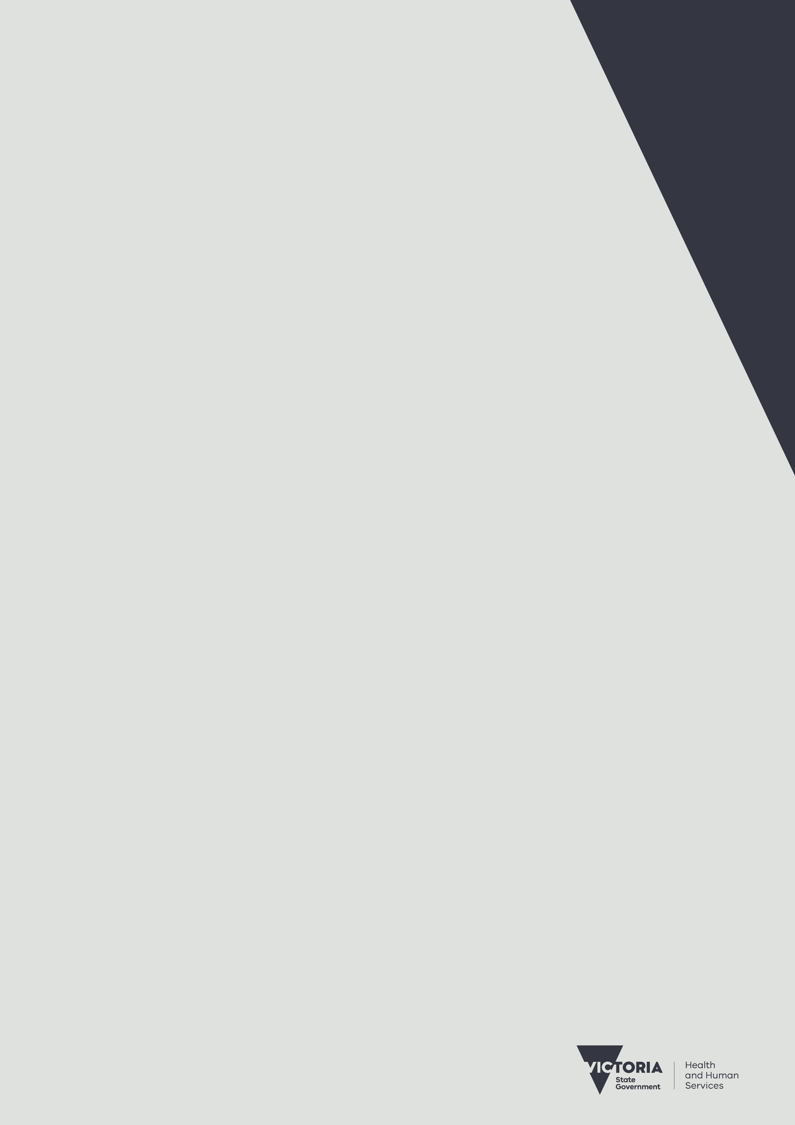
Your guide to food safety

.

For information on food safety contact:
- Food Safety Hotline on 1300 364 352 or email the Department of Health Food Safety Unit <foodsafety@health.vic.gov.au>
- Your local council

Visit
health.vic <https://www.health.vic.gov.au/public-health/food-safety>
Better Health Channel <https://www.betterhealth.vic.gov.au>
Food Standards Australia New Zealand <https://www.foodstandards.gov.au>

To receive this publication in an accessible format phone 1300 364 352, using the National Relay Service 13 36 77 if required, or email the Food Safety Unit <foodsafety@dhhs.vic.gov.au>
Authorised and published by the Victorian Government, 1 Treasury Place, Melbourne.
© State of Victoria, May 2020. Creative Commons Attribution 4.0 licence (creativecommons.org/licenses/by/4.0). The licence does not apply to any branding including the Victorian Government logo, images or artistic works.
Except where otherwise indicated, the images in this publication show models and illustrative settings only, and do not necessarily depict actual services, facilities or recipients of services.
Available online at health.vic <https://www.health.vic.gov.au/public-health/food-safety>
ISBN 978-1-76069-391-6 (Print)
ISBN 978-76069-392-3 (pdf/online/MS Word)
(2004698)

Enjoy your food

Don’t let your food turn nasty.
We Victorians love food and we produce some of the highest quality and freshest foods in the world.
We love to buy and cook food to eat at home, or outdoors on picnics, camping trips and barbecues, or to take to work and school.
Victorian and Australian food safety laws are designed to ensure the food we buy is safe.
All Victorian food businesses, such as supermarkets, delis, butchers, fishmongers, take-aways and restaurants, must comply with these laws and standards by selling food that is safe to eat and free of any contamination. Food businesses have a responsibility to sell food that is safe to eat.
Even the best food in the world can turn nasty if poorly handled, stored or cooked.
Once the food is in your hands, it is up to you to keep your food safe to eat.
This booklet will explain how simple practices can ensure the food that you buy and take home to prepare for yourself, your family or friends remains safe and enjoyable.

Ten easy steps to safe food
- Buy food from reputable businesses with clean premises.
- Avoid consuming spoiled food, food past its use‑by-date or food in damaged containers or packaging.
- Take chilled, frozen, or hot food straight home in insulated containers or bags.
- Keep raw food and ready-to-eat food separate.
- Avoid high-risk food left in the temperature danger zone (between 5 °C to 60 °C) for more than four hours.
- Keep high-risk food out of the temperature danger zone. Keep chilled food cold at 5 °C or colder and hot food hot at 60 °C or hotter.
- Thoroughly wash and dry your hands before, during and after preparing food.
- Use separate and clean utensils for raw food and ready-to-eat food.
- Cook minced meats, poultry, fish and sausages thoroughly.
- When in doubt, throw it out.
Food businesses have a responsibility to sell food that is safe to eat.

High-risk food

Bacteria grow and multiply on some types of food more easily than on others.
The types of food that bacteria prefer include:
- meat
- poultry
- dairy products
- eggs
- smallgoods
- seafood
- cooked rice
- cooked pasta
- prepared salads, coleslaws, pasta salads
- prepared fruit salads.
Ready-to-eat foods are foods that can be eaten without further preparation or cooking such as prepared salads, take-aways and prepared sandwiches.

Did you know?
Food poisoning bacteria are often naturally present in food, and in the right conditions a single bacterium can grow into more than two million bacteria in just seven hours.

Keep your food in the ‘right’ zone!

A basic food safety rule is to keep high-risk food in the right temperature zone for as long as possible.
When shopping:
- plan to buy frozen, chilled and/or hot food towards the end of your shopping trip
- keep hot food separate from cold food.
When storing and transporting food:
- keep chilled food at 5 °C or colder
- keep frozen food frozen solid
- keep hot food at 60 °C or hotter
- throw out high-risk food left in the temperature danger zone for
more than four hours
- consume high-risk food left in the temperature danger zone for
more than two hours – do not keep it for later.
Use a fridge thermometer to check the temperature in your fridge. The temperature should be below 5°C. Keep the freezer temperature around -15°C to -18°C.

Choose food carefully
- Only buy from reputable businesses with clean and tidy premises.
- Check the use-by-date or best-before-date, avoid food past its use-by-
or best-before-date.
- Check food labels for allergen and nutritional information.
- Avoid products in damaged, dented, swollen or leaking cans, containers
or other packaging.
- Avoid food that seems spoiled, such as mouldy or discoloured product.
- Check that staff use separate tongs when handling separate food types.
- Only buy eggs in cartons that identify the supplier – avoid cracked or soiled eggs.
- Avoid high-risk chilled and frozen food that has been left out of the fridge and freezer.
- Avoid hot food, like take-away, that is not steaming hot.
- Avoid ready-to-eat food left uncovered on counters.
If you have concerns with the way food is handled, stored or prepared by a business, contact your local council health department.
Once you purchase food, the safety of that food also becomes your responsibility.

Get food home quickly

Once you purchase food, the safety of that food becomes your responsibility.
- If you have purchased hot, chilled or frozen food, you should get them home as quickly as possible.
- Prevent meat, chicken or fish juices from leaking onto other products.
- For trips longer than about 30 minutes, or on very hot days, it is a good idea to take an insulated cooler or bag with an ice pack to keep chilled or frozen food cold.
- Consider placing hot food in an insulated container for trips longer than about 30 minutes.
- Consider wrapping hot food in foil.
- Once you arrive home, immediately transfer chilled and frozen food into your fridge and freezer.
Use an insulated container or bag to transport chilled or hot food.

Take care eating away from home
Follow these tips to keep food safe and enjoyable when eating outdoors or taking a packed lunch to work or school.
- Cut meats into serving-size pieces before leaving home and have all salads ready to eat.
- Put raw meats and high-risk foods into separate, leak-proof containers and into insulated coolers.
- Place containers with raw meats at the bottom of an insulated cooler and keep separate from ready-to-eat food.
- Avoid packing food that has just been cooked or is still warm, unless you can keep it out of the temperature danger zone. Refrigerate overnight before packing.
- Do not place ready-to-eat food into containers used for storing raw food without thoroughly washing and drying the containers first.
- Consider using disposable wipes if there is no safe water for hand washing.
- Pack plenty of ice packs around chilled food. Frozen drinks can serve as ice packs, especially in school lunches.
Take extra care when preparing, storing and handling food to eat away from home.

Store food well
Storing food well means there is less chance of our food making you sick and you wasting your food and money.
Keep food safe by:
- keeping high-risk chilled food in the fridge
- keeping frozen food frozen hard
- storing food in clean, non-toxic, food storage containers
- storing cooked food separately from raw food
- storing raw meats, seafood and chicken at the bottom of the fridge, in sealed or covered containers
- storing left-overs in the fridge. Packaged food and food from cans and jars can become high-risk once opened
- not storing food in opened cans
- avoiding egg, dairy and meat products past their use-by-date
- placing food in leak‑proof containers with tight-fitting lids or wrapping in foil or plastic film.
Cover food in leak‑proof containers with tight-fitting lids or wrap in foil or plastic film.

When in doubt, throw it out.

Did you know?
You can keep your food fresh for longer and save on energy costs by ensuring the door seals on your fridge are in good condition

Wash your hands before preparing food

To make sure you wash your hands for 20 seconds, try singing or humming the first verse of our national anthem, or any other tune for 20 seconds.
- Before preparing food, wash your hands with soap for at least 20 seconds in warm water and dry your hands with a clean towel or disposable paper towel.
- Wash your hands thoroughly after handling raw meats, chicken, seafood, eggs and unwashed vegetables.
- If you have any cuts or wounds on your hands, cover them with waterproof wound-strips.
- Wear clean, protective clothes, such as an apron, when preparing food.
- If you feel unwell, let someone else prepare the food.

Did you know?
Wet hands are more likely to transmit bacteria. After washing your hands take the time to dry them thoroughly

Keep it clean and separate
- Keep raw foods separate from ready-to-eat foods.
- Use separate and clean utensils and equipment for ready-to-eat food.
- Do not use the same equipment and utensils for raw food and for
ready-to-eat food without thoroughly cleaning them first.
- Thoroughly clean and dry chopping boards, knives, pans, plates,
containers and other utensils after using them.
- Use hot soapy water to wash things and ensure they are thoroughly dry before using them again.
- Use fresh, clean tea-towels or disposable towels to dry utensils and equipment or allow them to air‑dry.
- Use a dishwasher with appropriate detergents to wash and dry utensils and equipment.
- Wash raw fruits and vegetables under running water before using them.
- Do not allow pets around areas where food is prepared or stored.
- Remove pests and vermin from where food is prepared or stored.

Thaw it right – use the fridge

Bacteria can grow in frozen food while it is thawing, so keep frozen food out of the temperature danger zone.
- Unless instructions direct otherwise, thaw frozen food in the fridge or use a microwave oven.
- Packaged frozen food often comes with cooking instructions, make sure you prepare and cook the food as directed.
- Defrost frozen meats, fish and poultry thoroughly before cooking.
- Keep defrosted food in the fridge until it is ready to be cooked.
- If defrosting using a microwave oven, cook the food immediately after defrosting.
- If you are using a microwave oven, speed up the thawing by separating defrosted portions from still-frozen portions.
- Don’t re-freeze thawed food.
Use the fridge to thaw frozen food.

Cook it right

One of the most important things you can do to stop high-risk food turning nasty is to cook it thoroughly.
- Use a meat thermometer to help you get the temperature right.
- Thoroughly cook food made from eggs such as omelettes and baked egg custards.
- Cook poultry until the meat is white – there should be no pink flesh.
- Cook hamburgers, mince, sausages and rolled or stuffed roasts right through until any juices run clear.
- Cook white fish until it flakes easily with a fork.
- Most food should be cooked to at least 75 °C.
- Take extra care when preparing food where eggs remain uncooked, such as chocolate mousse and home-made mayonnaise, as bacteria on or in the egg can contaminate the food.
Meat thermometers are available from many retail stores that sell kitchen utensils and barbecue equipment.

Reheating and cooling food

If you need to store hot food for later use, once the steam stops rising, cover it and put it in the fridge.
- Reheat foods thoroughly so they are steaming (above 75 °C) or boiling.
- Keep cooked food out of the temperature danger zone.
- Food that has just been cooked or taken out of the oven to cool should be cooled as quickly as possible to prevent the growth of bacteria.
- When you cook ahead of time, divide large portions of food into small shallow containers for refrigeration.
- If you do not want to cool the food straight away, keep hot food at a temperature of 60 °C or hotter.
Stir food reheated in a microwave halfway through to ensure no under-heated parts remain.

Did you know?
Good airflow inside your fridge is important for effective cooling. Try to avoid overfilling your fridge.

Food poisoning

Food poisoning is frequently caused by bacteria from food that has been poorly handled, stored or cooked. The food may still look, taste and smell normal.
The symptoms of food poisoning may vary depending on the type of bacteria or contaminants causing the illness. You may experience one or more of the following symptoms:
- nausea
- stomach cramps
- diarrhoea
- fever
- headaches.
Symptoms can occur within 30 minutes after eating, several hours later, or even longer. Symptoms can be mild or severe.
Some bacteria can also cause other symptoms. Listeria bacteria may cause miscarriage or other serious illness in susceptible people and it can take weeks for symptoms to emerge.
Some people are more at risk from food poisoning including young children, pregnant women, the elderly and people with other illnesses.

Where to get help
- See your doctor.
- Report your illness to your local council, particularly if you think the illness is related to food that you have purchased or eaten, so that the cause can be investigated.

