Ban on smoking and vaping during organised underage sporting events
Information for residents of and visitors to Victoria


By law, smoking and the use of e-cigarettes (vaping) is banned within
10 metres of outdoor sporting venues during under 18s events in Victoria.

Where does the ban apply?
Smoking and vaping is banned within 10 metres (about two car lengths) of a sporting venue that is an outdoor public place during an organised underage sporting event. This includes training or practice sessions to prepare for an organised underage sporting event and breaks or intervals during the course of the event, training, or practice session.
The ban applies to outdoor drinking areas within 10 metres of an outdoor public sporting venue during an organised underage sporting event or training session.
These diagrams show examples of where the smoking and vaping ban applies.
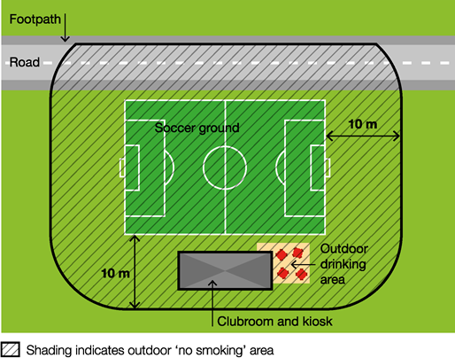
In the above diagram workplace smoking and vaping laws apply to the enclosed clubroom and kiosk.
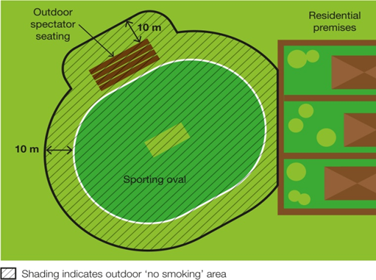
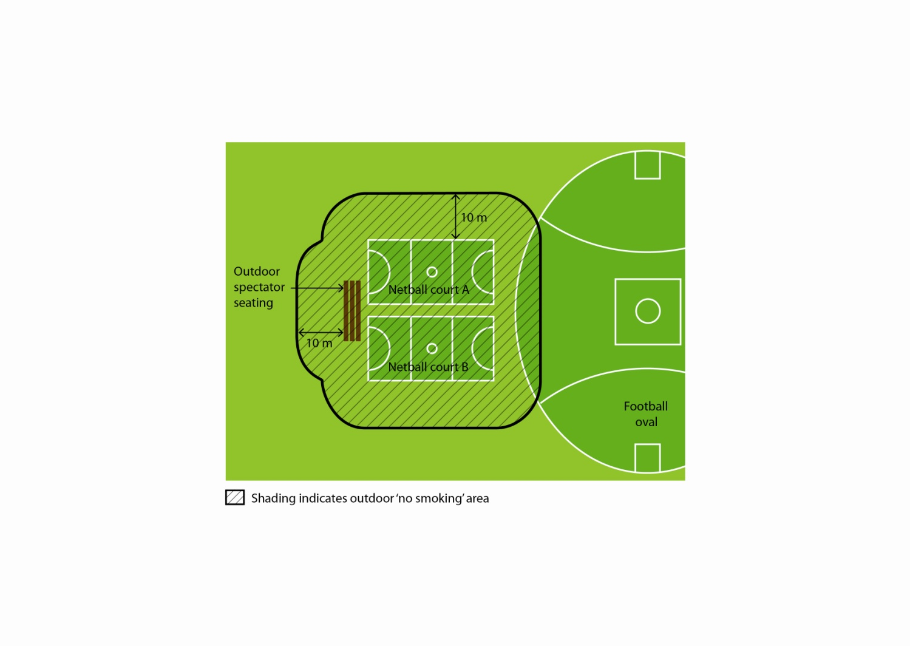
In the above diagram underage netball games are conducted on netball courts A and B.

Why does the ban exist?
To protect children and young people from the dangers of second-hand smoke and the aerosol from e-cigarettes
Underage sporting events attract families with children and young people. This ban creates a smoke-free and vape-free place where children and young people can enjoy themselves without being exposed to harmful second-hand tobacco smoke and the aerosol from e-cigarettes.
Second-hand tobacco smoke exposure is particularly dangerous for children and young people because they have smaller airways and less developed immune systems compared to adults.
To reduce the role modelling of smoking and vaping behaviours around children and young people
Children and young people are more likely to view smoking and vaping as socially acceptable when they regularly see people smoking and vaping. Banning smoking and vaping in areas used by children and young people will help to de-normalise smoking and vaping behaviour and discourage children and young people from taking up smoking and vaping.

What is considered a sporting venue?
Under this law, a ‘sporting venue’ includes:
- a playing field
- a track
- an arena
- a court or rink
- any permanently or temporarily erected public seating at the venue
- any seating, marshalling area, warm-up area, podium or other part of the venue reserved for the use of competitors or officials
- any part of the venue used to conduct the actual organised underage sporting event.
For example, if there are courts or ovals next to one another, the sporting venue is considered to be the court/s or oval/s where the actual underage sporting event is taking place.
Each sporting venue will be different. The diagrams above can help you to understand where the ban applies.

What is considered an underage sporting event?
Under this law, an ‘organised underage sporting event’:
- is planned in advance
- is organised or intended for, or predominantly participated in by, persons under the age of 18 years
- is conducted according to established rules by a professional or amateur sporting body or by an educational institution
- may be a one-off event or part of a series of events.
Examples
An organised underage sporting event | Not an organised underage sporting event
A Little Athletics meet | An open netball game where some of the players are minors
An interschool/school sporting event participated in by people in their final years of secondary school, some of whom may be over the age of 18 | An open age football match in which most of the players are over the age of 18
An underage football match run by regional football league | An informal or impromptu sporting activity involving minors at an outdoor public sporting venue

How will I know when the ban applies?
The smoking and vaping ban applies when an underage sporting event is taking place. To help you determine whether an underage sporting event is taking place, consider whether:
- children under 18 years old are playing in a match, game, tournament or other event conducted by an amateur or professional sporting body or educational institution
- participants are wearing sporting uniforms
- there is supervision that may consist of coaching, officiating or umpiring of underage people
- a whistle, siren or other alert is used to indicate the match, game or event has started or finished.
In most cases, spectators and parents will know an organised underage sporting event is occurring based on the way the event has been described. Underage sporting events are likely to be described as age-limited, for example ‘under 16s’ or ‘junior’.
There may also be ‘No smoking’ or ‘No smoking or vaping’ signs displayed at the venue to inform you of the ban.
Note that the ban also includes training or practice sessions to prepare for an underage sporting event, breaks and intervals in play.

When does the ban not apply?
The ban does not apply:
- if no underage sporting event is currently underway
- to a person at a residential premises (at privately owned homes and land)
- to a person in a motor vehicle that is driving or being driven past the sporting venue
- to a person in an area that is separated from the sporting venue by a road.

What if a sporting club or venue already has a smoke-free and vape-free policy?
The statewide ban is a minimum standard. If a sporting club has its own smoking and vaping ban in place you should comply with any further requirements of that in addition to the legislative ban.

How will people know about the ban?
‘No Smoking’ or ‘No smoking or vaping’ signs may be displayed in the smoke-free and vape-free area.

How will the ban be enforced?
There is strong community support for banning smoking and vaping at public places regularly attended by children. This means most people will voluntarily comply with the smoking and vaping ban and expect others to do so.
Inspectors authorised under the Tobacco Act 1987 may provide information about and, when necessary, enforce the ban. The first priority of the inspector is to make sure smokers and e-cigarette users understand the ban.
Inspectors may not be available to respond to every complaint, but where circumstances allow, may attend in response.
What penalties might apply?
The maximum penalty for someone breaking this law is five penalty units, with an infringement penalty of one penalty unit.

How can I find out more?
For more information:
- visit the tobacco reforms website <www.health.vic.gov.au/public-health/tobacco-reforms>
- call the Tobacco Information Line on 1300 136 775
To view the legislation visit the Victorian Government’s legislation website <www.legislation.vic.gov.au> and search Tobacco Act 1987.

To receive this document in another format, phone 1300 136 775, using the National Relay Service 13 36 77 if required, or email tobacco.policy@health.vic.gov.au
Authorised and published by the Victorian Government, 1 Treasury Place, Melbourne.
© State of Victoria, Australia, Department of Health, November 2023.
Except where otherwise indicated, the images in this document show models and illustrative settings only, and do not necessarily depict actual services, facilities or recipients of services.
DISCLAIMER: Please note that any advice contained in this factsheet is for general guidance only. The Department of Health does not accept any liability for any loss or damage suffered as a result of reliance upon the advice contained in this factsheet. Nothing in this factsheet should replace seeking appropriate legal advice.
ISBN 978-1-76131-096-6 (pdf/online/MS word)
Available at tobacco reforms website <www.health.vic.gov.au/public-health/tobacco-reforms>

¹ Section 5RI(1) of the Tobacco Act 1987.
² For current penalty unit values, visit the Department of Treasury and Finance website <www.dtf.vic.gov.au/financial-management-government/indexation-fees-and-penalties>

