

Forensic Leave Panel
Annual report 2022

To receive this document in another format, phone 1800 222 987, using the National Relay Service 13 36 77 if required, or email the Forensic Leave Panel
<flp@health.vic.gov.au>.

Authorised and published by the Victorian Government, 1 Treasury Place, Melbourne.
© State of Victoria, Australia, Department of Health, September 2023.
ISSN 2208-4673 - Print
ISSN 2206-5962 - Online (pdf/word)
Available from the Forensic Leave Panel’s webpage <https://www.health.vic.gov.au/mental-health-services/forensic-leave-panel>


8 September 2023

Jaclyn Symes MP Attorney-General
Level 26, 121 Exhibition Street
Melbourne VIC 3000

Dear Attorney-General
In accordance with section 63 of the Crimes (Mental Impairment and Unfitness to be Tried) Act 1997 (Vic), I am pleased to submit the annual report on the operations of the Forensic Leave Panel for the year ending 31 December 2022 for tabling in parliament.
A copy of this report has also been provided to the Minister for Mental Health, the Hon Gabrielle Williams MP, and the Minister for Disability, Ageing and Carers, the Hon Lizzie Blandthorn MLC, who are also responsible in part for the operation of the Act.

Yours sincerely

The Hon Justice Rita Incerti
President
Forensic Leave Panel

Contents

President’s report 6
Online hearings 6
Statistical data 6
Acknowledgements 6
Definitions 8
Forensic Leave Panel 9
Who we are 9
What we do 9
How we do it 9
Our people 10
Membership 10
Changes to our membership 11
The leave framework 12
On-ground leave and limited off-ground leave 12
Criteria for granting leave 12
Conditions attached to leave 13
Purpose of leave 14
Progression of leave 14
Suspension of limited off-ground leave 14
The hearing process 15
Hearings 15
Applications for leave 15
Supporting documentation 15
Conduct of hearings 16
Decisions about leave 16
Operational report 17
The year in review 17
Our finances 19
Appendix 1: The legal framework 20
Legal framework for progression under the Act 21
Appendix 2: Panel membership as at 31 December 2022 22
Supreme Court judges 22
County Court judges 22
Chief Psychiatrist and nominees 22
Psychiatrist members 23
Psychologist members 23
Community members 24
Appendix 3: Historical data 26
General information 26
Type of leave applications 26
Leave requests granted, suspended, appealed and revoked 27
Applicant demographics 28
Sentencing information 28

President’s report

I am pleased to present the annual report of the Forensic Leave Panel for 2022 – my first annual report as president of the panel and my fifth year as a judicial panel member.
I would like to thank my predecessor, the former Justice Terry Forrest, for his outstanding stewardship of the panel over the past four years, especially during the COVID- 19 pandemic. Justice Forrest joined the Forensic Leave Panel in February 2013 and became its president in February 2020. It was a pleasure working with him, and I admire the vision and initiative with which he led the panel during his time as president.
I would also like to thank Judge James Parrish, who recently retired from the County Court, for his work and commitment to the panel. I wish Judge Parrish all the best.

Online hearings
In 2020 the panel moved its operations online due to the COVID-19 pandemic. Since then, the panel has continued to operate online.
We have continued to make ongoing efforts to refine and improve the experience of online hearings for all participants. Forensic patients and residents continue to benefit from the participation of their support people (including family members), legal representatives and interpreters in online hearings.
Online hearings have proven to be an effective method to enable broader panel attendance (for example, panel members have been able to attend from regional and interstate locations), support hearings to run uninterrupted and ensure hearings are conducted in a safe way for all participants. Other positive impacts of hearings have included enabling more support people (including family members) to take part in hearings where they may not have otherwise been able to attend due to distance and/or other considerations. Online hearings have also increased the number of occasions on

which an interpreter has been able to attend and have provided the ability to support rearrangements where there have been late and unforeseen changes to attendance.

Statistical data
During 2022 the panel conducted 34 hearings (eight for forensic residents and 26 for forensic patients). Overall during 2022 there was a 9% increase in the number of forensic patients and residents making applications for leave.
While on-ground leave ceased in late 2021,1 in 2022, 109 forensic patients and residents made applications for limited off-ground leave. In comparison, in 2021 there were 100 applicants for on-ground and limited off- ground leave.
The panel considered 230 applications for limited off-ground leave and granted 96.5% of those applications. The proportion of leave granted in 2022 slightly increased compared with 2021 (92%) but is consistent with leave granted in previous years.
The data contained in this report shows that rates of granting and refusing applications have been fairly consistent since 2013 (refer to Appendix 3: Historical data).

Acknowledgements
I would like to acknowledge the expertise and skill of the panel members and thank them for their invaluable contribution to its operation.
I would like to thank Dr Michael Epstein and Dr Leon Turnbull, who finished up with us in 2022.

1 On-ground leave ceased in late 2021 and so forensic residents did not apply for on-ground leave in 2022.

I want to acknowledge the important role of the lawyers from Villamanta Disability Rights Legal Service Inc., Disability Justice Australia Inc., Kurnai Legal Practice and Victoria Legal Aid in providing legal representation and advice to applicants at panel hearings.
Finally, I wish to express my appreciation of the work and commitment of the staff of Forensic Residential Services, the Thomas Embling Hospital and the Department of Health’s Mental Health and Wellbeing

Division.

The Hon Justice Rita Incerti President
Forensic Leave Panel

Definitions
Throughout this report, unless otherwise specified:
- ‘The Act’ refers to the Crimes (Mental Impairment and Unfitness to be Tried) Act 1997.
- ‘The panel’ refers to the Forensic Leave Panel.
- ‘Forensic patient’ or ‘patient’ is a person remanded in or committed to custody in a designated mental health service under the Mental Health Act 2014.
- ‘Forensic resident’ or ‘resident’ is a person remanded in or committed to custody in a residential treatment facility or a residential service under the Disability Act 2006.
- ‘Purpose of leave’ refers to activities undertaken while a forensic patient or resident is on leave.
- ‘Forensic Residential Services’ or ‘FRS’ is a network of secure and non-secure services and includes two secure residential treatment facilities, the Intensive Residential Treatment Program (IRTP) and the Long-Term Residential Program (LTRP). FRS is a part of the Victorian Department of Families, Fairness and Housing. In this report, FRS refers to the IRTP and LTRP.2
- ‘Forensicare’ refers to the Victorian Institute of Forensic Mental Health, which is a statutory body established by the Mental Health Act. Thomas Embling Hospital is a campus of Forensicare.

2 In August 2021, following a restructure, the former Disability Forensic Assessment and Treatment Services (DFATS) became part of the newly formed FRS. In previous annual reports, DFATS referred to the IRTP.

Forensic Leave Panel

Who we are
The panel is an independent statutory tribunal established under the Crimes (Mental Impairment and Unfitness to be Tried) Act 1997 (the Act) to support the rehabilitation of forensic patients and residents and assist with their reintegration into the community.
The panel comprises members of the judiciary, the Chief Psychiatrist and nominees, psychiatrists, psychologists and community members.

What we do
The main role of the panel is to hear applications for limited off-ground leave from patients and residents to enable them to take part in a range of activities in the community to aid their rehabilitation. Prior to 2022 the panel’s role also included hearing applications for on-ground leave from patients and residents for the same purposes. The panel also hears appeals from patients and residents regarding refusal of special leave and transfers from one designated mental health service to another.

How we do it
The panel conducts hearings online from the Thomas Embling Hospital campus of
Forensicare and at Forensic Residential Services (FRS) to consider applications for limited off-ground leave from forensic patients and residents.
The panel considers applications from forensic patients and residents over the duration of their custody or detention.
Over time the panel may grant incremental increases to a person’s leave into the community when it is appropriate to do so. Leave is granted for a maximum of six months at any one time.
Since 2020, panel hearings have been held online via video link with attendance by participants, their support people (including family members), legal representatives, treating team and interpreters. Patients, residents and their treating teams continued to attend from their facility, and provision was also made for support people (including family members), legal representatives and translators to attend at the facility where requested and possible.
‘Appendix 1: The legal framework’ provides an overview of how a patient or resident may progress under the Act. It also identifies the panel’s responsibilities in the detention, management and release framework.

Our people

Membership
As at 31 December 2022 the panel comprised:
- seven judicial members from the Supreme Court of Victoria
- four judicial members from the County Court of Victoria
- the Chief Psychiatrist
- five nominees of the Chief Psychiatrist
- six registered medical practitioners with experience in forensic psychiatry

Figure 1: Panel membership

- three registered psychologists with experience in intellectual disability and forensic psychology
- six members to represent the views and opinions of the community.
The panel is supported by an executive officer from the Mental Health and Wellbeing Division of the Victorian Department of Health.
The structure of the panel is outlined in Figure 1.

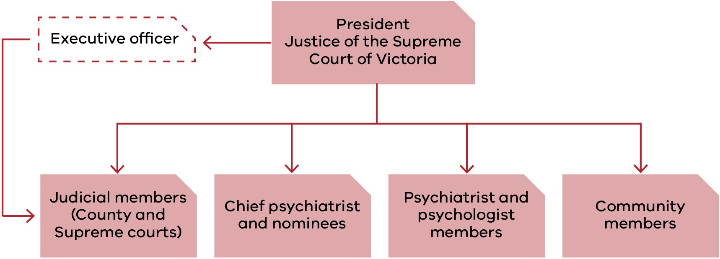

‘Appendix 2: Membership as at 31 December 2022’ contains a complete list of members, including their terms of appointment.

Changes to our membership

Supreme Court judicial members
- Justice Andrew Keogh was reappointed for a second term on 18 October 2022.
- Justice Jane Dixon was reappointed for a second term on 18 October 2022.

County Court judicial members
- Judge Sandra Davis was reappointed for a fourth term on 7 June 2022.
- Judge Douglas Trapnell was reappointed for a second term on 31 October 2022.

Psychiatrist members
- Dr Daniel O’Connor was appointed as a psychiatrist member of the panel on 1 March 2022.
- Dr Teresa Flower was reappointed for her fourth term on 7 June 2023.
- Dr Michael Epstein resigned on 30 June 2022 after serving six terms.
- Dr Leon Turnbull was reappointed for his second term on 7 June 2022 and later resigned on 21 February 2023.
- Dr Ahmed Mashhood was reappointed for his second term on 1 July 2022.

Psychologist members
- Ms Janina Tomasoni was reappointed for her sixth term on 1 July 2022.
- Dr Michelle Noon was reappointed for her second term on 1 July 2022.

Community members
- Mr Jack Nalpantidis was reappointed for his fifth term on 1 July 2022.
- Mr George Jiang was reappointed for his third term on 1 July 2022.
- Dr Patricia Mehegan was reappointed for her second term on 1 July 2022.

The leave framework

On-ground leave and limited off-ground leave
The panel has jurisdiction under the Act to grant on-ground and limited off-ground leave to forensic patients and forensic residents.
In late 2021 on-ground leave was no longer required and was ceased. The areas that used to be accessed through on-ground leave can still be accessed under other provisions.
The maximum period for which limited off- ground leave can be granted is six months.3 At the end of this period, a patient or resident may reapply to the panel.

On-ground leave
On-ground leave allows forensic patients and residents to be absent from the place of custody but within a defined area around the place of custody, known as ‘the surrounds’.
Forensic residents at the Long-Term Residential Program (LTRP) in Bundoora used to make extensive use of on-ground leave. However, in late 2021, the LTRP increased the grounds within its secure perimeter. At this time, it became a resident treatment facility and the area surrounding the facility, some of which was previously accessed via on-ground leave, became part of the secure perimeter of the facility. Other areas that used to be accessed via on-ground leave but are not part of the secure perimeter of the facility can now be accessed via limited off-ground leave. For this reason, the panel no longer receives applications for on-ground leave.
Forensic patients at the Thomas Embling Hospital campus of Forensicare and forensic
residents at the Intensive Residential Treatment Program (IRTP) did not require on- ground leave because there were enough grounds within the secure perimeter.
Accordingly, no grounds were declared under section 52 of the Act in relation to Thomas Embling Hospital or the IRTP.

Limited off-ground leave
Limited off-ground leave permits patients and residents to be absent from the place of custody between 6:00 am and 9:00 pm, or outside those hours for a maximum of three days in any seven-day period.

Criteria for granting leave
The panel may grant limited off-ground leave if it is satisfied that:
- the proposed leave will contribute to the patient’s or resident’s rehabilitation
- the safety of the person or members of the public will not be seriously endangered as a result of the patient or resident being allowed leave.
In determining whether to grant an application for leave or variation of leave, the panel must consider:
- the person’s current mental condition or pattern of behaviour
- the person’s clinical history and social circumstances
- the applicant’s profile and leave plan or statement, prepared in keeping with the Act.
The above criteria for granting leave applied to applications made to the panel prior to 2022 for on-ground leave.

3 The same maximum period (six months) applied to granting on-ground leave.

Conditions attached to leave
The panel can place any conditions on leave that it considers appropriate. Conditions commonly relate to:
- how many, if any, escorts are needed
- the duration and frequency of leave
- where a patient or resident may go (or where they may not go)
- the people a patient or resident can meet while on leave
- how a patient or resident is to travel to their leave destination
- drug and alcohol testing following leave.

Purpose of leave

The purpose of leave is to assist the rehabilitation process and provide a gradual progression towards a return to community living that is consistent with the needs of the individual and with community safety.
Patients and residents can apply to the panel to take part in a broad range of activities. All leave must form part of an overarching treatment and recovery plan. Common purposes of leave granted include leave to:
- attend medical, legal, dental or allied health appointments
- undertake activities of daily living such as personal shopping, banking and physical exercise
- build or maintain relationships with family and friends in the community
- participate in therapeutic and rehabilitation groups, activities or programs
- attend educational and vocational activities, groups or courses
- take part in or seek voluntary and/or paid work.

Progression of leave
The panel takes a graduated approach to granting leave. Initially, a patient or resident is granted a small amount of leave and is escorted by two or three staff members. This could include leave to attend medical appointments or may allow a patient or resident to attend a nearby facility (such as a park or a café) for one hour a week.
If a patient or resident can successfully participate in leave over a sustained period, the panel may decrease the number of escorts and increase the number of approved locations and purposes, as well as the duration, of further leave. This process allows patients or residents to gradually increase their participation in a wide variety of activities that form part of everyday living to prepare
them for release back into the community. This slow approach to leave allows for a steady reintroduction into the community and provides staff with a valuable opportunity to monitor how the person copes and adapts in the community.
A patient’s or resident’s progression depends on individual circumstances. The progression outlined above may not be the path followed by all patients and residents. Some may move backwards and forwards between various stages of this process depending on their progress and response to treatment.

Suspension of limited off- ground leave
Regular monitoring and review of leave takes place to ensure the safety of each patient or resident and to ensure the public is not seriously endangered. Before forensic residents or patients may access leave granted by the panel, they are subject to a clinical assessment.
The Act contains provisions that allow the Chief Psychiatrist (in the case of patients) and the Secretary of the Department of Families, Fairness and Housing (in the case of residents) to suspend leave granted by the panel if they are satisfied that the safety of the person or members of the public will be seriously endangered if leave is not suspended. The panel must record and report any suspensions of leave.
There were four instances of leave being partially or wholly suspended in 2022. The Secretary suspended leave for one resident and the Chief Psychiatrist suspended leave partially or wholly for three patients.

The hearing process

Hearings
The panel must conduct its hearings at the place where the patient or resident is detained to enable the person to attend and participate fully in the proceedings, unless the president determines otherwise. Since 2020 hearings have been held online, with the patients and residents attending from their corresponding service.
Patient hearings are generally held at Thomas Embling Hospital and the panel is made up of:
- a judge from the Supreme or County Court (depending on the patient’s original court of disposition)
- the Chief Psychiatrist or nominee
- a registered medical practitioner with experience in forensic psychiatry
- a community member.
Resident hearings are held at FRS and the panel is made up of:
- a judge from the Supreme or County Court (depending on the resident’s original court of disposition)
- a registered psychologist with experience in intellectual disability and forensic psychology
- a community member.

Applications for leave
A forensic patient or resident may apply to the panel for limited off-ground leave. Leave can include one or more purposes of leave.
All applications must specify:
- the purpose(s) of leave (for example, grocery shopping)
- the duration and frequency of each purpose (for example, two hours, once per week)
- the destination for each purpose (for example, the name of the shopping centre)
- the relationship to the person’s rehabilitation (for example, to build or maintain daily living skills).

Supporting documentation
Other documentation that must be submitted to the panel includes:
- an applicant profile
- a report from the consultant psychiatrist or psychologist
- a detailed leave plan prepared by the patient’s or resident’s treating team.
These are described below.

Applicant profile
The profile must have the following information:
- the person’s impairment, condition or disability
- the relationship between the impairment, condition or disability and the offending conduct
- the person’s clinical history and social circumstances
- the person’s current mental state or pattern of behaviour
- the offence that led to the supervision order being made
- the date of the supervision order, its nominal term and the day from which the nominal term had been declared to run.

Report from the consultant psychiatrist or psychologist
This report provides information on the person’s current mental state, medication, a risk assessment and any conditions that the clinician recommends should be placed on the leave. The clinician will also indicate if they support all or some of the purposes of leave the patient or resident is applying for.

Detailed leave plan
This plan is intended to show how any previous grants of leave have progressed and how the present leave applied for may contribute to the person’s rehabilitation goals. The plan also allows the person’s treating team to recommend any leave conditions or to recommend that leave should not be granted.

Conduct of hearings
Hearings are closed to the public unless the panel directs otherwise on the basis that it is in the best interest of the person or is in the public interest. Open hearings rarely occur, although the panel may occasionally allow an observer to be present for training or professional development purposes. No open hearings were conducted in 2022.
The panel must act according to equity and good conscience and is bound by the rules of natural justice.
The panel is not required to conduct its hearings in a formal manner. It is not bound by rules or practice relating to evidence and may inform itself on matters as it sees fit. This may include requests for extra information or, by way of summons, request that others attend.
During the hearing the panel discusses the leave application with the patient or resident
and their treating team. Discussions focus on such things as the person’s current mental state and pattern of behaviour, any notable achievements or incidents since the person’s last panel hearing and how any previous leaves granted by the panel have progressed.
If the patient or resident needs assistance during a hearing, the panel will engage an interpreter or other specialist, as necessary. During 2022 the panel engaged an interpreter on 20 occasions, in the following languages:
- Auslan
- Arabic
- Cantonese
- Filipino
- Italian
- Mandarin
- Turkish
- Vietnamese.
This was an increase from 15 occasions in 2021.
Applicants have a right to legal representation at hearings. Two patients and six residents chose to be legally represented over the course of the year on 13 separate occasions.

Decisions about leave
At the end of each hearing the panel advises the patient or resident of its decision and gives verbal reasons. A written determination is issued to the patient or resident after the hearing outlining the leave that was granted or refused and any conditions attached to the leave.
A patient or resident has the right to request a written statement of reasons for the decision. In 2022 no requests were made for a written statement of reasons.
Otherwise, no written statements of reasons are provided.

Operational report

The year in review

Forensic patients

Measure | 2022 | 2021 | Change
Applicants | 102 | 91 | +11
Male applicants | 87 | 76 | +11
Female applicants | 15 | 15 | 0
Applicants on Supreme Court orders | 59 | 56 | +3
Applicants on County Court orders | 43 | 35 | +8
First-time applicants | 14 | 9 | +5
Hearings | 26 | 27 | –1
Applications received | 210 | 191 | +19
Individual leave purposes requested | 898 | 814 | +84
Applications for on-ground leave | 0 | 0 | –
Applications for limited off-ground leave | 210 | 191 | +19
Leave granted without modification | 74% | 79% | –5%
Leave granted with modification | 22% | 14% | +8%
Total leave granted4 | 96% | 93% | +3%
Leave refused | 5% | 7% | –2%
Leave suspensions by the Chief Psychiatrist | 3 | 4 | –
Leave suspensions by the Secretary of the Department of Families, Fairness and Housing | N/A | N/A | N/A
Times a patient was assisted by an interpreter | 20 | 145 | +6
Number of languages used | 8 | 7 | +1
Legal representation | 2 | 2 | –
Appeals against refusal of special leave | 0 | 0 | –

4 The percentage of leaves granted, modified or refused by the panel may not always total 100% because at hearings applicants may withdraw leave requests, the panel may grant modified leave requests or, on occasion, grant additional leave requests.
5 There was another occasion in which, following technical difficulties, an applicant agreed to proceed with a hearing without the assistance of an interpreter.

Forensic residents

Measure | 2022 | 2021 | Change
Applicants | 7 | 9 | –2
Male applicants | 7 | 9 | –2
Female applicants | 0 | 0 | –
Applicants on Supreme Court orders | 2 | 3 | –1
Applicants on County Court orders | 5 | 6 | –1
First-time applicants | 1 | 1 | –
Hearings | 8 | 9 | –1
Applications received | 20 | 19 | +1
Individual leave purposes requested | 117 | 106 | +11
Applications for on-ground leave | 0 | 9 | –9
Applications for limited off-ground leave | 20 | 19 | +1
Leave granted without modification | 63% | 75% | –12%
Leave granted with modification | 37% | 15% | +22%
Total leave granted6 | 100% | 90% | +10%
Leave refused | 1% | 10% | –9%
Leave suspensions by the Chief Psychiatrist | N/A | N/A | N/A
Leave suspensions by the Secretary of the Department of Families, Fairness and Housing | 1 | 0 | +1
Times a resident was assisted by an interpreter | 0 | 1 | –1
Number of languages used | 0 | 1 | –1
Legal representation | 11 | 9 | +2
Appeals against refusal of special leave | 0 | 0 | –

6 The percentage of leaves granted, modified or refused by the panel may not always total 100% because at hearings applicants may withdraw leave requests, the panel may grant modified leave requests or, on occasion, grant additional leave requests.

The panel’s statistical information has remained relatively constant over recent years. Although variations occur in the number of hearings, applicants and applications, these differences are generally consistent with changes in the forensic patient and resident population.
In 2022 there were 26 hearings for forensic patients, which was slightly less than 2021 (27 hearings). However, the increased number of applicants, applications and leave purposes led to substantially longer hearings during the year. For forensic residents, there was an increase in the number of applications per resident across the year, with most residents submitting three applications each in 2022.7 Accordingly, despite the decreased population size (seven residents), there was an increase in both the number of applications and leave purposes compared with 2021. The increased number of applications did not include any special circumstances. All applications were standard leave requests, including applications considered in the two extra hearings held on request for residents who specifically applied for leave to take part in rehabilitation activities.8
Individual applications for leave increased from 210 in 2021 to 230 in 2022. Overall, requests for distinct leave purposes increased from 920 in 2021 to 1,015 in 2022. Resident requests for distinct leave purposes increased from 106 in 2021 to 117 in 2022. Similarly, patient requests for leave purposes increased from 814 in 2021 to 898 in 2022. This is consistent with changes in the forensic resident and patient population. The number of leave applications per applicant varied from one to three, with an average of 2.1 leave applications by each forensic patient or
resident.9 Out of the 109 applicants over the calendar year:
- Thirteen made one application.
- Seventy-one made two applications.
- Twenty-five made three applications.
‘Appendix 3: Historical data’ has more information on the number of patients and residents, hearings, leave applications and other demographic data for the period from 2013 to 2022.

Our finances
The Department of Health’s Mental Health and Wellbeing Division provided all operational support to the panel, managed the panel’s budget and maintained accounts and records. The department’s audited financial statements include the panel’s expenditure, which is reported in the department’s annual report.

7 In 2021 there were nine forensic residents with an average of 2.1 applications per resident.
8 Forensic patients and residents may apply for leave at any time.
9 These figures are for the 109 forensic patients and residents who applied for leave in 2022. It is noted that some forensic patients and residents did not apply for leave.

Appendix 1: The legal framework

The Crimes (Mental Impairment and Unfitness to be Tried) Act 1997 provides for the management, supervision and release of people found unfit to stand trial or not guilty of an offence because of mental impairment.
Under the Act, a court can impose several different supervision orders if it finds a person unfit to plead or not guilty because of mental impairment:
- custodial supervision orders (CSOs), which commit a person to custody in a designated mental health service under the Mental Health Act 2014 or to a residential treatment facility or residential service under the Disability Act 2006
- CSOs, which commit a person to custody in a prison but only if the court is satisfied that no practicable alternative exists
- non-custodial supervision orders (NCSOs), which allow the person to live in the community subject to conditions decided by the court and specified in the order.
The court also has the discretion to release a person unconditionally.
Figure 2 presents a brief overview of how a person may progress through the system under the Act and shows where the panel is situated within this framework.

Legal framework for progression under the Act

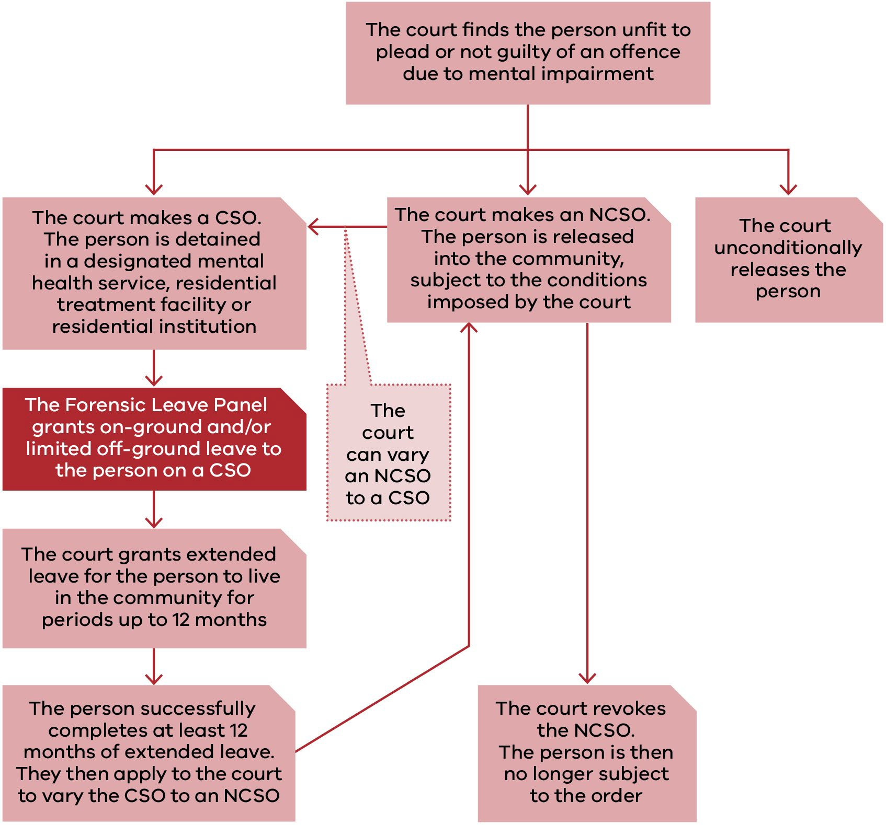
Figure 2: Legal framework for progression under the Crimes (Mental Impairment and Unfitness to be Tried) Act

Appendix 2: Panel membership as at 31 December 2022

Supreme Court judges

Panel member | Current appointment | Previous term(s) of appointment
The Hon Justice Terry Forrest  President of the Forensic Leave Panel from February 2020 | 17 April 2018  to 16 April 2023 | 26 February 2013  to 25 February 2018
The Hon Justice Rita Incerti | 28 May 2019  to 27 May 2024 | N/A
The Hon Justice Christopher Beale | 17 February 2020  to 16 February 2025 | 17 February 2015  to 16 February 2020
The Hon Justice Michael Croucher | 17 February 2020  to 16 February 2025 | 17 February 2015  to 16 February 2020
The Hon Justice Andrew Keogh | 18 October 2022 to  17 October 2027 | 25 July 2017  to 24 July 2022
The Hon Justice Jane Dixon | 18 October 2022 to  17 October 2027 | 25 July 2017  to 24 July 2022
The Hon Justice Richard Niall | 24 February 2020  to 23 February 2025 | N/A

County Court judges

Panel member | Current appointment | Previous term(s) of appointment
Her Honour Judge Sandra Davis | 7 July 2022 to 6 June 2024 | 4 October 2016  to 3 October 2021  - October 2011  to 3 October 2016  - September 2006  to 4 September 2011
His Honour Judge Douglas Trapnell | 31 October 2022 to  31 October 2027 | 31 October 2017  to 30 October 2022
His Honour Judge James Parrish | 17 April 2018  to 16 April 2023 | N/A
Her Honour Judge Rosemary Carlin | 12 May 2020  to 11 May 2025 | N/A

Chief Psychiatrist and nominees

Panel member | From | To

Panel member | From | To
Dr Neil Coventry (Chief Psychiatrist) | 20 November 2014 | Ongoing
Dr Steve Macfarlane | 9 November 2012 | Ongoing
Dr Daniel O’Connor | 27 April 2016 | Ongoing
Dr Vinay Lakra | 18 July 2016 | Ongoing
Dr Jennifer Babb | 11 March 2020 | Ongoing
Dr David Huppert | 4 September 2020 | Ongoing

Psychiatrist members

Panel member | Current appointment | Previous term(s) of appointment
Dr Michael Epstein | 1 July 2018  to 30 June 2022 | 24 October 2014  to 30 June 2018  24 October 2010  to 23 October 2014  24 October 2006  to 23 October 2010  10 September 2002  to 9 September 2006  21 April 1998  to 20 April 2002
Dr Teresa Flower | 7 June 2022 to 6 June 2024 | 27 March 2018  to 26 March 2022  30 August 2013  to 29 August 2017  30 August 2009  to 29 August 2013
Dr Jennifer Torr | 2 June 2019  to 1 June 2023 | 2 June 2015  to 1 June 2019
Dr Leon Turnbull | 7 June 2022 to 6 June 2024  (resigned 21 February 2023) | 27 March 2018  to 26 March 2022
Dr Ahmed Mashhood | 1 July 2022 to 30 June 2026 | 1 July 2018  to 30 June 2022
Dr Daniel O’Connor | 1 March 2022 to 1 March 2024 | N/A

Psychologist members

Panel member | Current appointment | Previous term(s) of appointment
Ms Janina Tomasoni | 1 July 2022 to 30 June 2026 | 1 July 2018  to 30 June 2022  24 October 2014

Panel member | Current appointment | Previous term(s) of appointment
to 30 June 2018
24 October 2010
to 23 October 2014
24 October 2006
to 23 October 2010
10 September 2002
to 9 September 2006
Dr Michelle Noon | 1 July 2022 to 30 June 2026 | 1 July 2018  to 30 June 2022
Dr Marilyn McMahon | 30 August 2019  to 29 August 2023 | 30 August 2017  to 29 August 2019

Community members

Panel member | Current appointment | Previous term(s) of appointment
Mr Paul Newland | 30 August 2019  to 29 August 2023 | 30 August 2017  to 29 August 2019  30 August 2013  to 29 August 2017  30 August 2009  to 29 August 2013  30 August 2005  to 29 August 2009  12 December 2000  to 11 December 2004  21 April 1998  to 20 April 2000
Mr Jack (Kyriakos) Nalpantidis | 1 July 2022 to 30 June 2026 | 1 July 2018  to 30 June 2022  24 October 2014  to 30 June 2018  24 October 2010  to 23 October 2014  24 October 2006  to 23 October 2010
Dr Genevieve Grant | 30 August 2019  to 29 August 2023 | 30 August 2017  to 29 August 2019  30 August 2013  to 29 August 2017  30 August 2009  to 29 August 2013
Mr Jie (George) Jiang | 1 July 2022 to 30 June 2026 | 1 July 2018  to 30 June 2022  15 July 2014

Panel member | Current appointment | Previous term(s) of appointment
 |  | to 30 June 2018
Dr Patricia Mehegan | 1 July 2022 – 30 June 2026 | 1 July 2018  to 30 June 2022
Dr Leslie Cannold | 30 August 2019  to 29 August 2023 | N/A

Appendix 3: Historical data
The table below provides information on the number of patients and residents, hearings, leave applications and other demographic data for the period from 2013 to 2022.

General information

Application information | 2022 | 2021 | 2020 | 2019 | 2018 | 2017 | 2016 | 2015 | 2014 | 2013
Forensic patients | 102 | 91 | 91 | 93 | 85 | 88 | 74 | 74 | 76 | 75
Forensic residents | 7 | 9 | 11 | 10 | 7 | 8 | 6 | 4 | 3 | 3
Hearings10 | 34 | 36 | 29 | 30 | 27 | 27 | 26 | 26 | 21 | 24
Hearing days11 | 30 | 3112 | 25 | 26 | 24 | 23 | 21 | 21 | 18 | 18
Total leave applications made to the panel | 230 | 210 | 197 | 216 | 216 | 228 | 201 | 180 | 227 | 216
Average leave applications made per hearing | 6.8 | 5.8 | 6.8 | 7.2 | 8 | 8.4 | 7.7 | 6.9 | 10.8 | 9
Average leave applications by each forensic patient or resident | 2.1 | 2.1 | 1.9 | 2.1 | 2.3 | 2.4 | 2.5 | 2.3 | 2.9 | 2.8
Average leave purposes per application | 4.4 | 4.4 | 4.8 | 4.5 | 4.8 | 4.9 | 4.9 | 4.8 | 5 | 4.7

Type of leave applications

Type of leave | 2022 | 2021 | 2020 | 2019 | 2018 | 2017 | 2016 | 2015 | 2014 | 2013
On-ground | 0 | 9 | 7 | 5 | 4 | 17 | 12 | 7 | 6 | 6
Off-ground | 230 | 210 | 197 | 216 | 216 | 211 | 189 | 173 | 221 | 210
Leave purposes | 1,015 | 920 | 949 | 974 | 1,025 | 1,107 | 980 | 874 | 1,139 | 1,023

10 The total number of times the panel convened for hearings for forensic patients and forensic residents.
11 Prior to 2021, hearings at Thomas Embling Hospital and the former DFATS were scheduled (when possible) to coincide so relevant members of a division of the panel could attend both hearings.
12 In 2021 there were four days in which more than one panel hearing was held.

Leave requests granted, suspended, appealed and revoked

Leave measure13 | 2022 | 2021 | 2020 | 2019 | 2018 | 2017 | 2016 | 2015 | 2014 | 2013
Granted | 96% | 92% | 97% | 96% | 90% | 85% | 86% | 91% | 90% | 85%
Modified and granted | 24% | 14% | 16% | 8% | 7% | 9% | 7% | 4% | 4% | 6.7%
Refused | 4.6% | 7.6% | 4% | 5% | 4% | 6% | 7% | 5% | 6% | 7.3%
Times applicants were assisted by interpreters | 20 | 15 | 14 | 16 | 14 | 9 | 7 | 8 | 18 | 13
Times applicants were legally represented | 13 | 11 | 22 | 11 | 11 | 20 | 29 | 14 | 36 | 11
Number of occasions patients or residents had limited off-ground leave suspended | 4 | 314 | 164 | 9 | 9 | 17 | 10 | 14 | 10 | 12
Appeals against refusal to grant special leave by the authorised psychiatrist or the Secretary of the Department of Families, Fairness and Housing | 0 | 0 | 0 | 0 | 0 | 0 | 0 | 1 | 0 | 0
Appeals against the transfer of a forensic patient from one designated mental health service to another | 0 | 0 | 0 | 0 | 0 | 0 | 0 | 0 | 0 | 0
Patients and residents granted extended leave by a court | 14 | 16 | 9 | 4 | 11 | 10 | 9 | 6 | 6 | 8
Revocation of extended leave by the court | 2 | 1 | 0 | 2 | 1 | 1 | 0 | 1 | 0 | 1

13 The percentage of leaves granted, modified or refused by the panel may not always total 100% because at hearings applicants may withdraw leave requests, the panel may grant modified leave requests or, on occasion, grant additional leave requests.
14 The data includes patients and residents who did not have a panel hearing in 2021. In these circumstances, a patient or resident was granted leave in 2020 that was later suspended in 2021 and the patient or resident did not apply for leave in 2021.

Applicant demographics

Demographic | 2022 | 2021 | 2020 | 2019 | 2018 | 2017 | 2016 | 2015 | 2014 | 2013
Male | 94 | 85 | 86 | 87 | 77 | 81 | 67 | 64 | 67 | 65
Female | 15 | 15 | 16 | 16 | 15 | 15 | 13 | 14 | 12 | 13
Average age of applicants (years) | 45.7 | 46.6 | 52 | 43.6 | 44.7 | 43 | 43.1 | 42.5 | 42.7 | 41.9

Sentencing information

Sentencing court/period | 2022 | 2021 | 2020 | 2019 | 2018 | 2017 | 2016 | 2015 | 2014 | 2013
County Court | 48 | 41 | 42 | 44 | 36 | 37 | 26 | 24 | 24 | 21
Supreme Court | 61 | 59 | 60 | 59 | 56 | 59 | 54 | 54 | 55 | 57
Average length of custody (years)15 | 8.516 | 8.817 | 8.4 | 7.9 | 8.6 | 8.4 | 9.0 | 9.0 | 8.2 | 8.6
Longest period of custody (years)18 | 33 | 32 | 31 | 30 | 29.4 | 41.4 | 40.4 | 39.4 | 38.4 | 40.4

15 The reference date used to calculate the average length of custody was 31 December in each year.
16 The average length of custody relates to 101 panel applicants only, rather than the 109 applicants who applied for leave in 2022. It excludes people who were not in custody as of 31 December 2022 for various reasons including, but not limited to, death or being granted extended leave. The decrease in 2022 is due to long-term forensic patients and residents receiving extended leave.
17 The average length of custody relates to 97 panel applicants only, rather than the 100 applicants who applied for leave in 2021. It excludes people who were not in custody as of 31 December 2021 for various reasons including, but not limited to, death or being granted extended leave.
18 The decrease in 2018 is due to a long-term forensic patient receiving extended leave.

