Victorian public health and wellbeing plan 2023–2027
Accessible version
OFFICIAL


To receive this document in another format, email the Department of Health <prevention@health.vic.gov.au>.
Authorised and published by the Victorian Government, 1 Treasury Place, Melbourne.
© State of Victoria, Australia, Department of Health, September 2023.
In this document, ‘Aboriginal’ refers to both Aboriginal and Torres Strait Islander people.
ISBN/ISSN 978-1-76131-175-8 (PDF/online/MS Word)

Foreword
Victorians enjoy one of the highest average standards of health and wellbeing in the world. We are fortunate to live in a state with clean air and clean water, and environments that support us to lead healthy, active and meaningful lives. We rank higher compared to other countries in areas such as income, jobs, education, health, quality of our environment, social connections and life satisfaction.
The Victorian public health and wellbeing plan 2023–2027 builds on work across the health sector and government departments. It sets us on a path towards a future where Victorians are the healthiest people in the world.
Good health and wellbeing contribute to workforce productivity and participation, a stronger economy, reduced inequality and decreased demands for our health services. This in turn supports our healthcare system to be sustainable.
Currently, more than a third of acute hospital activity is due to preventable disease. The rate is higher in certain groups such as those experiencing socioeconomic disadvantage and Victorians living in rural and remote regions.
While Victorians are living longer, the number of people living with one or more chronic disease continues to rise. Reducing risk factors for developing chronic diseases is essential to our population’s health. Tobacco use, overweight and obesity, dietary risks, high blood pressure and alcohol use continue to be leading risk factors contributing to total disease burden. More work is needed in these areas to improve outcomes and meet the ambitious targets we have set.
Improving public health and wellbeing outcomes in Victoria requires a long-term commitment to addressing public health challenges. We have taken forward the 10 priorities outlined in the previous plan and expanded our focus on strengthening the links between different priorities. Action at all levels can contribute to our progress.
This will be achieved by continuing to direct action towards those who experience poorer outcomes and higher burden of disease. This will ensure our actions have the biggest impact where they are most needed.
It is important that we know our actions are making a difference. We will continue to monitor progress against the Victorian public health and wellbeing outcomes framework to measure our success, and where needed, to identify opportunities to adapt our efforts.
I am proud of the achievements in public health in Victoria over the past four years, amid the many challenges we have faced.
We must continue to work together to take action to protect health, prevent illness and improve the health and wellbeing of all Victorians.
The Hon Mary-Anne Thomas MP
Minister for Health, Minister for Health Infrastructure, Minister for Medical Research
Contents
Foreword 3
Acknowledgement of Aboriginal people living in Victoria 6
Introduction 7
System coordination and partnerships 7
Progressing One Health and planetary health approaches 9
Aboriginal self-determination, health and wellbeing 9
Achievements 10
Health and wellbeing outcomes 12
How we are tracking 13
Improving health equity 14
Reducing racism and discrimination 14
Achieving sex and gender equality 14
Recognising intersectionality, diversity and inclusion 15
Our priorities 16
Improving sexual and reproductive health 18
Reducing harm from tobacco and e-cigarette use 20
Improving wellbeing 22
Increasing healthy eating 24
Increasing active living 27
Reducing harm from alcohol and drug use 29
Tackling climate change and its impacts on health 31
Preventing all forms of violence 33
Decreasing antimicrobial resistance across human and animal health 36
Reducing injury 38
Critical enablers for planning and implementation 41
A networked public health system 41
Public health planning 41
Governance 43
Tracking outcomes and reporting on progress 43
Appendix 1: Legislation 45
Appendix 2: The policy landscape 47
Appendix 3: Transcripts of figures 50
Glossary 57
References 59

Acknowledgement of Aboriginal people living in Victoria
The Victorian Government proudly acknowledges Victoria’s Aboriginal communities and the richness and depth of the world’s oldest living culture and pays respect to Elders past and present. We acknowledge Aboriginal people as Australia’s First peoples and as the Traditional Owners and custodians of the land and water on which we live, work and play. We recognise and value the ongoing contribution of Aboriginal people and communities to Victorian life and how this enriches our society more broadly. We are seeking to embed principles of self-determination and reconciliation, working towards self-determined outcomes and ensuring an equitable voice.
Within Aboriginal Victorian communities, there is a rich landscape of cultural and spiritual diversity, with varied heritages and histories, both pre- and post-invasion.
The Victorian Government has broad legislative and policy commitments with First Peoples in Victoria to advance Aboriginal self-determination. These commitments include supporting the truth-telling process being led by the Yoorrook Justice Commission and the Treaty process, which has been led in partnership with the First Peoples Assembly of Victoria.
The Victorian Government is deeply committed to Aboriginal self-determination and to supporting Victoria’s Treaty process. Victoria has established a framework to support the commencement of Treaty negotiations with Traditional Owners and the First Peoples of Assembly of Victoria as the representative body for Aboriginal Victorians. Government will work to ensure relevant actions outlined in this strategy align with government’s commitment to self-determination and are flexible to the outcomes of Treaty in Victoria. This includes corresponding funding, implementation of actions and governance mechanisms. We seek to create respectful and collaborative partnerships. We will develop policies and programs that respect and facilitate Aboriginal self-determination and align with Treaty aspirations and outcomes.
We recognise sovereignty was never ceded and commit to continue working proactively to establishing a framework for transferring decision-making power and resources to support self-determining Aboriginal communities to take control of matters that affect their lives.
We recognise the diversity of Aboriginal people living throughout Victoria. In this strategy, we have used the term ‘Aboriginal’ to include all people of Aboriginal and Torres Strait Islander descent living in Victoria.
As we work together to ensure Victorian Aboriginal communities continue to thrive, the government acknowledges the invaluable contributions of generations of Aboriginal warriors and matriarchs that have come before us, who have fought tirelessly for the rights of their people and communities towards Aboriginal self-determination. We are now honoured to be part of that vision.
Introduction
Our vision is a ‘Victoria free of the avoidable burden of disease and injury, so that all Victorians can enjoy the highest attainable standards of health, wellbeing and participation at every age’.
For Victorians to be the healthiest people in the world, we need a long-term commitment to public health and wellbeing. This is Victoria’s fourth legislated public health and wellbeing plan. It sets the direction for improving public health and wellbeing over the next four years. The plan provides a framework for coordinated action to ensure all Victorians have the opportunity for optimal health and wellbeing, so they can participate fully in their community, in education and employment.
Public health has a crucial role in promoting and protecting health and wellbeing in the community. It is vital across all settings where we live, grow, learn, work and age. Significant challenges including the COVID-19 pandemic and climate-related events, such as bushfires and floods, continue to have major impacts on our lives. While the COVID-19 pandemic had many negative impacts, it has led to innovations that will help with future emergencies and has transformed our public health system.
Our efforts to improve public health and wellbeing must continue to respond quickly to emerging threats and consider the places where we spend our time, and the diverse needs, experiences and identities of population groups across different life stages.
By connecting with community and across government, we have heard the views and perspectives of Victorians on public health and wellbeing priorities that matter to them to develop this plan. This included Aboriginal community members and leaders, young people, senior Victorians, multicultural communities, LGBTIQ+ communities, people with disability and other stakeholders.
This plan builds on previous priorities to ensure a long-term approach that puts prevention at the forefront of improving the health and wellbeing of Victorians, with a focus on:
- collaborative action across all levels of government, health sector partners, organisations and communities
- supporting safe and health-sustaining environments
- promoting the health and wellbeing of all Victorians, with targeted action towards those who need it most to advance health equity.

System coordination and partnerships
The public health system in Victoria plays a critical role in providing access to the right care at the right time to prevent or slow disease progression. This plan brings government departments and partners together in a coordinated systems approach to improve health and wellbeing for Victorians.
The system is supported by a framework (Figure 1) that aims to align efforts across defined geographic regions, and to streamline strategic planning, regional coordination of partners and the delivery of localised activity, in partnership with community stakeholders. The system will continue to evolve and respond to the diverse needs of communities, and drive action to improve public health and wellbeing.
With the introduction of Local Public Health Units, our new networked public health system enables greater coordination and collective action towards shared outcomes across the priorities of this plan.
A strong public health system supports our economy by:
- minimising the economic losses associated with the burden of illness, as public health interventions have been shown to provide a 14:1 return on investment¹
- increasing the gross domestic product of our state by increasing productivity, reducing hospitalisation, and reducing income loss due to disease and premature death
- avoiding unnecessarily costly and unsustainable health spending in future years, while freeing up health system capacity, reducing wait times and increasing accessibility.
Over the next four years, we will continue to work in partnership with Victorian organisations and communities tailoring responses to meet the needs of all population groups at all stages of life.
By recognising the importance of place, we can strengthen actions to improve the health and wellbeing outcomes for all Victorians. Place-based or ‘whole-of-community’ approaches empower communities to find solutions to local challenges and build on local strengths, delivering outcomes that matter most to them.²
A detailed overview of key implementation strategies, plans and frameworks being delivered across government and through sector partnerships is provided in Appendix 2: The policy landscape.
Figure 1: Strategic framework supporting public health action at state, regional and local levels
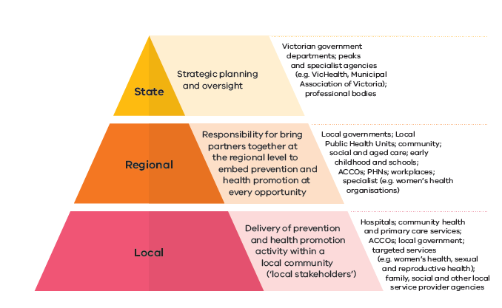

Progressing One Health and planetary health approaches
Planetary health refers to the health of human civilisation and the natural systems that it relies on. One Health aims to optimise the health of humans, animals and ecosystems. One Health and planetary health approaches work together to tackle threats to health and ecosystems by mobilising multiple sectors, disciplines and communities at varying levels of society.
Public health has a crucial role in driving these transdisciplinary cross-sector approaches, which are needed to address the human health risks posed by climate change, land clearing, biodiversity loss and pollution.

Aboriginal self-determination, health and wellbeing
Victorian Aboriginal communities continue to lead with strength and resilience in the face of ongoing transgenerational trauma, systemic racism and the impacts of colonisation, dispossession and removal of families and Country. Wellbeing for Aboriginal people is considered a holistic concept. Wellbeing is shaped by connections to culture, extended kinship, elders, ancestors, and spirituality, which in turn are influenced by social, historical, political, and cultural factors. Critically, this requires maintaining connection to Country and culture for Aboriginal Victorians.
This plan acknowledges there are priority groups within the Aboriginal Victorian population who particularly experience poor health and wellbeing outcomes. These groups have a right to enjoy and have control over their own health and wellbeing, in line with cultural values, kinship practices and individual ethics, and may need support to access culturally inclusive health services and programs.
Access to, and maintenance of, cultural knowledge and the opportunities to practise culture are key determinants of health and wellbeing outcomes for many Aboriginal people in Victoria. Traditional Owners’ have knowledge of Country and cultural obligations to manage and care for lands and waters as custodians. Supporting Traditional Owners to meet these cultural obligations is imperative to healing Country and improving outcomes for Traditional Owners’ wellbeing. The health and wellbeing of Aboriginal Victorians has been embedded across priorities in this plan. The plan is flexible to respond to Yoorrook Justice Commission inquiries and recommendations.
Self-determination involves the transfer of resources and decision-making powers and resources to First Peoples on matters that impact their lives. Inherent to self-determination is the right of Aboriginal Victorians to define for themselves what self-determination means.³ Treaty negotiations with Traditional Owners and the First Peoples Assembly of Victoria will further Aboriginal self-determination and strengthen the health and wellbeing of Aboriginal communities.
Embedding approaches to achieve self-determination in health and wellbeing policies and programs will build on the strengths within Aboriginal communities to support effective and sustainable outcomes for Aboriginal people living in Victoria, on their own terms.⁴ This includes:
- alignment with the self-determined priorities of the Aboriginal Health and Wellbeing Partnership Agreement and Action Plan
- Aboriginal-led or informed health and wellbeing plans such as the Balit Murrup: Aboriginal social and emotional wellbeing framework 2017–2027
- Victoria’s commitments to improving health outcomes under the National Agreement on Closing the Gap.

Achievements
Collective efforts across government have resulted in creating strong foundational structures for improved health and wellbeing. This new plan will build on recent achievements in priority areas while recognising emerging needs and opportunities (Figure 2).
Figure 2: Key cross-sector achievements
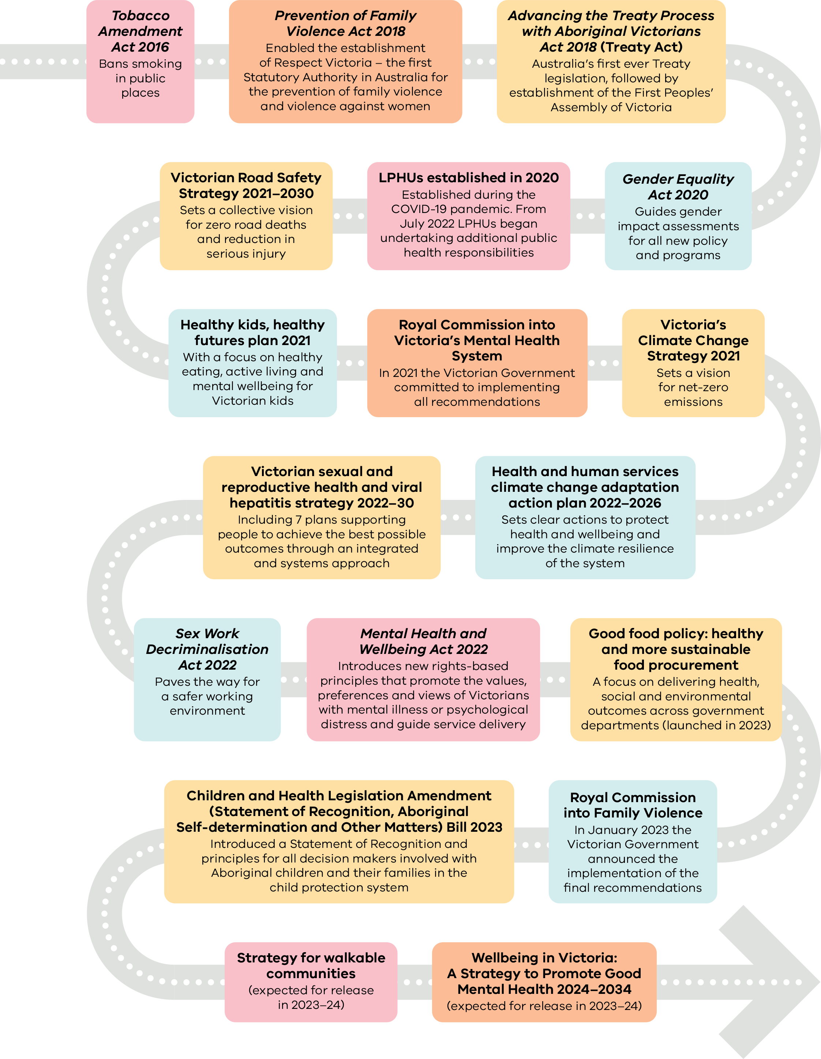

Health and wellbeing outcomes
In Victoria, we enjoy high levels of health and wellbeing, and rate well when compared with health outcomes nationally and internationally. In the past four years, we have experienced some positive outcomes, and welcomed new initiatives across government and non-government sectors that are driving improvements in health and wellbeing.
While some population health indicators like tobacco use display promising trends, others are not on target, including rates of overweight and obesity, healthy eating, and physical activity levels.
Good health and wellbeing outcomes are not shared equally by all Victorians. A stronger focus on specific health issues faced by priority groups, and the systemic barriers they face to accessing health and wellbeing services, is needed to improve health equity. For example, life expectancy for Aboriginal Victorians is 10 years less than non-Aboriginal Australians. On average, Aboriginal females live for 75.6 years. Aboriginal males live for 71.6 years.⁵
Chronic disease is still the largest cause of avoidable death for Victorians. The number of people living with these conditions will continue to increase with an ageing population. Recent evidence shows the prevalence of type 2 diabetes, and overweight and obesity has spiked in 2022, when compared with previous five-year trends.⁶
Improvements in public health and wellbeing in Victoria requires a long-term commitment to address public health challenges. The indicators set out in the Victorian public health and wellbeing outcomes framework⁷ are used to track progress against consecutive Victorian public health and wellbeing plans, providing a consistent, reliable, and enduring set of measures to effectively monitor change over time.
The framework improves our understanding of where there are avoidable gaps in health status between different population groups. This data is used to direct actions towards those who most need it to improve health equity across our population.
Figure 3 provides a snapshot of selected health and wellbeing outcomes in Victoria.

How we are tracking
Figure 3: Snapshot of health and wellbeing outcomes in Victoria
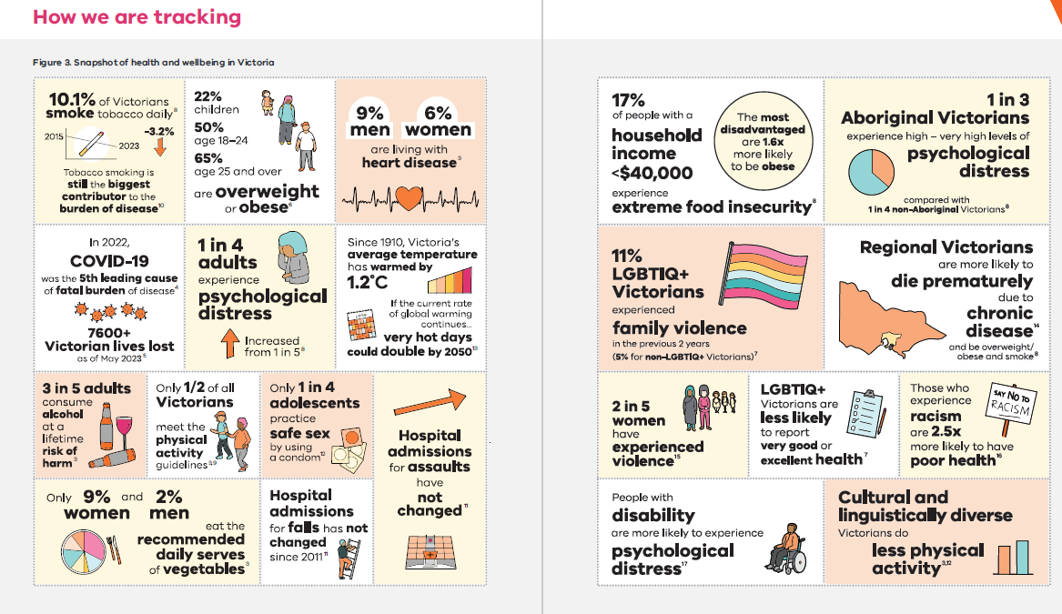

Improving health equity
An equitable approach to health means that everyone has a fair and just opportunity to attain their highest level of health and wellbeing, and that the causes of inequity are addressed. Influencing factors, such as education, income and housing, can overlap and result in poorer health and wellbeing outcomes for individuals, families and communities. These influencing factors (wider determinants) on health and wellbeing are explored in Figure 4, which expands on the influential model of social determinants of health published by Dahlgren and Whitehead in 1991.²²

Reducing racism and discrimination
Racism and discrimination are key drivers of health inequities. For Aboriginal Victorians, these experiences are compounded by the impacts of colonialisation and trans-generational trauma.²³
While most Australians (78 per cent) agree that accepting immigrants from many different countries makes Australia stronger, racial discrimination is still an issue.²⁴ In 2022, almost a quarter of people born overseas, and over a third of people who speak a language other than English, reported experiencing discrimination.²⁴
The Victorian Government supports state-based anti-discrimination laws that ensure Victorians have a right to be free from racism and discrimination.

Achieving sex and gender equality
Sex and gender are core determinants of health and wellbeing. While Victorian women experience one of the highest life expectancies in the world, they experience inequitable health outcomes in a range of areas, for example:
- Evidence shows that diseases that mainly affect women and have symptoms that are different to men are studied and treated less.²⁵
- Women are frequently misdiagnosed or undiagnosed, and are treated for pain less aggressively than men – despite reporting more severe levels of pain, more frequently and for a longer duration.²⁶ This can lead to delays in diagnosis and care.
- An Australian study found women admitted to hospital for heart attacks were less likely to receive invasive management, be referred for cardiac rehabilitation or be prescribed preventative medication at discharge, compared to men.²⁷ Six-months after admission to hospital, women were more than twice as likely to experience a major adverse cardiovascular event, and had twice the mortality rate compared to men.²⁷
A Gender Impact Assessment has informed the development of this plan.

Recognising intersectionality, diversity and inclusion
Every person has multiple and intersecting identities, needs and experiences that affect their health and wellbeing. Intersectionality recognises that the causes of disadvantage or discrimination do not exist independently, but intersect and overlap with identities, experiences and needs – magnifying the severity and frequency of impacts, while also raising barriers to support.²⁸ Adopting an intersectional approach recognises that addressing disadvantage in one group may not address discrimination and marginalisation experienced by all other groups equally. For example, 22.6 per cent of LGBTIQ+ people experience harassment, and this increases to 26.6 per cent of LGBTQ+ people from multicultural backgrounds.²⁹
The Victorian Government is committed to improving the lives of all LGBTIQ+ Victorians. Pride in our future: Victoria’s LGBTIQ+ strategy 2022–32 outlines how we will achieve this.²⁹
Figure 4: What influences health and wellbeing
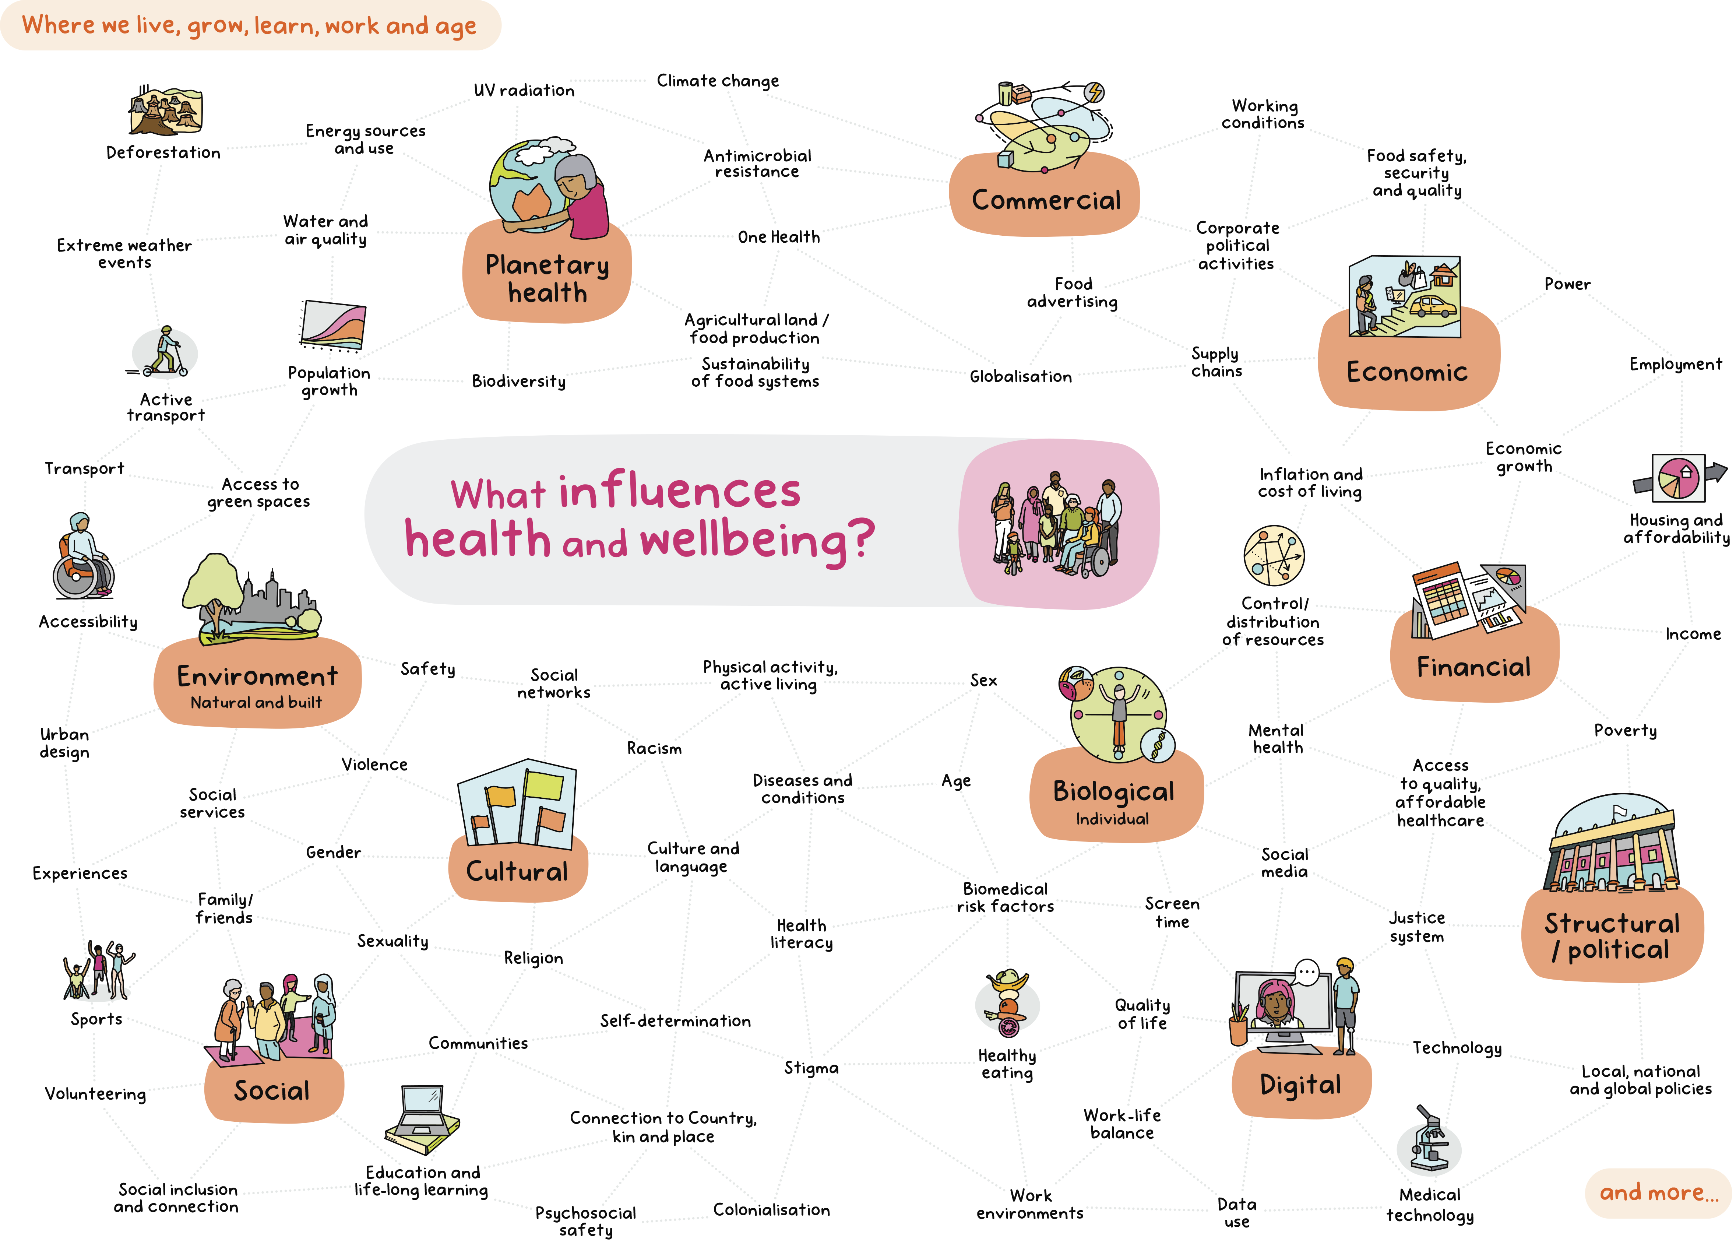

Our priorities
Achieving our vision for public health and wellbeing in Victoria requires a long-term commitment.
Chronic disease is the largest cause of avoidable death for Victorians. The increase in chronic preventable illness across the state is placing a growing burden on our health system, with potential for more complex, later-stage diagnoses, including increasing comorbidities and multi-morbidities that require more costly care.³⁰
For example, the prevalence of diabetes increased to 7.5 per cent in 2022, after remaining stable at around 5.8 per cent since 2015.⁶
The risk factors contributing to the most burden have remained consistent over time. They include:
- tobacco use (8.6 per cent)
- overweight (including obesity) (8.4 per cent)
- dietary risks (5.4 per cent)
- high blood pressure (5.1 per cent)
- alcohol use (4.5 per cent).³⁰
There are opportunities to reduce modifiable risk factors across the life course. For example, overweight and obesity increases with age. Twenty-two per cent of Victorian school-aged children are overweight or obese. This increases to 50 per cent into adolescence and young adulthood (18 to 24-year-olds) and to 65 per cent of people aged 25 years of age or older. Action to reduce the proportion of young Victorians who are overweight and obese has benefits across the life course.
Reducing exposure to modifiable risk factors has the potential to prevent around 38 per cent of the burden of disease in Australia and will help to drive down the burden of chronic preventable illness.³⁰
Our population is ageing, and it is expected that the number of Victorians aged 60 years and over will increase by around 60 per cent by 2046, equivalent to 25 per cent of the Victorian population.³¹ Our ageing population will, in turn, further increase the prevalence of chronic disease across the state.
The 10 priority areas (Figure 5) in this plan will continue as the overarching public health and wellbeing priorities in Victoria, because of their contribution to the modifiable burden of disease and because they are key drivers for ill-health across the lifespan. These priorities represent areas where sustained action can have the biggest impact on health and wellbeing.
The Victorian Government is committed to making progress across all the priority areas. Many of the priorities already have targeted strategies and plans to guide implementation, as detailed in Appendix 2: The policy landscape.
Figure 5: Health and wellbeing priorities 2023–2027

Our 10 priorities are:
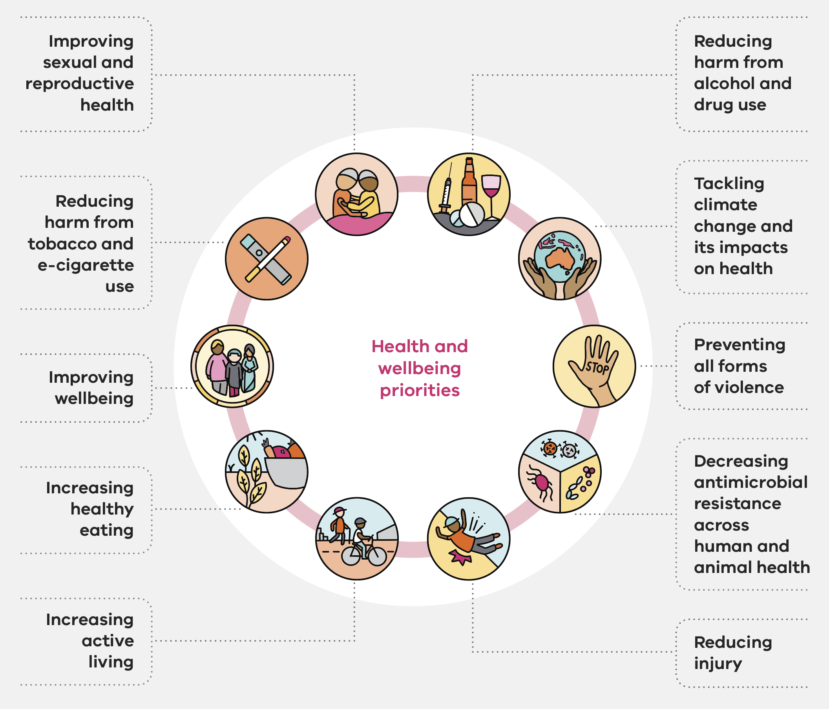

Improving sexual and reproductive health
Sexual and reproductive health is important for every Victorian. This includes focusing on reducing the impact of blood-borne viruses (BBV) and sexually transmissible infections (STI). Sexual health is not only important to people in their reproductive years but also across life stages. This includes puberty, through menopause and the senior years.
Did you know?
- Condom use is still one of the most effective methods to prevent the spread of sexually transmitted diseases. The rate of adolescents who practise safe sex by always using a condom has stayed constant at around 25 per cent from 2014 to 2018.¹⁶
- The rate of newly acquired HIV infections is higher in people aged 25–44 and in metropolitan areas compared with regional areas.³²
- The notification rate for hepatitis C has steadily decreased from 3.1 per 100,000 people in 2011 to 0.5 per 100,000 people in 2021.^{16,32}

Shared benefits across priorities
Good sexual and reproductive health contributes to improvements across a broad range of other health and wellbeing priorities. For example, promoting healthy lifestyles for women transitioning through menopause will improve mental wellbeing, physical health and healthy ageing.³³ Sexual and reproductive health is more than just physical health and wellbeing. It affects gender equality and includes the right to healthy and respectful relationships, safety and freedom from violence.

Improving health equity
Sexual and reproductive health is a human right. Women and gender diverse people often face barriers to accessing helpful and affordable services to help manage sexual and reproductive health.³³ This includes menstruation, fertility, chronic conditions (polycystic ovary syndrome and endometriosis), pelvic pain, contraception, STI and menopause.³³
Gender equality is essential for positive sexual reproductive health which is influenced by gender norms, power dynamics, gender expectations and gender bias that exists across systems. Stigma and discrimination can be barriers to accessing sexual and reproductive health or viral hepatitis services. These barriers can contribute to missed and late diagnoses, disease progression, onward transmission, more costly tertiary care and reduced quality of life. Addressing stigma, racism and discrimination will support Victorians to feel confident and culturally safe to access prevention services, testing, treatment and support.³⁴
Targeted actions and collaborations can contribute to more equitable health outcomes. For example, the burden of BBV and STI varies greatly across population groups and geographical areas. By addressing disparity of access to services, we help to achieve more equitable sexual and reproductive health outcomes and wellbeing.³⁴

Driving action to improve sexual and reproductive health
Building and strengthening system capacity is key to delivering accessible, affordable and inclusive sexual and reproductive health services.
Work to support a life-course approach for girls and women will drive better sexual and reproductive outcomes. It is important that we normalise health-seeking behaviours, such as participation in human papillomavirus (HPV) vaccination and cervical screening programs. This will ensure prevention and early diagnoses of diseases such as cervical cancer.³³ This is crucial for timely treatment of STI and BBV to reduce negative impacts on health and wellbeing. For example, a delayed diagnosis of STI can lead to long-term health issues and affect fertility and reproductive health.³³
Promoting good sexual and reproductive health relies on health services that are inclusive, safe and appropriate, with access to accurate information and testing, treatment, and timely support and services (including access to affordable contraception).

What we want to achieve
- Support Victorians to access culturally safe sexual and reproductive health services that are free from stigma, racism and discrimination.
- Strengthen the sexual and reproductive health of Victorian women, girls and gender diverse people across the life course, with a focus on areas such as menstrual health, contraception, abortion and assisted reproductive treatment.
- Eliminate hepatitis B and hepatitis C as a public health concern by 2030, eliminate congenital syphilis by 2030 and the virtual elimination of new HIV transmissions by 2025.
- Support Victorians to achieve optimal sexual and reproductive health and reduce the transmission and impact of BBV and STI.
- Ensure health professionals have the skills, knowledge and attitudes needed to deliver culturally safe, non-stigmatising, non-judgemental best-practice sexual and reproductive health and viral hepatitis prevention, testing, treatment and care.
- Improve sexual and reproductive health and viral hepatitis services and outcomes by increasing the quality and completeness of data and research.

Targeted strategies
Implementation occurs through statewide, regional and local partnerships to drive collective action aligned with:
- Strategy overview and system enabler plan 2022–30
- Victorian sexual and reproductive health and reproductive health plan 2022–30
- Victorian Aboriginal sexual and reproductive health plan 2022–30
- Victorian hepatitis B plan 2022–30
- Victorian hepatitis C plan 2022–30
- Victorian HIV plan 2022–30
- Victorian sexually transmittable infection (STI) plan 2022–30
- Victorian women’s sexual and reproductive health plan 2022–30.

Outcomes
The Victorian public health and wellbeing outcomes framework:
- Outcome 1.1 Victorians have good physical health
- Outcome 1.3 Victorians act to protect and promote health.

Reducing harm from tobacco and e-cigarette use
Did you know?
- 10.1 per cent of Victorians smoke tobacco daily.⁶ This is a decrease of 3.2 per cent since 2015.¹³
- E-cigarettes and tobacco smoking share many negative impacts on health and wellbeing.³⁵
- The rate of e-cigarette use in Australians aged 14 years-of-age and over has more than doubled since 2013 (11.3 per cent compared with 4.5 per cent).³⁶
Tobacco use is still the leading contributor to burden of disease and premature deaths in Victoria, despite considerable progress in reducing smoking rates. Tobacco use is responsible for 9.3 per cent of disease burden and 13.3 per cent of deaths in Australia.⁹ There are concerns this will increase with the uptake of e-cigarette use.

E-cigarettes are devices that deliver an aerosol by heating a solution that users breathe in. The solution may or may not contain nicotine. The aerosol is commonly called ‘vapour’. Using an e-cigarette is commonly known as ‘vaping’.
Tobacco harms our health through use, harms others through second-hand exposure and negatively impacts our environment. Smoking increases the risk of chronic diseases such as heart disease, diabetes, kidney disease, eye disease, stroke, dementia, certain cancers (for example, oral cancer), gum disease and respiratory diseases such as asthma, emphysema and bronchitis.³⁷
Smoking has a significant economic impact, with an estimated total cost of $136.9 billion dollars in 2015–16. This includes tangible costs, such as life lost and healthcare costs, and intangible costs, such as premature mortality and lost quality of life due to ill-health.³⁸

Responding to e-cigarette use
One of the greatest causes for concern is the potential for another generation of young people to become addicted to nicotine through e-cigarettes, undermining years of progress in reducing tobacco-related harm.
Urgent action is needed to decrease the rates of e-cigarette use, particularly among young Victorians. While e-cigarettes have not been around long enough for us to know the long-term impacts, we do know that use of e-cigarettes (even short-term use) has resulted in poisoning, acute lung injury, injuries and burns, toxicity and death, and neurological conditions, including seizures.³⁵

Shared benefits across priorities
Reducing harm from tobacco and e-cigarette use can drive improvements in physical health and wellbeing, including sexual and reproductive health.
Quitting tobacco smoking and e-cigarette use is recommended to improve fertility and reproductive health. Smoking during pregnancy is shown to carry risks for the health of mothers and babies, including low birthweight, pre-term birth and perinatal death.³⁹ Quitting smoking during pregnancy helps mothers to have a healthy pregnancy and supports babies to have the best start in life.
Reducing tobacco and e-cigarette use supports our environment and overall planetary health. These products harm the environment through plastic waste, fires, pollution and by decreasing our air quality.³⁵ Tobacco production has negative impacts on our environment at every stage including growth, manufacturing, distribution and disposal.⁴⁰

Improving health equity
The rapid rise in availability and use of e-cigarettes is a threat to public health that requires urgent action. We need to continue to prioritise working in partnership with people and communities that experience higher rates of tobacco smoking. This includes people who live in rural Victoria, Aboriginal Victorians, young Victorians, people with serious mental illnesses, Victorians who identify as LGBTIQ+, and people who have alcohol and drug disorders.^{13,37}
The smoking rate among Aboriginal people is declining at a faster rate than for non-Aboriginal people, although it remains disproportionately high.³⁷ Smoking rates are higher among adults who live in rural Victoria (14.1 per cent) compared with those in metropolitan Victoria (11.5 per cent).¹³
Targeted action is also needed to improve the health and wellbeing of mothers and babies. While smoking at any time during pregnancy has decreased, there are groups that have higher rates, including Aboriginal mothers (43 per cent), mothers aged under 20 years (34 per cent) and mothers aged 20–24 years (21 per cent).⁴¹

Driving action to reduce harm from tobacco and e-cigarette use
Coordinated efforts to reduce tobacco and e-cigarette use will reduce inequities for people who experience multiple forms of disadvantage. It will also reduce the negative economic, social and environmental impacts associated with tobacco and e-cigarette use.

What we want to achieve
- Strengthen the regulatory framework in relation to the availability of tobacco and e-cigarette products in Victoria. Reduce the number of environments where people can smoke.
- Prevent the uptake and reduce the harms associated with smoking and vaping, including second- and third-hand exposure, through ongoing support and strengthening tobacco and e-cigarette regulation in Victoria.
- Embed a national approach to tobacco and e-cigarette reform through implementing the National Tobacco Strategy 2023–2030.
- Support the use of e-cigarette products through a medically supervised pathway, only for the purposes of smoking cessation and the treatment of nicotine addiction.

Targeted strategies
Implementation occurs through statewide, regional and local partnerships to drive collective action aligned with:
- National Tobacco Strategy 2022–2030

Outcomes
The Victorian public health and wellbeing outcomes framework:
- Outcome 1.3 Victorians act to protect and promote health.

Improving wellbeing
The new Wellbeing in Victoria: A Strategy to Promote Good Mental Health 2024–2034 (Wellbeing Strategy) will be a subset of the Victorian public health and wellbeing plan 2023–2027. It will focus on promoting and supporting wellbeing, and reducing the prevalence of mental distress, suicidality, alcohol and drug harms, while more fully supporting people’s journey through these challenges.
Did you know?
- More than two in five Australians aged 16–85 years have experienced a mental disorder at some time in their life (this includes substance use disorders).⁴²
- Average levels of mental distress (including feelings of depression, anxiety and stress) continued to rise in 2022 compared with other pandemic years.⁴³
- There were 756 deaths by suicide in Victoria in 2022, representing a 9 per cent increase compared with 2021.⁴⁴
In 2022, we experienced the third year of the COVID-19 pandemic, with high case numbers and rises in the cost of living that were compounded by rising inflation and interest rate increases. The report from a survey conducted in 2022 found Australians’ subjective wellbeing showed a pattern of decline.⁴³ The average wellbeing score for people aged 18–25 years was the lowest in 21 years.⁴³

Shared benefits across priorities
By prioritising good mental health and wellbeing, we reduce stigma, increase social connection, improve physical health, promote productivity and create safer environments. Our mental health and our physical health are linked. People experiencing poor mental health may be at increased risk of poor physical health and developing chronic health conditions, such as diabetes and heart disease.⁴⁵ Similarly, people with poorer physical health, including overweight and obesity, may be more likely to experience poorer mental health.⁴⁶
Actions across a range of health and wellbeing priorities in a variety of settings can contribute to improvements in wellbeing. Taking action to improve healthy eating and active living, tackling climate change and its impacts on health, and reducing tobacco-related harm, are all shown to improve wellbeing and reduce the risk of developing a mental illness. For example, as little as 60 minutes of physical activity per week can prevent up to 17 per cent of incidents of depression.⁴⁷
Being physically active, eating a healthy diet, quitting smoking and engaging with the natural environment also play an important role in improving health outcomes for people diagnosed with a mental illness.^{48,49,50}

Improving health equity
The Wellbeing Strategy will be underpinned by principles of equity and focus on actions beyond the mental health care system. It will be complemented by:
- a Diverse Communities Framework and Blueprint, which moves beyond prevention and promotion to include treatment, care and support in the mental health care system
- a Suicide Prevention and Response Strategy, which takes a specific lens of, and response to, suicidality and suicidal crisis.
All three of these strategies were recommendations of the Royal Commission into Victoria’s Mental Health System.

Driving action to improve wellbeing
Wellbeing is a key determinant of overall health, and is a complex combination of a person's physical, mental, emotional and social health factors. A strong sense of wellbeing contributes to good mental health. Actions that support high levels of wellbeing are a major driver of social and economic prosperity, contributing to better learning, increased creativity, greater productivity, better quality relationships, improved physical health and longer life expectancy.^{51,52}
As the determinants of wellbeing lie beyond the mental health care system, a collaborative approach by whole-of-government, businesses and communities will be critical to effect lasting change in the places where we live, grow, learn, work and age.

What we want to achieve
The Wellbeing Strategy contains priority actions across a range of settings and sectors, which will respond to the wellbeing needs expressed by thousands of Victorians through extensive consultation.
These wellbeing needs are:
- Having our basic needs met before we can focus on other aspects of wellbeing
- Feeling safe and being respected for who we are
- Feeling connected to each other, our communities, cultures and spaces around us
- Understanding how we can navigate our wellbeing through the ups and downs of life
- Having opportunities to create meaning in our lives.

Targeted strategies
Implementation occurs through statewide, regional and local partnerships to drive collective action aligned with:
- Wellbeing in Victoria: A Strategy to Promote Good Mental Health 2024–2034 (for release in 2023–24)
- Diverse Communities Mental Health and Wellbeing Framework and Blueprint for Action (for release in 2023–24)
- Victorian suicide prevention framework 2016–2025
- Suicide Prevention and Response Strategy 2024–2034 (for release in 2023–24).

Outcomes
Outcomes for the Wellbeing Strategy will be linked to the Mental Health and Wellbeing Outcomes and Performance Framework, as well as to the Victorian public health and wellbeing outcomes framework:
- Outcome 1.2 Victorians have good mental health
- Outcome 1.3 Victorians act to protect and promote health
- Outcome 4.1 Victorians are socially engaged and live in inclusive communities.

Increasing healthy eating
Good nutrition is essential for health and wellbeing because it helps achieve and maintain a healthy weight, protects against chronic disease (including cardiovascular disease, type 2 diabetes, dementia and certain cancers), and supports a healthy immune system.
Poor diet, overweight and obesity are leading contributors to chronic disease and premature death in Victoria, accounting for 5.4 per cent and 8.4 per cent of preventable burden of disease respectively.³⁰
Did you know?
- Only 5.7 per cent of Victorian adults meet the recommended daily vegetable consumption guidelines. This proportion is lower for men (1.8 per cent) than women (9.4 per cent).⁸
- About one-third of Australians’ energy comes from unhealthy discretionary foods. These foods also account for over half of Australia’s packaged food supply.^{53,54}
- In 2022, more than half (56 per cent) of Victorians are overweight or obese, a 5.2 increase since 2020.⁶
- 43 per cent of Victorian children aged 5–10 years old have signs of tooth decay.⁵⁵
For infants and children, breastfeeding and healthy eating provides the nutrition required for optimal physical and cognitive development, and good oral health. High consumption of sugars is the main cause of tooth decay. Tooth decay can be prevented by reducing free sugar intake to less than 10 per cent of total energy intake, and ideally, reducing this even further minimises the risk of tooth decay throughout life.^{56,57}

Shared benefits across priorities
Diets that are consistent with Australian Dietary Guidelines are beneficial for health and have a lower carbon footprint which supports our environment.⁵⁸ This includes diets high in vegetables and fruit, and wholegrains, and low in highly processed discretionary foods. Nutritious diets also have clear benefits for good mental wellbeing across all ages and stages of life.
Environments that support healthy eating will improve physical health, mental wellbeing and planetary health. This requires ensuring everyone having access to healthy, safe and more sustainable food.

Improving health equity
Supporting improved dietary intake and chronic disease prevention improves population health across the life course.⁵⁹ Multiple strategies are needed to improve healthy eating across all age groups. Prioritising action in communities at greater risk of diet-related poor health is crucial to improving health equity.
For example, food insecurity is a continuing issue that has been worsened by the effects of COVID-19 pandemic and the rising cost of living.⁶⁰ In 2020, one in four Victorian adults (25.6 per cent) were ‘definitely’ worried or ‘sometimes’ worried about running out of money to buy food.¹³

Driving action to increase healthy eating
Improving sustainable food systems and promoting healthy food environments will support more Victorians to adopt healthy diets and will improve the health of our environment.
Food environments influence the foods and drinks we buy and consume. Unhealthy food environments that provide easy access to prominently advertised and often cheap discretionary foods and drinks makes it harder to eat for good physical and mental health. Creating healthy food environments in public sector and community settings is a key strategy for improving healthy eating.
Our food system is made up of activities related to the production, processing, transport and consumption of food, and food waste and re-use. There are key challenges our food system faces, such as severe weather events, which are becoming more frequent and intense, due to climate change. These events have resulted in interruptions to the delivery of affordable, safe and healthy food, at the same time as contributing to rising food prices.
As our food system continues to face challenges, biosecurity is crucial for preventing and managing the harms caused by pests and diseases. This will protect and enhance our food systems, communities and environments. We can protect our farms and parks, our pets and gardens, the cultural integrity of the landscape, the safety of our food and the success of our industries, by taking action to promote biosecurity in Victoria.

What we want to achieve
- Increase access, availability and consumption of a wide variety of nutritious foods such as fruit and vegetables, as recommended by the Australian Dietary Guidelines.⁶¹
- Prioritise implementation of policies that promote the uptake of healthy foods and drinks in key public settings (including health services, schools, early childhood services, workplaces, sport and recreation settings and events).
- Reduce children’s exposure to marketing of discretionary foods and drinks to reduce consumption.
- Promote healthy and more equitable, sustainable food systems across Victoria, with a focus on priority populations.
- Scale evidence-based approaches that promote breastfeeding and support parents and caregivers to provide good nutrition for infants and young children throughout their first 2,000 days of life.

Targeted strategies
Implementation occurs through statewide, regional and local partnerships to drive collective action aligned with:
- Victorian Action Plan to Prevent Oral Disease 2020–2030
- Healthy kids, healthy futures: Victoria’s five-year action plan to support children and young people to be healthy, active and well.

Outcomes
The Victorian public health and wellbeing outcomes framework:
- Outcome 1.3 Victorians act to protect and promote health.

Increasing active living
Active living supports everyone, at all stages of life, to live healthy, engaged and purposeful lives. Only half of Victorian adults meet the physical activity guidelines for sufficient physical activity (53.0 per cent of women, and 48.7 per cent of men).⁸
Did you know?
- Almost one in four adults spend eight hours or more sitting on a typical weekday (27.4 per cent of men and 21.4 per cent of women).⁸
- While some physical activity is better than none, evidence shows that 30 minutes of physical activity is not enough to counteract the negative health impacts of long periods spent sitting.^{62,63}
- The proportion of children aged 5–12 years who are physically active for an hour or more per day has declined from 62.2 per cent in 2013 to 47.3 per cent in 2021.¹⁴
Regular physical activity is a well-known protective factor for preventing and managing chronic disease including cardiovascular disease, type 2 diabetes and certain cancers.⁶⁴ Physical activity also plays an important role in improving quality of life, managing and decreasing pain, and promoting mental wellbeing.^{64,65}
Physical activity is particularly important for children because it supports optimum development, learning and growth. It also establishes the patterns for a lifelong trajectory of active living.⁶²
Physical activity is declining in children, and recreational screen time is increasing. Recreational screen time of two hours or more per day increased by 14.9 per cent between 2013 and 2021 for children aged 5–12 years old.¹⁴

Shared benefits across priorities
The benefits of active living extend beyond physical health. Regular physical activity (including active transport) improves mental health, helps to mitigate climate change, can reduce risk of injury and improve reproductive health.
The mental health benefits of regular physical activity can improve self-esteem, mood and sleep quality.^{65,66} Evidence also shows that spending time in green spaces and connecting with nature improves mental wellbeing by reducing anxiety and depression and can provide opportunities for social interaction and community connections.^{49, 67}
Active transport modes such as walking and riding, works to mitigate climate change through reducing traffic congestion, lowering carbon emissions from transport and improving air quality.^{68,69}

Improving health equity
Active living should be culturally appropriate, accessible, and inclusive for all Victorians. There are clear opportunities to advance equity by prioritising Victorians who face added barriers to living an active life. This includes women and gender diverse people, senior Victorians, people from lower socioeconomic backgrounds, Victorians with disability, Aboriginal Victorians, people with health conditions or physical limitations and multicultural and multifaith communities.⁷⁰
Being physically active as we age is important for maintaining mobility and independence and can help improve and maintain cognitive function, memory and attention, lower the risk of dementia, and maintain independent living for longer.^{70,71,72} Providing active transport options can offer opportunities for community connections and reduced social isolation.
For women and LGBTIQ+ communities, safety is a key driver of participation in outdoor physical activity.^{73,74} Action to promote safe environments and to decrease racism can enable women, particularly multicultural and multifaith women, to be active in public spaces and neighbourhoods, and increase public transport use.^{75,76}

Driving action to increase active living
Taking action to ensure our built and natural environments are healthy, safe, inclusive and accessible will support more Victorians to be physically active.
Integrating healthy design principles into land-use planning supports physical activity (and connectivity) through creating infrastructure and by ensuring amenities in our parks and open spaces.⁷⁷
Reducing barriers to being physically active in our natural environment is also important. Regreening urban areas and increasing access to safe open spaces can promote liveability and increase local biodiversity.⁷⁸ This also helps reduce the urban heat island effect and mitigate against the health-related impacts of climate change.

What we want to achieve
- Integrate healthy design principles into land-use planning to ensure improved health and wellbeing by increasing levels of physical activity through active transport modes, such as walking and riding.
- Improve safe access to parks, public open spaces and recreation opportunities in nature and provide opportunities for Victorians to connect with nature.
- Promote movement and reduce sitting time in workplaces, schools, at home and during leisure time.
- Increase participation in sport and active recreation, with a focus on Victorians who face barriers to participation.

Targeted strategies
Implementation occurs through statewide, regional and local partnerships to drive collective action aligned with:
- Strategy for walkable Communities (for release 2023–24)
- Active Victoria 2022–2026: A strategic framework for sport and active recreation
- Victorian Health Building Authority Universal Design Policy.

Outcomes
The Victorian public health and wellbeing outcomes framework:
- Outcome: 1.3: Victorians act to protect and promote health.

Reducing harm from alcohol and drug use
Consumption of alcohol and other drugs (AOD) is a significant preventable cause of disease and death in Victoria. It is associated with a wide range of health and wellbeing impacts.
While the impacts of drug use on health and wellbeing can vary, related harms can impact physical health through increased risk of chronic disease, exposure to infectious diseases, and mental health and wellbeing impacts.⁷⁹
Did you know?
- Alcohol use is the fifth-leading risk factor for disease, and contributes 4.5 per cent of the total burden of disease in Australia.³⁰
- Use of illicit drugs and related harms, including suicide, self-harm, poisoning and disease, is attributable to 3 per cent of the total disease burden in Australia.⁸
- Alcohol use contributes to the burden of 30 diseases and injuries, including alcohol use disorders, eight different types of cancer, chronic liver disease and 12 different types of injury – predominantly road traffic injuries, and suicide and self-inflicted injuries.³⁰

Shared benefits across priorities
The drivers of AOD use are complex and interact with many other health outcomes and determinants of health. AOD-related harm often co-exists with poor mental health and wellbeing.⁸⁰ Actions to improve mental health and wellbeing can reduce AOD-related harms as they are inextricably linked through shared risks and protective factors.
Reducing AOD-related harms has broad-reaching benefits across many areas of public health and wellbeing. This includes reducing the spread of blood-borne viruses, physical and mental impairments associated with drug overdoses, and may help prevent family violence and decrease the number of road incidents associated with AOD use.⁸¹

Improving health equity
AOD use has complex biological and social determinants, and affects individuals, families and communities in different ways. Some groups are affected more than others, particularly Aboriginal Victorians, people with co-occurring mental health conditions, LGBTIQ+ communities and people in contact with the criminal justice system.^{74,81} For example, improving health equity for Aboriginal people living in Victoria includes supporting AOD services that are culturally safe, and strengthening community-led services to address the determinants of AOD use.⁸²

Driving action to reduce harm from AOD
Over the next four years, we will increase service capacity and capability, and drive contemporary, holistic health-led responses to reduce harm from AOD. We will also continue to integrate mental health and AOD services for people with co-occurring needs.
There were 1031 overdose deaths in Victoria over the period July 2020 – June 2022 and 75 per cent of these deaths were determined to be unintentional.⁸³ Pharmaceutical drugs contributed to three-quarters of all deaths due to overdoses during this period.⁸³
For adult men and women, the risk of dying from alcohol-related disease and injury remains below 1 in 100, if no more than 10 standard drinks are consumed each week, and no more than four standard drinks are consumed on any one day.⁸⁴ The long-term risk of alcohol-related disease and injury can be lowered by drinking less often, and drinking less on each occasion.⁸⁴

What we want to achieve
- Provide contemporary and holistic health-led responses to AOD use that reduce stigma, increase help-seeking and reduce preventable harms.
- Continue to integrate AOD and mental health services to support people living with mental illness and substance abuse or addiction.
- Offer safe and accessible treatment options that are responsive to individual needs and support better outcomes for people and their communities.
- Increase accessibility by implementing targeted health-led responses to AOD harm, including new public intoxication responses, continuation of the medically supervised injecting service, and public health warnings enabled by drug surveillance activity.
- Reduce the risk of overdose by supporting increased access to opioid pharmacotherapy and naloxone.
- Drive increased knowledge and awareness of what makes a safe and accessible AOD service, including evaluation and research, as part of the Alcohol and Drug Research Innovation Agenda.

Targeted strategies
- Implementation occurs through statewide, regional and local partnerships to drive collective action aligned with:
- Victorian Aboriginal Health and Wellbeing Partnership Action Plan 2023–2025
- Wellbeing in Victoria: A Strategy to Promote Good Mental Health 2024–2034
- National Drug Strategy 2017–2026.

Outcomes
The Victorian public health and wellbeing outcomes framework:
- Outcome 1.2 Victorians have good mental health
- Outcome 1.3 Victorians act to protect and promote health.

Tackling climate change and its impacts on health
Did you know?
- Victoria’s climate is already changing, with increasing average temperatures, decreasing average rainfall and an increase in fire danger.¹⁷
- Climate change impacts influence health including socioeconomic status, social capital, education, housing, transportation, food security and access to health care.^{85,86}
- During periods of significant fire activity or air pollution during the 2019–20 bushfires, there was a 95 per cent increase for asthma in January 2020 compared with the five-year average.⁸⁷
Climate is a key determinant of health that affects other determinants and health equity. Climate change affects health in many ways – both directly and indirectly. Direct impacts include morbidity and mortality associated with extreme events such as heatwaves, floods, drought and bushfires. Indirect impacts are associated with ecological and land-use change (including changes in the spread of infectious diseases), along with worsening air, food and water quality.^{4,85,86}
Our climate is changing due to greenhouse gas emissions, which are causing a rise in average global temperatures and disruption of ecosystems. In Victoria, climate change is evident through increasing average temperatures, decreasing average rainfall and an increase in fire danger.¹⁷ Without significant action to reduce emissions locally and globally, the changes to our climate will become more extreme.⁸⁸
There are opportunities to improve the health and wellbeing of Victorians at scale. Strategies to reduce emissions, mitigate the future impact of climate change and support adaptation are important in preventing the harms that climate change can have on people’s health.

Shared benefits across priorities
Both climate change mitigation and adaptation-focused activities can create conditions that have benefits across a range of health and wellbeing priorities.
For example, initiatives to improve active transport, such as walking and riding, can help mitigate climate change impacts by:
- reducing transport-related emissions
- producing shared benefits through improving air quality
- increasing opportunities for physical activity.⁸⁹
Initiatives focused on improving equitable access to safe and healthy food, and the sustainability of food systems will help to mitigate emissions and deliver health and wellbeing benefits. Action to reduce emissions may also contribute to improvements in mental wellbeing, particularly for young Victorians affected by climate anxiety.
A greater focus on collaborative efforts to improve the health of our environment through climate action will minimise the impact of changing patterns of communicable diseases and will help manage the threat of increasing antimicrobial resistance in the community.

Improving health equity
Climate change widens existing inequalities, and disproportionately impacts the health and wellbeing of those more vulnerable.
For example, people who are financially disadvantaged are more likely to be affected by the impacts of climate change, as they are more likely to live in areas prone to extreme weather events, more likely to live in poor quality or insecure housing, and less likely to be able to afford cooling and heating and insure their homes.⁹⁰
There are significant opportunities to work across government and with priority communities to drive system change and share benefits in key areas, such as food, water, planning, transport, education and emergency management, to tackle climate change and its impacts on health, while also reducing inequity.

Driving action to tackle climate change and its impacts on health
Our health and wellbeing depend on a healthy environment. A safe climate, access to clean water, good quality air, safe and nutritious food, and healthy, natural environments, are essential for good health and wellbeing.⁸⁵
Climate change is already affecting the health and wellbeing of many Victorians. For example, climate change is contributing to changes in the spread and distribution of disease-causing pathogens and vectors. In 2022, Victoria responded to two significant public health incidents caused by pathogens that are considered unique public health threats for the state – mpox (monkeypox) and Japanese encephalitis – while also managing an increase in people affected by other mosquito-borne diseases associated with flooding events.
Fast action is needed to make rapid, significant cuts in greenhouse gas emissions and to adapt to climate change. Further delays risk missing a rapidly closing window of opportunity to secure a liveable and sustainable future.⁹¹

What we want to achieve
- Increase action to reduce greenhouse gas emissions across systems at the scale and pace required to reduce the impacts on health and wellbeing and realise associated health co-benefits.
- Create resilient and safe communities that can adapt to the public health impacts of climate change.
- Accelerate action to support communities to adapt to climate change and its impacts on health.
- Share successes and promote good practice examples of climate action.

Targeted strategies
Implementation occurs through statewide, regional and local partnerships to drive collective action aligned with:
- Health and human services climate change adaptation action plan 2022–2026
- Victoria’s Air Quality Strategy
- Regional climate change adaptation strategies
- Protecting Victoria’s Environment – Biodiversity 2037.

Outcomes
The Victorian public health and wellbeing outcomes framework:
- Outcome 5.1 Victorians belong to resilient and liveable communities
- Outcome 5.2 Victorians have access to sustainable built and natural environments.

Preventing all forms of violence
People who experience violence are affected in all areas of their health and wellbeing, including poorer physical, sexual and reproductive health outcomes, reduced mental wellbeing and sometimes loss of life.
Did you know?
- In 2021–22, two in five women reported having experienced violence at some point since the age of 15.¹⁹
- In 2021–22, 22 per cent of women and 6.1 per cent of men experienced sexual violence. Twenty per cent of women experienced stalking compared with 6.8 per cent of men.¹⁹
- One in six (14.8 per cent) of Australians aged 65 years and older report experiencing elder abuse, with only one-third seeking assistance from a third party.⁹²

Violence takes many forms including physical, emotional, psychological, financial and sexual violence. It also includes coercive control, intimate partner violence, elder abuse or actions that limit someone’s freedom and independence.⁹³
Violence is largely a gendered issue, perpetrated overwhelmingly by men against women.⁹⁴ Women experience higher rates of violence including sexual violence, stalking and sexual harassment.
Hospital admission rates due to assault are higher for men. But many women do not present to hospital, or present for other reasons when they experience family or sexual violence. Therefore, women are under-represented in hospital admissions data.¹⁵

Shared benefits across priorities
Family violence and sexual violence is a significant public health issue. The trauma of family violence and sexual violence can impact a person’s ability to work, their financial security and access to safe, affordable housing. Family violence can affect children’s emotional, behavioural and social wellbeing, including attendance and achievements at school.
Violence also affects sexual and reproductive health outcomes for women, who are at increased risk of violence at particular life stages, including while pregnant or while separating from a relationship.³³
AOD use has a significant influence on the incidence rate of violence in our communities, and actions to reduce these harms will result in better outcomes for Victorians, including reducing rates of community, family and sexual violence.
Family violence and violence against women increases during and after a natural disaster or crisis such as bushfires or floods.⁹⁵

Improving health equity
Some groups are at higher risk of all types of violence. Evidence is emerging that this may be due to social beliefs and practices, gender stereotyping, norms and structures, including economic inequality between men and women. Barriers that reduce people’s ability to seek assistance increase the likelihood that victim survivors remain unsafe, unsupported and at a higher risk of violence.
Aboriginal women and Aboriginal children are at higher risk of violence compared with other Victorians.⁹⁶ The cumulative effects colonialisation and individual, institutional and structural violence, bullying and racism over the generations have contributed to widespread poverty, disadvantage, pervasiveness of family violence and the severity of its impact on Aboriginal people today.⁹⁷
Senior Victorians are at risk of elder abuse, an area of family violence requiring targeted action. This type of family violence is perpetrated against older people, usually by a family member.⁹⁸

Driving action to prevent all forms of violence
The public health system needs to address the determinants of violence at a structural level. Actions to promote gender equality, positive attitudes towards ageing, and the right for all Victorians to be treated with respect and dignity, are crucial for preventing all forms of violence, and will benefit all Victorians, regardless of age, sex or gender. Strengthening statewide and local partnerships will deliver better outcomes in line with national and statewide strategies that aim to prevent family violence.

What we want to achieve
- Build a community-wide approach to preventing family, sexual and gendered violence to ensure every Victorian is treated equally with respect and dignity.
- All Victorians who experience violence receive the support they need when they need it, and work with people who use violence and hold them to account for their behaviour.
- Victorians experiencing violence can access culturally safe supports and services that are free from stigma, racism and discrimination and are empowered to make decisions about their safety and wellbeing.
- Work with men and boys to change attitudes and behaviours that can lead to violence and engage all Victorians in practical and creative ways to learn about respectful, safe and equitable relationships.
- Embed Aboriginal-led prevention and responses to victim survivors of violence.
- Identify and respond to cultural, social and technological shifts and their impact on the nature of family and sexual violence and prepare to respond to new forms of perpetration of family violence.

Targeted strategies
Implementation occurs through statewide, regional and local partnerships to drive collective action aligned with:
- The National Plan to End Violence against Women and Children 2022–2032
- Ending Family Violence – Victoria’s Plan for Change
- Free from violence – second action plan 2022–2025
- Victorian primary prevention of elder abuse framework (for release in 2023–24)
- Dhelk Dja: Safe Our Way – Strong Culture, Strong Peoples, Strong Families 2018–2028.

Outcomes
The Victorian public health and wellbeing outcomes framework:
- Outcome 2.1 Victorians live free from abuse and violence.

Decreasing antimicrobial resistance across human and animal health
Antimicrobial resistance (AMR) is a growing threat in Victoria, across our nation and globally. AMR affects the health of all humans and animals.
While antimicrobial medicines such as antibiotics, antivirals and antifungals have saved millions of human and animal lives, wide overprescribing and misuse have contributed to AMR.
AMR refers to when microorganisms that cause infections (bacteria, fungi, viruses and parasites) cannot be treated properly because they have developed resistance to antimicrobial medicines such as antibiotics.
Microorganisms that have become resistant to antimicrobials can spread quickly through people and animals, and spread through food, soil and water systems.
As a result of AMR, antimicrobial medicines are less effective. This means that common infections such as urinary tract infections and pneumonia have become even harder to treat. Taking action to reduce AMR will help antimicrobial medicines remain effective against infection.
In many countries, antimicrobials have been widely used in animal production, not only to improve animal health, but also to enhance animal growth rates and raise agricultural productivity. The use of antimicrobials, however, can lead to AMR and the transmission of resistant genes and bacteria between species. This compromises animal welfare, reduces food production and food security, increases food safety concerns and can result in economic losses to farmers. The greater the use of antimicrobials, the greater the risks and consequences.
Did you know?
- It is estimated that between 2015 and 2050, AMR will cost the health services in Australia, the United States and Canada, a combined 74 billion US.⁹⁹
- An estimated five million deaths globally per year are associated with AMR.¹⁰⁰
Without intervention by 2050, the global death toll from AMR will increase to 10 million each year.¹⁰¹

Shared benefits across priorities
Reducing AMR can drive improvements across other public health and wellbeing priorities such as sexual and reproductive health. The bacteria that cause gonorrhoea (an STI) is becoming more resistant to the common antibiotics used for treatment, and is an emerging issue here in Victoria, Australia and globally.¹⁰² AMR is linked with climate change, including via bacterial growth rates connected to higher temperatures.¹⁰³

Improving health equity
Victorian health services are already affected by AMR. From 2018 to 2021, there were 35 outbreaks of a resistant organism in Victorian hospitals and long-term residential care facilities. While AMR can affect anyone at any age, people in aged care facilities are particularly vulnerable, due to the higher rate of certain types of infections, weakened immune systems, multiple comorbidities and close living proximities. AMR can lengthen recovery, result in longer hospital stays and possibly death.
The use of antimicrobial medicines is decreasing in Australia, and this helps us fight AMR, however we are still behind other developed countries.¹⁰⁴ Evidence shows that in Australia, antimicrobial medicines are used the most in lower socioeconomic areas. This may be due to higher rates of susceptibility to infectious diseases or misuse of antimicrobial medicines.¹⁰¹

Driving a One Health and planetary health approach
The early stage of the COVID-19 pandemic showed us the impacts of having infections we cannot treat. Climate change, population growth, international travel and the global economy are all intertwined challenges that are increasing the effects of AMR and communicable disease threats more broadly.
Coordinated, longer term actions are needed to ensure antimicrobial medicines are used appropriately to stay effective. A ‘One Health’ approach is needed to address AMR. This involves:
- working with, and listening closely to communities
- taking coordinated action across all sectors where antimicrobials are used
- collaborating with global entities seeking to reduce AMR and to protect animal, human and planetary health.¹⁰⁵

What we want to achieve
- Increase awareness and understanding of AMR across the human health, animal health, food production and environmental sectors.
- Strengthen surveillance systems and research on antimicrobial resistance across the human, animal and environmental sectors.
- Develop comprehensive, consistent and evidence-based policies and interventions with cross-sector and sector-specific priorities to reduce antimicrobial resistance.
- Embed optimal antimicrobial usage and stewardship practices across the human and animal health sectors.
- Establish a planetary health approach, including a One Health methodology, towards AMR surveillance and response.

Targeted strategies
Implementation occurs through statewide, regional and local partnerships to drive collective action aligned with:
- Victorian antimicrobial resistance strategy 2023–2033 (for release in 2023–24)
- Australia’s National Antimicrobial Resistance Strategy – 2020 and beyond.

Outcomes
- Prevent and mitigate the negative impacts of antimicrobial resistance on human and animal health in Victoria.

Reducing injury
Injury is a major cause of morbidity and mortality across the world. It is both predictable and preventable.¹⁰⁸ The impact of injury and associated injury harms can be profound for individuals, families and communities, and may result in loss of income and productivity, reduced social participation, physical and psychological impairment. It can also affect daily living and quality of life.
Did you know?
- Injury is the fifth-leading health condition contributing to the burden of disease. It accounts for 9 per cent of disability-adjusted life years in Australia.⁹
- Falls are the leading cause of the injury burden in Victoria, accounting for 41 per cent of all injury-related deaths.¹⁰⁶
- Among admissions and emergency department presentations for injury, falls are the leading cause, accounting for 47.9 per cent of admissions and 36.3 per cent of emergency department presentations.¹⁰⁷

Injury is a complex public health issue that covers a broad range of causes. These include unintentional injury from falls, transport, sport and recreation, drowning, poisoning, burns and consumer product injuries. Injury may also be intentional due to suicide, self-harm and all forms of violence.

Shared benefits across priorities
Injury prevention has many benefits across other public health priorities such as mental health, prevention of violence and road safety. For example, actions to reduce injury relating to road trauma also aim to increase physical activity, neighbourhood liveability, productivity and lower carbon emissions. Equally, tackling climate change can reduce the risk of injury associated with events such as bushfires, floods and heatwaves, along with other physical and mental harms.
Paired with good nutrition, strength training promotes good bone health, which reduces the risk of bone fractures from falls. Exercise programs that include strength and balance training have been demonstrated to reduce the rate of falls by 23 per cent in older adults living in the community and reduce the number of people experiencing one or more falls by 15 per cent.¹⁰⁹ Regular physical activity promotes active ageing by improving life expectancy and quality of life.

Improving health equity
Despite efforts to prevent falls in high-risk settings, including in the community, hospitals and residential aged care, the rates of death and hospitalisation due to falls-related injury continues to rise, especially among female Victorians aged 65 years and over.^{106,107} The rate of admissions and emergency department presentations increases with age among older Victorian adults. Males account for 70 per cent of all unintentional injury deaths in people aged 65 years old or older.¹⁰⁶
Two-thirds of all Victorian drownings occur in open waters (rivers, creeks, beaches, lakes, dams and the ocean), and males account for 64 per cent of drowning deaths.¹¹⁰ Prevention approaches to encourage Victorians to safely enjoy recreation in and around water is needed to reduce the number of drownings and water-related injuries to zero.¹¹¹
People living in rural and regional Victoria have lower life expectancy and a higher disease and injury burden than those living in major cities.¹¹² Farm workers report worse mental health and are less likely to visit a general practitioner or mental health professional compared with non-farm workers, and have higher rates of suicide, compared with other occupations.¹¹³

Driving action to reduce injury
Targeted primary prevention approaches to falls and fall-related injury impacts are recommended. This is particularly the case in high-risk settings and for Victorians at high-risk of falls, such as older people in the community. We can prevent injury by encouraging safe behaviours, facilitating safe environments and reducing hazards. It is important to take a systems approach to coordinating evidence-based interventions, including creating safe environments and providing information on injury prevention and safety, alongside accessible health services for injury prevention and management.

What we want to achieve
- Decrease injury and associated harms across the Victorian population, with an emphasis on priority populations that are vulnerable to injury. These include children, young adults, older adults, Aboriginal Victorians, rural and regional communities and people experiencing socioeconomic disadvantage.
- Increase community awareness and education of injury prevention and safety risks to promote safe behaviours, proactive self-management of injury risks and reduction of hazards.
- Align action with national and statewide strategies, evidence-based interventions and best practice guidance to prevent falls and falls-related injury and promote healthy and active ageing.
- Continue delivering services that address safety, health and wellbeing for families and farmers in rural and regional communities and facilitate a culture of safety and positive health behaviours.
- Reduce injury, death and disability from road trauma​ and improve access to sustainable and active transport options.

Targeted strategies
Implementation occurs through statewide regional and local partnerships to drive collective action aligned with:
- Victorian Ageing Well Action Plan 2022–26
- National Injury Prevention Strategy 2020–2030
- National Road Safety Strategy 2021–2030
- Victorian Water Safety Strategy 2021–2025
- Victorian Road Safety Strategy 2021–2030.

Outcomes
The Victorian public health and wellbeing outcomes framework:
- Outcome 1.1 Victorians have good physical health.

Critical enablers for planning and implementation

A networked public health system
The COVID-19 pandemic has shown how important public health is in protecting and promoting the health of the Victorian community. The response to the pandemic has accelerated innovation, adaptation and reform of the Victorian public health system. We are transitioning to a model that offers more locally engaged, responsive and effective action on key population health and wellbeing needs.
The Victorian Government established nine Local Public Health Units (LPHUs) in 2020 to strengthen Victoria’s public health response to the pandemic. LPHUs provide capacity for a stronger, more responsive public health system delivered in partnership with local communities and services.
The Victorian Health Promotion Foundation (VicHealth) and the Victorian Aboriginal Community Controlled Health Organisation (VACCHO) are key delivery partners in the networked model. This reflects our ongoing commitment to Aboriginal self-determination as a foundational principle to improve health and wellbeing outcomes of Aboriginal people living in Victoria.
The public health system also draws on the skills and experience of:
- prevention sector stakeholders
- local government
- the community health workforce.
This new public health system is designed to deliver better coordination across the public health ecosystem (Figure 6) with partners driving improvement in Victorian public health and wellbeing outcomes and reducing associated inequities. This, in turn, will create supportive environments that promote good health and address risk factors for poor health across the life course, so that we can improve health outcomes for all Victorians.

Public health planning
This plan has been developed within the context of an integrated public health planning framework. It is legislated under Victoria’s Public Health and Wellbeing Act 2008 (the Act). Refer to Appendix 1: Legislation for more detail. One of the major requirements of the Act is preparing a state public health and wellbeing plan every four years.
Section 26 of the Act requires local councils to prepare a municipal public health and wellbeing plan within a period of 12 months after each election of the council and have regard for the state public health and wellbeing plans in its preparation. These plans inform each other, providing the basis for an integrated planning approach in our state.
Figure 6: Public health ecosystem
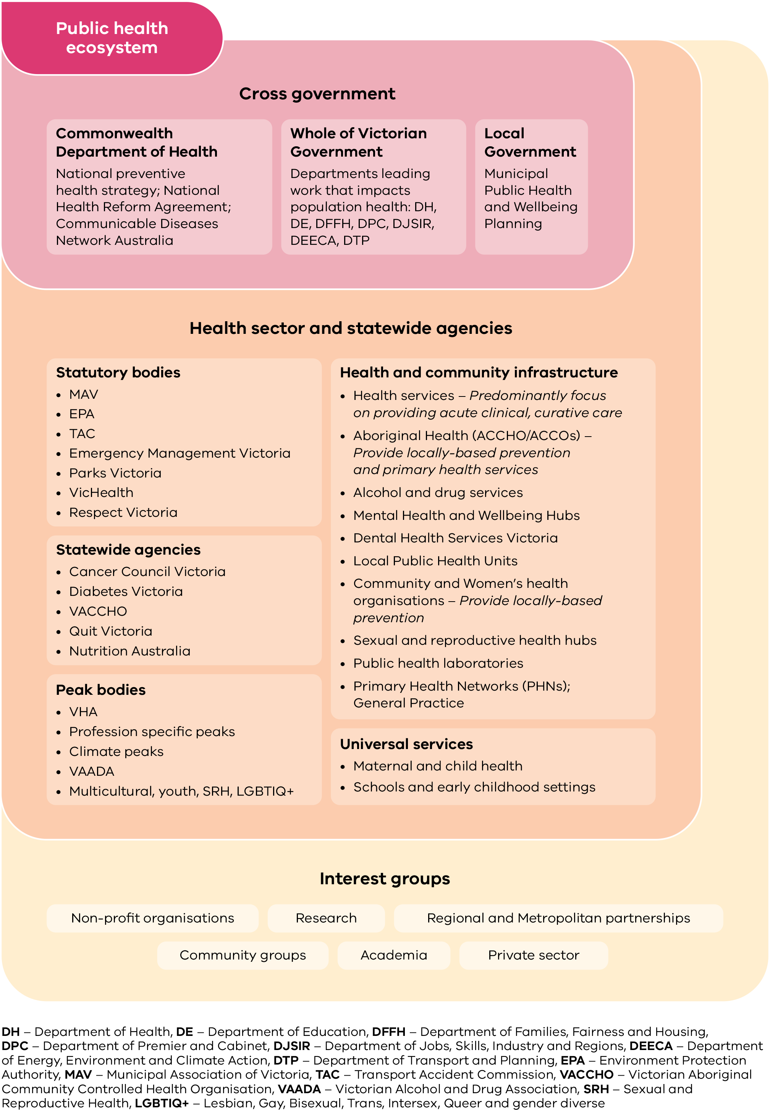
Legend: DH – Department of Health, DE – Department of Education, DFFH – Department of Families, Fairness and Housing, DPC – Department of Premier and Cabinet, DJSIR – Department of Jobs, Skills, Industry and Regions, DEECA – Department of Energy, Environment and Climate Action, DTP – Department of Transport and Planning, EPA – Environment Protection Authority, TAC – Transport Accident Commission, VACCHO – Victorian Aboriginal Community Controlled Health Organisation, VAADA – Victorian Alcohol and Drug Association, SRH – Sexual and Reproductive Health, LGBTIQ+ – lesbian, gay, bisexual, trans, intersex, queer and gender diverse.

Governance
A whole of Victorian Government Public Health and Wellbeing Interdepartmental Committee will oversee the implementation of this plan (Figure 7). The Department of Health and Department of Premier and Cabinet co-chair this committee.
The objectives of this group include:
- identifying collaborative strategies that contribute to achieving health and wellbeing targets
- contributing to a review of the public health and wellbeing outcomes framework
- informing development of the next plan for 2027–2030.
The Department of Health’s Executive Board provides advice and decision-making regarding the development of state public health and wellbeing plans.
An external advisory group of sector and consumer representatives will be established to provide advice on implementation of cross-government public health and wellbeing priorities.

Tracking outcomes and reporting on progress
The Victorian public health and wellbeing outcomes framework⁷ brings together a comprehensive set of indicators drawn from multiple data sources. These indicators help us track whether our combined efforts are improving the health and wellbeing of Victorians over time.
The framework is designed to track progress against consecutive Victorian public health and wellbeing plans. It includes indicators spanning the social, emotional and environmental determinants of health, health behaviours, and long-term health outcomes that relate to priority areas of this plan (Figure 7).
In particular, the framework will help us understand the extent to which avoidable gaps in health status between different population groups in Victoria are reducing.
There will be a stronger focus on tracking our progress towards improvements in public health and wellbeing outcomes between 2023–2027. This will be supported by a reporting dashboard that will be released in 2023–24.
Figure 7: Framework of the Victorian public health and wellbeing plan 2023–2027

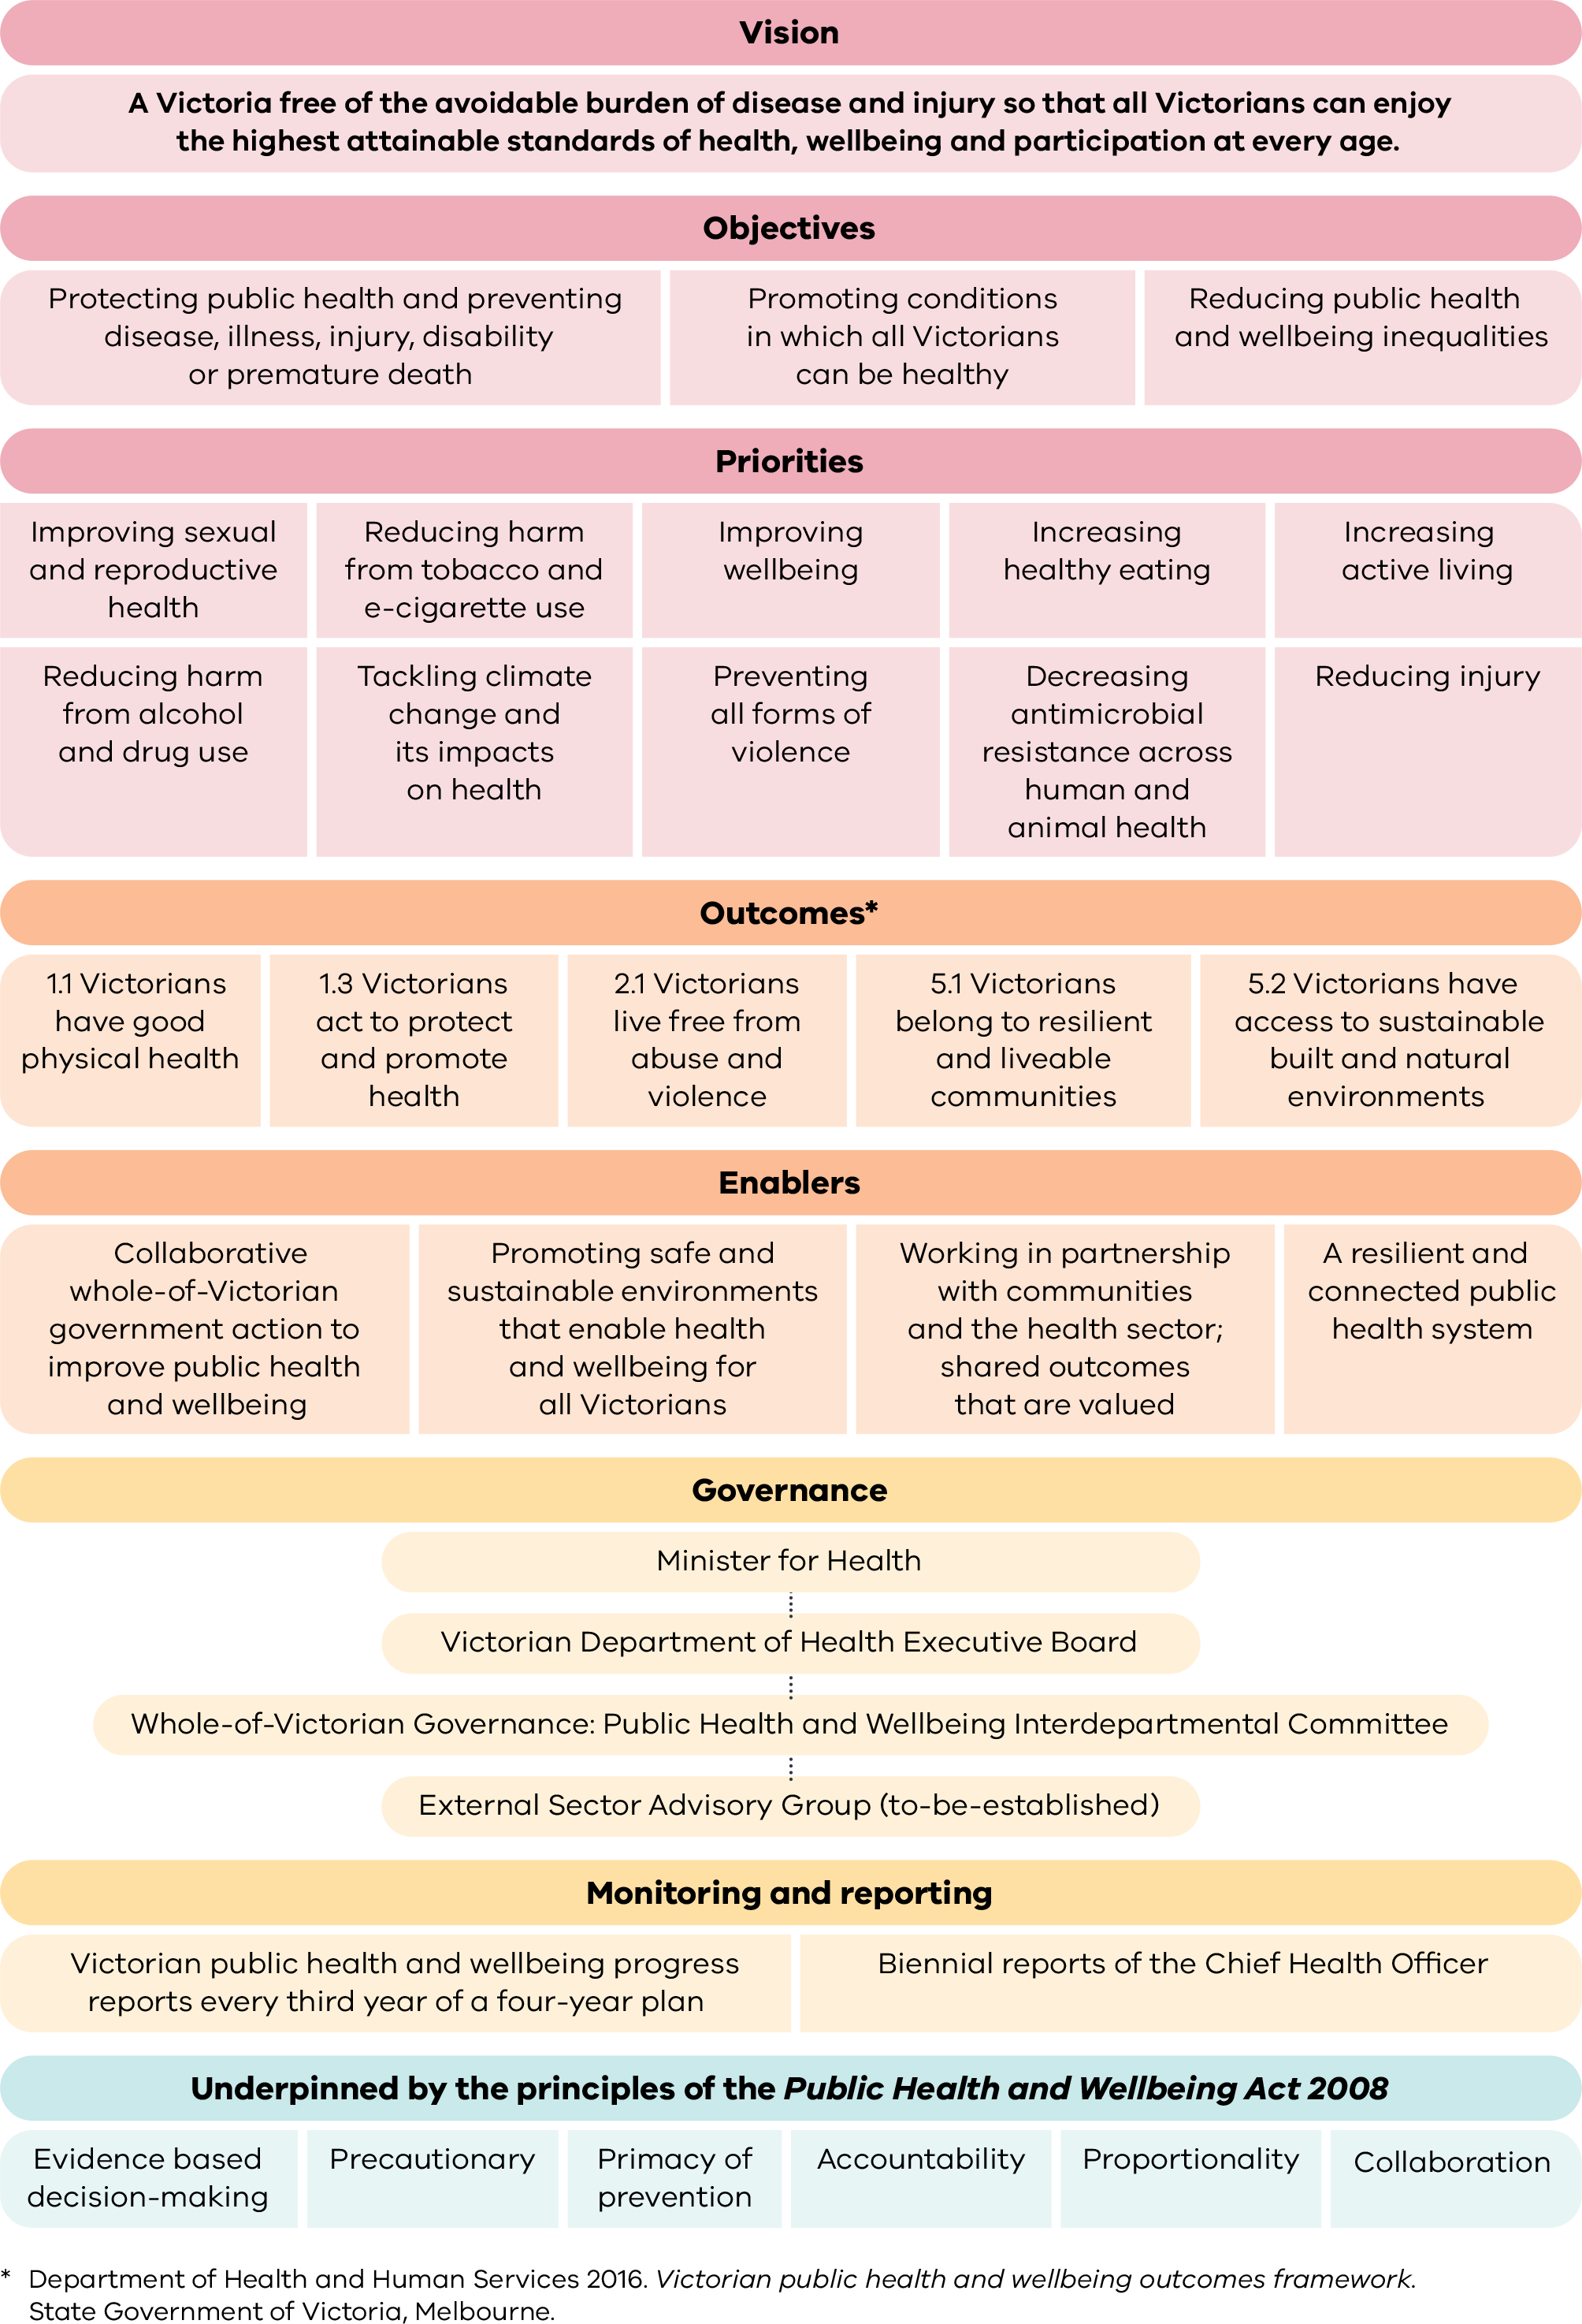

Appendix 1: Legislation
Public health and wellbeing in Victoria are safeguarded and promoted by our legislation. This includes legislation that directly impacts health, and legislation that works across the influences and determinants of health.
The Public Health and Wellbeing Act 2008
The Public Health and Wellbeing Act 2008 <https://www.legislation.vic.gov.au/in-force/acts/public-health-and-wellbeing-act-2008/056> (the Act) aims to achieve the highest attainable standard of public health and wellbeing by:
- protecting public health and preventing disease, illness, injury, disability or premature death
- promoting conditions in which persons can be healthy
- reducing inequalities in the state of public health and wellbeing.
The Act recognises that the state has a significant role in promoting and protecting the public health and wellbeing of people in Victoria. The Act requires a state public health and wellbeing plan to be prepared every four years, with the first plan released in September 2011.
Section 26 of the Act states that the state public health and wellbeing plan must:
(a) identify the public health and wellbeing needs of the people of the state
(b) include an examination of data relating to health status and health determinants within the state
(c) establish objectives and policy priorities for:
- the promotion and protection of public health and wellbeing in the state, and
- the development and delivery of public health interventions in the state
(d) identify how to achieve the objectives and policy priorities based on available evidence
(e) specify how the state will work with other bodies to achieve the objectives and policy priorities.
The Act requires local councils to prepare a municipal public health and wellbeing plan within a period of 12 months after each election of the council, and for councils to have regard to the state public health and wellbeing plan when preparing a municipal public health and wellbeing plan. These plans inform each other and provide the basis for an integrated planning approach in our state.
In addition, under the Climate Change Act 2017 <https://www.climatechange.vic.gov.au/legislation/climate-change-act-2017>, both the state and municipal public health and wellbeing plans must have regard to climate change.
Part 7 of the Family Violence Protection Amendment Act 2017 <https://www.legislation.vic.gov.au/as-made/acts/family-violence-protection-amendment-information-sharing-act-2017> amends the Public Health and Wellbeing Act and requires councils to specify measures to prevent family violence and respond to the needs of victims of family violence in the community, when preparing municipal public health and wellbeing plans.
The Gender Equality Act 2020 <https://www.legislation.vic.gov.au/in-force/acts/gender-equality-act-2020/004> requires the public sector, councils and universities to undertake gender impact assessments when developing or reviewing any policy, or program or services provided, that has a direct and significant impact on the public.

Appendix 2: The policy landscape
The Victorian public health and wellbeing plans intersect with many key state and national priorities, and are implemented in the context of the broader policy landscape.
All plans, polices and strategies referred to in this appendix are current at the time of publishing. A number of these will be released and/or updated during the life of this plan.
State plans, polices and strategies
Department of Health’s Strategy 2023–2027
Department of Health’s Our Operational Plan 2022–23
Victorian Cancer Plan 2020–2024
Victorian Government’s Framework for Place-Based Approaches
Victoria’s Gender Equality Strategy and Action Plan 2023–2027 (for release in 2023–24)
Safer Care Victoria: Partnering in Health Care Framework: A framework for better care and outcomes
Victorian Volunteer Strategy 2022–27
Plan Melbourne 2020–2050
Victorian Department of Health’s Community Health – Health Promotion program 2021–25
Local planning and implementation guidelines
Municipal public health and wellbeing plans
Local Public Health Unit catchment plans
Community Health – Health Promotion Program Guidelines
Victorian Women’s Health Program Funding and reporting guidelines 2023–25
National plans, polices and strategies
National Preventive Health Strategy 2021–2030
National Obesity Prevention Strategy 2022–2032
National Strategic Framework for Chronic Conditions
Australian National Diabetes Strategy 2021–2030
National Strategic Action Plan for Heart Disease and Stroke
National Tobacco Strategy 2022–2030
Safe and Supported: the National Framework for Protecting Australia’s Children 2021–2031
National Children’s Mental Health and Wellbeing Strategy
National Drug Strategy 2017–2026
Priority populations
Victorian Aboriginal Health and Wellbeing Partnership Action Plan 2023–2025
Dhelk Dja: Safe our Way – Strong Culture, Strong People, Strong Families 2018–2028
National Dementia Action Plan (for release in 2024–25)
Recognising and supporting Victoria’s carers: Victorian Carer Strategy 2018–22 (extended to 2023)
Our promise, Your future: Victoria’s youth strategy 2022–2027
Language services policy and guidelines
Healthcare that counts: A framework for improving care for vulnerable children in Victorian health services
Pride in our future: Victoria’s LGBTIQ+ strategy 2022–32
Inclusive Victoria: state disability plan (2022–2026)
Ageing Well in Victoria: An Action plan for strengthening wellbeing for senior Victorians 2022–2026
Department of Health Cultural Diversity Plan (for release in 2023–24)
National Agreement on Closing the Gap
Improving sexual and reproductive health
Victorian sexual and reproductive health and reproductive health plan 2022–30
Strategy overview and system enabler plan 2022–30
Victorian Aboriginal sexual and reproductive health plan 2022–30
Victorian hepatitis B plan 2022–30
Victorian hepatitis C plan 2022–30
Victorian HIV plan 2022–30
Victorian sexually transmittable infection (STI) plan 2022–30

Mental health and wellbeing
Wellbeing in Victoria: A Strategy to Promote Good Mental Health 2024–2034 (for release in 2023–24)
Diverse Communities Mental Health and Wellbeing Framework and Blueprint (for release in 2023–24)
Victorian suicide prevention framework 2016–2025
Suicide Prevention and Response Strategy 2024–2034 (for release in 2024–25)
Healthy eating and oral health
Victorian Action Plan to Prevent Oral Disease 2020–2030
Healthy kids, healthy futures: Victoria’s five-year action plan to support children and young people to be healthy, active and well
Active living and active transport
Strategy for walkable communities (for release in 2023–24)
Active Victoria 2022–2026: A strategic framework for sport and active recreation
Victorian Health Building Authority Universal Design Policy
Climate change and planetary health
Victorian antimicrobial resistance strategy 2023–2033 (for release in 2023–24)
Australia’s National Antimicrobial Resistance Strategy – 2020 and beyond
Health and Human Services Climate Change Adaptation Action Plan 2022–2026
Victoria’s Air Quality Strategy
Regional Climate Change Adaptation Strategies
Water is Life: Traditional Owner Access to Water Roadmap
Protecting Victoria’s Environment – Biodiversity 2037
Preventing family and gendered violence
National Plan to End Violence against Women and Children 2022–2032
Free from violence: Victoria's strategy to prevent family violence
Free from violence – second action plan 2022–2025
Ending Family Violence – Victoria’s 10-year plan for change
Family Violence Reform Rolling Action Plan 2020–2023
Victorian Child Safe Standards
Primary prevention of elder abuse framework (for release in 2023–24)
Victorian Crime Prevention Strategy to Keep Victorians Safer
Building from strength: 10-Year Industry Plan for Family Violence Prevention and Response
Preventing injury
National injury prevention strategy 2020–2030
National road safety strategy 2021–2030
National swimming and water safety framework
Australian safe communities foundation, framework and accreditation
Victorian road safety strategy 2021–2030
Victorian water safety strategy 2021–2025
Community safety statement
Victorian Health Building Authority universal design policy
Crime prevention strategy

Appendix 3: Transcripts of figures

Figure 1: Strategic framework supporting public health action at state, regional and local levels

State
Strategic planning and oversight
Victorian government departments; peaks and specialist agencies (for example, VicHealth, Municipal Association Victoria); professional bodies.

Regional
Responsibility for bringing partners together at the regional level to embed prevention and health promotion at every opportunity
Local governments; Local Public Health Units; community; social and aged care; early childhood and schools; Aboriginal Community Controlled Organisations; Public Health Networks; workplaces, specialist (for example, women’s health organisations)

Local
Delivery of prevention and health promotion activity within a local community (‘local stakeholders’)
Hospitals; community health and primary care services; ACCOs; local government; targeted services (for example, women’s health, sexual and reproductive health); family, social and other local service provider agencies.

Figure 2: Key cross-sector achievements
Tobacco Amendment Act 2016: Bans smoking in public places
Prevention of Family Violence Act 2018: Enabled the establishment of Respect Victoria – the first Statutory Authority in Australia for the prevention of family violence and violence against women
Advancing the Treaty Process with Aboriginal Victorians Act 2018 (Treaty Act): Australia’s first ever Treaty legislation, was followed by establishment of the First Peoples’ Assembly of Victoria.
Victorian Road Safety Strategy 2021–2030: sets a collective vision for zero road deaths and reduction in serious injury
Local Public Health Units established in 2020 during the COVID-19 pandemic: From July 2022 Local Public Health Units began undertaking additional public health responsibilities.
Gender Equality Act 2020: Guides gender impact assessments for all new policy and programs
Healthy kids Healthy futures plan 2021: Focuses on healthy eating, active living and mental wellbeing for Victorian kids
Health and Human Services Climate change adaptation action plan 2022: Sets clear actions to protect health and wellbeing and improve the climate resilience of the system
Good food policy: Healthy and more sustainable food procurement a focus on delivering health, social and environmental outcomes across government departments
Victoria’s Climate Change Strategy 2021: Sets a vision for net-zero emissions
Victorian sexual and reproductive health and viral hepatitis strategy 2022–30: Includes 7 plans supporting people to achieve the best possible outcomes through an integrated and systems approach
Royal Commission into Victoria’s Mental Health System: In 2021 the Victorian Government committed to implementing all recommendations
Sex Work Decriminalisation Act 2022: Paves the way for a safer working environment
Mental Health and Wellbeing Act 2022: Introduces new rights-based principles that promote the values, preferences and views of Victorians with mental illness or psychological distress and guide service delivery
Royal Commission into Family Violence: In January 2023 the Victorian Government announced the implementation of the final recommendations
Children and Health Legislation Amendment (Statement of Recognition, Aboriginal Self-determination and Other Matters) Bill 2023: Introduced a Statement of Recognition and principles for all decision makers involved with Aboriginal children and their families in the child protection system
Strategy for walkable communities (expected for release in 2023–24)
Wellbeing in Victoria: A Strategy to Promote Good Mental Health 2023–2030 (not yet released)

Figure 3: Snapshot of health and wellbeing outcomes in Victoria
10.1 per cent of Victorians smoke tobacco daily.⁶ A decrease of 3.2 per cent since 2015. Tobacco smoking is still the biggest contributor to the burden of disease.⁸
In 2017–18, 22 per cent of Victorian school aged children are overweight and obese, increasing to 50 per cent of 18–24-year-olds, and more than 65 per cent of people aged 25 or older.⁹
In 2019, nearly 9 per cent of men and 6 per cent of women reported they had been diagnosed with heart disease by a doctor.¹⁰
In 2022, COVID-19 was the fifth leading cause of fatal burden,⁸ with more than 7,600 lives lost to May 2023.¹¹
In 2020, one in four adults reported experiencing psychological distress, up from one in five adults in previous years.¹²
Victoria’s average temperature has warmed by 1.2 degrees since 1910, and the number of unusually hot days has increased. If the current rate of global warming continues, the number of very hot days is projected to double by 2050.¹³
In 2019, only half of all Victorian adults and children met the physical activity guidelines.^{10,14}
In 2018, only one in four adolescents practised safe sex by using a condom.¹⁵
In 2019, only 2 per cent of men and 9 per cent of women ate the recommended daily serves of vegetables.¹⁰
The rate of hospital admissions due to falls has not improved since 2011, at 4,500 per 100,000 population in 2021–22.¹⁶
From 2012–13 onwards, the hospitalisation rate due to assault (including same-day admissions) has not improved.¹⁶
In 2020, 17 per cent of people with a household income of less than $40,000 ran out of food and could not afford to buy more.¹² People of low socioeconomic status are 1.6 times as likely to be obese.⁹
In 2020, 32 per cent of Aboriginal Victorians experienced high or very high levels of psychological distress, compared with 23 per cent of non-Aboriginal Victorians.¹²
In 2019, three in five Victorian adults consumed alcohol at a lifetime risk of harm.¹⁰
Regional Victorians are more likely to die prematurely due to chronic disease,¹⁷ be overweight or obese, and smoke daily.¹²
In 2021–22, two in five women reporting having experienced violence at some point since the age of 15.¹⁸
In 2017, 42.5 per cent of Victorians self-rated their health as excellent or very good, compared with 35.7 per cent of LGBTIQ+ Victorians.¹⁹
Poor physical health is 2.5 times as likely in those who experience racism.²⁰
People with disability are more likely to experience psychological distress, be overweight or obese, and smoke daily.²¹
Cultural and linguistically diverse Victorians are less likely to meet the physical activity guidelines.

Figure 4: What influences health and wellbeing?
This diagram shows the connections between influencing factors (wider determinants) on health and wellbeing. It expands on the influential model of social determinants of health published by Dahlgren and Whitehead in 1991.²² Wider determinants of health are the conditions in which people are born, grow, work, live and age, and the wider set of forces and systems that shape the conditions of daily life.¹²⁴ These include social, environmental, structural, economic, cultural and commercial factors.¹¹⁴ These factors often connect and overlap to form a complex system that impacts health and wellbeing.

Figure 5: Health and wellbeing priorities 2023–2027
- Improving sexual and reproductive health
- Reducing harm from tobacco and e-cigarette use
- Improving mental wellbeing
- Increasing healthy eating
- Increasing active living
- Reducing harm from alcohol and drug use
- Urgently tackling climate change and its impacts on health
- Preventing all forms of violence
- Decreasing antimicrobial resistance across human and animal health
- Reducing injury

Figure 6: Public health eco-system

Cross government

Commonwealth Department of Health
National preventive health strategy; National Health Reform Agreement; Communicable Diseases; Network Australia

Whole of Victorian Government
Departments leading work that impacts population health: DH, DE, DFFH, DPC, DJSIR, DEECA, DTP

Local government
Municipal Health and Wellbeing Planning

Health sector and statewide agencies

Statutory bodies
- EPA
- TAC
- Emergency Management Victoria
- Parks Victoria
- VicHealth
- Respect Victoria

Statewide agencies
- Cancer Council Victoria
- Diabetes Victoria
- VACCHO
- Quit Victoria
- Nutrition Australia

Universal services
- Maternal and child health
- Schools and early childhood settings

Peak bodies
- VHA
- Profession specific peaks
- Climate peaks
- VAADA
- Multicultural, youth, SRH, LGBTIQ+

Health and community infrastructure
- Health services – Predominantly focus on providing acute clinical, curative care
- Aboriginal Health (ACCHO/ACCOs) – provide locally-based prevention and primary health services
- Alcohol and drug services
- Mental Health and Wellbeing Hubs
- Dental Health Services Victoria
- Local Public Health Units – work with regional partners to lead disease prevention and population health planning and programs
- Community and Women’s health organisations – provide locally-based prevention
- Sexual and reproductive health hubs
- Public health laboratories
- Primary Health Networks (PHNs)
- General Practice

Interest groups
- Non-profit organisations
- Community groups
- Research
- Private sector
- Regional and metropolitan partnerships
- Academia

Figure 7: Framework of the Victorian public health and wellbeing plan 2023–2027

Vision
A Victoria free of the avoidable burden of disease and injury so that all Victorians can enjoy the highest attainable standards of health, wellbeing and participation at every age.

Objectives
- Protecting public health and preventing disease, illness, injury, disability or premature death
- Promoting conditions in which all Victorians can be healthy
- Reducing public health and wellbeing inequalities

Priorities
- Improving sexual and reproductive health
- Reducing harm from tobacco and e-cigarette use
- Improving mental wellbeing
- Increasing healthy eating
- Increasing active living
- Reducing harm from alcohol and drug use
- Urgently tackling climate change and its impacts on health
- Preventing all forms of violence
- Decreasing antimicrobial resistance across human and animal health
- Reducing injury

Outcomes
- Outcome 1.1 Victorians have good physical health
- Outcome 1.3 Victorians act to protect and promote health
- Outcome 2.1 Victorians live free from abuse and violence
- Outcome 5.1 Victorians belong to resilient and liveable communities
- Outcome 5.2 Victorians have access to sustainable built and natural environments

Enablers
- Collaborative whole-of-Victorian government action across to improve public health and wellbeing
- Promoting safe and sustainable environments that enable health and wellbeing for all Victorians
- Working in partnership with communities and the health sector; shared outcomes that are valued
- A resilient and connected public health system

Governance
- Minister for Health
- Victorian Department of Health Executive Board
- Whole-of-Victorian Governance: Public Health and Wellbeing Interdepartmental Committee
- External Sector Advisory Group (to-be-established)

Monitoring and reporting
- Victorian public health and wellbeing progress reports every third year of a four-year plan
- Biennial reports of the Chief Health Officer

Underpinned by the principles of the Public Health and Wellbeing Act 2008
- Evidence based decision making
- Precautionary
- Primacy of prevention
- Accountability
- Proportionality
- Collaboration

Glossary
Blood-borne viruses (BBV) are viruses that spread by blood (and some body fluids). They include, for example, hepatitis B, hepatitis C and the human immunodeficiency virus (HIV).¹⁰²
Elder abuse is a single or repeated act, or lack of appropriate action, occurring within any relationship where there is an expectation of trust that causes harm or distress to an older person.⁹⁸ Elder abuse can take various forms including financial, physical, psychological, emotional and sexual abuse, or neglect.¹¹⁴
Environmental determinants include our natural environment (the atmosphere, land, water, oceans and the diversity of living things) and the built environment (surroundings and urban form; for example, the size, shape, population density and layout of buildings).¹¹⁴ A healthy natural environment is essential to sustaining planetary life. These determinants include air pollution, climate change and extreme weather events, UV radiation and vector-borne diseases.¹¹⁴ Built environmental determinants include urban design, walkability, public transport infrastructure, green and public open spaces, and food environments.¹¹⁴
Food insecurity exists ‘whenever the availability of nutritionally adequate and safe foods or the ability to acquire acceptable food in socially acceptable ways is limited or uncertain’.¹¹⁵
Health inequities are differences in health status or in the distribution of health resources between different population groups. They arise from the social conditions in which people are born, grow, live, work and age.¹¹⁶
Intersectionality is a theoretical approach that understands the interconnected nature of social categorisations such as gender, sexual orientation, ethnicity, language, religion, class, socioeconomic status, gender identity, ability or age. These create overlapping and interdependent systems of discrimination or disadvantage for either an individual or group.¹¹⁷
LGBTIQ+ is a collective term for people who are lesbian, gay, bisexual, trans and gender diverse, intersex and/or queer.
One Health is an integrated approach to optimise the health of people, animals, plants and the shared environment.¹¹⁸ This transdisciplinary approach is particularly important to prevent, predict, detect and respond to global health threats. It recognises:
- the interdependence and interrelatedness of sectors, communities and disciplines
- the need for collaboration to address root causes, create long-term, sustainable solutions and improve health.
Place-based approaches plan and adapt government services and infrastructure to ensure they meet local needs. Place-based approaches target the specific circumstances of a place and engage local people as active participants in development and implementation, requiring government to share decision making.¹¹⁹
Planetary health is ‘the health of human civilisation and the state of the natural systems on which it depends’. It is a transdisciplinary field focused on addressing the impacts of disruptions to the planet’s natural systems on all life on earth.¹²⁰
Sex and gender are two distinct concepts. Sex is based on a person’s biological sex characteristics (such as their chromosomes, hormones and reproductive organs). However, this can change over the course of their lifetime and may differ from their sex recorded at birth.¹²² Gender relates to social and cultural identity, expression and experience. It is about who a person feels themselves to be (such as man, woman, transgender, non-binary).¹²¹
Social determinants arise from a number of elements, such as family situation and early childhood circumstances, and support, from social connections to housing, working conditions and employment.¹¹⁴
Sexually transmitted infections (STI), such as syphilis, gonorrhoea and chlamydia, are caused by bacteria, viruses or parasites that spread from unprotected vaginal, oral or anal sex.¹⁰²
Sustainable food systems are those that contribute to food security and nutrition for all in such a way that the economic, social, cultural and ecological bases that generate food security and nutrition for future generations are safeguarded.¹²² Sustainable food systems are critical to supporting planetary health.
Wider determinants of health are the conditions in which people are born, grow, work, live and age, and the wider set of forces and systems that shape the conditions of daily life.¹²⁴ These include social, environmental, structural, economic, cultural and commercial factors.¹¹⁴

References
1. Masters R, Anwar E, Collins B, Cookson R, Capewell S 2017, 'Return on investment of public health interventions: a systematic review', Journal of Epidemiology and Community Health, 71(8):827.
2. Victorian Council of Social Service 2016, Communites taking power. Using place-based approaches to deliver local solutions to poverty and disadvantage. Melbourne: VCOSS; 2016.
3. Victorian Department of Health 2022, Victorian women’s sexual and reproductive health plan 2022–30. Melbourne: State Government of Victoria.
4. Watts N, Adger WN, Agnolucci P, Blackstock J, Byass P, Cai W, et al. 2015, 'Health and climate change: policy responses to protect public health', Lancet, 386(10006):1861–1914.
5. Australian Bureau of Statistics 2018, Life tables for Aboriginal and Torres Strait Islander Australians 2015–2017. Canberra: ABS; 2018. Cat. no: 3302.0.55.003.
6. Victorian Agency for Health Information 2023, Victorian Population Health Survey 2022. Melbourne: State Government of Victoria.
7. Department of Health and Human Services 2016, Victorian public health and wellbeing outcomes framework. Melbourne: State Government of Victoria.
8. Australian Institute of Health and Welfare 2022, Australian burden of disease study 2022. Canberra: AIHW. Cat. no: BOD 37.
9. Australian Bureau of Statistics 2018, National health survey 2017–18: Customised Victoria-specific report. Canberra: Australian Government.
10. Victorian Agency for Health Information 2020, Victorian Population Health Survey 2019. Melbourne: State Government of Victoria.
11. Department of Health 2023, Victorian COVID-19 data. Melbourne: State Government of Victoria.
12. Victorian Agency for Health Information 2022, Victorian Population Health Survey 2020. Melbourne: State Government of Victoria.
13. Department of Environment Land Water and Planning 2019, Victoria’s climate science report 2019. Melbourne: State Government of Victoria.
14. Department of Education and Training 2023, Victorian child health and wellbeing Survey 2021. Melbourne: State Government of Victoria.
15. Department of Education 2019, Victorian Student Health and Wellbeing Survey: summary findings 2018. Melbourne: State Government of Victoria.
16. Victorian Agency for Health Information 2022, Victorian Admitted Episodes Dataset. Melbourne: State Government of Victoria.
17. Victorian Department of Health 2022, Causes of death, Australia. Canberra: Australian Bureau of Statistics.
18. Australian Bureau of Statistics 2023, Personal safety, Australia. Canberra: Government of Australia. Available from: https://www.abs.gov.au/statistics/people/crime-and-justice/personal-safety-australia/latest-release#:~:text=Media%20releases-,Key%20statistics,who%20have%20experienced%20sexual%20violence.
19. Victorian Agency for Health Information 2020, The health and wellbeing of the lesbian, gay, bisexual, transgender, intersex and queer population in Victoria: findings from the Victorian Population Health Survey 2017. Melbourne: State Government of Victoria.
20. Department of Health and Human Services 2017, Racism in Victoria and what it means for the health of Victorians. Melbourne: State Government of Victoria.
21. Australian Institute of Health and Welfare 2022, People with disability in Australia. Canberra: AIHW. Cat. no: DIS 72.
22. Dahlgren G, Whitehead M 1991, ‘Policies and strategies to promote social equity in health. Background document to WHO strategy paper for Europe’, Institute for Futures Studies, 14.
23. Government of Victoria 2017, Balit Murrup: Aboriginal social and emotional wellbeing framework 2017–2027. Melbourne: State Government of Victoria.
24. O’Donnell, J 2022m Mapping social cohesion. Melbourne: Scalon Institute.
25. Wainer Z, Carcel C 2020, 'Sex and gender in health research: updating policy to reflect evidence', Med J Aust, 212(2):57–62.e1.
26. Zhang L, Losin EAR, Ashar YK, Koban L, Wager TD 2021, 'Gender Biases in Estimation of Others' Pain', The Journal of Pain, 22(9):1048–59.
27. Khan E, Brieger D, Amerena J, Atherton JJ, Chew DP, Farshid A, et al. 2018, 'Differences in management and outcomes for men and women with ST-elevation myocardial infarction', Medical Journal of Australia, 209(3):118–23.
28. Comissioner for Gender Equality in the Public Sector 2022, Applying intersectionality. Gender Equality Commission. Available from: https://www.genderequalitycommission.vic.gov.au/applying-intersectionality.
29. Department of Families, Fairness and Housing 2022, Pride in our future: Victoria’s LGBTIQ+ strategy 2022–32. Melbourne: State Government of Victoria.
30. Australian Institute of Health and Welfare 2021, Australian Burden of Disease Study 2018. Canberra: AIHW.
31. Government of Victoria 2022, Ageing well in Victoria: an action plan for strengthening wellbeing for senior Victorians 2022–2026. Melbourne: State Government of Victoria.
32. Victorian Department of Health 2023, Public Health Events Surveillance System. Melbourne: State Government of Victoria.
33. Victorian Department of Health 2022, Victorian women’s sexual and reproductive health plan 2022–30. Melbourne: State Government of Victoria.
34. Victorian Department of Health 2022, Victorian sexual and reproductive health and viral hepatitis strategy: strategy overview and system enabler plan 2022–30. Melbourne: State Government of Victoria.
35. Banks E, Yazidjoglou A, Brown S, Nguyen M, Martin M, Beckwith K, et al. 2022, ‘Electronic cigarettes and health outcomes: systematic review of global evidence’, Canberra: Australian National University.
36. Australian Institute of Health and Welfare 2019, National Drug Strategy Household Survey 2019. Canberra: Government of Australia.
37. Australian Institute of Health and Welfare 2019, Alcohol, tobacco & other drugs in Australia. Canberra: Government of Australia.
38. Whetton S, Allsop S, Tait R, Scollo M, Banks E, Chapman J, et al. 2019 ‘Identifying the social costs of tobacco use in Australia in 2015/16’, National Drug Research Institute.
39. Consultative Council on Obstetric and Paediatric Mortality and Morbidity 2022, Victoria’s mothers babies and children 2020 report and presentations. Melbourne: State Government of Victoria.
40. World Health Organization 2022, Tobacco: poisoning our planet. Geneva: WHO.
41. Australian Institute of Health and Welfare 2022, Australia's mothers and babies. Canberra: Australian Government.
42. Australian Institute of Health and Welfare 2023, Prevalence and impact of mental illness. Canberra: AIHW. Available from: https://www.aihw.gov.au/mental-health/overview/mental-illness#impact.
43. Crowe M, Capic T, Singh M, et al. 2023, Australians’ subjective wellbeing in 2022: climate change, mental distress, mood and social connection. Melbourne: Deakin University.
44. Coroners Court of Victoria 2023, Monthly suicide data report. December 2022 update. Melbourne: Coroners Court Victoria.
45. Firth J, Marx W, Dash S, Carney R, Teasdale SB, Solmi M, et al. 2019, ‘The effects of dietary improvement on symptoms of depression and anxiety: a meta-analysis of randomized controlled trials’, Psychosomatic Medicine: 81(3):265–280.
46. Luppino FS, de Wit LM, Bouvy PF, Stijnen T, Cuijpers P, Penninx BW, et al. 2010, ‘Overweight, obesity, and depression: a systematic review and meta-analysis of longitudinal studies’, Archives of General Psychiatry: 67(3):220–229.
47. Schuch FB, Vancampfort D, Firth J, Rosenbaum S, Ward PB, Silva ES, et al. 2018, ‘Physical activity and incident depression: a meta-analysis of prospective cohort studies’, American Journal of Psychiatry: 175(7):631–648.
48. Czosnek L, Lederman O, Cormie P, Zopf E, Stubbs B, Rosenbaum S 2019, ‘Health benefits, safety and cost of physical activity interventions for mental health conditions: a meta-review to inform translation efforts’, Mental Health and Physical Activity: 16:140–151.
49. Astell-Burt T, Feng X 2019, ‘Association of urban green space with mental health and general health among adults in Australia’, JAMA Network Open: 2(7):e198209-e.
50. Firth J, Solmi M, Wootton RE, Vancampfort D, Schuch FB, Hoare E, et al. 2020, ‘A meta-review of ‘lifestyle psychiatry’: the role of exercise, smoking, diet and sleep in the prevention and treatment of mental disorders’ World Psychiatry: 19(3):360–380.
51. Maccagnan A, Wren-Lewis S, Brown H, Taylor T 2019, ‘Wellbeing and society: towards quantification of the co-benefits of wellbeing’, Social Indicators Research: 141(1):217–243.
52. Kansky J, Diener E 2017, ‘Benefits of well-being: health, social relationships, work, and resilience’, Journal of Positive Psychology and Wellbeing: 1:129–169.
53. Australian Institute of Health and Welfare 2018, Nutrition across the life stages. Canberra: Australian Government. Cat. no: PHE 227.
54. Crino M, Sacks G, Dunford E, Trieu K, Webster J, Vandevijvere S, et al. 2018, ‘Measuring the healthiness of the packaged food supply in Australia’, Nutrients 10(6):702.
55. Government of Victoria 2020, Victorian action plan to prevent oral disease 2020–30. Melbourne: Victorian Government.
56. Moores CJ, Kelly SAM, Moynihan PJ 2022 ‘Systematic review of the effect on caries of sugars intake: ten-year update’, Journal of Dental Research: 101(9):1034–1045.
57. World Health Organization 2015, Guideline: Sugars intake for adults and children. Geneva: WHO.
58. Ridoutt B, Baird D, Hendrie GA 2021, ‘Diets within environmental limits: the climate impact of current and recommended Australian diets’, Nutrients: 13(4):1122.
59. Sacks G, Kwon J, Vandevijvere S, Swinburn B 2021, ‘Benchmarking as a public health strategy for creating healthy food environments: an evaluation of the INFORMAS Initiative (2012–2020)’, Annual Review of Public Health: 1;42:345–362.
60. Miller K, Li E 2022, Foodbank Hunger Report 2022. Yarraville: Foodbank Australia.
61. National Health and Medical Research Council 2013, Australian dietary guidelines. Canberra: Australian Government.
62. Chaput J-P, Willumsen J, Bull F, Chou R, Ekelund U, Firth J, et al. 2020, ‘WHO guidelines on physical activity and sedentary behaviour for children and adolescents aged 5–17 years: summary of the evidence’, International Journal of Behavioral Nutrition and Physical Activity: 17(1):141.
63. Sebastien C, Duncan M, Javier P-A, Keith MD, Maria H, Pedro Curi H, et al. 2021, ‘Joint association between accelerometry-measured daily combination of time spent in physical activity, sedentary behaviour and sleep and all-cause mortality: a pooled analysis of six prospective cohorts using compositional analysis’, British Journal of Sports Medicine: 55(22):1277.
64. World Health Organization 2022, Physical activity. Geneva: WHO. Available from: https://www.who.int/news-room/fact-sheets/detail/physical-activity.
65. Posadzki P, Pieper D, Bajpai R, Makaruk H, Könsgen N, Neuhaus AL, et al. 2020, ‘Exercise/physical activity and health outcomes: an overview of Cochrane Systematic Reviews’, BMC Public Health: 20(1):1724.
66. Twohig-Bennett C, Jones AP 2018, ‘The health benefits of the great outdoors: a systematic review and meta-analysis of greenspace exposure and health outcomes’, Environmental Research: 166:628–637.
67. Geneshka M, Coventry PA, Cruz J, Gilbody S 2021, ‘Relationship between green and blue spaces with mental and physical health: a systematic review of longitudinal observational studies’, International Journal of Environmental Research and Public Health: 18.
68. Brand C, Dons E, Anaya-Boig E, Avila-Palencia I, Clark A, de Nazelle A, et al. 2021, ‘The climate change mitigation effects of daily active travel in cities’, Transportation Research Part D: Transport and Environment: 93:102764.
69. Mizdrak A, Blakely T, Cleghorn CL, Cobiac LJ 2019, ‘Potential of active transport to improve health, reduce healthcare costs, and reduce greenhouse gas emissions: a modelling study’, PLoS One: 14(7):e0219316.
70. Australian Institute of Health and Welfare 2018, Physical activity across the life stages. Canberra: AIHW. Cat. No. PHE 225.
71. Australian Institute of Health and Welfare 2022, Dementia in Australia. Canberra: AIHW. Cat. No. DEM 2.
72. Iso-Markku P, Kujala UM, Knittle K, Polet J, Vuoksimaa E, Waller K 2022, ‘Physical activity as a protective factor for dementia and Alzheimer’s disease: systematic review, meta-analysis and quality assessment of cohort and case–control studies’, British Journal of Sports Medicine: 56(12):701–709.
73. Johnson M, Bennett E 2015, Everyday sexism: Australian women’s experiences of street harassment. Canberra: The Australia Institute.
74. Hill A, Bourne A, McNair R, et al. 2020, Private lives 3: the health and wellbeing of LGBTIQ people in Australia. La Trobe University: Australian Research Centre in Sex, Health and Society.
75. Ben J, Elias A, Issaka A, Truong M, Dunn K, Sharples R, et al. 2022, ‘Racism in Australia: a protocol for a systematic review and meta-analysis’, Systematic Reviews: 11(1):47.
76. Ma L, Liu Y, Cao J, Ye R 2022, ‘The impact of perceived racism on walking behavior during the COVID-19 lockdown’, Transportation Research Part D Transportation Environment: 109:103335.
77. National Heart Foundation of Australia 2023, Healthy active by design. Available from: https://www.healthyactivebydesign.com.au/.
78. Kelly D, Davern M, Farahani L, Higgs C, Maller C 2022, ‘Urban greening for health and wellbeing in low-income communities: a baseline study in Melbourne, Australia’, Cities: 120:103442.
79. Australian Institute of Health and Welfare 2023, Illicit drug use. Canberra: AIHW. Available from: https://www.aihw.gov.au/reports/illicit-use-of-drugs/illicit-drug-use#health%20impact.
80. Degenhardt L, Charlson F, Ferrari A, Santomauro D, Erskine H, Mantilla-Herrara A, et al. 2018, ‘The global burden of disease attributable to alcohol and drug use in 195 countries and territories, 1990–2013: a systematic analysis for the Global Burden of Disease Study 2016’, The Lancet Psychiatry: 5(12):987–1012.
81. Department of Health and Aged Care 2017, National drug strategy 2017–2026. Canberra: Australian Government.
82. Aboriginal Health and Wellbeing Partnership Forum 2023, Victorian Aboriginal health and wellbeing partnership agreement action plan 2023–2025. Melbourne: VACCHO and the Victorian Department of Health.
83. Coroners Court of Victoria 2022, Victorian overdose deaths. Quarterly update to June 2022. Melbourne: Coroners Court of Victoria.
84. National Health and Medical Research Council 2020, Australian guidelines to reduce health risks from drinking alcohol. Canberra: National Health and Medical Research Council.
85. World Health Organization 2021, Climate change and health. Geneva: WHO. Available from: https://www.who.int/news-room/fact-sheets/detail/climate-change-and-health.
86. Department of Families, Fairness and Housing 2022, Health and human services climate change adaptation action plan 2022–2026. Melbourne: State Government of Victoria.
87. Australian Institute of Health and Welfare 2021, Data update: Short-term health impacts of the 2019–20 Australian bushfires. Canberra: AIHW. Cat. no. PHE 276.
88. The Bureau of Meteorology 2022, State of Climate 2022. Canberra: Australian Government.
89. Buse CG, Patrick R 2020, ‘Climate change glossary for public health practice: from vulnerability to climate justice’, Journal of Epidemiology Community Health: 74(10):867–871.
90. Friel S 2022, ‘Climate change, society, and health inequities’, Medical Journal of Australia: 217(9):466–468.
91. Intergovernmental Panel of Climate Change 2022, Climate Change 2022: impacts, adaptation and vulnerability. United Nations: IPPC.
92. Australian Government 2021, National Elder Abuse Prevalence Study: final report. Canberra: Australian Government.
93. Government of Victoria 2022, Free from violence second action plan (2022–2025). Melbourne: State Government of Victoria.
94. Department of Social Services 2022, National plan to end violence against women and children 2022–2032. Canberra: Australian Government.
95. Department of Families, Fairness and Housing 2020, Family violence reform rolling action plan 2020–2023. Melbourne: State Government of Victoria.
96. Victoria FS 2019, Nargneit Birrang: Aboriginal holistic healing framework for family violence. Melbourne: State Government of Victoria.
97. Victorian Injury Surveillance Unit 2022, Injury deaths Victoria 2017–2019. Melbourne: Monash University.
98. Australian Human Rights Commission 2021, Elder abuse. Available from: https://humanrights.gov.au/elderabuse.
99. Organisation for Economic Cooperation and Development 2018, Stemming the superbug tide. OECD.
100. Antimicrobial Resistance Collaborators 2022, ‘Global burden of bacterial antimicrobial resistance in 2019: a systematic analysis’, Lancet: 399(10325):629–655.
101. Review on Antimicrobial Resistance 2014, Antimicrobial Resistance: Tackling a crisis for the health and wealth of nations. United Kingdom: Wellcome Trust.
102. Department of Health 2022, Victorian sexually transmissible infection (STI) plan 2022–30. Melbourne: State Government of Victoria.
103. Magnano San Lio R, Favara G, Maugeri A, Barchitta M, Agodi A 2023, ‘How antimicrobial resistance is linked to climate change: an overview of two intertwined global challenges’, International Journal of Environmental Research Public Health: 20(3).
104. Australian Commission on Safety and Quality in Health Care 2019, Antimicrobial medicines dispensing from 2013–14 to 2017–18. Canberra: ACSQHC.
105. World Health Organization 2021, Tripartite and UNEP support OHHLEP’s definition of ‘One Health’. Geneva: WHO. Available from: https://www.who.int/news/item/03-05-2023-quadripartite-welcomes-ohhlep-s-new-white-paper-on--zoonotic-spillover-prevention.
106. Pham T, Hayman, JI 2023, Injury deaths Victoria 2018–2020. Melbourne: Victorian Injury Surveillance Unit.
107. Pham TTL, Berecki-Gisolf J 2022, Unintentional hospital treated injury Victoria 2020/21. Melbourne: Monash University Accident Research Centre; 2022.
108. Australian Institute of Health and Welfare 2022, Injury in Australia 2022–25. Canberra: AIHW. Cat. no: INJCAT 213.
109. Sherrington C, Fairhall NJ, Wallbank GK, Tiedemann A, Michaleff ZA, Howard K, et al. 2019, ‘Exercise for preventing falls in older people living in the community’, Cochrane Database of Systemic Reviews: 1(1):Cd012424.
110. Live Saving Victoria 2021, Victorian Drowning Report 2020/21. Melbourne: Life Saving Victoria.
111. Government of Victoria. Victorian water safety strategy 2021–25. Melbourne: State Government of Victoria.
112. Australian Institute of Health and Welfare 2021, Rural and remote health. Australia’s Health. Canberra: AIHW; 2022.
113. Brew B, Inder K, Allen J, Thomas M, Kelly B 2016, ‘The health and wellbeing of Australian farmers: a longitudinal cohort study’, BMC Public Health: 16(1):988.
114. Department of Health 2021, National Preventative Health Strategy. Canberra: Australian Government.
115. Radimer KL, Radimer KL 2002, ‘Measurement of household food security in the USA and other industrialised countries’, Public Health and Nutrition: 5(6a):859–864.
116. World Health Organization 2018, Health inequities and their causes. Available from: https://www.who.int/news-room/facts-in-pictures/detail/health-inequities-and-their-causes.
117. State Government of Victoria 2018, Everybody Matters: Inclusion and Equity Statement. Melbourne: Government of Victoria.
118. Centers for Disease Control and Prevention 2022, One Health. Available from: https://www.cdc.gov/one-health/about/.
119. Government of Victoria 2020, Place-based approaches. Melbourne, State Government of Victoria.
120. Whitmee S, Haines A, Beyrer C, Boltz F, Capon AG, de Souza Dias BF, et al. 2015, ‘Safeguarding human health in the Anthropocene epoch: report of The Rockefeller Foundation-Lancet Commission on planetary health’, Lancet: 386(10007):1973–2028.
121. Australian Bureau of Statistics 2021, Standard for sex, gender, variations of sex characteristics and sexual orientation variables. Canberra: Australian Bureau of Statistics.
122. Global Panel on Agriculture and Food Systems for Nutrition 2020, Future Food Systems: For people, our planet and prosperity. London: Global Panel.
123. Wickramaratne PJ, Yangchen T, Lepow L, Patra BG, Glicksburg B, Talati A, et al. 2022, ‘Social connectedness as a determinant of mental health: a scoping review’, PLoS One: 17(10):e0275004.
124. World Health Organization 2022, Social determinants of health. Available from: https://www.who.int/news-room/questions-and-answers/item/determinants-of-health#:~:text=The%20determinants%20of%20health%20include,person's%20individual%20characteristics%20and%20behaviours.

