

Cemetery sector newsletter
Edition 2, 2024
OFFICIAL

In this issue
Contact us 1
Welcome 1
Storms and tree safety 1
Abstracts of accounts due 1 September 1
Burial and grave depths 2
Performance Support Program 2
Cemetery grants 2
Barnawartha Cemetery Trust grant project 3
Class A cemetery trust member appointments 3
Cemetery trust insurance 3
Class B cemetery trust member appointments 4
Advertising for Class B cemetery trusts 4
What is the right of interment permit? 5
Investing 5
Data security reporting 5
Free governance training 6
Links to key resources 6

Contact us
 | Email <cemeteries@health.vic.gov.au>
 | Phone 1800 034 280
 | Cemeteries and Crematoria website <https://www.health.vic.gov.au/public-health/cemeteries-and-crematoria>
 | Cemeteries and Crematoria  Department of Health  PO Box 4057  MELBOURNE VIC 3001

Welcome
Welcome to the Department of Health’s cemetery sector newsletter.

Storms and tree safety

Now that winter is here, cemeteries could be affected by an increase in significant storm events.
We encourage cemetery trusts to check trees in the cemeteries they manage to identify those that may pose a safety risk, such as trees with branches that are dead or damaged.
For help with tree management, cemetery trusts can apply for funding through the Cemetery Grants Program.
More information is available on the Cemetery Grants Program webpage <https://www.health.vic.gov.au/cemeteries-and-crematoria/cemetery-grants-program>.


Abstracts of accounts due 1 September
All Class B cemetery trusts are required to submit a financial report known as the abstract of accounts to the department each year.
A copy of the 2023–24 abstract of accounts was sent to each trust in mid-June and is due to the department on 1 September 2024.
Copies can also be downloaded from the Class B cemetery trust financial reporting webpage <https://www.health.vic.gov.au/cemeteries-and-crematoria/class-b-cemetery-trust-financial-reporting-and-procedures>.

Burial and grave depths

What is the difference?
The Cemeteries and Crematoria Regulations set burial depth requirements for interments of bodily remains. This is sometimes confused with how deep a grave should be dug to accommodate interments.

Burial depth

Burial depth regulations specify the minimum depth between the normal level of the ground and the top of the coffin.
This ensures interments are deep enough to be safe and protected from disturbance.
The minimum burial depth differs for different types of graves (unsealed or sealed cap with or without sides). Please refer to Regulation 24 in the Cemeteries and Crematoria Regulations <https://www.legislation.vic.gov.au/in-force/statutory-rules/cemeteries-and-crematoria-regulations-2015>.

Grave depth
Grave depth refers to the depth a grave is dug to accommodate the required number of interments.
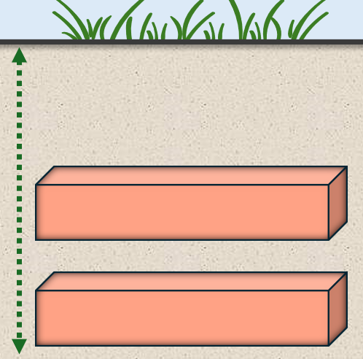
It is common for new graves to be dug to a depth that will allow more than one interment (unless there is a physical impediment such as rock).
Grave depth considers the minimum burial depth that will be needed between the top of the uppermost interment and ground level.

More information
Diagrams and recommended grave depths for single, double and triple graves are in Topic 12 of the Manual for Victorian Class B cemetery trusts <https://www.health.vic.gov.au/publications/manual-for-victorian-class-b-cemetery-trusts>.

Performance Support Program
The Performance Support Program (in its seventh year) chose six Class B cemetery trusts to provide a tailored independent review of their governance, operational and financial management.
Each review assessed the trust’s governance systems, processes and practices, identifying opportunities to strengthen trust governance.
The common themes from the performance reviews were summarised in an annual report. It is recommended that all trusts review the findings in the annual report to determine if there are any lessons or opportunities to improve their own governance structures.
The most recent report recommends trusts focus on strengthening the following areas of their operations: financial management; governance (delegations and conflicts of interest); contract management; complaints management; human resources and records management.
The Performance Support Program for Class B cemetery trusts annual report 2022–23 is available on the Cemeteries and crematoria reports webpage <https://www.health.vic.gov.au/cemeteries-and-crematoria/cemeteries-and-crematoria-reports>.
It has links to useful resources and templates for cemetery trusts.

Cemetery grants
The second round of the 2023–24 Cemetery Grants Program closed on 31 March 2024. Cemetery trusts that applied for a grant were notified of the outcome in May. More than $705,000 was awarded to 42 cemetery trusts.
The next round (2024–25, round 1) closes on 31 October 2024.
The Cemetery Grants Program guidelines, Cemetery grants application form and Vegetation removal, destruction or lopping attachment are available on the Cemetery Grants Program webpage <https://www.health.vic.gov.au/cemeteries-and-crematoria/cemetery-grants-program>.
Cemetery trusts managing sites with no or few burials may be eligible for a fixed grant of $500.
The Small Cemetery Operations Grants Program guidelines and application form are available on the Small cemetery operations grants program webpage <https://www.health.vic.gov.au/cemeteries-and-crematoria/small-cemetery-operations-grants-program>.

Barnawartha Cemetery Trust grant project
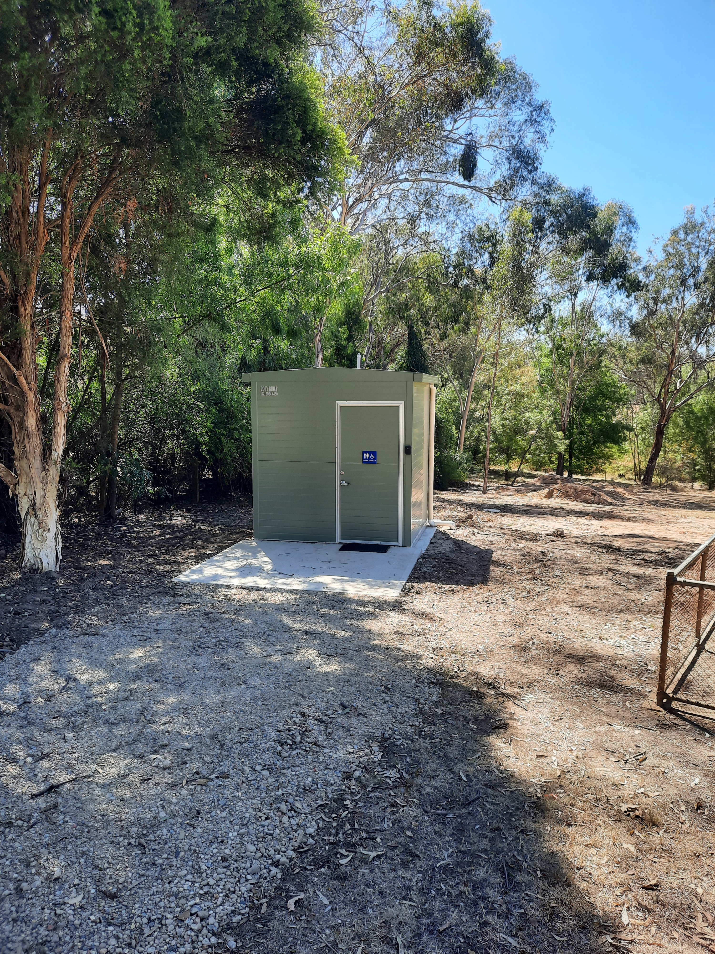
Barnawartha Cemetery Trust has completed a project to construct a unisex all-abilities toilet facility at Barnawartha Cemetery.
The trust received a grant of $20,625 for the project through the department’s Cemetery Grants Program.
This project is a fantastic example of a trust establishing a facility that benefits all cemetery visitors.

Class A cemetery trust member appointments
We would like to congratulate recent appointees to the five Class A cemetery trusts.
Twenty trust members have been appointed and their positions began on 1 July 2024. The department received a large number of applications and the field was extremely competitive.
The composition of Class A trusts can be found on each trust’s website:
- Ballarat General Cemeteries Trust <https://ballaratcemeteries.com.au/about-us/our-board-reports-and-meetings>
- Geelong Cemeteries Trust <https://gct.net.au/about>
- Greater Metropolitan Cemeteries Trust <https://www.gmct.com.au/trust-members>
- Remembrance Parks Central Victoria <https://www.rpcv.org.au/the-trust>
- Southern Metropolitan Cemeteries Trust <https://smct.org.au/about-us/our-organisation/trust-members>.

Cemetery trust insurance
The Victorian Managed Insurance Authority (VMIA) is the Victorian Government’s insurer and risk advisor. VMIA provides insurance for all Victorian public cemetery trusts.

What does the policy cover?
The policy covers physical loss or damage to property from fire, vandalism, adverse weather events such as storm, flood, theft or accidental damage, and extra costs because of this damage.
It can extend to cover the cost of repairing or replacing plaques, headstones and memorials in cases of theft, vandalism, storm damage or impact where a right of interment holder lodges a claim through the trust for damages.

Are trust members covered by VMIA insurance?
VMIA Personal Accident Insurance coverage for accidental-bodily personal injury extends to trust members and authorised volunteers while performing duties for the trust.
Trust members are also protected by the Combined Liability Insurance for claims of negligence made against them by third parties.

Accessing the VMIA portal
VMIA has an online portal for its insurance clients <https://www.vmia.vic.gov.au/our-portals>. Trusts can login, check and update their contact details, lodge claims and download documents via the portal.

How to register
You can register for access to the VMIA portal on the VMIA website <https://www.vmia.vic.gov.au/portal>.

How to use the portal
- Login with your registered email and VMIA password to access the home screen.
- Select the current financial year in the dropdown box next to policy year.
- Select a policy: Click ‘Download Documents’ for the policy you need.
- Choose a document: Select a document (for example, Certificate of Currency) and click the download link to save it as a PDF.
- Access your profile: Click ‘View Organisation Profile’ from the home screen. You can edit details by clicking ‘Edit Organisation Details’ then ‘Edit Address’. Update address: Enter the new address, select it from the dropdown menu or type it manually, and click ‘Submit’.
To see the steps above, watch this YouTube video <https://www.youtube.com/watch?v=s8q_8lPK8SY>.

Class B cemetery trust member appointments
Appointment round application deadline dates for membership terms due to expire on 31 October 2024
Members seeking reappointment whose terms of office expire on 31 October 2024 should submit their completed applications to their respective trusts for consideration as soon as possible.
Trusts must submit completed appointment application forms for members seeking reappointment to the department by 16 August 2024.
Note: If the department does not receive these applications by 16 August 2024, the applications cannot be processed before the members’ current terms of office expire.


Advertising for Class B cemetery trusts
Trusts and applicable members are contacted via email or letter approximately 5–6 months before members’ term expiry dates regarding information about the application process for members seeking reappointment.
As part of the standard process, and as advised in the notification, the department may arrange an advertisement for the upcoming vacancies to be placed in trusts’ first preference publication.
The list of preferred publications nominated by each trust can be downloaded from the department’s Recruitment and advertising webpage <https://www.health.vic.gov.au/cemeteries-and-crematoria/recruitment-and-advertising>.
Because advertisements are only placed in one publication for each trust, trusts should carefully consider their preference and contact the department by email if they wish to update their preferred publication.
In addition to advertising funded by the department, cemetery trusts should develop their own recruitment strategies using community networking, online recruitment and social media.
More information is available in the Recruitment toolkit for Class B cemetery trusts <https://www.health.vic.gov.au/cemeteries-and-crematoria/recruitment-and-advertising>.


Did you know?

Pedestrian access to public cemeteries
Does your trust restrict pedestrian access to a cemetery at certain times?
If a cemetery is not always open to pedestrian access, the trust must display the hours that pedestrian access is available at the main entrance and other prominent places within the cemetery.

What is the right of interment permit?
The right of interment permit is a document developed by the department for cemetery trusts to use when someone purchases a right of interment.
The permit can be used for rights of interment for bodily remains and/or cremated remains.
We recommend that cemetery trusts use the permit because it records important information for right of interment holders and ensures cemetery trusts are collecting the information required in the Cemeteries and Crematoria Regulations 2015.
Cemetery trusts can complete the permit, keep a digital or hard copy, and provide the original permit to the right of interment holders.
The permit can be downloaded from the department’s Right of interment permit webpage <https://www.health.vic.gov.au/cemeteries-and-crematoria/right-of-interment-permit>.
Page 1 of the right of interment permit:
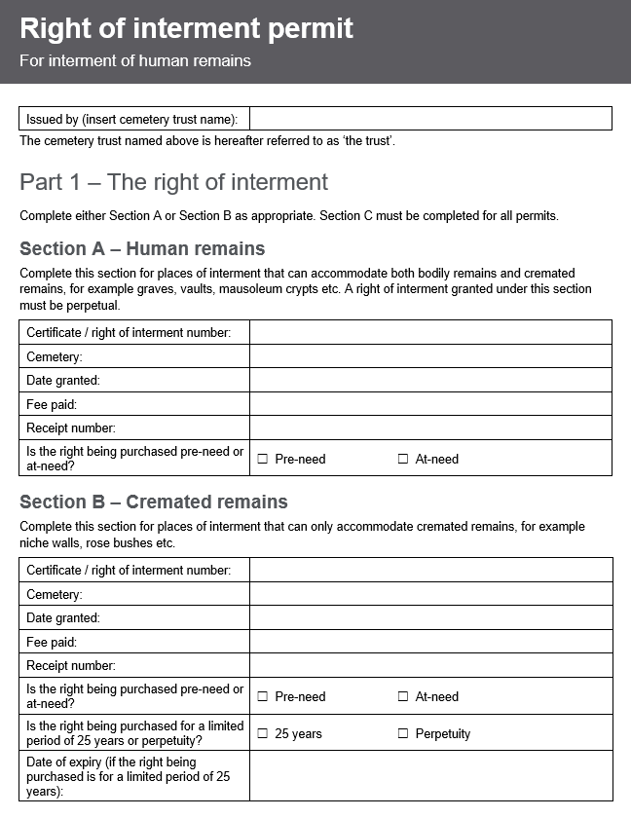


Investing
A cemetery trust may invest its money in any way it sees fit to optimise its financial position.
If using term deposits or high-interest accounts, it is important that trusts regularly review their investment income to ensure the products being used by a trust are providing a competitive market return.
As part of a long-term financial strategy, trusts could consider using shares to help fund perpetual cemetery maintenance (for example, an index fund).
The department recommends that trusts seek professional advice (for example, a financial advisor) for investment strategies.


Data security reporting
Cemetery trusts are required to meet data security reporting obligations under the Privacy and Data Protection Act 2014.
Data security reporting for 2022–23 and 2023–24 is due to the Office of the Victorian Information Commissioner (OVIC) by 31 August 2024.

Class A cemetery trusts
Class A cemetery trusts are to report by completing the Single Organisation Protective Data Security Plan (PDSP) available on the OVIC website <https://ovic.vic.gov.au/information-security/agency-reporting-obligations/vps-stakeholders/>.

Class B cemetery trusts
Class B cemetery trusts are to report by completing the Class B cemetery trust PDSP available on the OVIC website <https://ovic.vic.gov.au/information-security/agency-reporting-obligations/class-b-cemetery-trust-stakeholders/>. There is also a ‘how to’ guide on the website to help Class B cemetery trusts complete the PDSP report.

Contact OVIC
For assistance, please contact OVIC by calling 1300 006 842 or email OVIC <security@ovic.vic.gov.au>.


Free governance training
Free face-to-face governance training workshops for Class A and Class B cemetery trusts are held across Victoria and are delivered by the Institute of Community Directors Australia (ICDA), an enterprise of Our Community, on behalf of the department.
To register for an upcoming workshop in your area please visit the ICDA website <https://communitydirectors.com. au/training/victorian-cemetery-trusts-governance-and-operational-training>.
For help with registrations or to arrange a workshop in your area by request, please contact Our Community:
Phone: 1300 137 475
Email: <learn@ourcommunity.com.au>

Class B online training
The department has developed a free online training program called Cemetery Essentials for Class B Cemetery Trusts.
If you would like to take part, please email Our Community <learn@ourcommunity.com.au> to request an invitation.
Please note: To access the course, participants need to have an email address.

Links to key resources
- Manual for Victorian Class B cemetery trusts <https://www.health.vic.gov.au/publications/manual-for-victorian-class-b-cemetery-trusts>
- Recruitment toolkit for Class B cemetery trusts <https://www.health.vic.gov.au/cemeteries-and-crematoria/recruitment-and-advertising>
- Secretary’s handbook: guidance for Class B cemetery trust secretaries <https://www.health.vic.gov.au/cemeteries-and-crematoria/class-b-cemetery-trust-governance>
- Records management handbook: guidance for Class B cemetery trusts <https://www.health.vic.gov.au/cemeteries-and-crematoria/cemetery-trust-records-management>
- Right of interment permit and factsheet <https://www.health.vic.gov.au/cemeteries-and-crematoria/right-of-interment-permit>
- Policy templates <https://www.health.vic.gov.au/cemeteries-and-crematoria/policy-templates>
- Conflict of interest management plan template for Class B cemetery trusts <https://www.health.vic.gov.au/cemeteries-and-crematoria/class-b-cemetery-trust-governance>

To receive this document in another format, phone 1800 034 280, using the National Relay Service 13 36 77 if required, or email the department <cemeteries@health.vic.gov.au>.
Authorised and published by the Victorian Government, 1 Treasury Place, Melbourne.
© State of Victoria, Australia, Department of Health, July 2024
SSN 2208-8830 (print) 2208-8849 (online/PDF/Word)
Available on the Cemeteries and Crematoria website <https://www.health.vic.gov.au/cemeteries-and-crematoria/cemetery-sector-newsletters>.
Printed by Snap, Docklands

