Victorian Integrated Non-Admitted Health Minimum Data Set (VINAH MDS) manual 2024-25
Section 5c – HL7 reference and implementation guide
19th edition, July 2024
Version 1.0
OFFICIAL


To receive this publication in an accessible format email HDSS helpdesk <hdss.helpdesk@health.vic.gov.au>.
Authorised and published by the Victorian Government, 1 Treasury Place, Melbourne.
© State of Victoria, Australia, Department of Health, July 2024.
Except where otherwise indicated, the images in this document show models and illustrative settings only, and do not necessarily depict actual services, facilities or recipients of services. This document may contain images of deceased Aboriginal and Torres Strait Islander peoples.
In this document, ‘Aboriginal’ refers to both Aboriginal and Torres Strait Islander people. ‘Indigenous’ or ‘Koori/Koorie’ is retained when part of the title of a report, program or quotation.

ISBN 978-1-76131-678-4 (pdf/online/MS word)
Available at VINAH minimum data set <https://www.health.vic.gov.au/data-reporting/victorian-integrated-non-admitted-health-vinah-dataset>

Contents
Introduction 1
How to use 1
Intended audience 1
Use of this document 1
Limitations 1
Referenced documents 1
HL7 message actions 2
Insert messages 2
Update messages 2
Delete messages 2
Merge messages 2
HL7 file assembly 3
File contents 3
HL7 conceptual structure 3
File 3
Batch 3
Message/Record 3
Packaging methods 4
Message templates 4
Generating data from a binding table 4
Message template binding 4
Processing options 5
Business rule processing modes 5
Purge after load 5
About the A08 5
HL7 reference - global and required settings 5
Messaging standard 5
Message encoding rules 6
Message delimiters 6
Character set 6
Validation tables 7
Referenced documents 7
Message set representation 7
Definition 7
Components 7
Use case model 8
Data element binding 8
Dynamic definitions 8
Static definitions 8
Message level profile (textual description) 8
Segment and field level profiles 8
Dates and times 9
Usage 9
Cardinality 10
File and batch structures 11
Message FILE 11
Message BATCH 11
Data element binding 12
HL7 message composite type definitions 12
Composite CE 12
Composite CWE 12
Composite CX 13
Composite DTM 13
Composite EI 13
Composite FN 14
Composite HD 14
Composite MSG 14
Composite PL 14
Composite PT 14
Composite TS 14
Composite VID 15
Composite XAD 15
Composite XCN 15
Composite XON 15
Composite XPN 15
Message segment definitions 16
Segment BHS 16
Segment BTS 16
Segment ERR 17
Segment EVN 17
Segment FHS 17
Segment FTS 18
Segment MRG 18
Segment MSA 18
Segment MSH 18
Segment NK1 19
Segment OBR 20
Segment OBX 20
Segment PD1 21
Segment PDA 21
Segment PID 22
Segment PR1 23
Segment PRB 24
Segment PRD 24
Segment PTH 24
Segment PV1 25
Segment PV2 26
Segment RF1 26
Segment ROL 27
HL7 message set profiles 28
Transaction summary 28
Data element binding 29
Client registration message set 29
Client – Insert 29
Message ADT_A04 29
Client – Update 30
Message ADT_A08 30
Client – Merge 31
Message ADT_A40 32
Episode message set 32
Episode – Insert 32
Message PPP_PCB 32
Episode – Update 33
Message PPP_PCC 34
Episode – Delete 35
Message PPP_PCD 36
Message ACK_PCD 36
Contact message set 37
Complete contact 37
Message ADT_A03 38
Update contact 39
Message ADT_A08 40
Message ACK_A08 41
Delete contact 42
Message ADT_A13 43
Message ACK_A13 43
Client referral message set 43
Receive client referral 43
Message RRI_I12 45
RRI_I12.PV1 45
Send client referral 46
Message REF_I12 47
Message RRI_I12 47
Update client referral 47
Dynamic interaction model 48
Message REF_I13 48
Message RRI_I13 48
Delete client referral 49
Message REF_I14 50
Message RRI_I14 50

Introduction
This section of the VINAH MDS manual specifies best practice for designing and implementing software to generate VINAH MDS HL7 transmissions and maintain compliance with submission requirements over time.

How to use

Intended audience
This section of the manual is intended for use primarily by software designers and developers responsible for implementation of the VINAH MDS in the information systems used by agencies.

Use of this document
This document is a guide only. Compliance with all aspects of this implementation guide is not mandatory or measurable by the Department. Health care organisations may reference this standard when specifying requirements for their software.
Where this guide is inconsistent with other parts of the VINAH MDS manual, those other parts will take precedence. If any errors or inconsistencies are found, please notify the HDSS Helpdesk.

Limitations
Applying principles outlined in this implementation guide either in part or in full may not guarantee compliance with the requirements of the data collection. This document is a guide for software developers to develop an understanding of the mechanics of the VINAH MDS data submission lifecycle.
This document provides guidance around the best practices for the VINAH MDS submission process. The usage of methods outlined within this document does not imply acceptance of any product or process by the Department.
The Department is willing on request (where possible and appropriate) to review specifications by vendors designing software systems, but such review does not constitute acceptance, sign off or certification of those specifications.

Referenced documents
This document, along with the other sections that comprise the VINAH MDS manual, should be read in conjunction with the following references:
HL7 Messaging Standard Version 2.5, Health Level Seven Inc., 2003
HL7 V2.x Message Profiling Specification V2.2, Health Level Seven Inc., 2000
For more information about HL7, see HL7 standard webpage <http://www.hl7.org/>

HL7 message actions
Message actions are dictated by the message type itself (for example, an ADT_A04 is an insert; an ADT_A08 is an update). The message actions are further defined in the HL7 message set profiles.

Insert messages
An insert message will fail if a previous insert message has been sent and accepted.

Update messages
An update message will fail if a previous insert message has not been sent and accepted.
An update message cannot be used to perform an insert where the sending system is unsure whether an original insert has been sent and accepted.
In all cases, an update message will overwrite data in all fields related to the message; the implication of this is that all fields in the message must be populated with the correct data values regardless of whether they have changed or not. For example, if a Patient/Client's locality changes and triggers an A08 message, all fields on the A08 must be populated with the Patient/Client's current details, not just the locality field. The data transmitted in the A08 will overwrite all data transmitted in the A04 or previous A08 messages.

Delete messages
A delete message will fail if a previous insert message has not been sent and accepted.
In the case of delete messages, all data content is ignored except the key fields (e.g.: Episode Identifier, Identifier Type, and Local Identifier Assigning Authority on the PPPPCD). However, if data other than the key values are submitted on these messages, it must be valid.
Where records refer to parent records, the deletion of the higher-level entity will automatically delete all included lower-level entities. For example, when a PPP_PCD message is sent to delete an Episode, any contacts attached to the episode will be removed from the VINAH MDS repository. If it was desired to keep the contacts but attach them to a different episode, the submitting organisation system should, in the previous example, either send ADT_A08 update messages to alter the Episode Identifier to refer to the new parent episode before sending the PPP_PCD or resend the ADT_A03 contact messages with the new episode identifiers after sending the PPP_PCD.
It should be noted that where a submission that has performed deletes is rolled back (purged), the records deleted as a result of that submission will be reinstated; this includes any lower-level entities that were deleted automatically.

Merge messages
Merge messages will merge two previously accepted messages into one. All records that refer to the Prior Identifier will be updated to refer to the New Identifier. The Prior Record is then deleted, although it can be re-created through an ADT_A04 message after this point.

HL7 file assembly

File contents
VINAH MDS system designers should create logic to send the correct codes and meet business rules for the VINAH MDS version they are transmitting in. It is not acceptable to simply pass whatever code was stored in the Patient Administration System (PAS) or activity system, as these codes change over time.

HL7 conceptual structure
With a wide variety of health care administration software systems implementing the VINAH MDS, there are some simple ways to extend existing software to support VINAH MDS submissions.

File
A VINAH MDS submission file is a group of batches that are compiled into a HL7 text file for submission to the Department. A file contains one or more batches of messages which contain information covering a certain period of time, or certain data.
In HL7, the file header and footer are defined using the HL7 FHS and FTS segments, outlined in the HL7 reference section of this document.

Batch
In HL7, batch transaction boundaries are defined using the HL7 BHS and BTS segments, outlined in the HL7 reference section of this document. For more information on the behaviour and layout of batches, see Section 5b – VINAH MDS transaction implementation guide.

Message/Record
A VINAH MDS record is a set of data that is generated as a result of an event occurring in a clinical or administrative setting. This set of data is defined by the data concepts outlined in Section 2 of the manual, and its data elements defined in Section 3.
In most cases, health care administration software can identify existing data structures that by themselves can be considered VINAH MDS records. For example, a patient record in a PAS is analogous to a VINAH MDS patient registration, albeit a subset of some of the richer data elements available in a PAS. It is likely that the VINAH MDS record will be comprised of various tables or records within the system, and logic should be implemented to extract and combine these data for the purposes of VINAH MDS reporting.
In HL7, a message is defined using the HL7 MSH segments, outlined in the HL7 reference section of this document.

Packaging methods
There are several different options available when it comes to assembling the required data elements into HL7 methods. This section explores a few possible solutions.

Message templates
With this approach each entity/action combination (i.e. Patient/Insert, Episode/Update) has a pre-defined HL7 message template used as a base. For example, the Patient/Insert message, assigned to the ADT_A04 message could be assembled from a template as such:
MSH|^~\&||<OrgID>||AUSDHSV|<MessageDT>||ADT^A04^ADT_A01|<MessageControlID>|P|2.5|||NE|NE|AU|ASCII
EVN|A04|<MessageDT>
PID|1||<PatientIdentifer>^^^<LocalIDAssignAuth>^A||<PatientName>^^^^^^S||<DateOfBirth>|1||4|^^<Locality>^^<PostCode>||||||||||||<CountryOfBirth>|||||||||<DateOfBirthAccuracy>
PD1||2
NK1|<CarerResidencyStatus>||1||||||||||||||||||2
PV1|1|O||||^^^^^1
(Note template is a sample only and may not be complete)
Using the above template, the placeholders marked between angled brackets can be replaced with data values from the record. There are some challenges to be met when generating HL7 fields that repeat.

Generating data from a binding table
The binding table that forms Appendix A can be used to bind data to a message, combined with the message segment grammar listed in the Message Set Profiles for each message, e.g.:
MSH [ EVN ] PID PD1 NK1 PV1
HL7 segments and fields are populated using the defined delimiters – (|^~) based on positions specified in the binding tables.
For example, the field Patient/Client Birth Country has a location of PID.23 (PID segment, field 23), which could be generated to have a value of 1100 (not withstanding other required fields in the PID segment) as:
PID||||||||||||||||||||||||||||||||1100

Message template binding
A hybrid of the two approaches described in this section can be used, where a template is generated from the binding tables and substitutions made.

Processing options
Some processing options can be included in the FileHeaderComment field (FHS.10) of the FHS segment to perform additional functions during the load process. It is suggested that VINAH MDS software suppliers allow these processing options to be configured by the user performing the extract. Where multiple operators are included, they may be separated by a semi colon (;) character.

Business rule processing modes
Processing modes to override or relax business rules are no longer supported in any version of the VINAH MDS.

Purge after load
During testing periods this option can be included to allow immediate rollback of a submission from the VINAH MDS repository. This is useful if an individual submission is to be tested against the business rules but is not to be stored long term. Any updates/deletes to existing data held within the VINAH MDS repository will be performed but rolled back to their original state.
The operator is: PurgeAfterLoad=True;
e.g.: FHS|^~\&||ABCHS||AUSDHSV|20070101123401|||abchs2010401.hl7|PurgeAfterLoad=True;
Note that this option should be turned off during integrity testing and during full test/live submissions and should not be left on by default. Users should be warned during the extraction process that the data will not be stored by the Department, and this may affect compliance.

About the A08
The ADT_A08 message is used to send updates to both the Patient/Client (created with an insert A04 message) and the Contact (created with an insert A03 message.) The difference between an A08 used to update an A04 and an A08 used to update an A03 is the presence of an NK1 Segment on the A04 update.
The NK1 Segment is used to transmit the information about the patient/client's carer, that is, Carer availability, Carer residency status and Main carer's relationship to the patient. Although these data elements are optional for some programs and until the date of the first Contact the NK1 segment must be included on A04 and A08 messages used to update the A04, even if the relevant HL7 fields are left null.

HL7 reference - global and required settings

Messaging standard
The data to be supplied as the minimum data set will comply with the HL7 v2.5 standard format.
HL7 v2.5 was used for this interface to take advantage of the use of message conformance profiles. Where the specification uses components introduced are new to version 2.5 this will be highlighted in the document. There are two instances where this occurs:
- The MSG Composite replaces the CM Composite documented in the MSH Segment prior to version 2.5, however the implementation is identical and is only a terminological change.
- The XON.10 field used to transmit the Contact Provider value is new to version 2.5.

Message encoding rules
Submission data will be encoded according to the HL7 standard message encoding rules to generate variable length delimited messages as the default. This sub-section provides specifications for constructing messages in this format. A single transmission cannot combine encoding formats.

Message delimiters
The following delimiters shall be used for messages:
Delimiter | Suggested value | Encoding character position | Usage
Segment Terminator | <cr> | - | Terminates a segment record. This value cannot be changed by implementers.
Field Separator | | | - | Separates two adjacent data fields within a segment. It also separates the segment ID from the first data field in each segment.
Component Separator | ^ | 1 | Separates adjacent components of data fields where allowed.
Subcomponent Separator | & | 4 | Separates adjacent subcomponents of data fields where allowed. If there are no subcomponents, this character may be omitted.
Repetition Separator | ~ | 2 | Separates multiple occurrences of a field where allowed.
Escape Character | \ | 3 | Escape character for use with any field represented by an ST, TX or FT data type, or for use with the data (fourth) component of the ED data type. If no escape characters are used in a message, this character may be omitted. However, it must be present if subcomponents are used in the message.

Character set
The file shall use 7 bit-ASCII character set encoding.

Validation tables
Validation tables referenced in this section are listed in Section 9 – Code list of this manual.
Note that wherever possible HL7 user-defined tables have been used. However, where the table is for a VINAH MDS data item, the values listed in the validation table that represent code lists in Section 9 will be the set valid for the minimum data set (which are generally also listed in Section 3 of the manual, under the relevant data item). Note that these values may not be the HL7 suggested values, nor the values used within a particular site for other HL7 implementations.

Referenced documents
This document should be read in conjunction with the following references:
- HL7 Messaging Standard Version 2.5, Health Level Seven Inc., 2003
- HL7 V2.x Message Profiling Specification V2.2, Health Level Seven Inc., 2000
For more information about HL7, see http://www.hl7.org/

Message set representation

Definition
Each of the specified message sets are defined in this section as HL7 V2.x Message Profiles. A message profile is defined as follows:
An HL7 V2.x Message Profile is a precise and unambiguous specification of a standard HL7 message that has been analysed for use within a particular set of requirements. It is a particular style or usage of a standard HL7 message, driven by use case analysis and interaction modelling.
An HL7 V2.x Message Profile defines both the static structure and content of the message and the dynamic interaction, which involves the communication of the message from the sending application to one or more receiving applications.
HL7 V2.x Message Profiles must consist of the following components:
Use Case Model - this may be a use case diagram supported with text or just a textual description
Static Definition – consisting of Message Level Profile, Segment Level Profile, and Field Level Profile
Dynamic Definition – consisting of an Interaction Model and Dynamic Profile
An HL7 V2.x Message Profile is compliant, in all aspects, with the HL7 defined message it profiles, although it may specify constraints on the standard HL7 message definition.
Refer Health Level Seven, Message Profiling Specification, Version 2.2, 30 November 2000, page 4 for further information.

Components
In this section, the components of each message profile are detailed under the following headings:

Use case model
This sub-section details the functional requirements that form part of the requirements for the VINAH MDS. The functional requirements are documented as a “use case model”, “actor definitions” and detailed “use cases”.

Data element binding
A mapping of the VINAH MDS data elements defined in Section 3 to fields in a given HL7 message is detailed after the use cases for each message set. This data element binding is intended to provide traceability from the VINAH MDS data element specified in Section 3 to its representation in the HL7 message structure.

Dynamic definitions
This sub-section details the system interactions and the HL7 acknowledgment protocols that apply for each interaction.

Static definitions
This sub-section details the static structures, format and contents of each of the applicable messages within the interaction model. The Message Segments that make up the Message Sets are defined once each in the Message Segment sub-section to avoid repetition.

Message level profile (textual description)
Each message is defined in special notation that lists the segment IDs in the order they would appear in the message.
Braces, { . . . }, indicate one or more repetitions of the enclosed group of segments of course, the group may contain only a single segment.
Brackets, [ . . . ], show that the enclosed group of segments is optional.
If a group of segments is optional and may repeat it will be enclosed in brackets and braces, [{ . . .}].
Whenever braces or brackets enclose more than one segment ID a special stylistic convention is used to help the reader understand the hierarchy of repetition. For example, the first segment ID appears on the same line as the brace, two columns to the right. The subsequent segment IDs appear under the first. The closing brace appears on a line of its own in the same column as the opening brace. This convention is an optional convenience to the user. If there is conflict between its use and the braces that appear in a message schematic, the braces define the actual grouping of segments that is permitted.
Segments and fields NOT required in this implementation are not included in this document.

Segment and field level profiles
Each segment and field is described in static detail including the following parameters for elements:
Name: | The HL7 element name.
Sequence: | The sequence reference number for each element.
Data Type: | The HL7 data type for this element. Where a data type is made up of sub-types (composite) the structure of the sub-type will be described immediately below and indented.
Usage: | Describes the usage and optional nature of each element. Interpretations of the usage codes are listed below.
Length: | The maximum length for each element, including components, sub-components and delimiters.
Cardinality: | This expands on the usage code by describing the number of possible occurrences (cardinality) of each component. A full description of cardinality is listed below.
Fixed Value: | Where the value for a field is fixed, the value is indicated in this column.
Table: | Where an element uses values from a defined set, the HL7 table reference number will be listed here. Where an element uses a subset of values from a referenced table, a lower case letter indicating the subset referenced will follow the table number.

Dates and times
Note: The maximum precision of date/time formats is “YYYYMMDDHS.SSSS±ZZZZ” providing accuracy to milliseconds; however truncated values are allowed if the data source has less accuracy, i.e. "YYYYMM" to show the month or "YYYY" to show the year only.
Note, however, that certain validation edits may require a minimum level of date accuracy.
Some example date/time values are shown below:
Date | Representation
Year 2018 | 2018
March 2018 | 201803
3 March 2018 | 20180303
3 March 2018 1:53 PM AEST | 201803031353+1000
3 March 2018 03:53:55 1528 milliseconds UTC | 20180303015355.1528+0000

Usage
Usage refers to the circumstances under which an item (segment group, segment, data item) appears in a message. Some items must always be present, others may never be present, and others may only be present in certain circumstances. A set of codes has been defined to clearly identify the rules governing the presence of a particular item. The rules govern the expected behaviour of both the sending and receiving application with respect to the item. The codes are:
Usage code | Description | Comments
R | Required | The item must be present in the message.  MANDATORY  Messages missing data items that are mandatory due to HL7 or profile requirements may be rejected by the receiving software.
O | The field is optional | The item may be missing from the message but must be sent and understood by the sending/receiving application if there is relevant data.  DESIRABLE  All data items that are available to the sending system software must be sent in the message.  All data items that have been entered and/or captured by the sending system software must be sent in the message.
C | Conditional | The item must be present if the specified condition predicate is true. Otherwise, the item must not be present.
X | Not supported | For sending applications, the item will not be sent. For receiving applications, the item group will be ignored if sent.
Note that the tables defined in the sub-sections below only include items that are required, optional or conditional. Omission of an item (i.e. segment, field, component) implies that the item is not supported i.e. the receiving application will ignore the item if sent.

Cardinality
Cardinality identifies the minimum and maximum number of repetitions for a particular item (segment group, segment or data item). Cardinalities are expressed as a minimum-maximum pair of non-negative integers (such that the minimum is less than or equal to the maximum). A conformant application must always send at least the minimum number of repetitions and may never send more than the maximum number of repetitions.
Cardinality may be defined as follows:
Cardinality | Description
[0..0] | Element never present
[0..1] | Element may be omitted and it can have at most one occurrence
[1..1] | Element must have exactly one occurrence
[0..n] | Element may be omitted or may repeat up to n times
[1..n] | Element must appear at least once, and may repeat up to n times
[0..*] | Element may be omitted or repeat for an unlimited number of times
[1..*] | Element must appear at least once, and may repeat unlimited number of times
[m..n] | Element must appear at least “m” and at most ”n” times

File and batch structures
VINAH MDS data is to be transmitted to the Department as a file containing one or more batches of one or more HL7 messages. For segment definitions, see the Message Segment Definitions sub-section below.
Please note, data acceptance and rejection is processed at the batch level i.e. an entire batch passes or fails validation based on validation rules applied to messages and the information they contain. Developers may wish to consider structuring transmissions such that one batch contains messages that relate to one client in order to isolate errors.

Message FILE
Item | Description
FHS
{ (1 – n)
BHS
{ (0 - n)
MSH... (Message Set Messages)
}
BTS
}
FTS

Message BATCH
Item | Description
BHS
{ (0 – n)
MSH... (Message Set Messages)
}
BTS

Data element binding
Message | Data element name | HL7 attribute name | Location | Value domain
BATCH | Batch Control Identifier | BatchControlID | BHS.11 | Identifier
BATCH | Message Date and Time | BatchCreationDate/Time (DateTime) | BHS.7\TS.1 | Date/Time
BATCH | Organisation Identifier | BatchSendingFacility(NamespaceID) | BHS.4\HD.1 | HL70362
FILE | Message Date and Time | FileCreationDate/Time (DateTime) | FHS.7\TS.1 | Date/Time
FILE | Organisation Identifier | BatchSendingFacility(NamespaceID) | FHS.4\HD.1 | HL70362
FILE | VINAH Version | FileReceivingApplication | FHS.5 | 990037

HL7 message composite type definitions
This sub-section defines the Message Data Types that comprise the HL7 messages used for transmission of VINAH MDS data. This section should be read in conjunction with each Message Segment definition. Message composites in the Message Segment definition override those listed here.

Composite CE
 | Name | Data type | Required | Length | Fixed value | Validation table
1 | Identifier | ST | Required | 0. .20
3 | NameOfCodingSystem | ID | Conditional | 0 .20
4 | AlternateIdentifier | ST | Conditional | 0. .199

Composite CWE
 | Name | Data type | Required | Length | Fixed value | Validation table
1 | Identifier | ST | Required | 0. .20
2 | Text | ST | Optional | 0. .199
7 | CodingSystemVersionID | ST | Conditional | 0. .10

Composite CX
 | Name | Data type | Required | Length | Fixed value | Validation table
1 | IDNumber | ST | Required | 0. .15
4 | AssigningAuthority | HD | Required | 0. .227 |  | HL70300  HL70362  HL70363
5 | IdentifierTypeCode | ID | Required | 0. .5 |  | HL70203

CX.4 (AssigningAuthority)
AssigningAuthority takes its value from one of the listed reference tables based on the value of CX.5; see Identifier Type in Section 3, Part 2 for further information.

CX.5 (IdentifierTypeCode)
See Identifier Type in Section 3, Part 2 for further information about the use of IdentifierTypeCode.

Composite DTM
 | Name | Data type | Required | Length | Fixed value | Validation table
1 | Year | 2 Byte Short | Required | 4. .4
2 | Month | 2 Byte Short | Required | 2. .2
3 | Day | 2 Byte Short | Required | 2. .2
4 | Hours | 2 Byte Short | Required | 2. .2
5 | Minutes | 2 Byte Short | Required | 2. .2
6 | Seconds | 2 Byte Short | Required | 2. .2 | .

Composite EI
 | Name | Data type | Required | Length | Fixed value | Validation table
1 | EntityIdentifier | ST | Required | 0. .199
2 | NamespaceID | IS | Required | 0. .20 |  | HL70363

Composite FN
 | Name | Data type | Required | Length | Fixed value | Validation table
1 | Surname | ST | Required | 0. .50

Composite HD
 | Name | Data type | Required | Length | Fixed value | Validation table
1 | NamespaceID |  | Required

Composite MSG
The MSG composite is new to HL7 version 2.5. It replaces the discontinued CM data type documented in version 2.4 for the MSH message but is identical in implementation.
 | Name | Data type | Required | Length | Fixed value | Validation table
1 | MessageType | ID | Required | 0. .3 |  | HL70076
2 | TriggerEvent | ID | Required | 0. .3 |  | HL70003
3 | MessageStructure | ID | Required | 0. .8 |  | HL70354

Composite PL
 | Name | Data type | Required | Length | Fixed value | Validation table
6 | PatientLocationType | IS | Required | 0. .1

Composite PT
 | Name | Data type | Required | Length | Fixed value | Validation table
1 | ProcessingID | ID | Required | 0. .1 |  | HL70103

Composite TS
 | Name | Data type | Required | Length | Fixed value | Validation table
1 | Time | DTM | Required | 0. .24

Composite VID
 | Name | Data type | Required | Length | Fixed value | Validation table
1 | VersionID | ID | Optional | 0. .5 | 2.5 | HL70104

Composite XAD
 | Name | Data type | Required | Length | Fixed value | Validation table
3 | City | ST | Required | 0. .50 | 2.5 | 990025
5 | ZipOrPostalCode | ST | Required | 0. .12 |  | 990025

Composite XCN
 | Name | Data type | Required | Length | Fixed value | Validation table
1 | IDNumber | ST | Required |  |  | 990035
8 | SourceTable | ST | Required |  |  | 990035

Composite XON
Note that XON.10 is new to HL7 v2.5.
 | Name | Data type | Required | Length | Fixed value | Validation table
1 | OrganisationName | ST | Required | 0. .50

Composite XPN
 | Name | Data type | Required | Length | Fixed value | Validation table
1 | FamilyName | FN | Required | 0. .194
7 | NameType | ID | Required | 0. .5 | S | HL70200

Message segment definitions
This sub-section defines the Message Segments that comprise the HL7 messages used for transmission of VINAH MDS data and any composite data types used in those message segments.

Segment BHS
 | Name | Data type | Required | Length | Cardinality | Fixed value | Validation table
1 | FieldSeparator | ST | Required | 1. .1 | 1. .1 | |
2 | EncodingCharacters | ST | Required | 3. .3 | 1. .1 | ^~\&
4 | BatchSendingFacility | HD | Required | 0. .227 | 1. .1 |  | HL70362
6 | BatchReceivingFacility | HD | Required | 0. .227 | 1. .1 | AUSDHSV | HL70362
7 | BatchCreationDateTime | TS | Required | 0. .26 | 1. .1
10 | BatchComment | ST | Optional | 0. .80 | 1. .1
11 | BatchControlID | ST | Required | 0. .20 | 1. .1

BHS.6 (BatchReceivingFacility)
This field uses validation table HL70362, however the value for submitting to the VINAH MDS will be the fixed value of AUSDHSV.

BHS.11 (BatchControlID)
The Batch Control Identifier (BCID) is required and should be a unique identifier for each batch sent by a health service for the life of the VINAH MDS collection. The health service is responsible for supplying specific identifiers that meet these requirements and those specified in Section 3.

Segment BTS
 | Name | Data type | Required | Length | Cardinality | Fixed value | Validation table
1 | BatchMessageCount | ST | Required | 0. .10 | 1. .1
2 | BatchComment | ST | Optional | 0. .80 | 1. .1

BTS.1 (BatchMessageCount)
The batch message count should be equal to the total number of messages (or MSH Segments) in the file.

Segment ERR
 | Name | Data type | Required | Length | Cardinality | Fixed value | Validation table
3 | HL7ErrorCode | CWE | Required | 0. .705 | . .
4 | Severity | ID | Required | 0. .2 | . . |  | HL70516
5 | ApplicationErrorCode | CWE | Required | 0. .705 | . . |  | HL70357
6 | ApplicationErrorParameter | ST | Conditional | 0. .80 | 0. .10 |  | HL70533

ERR.3.1 (Identifier)
Validation table for the composite is applied to field 1 (Identifier) of the composite type.

Segment EVN
The HL7 standard specifies EVN segments as being required for several messages, however inclusion of the EVN segment in a VINAH MDS message is optional. No data elements are currently bound to any fields in the EVN segment. Its inclusion or exclusion will not cause a VINAH MDS message to reject. If included, it must comply with the HL7 standard to ensure it does not break validation.

Segment FHS
 | Name | Data type | Required | Length | Cardinality | Fixed value | Validation table
1 | FieldSeparator | ST | Required | 1. .1 | 1. .1 | |
2 | EncodingCharacters | ST | Required | 4. .4 | 1. .1 | ^~\&
3 | File sending Application | HD | Required | 3. .3 | 1. .1 |  | HL70361
4 | FileSendingFacility | HD | Required | 0. .227 | 1. .1 |  | HL70362
5 | FileReceivingApplication | ST | Required | 0. .15 | 1. .1 |  | 990037
6 | FileReceivingFacility | HD | Required | 0. .227 | 1. .1 | AUSDHSV | HL70362

FHS.5 (FileReceivingApplication)
This field is used from 2007-08 to assist transition processing and monitor compliance with annual changes to the VINAH MDS version.

FHS.6 (FileReceivingFacility)
This field uses validation table HL770362, however the value for submitting to the VINAH MDS will be the fixed value ‘AUSDHSV’.

Segment FTS
 | Name | Data type | Required | Length | Cardinality | Fixed value | Validation table
1 | FileBatchCount | NM | Required | 0. .10 | 1. .1
2 | FileTrailerComment | ST | Optional | 0. .80 | 1. .1

Segment MRG
 | Name | Data type | Required | Length | Cardinality | Fixed value | Validation table
1 | PriorPatientIdentifierList | CX | Required | 0. .250 | 1. .1

Segment MSA
 | Name | Data type | Required | Length | Cardinality | Fixed value | Validation table
1 | AcknowledgementCode | ID | Required | 0. .2 |  |  | HL70008
2 | MessageControlID | ST | Required | 0. .20

Segment MSH
 | Name | Data type | Required | Length | Cardinality | Fixed value | Validation table
1 | FieldSeparator | ST | Required | 0. .1 | 1. .1 | |
2 | EncodingCharacters | ST | Required | 0. .4 | 1. .1 | ^~\&
4 | SendingFacility | HD | Required | 0. .227 | 1. .1 |  | HL70362
6 | ReceivingFacility | HD | Required | 0. .227 | 1. .1 |  | HL70362
7 | DateTimeOfMessage | TS | Required | 0. .26 | 1. .1
9 | MessageType | MSG | Required | 0. .15 | 1. .1
10 | MessageControlID | ST | Required | 0. .20 | 1. .1
11 | ProcessingID | PT | Required | 0. .3 | 1. .1 |  | HL70103
12 | VersionID | VID | Required | 0. .60 | 1. .1 | 2.5 | HL70104
15 | AcceptAcknowledgement Type | ID | Required | 0. .2 | 1. .1 | NE | HL70155
16 | ApplicationAcknowledgement Type | ID | Required | 0. .2 | 1. .1 | NE | HL70155
17 | CountryCode | ID | Required | 0. .3 | 1. .1 | AU | HL70399
18 | CharacterSet | ID | Required | 0. .16 | 1. .1 | ASCII

MSH.1 (FieldSeparator)
This field contains the separator between the segment ID and the first ‘data submission’ field, MSH-2-encoding characters. As such it serves as the separator and defines the character to be used as a separator for the rest of the message. Recommended value is | (ASCII 124).

MSH.2 (EncodingCharacters)
This field contains the four characters in the following order: the component separator, repetition separator, escape character, and subcomponent separator. Recommended values are ^~\& (ASCII 94, 126, 92, and 38, respectively).

MSH.4 (SendingFacility)
This field contains the fixed value ‘AUSDHSV’ when the message is being sent by the Department (e.g.: ACK messages) in all other cases it should contain the appropriate value indicating the sending facility.

MSH.6 (ReceivingFacility)
This field must contain the fixed value ‘AUSDHSV’ when the message is being sent to the Department. In all other cases (e.g.: ACK messages sent by the Department) it will contain the appropriate value indicating the receiving facility.

Segment NK1
 | Name | Data type | Required | Length | Cardinality | Fixed value | Validation table
1 | SetID | SI | Required | 0. .4 | 1. .1 | 1
3 | Relationship | CE | Required | 0. .250 | 1. |  | missing
7 | ContactRole | CE | Conditional | 0. .250 | 0. .1
21 | Living Arrangement | IS | Required | 0. .2 | 1. .1 |  | 990014

NK1.3 (Relationship)
Composite CE
 | Name | Data type | Required | Length | Fixed value | Validation table
1 | Identifier | ST | Required | 0. .20 |  | HL70063

NK1.7 (ContactRole)
Composite CE
 | Name | Data type | Required | Length | Fixed value | Validation table
1 | Identifier | ST | Required | 0. .20 |  | HL70131

Segment OBR
This segment is a placeholder for the outcome and outcome date associated with a Referral In, that is, it is required by the HL7 standard when the OBX is present for a Referral In. However, no VINAH MDS data elements are bound to its fields.
 | Name | Data type | Required | Length | Cardinality | Fixed value | Validation table
1 | Set ID – Observation request | ID | Required | 0. .2 | 1. .1 | 1
2 | Place Order Number | EI | Not Required | 0. .22 | 1. .1
43 | Planned Patient Transport Comment |  | Not Required | 0. | 1. .1

Segment OBX
Used in this implementation for two purposes;
- To code a health condition (i.e. diagnosis code) associated with a given episode.
- To code a Referral In outcome and associated outcome date.
 | Name | Data type | Required | Length | Cardinality | Fixed value | Validation table
1 | SetID | SI | Required | 0. .4 | 1. .1
2 | ValueType | ID | Required | 0. .3 | 1. .1 | CE | HL70125
3 | ObservationIdentifier | CE | Required | 0. .250 | 1. .1
7 | ReferencesRange* | ST | Required | 0. .60 | 0. .1
11 | ObservationResultStatus | ID | Required | 0. .1 | 1. .1 | F | HL70085
* Referral In Outcome Date (not required for episode items)

OBX.3 (ObservationIdentifier)
Composite CE
 | Name | Data type | Required | Length | Fixed value | Validation table
1 | Identifier | ST | Required | 0. .20 |  | 990033  990036  990080  HL70283
3 | NameOfCodingSystem | ID | Required | 0. .20 |  | HL70396

Segment PD1
 | Name | Data type | Required | Length | Cardinality | Fixed value | Validation table
2 | LivingArrangement | IS | Required | 0. .2 | 1. .1 |  | HL70220

Segment PDA
 | Name | Data type | Required | Length | Cardinality | Fixed value | Validation table
2 | DeathLocation | PL | Required | 0. .80 | 1. .1

PDA.2 (DeathLocation)
Composite PL
 | Name | Data type | Required | Length | Fixed value | Validation table
6 | PatientLocationType | IS | Required | 0. .1 |  | 990034

Segment PID
 | Name | Data type | Required | Length | Cardinality | Fixed value | Validation table
1 | SetID | SI | Required | 0. .4 | 1. .1 | 1
2 | CheckDigit | ST | Required | 0. .3 | 1. .1
3 | PatientIdentifierList | CX | Required | 1. .250 | 2. .5
5 | PatientName | XPN | Conditional | 0. .250 | 1. .5
7 | DateTimeOfBirth | TS | Required | 0. .26 | 1. .1
8 | Sex | IS | Required | 0. .1 | 1. .1 |  | HL70001
10 | Race | CE | Required | 0. .250 | 1. .1 |  | HL70005
11 | PatientAddress | XAD | Required | 0. .250 | 1. .1
15 | PrimaryLanguage | CE | Required | 0. .250 | 1. .1 |  | HL70296
23 | BirthPlace | ST | Required | 0. .250 | 1. .1 |  | HL70399
29 | PatientDeathDateAndTime | TS | Optional | 0. .26 | 0. .1
32 | IdentityReliabilityCode | IS | Required | 0. .20 | 0. .2 |  | HL70445
33 | Gender | CE | Optional | 0. .1 | 0. .1 |  | HL70002

PID.3 (Patient Identifier List)
Composite CX
 | Name | Data type | Required | Length | Fixed value | Validation table
3 | PatientIdentifierList | CXD | Required | 1. .250

PID.10 (Race)
Composite CE
 | Name | Data type | Required | Length | Fixed value | Validation table
1 | Identifier | ST | Required | 0. .20 |  | HL70005

PID.15 (Primary language)
Composite CE
 | Name | Data type | Required | Length | Fixed value | Validation table
1 | Identifier | ST | Required | 0. .20 |  | HL70296

PID.32 (IdentityReliabilityCode)
The first repetition of this field contains the data element Patient/Client Birth Date Accuracy code.
The second repetition of this field contains the data element Patient/Client Death Date Accuracy code and is required only if Date of deathPatient/Client Death Date (PID.29) is provided.

PID.33 (Gender)
Composite CE
 | Name | Data type | Required | Length | Fixed value | Validation table
1 | Identifier | ST | Mandatory | 0. .1 |  | HL70002

Segment PR1
 | Name | Data type | Required | Length | Cardinality | Fixed value | Validation table
1 | SetID | SI | Required | 0. .4 | 1. .1
3 | ContactPurpose | CW | Required | 0. .250 | 1. .1 |  | HL70230
5 | ProcedureDateTime | TS | Required | 0. .26 | 1. .1
6 | ProcedureFunctionalType | IS | Required | 0. .2 | 1. .1 |  | 990024

PROCEDURE.PR1.3 (ProcedureCode)
Composite CE
 | Name | Data type | Required | Length | Fixed value | Validation table
1 | Identifier | ST | Required | 0. .20 |  | HL70088

Segment PRB
This segment is a placeholder for the diagnoses and conditions associated with an episode, that is, it is required by the HL7 standard when the OBX is present but no VINAH MDS data elements are bound to its fields.
 | Name | Data type | Required | Length | Cardinality | Fixed value | Validation table
1 | ActionCode | ID | Required | 1. .2 | 2. .1 | AD | HL70287
2 | ActionDateTime | TS | Required | 0. .26 | 1. .1
3 | ProblemID | CE | Required | 1. .250 | 2. .1
4 | ProblemInstanceID | EI | Required | 0. .60 | 1. .1

Segment PRD
 | Name | Data type | Required | Length | Cardinality | Fixed value | Validation table
1 | ProviderRole | CE | Required | 0. .250 | 1. .1

PRD.ProviderRole.1 (ProviderRole)
Composite CE
 | Name | Data type | Required | Length | Fixed value | Validation table
1 | Identifier | ST | Required | 0. .20 | RP
4 | AlternateIdentifier | ST | Required | 0. .199

Segment PTH
The pathway segment contains the data necessary to add, update, correct, and delete from the record plans that are utilised to address an individual’s health care. In the VINAH MDS domain this segment contains details of the client’s goal plan.
 | Name | Data type | Required | Length | Cardinality | Fixed value | Validation table
1 | ActionCode | ID | Required | 0. .2 | 1. .1 | AD | HL70287
2 | PathwayID | CE | Required | 0. .250 | 1. .1
3 | PathwayInstanceID | EI | Required | 0. .60 | 1. .1
4 | PathwayEstablishedDateTime | TS | Conditional | 0. .26 | 1. .1
5 | PathwayLifeCycleStatus | CE | Required | 0. .1 | 1. .1 |  | 990050

Segment PV1
Segment PV1 is used in many VINAH MDS message sets. See the Message Set specifications for specific configurations of the PV1 in each set. As noted under Message Set Representation - usage fields not required will be ignored if sent. However, all usage fields present in the segment must conform to HL7 rules and contain valid codes.
 | Name | Data type | Required | Length | Cardinality | Fixed value | Validation table
1 | SetID | SI | Optional | 0. .4 | 1. .1 | 1
2 | PatientClass | IS | Required | 0. .1 | 1. .1 |  | HL70004
3 | AssignedPatientLocation | PL | Optional | 0. .80 | 0. .1 |  | HL70305
5 | PreadmitNumber | CX | Optional | 0. .250 | 0. .1
6 | PriorPatientLocation | PL | Optional | 1. .80 | 0. .1 |  | 990027
7 | AttendingDoctor | XCN | Optional | 0. .250 | 0. .1
10 | HospitalService | IS | Optional | 0. .3 | 0. .1 |  | HL70069
15 | AmbulatoryStatus | IS | Optional | 0. .2 | 0. .1 |  | HL70009
19 | VisitNumber | CX | Optional | 0. .250 | 0. .1
20 | FinancialClass | FC | Optional | 0. .50 | 0. .1 |  | HL70064
22 | CourtesyCode | IS | Optional? | 1. .9 | 0. .1
36 | DischargeDisposition | IS | Optional | 0. .3 | 0. .1 |  | HL70112
39 | ServicingFacility | IS | Optional | 0. .2 | 0. .1 |  | HL70115
44 | AdmitDateTime | TS | Optional | 0. .26 | 0. .1
45 | DischargeDateTime | TS | Optional | 0. .26 | 0. .1
51 | VisitIndicator | IS | Optional | 0. .1 | 0. .1 |  | HL70326

PV1.3 (AssignedPatientLocation)
Composite PL
 | Name | Data type | Required | Length | Fixed value | Validation table
6 | PatientLocationType | IS | Required | 0. .1 |  | HL70305

PV1.6 (PriorPatientLocation)
Composite PL
 | Name | Data type | Required | Length | Fixed value | Validation table
6 | PatientLocationType | IS | Required | 0. .1 |  | 990027

Segment PV2
 | Name | Data type | Required | Length | Cardinality | Fixed value | Validation table
7 | VisitUserCode | IS | Required | 1. .2 | 1. .1 |  | HL70130
18 | SpecialProgramCode | IS | Optional | 0. .2 | 0. .1 |  | 990090
23 | ClinicOrganisationName | XON | Required | 0. .250 | 1. .1 |  | 990012
24 | PatientStatusCode | IS | Optional | 0. .2 | 0. .1 |  | HL70216
40 | AdmissionLevelOfCareCode | CE | Optional | 0. .250 | 0. .1 |  | HL70432

PV2.23 (ClinicOrganisationName)
Composite XON
 | Name | Data type | Required | Length | Fixed value | Validation table
10 | OrganisationIdentifier | ST | Required | 0. .20 |  | 990012

Segment RF1
 | Name | Data type | Required | Length | Cardinality | Fixed value | Validation table
1 | ReferralOutcome | CE |  | 0. .250 | 1. .1 |  | HL70283
2 | ReferralPriority | CE | Optional | 0. .250 | 1. .1 |  | HL70280
6 | OriginatingReferral Identifier | EI | Required | 0. .30 | 0. .1
7 | EffectiveDate | DTM | Required | 0. .24 | 0. .1
8 | ReferralEndDate | DTM | Required | 0. .24 | 0. .1
9 | Process Date | DTM | Required | 0. .24 | 0. .2
10 | ReferralReason | CE | Required | 0. .1 | 1. .1 |  | 990095
11 | External Referral Identifier | EI | Required | 0. .30 | 0. .1

RF1.9 (Process Date)
The first repetition of this field contains the data element Referral in receipt acknowledgement date.
The second repetition of this field contains the data element Referral in clinical referral date and is required only if the Referral in program/stream indicates a Specialist Clinics (Outpatient) referral.

Segment ROL
 | Name | Data type | Required | Length | Cardinality | Fixed value | Validation table
1 | RoleInstanceID | EI | Required | 0. .60 | 1. .1
2 | ActionCode | ID | Required | 0. .2 | 1. .1 | AD | HL70287
3 | Role | CE | Required | 0. .250 | 1. .1
4 | RolePerson | XCN | Required | 0. .250 | 1. .1
9 | ProviderType | CE | Required | 0. .250 | 2. .1 |  | 990013
10 | ContactDeliveryMode | CE | Required | 0. .250 | 1. .1

ROL.9 (ProviderType)
Composite CE
 | Name | Data type | Required | Length | Fixed value | Validation table
1 | Identifier | ST | Required | 0. .20 |  | 990013

ROL.10 (OrganisationUnitType)
Composite CE
 | Name | Data type | Required | Length | Fixed value | Validation table
1 | Identifier | ST | Required | 0. .20 |  | HL70406

HL7 message set profiles

Transaction summary
For a given health service's client, data relating to the following HL7 events is to be transmitted:
Entity/Event | Transaction | HL7 event | VINAH MDS summary
 | Insert | ADT_A04 | Inserts a client record
Client | Update | ADT_A08 | Updates client information previously sent
 | Merge | ADT_A40 | Merges two previously accepted clients
 | Insert | RRI_I12 | Inserts a referral
Referral In | Update | RRI_I13 | Updates referral previously sent
 | Delete | RRI_I14 | Deletes a referral
 | Insert | PPP_PCB | Creates an episode
Episode | Update | PPP_PCC | Updates an episode
 | Delete | PPP_PCD | Deletes an episode
 | Insert | ADT_A03 | Inserts a contact
Contact | Update | ADT_A08 | Updates a contact
 | Delete | ADT_A13 | Deletes a contact
 | Insert | REF_I12 | Inserts a referral
Referral Out | Update | REF_I13 | Updates a referral
 | Delete | REF_I14 | Deletes a referral
Each of these sets of messages is expanded in the sub-sections that follow. The behaviour and structure for each message in each set is defined in the format described in the “How to use” information provided earlier in this section. This format is a message profile as defined in Chapter 2 of the HL7 v2.5 Manual.

Data element binding
The following sub-sections outline the HL7 template structure and the layout of the segments within each message. Data elements listed in Section 3 are to be reported within these segments at specific locations.

Client registration message set

Client – Insert
State transition
Client information is registered, created or inserted in the Patient Administration System.
Transaction data criteria
- clients that meet the definitions in Section 2, where:
- clients who have activity (referrals, episodes and contacts) during the reference period of the data collection.
Transaction trigger
- the client record is created or changed, and
- the client record has not previously been accepted by the Department.
Implementation notes
The A08 message is also used in the Update Contact transaction. See section ‘About the A08’ for more information.

Message ADT_A04
Item | Description
MSH | Message Header
[ EVN ] | Event Type
PID | Patient Identification
PD1 | Additional Demographics
NK1 | Next of Kin / Associated Parties
PV1 | Patient Visit
PDA | Patient/Client Death Place

Message Segment Definition Extensions

ADT_A04.PV1
 | Name | Data type | Required | Length | Cardinality | Fixed value | Validation table
1 | SetID | SI | Optional | 0. .4 | 1. .1 | 1
2 | PatientClass | IS | Required | 0. .1 | 1. .1 | O | HL70004
6 | PriorPatientLocation | PL | Optional | 1. .80 | 0. .1

PV1.6 (PriorPatientLocation)
Composite PL
 | Name | Data type | Required | Length | Fixed value | Validation table
6 | PatientLocationType | IS | Required | 0. .1 |  | 990027

Client – Update
State transition
Client information is changed, revised or updated in the Patient Administration System
Transaction data criteria
- clients that meet the definitions in Section 2, and
- clients who have activity (referrals, episodes and contacts) during the reference period of the data collection, and
- the client registration has previously been accepted by the Department.
Transaction trigger
- A change to the client’s information has been made since the last date of acceptance of the client’s information.
Implementation notes
The A08 message is also used in the Update Contact transaction. See section ‘About the A08’ for more information.

Message ADT_A08
Item | Description
MSH | Message Header
EVN | Event Type
PID | Patient Identification
PD1 | Additional Demographics
NK1 | Next of Kin / Associated Parties
PV1 | Patient Visit
PDA | Patient/Client Death Place

Message Segment Definition Extensions

ADT_A08.PV1
 | Name | Data type | Required | Length | Cardinality | Fixed value | Validation table
1 | SetID | SI | Optional | 0. .4 | 1. .1 | 1
2 | PatientClass | IS | Required | 0. .11. | .1 | O | HL70004
6 | PriorPatientLocation | PL | Optional | 1. .80 | 0. .1

PV1.6 (PriorPatientLocation)
Composite PL
 | Name | Data type | Required | Length | Cardinality | Fixed value | Validation table
6 | PatientLocationType | IS | Required | 0. .1 |  |  | 990027

Client – Merge
Transaction criteria
- clients that meet the definitions in Section 2, and
- clients who have activity (referrals, episodes and contacts) during the reference period of the data collection, and
- two client registrations have previously been accepted by the Department.
Transaction trigger
- two client records are identified as representing the same person.
Implementation notes
Upon receipt of a merge message all Client, Episode and Contact data associated with the Prior Patient Identifier will be re-linked to the Patient Identifier. The client referred to by the Prior Patient Identifier will be deleted. The merge message will fail and be rolled back should the batch containing it not be accepted.

Message ADT_A40
Item | Description
MSH | Message Header
[ EVN ] | Event Type
PID | Patient Identification
MRG | Merge Information

Episode message set

Episode – Insert
State transition
Episodes registered, created or inserted in the Patient Administration System.
Transaction data criteria
- episodes that meet the definitions in Section 2, where:
- episodes that occur during the reference period of the data collection.
Transaction trigger
- the episode record is created or changed, and
- the episode record has not previously been accepted by the Department.

Message PPP_PCB
Item | Description
MSH | Message Header
PID | Patient Identification
PV1 | Patient Visit
PV2 | Patient Visit - Additional Information
PTH | Pathway Detail
{ (1 - n) | PROBLEM Group
PRB | Detail Problem
{ (1 - n) | PROBLEM_OBSERVATION Group
OBX | Observation/Result
}
}

Message Segment Definition Extensions

PPP_PCC.PID.10
 | Name | Data type | Required | Length | Cardinality | Fixed value | Validation table
10 | Race | CE | Optional | 0. .250 | 1. .1 |  | HL70005

PPP_PCB.PV1
 | Name | Data type | Required | Length | Cardinality | Fixed value | Validation table
1 | SetID | SI | Optional | 0. .4 | 1. .1 | 1
2 | PatientClass | IS | Required | 0. .1 | 1. .1 | O | HL70004
5 | PreadmitNumber | CX | Required | 0. .250 | 1. .1
10 | HospitalService | IS | Required | 0. .3 | 1. .1 |  | HL70069
19 | VisitNumber | CX | Required | 0. .250 | 1. .1
22 | CourtesyCode | IS | Optional | 1. .9 | 0. .1
39 | ServicingFacility | IS | Optional | 0. .2 | 0. .1 |  | HL70115
44 | AdmitDateTime | TS | Required | 0. .26 | 1. .1
45 | DischargeDateTime | TS | Optional | 0. .26 | 1. .1
51 | VisitIndicator | IS | Required | 0. .1 | 1. .1 | E | HL70326

Episode – Update
State transition
Episode information is changed, revised or updated in the Patient Administration System.
Transaction data criteria
- episodes that meet the definitions in Section 2, where:
- episodes that occur during the reference period of the data collection.
Transaction trigger
- a change to the episode record has been made since the last date of acceptance of the episode information., and
- the episode record has previously been accepted by the Department.
Implementation notes
Previous versions of this document have specified Close Episode as a standalone state transition. The close episode is transactionally equivalent to the Episode – Update transaction and has been omitted. Any field requirements present when an episode is closed are listed in the Data element timing table.

Message PPP_PCC
This message is used to capture details of an update or correction to Episode details. Note that updates to client demographics or Contact details should be triggered by an Update Client (A08) event.
Item | Description
MSH | Message Header
PID | Patient Identification
PV1 | Patient Visit
PV2 | Patient Visit - Additional Information
PTH | Pathway Detail
{ (1 - n) | PROBLEM Group
PRB | Detail Problem
{ (1 - n) | PROBLEM_OBSERVATION Group
OBX | Observation/Result
}
}

Message Segment Definition Extensions

PPP_PCC.PID.10
 | Name | Data type | Required | Length | Cardinality | Fixed value | Validation table
10 | Race | CE | Optional | 0. .250 | 1. .1 |  | HL70005

PPP_PCC.PV1
 | Name | Data type | Required | Length | Cardinality | Fixed value | Validation table
1 | SetID | SI | Optional | 0. .4 | 1. .1 | 1
2 | PatientClass | IS | Required | 0. .1 | 1. .1 | O | HL70004
5 | PreadmitNumber | CX | Required | 0. .250 | 1. .1
10 | HospitalService | IS | Required | 1. .3 | 0. .1 |  | HL70069
19 | VisitNumber | CX | Required | 1. .250 | 0. .1
39 | ServicingFacility | IS | Optional | 1. .2 | 0. .1 |  | HL70115
44 | AdmitDateTime | TS | Required | 1. .26 | 0. .1
45 | DischargeDateTime | TS | Optional | 0. .26 | 0. .1
51 | VisitIndicator | IS | Required | 1. .1 | 0. .1 | E | HL70326

PPP_PCC.PATIENT_VISIT.PV1.DischargeDateTime.1 (Time)
Composite DTM
 | Name | Data type | Required | Length | Fixed value | Validation table
1 | Year | 2 Byte Short | Required | 1. .4
2 | Month | 2 Byte Short | Required | 1. .2
1 | Year | 2 Byte Short | Required | 1. .4

PPP_PCC.PATIENT_VISIT.PV2.13 (ReferralSourceCode)
Composite XCN
 | Name | Data type | Required | Length | Fixed value | Validation table
13 | IdentifierTypeCode | IS | Optional | 1. .5 |  | HL70203

Episode – Delete
State transition
Episodes deleted in the Patient Administration System.
Transaction data criteria
- episodes that meet the definitions in Section 2, where:
- episodes that occur during the reference period of the data collection.
Transaction trigger
- the episode record is deleted, and
- the episode record has previously been accepted by the Department.
Implementation notes
Please note in the case of delete messages, all data content is ignored except the Key fields - the Episode Identifier, Identifier Type, and Local Identifier Assigning Authority - however the message must still conform to all business rules in order to pass HL7 validation and be actioned.
Static structure

Message PPP_PCD
Item | Description
MSH | Message Header
PID | Patient Identification
PV1 | Patient Visit
PV2 | Patient Visit - Additional Information
PTH | Pathway Detail
{ (1 - n) | PROBLEM Group
PRB | Detail Problem
{ (1 - n) | PROBLEM_OBSERVATION Group
OBX | Observation/Result
}
}
Z1 | AUSDHSV Specific

Message ACK_PCD
Item | Description
MSH | Message Header
MSA | Software Segment
[ { ERR } ] (0 - 99) | Error

Contact message set

Complete contact
Use case model
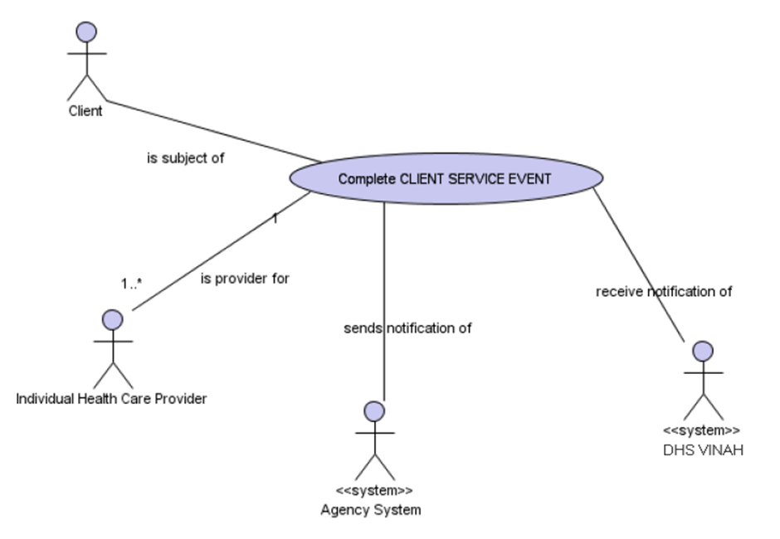
Further detail in relation to this system use case is included in Appendix A.
Data element binding
Message | Data element name | HL7 attribute name | Location | Value domain
ADTA03 | Refer to Appendix A – Data element and binding table
Dynamic interaction model
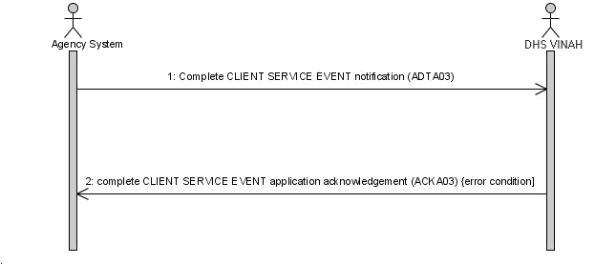The following are the derived events involved in this interaction.
Static Structure

Message ADT_A03
Item | Description
MSH | Message Header
EVN | Event Type
PID | Patient Identification
PV1 | Patient Visit
PV2 | Patient Visit - Additional Information
{ ROL } (1 - 5) | Role
{ (1 - 5) | Procedure Group
PR1
}

ADT_A03.PV1
 | Name | Data type | Required | Length | Cardinality | Fixed value | Validation table
1 | SetID | SI | Optional | 4. .4 | 2. .1 | 1
2 | PatientClass | IS | Required | 0. .1 | 0. .1 |  | HL70004
3 | AssignedPatientLocation | PL | Required | 0. .80 | 0. .1 |  | HL70305
5 | PreadmitNumber | CX | Required | 1. .250 | 0. .1
7 | AttendingDoctor | XCN | Required | 0. .250 | 1. .1
15 | AmbulatoryStatus | IS | Required | 0. .2 | 1. .1 |  | HL70009
19 | VisitNumber | CX | Required | 0. .250 | 1. .1
20 | FinancialClass | FC | Required | 0. .50 | 1. .1 |  | HL70064
45 | DischargeDateTime | TS | Required | 0. .26 | 1. .1
51 | VisitIndicator | IS | Required | 0. .1 | 1. .1 |  | HL70326

PV1.3 (AssignedPatientLocation)
Composite PL
 | Name | Data type | Required | Length | Fixed value | Validation table
6 | PatientLocationType | IS | Required | 1. .1

Message ACK_A03
Item | Description
MSH | Message Header
MSA | Software Segment
[ { ERR } ] (0 - 99) | Error

Update contact
Use case model
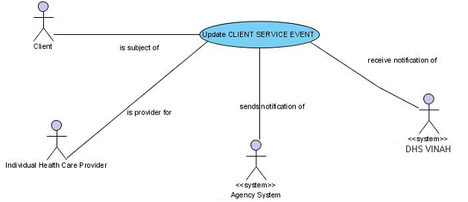Further detail in relation to this system use case is included in Appendix A.
Data element binding
Message | Data element name | HL7 attribute name | Location | Value domain
ADTA08 | Refer to Appendix A –Data element and binding table
Dynamic interaction model
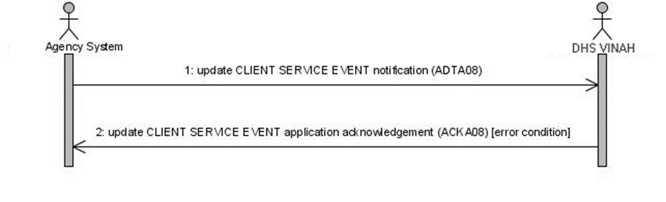
The following are the derived events involved in this interaction.
Static Structure

Message ADT_A08
Item | Description
MSH | Message Header
EVN | Event Type
PID | Patient Identification
PV1 | Patient Visit
PV2 | Patient Visit - Additional Information
{ ROL } (1 - 5) | Role
{ (1 - 5) | Procedure Group
PR1
}

ADT_A08.PV1
 | Name | Data type | Required | Length | Cardinality | Fixed value | Validation table
1 | SetID | SI | Optional | 1. .4 | 0. .1 | 1
2 | PatientClass | IS | Required | 1. .1 | 0. .1 |  | HL70004
3 | AssignedPatientLocation | PL | Required | 0. .80 | 1. .1 |  | HL70305
5 | PreadmitNumber | CX | Required | 0. .250 | 1. .1
7 | AttendingDoctor | XCN | Required | 0. .250 | 1. .1
15 | AmbulatoryStatus | IS | Required | 0. .2 | 1. .1 |  | HL70009
19 | VisitNumber | CX | Required | 0. .250 | 1. .1
20 | FinancialClass | FC | Required | 0. .50 | 1. .1 |  | HL70064
45 | DischargeDateTime | TS | Required | 0. .26 | 1. .1
51 | VisitIndicator | IS | Required | 0. .1 | 0. .1 |  | HL70326

PV1.3 (AssignedPatientLocation)
Composite PL
 | Name | Data type | Required | Length | Cardinality | Fixed value | Validation table
6 | PatientLocationType | IS | Required | 1. .1

Message ACK_A08
Item | Description
MSH | Message Header
MSA | Software Segment
[ { ERR } ] (0 - 99) | Error

Delete contact
Use case model
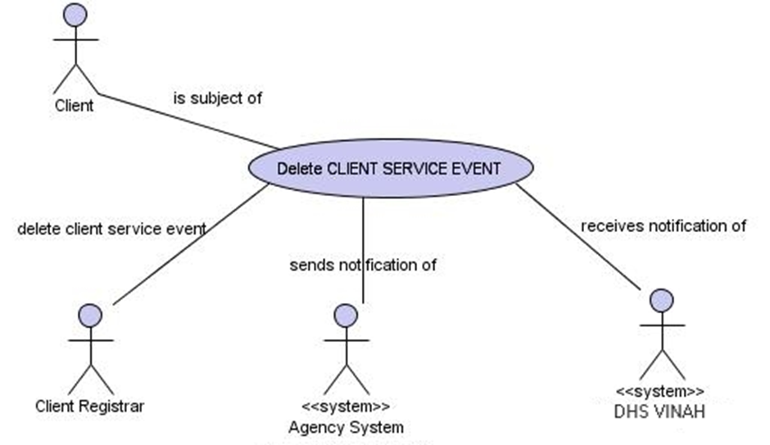
Further detail in relation to this system use case is included in Appendix A.
Data element binding
Message | Data element name | HL7 attribute name | Location
ADTA13 | Refer to Appendix A – Data element and binding table
Please note in the case of delete messages, all data content is ignored except the Key fields - the Person Identifier, Identifier Type, and Local Identifier Assigning Authority - however the message must still conform to all business rules in order to pass HL7 validation and be actioned.
Dynamic interaction model
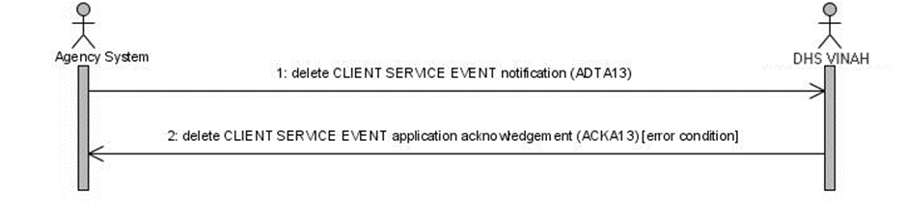The following are the derived events involved in this interaction.
Static Structure

Message ADT_A13
Item | Description
MSH | Message Header
EVN | Event Type
PID | Patient Identification
PV1 | Patient Visit
PV2 | Patient Visit - Additional Information
{ ROL } (1 - 5) | Role
{ (1 - 5) | Procedure Group
PR1
}

Message ACK_A13
Item | Description
MSH | Message Header
MSA | Software Segment
[ { ERR } ] (0 - 99) | Error

Client referral message set

Receive client referral
Use case model
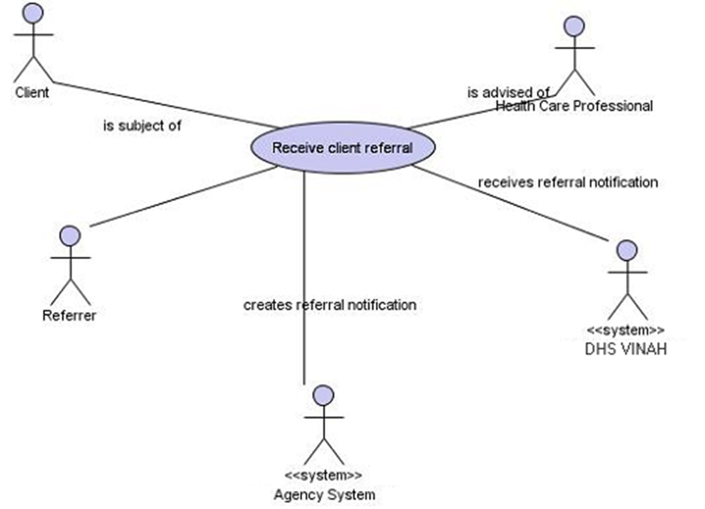Note, in the VINAH MDS context, the following characteristics of the receive client referral use case:
- the VINAH MDS is only intended to capture data regarding the acknowledgment of receipt of a referral; and
- referral instances may or may not lead to an instance of an Episode for a given client.
Further detail in relation to this system use case is included in Appendix A of this manual.
Data Element Binding
Message | Data element name | HL7 attribute name | Location | Value domain
ADTA13 | Refer to Appendix A – Data element and binding table
Dynamic interaction model
Note that this implementation only requires that the DH-VHIRS_VINAH system receive the RRI referral receipt acknowledgment (RRI) not the initiating referral (REF).
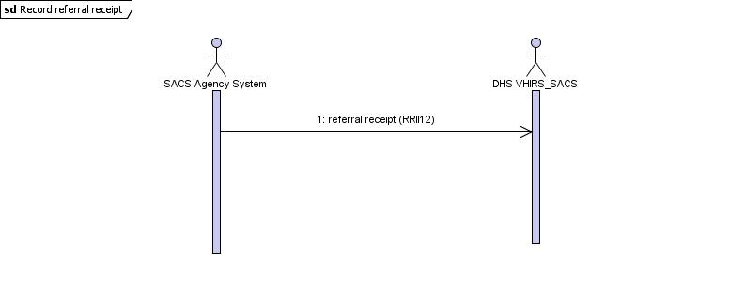Static Structure

Message RRI_I12
Item | Description
MSH | Message Header
RF1 | Referral Information
PRD | Provider Data
PID | Patient Identification
[PV1] | Patient Visit
OBR | Observation Request
{ (1 - n)
OBX | Observation/Result
{

RRI_I12.PV1
 | Name | Data type | Required | Length | Cardinality | Fixed value | Validation table
1 | SetID | SI | Optional | 1. .4 | 1. .1 | 1
2 | PatientClass | IS | Required | 1. .1 | 1. .1 | O | HL70004
10 | HospitalService | IS | Required | 1. .3 | 0. .1 |  | HL70069
51 | VisitIndicator | IS | Required | 0. .1 | 1. .1 | E | HL70326

Send client referral
Use case model
Note that this implementation only requires that the DH-VHIRS_VINAH system receive the initiating referral (REF) not the referral receipt acknowledgment (RRI).
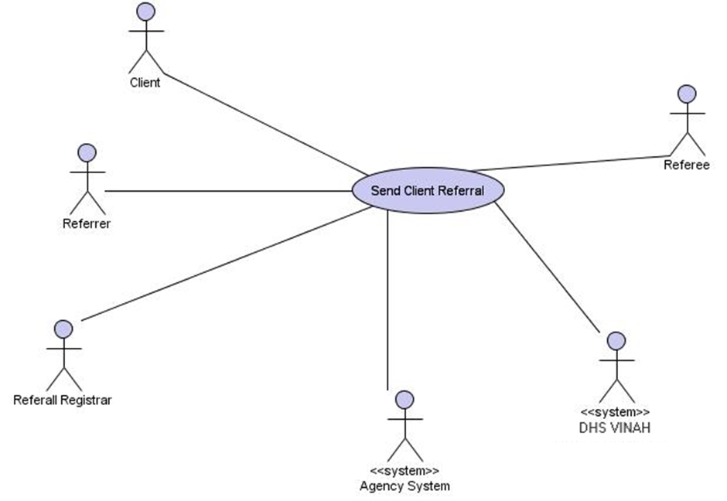Further detail in relation to this system use case is included in Appendix A of this manual.
Data element binding
Message | Data element name | HL7 attribute name | Location | Value domain
REFI12 | Refer to Appendix A – Data element and binding table
Dynamic interaction model
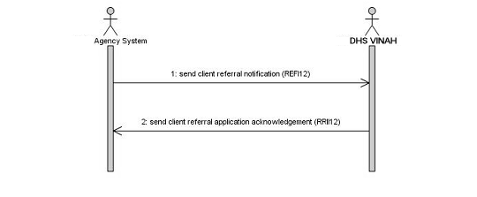Static Structure

Message REF_I12
Item | Description
MSH | Message Header
RF1 | Referral Information
PRD | Provider Data
PID | Patient Identification

Message RRI_I12
Item | Description
MSH | Message Header
MSA | Message Acknowledgement
PRD | Provider Data
PID | Patient Identification

Update client referral
Use case model
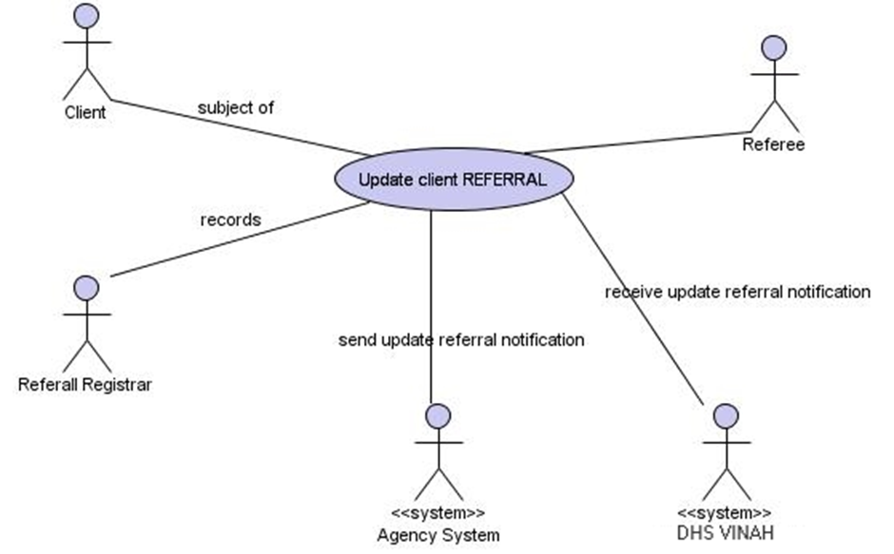Further detail in relation to this system use case is included in Appendix A of this manual.
Data element binding
Message | Data element name | HL7 attribute name | Location | Value domain
REFI13 | Refer to Appendix A – Data element and binding table

Dynamic interaction model
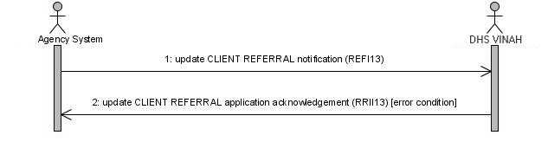Static Structure

Message REF_I13
Item | Description
MSH | Message Header
RF1 | Referral Information
PRD | Provider Data
PID | Patient Identification
Data element binding
Message | Data element name | HL7 attribute name | Location | Value domain
REFI13 | Refer to Appendix A – Data element and binding table

Message RRI_I13
Item | Description
MSH | Message Header
MSA | Message Acknowledgement
PRD | Provider Data
PID | Patient Identification

Segment RRI_I13.MSA
 | Name | Data type | Required | Length | Cardinality | Fixed value | Validation table
1 | AcknowledgementCode | ID | Required | 0. .2 | . . |  | HL70008
2 | MessageControlID | ST | Required | 0. .20 | . .

Delete client referral
Use case model
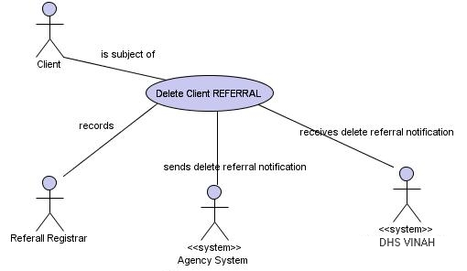Note that this implementation only requires that the DH-VHIRS_VINAH system receive the initiating referral (REF) not the referral receipt acknowledgment (RRI).
Further detail in relation to this system use case is included in Appendix A of this manual.
Data element binding
Message | Data element name | HL7 attribute name | Location | Value domain
REFI14 | Refer to Appendix A – Data element and binding table
Please note in the case of delete messages, all data content is ignored except the Key fields - the Referral Identifier, Identifier Type, and Local Identifier Assigning Authority - however the message must still conform to all business rules in order to pass HL7 validation and be actioned.
Dynamic interaction model
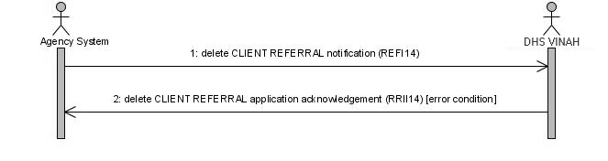Static Structure

Message REF_I14
Item | Description
MSH | Message Header
RF1 | Referral Information
PRD | Provider Data
PID | Patient Identification

Data element binding
Message | Data element name | HL7 attribute name | Location | Value domain
RRII14 | Refer to Appendix A – Data element and binding table
Please note in the case of delete messages, all data content is ignored except the Key field - the Referral Identifier - however the message must still conform to all business rules in order to pass HL7 validation and be actioned.

Message RRI_I14
Item | Description
MSH | Message Header
MSA | Message Acknowledgement
PRD | Provider Data
PID | Patient Identification

