
Agency Information Management System (AIMS) Manual
2024-25
July 2024
OFFICIAL

To receive this document in another format, email HDSS Helpdesk <HDSS.Helpdesk@health.vic.gov.au>.
Authorised and published by the Victorian Government, 1 Treasury Place, Melbourne.
© State of Victoria, Australia, Department of Health, July 2024.
ISBN 978-1-76131-683-8 (pdf/online/MS word)
Available at HDSS website < https://www.health.vic.gov.au/data-reporting/health-data-standards-and-systems>

Contents
Section 1: Introduction 5
Overview of the Agency Information Management System 5
HealthCollect portal 5
Agency hierarchy structure – AU, CA, ACS, CS 5
Due date for AIMS reporting 6
Overdue reporting 7
Final date for 2024-25 data submission 7
Summary table of AIMS forms – agency level, reporting frequency and due dates 7
Data quality statement 11
Accuracy 11
Validity 11
Completeness 11
Coherence 11
Interpretability 12
Timeliness 12
Accessibility 12
Consistency with reporting agency data sources 12
AIMS update cycle – annual changes process 12
Recent changes to AIMS data collections 13
Abbreviations 14
Section 2: Using HealthCollect and reporting AIMS data collections 16
Request access to the HealthCollect portal 16
Accessing the HealthCollect portal 16
Password Reset – new user, password forgotten or change 17
Contexts – HealthCollect functions 17
Default context – edit HealthCollect account details and password after login 18
AIMS context – find AIMS data collections in HealthCollect 19
Standard AIMS data collection webform layout and features 21
To enter data into AIMS webforms 23
To submit data – all forms except S10, S11, S11A, S12, PCCP 23
To submit data – S10, S11, S11A, S12 and PCCP forms 24
Correcting data after submission to the department 24
File Upload procedure – S10 and S11 data collections 24
Section 3: Form specific information 28
Form AR7A: Annual Return: Medical Equipment and Plant and Equipment (non-medical) Purchases – aggregate cost data on plant and equipment purchases 29
Form AR7B: Annual Return: Replacements under the Medical Equipment Replacement Program and the Engineering Infrastructure Replacement Program – Specific-Purpose Capital Grants – Purchases 30
HRA: Hospital Research Activities 33
Nursing and Midwifery Workforce Data Collection 36
QIPSRACS: National Quality Indicators 39
S5_115 AN-ACC: Aged Persons Mental Health Residential Aged Care Services 40
S5_129 AN-ACC: Residential Aged Care 40
A2: Specialised Services Indicators 41
A3: Public Hospital Beds 44
DCOR: Daily Capacity and Occupancy Register 48
PCCP: Palliative Care Consultancy Program 57
S10: Acute Non-Admitted Clinic Activity 60
S11: Sub Acute Non-Admitted Activity 71
S11A: Sub Acute Non-Admitted Multidisciplinary case conferences (MDCC) when patient not present 79
S12: Self-delivered Non-admitted Services 81
S1A: Admitted Patients Aggregate Collection 84
Statutory Duty of Candour 86
SAAI: Sub-Acute Access Indicators 92
TCPKPIs: Transition Care Program Key Performance Indicators 96
Urgent Care Centre 99
S8: Radiotherapy Non-Admitted Services 107
Section 4 – AIMS Online Reports 109
Compliance Reports 111
Non-admitted Clinic Reports 113
Year-To-Date Reports 116

Section 1: Introduction

Overview of the Agency Information Management System
The Agency Information Management System (AIMS) is an online data entry system and reporting facility primarily used by Victorian health services and aged care services to report summary level statistical information to the Department of Health (the department).
The department uses AIMS data to monitor programs, for funding and acquittal purposes, in demand management, and to meet reporting requirements to Commonwealth Departments and the Australian Institute of Health and Welfare (AIHW).
The department collects information in discrete financial years. The reporting period – annual, quarterly, monthly or more frequently – is specific to each AIMS data collection.

HealthCollect portal
The department provides the HealthCollect portal, a secure data transfer system, to enable health and aged care service entities to report data using specific webforms, and to access reports to monitor data they submit to the department. The HealthCollect portal uses a service and component-based architecture to support a range of applications and data collections, which are grouped in ‘contexts’, equivalent to applications. The AIMS context is a cluster of data collections each reported using a separate specific webform.
To submit data, and access reports, requires a HealthCollect UserName, assigned by the department. Each UserName is linked to the health and/or aged care service, and data collection/s, nominated when the user requests their HealthCollect access. Each user request must provide the details of the senior officer at the agency who authorises the access requested. Accessing the HealthCollect portal requires a valid UserName and password combination. A UserName is assigned to the individual requesting it, and must not be shared with others.
In this manual:
Section 2 explains how to use the HealthCollect portal to access AIMS data collections and reports;
Section 3 describes the data collection in the AIMS context;
Section 4 lists the reports available via HealthCollect, and how agencies should use these to ensure all data are submitted, correct and complete by the relevant due date.

Agency hierarchy structure – AU, CA, ACS, CS
The data collections within the AIMS context are reported at different agency levels. To manage this, HealthCollect uses a hierarchy of agency levels to identify parent-and-child agency relationships, and to link data collections with the relevant agency level.
Data collections are reported at one of four agency levels, which are identified by a suffix, eg (AU):
Health service – whole-of-health-service (auspice) reporting (AU)
Hospital campus – a sub-category of a health service (CA)
Aged care service – an aged care service attached to a health service (ACS)
Clinical site – radiotherapy clinic site where service is provided (CS)
The relationship between these agency levels is depicted below:
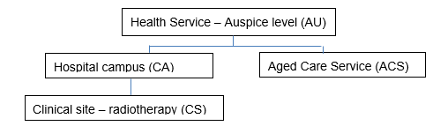

Due date for AIMS reporting
Health and aged care services must submit AIMS data by the due date for each reporting period.
When the due date falls on a weekend or public holiday, reporting is due on the prior business day. The only exceptions to this are:
- COVID-19 Daily Capacity and Occupancy Register:
reported for each day, by 1pm the following weekday; or
data for the preceding 7 days (Monday to Sunday) must be reported by 1pm each Monday;
when Monday is a public holiday, by 1pm on the next business day;
- Nursing and Midwifery Workforce Data Collection:
due by 21st day of the next month;
when the 21st day is a non-business day, reporting must be completed the next business day.
Non-compliance with reporting due dates may incur a penalty as set out in the department’s Policy and funding guidelines.

Reporting due date for annual data collections
Four AIMS data collections are reported once each year:
- One is an annual survey completed in June each year;
- Three report aggregate data on activity during the full prior financial year.
These annual data collections are listed below, with their respective reporting periods and the date by which reporting must be completed.
AIMS data collections reported annually
Data collection | Reporting period | Report by
A2: Specialised Services Indicators  (annual survey) | Completed in June 2024 | 14 July 2024
Hospital Research Activity | 2023-24 financial year | 21 July 2024
AR7A: Plant & Equipment purchased during the year | 2023-24 financial year | 30 September 2024
AR7B: Replacements under ME & EI grant | 2023-24 financial year | 30 September 2024

Reporting periods for quarterly data collections
Some AIMS data collections are reported by financial year quarter. Quarterly reporting periods are represented by the quarter number which refer to the quarter within the financial year, for example Quarter 1 or Q1 represents the first quarter of the financial year as set out in the following table.
Reporting periods and corresponding date ranges for data collections submitted quarterly
Reporting period | Period dates
Quarter 1 (Q1) | 1 July to 30 September
Quarter 2 (Q2) | 1 October to 31 December
Quarter 3 (Q3) | 1 January to 31 March
Quarter 4 (Q4) | 1 April to 30 June

Overdue reporting
It is the responsibility of the health service to ensure reporting is completed by the due date. The department recommends ensuring more than one person in each health service is aware of, and has access to, AIMS reporting forms to ensure compliance during periods of staff leave.
For some AIMS reporting, reminder emails are automatically sent to health services immediately after the end of the period for which the data are to be reported, and when reports are overdue. These emails are sent to the person who most recently opened that data collection form, as the department is unable to identify specific users responsible for completing each form.

Final date for 2024-25 data submission
In addition to the due date for each reporting period, each collection has a final date by which all data must be reported, and all corrections completed and submitted, for the financial year. After the final date, the collection is closed and no further changes can be made. For most AIMS data collections, that date is 24 August.
Final data submission dates for 2024-25 will be published in the HDSS Bulletin <https://www.health.vic.gov.au/data-reporting/health-data-standards-and-systems-communications>
The department strongly recommends that those responsible for reporting to AIMS data collections subscribe to the HDSS Bulletin <https://www.health.vic.gov.au/data-reporting/subscribe>.

Summary table of AIMS forms – agency level, reporting frequency and due dates
The following table lists all current AIMS data collections and the agency level at which it is reported – those reported at AU level are listed first, then ACS, CA and finally CS. To find data collections for the prior financial year, select that year in the Year window in the AIMS selector.
Within each agency level, data collections are listed in the order in which they appear in the drop down list in the Collection window in the AIMS Selector.
The reporting period (annual, quarterly, monthly or daily) and due date are provided, along with a brief overview of the data collected.

Summary table of AIMS forms – agency level, reporting frequency and due dates
Agency Level | Data Collection Name | Brief description of data collected | Reporting frequency (period of data reported) | Due date
AU | AR7A: Plant & Equipment purchased during the year | Expenditure data for medical equipment and plant and equipment (non-medical). | Annual | 30 September for prior financial year
AU | AR7B: Replacements under ME & EI grant | Items purchased and total expenses of in-scope medical equipment replacements and total expenses for engineering infrastructure in-scope replacements purchased under the specific-purpose capital grants. | Annual | 30 September for prior financial year
AU | Hospital Research Activities | Research activities undertaken by health services. | Annual | 21 July for prior financial year
AU | Nursing and Midwifery Workforce | Aggregate nursing and midwifery workforce information. | Monthly | 21st of next month
ACS | QIPSRACS: National Quality Indicators | Quality indicators data reported by public sector residential aged care services, as specified by the Commonwealth, with some Victorian indicators. | Quarterly | 15th of month after end of reporting quarter
ACS | S5_115 AN-ACC: Aged Persons Mental Health Residential Aged Care Services | Aggregate data for residents in mental health residential aged care services. | Monthly | 21st of next month
ACS | S5_129 AN-ACC: Residential Aged Care | Aggregated data for residents in generic and flexible residential aged care services. | Monthly | 21st of next month
CA | A2: Specialised Services Indicators | Annual survey of specialised services in health services, completed in June. | Annual | 14 July for prior financial year
CA | A3: Public Hospital Beds | Aggregate bed information for public hospitals with acute and subacute admitted patient services. | Monthly | 12th of next month
CA | COVID-19 Daily Capacity and Occupancy Register | Availability of beds by a number of bed categories, and staff unavailable due to COVID. | Daily data.  Submit at least weekly.  Must be up to date by 1pm each Monday. | 1pm each Monday for the preceding week (Monday to Sunday inclusive)
CA | Palliative Care Consultancy Program | Aggregate activity for hospital, regional and statewide palliative care consultancy programs. | Quarterly | 15th of month after end of reporting quarter
CA | S10: Non-Admitted Clinic Activity | Aggregate activity for acute non-admitted clinics. | Monthly | 12th of next month
CA | S11: Sub Acute Non-Admitted Activity | Aggregate activity for non-admitted subacute services. | Monthly | 12th of next month
CA | S11A: Subacute Non-Admitted MDCC patient not present | Aggregate activity for subacute non-admitted multidisciplinary case conferences at which patient is not present. | Monthly | 12th of next month
CA | S12: Self-delivered Non-Admitted Services | Aggregate active episodes by program stream for self-delivered non-admitted services. | Monthly | 12th of next month
CA | S1A: Admitted Patients | Aggregate data on numbers of admitted patients by month when public hospitals are unable to submit patient level data to the VAED by the specified deadline. The S1A submission is an interim measure until the transmission of patient level data to the VAED commences/resumes. | Monthly (required only if unable to submit patient level data to VAED for a full calendar month) | 10th of next month
CA, ACS, AU | Statutory Duty of Candour | Number of serious adverse patient safety events and the Statutory Duty of Candour activity related to those events. Agency level depends on type of health service entity. Section 3 of this manual provides agency level details. | Quarterly | 14th of month after end of reporting quarter
CA | Sub Acute Access Indicators | Reports three indicators under the subacute and residential aged care access indicators project. | Monthly | 15th of next month
CA | Transition Care Program KPIs | Reports up to eight quality indicators for bed based and home-based care. | Quarterly | 21st of month after end of reporting quarter
CA | Urgent Care Centre | Aggregate data on the visit type, departure status and triage category of patients attending urgent care centres. | Monthly | 14th of next month
CS | S8: Acute Health Services Radiotherapy Non-Admitted Services | Consultations for radiotherapy services provided to non-admitted oncology patients. | Monthly | 15th of next month
Refer to Section 2 for more details about the AIMS Selector, to Section 3 for more details about each AIMS data collection, and to Section 4 for details of accessing reports.

Data quality statement
This is a summary of what the department does to ensure consistent capturing and reporting of data quality across data sets and over time.

Accuracy
To provide clarity on reporting requirements for health services and aged care services and information for data users, the department publishes the AIMS manual on the HDSS website < https://www.health.vic.gov.au/data-reporting/agency-information-management-system-aims>.
The AIMS manual is accurate at the time of publication. Advice of any updates to the AIMS manual, and other information relevant to AIMS reporting during 2024-25, is published in the HDSS Bulletin <https://www.health.vic.gov.au/data-reporting/health-data-standards-and-systems-communications>.
While some AIMS forms incorporate validations, health services and aged care services are responsible for the accuracy of the data reported to AIMS collections, and its consistency with data reported at patient level to other relevant data collections, and should not rely solely on the webform validations.
The department performs additional data quality checks including for:
- Valid value combinations
- Logical consistency
- Consistency between aggregate data reported in relevant AIMS forms with patient level data reported in other data collections.
Where anomalies are detected, the department requests that health services and aged care services correct the data prior to the closure of reporting for the financial year.

Validity
Reports of data submitted to AIMS collections are provided via HealthCollect. It is the responsibility of health services and aged care services to use these reports to verify the accuracy of the data submitted, reconcile data reported with internal data sources and with patient level data reported in other data collections, and make appropriate corrections in a timely manner.

Completeness
While the department monitors compliance with reporting due dates, and contacts health services and aged care services when reporting is not completed by the due date, or data quality questions arise, it is the responsibility of each health and/or aged care service to ensure data are submitted by the due date, in full, and accurately.

Coherence
Each year the department reviews the AIMS data collections to ensure they:
- Support the department’s state and national reporting obligations
- Support health service planning
- Assist planning and policy development
- Incorporate appropriate feedback from data providers on improvements
- Utilise definitions for common data items that are consistent with related data collections.

Interpretability
The AIMS manual provides definitions of concepts, data items, valid code sets and reporting guidelines, and links to other department webpages for more details for relevant data collections.
Changes to AIMS data collections during the year are notified to stakeholders promptly via the HDSS Bulletin.
The department provides data reporting advice and support to health services and aged care services via specific department contacts as listed in Section 3 of this manual, and via the HDSS HelpDesk <hdss.helpdesk@health.vic.gov.au> for other AIMS data collections, and the HealthCollect portal.

Timeliness
Health services and aged care services must submit data to relevant AIMS data collections by the due date for reporting that data collection for each reporting period, and by the final date for the year’s data.
The date by which each AIMS collection is to be reported is provided in the summary table above, and is shown for each AIMS collection in Section 3.

Accessibility
The department provides reports, accessible via HealthCollect, that enable health services and aged care services to verify the data entered has been successfully submitted to the department, and to identify errors in the data reported. It is the responsibility of each health service and aged care service to use these resources to ensure the data they report is complete, correct and submitted by the due date. Refer to Section 4 of this manual for details.

Consistency with reporting agency data sources
It is expected that data reported to AIMS data collections is consistent with the data held in the information systems of the reporting health service or aged care service. The department does not condone manipulation of data submitted to AIMS, whether entered into webforms or via file upload.

AIMS update cycle – annual changes process
Each year the AIMS data collections are reviewed to ensure they continue to meet the department's reporting requirements and reflect changes in hospital funding and service provision arrangements for the coming financial year. Refer to HDSS Annual Changes <https://www.health.vic.gov.au/data-reporting/annual-changes> for information about this process, including documentation of any Proposals for revisions to AIMS, and Specifications for revisions to AIMS, for the next financial year.
Information about AIMS collections is released throughout the year in the HDSS Bulletin, found at HDSS Communications <https://www.health.vic.gov.au/data-reporting/health-data-standards-and-systems-communications>. Subscribe to the HDSS Bulletin <https://www.health.vic.gov.au/data-reporting/subscribe>.

Recent changes to AIMS data collections
2024-25
Changes to existing data collections:
- S10: Acute Non-Admitted Clinic Activity form
  - Removed Urgent Care Centre reporting
- S11: Sub Acute Non-Admitted Activity form
  - Added Program/Stream VRSS General – Medical and Non-medical substreams
- S12: Self-administered Non-admitted Services form
  - Removed reporting of VRSS Not on ventilation active episodes
  - Added Program/Stream SCIg to report Service events
- Urgent Care Centre form
  - Increased number of sites reporting this data collection
- Amended due date for QIPSRACS to 15th day after end of reporting period (quarter) from 1 July 2024
- Ceased Maternity Demand Booking Data collection from 1 July 2024
- Ceased S2_118 Early Years Services Non-Admitted Services data collection from 1 July 2024

2023-24
Changes to existing data collections from 1 July 2023:
- Amend COVID-19 Daily Capacity and Occupancy Register (DCOR) data collection:
  - Remove reporting of: Decommissioned stock, Current occupancy – Beds occupied by suspected COVID-19 patients, Staff capacity impacted by COVID-19
  - Add a single column to report Staff capacity impacted by COVID-19
- Amend A3 Public Hospital Beds – changes to Bed Categories
New AIMS data collections:
- Hospital Research Activity
- Maternity Demand Booking Data
- Statutory Duty of Candour
Changes to existing data collections during financial year:
- COVID-19 Daily Capacity and Occupancy Register (DCOR) data collection – from 1 February 2024:
  - Remove reporting of: Staff capacity, Staff capacity impacted by COVID19, COVID specific beds, Mortuary.
- COVID-19 Vaccination Status – Health Service Workforce – ceased January 2024

Abbreviations
ABF | Activity Based Funding
ACHS | Australian Council of Healthcare Standards
AIHW | Australian Institute of Health and Welfare
AIMS | Agency Information Management System
AN-ACC | Australian National Aged Care Classification
CEO | Chief Executive Officer
CSV | Comma separated values
DCU | Data Collections Unit
DH | Department of Health
DVA | Department of Veterans’ Affairs
ED | Emergency Department
EI | Engineering Infrastructure
FCP | Family Choice Program
GEM | Geriatric evaluation and management
HACC | Home and Community Care
HACC PYP | Home and Community Care Program for Younger People
HARP | Hospital Admission Risk Program
HARP – GEM | Hospital Admission Risk Program – Geriatric evaluation and management
HARP – HIV | Hospital Admission Risk Program – Human Immunodeficiency Virus
HDSS | Health Data Standards and Systems
HEN | Home Enteral Nutrition
HIV/AIDS | Human Immunodeficiency Virus/Acquired Immune Deficiency Syndrome
IHACPA | Independent Health and Aged Care Pricing Authority
KPI | Key Performance Indicator
MBS | Medicare Benefits Schedule
MDCC | Multi-Disciplinary Case Conference
ME | Medical Equipment
NACCC | Non-admitted Clinical Classification Committee
NACMS | Non-admitted Clinic Management System
NDIS | National Disability Insurance Scheme
NGO | Non-government organisation
NHRA | National Health Reform Agreement
NWB | Non-weight bearing
PCCP | Palliative Care Consultancy Program
PSRACS | Public Sector Residential Aged Care Services
SAAI | Sub-Acute Access Indicators
SCIg | Subcutaneous Immunoglobulin
SDC | Statutory Duty of Candour
SRHS | Small rural health service
TAC | Transport Accident Commission
TCP | Transition Care Program
TPN | Total Parenteral Nutrition
UCC | Urgent Care Centre
UDG | Urgency Disposition Group
VAED | Victorian Admitted Episode Dataset
VCAT | Victorian Civil and Administrative Tribunal
VEMD | Victorian Emergency Minimum Dataset
VINAH | Victorian Integrated Non-admitted Health dataset
VRMDS | Victorian Radiotherapy Minimum Data Set
VRSS | Victorian Respiratory Support Service
WC | WorkSafe Victoria
YTD | Year-to-date

Section 2: Using HealthCollect and reporting AIMS data collections
Data submissions to AIMS data collections are made through the HealthCollect secure portal. Access to the HealthCollect portal requires a UserName, which is assigned by the department.
This section of the AIMS manual describes how to request a HealthCollect UserName, access the HealthCollect portal, find AIMS data collections, and submit data. Section 4 describes the compliance and year-to-date summary reports found in HealthCollect.

Request access to the HealthCollect portal
To request a new HealthCollect portal user account, and access to the AIMS data collection to be reported, complete the HealthCollect portal user request form <https://forms.office.com/Pages/ResponsePage.aspx?id=H2DgwKwPnESciKEExOufKIQCYRhq7MNNvvjya8xeYoZUNzE3UEZWTlpPNlc0WUhaMERaMEw1SjRDSS4u> .
Complete all required details, including the user’s name and contact details, the contact details of the senior officer authorising the requested access, the health service and/or aged care service for which data are to be reported, and the data collection/s to be reported. Providing complete and accurate information assists prompt request processing. Please allow two business days to process requests.
When the HealthCollect account is created, the UserName and login details will be forwarded to the email address provided in the login request.
Each UserName is linked to a specific health service and/or aged care service, including to the relevant agency hierarchy level, and to the requested data collection/s.
An existing HealthCollect user who wants to access a different AIMS data collection must also complete the HealthCollect Portal User Request Form to request this variation to their user account.
An individual HealthCollect user name will usually be linked to a single health service only. Where an individual seeks access to more than one health service in HealthCollect, written authorisation from a senior officer at each health service will be required before access is assigned.
UserNames are assigned to individuals and should not be shared.

Accessing the HealthCollect portal
When assigned a HealthCollect UserName, a password must be created.
Go to the HealthCollect portal <https://www.healthcollect.vic.gov.au> .
Enter the required details in the Password Reset window. Click the ‘Reset’ button.
If validated against the details held for the UserName entered, a link to set a Password is sent to the email address linked to the UserName.
HealthCollect homepage
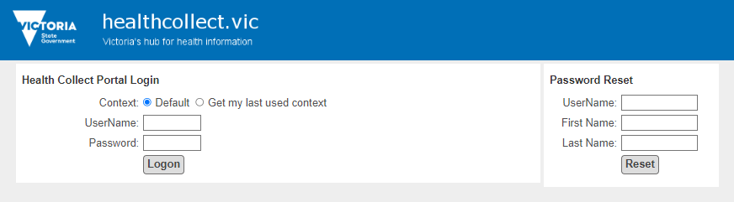

Password Reset – new user, password forgotten or change
HealthCollect users can request a new password at any time by completing the details in the Password Reset section on the HealthCollect home page.
- Enter UserName, First Name and Last Name.
- Capitalise the first letter of First name and Last name followed by lower case letters.
- Do not leave any spaces before or after the names. The details entered must match those provided in the HealthCollect Portal User Request Form.
A message is returned on screen with advice confirming a password reset email has been sent: the link to reset the password is sent to the email address linked to that UserName based on the information provided in the HealthCollect Portal User Request Form.
If the password reset function fails, a message will advise the user to contact the HDSS helpdesk <hdss.helpdesk@health.vic.gov.au>.
Passwords are case sensitive. Long passwords with a mix of alphanumeric characters and symbols are recommended.

Contexts – HealthCollect functions
The AIMS context is assigned to users requesting access to AIMS data collections.
After login, contexts assigned to a user appear as tabs across the HealthCollect home page beneath the blue HealthCollect banner.
The selected context is highlighted in red font.
The options for the selected context appear in the panel beneath and to the left of screen.
Three contexts are assigned to all AIMS users:
Default context allows users to manage their user account details
AIMS context provides access to the AIMS data collections (see Section 3 of this manual)
Reports context provides access to AIMS online reports (see Section 4 of this manual).

Default context – edit HealthCollect account details and password after login
- The Default context panel is displayed on the left at login
- Click on ‘My Account’ in the Default context panel

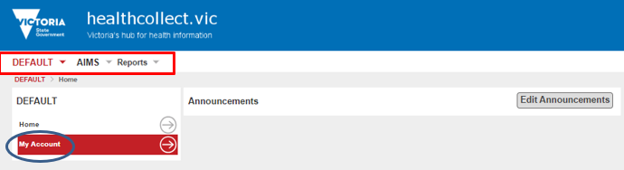
- The Default context options open in centre of screen allowing editing of selected details for this HealthCollect user name, and password re-set after login

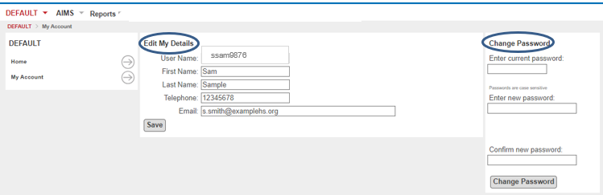

- Edit My Details:
  - edit the name, telephone number, email address for the username
  - click the ‘Save’ button
- Change Password:
  - enter current password, and new password
  - click the ‘Change Password’ button

AIMS context – find AIMS data collections in HealthCollect
More than twenty data collections are accessed in the AIMS context. These are reported at different agency levels, and for different reporting periods, depending on the data collection.
The Summary table of AIMS data collections in Section 1 of this manual lists all AIMS data collections, with its agency hierarchy level, reporting frequency and period, to help users find data collections.
Each UserName is assigned access only to the data collections nominated in the HealthCollect portal user request form, which also records the agency’s authorising officer for the requested access. Accordingly, not all AIMS data collections will be listed for each user.
After logging in to HealthCollect, select the AIMS context tab, then AIMS Selector:
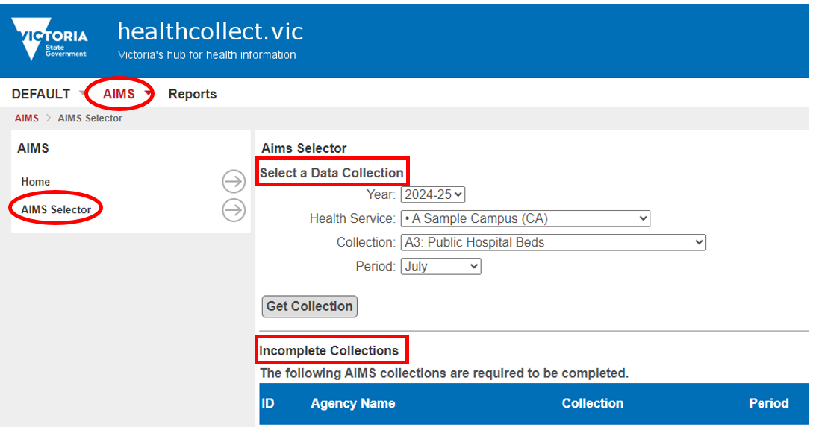
Two options to select AIMS data collections are displayed:
- Select a Data Collection – top of page
- Incomplete Collections – lower half of page.

Incomplete Collections
Data collections due for completion are listed on the lower half of the AIMS Selector page.
Data collections listed are relevant for this user’s health service and agency level access. Each listing is an active link to open the data entry screen for that data collection. Click the link, enter and submit the data.
After the linked webform is completed and the data submitted, the active link no longer displays in the Incomplete Collections list. To re-open a data collection webform, or edit data on a webform already submitted, find the data collection using the Select a Data Collection steps.

Select a Data Collection
Select the relevant details in each selector window to access the required data collection. The selection in each window restricts the options in drop down lists for other windows – for example, if the Health Service selected is an Aged Care Service (ACS), only aged care service data collections will appear in the Collection window drop down list, and only options relevant to the aged care data collection selected will appear in the Period window drop down list.
Agency hierarchy level
AIMS data collections are reported at different agency levels. Refer to the description of Agency hierarchy level and the Summary table of AIMS data collections (both in Section 1) or the specific data collection description (in Section 3) for the agency level of each data collection.
When using the Select a Data Collection windows to find an AIMS data collection, the correct agency level for the data collection must be selected in the Health Service window in order to display the data collection in the drop down list in the Collection window.
The agency level abbreviation is shown after the agency name. Subordinate level agencies also have one or more dot/s before the agency name.
Hierarchy of agency levels shown in the Health Service window in Select a Data Collection
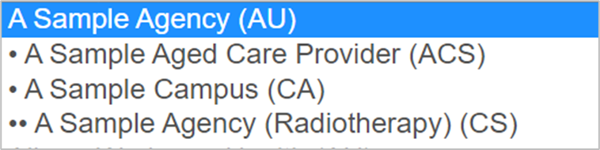
The Health Service window sequences the whole-of-health-service level (AU suffix) first, then lists, in alphabetical order of site names, all subordinate agencies for that health service entity, along with the subordinate site’s hierarchy level suffix – aged care service (ACS), campuses (CA), and clinical site (radiotherapy services) (CS).
Where agencies at different hierarchy levels share the same name, use the suffix code and preceding dots to identify the relevant hierarchy level for the data collection.
An AIMS user can be linked to one or many agencies depending on their reporting requirements and user authorisation privileges set up in their HealthCollect account. Health Service lists display only those agencies, and hierarchy levels, to which the UserName has been assigned access.
Using Select a Data Collection
Refer to the Summary table of AIMS data collections in Section 1 to select the relevant agency hierarchy level and reporting period for the data collection you are seeking.
- Select ‘Year’ of data to be updated. The Year displays the default year, which is the current financial year (2024-25). This changes on 1 July each year. To enter data for any period in the prior financial year (eg 2023-24), select that year from the drop down list in the Year window.
- Select ‘Health Service’ from the drop-down list. The list of available health services or campuses is linked to the user’s authorised access permissions. Select the correct agency level for the data collection.
- Select the ‘Collection’ to be reported from the drop down list. The collections listed will depend on the Year and Health Service selected, including the agency level, and user’s authorisation.
- Select the ‘Period’ of the data being reported.The period options listed will be relevant to the Collection selected. Change the Year selected for a reporting period in the prior financial year.
Click the ‘Get Collection’ button to open the form.

Standard AIMS data collection webform layout and features
AIMS data collection webforms follow a standard layout across two sections:
Form header
shows data collection name, brief description of the data collected, the agency and reporting period. There are also at least two buttons – Validate and Save – and the ‘Completed’ check box.
Body of form
may include section and sub-section headings.
Row labels identify data field names; red asterisks indicate mandatory data items; aqua coloured boxes indicate cells pre-populated with data from the previous reporting period or values calculated for sub-totals and totals using data entered in this form; column labels indicate data entry boxes for the date field in that row.
Sample form layout

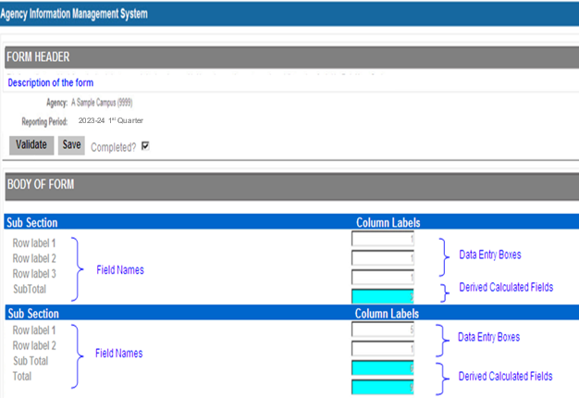
Mandatory items
Mandatory data items are identified with a red asterisk (*) at the end of the data label.
A value must be entered for mandatory items.
Calculated and derived fields
Calculated and derived fields are highlighted with aqua coloured backgrounds. These fields update as the data are entered.
Data pre-populated from the previous reporting period also appear in aqua coloured cells in some forms.
Validate button
The Validate button activates webform checks that the data entered meet reporting requirements (eg values are reported in each mandatory cell).
If webform business rules have not been met, validation messages are displayed in red font and the cell related to the validation is highlighted in red.
The data cannot be submitted until all validations are resolved.
Sample validation message
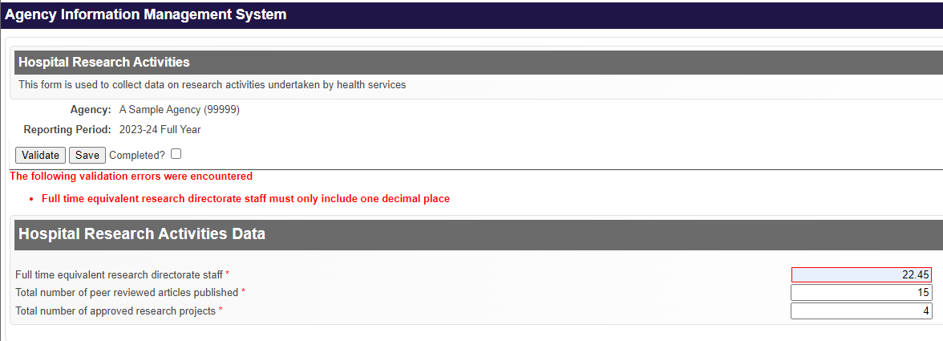
Save button
The Save button saves both valid and invalid data. It does not apply form level validations. It is useful when entering data in collection forms with many data items, or when entering data in stages.
The message ‘Submission saved successfully’ displays when the data is saved.
The Save button is only active when the ‘Completed’ check box is not ticked.
Completed checkbox
The Completed checkbox is important: until the Completed box is checked, the data collection will not be submitted, making the agency liable to late data penalties.
Checking the Completed box:
- Activates webform validations and saves the data entered
- Disables the Validate and Save buttons on this webform, and prevents further editing
- Indicates the form is complete with all validation rules satisfied and appropriate approvals for release obtained
- Enables submission of the webform’s data to the department for most data collection forms (see also Submit button, below)
- Enables pre-population of subsequent webforms (for selected data collections).
The message ‘Submission transmitted to the department successfully’ is displayed when webform business rules have been met, data saved, Completed box checked, and data submitted.
An un-checked Completed box indicates the webform is incomplete or data validations are unresolved.
Data entered on a webform for which the Completed box is not checked, and hence for which the data has not been submitted to the department, will not be included in activity reports or extracts prepared by the department, and will not pre-populate the next period’s webform (where that function is enabled).
Before entering data for a new period, check the prior period is correct and the Completed box in the prior period’s webform is checked.
Submit button
Selected webforms include an additional ‘Submit’ button: where present, this must be clicked to submit data to the department. Where the Submit button is present, the Completed box must be checked before the Submit button is clicked.
Print icon
A Print icon appears on all AIMS forms in the upper right hand corner of the webform. In some forms, there is also a Print button in the form header section. Both open a Print window.
Click the Save button before printing to prevent data loss.
Use Print preview to adjust form size and print orientation to suit the webform layout (eg shrink to size or landscape/portrait layout).
Close function
To close the webform click the browser close button (X) in the top right corner of the form.

To enter data into AIMS webforms
Open the webform for the data collection:
- Click in the first cell you want to enter data into and enter a value
- Use TAB key to move curser to the next data entry cell, or click on the next cell you want to enter data into: enter a value.
- Enter data into each mandatory cell – these are marked with a red asterisk *
- Report zero (0) only when that is the correct value, not as a default or dummy value.
- Continue until all data are entered.
- Click the Validate button to check the data entered meets the webform’s business rules.
  - Where data does not meet business rules, a validation message appears in red font and the associated cells causing the error are highlighted in red. Correct data as required.
  - Where validation rules are met, a message displays indicating ‘All data valid’.
- Click the Save button to save data to the database and retain on the form. Save data before printing to prevent data loss.

To submit data – all forms except S10, S11, S11A, S12, PCCP
- Check the Completed box when all the data are entered, checked and verified as correct.
- This locks the webform, deactivates the Validate and Save buttons, and submits the data to the department.
- When the data has been successfully submitted to the department, the following message displays:
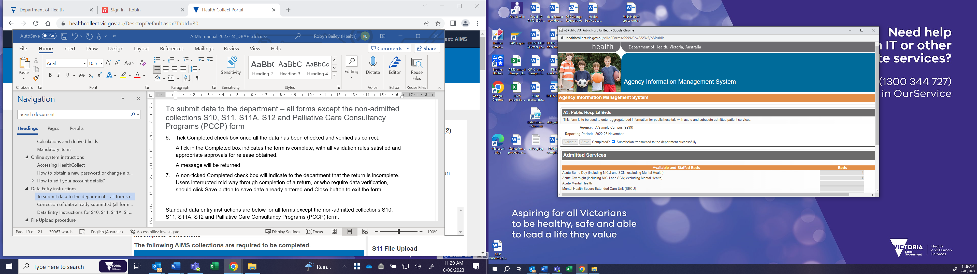
- Close the webform by clicking the X in the top right corner of the form.

To submit data – S10, S11, S11A, S12 and PCCP forms
These webforms have a Submit button as well as the Completed check box, as shown below:
Form with Submit button
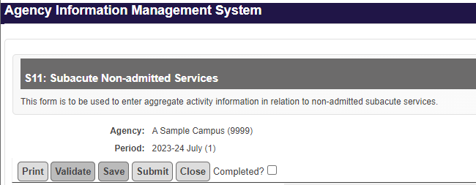
- Check the Completed box when data entry to the form is completed, checked and verified as correct.
- Click the Submit button to submit data to the department. You can only submit data if the Completed check box is ticked.
- A message is returned when a form is successfully submitted to the department: ‘The form has been successfully submitted’.
- Click the Close button to exit the webform.

Correcting data after submission to the department

All forms except A3 Public Hospital Beds
When a user detects an error in the data already submitted to the department, the error must be corrected and re-submitted.
To correct an error:
- open the webform containing the error
- un-check the Completed box to unlock the form and activate edit mode
- amend data
- re-check the Completed box to re-submit and lock the form.

Form A3 Public Hospital Beds
Refer to Section 3 for guidance on correcting A3 Public Hospital Beds data.

File Upload procedure – S10 and S11 data collections
There are three options for submitting data for the S10 and S11 non-admitted data collections:
- enter data directly into the webform, or
- upload data as a comma delimited (.csv format) file, or
- a combination of both data entry and file upload.
Data submitted by upload file populate only the clinic or service stream data field(s) included in the upload file: the upload does not impact clinics or service streams for which data are not uploaded, which can be submitted directly to the webform as required. Refer to Section 3 of this manual for upload file details including file structures relevant to data being reported.
When a file is uploaded, the Completed box on the relevant webform is automatically un-checked. After uploading a file, open the webform for the relevant data collection and period, confirm data has populated the form correctly, and check the Completed box after confirming data upload.
A separate file is required for each agency/campus and reporting period.
Data submitted later will overwrite any data submitted previously by either upload or entry to the webform for that clinic ID for that period.
Steps to complete S10 or S11 file upload:
Log into the HealthCollect portal <https://www.healthcollect.vic.gov.au> .
- Click AIMS context on the HealthCollect home page.
- Click AIMS Selector under Context Functions.
- Three File Upload sections are shown on the right hand panel of the AIMS Selector screen:
- S10 File Upload – No S19(2) Exemptions
- S10 File Upload – S19(2) Exemptions
- S11 File Upload.
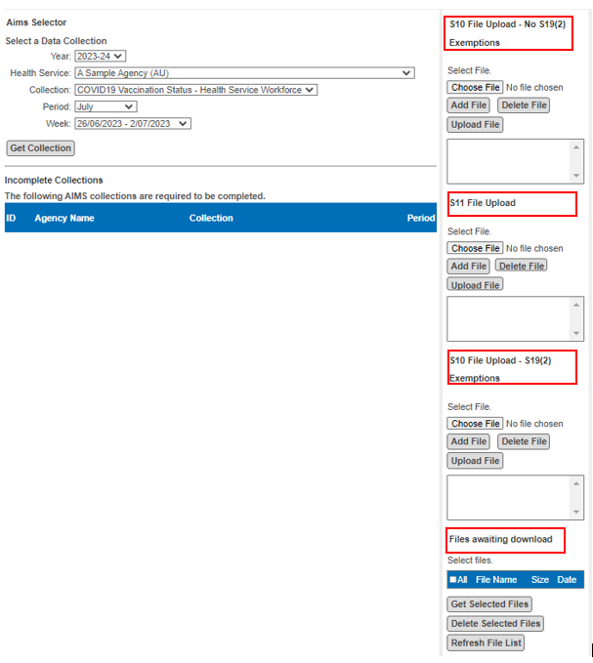
- In the relevant section for the file being uploaded, click Choose File: browse to select the file to upload.
- Click Add File.
- Check this is the file to be uploaded. If so, click Upload File. The file will begin to upload. Once upload is completed, a message will appear in the panel advising whether the upload was successful.
- When file upload is notified as successful, go to the Files awaiting download section at the foot of the right hand panel: click Refresh File List to display the report of the file uploaded.
File upload panel – Files awaiting download
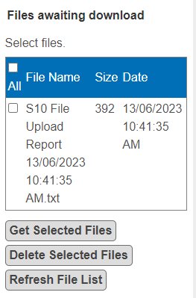
- To open the report, click the check box beside that file name, then click Get Selected Files. The file will appear in your computer’s Downloads folder. Download the file; save to a local directory.
- The text report indicates whether the file upload process was successful.
- When a file upload is unsuccessful, none of the data in that file is uploaded.
- The report of the file’s processing shows the reason the upload was unsuccessful. For example, the file may include records with invalid clinic codes or an invalid number of columns. Correct the errors and upload the corrected file.
Sample text report – file processing unsuccessful
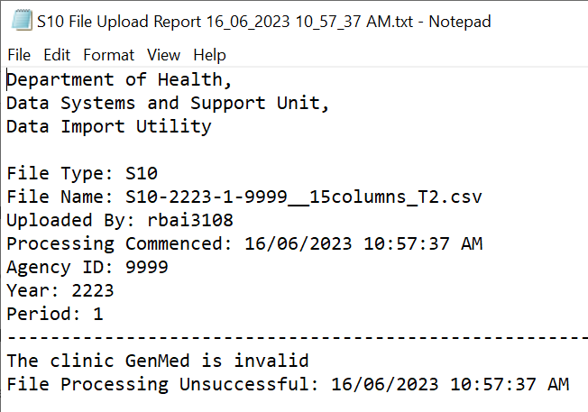
Sample text report – file processing successfully completed
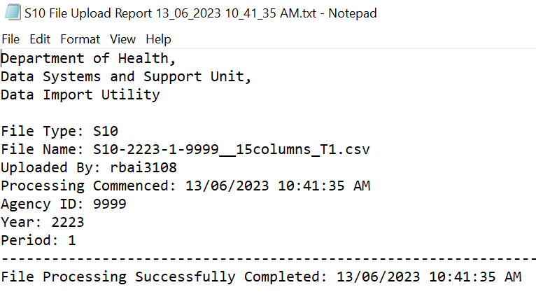
- After a successful upload, open the relevant webform – S10 or S11: review and complete data submission for the period by entering any other data into the webform directly.
- Check the Completed box: this must be done whether or not any additional data are entered directly to the webform.

Section 3: Form specific information
Section 3 provides a description of each AIMS data collection open during the financial year covered by this manual.
Data collections are listed in the same sequence in which they appear in the AIMS Selector, by agency hierarchy level, and as shown in the Summary table of AIMS forms in Section 1 of this manual.
Refer to Section 2 for information about how to obtain a HealthCollect UserName, resetting passwords and accessing each AIMS form in the AIMS Selector in the HealthCollect portal.
Refer to Section 4 for information about accessing reports of data submitted to AIMS data collections.

Form AR7A: Annual Return: Medical Equipment and Plant and Equipment (non-medical) Purchases – aggregate cost data on plant and equipment purchases

Reported at Agency level: AU (whole of health service)

Reporting frequency: Annual

Due Date: by 30 September 2024 to report 2023-24 financial year

Reporting guidelines
Reports expenditure data for medical equipment and plant and equipment (non-medical) purchases for the financial year regardless of funding source.
Report expenditure data exclusive of GST. Dollar values are entered as $’000. For example, expenditure of $100,000 is entered as $100.
Sample form view
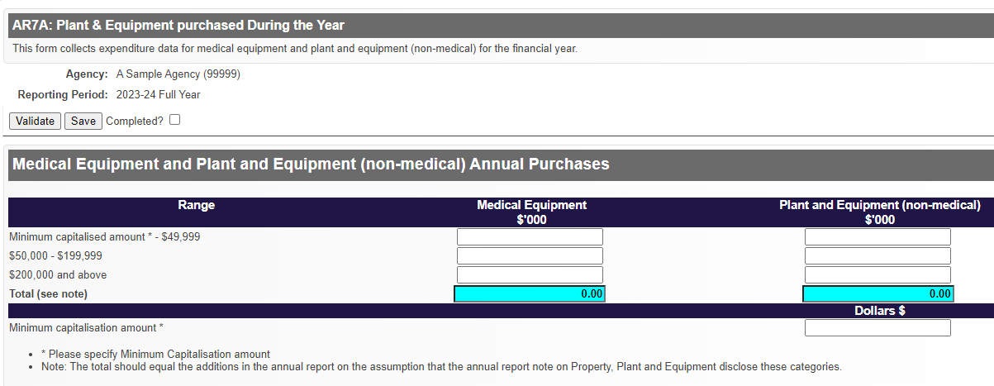
Click the ‘Save’ button so data entered are not lost; then ‘Print’ to generate a printout of the final figures reported, which should be signed by the chief executive officer and retained at the hospital.
The form to report data for the 2024-25 financial year will be released in July 2025.

Further information
Questions about reporting to the AR7A data collection, including inability to report by the due date, should be directed to the Health Infrastructure team <MERPandEIRP@health.vic.gov.au>.
Questions about accessing this data collection in HealthCollect should be emailed to the HDSS HelpDesk <hdss.helpdesk@health.vic.gov.au> .

Form AR7B: Annual Return: Replacements under the Medical Equipment Replacement Program and the Engineering Infrastructure Replacement Program – Specific-Purpose Capital Grants – Purchases

Reported at Agency level: AU (whole of health service)

Reporting frequency: Annual

Due Date: by 30 September 2024 to report 2023-24 financial year

Reporting guidelines
Reports the number of items purchased, and total expenses, of listed categories of in-scope medical equipment replacements purchased under the Medical Equipment Replacement Program (MERP) – Specific-Purpose Capital Grant, and total expenses for engineering infrastructure in-scope replacements purchased under the Engineering Infrastructure Replacement Program (EIRP) Specific-Purpose Capital Grant. All data are reported for the relevant financial year.
The collection requires a compilation of the procurement transactions undertaken with the Specific-Purpose Capital Grant monies provided to eligible metropolitan and major regional health services with acute clinical services after the end of the financial year, grouped according to categories as specified in the funding guidelines. Any funds carried forward from previous years that have not been accounted for are required to be reported on.
Click the ‘Save’ button before ‘Print’ to generate a printout of the final figures reported, which should be signed by the chief executive officer and retained at the hospital.
Note:
- Form AR7B is presented in two sections:
Section 1 reports medical equipment replacement;
Section 2 reports engineering infrastructure replacement.
The AR7B form is pre-populated with the grant allocation for the reporting year, and the carry forward amount reported in the previous financial year’s AR7B form. The carry forward amount is updated each time the form is opened and saved. Note however that if data in a prior year is updated, but the subsequent year’s form is not opened, the updated prior year data will not populate the subsequent year’s form, or HealthCollect reports displaying the subsequent years’ data.
Form AR7B is for reporting on 2023-24 Specific-Purpose Capital Grant expenditure only on items purchased and assets renewed/replaced. Funding from other sources or the High Value Statewide Replacement Fund should be excluded.
Expenditure is for in-scope items only – inclusions and exclusions for the use of the 2023-24 Specific-Purpose Capital Grants are provided in the guidelines locate at the Grant programs website < https://www.vhba.vic.gov.au/resources/grant-programs>.
It is expected that the ‘other’ category will be used minimally. This should relate to in-scope assets that may not be covered in existing categories. The ‘other’ section has a text field for health services to provide a description of the in-scope medical equipment or engineering infrastructure replaced.
Grant expenditure should normally be made in the year it is awarded. In some cases health services may need to set aside funds to stage or fund prioritised replacements over several years to enable the Specific-Purpose Capital Grant to deliver the best outcomes. If funds are to be carried forward for expenditure in future years they must be earmarked against specific high-risk assets identified in the comments section and be consistent with the health service asset management plans.
Reporting in the AR7B form should be consistent with health service asset management plans.
Dollars are exclusive of GST and entered as $’000. For example, $100,000 is entered as $100.
A comments section is provided for both medical equipment and engineering infrastructure reporting for health services to outline carry forward and commitments.
Off-line reports may be required by the department for updating expenditure of grants.
For information on the individual grants, refer to the following websites:
Medical Equipment Replacement Program <https://www.vhba.vic.gov.au/health/equipment-engineering-upgrades/medical-equipment-replacement-program>
Engineering Infrastructure Replacement Program < https://www.vhba.vic.gov.au/health/equipment-engineering-upgrades/engineering-infrastructure-replacement-program>
Policy and funding guidelines for health services for 2024-25 <https://www.health.vic.gov.au/policy-and-funding-guidelines-for-health-services>, in particular section 11 Capital funding programs.

Accountability, compliance and reporting
Specific-Purpose Capital Grant allocation outlined in the Victorian health policy and funding guidelines is approved by the Minister for Health. The grant must be managed and invested in compliance with health service or hospital board fiduciary responsibilities, as well as department and government asset management policy requirements.
Under the 2023-24 Medical Equipment Replacement Program and the 2023-24 Engineering Infrastructure Replacement Program, health services are required to report on their asset replacement under the Specific-Purpose Capital Grant as a condition of the funding. This demonstrates financial and asset accountability, including progressive reporting on investment against asset management plans and critical risk mitigation achieved. Any funding carried forward for assets identified in the comments section and asset management plans will require updates when the funds have been expended and/or as requested by the department.
Reporting will be used for both accountability and policy and practice development purposes.
The submitted data needs to:
- include items purchased and assets renewed/replaced.
- be consistent with the asset management plan.
- be able to be supported by evidence of actuals in financial expenditure.

Further information
Questions about reporting to the AR7B data collection, including inability to report by the due date, should be directed to the Health Infrastructure team <MERPandEIRP@health.vic.gov.au>.
Questions about accessing this data collection in HealthCollect should be emailed to the HDSS HelpDesk <hdss.helpdesk@health.vic.gov.au> .

HRA: Hospital Research Activities

Reported at Agency level: AU (whole of health service)

Reporting frequency: Annual

Due Date: by 21 July 2024 to report 2023-24 financial year

Reporting overview
Data about number of research department staff and research activities, funded by the state, associated with, and occurring in, Victorian public hospitals in the prior financial year. Reported by public health services at the whole-of-health service (AU) level.
Health services may choose to gather more information on research activities with which they are involved, however the data reported to this collection must be consistent with these specifications, as the data are reported to the Independent Hospital and Aged Care Pricing Authority (IHACPA).
Report zero only when that is the correct value, or when the category is not applicable to your service for this reporting period.
For the purposes of this data collection, the term ‘research’ refers to activities undertaken in a public health service where the primary objective is the advancement of knowledge that ultimately aims to improve consumer and patient health outcomes or health system performance.
The activity must be undertaken in a structured and ethical way, be formally approved by a research governance or ethics body, and have potential for application outside the health service in which the activity is undertaken.
For the purposes of this reporting, the definition of research relates to the public health service’s contribution to maintain research capability, excluding the costs of research activities that are funded from a source other than the state or provided in kind.
It is intended that the data reported will capture those activities that are unique to hospital delivery and thus activities that set public health services apart in terms of costs.

Data items and definitions

Full time equivalent research directorate staff
Definition
The total number of full-time equivalent research directorate staff in the health service.
A research directorate is a department that administratively supports and facilitates research through infrastructure and resources.
Format Number N[NNN{.N}]
Valid range 0 to 9998.9
Minimum one character; maximum five characters, including an optional one decimal place.
Round to the nearest one decimal place (eg 18 FTE reported as 18, 18.47 FTE reported as 18.5)
FTE calculation method
Average the total FTE in the financial year by summing the FTE count at the end of each month and dividing the total by 12. Do not use the FTE count on 30 June, as that provides only a snapshot.
Count FTE as a ratio of hours. While the number of hours equating with ‘full time’ may vary (eg 36 hours or 38 hours), the proportion of FTE is a consistent measure, so that a person working a three day week is considered to be 0.6 FTE, regardless of whether ‘full time’ is 36 or 38 hours per week.

Total number of approved research projects
Definition
The total number of approved research projects being undertaken at the health service.
Format Number N[NNN]
Valid range 0 to 9998
Minimum one character, maximum four characters (eg report 15 approved research projects as 15.)
Reporting guide
Approved research projects are those that have been approved through a formal ethics and/or governance process, which must meet the standards of the National Health and Medical Research Council.
Research projects that extend across financial years are to be counted within the financial year in which the project was approved by the research governance or ethics body.
Research projects that involve multiple establishments are to be counted once at the major or primary establishment.
Research projects that have multiple researchers are to be reported only by the establishment of the chief or primary author, being the project leader who takes the lead role in the conduct of the research project, and takes responsibility for the completion and lodgement of any required applications.
Although approved research projects/activities are applied to health sector research, such studies or activities will have potential for application outside the health service in which they are undertaken.
While this focuses reporting on the primary or major site, and does not reflect all sites involved in research activity, these IHACPA reporting requirements seek to prevent duplication while capturing data on the infrastructure supporting research. The IHACPA may expand the collection in future to capture multi-centre research activity.

Total number of peer reviewed articles published
Definition
The total number of articles authored within an establishment that are published in a peer reviewed publication.
Format Number N[NNN]
Valid range 0 to 9998
Minimum one character; maximum four characters (eg report 15 published peer reviewed articles as 15).
Reporting guide
A peer reviewed publication is either a book or periodical in electronic or printed format for which the content is reviewed by equal or higher ranked people in the same field.
The articles must be directly linked with a research project that has been through a formal approval process that includes an ethics committee or equivalent governance approval.
The peer review process will be specific to the agency responsible for the ultimate publication. Articles must go through a new peer review process for each publication.
Where there are multiple authors across multiple sites, the article should be reported by the health service of the chief or primary author, being the project leader who takes the lead role in the conduct of the research project, and has responsibility for completion and lodgment of any required applications.
Articles should be counted within the financial year in which they were published, irrespective of when the research project was undertaken. Articles submitted for publication or accepted but not published or ‘in press’ or ‘pre-print’, but not yet published, are not counted until finalised and formally published.
Non-journal articles which may not be reviewed by academic peers, such as clinical quality guidelines, community engagement practices, reports of lived experience/community research, are out of scope for this reporting and should not be included in this count.
Hospital Research Activities form – sample view
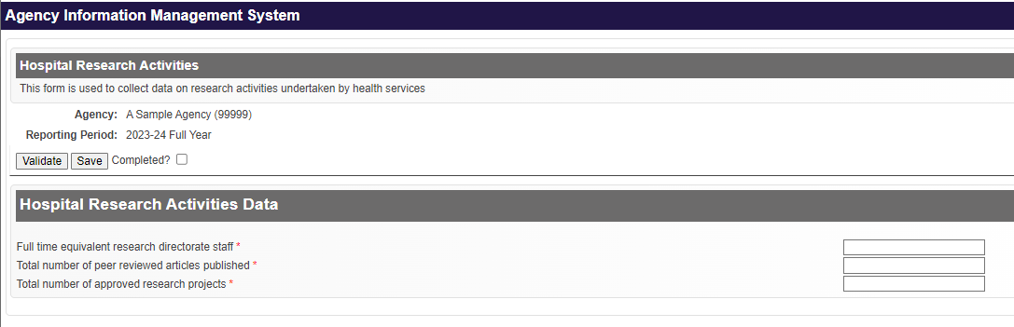
A valid value must be entered into each data field. Report zero only when that is the correct value, or when the category is not applicable to your service for this reporting period.
When reporting is not completed by the due time, a reminder email will be sent to the email address of the person who most recently logged in to the webform.

Further information
Questions about the data items to be reported, or notification of inability to report by the due date, should be emailed to the HDSS HelpDesk <hdss.helpdesk@health.vic.gov.au>.

Nursing and Midwifery Workforce Data Collection

Reported at Agency level: AU (whole of health service)

Reporting frequency: Monthly

Due Date: 21st day of the next month

Reporting overview
Reported at whole-of-health-service level (ie not at campus level) by participating public health services, this data collection enables the department to monitor workforce vacancies and other workforce pressures to determine where there are significant vacancy levels, compare other workforce indicators across like services and inform workforce priority actions.

Reporting guidelines
Data for each calendar month are due by 11.59pm on the 21st day of the following month. If the 21st day is a non-business day, reporting must be completed on the next business day.
When reporting is not completed by the due date, autogenerated reminder emails are sent to the person who most recently opened the webform.
Exclude from reporting:
Nurse and Midwife Pool Permanent part-time/full-time nursing or midwifery staff allocated on a
shift-by-shift basis across different wards by a central staffing allocations
department.
Generic roles Generic multi-disciplinary roles able to be filled by nurses or allied health
professionals, for example some care coordination, case management
and chronic disease services.

Workforce categories
Two workforce categories appear on the form:
- All services (excluding maternity and newborn services)
- Maternity and newborn services.

Data items reporting FTE
For each of the two workforce categories, two data items report FTE on the last date of the month being reported:
- Total Approved FTE The total approved nursing and midwifery FTE that can be recruited to
- Current FTE Total nursing and midwifery contracted FTE
Vacant FTE is derived on the form: Total Approved FTE minus Current FTE

Data items reporting Hours
For each of the two workforce categories, four data items report the number of hours during the full calendar month:
- *Personal leave hours Total nursing and midwifery personal leave hours (paid and unpaid
inclusive of standard personal leave and COVID related leave) across
the health service
- Agency hours Total nursing and midwifery agency hours used
- *Overtime hours Total nursing and midwifery paid overtime hours
- *Basic hours Total nursing and midwifery ordinary hours worked
* Include hours for all contracted staff including permanent and temporary contracted employees when reporting Personal leave hours, Overtime hours and Basic hours (but not Agency hours).

High risk areas
High risk areas are clinical streams with more than 10% FTE nursing and midwifery workforce deficit.
These clinical streams can be in acute, subacute, ambulatory (inclusive of outpatients/specialist clinics and day procedure units), community, mental health, COVID vaccination/testing, aged care residential (inclusive of general and aged person mental health), administration and education units.
There are separate lists of clinical streams for the two workforce categories on the webform: check the box of each clinical stream with a deficit of more than 10% FTE. If a clinical stream is not listed, tick the Other box to open a Comments text field and enter other clinical streams.
The High risk areas listed are:
- For All Services (excluding maternity and newborn services):
Administration, Aged care residential, Ambulatory care, Community, Coronary care/Cardiac Unit, COVID testing, COVID vaccination, Dialysis, Education, Emergency Department, High dependency, Hospital in the Home, Intensive care, Medical, Mental Health, Oncology, Operating Theatres, Outpatients/ Specialist clinics, Paediatrics, Palliative Care, Radiology, Rehabilitation/ Geriatric Evaluation and Management, Surgical, Transitional care, Urgent Care, Other
- For Maternity and Newborn Services:
Antenatal, Birthing suite, Neonatal intensive care, Postnatal, Special care nursery, Other, including midwifery assessment units, administration and education units.

Entering data on the webform
A red asterisk (*) indicates data items that are mandatory to report: for these, a value must be entered. Enter zero (0) only when that is correct: do not enter zero as a dummy or default value.
An image of the Nursing and Midwifery Workforce data collection form is shown below:
Nursing and Midwifery Workforce data collection form
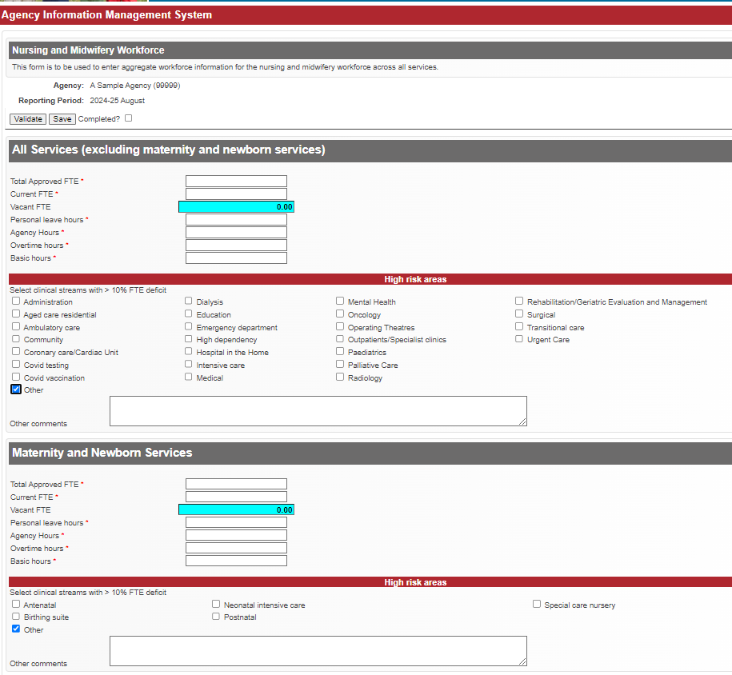

Further information
Questions about the data items to be reported, or notification of inability to report by the due date, should be emailed to the Nursing and Midwifery Workforce team at nmw@health.vic.gov.au .
Questions about accessing this data collection in HealthCollect should be emailed to the HDSS HelpDesk <hdss.helpdesk@health.vic.gov.au> .

QIPSRACS: National Quality Indicators

Reported at Agency level: ACS (aged care service)

Reporting frequency: Quarterly

Due Date: 15th day after end of reporting period

Reporting guidelines
In 2024-25 Victorian public sector residential aged care services (PSRACS) will continue to report data consistent with the Commonwealth’s National Aged Care Mandatory Quality Indicator program introduced from 1 July 2021, and expanded during 2022-23, in which all Commonwealth funded residential aged care services are required to participate.
Details of the National Aged Care Quality Indicator Program are at National Aged Care Mandatory Quality Indicator Program | Australian Government Department of Health <https://www.health.gov.au/initiatives-and-programs/national-aged-care-mandatory-quality-indicator-program-qi-program>
The Commonwealth Manual provides relevant definitions applicable for data entry on the QIPSRACS webform.
The Commonwealth’s reporting requirements are reflected in the QIPSRACS form, including data validations within the data entry form.
Consistent with prior years, Victorian PSRACS need only submit quality indicators via the HealthCollect portal. The department will continue to forward the necessary indicators to the Commonwealth, and return to agencies reports of the data submitted via the QIPSRACS webform.
From 2024-25, the due date for this data collection has been brought forward to the 15th day after the end of the quarter being reported, to allow more time for data checking and to prepare for submission to the Commonwealth.

Further information
Questions about the QIPSRACS data collection or the National Aged Care Mandatory Quality Indicator program should be emailed to the PSRACS Operations and Performance team <VICPSRACS@health.vic.gov.au>
Questions about accessing this data collection in HealthCollect should be emailed to the HDSS HelpDesk <hdss.helpdesk@health.vic.gov.au> .

S5_115 AN-ACC: Aged Persons Mental Health Residential Aged Care Services

S5_129 AN-ACC: Residential Aged Care

Reported at Agency level: ACS (aged care service)

Reporting frequency: Monthly

Due Date: 21st day after end of reporting period

Reporting guidelines
Public Sector Residential Aged Care Services (PSRACS) are operated by agencies including health services and multi-purpose services, in metropolitan, regional and small rural communities.
In 2024-25 the Department of Health will continue to provide top-up funding to designated PSRACS to support the viability of small rural residential aged care services, services supporting residents with specialised care needs, and additional costs incurred for the public sector workforce. This includes continuation of the unit priced funding approach for high-care and low-care beds in designated services.
The Policy and funding guidelines specify that, as a condition of this funding, health services or other PSRACS providers report on service provision in residential aged care by the due date. Agencies can continue to use the Services Australia Payment Advice as the data source to complete this reporting, by entering the data into the S5 form appropriate for their agency:
- S5_129 AN-ACC: Residential Aged Care (includes Multi-purpose services) or
- S5_115 AN-ACC: Aged Persons Mental Health Residential Aged Care Services.
Both forms report the number of residents and resident days per month for a range of place categories, and reflect reporting requirements under the Australian National Aged Care Classification (AN-ACC) funding model.
Data items to meet Victorian reporting needs include demographic data items on both S5 forms, as well as data items to enable PSRACS to report any additional unfunded residential places being operated. There is no change to reporting of multi-purpose service data.
Completed forms together with documentation supporting the data submitted must be retained by the health services and made available for auditing purposes when requested by department officers.

Further information
For assistance with entering PSRACS data into HealthCollect or enquiries about reported data items or inability to meet due date for reporting the PSRACS Operations and Performance team <VICPSRACS@health.vic.gov.au>
Questions about accessing this data collection in HealthCollect should be emailed to the HDSS HelpDesk <hdss.helpdesk@health.vic.gov.au> .

A2: Specialised Services Indicators

Reported at Agency level: CA (campus)

Reporting frequency: Annual survey

Due Date: 14 July 2024 for reporting June 2023 survey result

Reporting guidelines
The department requires each public health service campus to report the specialised services operating at that campus as at June of each year. This information is required for interjurisdictional reporting.
Data submitted in June of the previous year are pre-loaded on to the form and must be reviewed and updated as required, and the form submitted.
Change the entry where any specialised services operating at the hospital have changed since the previous year: to make changes, check the box to report a new specialised service, or uncheck the box to indicate a service previously provided is no longer operating at this campus.
Check the ‘Completed’ box to submit the data, even if no change is made.
Specialised services listed on the A2 webform:
Specialised service | Description
Obstetric/Maternity Services | A specialised facility dedicated to the care of obstetric/maternity patients.
Specialist Paediatric Services | A specialised facility dedicated to the care of children aged 14 or less.
Psychiatric Unit/Ward | A specialised unit/ward dedicated to the treatment and care of admitted patients with psychiatric, mental, or behavioural disorders
Intensive Care Unit (Level 3) | A specialised facility dedicated to the care of paediatric and adult patients requiring intensive care and sophisticated technological support services.
Hospice Care Unit | A facility dedicated to the provision of palliative care to terminally ill patients.
Nursing Home Care Unit | A facility dedicated to the provision of nursing home care.
Geriatric Assessment Unit | Facilities dedicated to the Commonwealth-approved assessment of the level of dependency of (usually) aged individuals either for purposes of initial admission to a long-stay institution or for purposes of reassessment of dependency levels of existing long-stay institution residents.
Domiciliary Care Services | A facility/service dedicated to the provision of nursing or other professional paramedical care or treatment and non-qualified domestic assistance to patients in their own homes or in residential institutions not part of the establishment.
Alcohol and Drug Unit | A facility/service dedicated to the treatment of alcohol and drug dependence.
Acute Spinal Cord Injury Unit | A specialised facility dedicated to the initial treatment and subsequent ongoing management and rehabilitation of patients with acute spinal cord injury, largely conforming to Australian Health Minister's Advisory Council guidelines for service provision.
Coronary Care Unit | A specialised facility dedicated to acute care services for patients with cardiac diseases.
Cardiac Surgery Unit | A specialised facility dedicated to operative and peri-operative care of patients with cardiac disease.
Acute Renal Dialysis Unit | A specialised facility dedicated to dialysis of renal failure patients requiring acute care.
Maintenance Renal Dialysis Centre/Unit | A specialised facility dedicated to maintenance dialysis of renal failure patients. It may be a separate facility (possibly located on hospital grounds) or known as a satellite centre or a hospital-based facility but is not a facility solely providing training services.
Burns Unit (Level 3) | A specialised facility dedicated to the initial treatment and subsequent rehabilitation of the severely injured burns patient (usually >10 per cent of patients body surface affected).
Major Plastic/Reconstructive Surgery Unit | A specialised facility dedicated to general purpose plastic and specialised reconstructive surgery, including maxillofacial, microsurgery and hand surgery.
Oncology (Cancer Treatment) Unit | A specialised facility dedicated to multidisciplinary investigation, management, rehabilitation and support services for cancer patients. Treatment services include surgery, chemotherapy and radiation.
Neonatal Intensive Care Unit (Level 3) | A specialised facility dedicated to the care of neonates requiring care and sophisticated technological support. Patients usually require intensive cardiorespiratory monitoring, sustained assistance ventilation, long-term oxygen administration and parenteral nutrition.
In-vitro Fertilisation Unit | A specialised facility dedicated to the investigation of infertility provision of in-vitro fertilisation services.
Comprehensive Epilepsy Centre | A specialised facility dedicated to seizure characterisation, evaluation of therapeutic regimes, pre-surgical evaluation and epilepsy surgery for patients with refractory epilepsy.
Transplantation Unit | A specialised facility dedicated to organ retrieval, transplantation and ongoing care of the transplant recipient:  - bone marrow  - renal  - heart, including heart-lung  - liver  - pancreas
Clinic Genetics Unit | A specialised facility dedicated to diagnostic and counselling services for clients who are affected by, at risk of or anxious about genetic disorders.
Sleep Centre | A specialised facility linked to a sleep laboratory dedicated to the investigation and management of sleep disorders.
Neurosurgical Unit | A specialised facility dedicated to the surgical treatment of neurological conditions.
Infectious Diseases Unit | A specialised facility dedicated to the treatment of infectious diseases.
AIDS Unit | A specialised facility dedicated to the treatment of HIV/AIDS patients.
Diabetes Unit | A specialised facility dedicated to the treatment of diabetics
Rehabilitation Unit | Dedicated units within recognised hospitals that provide post-acute rehabilitation and are designed as such by the State health authorities.
Clinical Pharmacology or Toxicology Service | A specialised facility dedicated to the provision of clinical pharmacology or toxicology service.

Further information
Questions about accessing this data collection in HealthCollect, or notification of inability to report by the due date, should be emailed to the HDSS HelpDesk <hdss.helpdesk@health.vic.gov.au> .

A3: Public Hospital Beds

Reported at Agency level: CA (campus)

Reporting frequency: Monthly

Due Date: 12th day after the end of the reporting period

Reporting guidelines
The number of available (staffed) beds in selected bed categories at the campus as at 11.59pm on the last Wednesday of each month, or the next working day if the last Wednesday is a public holiday or the agency is closed that day. Reported by public health services and hospitals, the data are used by the department for planning purposes and to support interjurisdictional reporting.
An available bed is a suitably located and equipped bed, chair, trolley or cot where the necessary financial and human resources are provided for admitted patient care.
Available beds = Occupied beds + Unoccupied but staffed beds
Include both occupied and unoccupied beds designated for acute medical and surgical services, acute mental health care, mental health secure extended care, sub-acute care including rehabilitation and palliative care, day surgery unit beds, dialysis, chemotherapy and dental chairs for admitted patients.
Exclude beds in wards that are closed or not staffed for any reason.
Report beds on the A3 form of the physical campus where the beds are located. For multi-campus hospitals, report beds consistent with the reporting of admitted patient activity to the VAED. Any multi-campus hospital not reporting on this basis should immediately contact the HDSS HelpDesk <hdss.helpdesk@health.vic.gov.au> .
No adjustment should be made for contracted services (that is, a purchasing hospital should not add beds purchased from a contracted hospital, nor should a contracted hospital delete beds contracted to a purchasing hospital).
In Acute services (excluding mental health) – same day beds, report the maximum number of beds/chairs staffed and available on the reference day. Include same day beds that may not operate on the specified reference day (last Wednesday of the month) but routinely operate on a defined/regular schedule during the reference month.
Total beds Previous Period is pre-populated from the Total beds reported on the previous month’s form. See below – Correction of A3 data submitted previously.
Total beds for the month being reported is calculated from the data entered in the six Bed categories for the current month.
A Validation message appears when Total beds vary by +/- 7.5% from the previous month’s figure. This tolerance is increased to +/-15% of total beds during December and January.
Example of validation error
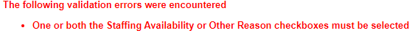

Variation Reasons
Account for variance in Total beds by checking one or both of the Variation Reason boxes:
- Staffing Availability or
- Other.
When checked, these open other check boxes to indicate whether the variation Occurrence is Planned/Seasonal or Unplanned, and for each of those, whether the Estimated Effect is Short term or Long term. An Explanation box is provided to enter free text comments to explain the reason for the bed variation from the previous month, including if the available beds on the reference day are not representative of the bed availability during the month, for example, variation due to staffing availability or service restructuring.
Variation reasons and comments can also be submitted in an Explanation box when the data is within the tolerance: check one of the Variation Reason boxes to open the Explanation box.
At the end of the financial year, the department may require a sign-off by the health service CEO of annual data and advice of reasons for variations.
A3 webform image showing Variation Reason check boxes
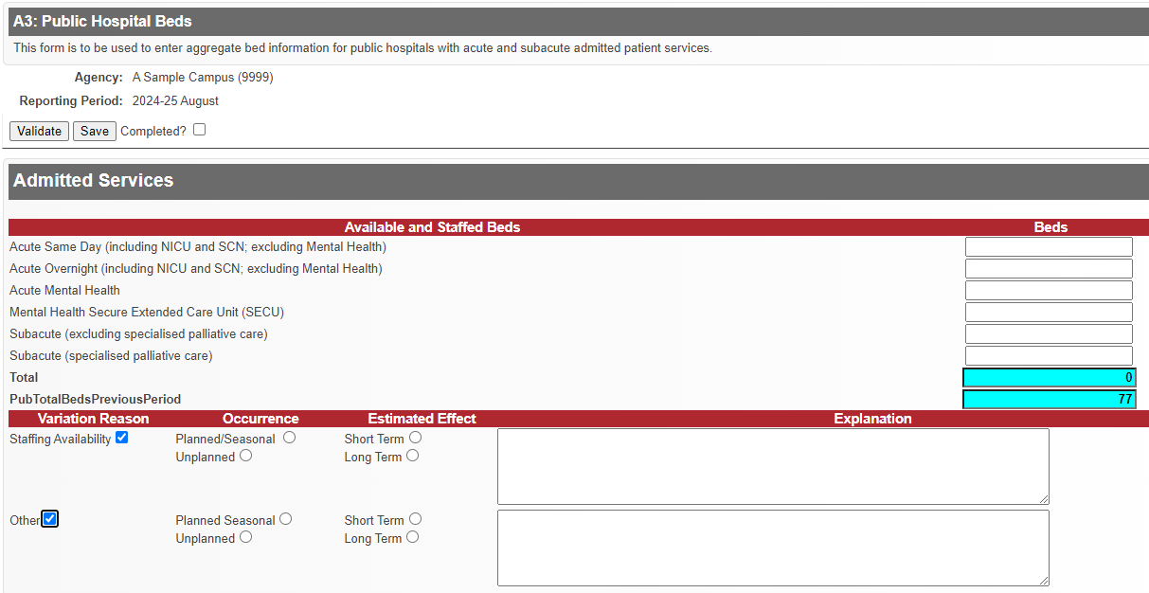

Bed categories
Report the number of Available and Staffed Beds for each of six mutually exclusive categories:

Acute Same Day (including NICU and SCN; excluding Mental Health)
Beds or chairs immediately available for the specific intent of accommodating acute admitted day only care or treatment – includes day surgery unit beds, same day dialysis, chemotherapy and dental chairs for admitted patients, including chairs located in satellite or community settings for which VAED activity is reported for this campus.
In day surgery units, such as endoscopy suites, patients may remain on the same trolley throughout their stay. The trolley is moved between where they are accommodated to the procedure room, onto the recovery room and back to where they are accommodated. In these cases, only count the number of ward spaces available to accommodate patients, do not count spaces in the procedure or recovery rooms.
Exclude beds or chairs designated for same-day non-admitted patient care, discharge lounges, medi-hotel beds, hospital in the home (HITH), rehabilitation in the home (RITH), residential nursing home, hostel and other non-acute residential beds.

Acute Overnight (including NICU and SCN; excluding Mental Health)
Beds immediately available for acute medical and surgical admitted patient services, located in a suitable place for care, and available to accommodate overnight stay patients. Beds that can accommodate both same day and overnight patients should be reported as Acute services—overnight. For example, nocturnal dialysis; registered short stay unit beds; emergency medical units; mental health, alcohol and other drugs hubs.
For combined ICU/CCU, report the count of Available and staffed beds according to the ratio of staff to patients required for the respective service levels (ICU or CCU).
Exclude surgical tables, recovery trolleys, delivery beds, emergency trolleys/stretchers/beds, cots for normal (unqualified) neonates, discharge lounges, medi-hotel beds, hospital in the home (HITH), rehabilitation in the home (RITH), residential nursing home, hostel and other non-acute residential beds.
Note: Delivery beds are excluded because patients are not accommodated in delivery beds, rather they are accommodated in maternity wards. However, if in a birthing suite patients are admitted, deliver and are discharged from the same bed, such beds should be included.

Acute Mental Health
Beds in designated acute admission units dedicated to the treatment and care of admitted patients with psychiatric, mental or behavioural disorders funded by the Mental Health Program.
Include Psychiatric Assessment and Planning Unit (PAPU-ED) beds.
Exclude community based and residential mental health beds, residential nursing home, hostel and other non-acute residential beds.

Mental Health Secure Extended Care Unit (SECU)
Beds in designated secure extended care units dedicated to the provision of secure in-patient treatment and care for people with severe symptomatology and associated behavioural disturbance who require an extended period of sustained treatment and rehabilitation in a contained environment.

Subacute (excluding specialised palliative care)
Beds dedicated to providing subacute services, including rehabilitation, geriatric evaluation and management, geriatric respite and maintenance care. Include on-site beds only.
Exclude subacute specialised palliative care beds, hospital in the home (HITH), rehabilitation in the home (RITH), transition care beds, Transition Support Unit (TSU) beds, off-site maintenance care beds, residential nursing home, hostel and other non-acute residential beds.

Subacute beds (specialised palliative care)
Overnight beds dedicated for providing inpatient palliative care.
Exclude admitted palliative care at home, same day beds, and other subacute beds.

Correction of A3 data submitted previously
A3 forms must be submitted sequentially, for example January must be submitted after December.
To amend data on an A3 form for a prior month, all prior forms must be re-opened in sequence, beginning with the most recently submitted data, as follows:
- Open the latest A3 form submitted and untick the Completed box to unlock the form.
- Work backwards opening each month’s A3 form in order and untick the Completed box on each form until you open the month requiring amendment.
- Amend data as required and when finished, click the Validate button to check the data on that form meets business rules.
- Check the Completed box to submit the updated data on that month’s A3 form.
- Re-open each subsequent month’s A3 form again, update any variance reasons if required due to the change in the prior month’s data, and re-check the Completed box on each form.

Further information
Questions about accessing this data collection in HealthCollect, or notification of inability to report by the due date, should be emailed to the HDSS HelpDesk <hdss.helpdesk@health.vic.gov.au> .

DCOR: Daily Capacity and Occupancy Register

Reported at Agency level: CA (campus)

Reporting frequency: Daily

Due Date: 1pm following business day (if submitted daily) or
by 1pm Monday for prior week’s data (Monday to Sunday)

Reporting overview
The Daily Capacity and Occupancy Register (DCOR) provides the department with regular and timely insight into hospital capacity.
For each date, data are reported on:
- Total physical capacity: Total physical beds/spaces (operational or not)
- Current operational capacity: Staffed beds/spaces generally available for use (occupied or not)
- Current occupancy (as at 11.59pm on the date being reported):
  - Total occupied beds/spaces
  - Beds occupied by confirmed COVID-19 patients
The DCOR is reported for each campus.
Data can be reported for each day by 1pm the following business day, or, at the hospital’s discretion, DCOR data can be reported for each day of the preceding week (Monday to Sunday) by 1pm the following Monday (or next business day).
When reporting is not completed by 1pm on Monday for the preceding week, an automated overdue email is sent to the person who most recently opened the webform. This email lists any day in the preceding 14 day period for which the DCOR data has not been reported. It does not report any prior non-compliance.
The DCOR webform is accessible for prior dates only. Future dates are not available.
Report a value in each data field.
When forms are completed in date sequence, data reported in the previous day’s form pre-populate the next day’s form, except when a form is re-opened after data submission.
Review and update pre-populated data before submitting for each date.
Operational capacity differs from ‘funded places’ and must be updated for each day to reflect changes in staffing and/or equipment capacity as they occur.
Report zero (0) for bed categories not relevant to the campus, and only when that is accurate: do not report zero (0) as a dummy or default value.
Definitions used in DCOR reporting are provided below: note that some differ from definitions used for other reporting. Apply the definitions relevant to the DCOR when completing this reporting.

DCOR form layout
The DCOR form is comprised of five columns: one column lists Categories of bed/space/at home care, and four columns provide spaces in which to enter data on the bed/space capacity and occupancy for the bed/space/at home Category rows.
A sample DCOR form layout is shown below, along with definitions and reporting guidance for the bed/space/at home care Categories, and the four capacity and occupancy measures (columns).
COVID19 Daily Capacity and Occupancy Register sample form
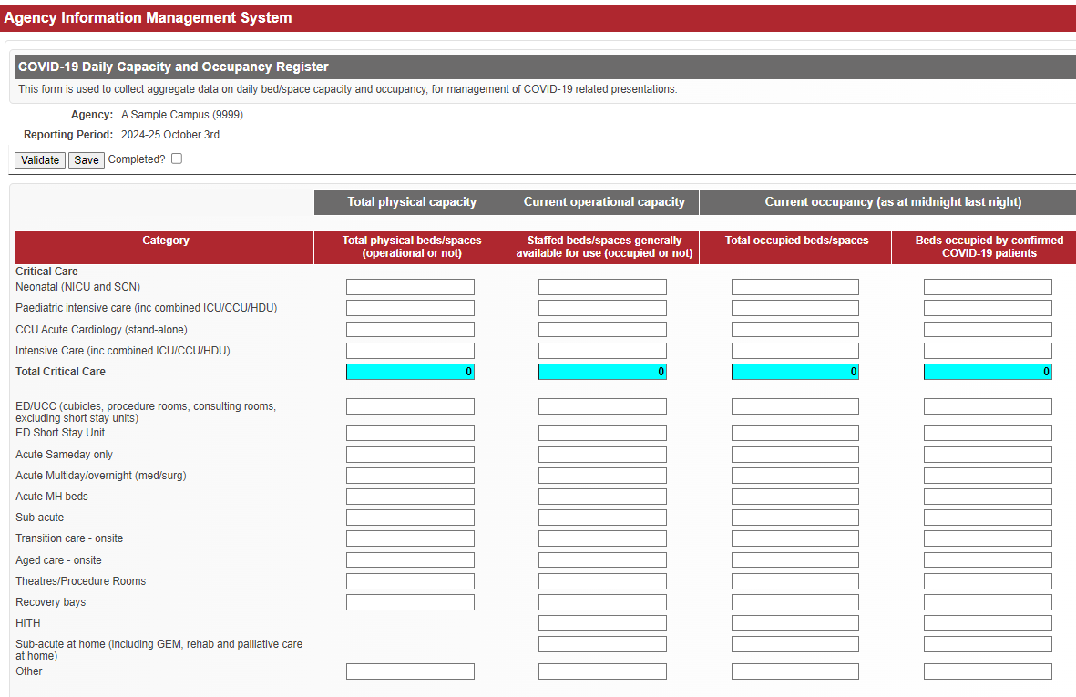

Definitions

Category of bed/space/at home care
The column titled ‘Category’ lists a number of types of bed/space/at home care. For each of these, report the data for the reporting day in the spaces provided in relevant columns.
The following definitions of these bed/space/at home care categories align with the reporting rules of the Victorian Admitted Episodes Dataset (VAED), or the Victorian Emergency Minimum Dataset (VEMD) unless otherwise stated, or not defined.

Critical Care section
Report data for each column for each of the four Critical Care category rows, as relevant for this campus:

Neonatal (NICU and SCN)
Designated ward or wards specially staffed and equipped to provide observation, care and treatment to newborns with actual or potential life-threatening illnesses, injuries or complications, from which recovery is possible. May be a facility approved by the Commonwealth Minister for the purpose of provision of neonatal intensive care (NICU) and/or a designated special care nursery (SCN).
An approved NICU must be capable of providing complex, multisystem life support for an indefinite period. It must be capable of providing mechanical ventilation and invasive cardiovascular monitoring, or care of a similar nature.

Paediatric intensive care (including combined ICU/CCU/HDU)
Royal Children’s Hospital and Monash Medical Centre Clayton only: other campuses, report 0.
A designated ward specially staffed and equipped to provide observation, care and treatment to infants and children less than 16 years of age, with actual or potential life-threatening illnesses, injuries or complications, from which recovery is possible.
Must be capable of providing complex, multisystem life support for an indefinite period; be a tertiary referral centre for children needing intensive care; and have extensive backup laboratory and clinical service facilities to support this tertiary role. Must be capable of providing mechanical ventilation, extracorporeal renal support services and invasive cardiovascular monitoring for an indefinite period.

CCU Acute Cardiology (stand-alone)
A designated ward specifically staffed and equipped to provide observation, care and treatment to patients with acute cardiac problems, such as acute myocardial infarction and unstable angina, and who may have undergone interventional procedures from which recovery is possible.
The CCU provides special facilities and utilises the expertise and skills of medical, nursing and other staff trained and experienced in the management of these conditions.
Excludes: Combined ICU/CCU beds/units: report as Intensive Care.

Intensive Care (including combined ICU/CCU/HDU)
Report only if this campus is approved to report ICU activity to the VAED (including new approvals granted during the pandemic).
A designated ward specially staffed and equipped to provide observation, care and treatment to patients with actual or potentially life-threatening illnesses, injuries or complications, from which recovery is possible.
The ICU provides special expertise and facilities for the support of vital functions and utilises the skills of medical, nursing and other staff trained and experienced in the management of these problems.
Must be capable of providing basic multisystem life support including (at least) mechanical ventilation and simple invasive cardiovascular monitoring.
Includes:
- High dependency unit-type (HDU) within an ICU, administratively and/or physically
- Coronary care unit (CCU) within an ICU, administratively and/or physically.
Excludes:
- Paediatric intensive care
- Neonatal intensive care and Special Care Nurseries
- Coronary Care Units (standalone)
- Intensive Nursing Units
- Stepdown Units.

Total Critical Care (calculated)
The total of values entered in the four Critical Care categories is calculated in the webform, and displayed in the Total Critical Care row (aqua coloured highlighting) for each Capacity and Occupancy column.

ED (Emergency Department)/UCC (Urgent Care Centre) (cubicles, procedure rooms, consulting rooms, excluding short stay units)
Report only if this campus is a public hospital reporting to the VEMD.
A dedicated area in a hospital organised and administered to provide emergency care (including reception, triage, initial assessment and management) to people who perceive the need for, or are in need of, acute or emergency care.
In an emergency department, possible beds and spaces may include all points of care including resuscitation bays, cubicles (trolley and chair), consulting rooms (general, specific/restricted use) treatment/procedure rooms and behavioural assessment rooms.
Excludes: Emergency Department Short Stay Units

ED (Emergency Department) Short Stay Unit
Report only if this campus is approved to report activity under this category to the VAED.
An Emergency Department (ED) Short Stay Unit (SSU) is a designated unit that is specifically staffed and equipped to provide observation, care and treatment for emergency patients who have an expected length of stay between 4 and 24 hours. The facility may be adjacent to, within, or remote from the Emergency Department.

Acute Sameday only
Designated same day units designed for day-stay patients, including day procedures, chemotherapy and renal dialysis.
Excludes:
- Recovery bays
- HITH

Acute multiday/overnight (med/surg)
Accommodation intended for acute overnight patients.
Excludes:
- Critical care wards: report under appropriate critical care unit type
- ED Short stay
- Acute mental health
- HITH

Acute Mental Health (MH) beds
Accommodation intended for acute overnight mental health patients.
Excludes:
- Accommodation intended for same day acute mental health patients: report as Acute same day only
- Secure extended care beds: report as ‘Other’

Sub-acute (on-site)
Report only if this campus is approved to report Care Type 6, P, 9 or 8 to the VAED and the patient is accommodated on the hospital premises on the reported day.
Sub-acute beds/spaces onsite at the hospital include those usually used for treating patients in the following care types:
- Rehabilitation
- Paediatric Rehabilitation
- Geriatric Evaluation and Management (GEM)
- Palliative Care
Excludes: any of these Care types provided in the home or off-site as ‘Sub-acute at home’ care: report as ‘Sub-acute at home’

Transition care – onsite (acute facilities only)
Transition care is a jointly funded program between the Victorian Department of Health and the Commonwealth Department of Health and Aged Care.
Includes: Transition care beds located within acute hospital facilities
Excludes:
- home-based transition care, transition care beds in sub-acute or non-acute facilities
- a patient receiving services under the Transition care program outside the hospital, who receives admitted type treatment/care off-site under HITH or Sub-acute at home that meets a Criterion for admission and criteria for DCOR reporting on the day: report in HITH or Sub-acute at home, as relevant.

Aged care – onsite
Residential Aged Care places within an approved Commonwealth aged care facility that is located within the hospital campus.
Excludes:
- Off-site residential aged care beds/facilities managed by the hospital
- Beds/spaces on-site designated for the provision of Geriatric Evaluation and Management (GEM) or inpatient Rehabilitation: report as Sub-acute (on-site)
- a resident of an off-site aged care service who receives admitted type treatment/care under a HITH or Sub-acute at home service that meets a Criterion for admission and criteria for DCOR reporting on the day: report in HITH or Sub-acute at home, as relevant

Theatres/Procedure Rooms
Operating theatres or procedure rooms, including cardiac catheter laboratories and endoscopy suites.
Excludes:
- Consulting rooms
- Other areas where minor procedures may take place.
As a guide, include theatres or procedure rooms used to perform procedures in scope for reporting Procedure Start Date/Time to the VAED.

Recovery bays
Rooms or spaces where patients are located temporarily following surgery.

HITH (Hospital in the Home)
Report only admitted patients, ie patients who:
- meet a Criterion for admission and
- received admitted type treatment/care* in HITH on the reported day and
- whose admitted episode is reported to the VAED with:
  - Accommodation Types:
4 HITH or
R Off-site: care delivered in an off-site facility which is not the patient’s usual residence and
  - Care Type 4 Other (Acute) Care.
Exclude from the day’s count any HITH patient who, on that day:
- did not receive admitted type HITH treatment/care, or
- was accommodated on the hospital premises in another bed category.
HITH for the purposes of DCOR reporting is defined as set out in Section 2 of the VAED manual: Provision of care to hospital admitted patients in their place of residence as a substitute for traditional hospital accommodation. Place of residence may be permanent or temporary, and includes residential facilities such as nursing homes, hostels or other forms of supported accommodation. HITH might combine hospital and home-based care or replace hospital care completely. Medi-hotels are excluded. The use of HITH is voluntary for the patient.
Report only when acute admitted type treatment/care is provided: the patient was visited (may include video conferencing but not teleconferencing) in their home (or other residential service not providing admitted care), or a substitute location, by HITH staff providing admitted services to the patient on the reported day. Acute care for this purpose is defined as set out in Section 2 of the VAED manual.

Subacute at home (including GEM, rehab and palliative care at home)
Report only if this campus is approved to report Rehabilitation, Paediatric Rehabilitation, GEM or Palliative care Care Type to the VAED.
Report only admitted patients, ie patients who:
- meet a Criterion for admission and
- received admitted type treatment/care in that setting on the reported day and
- whose admitted episode is reported to the VAED with:
  - Accommodation Types
4 HITH or
R Off-site: care delivered in an off-site facility which is not the patient’s usual residence and
  - Care Type:
6 Designated Rehabilitation Program/Unit or
P Designated Paediatric Rehabilitation Program/Unit or
8 Palliative Care Program or
9 Geriatric Evaluation and Management (GEM) Program.
Exclude from the day’s count any Subacute at home patient who, on that day:
- did not receive admitted type Sub-acute at home treatment/care, or
- was accommodated on the hospital premises in another bed category.
Sub-acute at home is care delivered in the patient’s place of residence, as a substitute for sub-acute admitted care in traditional hospital accommodation (on-site). Place of residence may be permanent or temporary, and includes residential facilities such as nursing homes, hostels or other forms of supported accommodation. Sub-acute at home might combine hospital and home-based care or replace hospital care completely. Medi-hotels are excluded. The use of Sub-acute at home is voluntary for the patient.
Report only when sub-acute admitted type treatment/care is provided: the patient was visited (may include video conferencing but not teleconferencing) in their home (or other residential service not providing admitted care), or a substitute location, by sub-acute at home staff providing admitted services to the patient on the reported day. Sub-acute care for this purpose is defined as set out in Section 2 of the VAED manual.

Other
For Total physical capacity:
- Any other type of bed/space not listed above, excluding HITH and Sub-acute at home.
For Current operational capacity and both Current occupancy columns:
- Any other type of bed/space not listed above.

Total physical capacity:
Total physical beds/spaces (operational or not)
The number of physical beds, day-treatment chairs including dialysis or day-oncology chairs, or treatment spaces, that can/could accommodate patients requiring a physical bed or trolley, regardless of whether that bed/space is currently operational or staffed.
Beds/spaces currently in use plus non-operational, unstaffed, unfunded, and decommissioned stock.
The number of spaces that could be used to accommodate a bed or trolley. For example, a space that could house three beds should be counted as 3.
This definition of ‘bed’ differs from that generally used for average available bed reporting to AIMS.
Not reported for: HITH or Sub-acute at home.

Current operational capacity:
Staffed beds/spaces generally available for use (occupied or not)
Beds/treatment spaces currently staffed and equipped to accommodate patients, whether currently occupied or not. This differs from ‘funded places’ as reported elsewhere. Operational capacity must be reported accurately for each reported day, reflecting changes to staffing and/or equipment capacity, as they occur.
HITH and Sub-acute at home: report the number patients for whom the campus has operational capacity to provide admitted type treatment/care in the HITH or Sub-acute at home setting, on the day being reported.

Current occupancy (as at midnight last night):
The beds/spaces occupied at midnight (ie 11.59 pm) on the reported day, by bed/space/at home Category.

Total occupied beds/spaces
Beds/spaces in which a patient was accommodated for treatment/care at the end of the reported day.
Include: deceased patients occupying a bed at midnight pending transfer to the mortuary.
HITH and Sub-acute at home:
- HITH or Sub-acute at home patients, including confirmed COVID-19 patients, who, on the reported day, met the criteria for DCOR reporting, as defined under HITH and Sub-acute bed categories above

Beds occupied by confirmed COVID-19 patients
Beds/spaces occupied for treatment/care, as at midnight on the day being reported, by a patient who is confirmed COVID-19, ie has received a positive SARS-CoV-2 pathology test and in whom the virus has not yet resolved.
Exclude:
- patients/residents under quarantine for suspected SARS-CoV-2 infection and/or awaiting a test result or
- patients/residents previously infected with SARS-CoV-2 who have since received negative pathology test results or
HITH and Sub-acute at home:
- confirmed COVID-19 patients in HITH or Sub-acute at home, who, on the day being reported, met the criteria for DCOR reporting, as defined under HITH and Sub-acute bed categories above.

HITH Acute admitted care at home
Acute Care is (admitted patient) care in which the clinical intent or treatment goal is to:
- Manage labour (obstetric)
- Cure illness or provide definitive treatment of injury
- Perform surgery
- Relieve symptoms of illness or injury (excluding palliative care)
- Reduce severity of an illness or injury
- Protect against exacerbation and/or complication of an illness and/or injury which could threaten life or normal function and/or
- Perform diagnostic or therapeutic procedures.

Sub-acute admitted care at home
Subacute care is time limited, goal-orientated, individualised, interdisciplinary care that aims to help people who are disabled, frail, chronically ill or recovering from traumatic injury to regain and/or maintain optimal function to allow as many people as possible to maximise their independence and return to (or remain in) their usual place of residence. For the purpose of this register only report admitted subacute bed equivalents.
These include beds associated with:
- Designated Rehabilitation Programs
- Geriatric Evaluation and Management Program
- Palliative Care
Report the number of patients receiving admitted type treatment / care under HITH and Sub-acute at home programs on the reported day.
Do not include a count of any patients on leave from HITH, or Sub-acute at home care on the reported day, consistent with VAED reporting.
Definitions of ‘HITH’ and ‘Sub-acute’ for this reporting are consistent with those in the VAED manual.
A patient cannot be counted as receiving admitted type treatment / care in HITH or Sub-acute at home, and also counted as occupying a hospital bed, on the same day.
All patients reported as HITH and Sub-acute at home, whether confirmed COVID, suspected COVID, or neither, must meet a Criterion for admission, consistent with VAED reporting requirements.
Confirmed COVID is defined consistent with criteria for reporting occupancy of these patients in hospital beds, as noted in this document.
Report HITH and Sub-acute at home patients in only the ‘Current Operational Capacity’ column and the three ‘Current occupancy’ columns.

Further information
Questions about accessing this data collection in HealthCollect, or notification of inability to report by the due date, should be emailed to the HDSS HelpDesk <hdss.helpdesk@health.vic.gov.au> .

PCCP: Palliative Care Consultancy Program

Reported at Agency level: CA (campus)

Reporting frequency: Quarterly

Due Date: 15th day after end of reporting period (quarter)

Reporting guidelines
Reports information across the consultancy program to monitor statewide activity and meet the department’s reporting obligations.

Data Definitions

Contacts
The number of direct contacts that occurred during the reporting period (quarter).
Contacts refer to interactions that occurred between the consultancy service and a client/patient that were clinically significant in nature (not administrative).
Interactions between the consultancy service and another health professional are not counted.
Direct contacts as outlined in Section 2 of the VINAH minimum dataset manual are in-scope to count towards the contact count.
- Count interactions provided by a medical practitioner or nurse practitioner under the Contacts (medical) column.
- Count interactions provided by allied health or nursing personnel under the Contacts (non-medical) column.
- Count contacts provided by a nurse practitioner candidate under the Contacts (non-medical) column. This activity is classified as a nursing Tier 2 class (in alignment with national reporting) until the candidate is accredited.

Active Episodes
The total number of active episodes open during the reporting quarter. An episode is ‘active’ during the period when the palliative care program was providing advice. Episodes for palliative care consultancy may be one day (opened and closed on the same day) or may be greater than one day.

Episodes Opened
The number of episodes that commenced during the reporting period. That is, the count of all episodes where the episode start date fell within the reporting period.

Episodes Closed
The number of episodes that ended during the reporting period. That is, the count of all episodes with an end date that fell within the reporting quarter.

Referrals Received
The number of referrals received by the program for advice about specific clients. All referrals – both appropriate and inappropriate – should be included when calculating the total number of referrals received for the quarter.

Patients
The number of distinct clients that the program provided consultative advice for during the reporting period. If a client had two episodes during the quarter, this would result in a count of one patient, not two, for this data item.
Illustration showing scenarios for reporting Active, Opened and Closed episodes
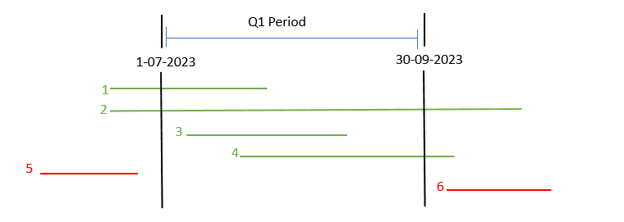
The scenarios illustrated above in green are included in the counts of Active, and/or Opened and/or Closed, episodes for a reporting period (eg Quarter 1).
- Episode 1 opened prior to the Q1 period and closed within the Q1 period:
count as Active and Closed episode.
- Episode 2 opened prior to the Q1 period and closed after the end of the Q1 period:
count as Active.
- Episode 3 opened during the Q1 period and closed within the Q1 period:
count as Opened, Active and Closed.
- Episode 4 opened during the Q1 period and closed after the end of the Q1 period:
count as Opened and Active.
Episodes shown in red above would not be included in this quarter’s reporting because they started or ended outside the reporting period, and neither was active at any time during this quarter:
Episode 5 opened before the start of the period and closed before the start of the period.
Episode 6 opened after the end of the reporting period.

Sample Palliative Care Consultancy Program webform:
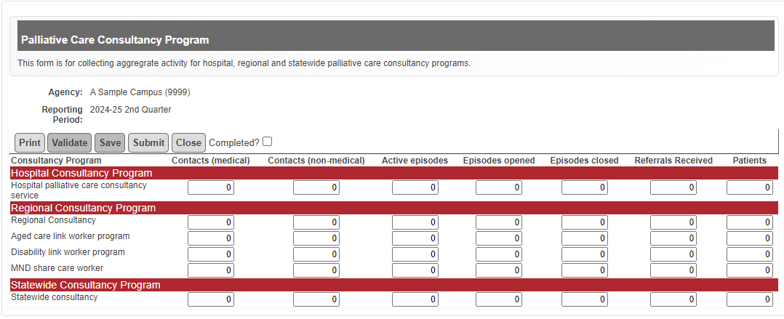

Further information
Questions about the data items to be reported, or to notify of inability to report by the due date, should be emailed to the department’s Palliative Care team < pallcare@dhhs.vic.gov.au > .
Questions about accessing this data collection in HealthCollect should be emailed to the HDSS HelpDesk <hdss.helpdesk@health.vic.gov.au> .

S10: Acute Non-Admitted Clinic Activity

Reported at Agency level: CA (campus)

Reporting frequency: Monthly

Due Date: 12th day after end of reporting period

Reporting guidelines
Non-admitted service activity data is to be submitted on the S10 form by:
- Health services in-scope for activity based funding (ABF) that deliver acute non-admitted services.
- Block-funded services (ie small rural health services) that deliver acute non-admitted services.
Acute non-admitted activity reported via the S10 must be within the scope of a non-admitted public hospital service as determined annually by the IHACPA. For detailed definition of what is within scope as a non-admitted public hospital service for 2024-25, refer to the IHACPA Pricing Framework for Australian Public Hospital Services 2024-25 < https://www.ihacpa.gov.au/resources/pricing-framework-australian-public-hospital-services-2024-25 >
In particular, health services need to be aware that for non-admitted allied health or nurse led activity to be considered ‘in scope’ it must be:
- Directly related to an inpatient admission or emergency department attendance; or
- Intended to substitute directly for an inpatient admission or emergency department attendance; or
- Expected to improve the health or better manage the symptoms of persons with physical or mental health conditions who have a history of frequent hospital attendance or admission.

Exclusions:
The following services are excluded from S10 Reporting:
- Urgent care centre activity: this is to be submitted using the AIMS Urgent Care Centre form from 1 July 2024 for all sites with an urgent care centre.
- Non-admitted activity reported through the Victorian Emergency Minimum Dataset (VEMD).
- Non-admitted activity submitted through other AIMS non-admitted forms or other Department of Health reporting arrangements. For example, home self-administered renal dialysis services, self-delivered non-admitted services, Health Independence Program (HIP) subacute non-admitted services, mental health non-admitted clinics, primary and community health, disability services, home and community care program for younger people (HACC-PYP).
- Services provided to non-admitted patients by medical practitioners or other health professionals on a completely private basis where the medical record is not held by the health service.
- Non-admitted services directly funded or contracted by other funding bodies eg the Commonwealth or nursing services when not sub-contracted by the health service.
- Hospital in the Home (HITH) activity: this is an admitted patient service reported through the Victorian Admitted Episode Database (VAED).
- Services provided to patients while they are admitted.
- Dental Services funded by Dental Health Services Victoria.
- Services where the patient is charged a fee to attend e.g. childbirth/parenting classes.
- Diagnostic clinics are not counted as non-admitted patient service events.
If a health service is unsure what may be excluded please email the HDSS helpdesk <hdss.helpdesk@health.vic.gov.au>

Reporting Requirements
The S10 Non-Admitted Clinic Activity form collects acute non-admitted aggregate data at the Tier 2 non-admitted clinic category.
The development and maintenance of the Tier 2 non-admitted clinic categories and definition of a service event, used as the activity counting unit on the S10, are set by the IHACPA in consultation with State and Territory jurisdictions.
All Victorian public health services that provide acute non-admitted clinic services must report in-scope activity on the S10 form against the campus responsible for providing the service. This applies whether the health service is in-scope for ABF, or is block-funded for delivery of acute non-admitted services (ie small rural health services).

Registering clinics for reporting on the AIMS S10
Acute non-admitted activity is reported against clinics registered for the health service campus using the Non-Admitted Clinic Management System (NACMS), which is accessible in the HealthCollect portal.
The AIMS S10 form is assigned for each campus that has at least one acute non-admitted clinic registered in the NACMS. Campuses with no acute non-admitted clinics registered in the NACMS will not have the AIMS S10 form listed in HealthCollect.
All clinics are categorised when registered in the NACMS according to the type of service provided, with these service types linked to Tier 2 classes as set by the IHACPA:
- Procedure Clinics
- Medical – Consultation
- Allied Health and/or Clinical Nurse Specialist Interventions
All health services must:
- identify their non-admitted clinics providing acute clinical services that are in scope for reporting
- classify those acute non-admitted clinics to the most appropriate Tier 2 class
- register those clinics by submitting relevant details using the NACMS
- submit data on activity using the S10 form.
HealthCollect users with access to AIMS reporting for the campus can view the registered non-admitted clinics for that campus on the S10 form or in HealthCollect reports.
Health services should ensure that appropriate staff are authorised to access the NACMS and have mechanisms in place to follow the correct processes for new clinic registrations and changes to existing clinics. Only approved users may register clinics.
Details about NACMS are available in the Non-Admitted Clinic Management System Manual < https://www.health.vic.gov.au/publications/non-admitted-clinic-management-system-nacms-manual> .
Request access to the NACMS using the HealthCollect Portal User Request Form < https://forms.office.com/Pages/ResponsePage.aspx?id=H2DgwKwPnESciKEExOufKIQCYRhq7MNNvvjya8xeYoZUNzE3UEZWTlpPNlc0WUhaMERaMEw1SjRDSS4u> .

Clinic registration status
Only clinics that are active for the reporting period are displayed on the S10 for entry of activity data. Active clinics have a clinic status of Pending, Reviewed or Approved:
- Pending: the clinic has been submitted via the NACMS for registration with the department and is under consideration by the department. Activity data can be submitted for clinics with Pending status. Clinics with Pending status are displayed in the AIMS S10 webform in dark green font.
- Reviewed: the clinic has been reviewed by the department prior to submission to the Non-Admitted Clinical Classification Committee (NACCC) and is awaiting a final decision. Activity data can be submitted for clinics with Reviewed status.
- Approved: the clinic has been approved by the department. Activity data can be submitted.
Clinics that are in ‘draft’ will not display on the S10 form. Activity data cannot be submitted against a draft clinic.
Clinics that are inactive or closed will not be displayed for submission periods after the date on which the clinic became inactive or ceased. For example, if a clinic is closes in March, it will appear on the S10 up to and including March but will be removed from the S10 from April. Health services submit changes to the status of clinics via the NACMS.
Clinics assessed by the department as ineligible will be removed from the S10. Data entered against a clinic subsequently assessed as ineligible cannot be amended in the S10 webform and is removed from S10 reports. An ineligible clinic is one that undertakes activity which is either not an acute service in scope for ABF, not clinically directed at hospital patients or is undertaken solely by the private sector.

Definitions

Non-Admitted Patient
A patient/client is a person for whom an organisation accepts responsibility for providing treatment or care. A non-admitted patient does not undergo a hospital’s formal admission process.
Not all non-admitted patient services are required to be reported via the S10 form. See Exclusions.

Service Event
A non-admitted patient service event is defined as an interaction between one or more healthcare provider(s) with one non-admitted patient, which must contain therapeutic/clinical content and result in a dated entry in the patient’s medical record.
To qualify as a patient service event:
- The patient must be a key participant in the service event.
- The interaction must be clinical/therapeutic in nature and result in a dated entry in the patient’s medical record. The interaction must not be for administrative purposes ie administrative phone calls or emails must not be counted as a service event.
- One or more healthcare providers must provide the clinical/therapeutic content.

New and Review Service Events
Public individual patient service events are collected according to the purpose of an appointment.
- New service event is for the purpose of initial assessment or treatment.
- Review service event is for the purpose of review following a previous non-admitted service event, or post discharge as an admitted patient.

Counting Service Events
A non-admitted patient service event should be counted once only, regardless of the number of healthcare providers present:
- Non-admitted services involving multiple healthcare providers are counted as one non-admitted patient service event.
- If the clinic providing the service is a clinic where care is provided by multiple healthcare providers, then it is irrelevant whether the patient was seen jointly or separately by multiple providers. This should still be counted as one non-admitted patient service event.
- One non-admitted MDCC (multi-disciplinary case conference) service event is recorded for each patient discussed at a non-admitted MDCC where the patient is not present.
The service event may occur in a range of settings, on a health service campus or non-health service site or in the patient’s home.
Services provided to non-admitted patients of another hospital, such as allied health services, should only be counted if the hospital is not reimbursed for these services by the other hospital.
Any service provided to a patient while they are admitted must not be counted as a non-admitted patient service event. This includes patients admitted to one hospital that are then transferred to another hospital for a non-admitted service.
The patient may participate via a range of modes including face-to-face, Information and Communication Technology (ICT) including but not limited to video-conference or telephone. Services delivered via ICT can only be counted if they are a direct substitute for a face-to-face consultation and meet the definition of a non-admitted patient service event. That is, the event must be necessary and if the event were not delivered via ICT then the patient would have been required to receive that service in a face-to-face consultation.
ICT service events should be counted by both the health service providing the consultation (provider end) and by the public hospital service where the patient is present (receiver end).

Sub-contracted/purchased services
Service events that are purchased by a health service should be reported by the health service which pays for/purchases the service. For example, where a health service purchases visits from another health service agency such as district nursing, community health centre or private midwifery service, the service events should be reported by the health service which pays for/purchases the service.

Domiciliary post natal care services
For health services in scope for reporting specialist outpatient clinic data through VINAH and AIMS S10, reporting of post natal domiciliary care is completed by the health service delivering the post natal domiciliary care service. Refer to the Post Natal Domiciliary Care guidelines for reporting <https://www.health.vic.gov.au/publications/post-natal-domiciliary-care-guidelines-for-reporting> for further information.

Service Events including multiple health care providers
Non-admitted services involving multiple healthcare providers are counted as one non-admitted patient service event.
If the clinic providing the services is a clinic where care is provided by multiple healthcare providers, then it is irrelevant whether the patient was seen jointly or separately by multiple healthcare providers. This should be counted as one non-admitted patient service event.
For example, a diabetic patient who will see an endocrinologist, followed by a nurse and then a dietician I the same clinic will be counted as one non-admitted service event.
Clinics where services are provided by multiple healthcare providers must not be registered as separate clinics to increase non-admitted patient service events.
If the non-admitted patient service event was intended to be unbroken, but due to circumstances the healthcare provider was called away and returned later, then only a single non-admitted patient service event must be counted.

Group Sessions
A group is defined as two or more patients receiving the same service at the same time from the same healthcare provider(s), for example, a movement class or a hydrotherapy class, where all participants follow the same intervention at the same time and where the group nature of the activity is part of the benefit to the patient.
A group session may be delivered by more than one healthcare provider. This may be multidisciplinary care within one clinic appointment as part of a group, eg a group session jointly delivered by a physiotherapist and an occupational therapist.
If care is delivered to a number of patients in the same physical space at the same time but the patients are not receiving precisely the same services (that is, where a clinician works one-on-one with several different patients in the same space over a period of time but each patient is following their own personalised program) then for reporting purposes this is not considered a group.

Group Service Events
One service event is recorded for each patient who attends a group session. Spouses, parents or carers attending the session are only counted for the group session if they also participate in the service as a patient (see definition of a service event).
Each group service event should be counted and recorded against the relevant funding source of the participant—either public, DVA, MBS or other funded.
For example, if 20 people attend a group session, of which 15 are public, 2 are DVA and 3 are TAC/WC, data should be reported on the S10 as follows:
- 1 group session
- 15 public group service events
- 2 DVA group service events
- 0 MBS group service events
- 3 Other Funded group service events.

Multidisciplinary case conference (MDCC) – patient not present
One non-admitted MDCC service event may be counted for each patient discussed at a non-admitted MDCC where the patient is not present. A MDCC where the patient is not present must involve three or more healthcare providers who have direct care responsibilities for the patient discussed. The healthcare providers may be of the same profession however they must each have a different speciality so that the care provided by each provider is unique. Alternatively, the healthcare providers may be of different professions but of the same specialty.

Multiple appointments on a single day
Patients can be counted as having multiple non-admitted patient service events on the same day, provided that every visit meets each of the criteria in the definition of a non-admitted patient service event.

Other
Additional counting rules also apply and are listed in the IHACPA Tier 2 Non-Admitted Services Compendium 2024-25 < https://www.ihacpa.gov.au/resources/tier-2-non-admitted-services-2024-25> .

Validation rules for groups
Validation rules are applied on the S10 form when values are entered against group sessions and group service events. All validation rules must be met before the form can be saved.
Group validation rules:
- When the value of ‘Number of Group Sessions’ is greater than 0, then at least one of the four group service event items (public group service event or DVA group service event or MBS group service event or other group service event) must be greater than 0.
- The total of group service events (public group service event or DVA group service event or MBS group service event or other group service event) must be greater than the value for Number of Group Sessions, unless all values are zero.
- When a value is greater than 0 in at least one of the four group service event items (public group service event or DVA group service event or MBS group service event or other group service event) then the value in Number of Group Sessions must be greater than 0.

Multiple Healthcare Providers
An asterisk (*) will appear on the S10 form for a clinic that has been identified as a multiple healthcare provider clinic.

Funding source categories

Public Service Events
Non-admitted service events for persons eligible for Medicare who elect to be treated as public patients.

DVA Service Events
Non-admitted services provided to eligible Department of Veterans’ Affairs veterans and war widow(er)s whose charges are met by the Department of Veterans’ Affairs.

MBS Service Events
Non-admitted services where the clinician bills Medicare for the patient’s treatment.
Exclude services provided to non-admitted patients by medical practitioners or other health professionals on a completely private basis where the medical record is not held by the health service.

Other Funded Service Events
Non-admitted service events for patients who are responsible for payment of charges or whose charges are met by a third party (other than DVA). This includes workers’ compensation, Transport Accident Commission, criminal injury and common law cases, members of the Defence Forces and seamen, patients not eligible under Medicare and not exempt from fees or other patients who elect to self-fund.

S19(2) Exemption Service Events
A service event or presentation for persons eligible for Medicare where the hospital provides care by its own eligible staff under Section 19(2) Exemptions Initiative – Improving Access to Primary Care in Rural and Remote Areas.

Data Submission
Health services have three options for populating data on the S10 form:
- manual entry or
- S10 flat file upload process or
- a combination of both.
The flat file upload allows health services to submit clinic-specific aggregate data in a pre-defined file format to HealthCollect. This process only populates rows for clinics included in the uploaded file. Clinics not included in the uploaded file are not affected.
Data submitted later will overwrite any data submitted previously by either upload or entry to the webform for that clinic ID for that period.

To edit/modify S10 data after submission
To correct an error detected after data has been submitted to the department, open the form with the error, un-tick the Completed box and amend data as necessary. When entries are complete, re-tick the Completed box and re-submit to the department.

S10 Flat File Specifications
The S10 file upload function allows a user to select two file type options:
- No S19(2) Exemptions. This file format consists of 15 columns which EXCLUDES the S19(2) Exemptions patient payment status field.
- S19(2) Exemptions. This file format consists of 16 columns which INCLUDES the S19(2) Exemptions patient payment status field. The column reporting S19(2) Exemptions is row 16 sequenced at the end of the file.
S10 file format:
Order | Field Name | Data Element Name | Element type
1 | Year | Year | Character
2 | Period | Period | Integer
3 | AgencyID | Campus Code/Agency Identifier | Code
4 | RegistrarTypeCode | Registrar Type Code | Code
5 | ClinicID | Clinic Identifier | Code
6 | PublicIndividualServiceEventNew | Public individual service events new | Integer
7 | PublicIndividualServiceEventReview | Public individual service events review | Integer
8 | DVAIndividualServiceEvent | DVA individual service events | Integer
9 | MBSIndividualServiceEvent | MBS individual service events | Integer
10 | OtherIndividualServiceEvent | Other individual service events | Integer
11 | GroupSessions | Number of Group Sessions | Integer
12 | PublicGroupServiceEvent | Public Group service events | Integer
13 | DVAGroupServiceEvent | DVA Group service events | Integer
14 | MBSGroupServiceEvent | MBS Group service events | Integer
15 | OtherGroupServiceEvent | Other Group service events | Integer
16 | S19_2_ExemptionServiceEvent | S19 (2) Exemption service events | Integer
When sending data use csv format, i.e. send one record per line with each element delimited by a single ‘,’ as follows:
File containing 15 fields:
2425,1,99999,CA,UROL,15,50,2,10,0,10,5,2,1,5
2425,1,99999,CA,MED1,10,35,4,20,2,2,1,12,1,1
File containing 16 fields:
2425,1,99999,CA,UROL,15,50,2,10,0,10,5,2,1,5,0
2425,1,99999,CA,MED1,10,35,4,20,2,2,1,12,1,1,1
As per csv conventions any field containing punctuation characters, including spaces, should be enclosed in double quotes. This will only apply to the Clinic Identifier.

Key points to remember:
- Make sure you provide the correct agency identifier for each record.
- Each field is to be delimited by a single comma i.e. ‘,’
- All fields sent must have a value.
- A separate file must be sent for each agency/campus and period.

Field definitions

Year
A four-digit number of the format Y1Y2 representing the financial year, eg 2425 for 2024-25 financial year.

Period
The period (month) in which the sessions/service events occurred.
Code | Description
1 | July
2 | August
3 | September
4 | October
5 | November
6 | December
7 | January
8 | February
9 | March
10 | April
11 | May
12 | June

Campus Code/Agency Identifier
The identifier of the health service campus to which the clinic is registered.
The agency identifier is the code shown to the right of the ‘Agency’ field on the S10 form. It will usually correspond to the VAED campus code of the hospital.
A full list of codes can be found in Campus code table < https://www.health.vic.gov.au/data-reporting/vemd-vaed-vinah-esis-reference-files >.

Registrar Type Code
A code indicating the type of agency submitting data. All agencies will set this value to ‘CA’ unless otherwise specified

Clinic Identifier
The unique identifier of a clinic registered in NACMS.

Public Individual Service Events New
The count of the number of public individual new service events that occurred for the clinic within the specified year and period.

Public Individual Service Events Review
The count of the number of public individual review service events that occurred for the clinic within the specified year and period.

DVA Individual Service Events
The count of the number of DVA individual service events that occurred for the clinic within the specified year and period.

MBS Individual Service Events
The count of the number of MBS individual service events that occurred for the clinic within the specified year and period.

Other Individual Service Events
The count of the number of other funded individual service events that occurred for the clinic within the specified year and period.

S19(2) Exemptions Service Events
The count of the number of section 19(2) exemptions service events that occurred for the clinic within the specified year and period.

Group Sessions
The count of the number of group sessions that occurred for the clinic within the specified year and period.

Public Group Service Events
The count of the number of public group service events that occurred for the clinic within the specified year and period

DVA Group Service Events
The count of the number of DVA group service events that occurred for the clinic within the specified year and period.

MBS Group Service Events
The count of the number of MBS group service events that occurred for the clinic within the specified year and period.

Other Group Service Events
The count of the number of other funded group service events that occurred for the clinic within the specified year and period.

Further information
Questions about S10 reporting, including the data items to be reported, accessing the S10 form in HealthCollect, or notification of inability to report by the due date, should be emailed to the HDSS HelpDesk <hdss.helpdesk@health.vic.gov.au> .
Questions about registering acute non-admitted clinics in the NACMS should be emailed to the NACMS team <nacms@health.vic.gov.au> .
Health services with clinics assigned on the S10 for which activity no longer occurs should close those clinics in the NACMS. Where all clinics are closed, and the campus no longer needs to report the S10 collection, the health service should email the HDSS HelpDesk <hdss.helpdesk@health.vic.gov.au> . This includes campuses that previously reported Urgent Care activity on the AIMS S10.

S11: Sub Acute Non-Admitted Activity

Reported at Agency level: CA (campus)

Reporting frequency: Monthly

Due Date: 12th day after end of reporting period

Reporting guidelines
Health services and non-government organisations (NGOs) that receive funding for the following in scope non-admitted subacute programs must report non-admitted subacute activity data on the S11 form:
- Health Independence Program services
  - Subacute Ambulatory Care Services
  - Hospital Admission Risk Program
  - Post Acute Care
  - Residential In-Reach
- Community Palliative Care
- Regional Palliative Care Consultancy
- Palliative Care Day Hospice
- Statewide Palliative Care Service
- Victorian Paediatric Palliative Care
- Statewide Grief and Bereavement Program
- Statewide Paediatric Psycho-social Program
- Statewide Psycho-Oncology Program
- Statewide Motor Neurone Disease Program
- Victorian Artificial Limb Program
- Complex Care (FCP)
  - Complex Care (FCP) General
  - Complex Care (FCP) HARP
  - Complex Care (FCP) PAC
- Victorian Respiratory Support Service (VRSS) – general

Exclusions
Services provided to non-admitted patients by medical practitioners or other health professionals on a completely private basis where the medical record is not held by the health service.

Reporting Requirements
Health services/NGOs are to report activity each month by subacute program/stream against the campus responsible for providing the service. The unit of count to be reported is a Service Event.
The S11 form for each provider is customised to only show the program/streams for which the provider receives funding. Where there are multiple campuses for the one health service, the S11 for each campus will be identical. Each campus is only required to report activity for the program streams provided at that campus. Health services are responsible for coordinating the submission of health service wide data.
Where relevant, Program/streams have been separated into ’medical‘ and ’non-medical’ streams which align with ABF Tier 2 classes.

Data submission
Health services have three options for populating data on the S11 form:
- manual entry or
- S11 flat file upload process or
- a combination of both.
The flat file upload process allows health services to populate data into the S11 form via an electronic file in comma delimited (csv) format. This process populates S11 rows only for service streams included in the upload file. S11 rows for service streams not included in the upload file are not affected.
Data submitted later will overwrite any data submitted previously by either upload or entry to the webform for that clinic ID for that period.

Definitions

Non-Admitted Patient
A patient/client is a person for whom an organisation accepts responsibility for providing treatment or care. A non-admitted patient does not undergo a hospital’s formal admission process.
The S11 form is used for submitting subacute non-admitted patient services data. See above to identify in scope non-admitted subacute activity.

Service Event
A non-admitted patient service event is defined as an interaction between one or more healthcare provider(s) with one non-admitted patient, which must contain therapeutic/clinical content and result in a dated entry in the patient’s medical record.
For patient encounters to be defined as a service event, the following parameters must be met:
- The patient must be present at the encounter.
- For services that are delivered via modes other than face-to-face with the clinician for example, via telephone or email, the service must be a substitute for a face-to-face encounter and the other requirements of a service event must be met.
The patient must not currently be an admitted patient.
The service event may occur in a range of settings, on a health service campus or non-health service site or in the patient’s home or home-like environment (e.g. residential service).
Where the provider is a medical practitioner or a nurse practitioner the service event should be reported in the medical stream on the S11 form. It is assumed there may also be input from allied health personnel or nursing personnel. Where there is a mix of clinicians that interact with the patient and at least one of the clinicians is a medical practitioner or a nurse practitioner, the service event should be classified in the medical stream.
Where there are allied health personnel, nursing personnel or therapy aides providing a service event (with no medical practitioner or nurse practitioner present), the service event should be categorised to the appropriate non-medical stream.

Counting Service Events
Patient interacts with one clinician
- Where a patient has one interaction/contact with a single clinician on a particular day, the health service should report one service event in the relevant medical or non-medical category on the S11 form. A service event with a nurse practitioner should be reported in the relevant medical category.
Patient interacts with multiple clinicians on the same day
- Where a patient has an interaction/contact with multiple clinicians on the same day in the same service/program, the health service should report one service event on the S11 form.
- Where one of the multiple interactions/contacts on the same day in the same service/program is with a doctor (or nurse practitioner), health services should classify this as “medical” and report one service event in the medical category on the S11 form.
- Where there are multiple interactions/contacts on the same day in the same service/program, but none of the interactions involve a doctor (or nurse practitioner), the health service should classify this as “non-medical” and report one service event in the non-medical category on the S11 form.
Service events may occur on-campus or off-campus.
Service events provided by the staff of one hospital (hospital A) to non-admitted patients of another hospital (hospital B), such as allied health services, should only be counted if hospital A is not reimbursed for these services by hospital B.

Public service events
Non-admitted service events for persons eligible for Medicare who elect to be treated as public patients.

DVA service events
Non-admitted services provided to eligible Department of Veterans’ Affairs veterans and war widow(er)s whose charges are met by the Department of Veterans’ Affairs.
Note: A component of the health independence programs block grant covers the DVA contribution for these services.

MBS service events
Non-admitted services where the clinician bills Medicare for the patient’s treatment.
Exclude services provided to non-admitted patients by medical practitioners or other health professionals on a completely private basis where the medical record is not held by the health service.

Other funded service events
Non-admitted service events for patients who are responsible for payment of charges or whose charges are being met by a third party (other than DVA). This includes workers’ compensation, Transport Accident Commission, criminal injury and common law cases, members of the Defence Forces and seamen, patients not eligible under Medicare and not exempt from fees or other patients who elect to self-fund.

Group Sessions
A group is defined as two or more patients receiving the same service at the same time from the same healthcare provider(s), for example, a movement class or a hydrotherapy class, where all participants are following the same intervention at the same time and where the group nature of the activity is part of the benefit to the patient.
The group session must contain therapeutic/clinical content for each patient in the group in order to be counted as a non-admitted service event and the interaction must be documented in the individual patient medical record. Family members seen as a group can each be counted as non-admitted service events as long as each family member was provided with therapeutic/clinical input and a dated entry was made in each family member’s medical record. Family members/carers accompanying a patient to an appointment must not be counted.
If care is delivered to a number of patients in the same physical space at the same time but the patients are not receiving precisely the same services (that is, where a clinician works one-on-one with several different patients in the same space over a period of time but each patient is following their own personalised program) then for reporting purposes this is not considered a group.

Reporting Group Service Events
Each patient who attends a group session should be reported as having received a group service event. Each group service event should be counted and recorded against the relevant funding source of the participant—either public, DVA, MBS or Other Funded.
For example, if 8 patients attend a group event, of which 6 are public, 1 is DVA and 1 is TAC/WC, data should be reported on the S11 as follows:
- 1 group session
- 6 public group service events
- 1 DVA group service events
- 0 MBS group service events
- 1 Other Funded group service events.

Validation rules for groups
Validation rules are applied on the S11 form when values are entered against group sessions and group service events. All validation rules must be met before the form can be saved.
Group validation rules:
- When the value of ‘Number of Group Sessions’ is greater than 0, then at least one of the four group service event items (public group service event or DVA group service event or MBS group service event or other funded group service event) must be greater than 0.
- The total of group service events (public group service event or DVA group service event or MBS group service event or other funded group service event) must be greater than the value for Number of Group Sessions, unless all values are zero.
- When a value is greater than 0 in at least one of the four group service event items (public group service event or DVA group service event or MBS group service event or other funded group service event) then the value in Number of Group Sessions must be greater than 0.

To edit/modify data
To correct an error detected after data has been submitted to the department, open the form containing the error, un-tick the Completed box to unlock the form and amend data as necessary. When entries are complete, re-tick the Completed box and re-submit to the department.

S11 Flat File Specifications
The format of the file is specified as follows:
Order | Field Name | Data Element Name | Element type
1 | Year | Year | Character
2 | Period | Period | Integer
3 | AgencyID | Campus Code/Agency Identifier | Code
4 | RegistrarTypeCode | Registrar Type Code | Code
5 | ProgramStreamID | Program/Stream Identifier | Code
6 | ProfessionalGroupTypeCode | Professional group type code | Code
7 | PublicIndividualServiceEvent | Public individual service events | Integer
8 | DVAIndividualServiceEvent | DVA individual service events | Integer
9 | MBSIndividualServiceEvent | MBS individual service events | Integer
10 | OtherIndividualServiceEvent | Other individual service events | Integer
11 | GroupSessions | Number of Group Sessions | Integer
12 | PublicGroupServiceEvent | Public Group service events | Integer
13 | DVAGroupServiceEvent | DVA Group service events | Integer
14 | MBSGroupServiceEvent | MBS Group service events | Integer
15 | OtherGroupServiceEvent | Other Group service events | Integer

When sending in data use csv format i.e. send one record per line with each element delimited by a single ‘,’ as follows:
2425,1,99999,CA,1,M,52,2,10,0,10,5,2,1,5
2425,1,99999,CA,41,N,30,4,20,2,2,1,12,1,1
Key points to remember:
Make sure you provide the correct agency identifier for each record
Each field is to be delimited by a single comma i.e. ‘,’
All fields sent must have a value.
A separate file must be sent for each agency/campus and period.
Do NOT include column headers in first row.

Field definitions

Year
A four-digit number of the format Y1Y2 representing the financial year. For example
For 2024-25 financial year, the year will be 2425.

Period
The period (month) in which the sessions/service events occurred.
Code | Description
1 | July
2 | August
3 | September
4 | October
5 | November
6 | December
7 | January
8 | February
9 | March
10 | April
11 | May
12 | June

Campus Code/Agency Identifier
The identifier of the agency to which the clinic is registered.
The agency identifier is the code shown to the right of the ‘Agency’ field on the S11 form. It will usually correspond to the VAED campus code of the hospital.
Visit the HDSS website for the Campus code table <https://www.health.vic.gov.au/data-reporting/health-data-standards-and-systems>.
For agencies that don’t provide admitted patient services, please contact the HDSS helpdesk <hdss.helpdesk@health.vic.gov.au> to find out your Agency Identifier code.

Registrar Type Code
A code indicating the type of agency submitting data.
All agencies will set this value to ‘CA’ unless otherwise specified.

Program/Stream Identifier
The identifier of the subacute program/stream
Code | Description
1 | Rehabilitation
2 | Specialist Continence
3 | Specialist Cognitive
4 | Specialist Pain Management
5 | Specialist Falls
6 | Specialist Wound Management
7 | Younger Adult/Transition
8 | Specialist Paediatric Rehabilitation
9 | Specialist Polio
11 | Specialist Movement Disorders
12 | Cardiac Rehabilitation
19 | Specialist Other
27 | HARP – HIV
28 | HARP
30 | HARP – Geriatric evaluation and management (GEM)
31 | Post Acute Care
41 | Community Palliative Care
54 | Complex Care (FCP) General
55 | Complex Care (FCP) HARP
56 | Complex Care (FCP) PAC
86 | Victorian Respiratory Support Service (VRSS) – general
1201 | Residential In-reach
1400 | Palliative Care Day Hospice
1600 | Statewide Palliative Care Service
1700 | Victorian Artificial Limb Program
Notes:
- To check all valid subacute programs/streams identified for an agency, log onto the HealthCollect portal and run the Non-Admitted Subacute report.
- This field is consistent with the VINAH Episode Program/Stream Identifier.

Professional Group Type
The identifier of the professional group type. This identifies if the service event is to be reported in the medical sub-stream or the non-medical sub-stream.
Code | Description
M | Medical
N | Non-medical

Public Individual Service Events
The count of the number of public individual service events that occurred for the program sub-stream within the specified year and period.

DVA Individual Service Events
The count of the number of DVA individual service events that occurred for the program sub-stream within the specified year and period.

MBS Individual Service Events
The count of the number of MBS individual service events that occurred for the program sub-stream within the specified year and period.

Other Individual Service Events
The count of the number of other funded individual service events that occurred for the program sub-stream within the specified year and period.

Group Sessions
The count of the number of group sessions that occurred for the program sub-stream within the specified year and period.

Public Group Service Events
The count of the number of public group service events that occurred for the program sub-stream within the specified year and period.

DVA Group Service Events
The count of the number of MBS group service events that occurred for the program sub-stream within the specified year and period.

MBS Group Service Events
The count of the number of MBS group service events that occurred for the program sub-stream within the specified year and period.

Other Funded Group Service Events
The count of the number of other funded group service events that occurred for the program sub-stream within the specified year and period.

Further information
Questions about S11 reporting, including the data items to be reported, and accessing the S11 form in HealthCollect, or notification of inability to report by the due date, should be emailed to the HDSS HelpDesk <hdss.helpdesk@health.vic.gov.au> .

S11A: Sub Acute Non-Admitted Multidisciplinary case conferences (MDCC) when patient not present

Reported at Agency level: CA (campus)

Reporting frequency: Monthly

Due Date: 12th day after end of reporting period

Reporting guidelines
The S11A Subacute non-admitted MDCC patient not present form is used for health services funded under the Health Independence Program (HIP) and other subacute programs to report activity for non-admitted multidisciplinary case conferences when the patient is not present.
The S11A form for each health service is customised to show only the subacute programs for which the provider receives funding, similar to the format of the AIMS S11 form.

Scope
HIP and other subacute programs to be reported on the S11A form:
- Health Independence Program (HIP):
  - Subacute Ambulatory Care Services (SACS)
  - Hospital Admission Risk Program (HARP)
  - Post Acute Care (PAC)
  - Residential In-Reach (RIR)
- Other subacute programs:
  - Palliative Care
  - Complex Care (FCP)
  - Victorian Respiratory Support Service (VRSS)
  - Victorian Artificial Limb Program (VALP)

Reporting requirements
Non-admitted multidisciplinary case conference (MDCC) where the patient is not present is a meeting or discussion held concurrently between healthcare providers, arranged in advance, to discuss a non-admitted patient in detail and to coordinate care. Non-admitted MDCCs ensure that a patient’s multidisciplinary care needs are met through a planned and coordinated approach.
One non-admitted MDCC service event may be counted for each patient discussed at a non-admitted MDCC where the patient is not present. A MDCC where the patient is not present must involve three or more healthcare providers who have direct care responsibilities for the patient discussed. The healthcare providers may be of the same profession however they must each have a different speciality so that the care provided by each provider is unique. Alternatively, the healthcare providers may be of different professions but of the same specialty.
Where the majority of health care providers participating in the MDCC are medical officers or nurse practitioners, classify this as a medical service event.
Where the majority of health care providers participating in the MDCC are allied health staff, classify this as a non-medical service event.
A multidisciplinary management plan must be in place or developed at the MDCC and one participating health care provider must record details of the MDCC meeting in each patient’s clinical record.
Non-admitted service events counted for MDCC when patient not present are reported as individual service events against the relevant funding source of the patient—either public, DVA, MBS or other funded.

Further information
Questions about S11A reporting, including the data items to be reported, and accessing the S11A form in HealthCollect, or notification of inability to report by the due date, should be emailed to the HDSS HelpDesk <hdss.helpdesk@health.vic.gov.au> .

S12: Self-delivered Non-admitted Services

Reported at Agency level: CA (campus)

Reporting frequency: Monthly

Due Date: 12th day after end of reporting period

Reporting guidelines
AIMS Form S12 Self-delivered Non-admitted Services is used to collect active episodes for four non-admitted programs where the medical procedure is performed by the patient or patient’s carer in their own home without the presence of a healthcare provider.
From 1 July 2024, the AIMS S12 form includes Subcutaneous Immunoglobulin (SCIg) infusion therapy – self administered, for which service events are reported, rather than active episodes.
The S12 form is customised for each provider to show only the programs/program streams for which the provider receives funding.

Scope
Non-admitted programs/program streams to be reported on the S12 form:
- Complex Care (FCP)
  - On ventilation, dependent
  - On ventilation, not dependent
- Home Enteral Nutrition
- Subcutaneous Immunoglobulin (SCIg) infusion therapy
- Total Parenteral Nutrition
- Victorian Respiratory Support Services
  - On ventilation, dependent
  - On ventilation, not dependent
Patients with a National Disability Insurance Scheme (NDIS) plan are eligible for home-delivered services if this is not provided as part of that person’s NDIS plan. Where a home delivered service is provided as part of a person’s NDIS plan health services should process payments through the NDIS; these services must not be reported on the S12 form.

Reporting requirements
With the exception of Subcutaneous Immunoglobulin (SCIg) infusion therapy – self administered, the S12 form collects active episodes. An active episode refers to the period of time during which a patient/client receives services within a defined program and stream. For each program stream reporting active episodes, health services will submit a count of the number of active episodes open during the reporting period (month).

Definitions for Programs/Program streams reported as ‘Active episodes’

Active Episodes
An active episode refers to the period of time during which a patient/client receives services within a defined program and stream.
Count and report the number of episodes that are open at any time during the reporting period.
- An episode is to be opened for the period during which a patient/client is responsible for their administration of the treatment and the episode is to be closed when the patient/client ceases home self-administration of their treatment.
- One episode can be counted for each calendar month or part month that a non-admitted patient self-administers a service in their home.
- Patients that are admitted to hospital must not be counted during the period they are admitted.
- For Complex Care (FCP) and VRSS programs, when patients transition between ventilator streams during a calendar month, one episode can be counted against each ventilator status.

Complex Care (FCP)
Complex Care program, previously known as the Family Choice Program (FCP) is a state-wide program which provides home based support to families of children (0-17) with high levels of complex ongoing medical care needs. The support provided is flexible and tailored to the needs of the child and family based on a care plan to support the high level of ongoing medical care in the home.

Home Enteral Nutrition (HEN)
Home Enteral Nutrition is the administration of nutrition, either orally or by feeding tube directly into the gastrointestinal tract, that is self-administered by the patient or carer in the patient’s home setting.

Total Parenteral Nutrition (TPN)
Total parental nutrition (TPN) is the administration of nutrition, by means of an infusion of an intravenous nutrition formula that is self-administered by the patient or carer in the patient’s home setting. TPN is generally only used when it is not possible to meet a patient’s nutrition requirements through an oral or enteral route.

Victorian Respiratory Support Service (VRSS)
The Victorian Respiratory Support Service (VRSS) is a state-wide specialist program providing a range of services to adults with a chronic respiratory condition.

Definitions for Program/Program stream reported as ‘Service events’

Service events
The only activity for which the unit of reporting on the AIMS S12 is ‘service events’ is Subcutaneous Immunoglobulin (SCIg) infusion therapy – self administered, for which a ‘service event’ is the equivalent of an infusion, limited to a count of one per day, provided there is documentation of the procedure in the patient’s medical record. For the purposes of reporting to AIMS, a dated entry in the patient’s medical record (eg a Care Plan outlining Treatment) is considered adequate documentation of the procedure.
For example:
- A patient self-administers SCIg infusion therapy in their own home three times per week, with no disruptions or changes to this routine for the month, and each procedure is documented in the patient’s medical record: one non-admitted patient service event is counted for each procedure.
- A patient performs SCIg infusion therapy every day in their own home. Within the month, the patient becomes unable to perform this independently, and requires assistance to perform the SCIg infusion therapy. A nurse from the hospital makes a home visit to assist the patient with SCIg infusion therapy administration and the procedure is documented in the patient’s medical record: one non-admitted patient service event is counted for each SCIg infusion therapy administration, including the nurse’s visit (ie one service event, not two).

Subcutaneous Immunoglobulin (SCIg) infusion therapy – self administered
Subutaneous immunoglobulin (SCIg) infusion therapy is the administration of immunoglobulin via subcutaneous injection, usually administered one or more times per week.
SCIg infusion therapy may be counted as a non-admitted patient service event when it is performed:
- By the patient without a healthcare provider present
- By the patient’s carer without a healthcare provider present
- With the assistance of a healthcare provider in the patient's own home
- Provided there is documentation in the patient’s medical record of each administration.
Health services funded to provide consumables to support approved patients who self-administer SCIg infusion therapy must report aggregate data on SCIg activity using the AIMS S12 form.
Health services that only dispense SCIg via their pharmacy, but do not provide specialist clinician support or consumables and equipment, do not receive funding for, nor do they report, that activity via the AIMS S12. SCIg administered in the inpatient setting must not be reported on the AIMS S12.
The SCIg program is assigned to the AIMS S12 form of the main acute campus of multi-campus participating health services or to specific campuses if more than one site is involved.
Health services that wish to report SCIg activity must contact the HDSS HelpDesk <hdss.helpdesk@health.vic.gov.au> to request set up of reporting capacity.

Further information
Questions about S12 reporting, including the data items to be reported, and accessing the S12 form in HealthCollect, or notification of inability to report by the due date, should be emailed to the HDSS HelpDesk <hdss.helpdesk@health.vic.gov.au> .

S1A: Admitted Patients Aggregate Collection

Reported at Agency level: CA (campus)

Reporting frequency: Monthly (when required)

Due Date: 10th day after end of reporting period

Reporting guidelines

Reporting Requirements
Public health services experiencing difficulties submitting patient level admitted episode data to the Victorian Admitted Episodes Dataset (VAED) via the Managed File Transfer (MFT) process by the specified deadlines are required to complete and submit aggregate data.
Aggregate data is submitted via the AIMS S1A form.
Hospitals are required to submit aggregate data for each month on:
- Total separations by Care Type
- Number of same day separations
- Number of emergency separations
- Number of bed days
- Number of discharges from NICU or SCN.

Definitions

Total Separations by Care Type
The number of separations during the month, by Care Type, as defined in the VAED manual <https://www.health.vic.gov.au/data-reporting/victorian-admitted-episodes-dataset>.

Number of same day separations
Total separations during the month where the admission date is the same as the discharge date.

Number of emergency separations
Total separations during the month with an Admission Type of C Emergency admission through Emergency Department at this campus or O Other emergency.

Number of bed days
Total length of stay less leave days of patients separated during the month.

Number of discharges from NICU or SCN
The number of separations during the month where the patient spends all or part of their stay in a neonatal intensive care unit or special care nursery.
Sample S1A: Admitted Patients Aggregate Collection:
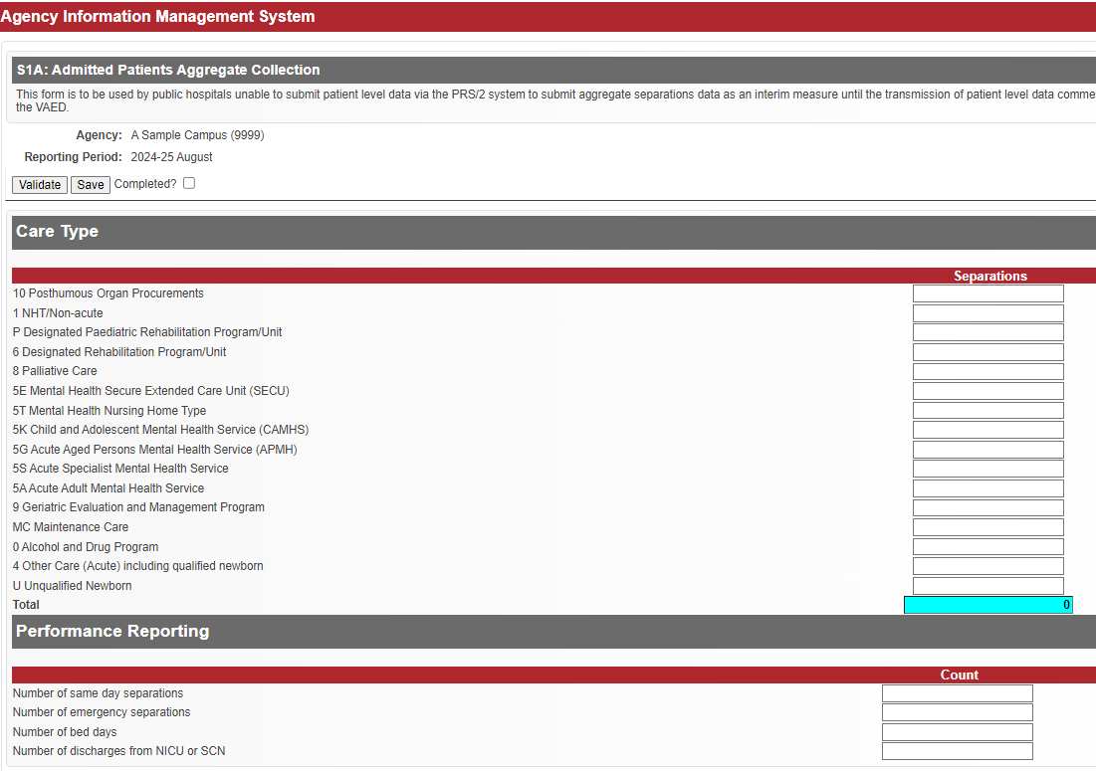

Further information
Questions about submitting the S1A form, including the data items to be reported, accessing the S1A form in HealthCollect, or notification of inability to submit this form by the due date, should be emailed to the HDSS HelpDesk <hdss.helpdesk@health.vic.gov.au> .

Statutory Duty of Candour

Reported at Agency level: CA (campus) and ACS (aged care service)

Reporting frequency: Quarterly

Due Date: 14th day after end of reporting period (quarter)*

Reporting guidelines
The Statutory Duty of Candour (SDC) data collection reports key performance metrics that allow relevant Victorian health service entities to monitor compliance with their legal obligations, and Safer Care Victoria to monitor the uptake of SDC practice.
Effective from 30 November 2022, the Health Legislation Amendment (Quality and Safety) Act 2022, requires relevant health service entities to undertake Statutory Duty of Candour (SDC) processes within 50-75 working days of the identification of a ‘serious adverse patient safety event’ (SAPSE). The SDC has been outlined in the Health Services Act 1988, the Mental Health Act 2014 and the Ambulance Services Act 1986. The Victorian Duty of Candour Guidelines <https://www.safercare.vic.gov.au/support-training/adverse-event-review-and-response/duty-of-candour> (legislative instrument) provides information on the timelines and requirements for statutory duty of candour processes.
The SDC builds on the mandatory obligations of the Australian Open Disclosure Framework < https://www.safetyandquality.gov.au/our-work/open-disclosure/the-open-disclosure-framework> , ensuring patients, their families or carers are apologised to and communicated with openly and honestly when a SAPSE has occurred. The Australian Open Disclosure Framework must otherwise be followed for all other cases of harm that do not meet the SAPSE definition.

Agencies to report SDC
The scope of the SDC includes relevant ‘health service entities’:
- a public health service
- a public hospital
- a multi purpose service
- a denominational hospital
- a private hospital
- a day procedure centre
- an ambulance service within the meaning of the Ambulance Services Act 1986, and
- the Victorian Institute of Forensic Mental Health established by section 328 of the Mental Health Act 2014.

Agency level for reporting SDC
SDC data is to be reported:
- at campus level for Victorian public hospitals and health services, including denominational and multi-purpose hospitals, and private hospitals and registered day procedure centres
- where a relevant health service entity has any other service under its governance, including, but not limited to, residential aged care or community services, those services must also report SDC data, reporting data separately for each campus, or each aged care or community service, whether co-located on the same site as the acute health service/hospital or separately located
- at whole-of-entity level for all other health service entities required to undertake SDC processes under the legislation, i.e. ambulance services and the Victorian Institute of Forensic Mental Health.

Reporting – due date, frequency and period
SDC data is to be reported:
- at quarterly intervals
- by the 14th day of the month after the end of each calendar quarter
- for SAPSEs that are identified in one quarter and the SDCs conducted or opted out of in that quarter and the following quarter, arising from those SAPSEs.
Mandatory reporting applies to all SAPSE events: SAPSEs identified within each calendar quarter, and the SDCs for those SAPSEs conducted or opted out of in the six months beginning on the first day of the calendar quarter, must be reported by the 14th day of the month after the end of the 6-month SDC reporting period.
SAPSE reporting schedule and AIMS Selector Year and Period to find SDC data collection form:
Quarter SAPSE identified | 6-month period of SDC process | Due date for submission of SAPSE events | Reporting status | AIMS Selector: Year | AIMS Selector: Period
Apr-Jun 2024 | Apr-Sep 2024 | 1-14 Oct 2024 | Mandatory | 2023-24 | 4th Quarter
Jul-Sep 2024 | Jul-Dec 2024 | 1-14 Jan 2025 | Mandatory | 2024-25 | 1st Quarter
Oct-Dec 2024 | Oct 2024-Mar 2025 | 1-14 Apr 2025 | Mandatory | 2024-25 | 2nd Quarter
Jan-Mar 2025 | Jan-Jun 2025 | 1-14 Jul 2025 | Mandatory | 2024-25 | 3rd Quarter
Apr-Jun 2025 | Apr-Sep 2025 | 1-14 Oct 2025 | Mandatory | 2024-25 | 4th Quarter

Data to be reported
- Number of SAPSE identified within the 3-month reporting period
- For these SAPSE, the number of instances where:
  - the SDC was commenced within the 6-month reporting period
  - the SDC report was provided by the health service entity within the 6-month reporting period
  - the patient/NOK/carer opted out of that SDC within the 6-month reporting period.
Sample Statutory Duty of Candour data collection form
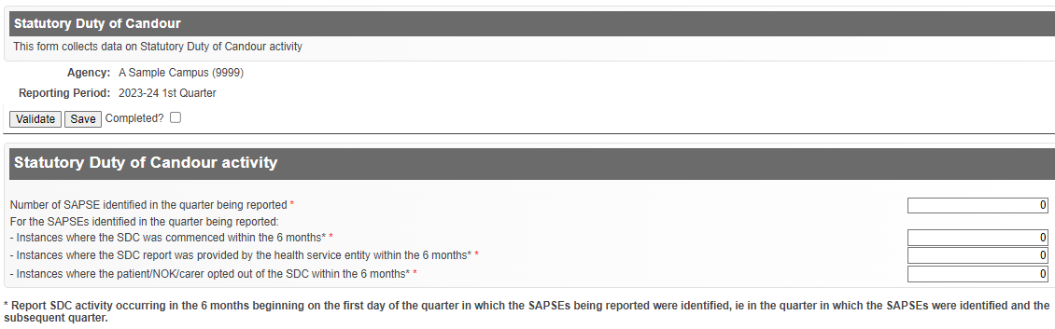
A valid value must be entered into each data field. The valid range for each data field is 0 to 500 inclusive. Report zero (0) only when that is the corret value: do not report zero (0) as a dummy value.

Data definitions

Number of SAPSE identified
Total number of SAPSE identified by the health service entity within the quarter being reported. Report events identified by the health service entity during that quarter as being SAPSEs. Many SAPSE will be identified on the date on which they occur; other events may be determined/confirmed to be a SAPSE after further review of the event.

Instances where the SDC was commenced
Of the SAPSE identified in the quarter being reported, the number for which the SDC had commenced with the patient/next-of-kin/family/carer by the end of the quarter after the quarter in which the SAPSE was identified. An SDC commencement for the purposes of this reporting occurs when the health service entity provides the initial apology and acknowledgment to the patient/next-of-kin/ family/carer.

Instances where the SDC report was provided by the health service entity
Of the SAPSE identified in the quarter being reported, the number for which the patient/next-of-kin/ family/carer is first presented with the SDC report produced post the review of the SAPSE, by the end of the quarter after the quarter in which the SAPSE was identified. The patient/next-of-kin/family/carer may seek further discussion of the report, but it is the timing of the first presentation of the SDC report that is to be reported here.

Instances where the patient/NOK/carer opted out of the SDC
Of the SAPSE identified in the quarter being reported, the number for which the patient/next-of-kin/ family/carer opted out of the SDC process by signed statement, by the end of the quarter after the quarter in which the SAPSE was identified. Where the patient/next-of-kin/family/carer verbally declines involvement, but does not provide the health service entity with a signed statement to opt out, the SDC remains open, and is not reported as an opt out, because the patient/next-of-kin/family/ carer may subsequently decide to engage in the SDC process: if they do so, that would be reported as a SDC commencement only if the decision is made within the six months for reporting SDC activity related to that SAPSE.
Where the patient lacks capacity or has died, a decision to opt out of the SDC made by the patient’s immediate family, carer, next-of-kin, or a person nominated by the patient is reported here.

Reporting guidelines
To be reported as a SAPSE, the event must meet the definition of SAPSE within the Health Services (Quality and Safety) Regulations 2020 under the Health Services Act 1988. These Regulations include the following definition of a SAPSE:
Serious adverse patient safety event
- For the purposes of the definition of a serious adverse patient safety event in Section 3(1) of the Health Services Act 1988, a prescribed class or category is an event that -
occurred while the patient was receiving health services from a health service entity; and
in the reasonable opinion of a registered health practitioner, has resulted in, or is likely to result in, unintended or unexpected harm being suffered by the patient.
To avoid doubt, an event in sub-regulation (1) includes an event that is identified following discharge from the health service entity.
Harm includes moderate harm, severe harm and prolonged psychological harm;
Moderate harm means harm that requires a moderate increase in treatment to a patient, such as an unplanned or unexpected return to surgery, but does not include harm that causes permanent damage or injury to an individual;
Prolonged psychological harm means psychological harm which a patient has experience, or is likely to experience, for a continuous period of at least 28 days;
Severe harm means harm that causes a permanent lessening in the functioning of an individual that is unrelated to the natural course of a person’s illness or underlying condition including harm that can lead to a person experiencing a permanent impairment or disability, or death.
A SAPSE is equivalent to valid clinical incidents with ISR 1 and 2, severe and moderate harm, in Victorian Health Incident Management System (VHIMS), whilst also meeting the SAPSE definition.
The initial apology should be provided verbally and in person where able, by a suitably qualified health professional. It is recommended that evidence of this apology is documented within the clinical incident management system, and/or the patient’s medical record, as well as who it was delivered to.
Where more than one SAPSE is identified for a single patient, each individual SAPSE identified in the quarter must be counted and reported, and the SDC actions that occur in the 6 month reporting period, associated with each individual SAPSE, must also be counted and reported.
Where the patient/next-of-kin/family/carer verbally declines to participate in the SDC process and/or declines to provide the health service entity with a signed statement to opt out, the health service may make e-forms available, but if the patient/next-of-kin/family/carer decline to sign, the SDC process remains open.
If the patient/next-of-kin/family/carer declines a meeting with the health service entity but would like a copy of the report, this is not opting out of the SDC process, so is included in the counts of SDC processes commenced and SDCs where a report was provided. It is not included in the count of Instances opted out of the SDC.
Where the patient/next-of-kin/family/carer formally opts out of the SDC process by providing the health service entity with a signed statement to opt out, the health service entity is not required to offer them a copy of the report.
The meeting with the patient/next-of-kin/family/carer to acknowledge, and apologise for, the SAPSE can be conducted by telephone, or via Zoom or similar platforms, or in person, with the preference of the patient/next-of-kin/family/carer to be considered in determining the medium used. The health service should document this preference, including instances where a face-to-face meeting is declined by the patient/next-of-kin/family/carer.
Upon identification of a SAPSE, the health service must make reasonable efforts to contact the patient/next-of-kin/family/carer, however where they cannot be contacted, including where this continues for some time, the health service should proceed to review the circumstances of the SAPSE, and document in the patient record their efforts to make contact. Where the health service entity cannot contact the patient/next-of-kin/family/carer during the 6 month SDC period for the SAPSE, the SAPSE identified by the health service entity is reported, but no data is reported for the three SDC items - SDC commenced, SDC report provided and SDC opted out.
The timing of the initial apology and acknowledgement is not influenced by public holidays and weekends.
There may be instances where the SAPSE being identified and the SDC commencement is within the reporting period, however the date that the SDC report was provided to the family is not, and therefore is extended beyond the reporting period of six months. In this situation, the date the report is provided to the family is not captured in this reporting timeframe. In summary, no data for prior quarters’ SAPSE are included in subsequent reporting periods.
If the SAPSE occurs across 2 or more health service entities (i.e. all contributed to the harm), it should be discussed how the SDC process would occur. However, it will be the responsibility of all entities to conduct the SDC, and also to report compliance. This is to ensure that the requirement to complete the SDC sits with each health service entity.
If the SAPSE occurs at one health service entity, and the patient is admitted to or transferred to another health service entity for care, it is the responsibility of the health service entity where the event occurred to report the SAPSE and conduct, and report on, the SDC. See the Victorian Duty of Candour Framework for further information, including regarding collaboration between health service entities in such circumstances.
Where a health service entity has zero SAPSEs to report for that quarter (such as in the case of a mobile service or single operator), they must still complete each data item on the AIMS form and submit the data to ensure compliance with their reporting obligations under the relevant Act.
At times, the severity of the harm may not be clear when the event is entered into the clinical incident management system and requires an external review (including coronial review). In these cases, ‘time zero’ would be when this is identified by the health service entity as a SAPSE post the review. The SAPSE in such instances would be reported in the quarter in which it is identified as a SAPSE.
For harm events that are unclear at the time whether they meet SAPSE criteria, or for all other harm events, health service entities are encouraged to take a patient-centred approach, to ensure that the appropriate steps and communication is being completed.

Further information
Health service entities should also refer to the relevant Act and Regulations for more details and for the definitions of SAPSE and SDC.
To support health service entities in establishing SDC processes, Safer Care Victoria has compiled a range of resources <https://www.safercare.vic.gov.au/support-training/adverse-event-review-and-response/duty-of-candour>.
Questions regarding definitions, or data to be reported to the SDC data collection, or notification of inability to report by the due date, should be directed to the Safer Care Victoria project team by email dutyofcandour@health.vic.gov.au.
Questions about accessing the SDC form in HealthCollect should be emailed to the HDSS HelpDesk <hdss.helpdesk@health.vic.gov.au> .

SAAI: Sub-Acute Access Indicators

Reported at Agency level: CA (campus)

Reporting frequency: Monthly

Due Date: 15th day after end of reporting period

Reporting guidelines
The department determines the number of patients eligible and waiting for a Residential Aged Care or Transition Care Program place, and the length of time they are waiting, through linkage of the Victorian Admitted Episodes Dataset (VAED) and Aged Care Assessment Service data. The Sub-acute and Residential Aged Care Access Indicators Project collects and reports on a number of indicators that aim to measure efficiency and effectiveness of care in admitted sub-acute services, as well as access to beds in Transition Care Program and residential aged care. Periods must be submitted in sequence.

Reporting Requirements
Indicators utilise data from the VAED, AIMS and manual submission. Indicators submitted on the SAAI form include:

Number of patients within the health service (acute and subacute beds) waiting on residential care or Transition Care Program placement.
If a residential care bed or Transition Care Program (TCP) place is available on the census day, is the patient able to be transferred on the census day?
The definition assumes that:
- The patient is medically stable
- ACAS assessment is completed
- Patient/family agreement for residential care
- Issues such as equipment provision and VCAT applications all completed
Data to be reported:
- Patients awaiting residential care placement
- Patients awaiting TCP (includes both bed based and home based TCP)
Collection: Monthly census count on last Wednesday of each month. Count each individual once only.

Number of subacute referrals accepted per bed per month
The number of referrals accepted onto the subacute waiting list per month. That is, the total number of patients referred and accepted for access to all subacute beds. Include both internal and external referrals.
Data to be reported: Number of referrals accepted to available subacute beds (as reported on the A3 Public Hospital Beds form).
Collection: On the last day of each month which will include a cumulative total from the first day of the month to the last day of the month. Each individual must only be counted once.

Number of patients in acute beds waiting for subacute beds in your health service, and in another health service.
If there is a subacute bed available on the census day, how many patients would be ready for transfer to that subacute bed?
The definition assumes that the patient:
- is medically stable
- has had all required assessments and paperwork completed
- is on the waiting list for a subacute bed, and
- other transfer preparations have been completed.
Data to be reported: This number should be broken down into two components –
- those awaiting a subacute bed within your health service and
- those awaiting a subacute bed at another health service (including those awaiting private rehabilitation beds).
Note: If the patient is waiting for a bed within this health service and is also waitlisted for a bed at another health service, count the patient once only, for the preferred placement – same health service or another health service.
Collection: Monthly census count on last Wednesday of each month. Count each individual once only.

Number of non-weight bearing patients in a subacute bed
- a patient who can place no weight on their fractured limb until such time that the patient has been seen by an Orthopaedic Specialist;
- a patient whose non weight bearing status prevents them from participating actively in rehabilitation whilst in a subacute bed.
- a patient in a subacute bed who is touch weight bearing or partial weight bearing is not included in this census count.
NWB patients in Restorative Care (TCP+) should be excluded.
Collection: Monthly census count in each health service on last Wednesday of each month. Each individual must only be counted once

Definitions

Acute beds
Beds immediately available for acute medical and surgical admitted patient services. For further information, see reporting requirements for the AIMS A3: Hospital Beds—Public data collection.

Admitted patients
Patients who receive treatment and/care in a traditional hospital setting. This collection does not include Hospital in the Home.

Admitted patients – new
Admitted patients who were not waiting on the last Wednesday of the previous month.

Admitted patients – existing
Admitted patients who were waiting on the last Wednesday of the previous month.

Patients awaiting placement
The patient is ready to be transferred if the patient:
- is medically stable,
- has had all required assessments and paperwork completed including transfer preparations, and
- is on the waiting list for a sub-acute bed, residential aged care or transition care program place.
Note: If the patient is wait listed at more than one health service, count one only, as the preferred option.

Patient count
Census counts report the status on the last Wednesday of the month at 2:00pm (mid-shift).
Total counts report cumulative total on the last day of each month of patients for that month.

Rehabilitation beds
Rehabilitation is care in which the clinical intent or treatment goal is to optimise the function, independence and quality of life of a patient with a loss of functional ability, either congenital or acquired. It includes care provided in a designated rehabilitation unit or in a designated rehabilitation program.

Geriatric evaluation and management services (GEM) beds
Geriatric evaluation and management (GEM) is care of chronic or multidimensional presenting conditions associated with ageing, cognitive dysfunction, chronic illness or loss of functional ability. Geriatric evaluation and management includes care provided in a GEM unit or in a designated GEM program.

Transition Care Program
Provides bed or home based places with low intensity therapy and case management for older patients with complex care needs. Patients must have completed their acute or subacute episode of care but would benefit from more time to regain their function so as to return to their previous place of residence or to be supported into long-term care.
Sub Acute Access Indicators sample form
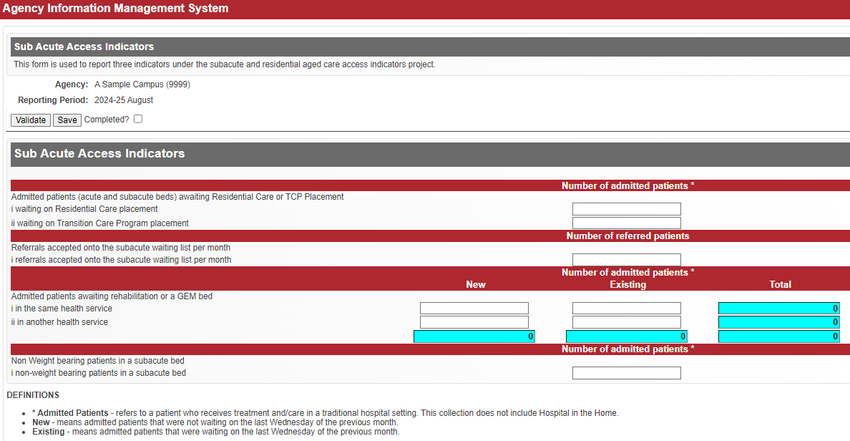

Further information
Questions about accessing the SAAI form in HealthCollect, or notification of inability to report by the due date, should be emailed to the HDSS HelpDesk <hdss.helpdesk@health.vic.gov.au>

TCPKPIs: Transition Care Program Key Performance Indicators

Reported at Agency level: CA (campus)

Reporting frequency: Quarterly

Due Date: 21 days after end of reporting period (quarter)

Reporting guidelines
The Victorian government is the approved provider for the Transition Care Program (TCP) and responsible for the decisions about delivery of care. TCP is jointly funded by the Commonwealth Department of Health and the Department of Health. TCP provides case management, low-intensity therapy and personal support to older people discharged from hospital. It gives people more time to complete their restorative process as well as ensure they are not placed in aged care prematurely. To receive TCP older people need to be assessed as eligible by the Aged Care Assessment Service while in hospital and matched with a facility that can cater for their needs.
For more information, visit the Transition Care Program <https://www.health.vic.gov.au/patient-care/transition-care-program>.
The TCPKPI data collection is submitted quarterly, and collects data on eight indicators for bed based TCP places and seven indicators for home based TCP places.
Completed forms together with documentation used to support the submission of data is to be retained by the health service.

Data definitions – quality indicators – bed based places

Number of admissions
Number of patients admitted into a TCP bed during the quarter.
To be eligible for admission clients require a valid and complete assessment and approval to enter the transition care program, a signed TCP agreement and be medically ready for transfer.

Number of occupied bed days
The number of bed days occupied by TCP clients in a TCP bed based setting during the quarter.

Number of falls with major injury – ISR 1-2
Number of reported client falls with major injury (ISR 1-2) in a TCP bed based setting during the quarter.

Number of falls – ISR 3-4
Number of reported client falls (ISR 3-4) in a TCP bed based setting during the quarter.

Number of clients with unexpected weight loss during TCP episode of care
Service providers are expected to monitor the number of clients with unplanned weight loss and trends. As part of admission process to TCP, a client's weight should be recorded.
Noted weight loss should be for an episode of care and comparing this to the admission weight, noting admission BMI and client's weight history.
Unplanned weight loss occurs among older people for a range of reasons. For some clients, as part of their medical condition, weight loss will be expected (for example, cancer, hyperthyroidism, etc.). The goal is to identify the cause for clients experiencing unexpected weight loss and, where possible, address the issue. For example, has there been a change to their diet or activity level? Any mood changes? Difficulty chewing or swallowing? Poor absorption of nutrients? Complaints of nausea? etc.

Number of clients with new pressure injuries during TCP episode of care
A pressure injury is a localised injury to the skin and/or underlying tissue, usually over a bony prominence, as a result of pressure, shear, or a combination of these factors.
All clients should have a comprehensive assessment on admission which includes identifying pressure injury risk factors, which informs the client's care plan. This item reports the number of clients that develop new pressure injuries. This excludes skin tears as a result of a fall or bump against furniture, etc.

Number of clients who have a planned discharged to inpatient rehabilitation or GEM
Number of clients that have completed their TCP episode of care and made gains consistently warranting admission to an inpatient rehabilitation service or GEM to maximise the restorative process.

Number of clients that moved between care setting during the TCP episode
Number of clients that moved between care settings (that is to home-based care or vice versa) during the TCP episode of care. This excludes moves between bed based facilities if a health service is utilising more than one site for its bed based provision.

Data definitions – quality indicators - home based places

Number of admissions
Number of patients admitted to TCP to a home based place during the quarter.
To be suitable for admission clients require a valid and complete assessment and approval to enter the transition care program, a signed TCP agreement and be medically ready for transfer.
Excludes clients transferred from a bed based TCP place.

Number of occupied bed days
The number of bed days occupied by TCP clients in a TCP home based setting during the quarter. Include days when people may be away from home but have not been discharged from the Program.

Number of falls with major injury – ISR 1-2
Number of reported client falls with major injury (ISR 1-2) in a TCP home based setting during the quarter.

Number of clients with unexpected weight loss during TCP episode of care
Service providers are expected to monitor the number of residents with unplanned weight loss and trends. As part of admission process to TCP, a client's weight should be recorded.
Noted weight loss should be for an episode of care and comparing this to the admission weight, noting admission BMI and client's weight history.

Number of clients with new pressure injuries during TCP episode of care
A pressure injury is a localised injury to the skin and/or underlying tissue, usually over a bony prominence, as a result of pressure, shear, or a combination of these factors.
All clients should have a comprehensive assessment on admission which includes identifying pressure injury risk factors, which informs the client's care plan. Therefore, this item will focus on the number of clients that develop new pressure injuries. This excludes skin tears as a result of a fall or bump against furniture, etc.

Number of clients who have a planned discharged to inpatient rehabilitation or GEM
Number of clients that have completed their TCP episode of care and made gains consistently warranting admission to an inpatient rehabilitation service or GEM to maximise the restorative process.

Number of clients that moved between care setting during the TCP episode
Number of clients that moved between care settings (that is home based to bed based or vice versa) during the TCP episode of care.
Transition Care Program KPIs sample form
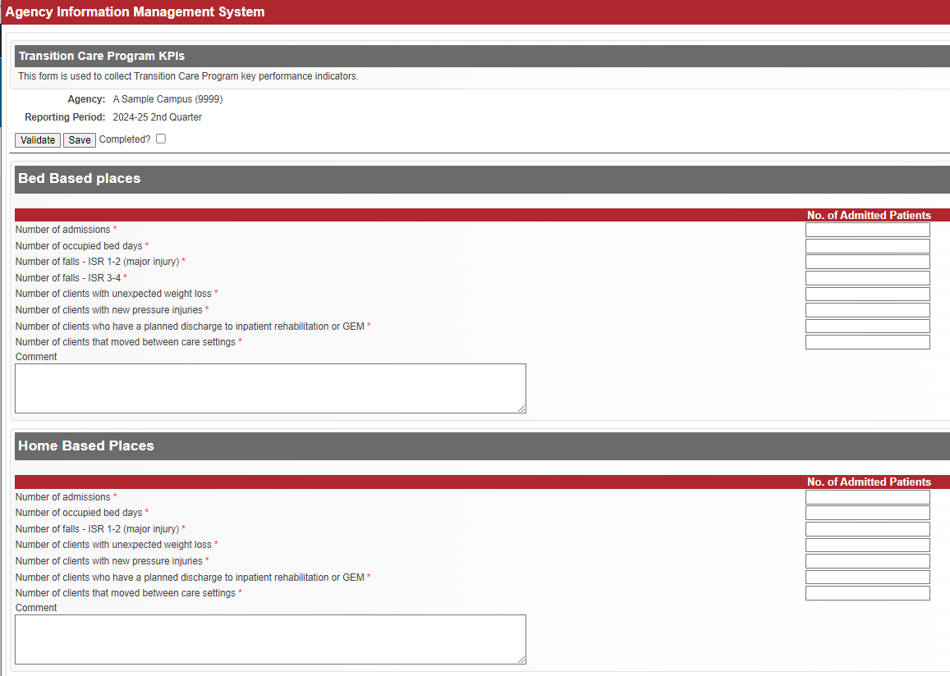

Further information
Questions about TCPKPI reporting, including data items reported, entering TCP data into HealthCollect, or inability to report by the due date, should be emailed to Deborah Senior <deborah.senior@health.vic.gov.au>.
Questions about accessing the TCPKPI form in HealthCollect, should be emailed to the HDSS HelpDesk <hdss.helpdesk@health.vic.gov.au> .

Urgent Care Centre

Reported at Agency level: CA (campus)

Reporting frequency: Monthly

Due Date: 14th day after end of reporting period

Reporting guidelines
The AIMS Urgent Care Centre data collection reports aggregate data on number of presentations, by visit type, triage category and departure status, for selected payment categories, at urgent care centres (UCCs) at selected campuses. This collection provides more details on the models of care and demand for UCC services than the monthly aggregate service event data reported in the S10 Non-admitted Clinic Activity form, and supports transition to funding emergency care using Urgency Disposition Group (UDG) as part of the National Health Reform.
Health services listed in Table 1 are required to submit this collection for each listed campus.
Table 1: List of health service campuses reporting to the Urgent Care Centre data collection
Health Service | Campus
Alexandra District Health | Alexandra District Health
Alpine Health | Alpine Health [Bright]
Alpine Health | Alpine Health [Mount Beauty]
Alpine Health | Alpine Health [Myrtleford]
Barwon Health | Barwon Health North
Bass Coast Health | Phillip Island Health Hub
Beaufort & Skipton Health Service | Beaufort & Skipton Health Service [Beaufort]
Beaufort & Skipton Health Service | Beaufort & Skipton Health Service [Skipton]
Beechworth Health Service | Beechworth Health Service
Benalla Health | Benalla and District Memorial Hospital
Boort District Health | Boort District Health
Casterton Memorial Hospital | Casterton Memorial Hospital
Central Gippsland Health | Central Gippsland Health [Maffra]
Central Highlands Rural Health | Central Highlands Rural Health [Creswick]
Central Highlands Rural Health | Central Highlands Rural Health [Daylesford]
Central Highlands Rural Health | Central Highlands Rural Health [Kyneton]
Cohuna District Hospital | Cohuna District Hospital
Colac Area Health | Colac Area Health
Corryong Health | Corryong Health
Dhelkaya Health | Dhelkaya Health [Castlemaine]
Dhelkaya Health | Dhelkaya Health [Maldon]
East Grampians Health Service | East Grampians Health Service [Ararat]
East Wimmera Health Service | East Wimmera Health Service [Birchip]
East Wimmera Health Service | East Wimmera Health Service [Charlton]
East Wimmera Health Service | East Wimmera Health Service [Donald]
East Wimmera Health Service | East Wimmera Health Service [St Arnaud]
East Wimmera Health Service | East Wimmera Health Service [Wycheproof]
Gippsland Southern Health Service | Gippsland Southern Health Service [Korumburra]
Gippsland Southern Health Service | Gippsland Southern Health Service [Leongatha]
Grampians Health | Grampians Health [Edenhope]
Grampians Health | Grampians Health [Dimboola]
Grampians Health | Grampians Health [Stawell]
Great Ocean Road Health | Great Ocean Road Health [Apollo Bay]
Great Ocean Road Health | Great Ocean Road Health [Lorne]
Heathcote Health | Heathcote Health
Hesse Rural Health | Hesse Rural Health [Winchelsea]
Heywood Rural Health | Heywood Rural Health
Inglewood & Districts Health Service | Inglewood & Districts Health Service
Kerang District Health | Kerang District Health
Kooweerup Regional Health Service | Kooweerup Regional Health Service
Kyabram and District Health Service | Kyabram and District Health Service
Mallee Track Health and Community Service | Mallee Track Health and Community Service [Ouyen]
Mallee Track Health and Community Service | Mallee Track Health and Community Service [Sea Lake]
Mansfield District Hospital | Mansfield District Hospital
Maryborough District Health Service | Maryborough District Health Service [Maryborough]
Moyne Health Services | Moyne Health Services [Port Fairy]
NCN Health | NCN Health [Cobram]
NCN Health | NCN Health [Nathalia]
NCN Health | NCN Health [Numurkah]
Northern Health | Northern Health [Kilmore]
Omeo District Health | Omeo District Health
Orbost Regional Health | Orbost Regional Health
Portland District Health | Portland District Health
Robinvale District Health Services | Robinvale District Health Services [Manangatang]
Robinvale District Health Services | Robinvale District Health Services [Robinvale]
Rochester & Elmore District Health Service | Rochester & Elmore District Health Service [Rochester]
Rural Northwest Health | Rural Northwest Health [Hopetoun]
Rural Northwest Health | Rural Northwest Health [Warracknabeal]
Seymour Health | Seymour District Memorial Hospital
South Gippsland Hospital | South Gippsland Hospital [Foster]
South West Healthcare | South West Healthcare [Camperdown]
Tallangatta Health Service | Tallangatta Health Service
Terang & Mortlake Health Service | Terang & Mortlake Health Service [Terang]
Timboon & District Healthcare Service | Timboon & District Healthcare Service
West Wimmera Health Service | West Wimmera Health Service [Jeparit]
West Wimmera Health Service | West Wimmera Health Service [Kaniva]
West Wimmera Health Service | West Wimmera Health Service [Nhill]
West Wimmera Health Service | West Wimmera Health Service [Rainbow]
West Wimmera Health Service | West Wimmera Health Service [Rupanyup]
Western District Health Service | Western District Health Service [Coleraine]
Western Health | Western Health [Bacchus Marsh]
Western Health | Western Health [Melton]
Yarram & District Health Service | Yarram & District Health Service
Yarrawonga Health | Yarrawonga Health
Yea & District Memorial Hospital | Yea & District Memorial Hospital

Concept Definitions
The following concepts underlying this collection draw on national reporting data items and definitions where relevant.

Urgent Care Centre

Definition
A dedicated area in a hospital organised and administered to provide emergency care (including reception, triage, initial assessment and management) to people who perceive the need for, or are in need of, acute or urgent care.
At a minimum UCCs have the capacity to perform emergency resuscitation and stabilisation for adults and children and prepare and manage patients for transfer to higher level care as clinically appropriate.
Urgent care centres provide emergency care that is available 7 days a week 24 hours a day.

Presentation

Definition
A presentation is the reporting unit of the Urgent Care Centre form. All presentations assessed to the extent that they are allocated a Triage Category should be reported.
A presentation concludes when the patient physically leaves the UCC.

Guide for Use
Some form of formal or informal triage event logically precedes the act of receiving treatment in the UCC. For instance, a patient may be so critically ill that they by-pass the formal triage process to receive resuscitative intervention. However, the act of prioritising access to care according to the level of need has still occurred.
A UCC presentation should be reported even if the patient leaves the UCC before the treatment has commenced or if the registration was commenced but not completed (use the appropriate Departure Status code).
If a patient attends the UCC for the treatment of two or more conditions concurrently, only one presentation should be reported.

Triage

Definition
Triage is the structured screening of a patient presenting at the UCC to determine the urgency of their complaint (Triage Category) and thereby assist in determining their priority of care.

Guide for Use
The Triage Category is used to determine the urgency with which patients are investigated or treated by UCC staff.
Treatment can commence before, during or after triage. Information obtained during triage should be sufficient to determine the needs and urgency of treatment, but does not exclude the instigation of more detailed investigation or recommendations by the triage staff. At or subsequent to triage, the patient may receive advice about UCC and alternative treatment options. On consideration of this advice, the patient may choose to leave the UCC without being treated.
Triage relies on expertise in the following:
- Assessment (of)
  - Characteristics and severity of the presenting condition
  - Brief physical assessment
  - Patient’s history
  - Presenting signs and symptoms
  - Vital signs
  - Overall appearance.
- Knowledge (of)
  - Physiology and pathology
  - Resources
  - Department capabilities
- Intuition
  - Skill
  - Sensitivity
  - Surveillance.

Data Definitions
The following data items and definitions are applicable to the Urgent Care Centre data collection.

Patient payment status
Patient payment status of the UCC presentation
MBS presentation | The clinician bills Medicare for the patient’s treatment.
Public | Eligible for Medicare where the hospital provides care by means of its own staff, or by other agreed arrangements, without charge to the patient.  Public patients are further categorised by the profile of UCC staff the patient was seen by:  Nurse only  - Public patient seen by a nurse only.  Doctor with or without a nurse  - Public patient seen by a nurse and doctor.
DVA | Eligible Department of Veterans’ Affairs veterans and war widow(er)s whose charges are met by the Department of Veterans’ Affairs.
Compensable/Other | Entitled to claim damages under Motor Vehicle Third Party insurance or worker’s compensation, public liability, criminal injury and common law cases, members of the Defence Forces and seamen, and patients who are not eligible under Medicare and not exempt from fees.
S19(2) Exemptions | Eligible for Medicare where the hospital provides care by its own eligible staff under the Section 19(2) Exemptions Initiative – Improving Access to Primary Care in Rural and Remote Areas. Information about Section 19(2) Exemption can be found here < https://www.health.vic.gov.au/improving-access-to-primary-care-in-rural-and-remote-areas>

Total presentations by departure status, visit type and triage category

Reported for
Every UCC presentation by the appropriate category.

Reporting guide
Aggregate presentations to the most appropriate departure status, visit type and triage category.

Departure Status
Patient destination or status on departure from the UCC
Admitted | Patient is formally admitted to the hospital after attending the UCC.
Non-Admitted | Patient returns to their home or usual residence including a boarding/ rooming house, residential care facility or mental health residential facility after attending the UCC.
Did not Wait | Patient departs UCC before being seen by a service provider or at or subsequent to triage, the patient has received advice about the UCC and alternative treatment options and on consideration of this advice, the patient chooses to leave without being seen by a service provider.  Includes patient redirected from the UCC directly to a GP co-located clinic.
Transfer to another health service | The UCC is responsible for care and treatment of a patient awaiting transport to another institution. Patient is transferred to another health service and the transfer is arranged by the hospital.  Excludes patients requiring acute unscheduled care.  Excludes patients who are advised to attend another health service as it is not known if the patient follows the advice given.
Dead on Arrival | Patient is pronounced dead by a medical practitioner before (or without) being brought into the UCC or where the patient is bought into the UCC but there is no intention to resuscitate.
Died in urgent care centre | Patient died after commencement of UCC presentation. Includes where there is an intention to resuscitate but the patient is later pronounced dead.

Visit Type
The reason the patient presented to the UCC
Planned return visit | Planned return to the UCC as a result of a previous UCC presentation or return visit. The return visit may be for planned follow-up treatment or as a consequence of test results indicating need for further treatment or as a result of a care plan initiated at discharge; or outpatient appointment for a planned presentation.
Unplanned presentation | Attendance requiring acute unscheduled care. Includes presentation due to an actual or suspected new clinical condition; or an unplanned presentation for a continuing actual or suspected condition.

Triage Category
Classification according to urgency of need for medical and nursing care, using the National Triage Scale
Triage Category | Description
Triage 1 | Resuscitation: immediate (within seconds)
Triage 2 | Emergency: within 10 minutes
Triage 3 | Urgent: within 30 minutes
Triage 4 | Semi-urgent: within 60 minutes
Triage 5 | Non-urgent: within 120 minutes

Reporting guide
The triage category is to be allocated by an experienced registered nurse or medical practitioner.
It is imperative that the category accurately reflects the demand placed on UCC services, therefore, once a patient is triaged, the presentation must be recorded in all instances. This applies even when the patient did not wait for treatment to commence or if registration was commenced but not completed.
Changes in triage category:
- When a patient’s original triage category is altered during an emergency presentation, report the original triage category regardless of whether the re-categorisation is higher or lower.
- Changes in triage categories may be recorded locally if required, but do not amend for reporting to the Urgent Care Centre data collection.

Sub-categories (also included above)

Reported for
Every UCC presentation for the sub-categories listed.

Reporting guide
Pre-arranged Admission | Presentation at the UCC for clerical, nursing or medical processes to be undertaken. Admission has been arranged by the referring medical officer and a ward bed allocated.
Left at own risk | Patient departs the UCC after being seen by a service provider despite being advised by clinical staff not to leave.
Urgent Care Centre data collection sample form:
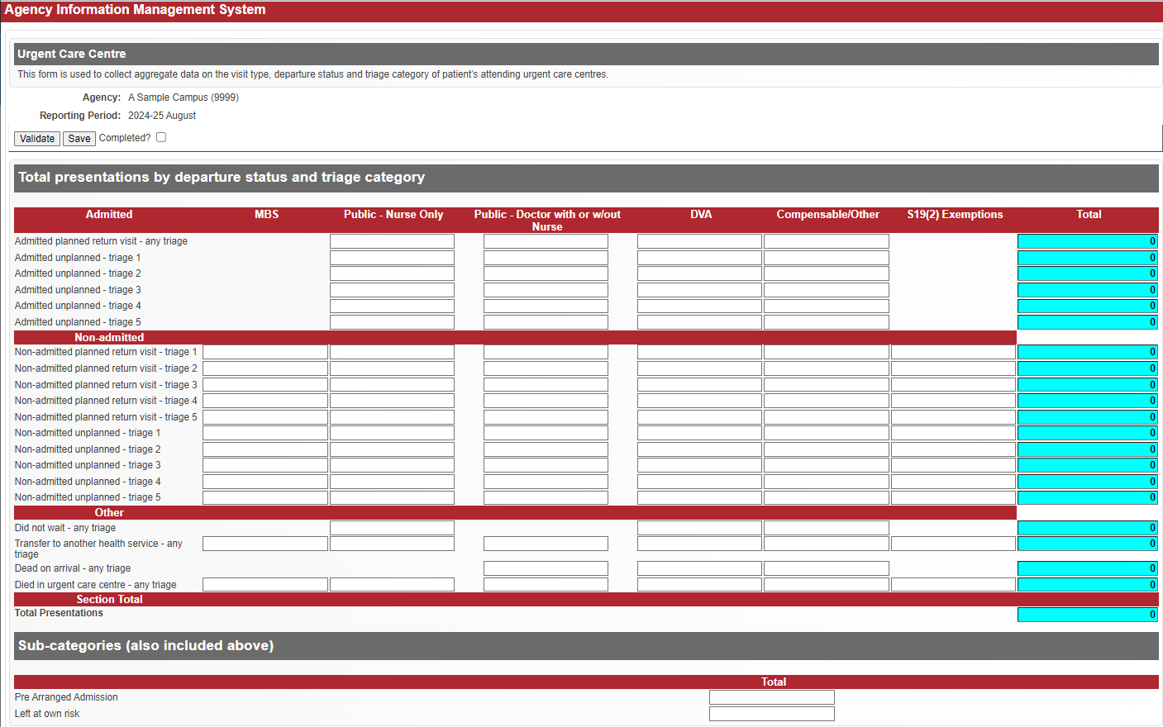

Further information
Questions about Urgent Care Centre reporting, including the data items to be reported, and accessing the Urgent Care Centre form in HealthCollect, or notification of inability to report by the due date, should be emailed to the HDSS HelpDesk <hdss.helpdesk@health.vic.gov.au> .

S8: Radiotherapy Non-Admitted Services

Reported at Agency level: CS (clinical site)

Reporting frequency: Monthly

Due Date: 15th day after end of reporting period

Reporting guidelines
Report consultations for radiotherapy services provided to non-admitted radiotherapy patients, including DVA and non-DVA patients.
Treatment related items, including treatment reviews, are reported to the Victorian Radiotherapy Minimum Dataset (VRMDS) only.
The Victorian hospital operators of radiotherapy services that provide treatment to non-admitted patients are:
- Austin Health
- Barwon Health
- The Alfred
- Peter MacCallum Cancer Centre.
Only these sites are to complete Form S8 – however, the consultations should be reported according to the clinic site where the service is provided.

Definitions
The data fields collected in the S8 Form are matched with the item numbers in the Medicare Benefits Schedule (MBS) Book Group T2 – Radiation Oncology at MBS Online <http://www.mbsonline.gov.au/>.
Treatment Component | Non-Admitted Program Radiotherapy Bands | MBS Item Number | Description
Consultation | Initial | 104, 871, 872 | 104: Specialist, Referred Consultation – Surgery or Hospital  (Professional attendance at consulting rooms or hospital by a specialist in the practice of his or her specialty where the patient is referred to him or her)  - Initial attendance in a single course of treatment, not being a service to which item 106 applies  871: multidisciplinary cancer case conference 3 other medicos  872: multidisciplinary cancer case conference 4 other medicos
Consultation | Subsequent | 105 | 105: Each attendance subsequent to the first in a single course of treatment.
S8: Radiotherapy Non-Admitted Services sample form
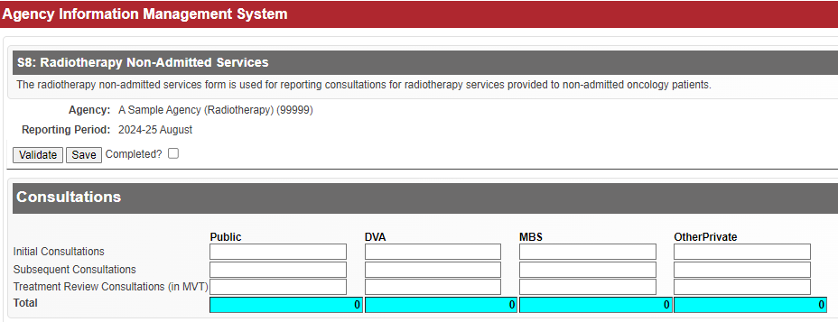

Further information
Questions about S8 reporting, including accessing the S8 form in HealthCollect, or notification of inability to report by the due date, should be emailed to the HDSS HelpDesk <hdss.helpdesk@health.vic.gov.au>

Section 4 – AIMS Online Reports
AIMS online reports are available on the HealthCollect portal to allow agencies to monitor and view data submitted to the department. These reports refresh every time they are opened enabling users to view current data at all times.
Three types of AIMS reports are available for health services:
Compliance reports – monitor the status of data submissions to the department.
Non-admitted Clinics – view registration details of non-admitted clinics registered on the Non-admitted Clinic Management System (NACMS).
Year-to-date (YTD) reports – view or download data submitted to the department.

Access to online reports
To access the online reports, log in to HealthCollect, then click on ‘Reports’ tab,
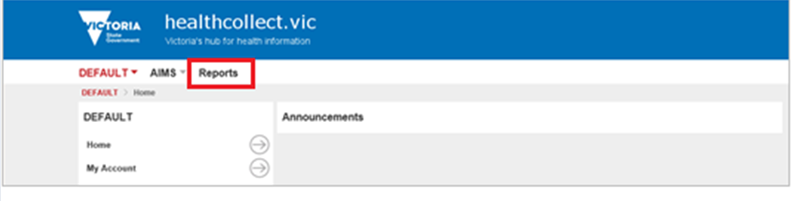
then click on the ‘AIMS’ folder.
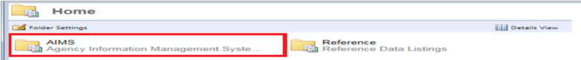
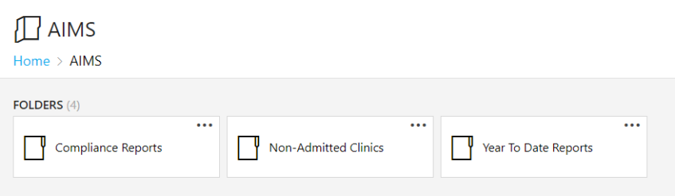

Standard report features

Report parameters
When requesting a report, report parameters are used to filter data. This enables a user to control the information included in a report and varies the report presentation. Click a report parameter’s drop-down arrow list to see the list of items for the report parameter. Click on an item to select the filter for the type of report required.
Example report parameters
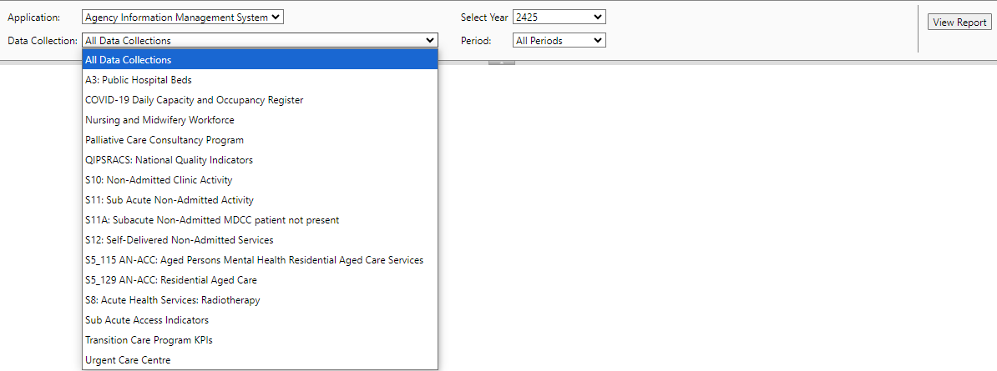

To run a report
After selecting report parameters, press the View Report button on the far right of page.

Export function
All reports can be exported and saved to a local directory in a range of file formats.
Export function showing download file format options
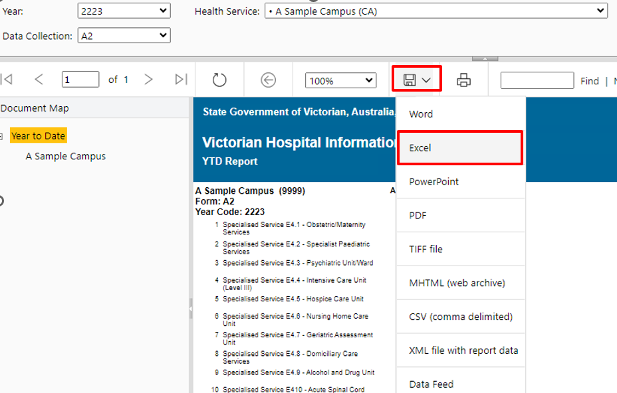
- Click the Export icon.
Choose the file format of the report to be exported, for example Excel.
Select the exported file in your Downloads folder: open from Downloads and Save to a local directory.

Report navigation
The document map, on the left panel of a report, provides a set of navigational links to report items. A user can click links in the document map to jump direct to a target page.
Some reports may display a tree hierarchy icon. You can expand or collapse the hierarchy levels by clicking on the plus sign (+) or minus sign (-) located to the left of the text describing the hierarchy level.

Compliance Reports
Compliance reports show the status of AIMS forms submitted to the department by health services during a financial year.
Completed status on compliance detailed reports identify submitted forms, incomplete forms and outstanding forms:
- True indicates a form is submitted.
- False indicates a transaction is recorded against a form however form is incomplete.
- Not provided indicates a form has not been opened.and is incomplete.
Compliance reports available:
- Compliance Detail by Data Collection
- Compliance Detail by Health Service
- Compliance Summary by Data Collection
- Compliance Summary by Health Service

Compliance Detail by Data Collection

Report description
For data collection and period selected, report shows health services, date and contact information by completed status.

Report parameters
Application – select Agency Information Management System
Year – select relevant year from drop down list
Data collection – select from drop down list
Period – period option changes to match the reporting period of a data collection e.g. month, quarter

Report columns
Completed status
Form name
Health service
Period
Date & Time Received
Contact – Name, telephone number and email address of the HealthCollect user who most recently opened this webform, whether or not a submission was completed.

Compliance Detail by Health Service

Report description
Report shows compliance status of forms by health service.

Report parameters
Application – select Agency Information Management System
Year – select relevant year from drop down list
Data collection – select from drop down list

Report columns
Health service
Form name
Period
Date and Time Received
Completed status
Contact – Name, telephone number and email address of the user who submitted the form, or if no current submission, the contact details of the user who last submitted the form.

Compliance Summary by Data Collection

Report description
Report shows summary statistics on the current status of forms submitted for a data collection for the financial year selected.

Report parameters
Application – select Agency Information Management System
Year – select relevant year from drop down list
Show Health Services
- click True to show summary statistics by health service
- click False to exclude health services and show summary statistics by data collection only

Report columns
Form name
Health service (when True is selected)
Expected – maximum number of submissions expected for financial year
Total Received – total number of submissions received for financial year
Received Complete – number of completed submissions received for financial year
Received Incomplete – number of incomplete submissions received for financial year (Total received less Received Complete)
Percent Complete – percentage of completed submissions
Outstanding – number of missing or incomplete submissions (total expected less total completed)

Compliance Summary by Health Service

Report description
Report shows summary statistics on the current status of form submissions for the financial year selected.

Report parameters
Application – select Agency Information Management System
Year – select relevant year from drop down list

Report columns
Health service
Form name
Expected – maximum number of submissions of listed report expected for financial year
Total Received – total number of submissions of listed report received for financial year
Received Complete – number of completed submissions received (Completed box is ticked) for financial year
Received Incomplete – number of incomplete submissions received for financial year (Total received less Received Complete)
Percent Complete – percentage of completed submissions
Outstanding – number of missing or incomplete submissions (total expected less total completed)

Non-admitted Clinic Reports
Health services must register all acute non-admitted clinics on HealthCollect via the Clinic Non-admitted Management System (NACMS) for reporting on the AIMS S10 form. Online reports are available for AIMS users to view clinic registration details held on NACMS.
A report is also available showing non-admitted subacute program streams registered for health services submitting non-admitted services on the AIMS S11 form.
Three non-admitted clinic reports are available:
- Non-admitted Clinic Details (acute clinics)
- Non-admitted Clinic Summary (acute clinics)
- Non-admitted Subacute (subacute program streams)
Refer to the NACMS manual < https://www.health.vic.gov.au/publications/non-admitted-clinic-management-system-nacms-manual> .

Non-admitted Clinic Details

Report description
Report shows registration details of acute clinics registered on NACMS. A separate clinic displays on each page.

Report parameters
Agency
Status – select from the following options in the drop down list:
- All
- Clinic approved by DH following NACCC consideration
- Clinic closed and no longer active
- Clinic awaiting submission to DH
- Clinic approved but not currently active
- Ineligible/Not for reporting
- Clinic pending review by the Department of Health
- Clinic reviewed by Department of Health, pending assessment by NACCC
Tier 2 Category – select from the following options in the drop down list:
- Procedures Clinics
- Medical – Consultation
- Stand-alone Diagnostic
- Allied Health &/or Clinical Nurse Specialist Interventions
- Other
- All
Tier 2 Class – select from drop down list
Clinic ID
Clinic Name

Report content
Agency
Tier 2 Category
Clinic code and name
Health Service Proposed Tier 2 Class
DH Proposed Tier 2 Class
Approved Tier 2 Class
Tier 2 History – Tier 2 code, Effective from, Effective to
Date Commenced
Notified – date and by whom
Closed – when clinic closed: date and contact name
Estimated Service Events per Month
Sessions – Patients Seen: Individual or Group Sessions
Funding
Activity Description
Face to Face Contacts %
Doctor Consultation
Multiple Healthcare Provider
Contact – Name, position title, telephone number and email address of the most appropriate person for the department to contact for follow-up

Non-admitted Clinic Summary

Report description
Report provides a tabular view of clinics grouped by Tier 2 Category.

Report parameters
Status – select from the following options in the drop down list:
- All
- Approved: Clinic approved by DH following NACCC consideration
- Closed: Clinic closed and no longer active
- Draft: Clinic awaiting submission to DH
- Inactive: Clinic approved but not currently active
- Ineligible: Ineligible/Not for reporting
- Pending: Clinic pending review by the Department of Health
- Reviewed: Clinic reviewed by Department of Health, pending assessment by NACCC
Agency – select from the drop down list
Tier 2 Category – select from the following options in the drop down list:
- Procedures Clinics
- Medical – Consultation
- Stand-alone Diagnostic
- Allied Health &/or Clinical Nurse Specialist Interventions
- Other
- All
Tier 2 Class – select from the drop down list
ClinicID Filter
Clinic Name Filter

Report columns
Agency
Tier 2 Category
Tier 2 Class
Clinic ID
Clinic Name
Status
Health Professionals
Multiple Healthcare Provider
Estimated Monthly Service Events
Funding Source
Descriptions – of the activities performed in the non-admitted clinic, as specified on NACMS to questions 1, 2, 3, 4, 5, 6 and 7:
List the types of conditions the majority of patients seen in this clinic have
Is the clinic targeted to any particular patient group?
What is the main purpose of the clinic?
List any procedures/treatments routinely performed in this clinic
If a doctor/nurse practitioner attends the clinic do they see every patient?
Are notes documented in the agency medical record?
Other comments

Non-admitted Subacute

Report description
Report shows non-admitted subacute program streams by agency, with medical and non-medical sub-streams and assigned Tier 2 classes.

Report parameters
Agency

Report columns
Agency
Program/Stream
Professional Group Type – medical, non-medical sub-stream
Tier 2 Class

Year-To-Date Reports
Year-to-date (YTD) reports provide a view of data submitted each period by health services to the department. The reports allow health services to easily monitor data trends and data quality.
Year-to-Date reports available:
- Year to Date
- Year to Date_By Month
- S10 YTD Report – Individual Service Events
- S10 YTD Report – Total Service Events
- S10 YTD Report – Group Service Events
- S11 YTD Report – Total Service Events
- S11 YTD Report – Group Service Events
- S11A YTD Report – Individual Service Events
- S12 YTD Report – Active Episodes
- PCCP YTD Report
- YTD_EnergyConsumption
When selecting and opening a report, remember the health service drop down list is organised alphabetically in a three-level agency hierarchy structure and is dependent on a user’s authorisation privileges. Similarly, the data collection drop down list is dependent on which AIMS forms are submitted by the health service or campus selected.

Year to Date

Report description
Report provides a year-to-date view of data submitted each period by a health service, for the data collection selected.

Report parameters
Year
Health service
Data collection

Report columns
Form name
Health service
Year
Period – months/quarters successfully submitted
YTD Total – total activity submitted year-to-date

Report rows
Data items –data items of the forms selected
Values – activity submitted

Year to Date by Month

Report description
Report provides a view of data submitted for one period by a health service, for the data collection selected.

Report parameters
Year
Health service
Data collection

Report columns
Form name
Health service
Year
Period – month selected

Report rows
Data items – data items of the form selected
Values – activity submitted

S10 YTD Report – Individual Service Events

Report description
Report provides a view of individual service events submitted each period for an agency, by Tier 2 Class and service event type.

Report parameters
Year
Agency
Tier 2 Category: – select from the following options in the drop down list:
- Procedures Clinics
- Medical – Consultation
- Stand-alone Diagnostic
- Allied Health &/or Clinical Nurse Specialist Interventions
- Other
- All
Service Event Type: – select from the following options in the drop down list:
- All
- DVA Service Events
- MBS Service Events
- Other Funded Service Events
- Public Service Events (public new, public review and total public)
- S19(2) Exemptions Service Events

Report columns
Campus name
Tier 2 Class code and description
Service Event type (public new, public review and total public, DVA, MBS, other)
Periods – activity submitted for each month
YTDTotal – total activity submitted year-to-date

S10 YTD Report – Total Service Events

Report description
Report provides a view of total service events (individual and group) submitted each period for an agency, by Tier 2 Class and service event type.

Report parameters
Year
Agency
Tier 2 Category: – select from the following options in the drop down list:
- Procedures Clinics
- Medical – Consultation
- Stand-alone Diagnostic
- Allied Health &/or Clinical Nurse Specialist Interventions
- Other
- All
Service Event Type: – select from the following options in the drop down list:
- DVA Service Events
- MBS Service Events
- Other Funded Service Events
- Public Service Events
- S19(2) Exemptions Service Events
- Total Service Events

Report columns
Campus name
Tier 2 Class code and description
Period – activity submitted each month
YTDTotal – total activity submitted year-to-date

S10 YTD Report – Group Service Events

Report description
Report shows the number of group sessions and total group service events submitted each period for an agency, by Tier 2 Class and service event type.

Report parameters
Year
Agency
Tier 2 Category: – select from the following options in the drop down list:
- Procedures Clinics
- Medical – Consultation
- Stand-alone Diagnostic
- Allied Health &/or Clinical Nurse Specialist Interventions
- Other
- All
Group Service Event Type: – select from the following options in the drop down list:
- DVA Group Service Events
- MBS Group Service Events
- Other Funded Group Service Events
- Public Group Service Events
- Total Group Service Events

Report columns
Campus name
Tier 2 Class code and description
Two rows will display for each Tier 2 Class:
- 1st row shows number of group sessions
- 2nd row shows number of group service events
Period – activity submitted each month
Total – total activity submitted year-to-date

S11 YTD Report – Total Service Events

Report description
Report shows total service events (individual and group) submitted each period by subacute program sub-stream for an agency, by service event type selected.

Report parameters
Year
Agency
Service Event Type: – select from the following options in the drop down list:
- DVA Service Events
- MBS Service Events
- Other Funded Service Events
- Public Service Events
- Total Service Events

Report columns
Campus name
Program name
Program sub-stream – subacute sub-stream as collected on the S11 form
Period – activity submitted each month
YTDTotal – total activity submitted year-to-date

S11 YTD Report – Group Service Events

Report description
Report shows the number of group sessions submitted for each period, and total group service events submitted, for an agency, by subacute program sub-stream and service event type selected.

Report parameters
Year
Agency
Group Service Event Type: – select from the following options in the drop down list:
- DVA Group Service Events
- MBS Group Service Events
- Other Funded Group Service Events
- Public Group Service Events
- Total Group Service Events

Report columns
Campus name
Program name
Program sub-stream
Two rows will display for each program sub-stream:
- 1st row shows number of group sessions
- 2nd row shows number of group service events
Period – activity submitted each month
Total - total activity submitted year-to-date

S11A YTD Report – Individual Service Events

Report description
Report shows the number of service events submitted each period for an agency, by subacute program and service event type selected.

Report parameters
Year
Agency
Service Event Type: – select from the following options in the drop down list:
- DVA Service Events
- MBS Service Events
- Other Funded Service Events
- Public Service Events
- Total Service Events

Report columns
Campus name
Program code
Program stream
Periods – activity submitted each month
Total – total activity submitted year-to-date

S12 YTD Report – Active Episodes

Report description
Report shows the number of active episodes, and service events, for program streamssubmitted for each period for an agency.

Report parameters
Year
Agency

Report columns
Program stream
Period – active episodes and service events submitted each month for each program stream relevant to this campus
Total – total active episodes and service events submitted year-to-date for each program stream relevant to this campus

PCCP YTD Report

Report description
Report shows activity measures submitted by palliative care consultative program each period.

Report parameters
Year

Report columns
Palliative care program group:
- HCP – hospital consultancy program
- RCP – regional consultancy program
- SCP – statewide consultancy program
Palliative care program service:
- HPCCS – hospital based palliative care consultancy service
- ACLWP – aged care link worker program
- DLWP – disability link worker program
- MSCW – MNS share care worker
- RC – regional consultancy
- SC – statewide consultancy
Palliative care activity (contacts medical, contacts non-medical, active episodes, episodes opened, episodes closed, referrals received, patients)
Period – activity submitted each quarter
YTDTotal – total activity submitted year-to-date

Section 4 of the Health Services Act 1988.

