

Blood transfusion
Patient information
OFFICIAL

Some common reasons why a blood transfusion may be needed
- large blood loss from surgery, major accidents or childbirth
- some people are not able to make enough healthy blood cells due to illness
- a severely low red blood cell count (anaemia) that cannot be treated with iron or other therapies
Your doctor will tell you the specific reason for recommending a blood transfusion for you.
Types of blood products
A blood component or product is any part of the blood that is given to a patient.
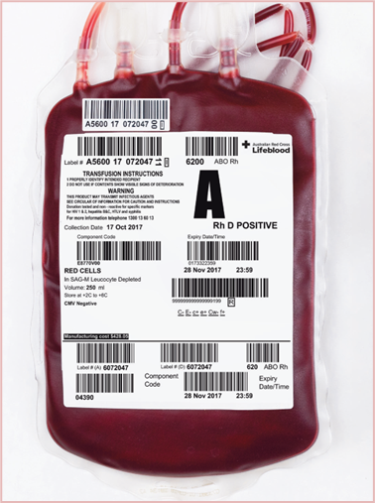 | Red blood cells deliver oxygen to your tissues and organs and are given to patients with severe anaemia or critical bleeding.
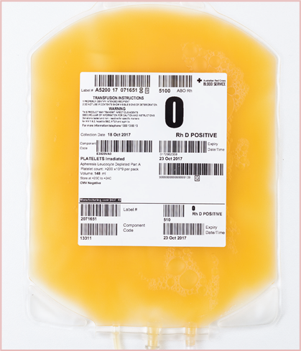 | Platelets are yellow in colour. They are given to patients to prevent or stop bleeding.
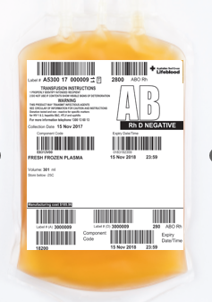 | Fresh frozen plasma and cryoprecipitate are yellow in colour. They contain clotting factors that work with platelets to stop bleeding.  Plasma is also used to make products such as albumin, immunoglobulins and other products containing antibodies for vaccinations, or factors to help blood to clot.
Blood transfusion safety
There are many safeguards in place to ensure Australia has one of the safest blood supplies in the world.
- All blood is donated voluntarily by unpaid donors in Australia.
- All donations are tested before they can be given to patients. Any that fail testing are not used.
Despite testing, there is a very small risk of infection. The estimated risks are:
Infectious disease | Estimated residual risk
HIV | Less than 1 in a million
Hepatitis B | Less than 1 in a million
Hepatitis C | Less than 1 in a million
LIfeblood risk of transfusion-transmissible infection 2023 < https://www.lifeblood.com.au/health-professionals/clinical-practice/adverse-events/other-transfusion-transmitted-infections/transfusion-transmissible-infections>.

Other risks
Other risks include:
- minor reactions such as chills or fever or a rash
- fluid excess that could cause breathing problems
- severe allergic reaction or lung injury, which are rare
- blood not being correctly matched to you. The risk of this more serious reaction is reduced by strict patient identification and checking actions, along with strict checking in the laboratory.
You will be watched very closely during the transfusion. If you are worried that you might be having a reaction, or you are not feeling well in any way during the transfusion, tell the nurse.
Your doctor will talk with you about the risks as well as the benefits of having a transfusion.
How to decrease the need for a blood transfusion
There are treatments such as iron that can help your body make haemoglobin. Iron can be used if you have low levels of iron in your body. This may prevent the need for a transfusion. If you would like to know more about other treatments and ways to prevent a transfusion that could work for you, please ask your doctor.
Consenting to or refusing a blood transfusion
You will be asked to consent to the transfusion. Usually, you will be asked to sign a consent form. Before signing the consent form it is important that you have talked to your doctor about:
- the reason the blood transfusion is needed
- the blood component you need
- the risks of having the blood transfusion
- the expected benefits of the blood transfusion
- the risks of not having the blood transfusion
- any questions you may have.
If you have any reason for not wanting a blood transfusion, it is important to discuss this with your doctor. You may be asked to sign a form confirming your choices.
Before getting a transfusion
You need a blood test to confirm your blood group before you can have a blood transfusion. For a red blood cell transfusion, a ‘cross match’ is done to ensure the blood you are given is safe for you.
When your blood test is taken, you will be asked your first name, surname and date of birth. This will be checked against your wristband (if you are in hospital) and the test request form to make sure blood is being taken from the right person. You should be asked to check that the details on the blood test are correct. This is to prevent your blood from being confused with another patient’s blood.
How is a blood transfusion given?
The blood is given intravenously (through a needle into a vein), usually in your arm or hand. The process should be painless, apart from slight discomfort when the needle is put in.
Two staff members will individually ask you your first name, surname and date of birth before giving you the blood. They will check that these details and your medical record number match the information on your identification band, the blood bag and paperwork. All details must match exactly for transfusion to go ahead.
This is a safety check to make sure you are given the right blood. Every bag of blood given to you will be checked this way.
During the transfusion, your temperature, heart rate, breathing rate, blood pressure and general condition will be closely monitored. You must tell the nurse if you feel unwell during or after the transfusion. You will be assessed by a doctor if you feel unwell during the transfusion.
How long does a transfusion take?
How long the transfusion takes will depend on your specific condition, the number of bags and type of blood components you get. In general:
- red blood cells usually take 2 to 3 hours per bag
- platelets usually take 30 to 60 minutes per bag
- fresh frozen plasma usually takes 30 to 60 minutes per bag
- cryoprecipitate usually takes 15 to 30 minutes per dose
It’s a good idea to make sure you are comfortable, bladder empty and have your call bell before the transfusion starts, as you could be attached to the blood transfusion for up to 4 hours.
What else you should tell your doctor?
- If you have a reason not to accept a blood transfusion
- If you have had a reaction to any blood product in the past or require any special products
- If you are taking any medications – including natural therapies.
For more information about blood transfusions, visit the Lifeblood website <https://www.lifeblood.com.au/patients.> or talk to your treating doctor.
Information checklist
1. Do you understand why you need the blood transfusion?
2. Have the possible risks and benefits been explained to you?
3. Have the alternatives or other treatment options been explained to you?
4. Do you understand the information, and have all your questions been answered?

To receive this document in another format, email Blood Matters <Bloodmatters@redcrossblood.org.au>.
Authorised and published by the Victorian Government, 1 Treasury Place, Melbourne.
© State of Victoria, Australia, Department of Health, December 2024 year.
ISBN 978-1-76131-715-6 (pdf/online/MS word)
Available at Blood Matters < https://www.health.vic.gov.au/patient-care/blood-matters-program>.

