

Mpox
Information on mpox (monkeypox)
OFFICIAL

What is mpox?
Mpox (formerly known as monkeypox) is a disease caused by the monkeypox virus. It normally causes a mild illness with a rash. Mpox does not spread easily between people and is usually spread through close skin-to-skin contact with a person who has the virus. Close skin-to-skin contact can look like: touching mpox sores or the fluid from the sores, intimate skin-to-skin contact including, touching, kissing, and oral, vaginal or anal sex.
It can also be spread through contact with clothing or objects (bedding or towels) used by someone with mpox, and through respiratory droplets (coughs and sneezes). People may be infectious up to four days before they develop their first symptoms until all lesions crust over, dry and fall off with a new layer of skin forming underneath, and other symptoms have resolved. Most people recover within a few weeks.

Symptoms of mpox
Symptoms of mpox may develop up to 21 days after contact with an infected person. Symptoms can include a rash, that can be painful and affect any part of the body, including the genitals, area around the anus and buttocks, inside the mouth, face, hands and arms, feet and legs.

The rash may involve vesicles, pustules, pimples or ulcers and the number of lesions can vary. The rash may change and go through different stages, like chickenpox, before finally becoming a scab that falls off.
Other symptoms that can occur before or alongside the rash, include:

- fevers
- chills
- muscle aches
- swollen lymph nodes
- exhaustion
- headache
- sore throat
- anal and rectal pain
- pain during urination

Symptoms can resemble sexually transmitted infections (STIs) like herpes or syphilis as well as other diseases with a rash such as measles or chickenpox.
Most people have a mild illness and recover within a few weeks, but some people may develop severe disease and require hospitalisation. Children, pregnant women and people who have a weakened immune system are considered at higher risk of developing severe disease.
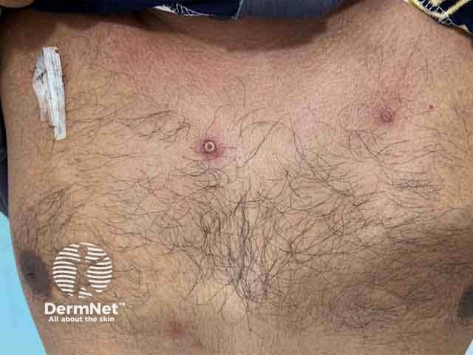
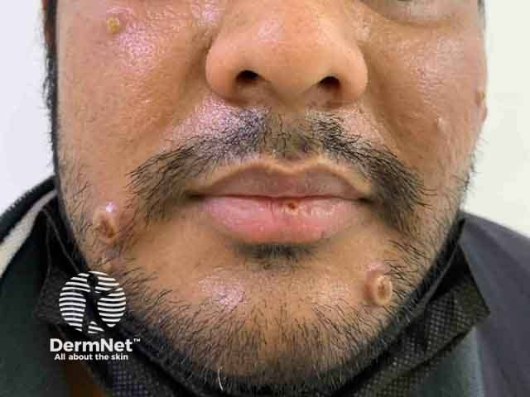
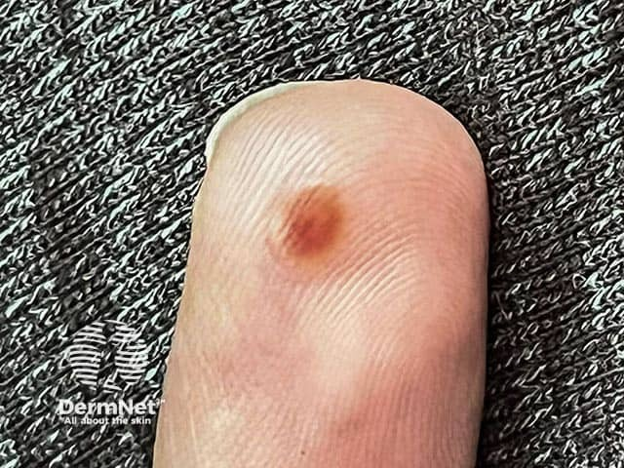
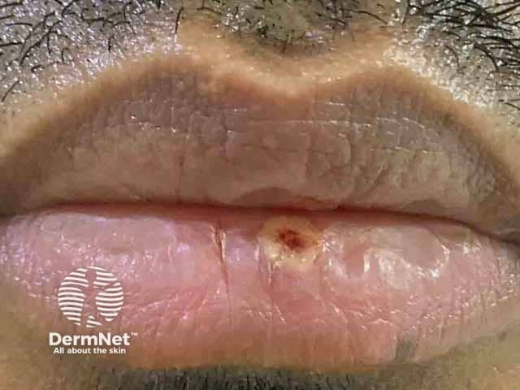

Figures: These figures are examples of what the mpox rash can look like.
Image source: DermNet <https://dermnetnz.org/images/mpox-images>

Prevention of mpox
Vaccination against mpox is an important preventative measure. Two doses of the vaccine are required for the optimal protection against infection and disease. No vaccine is 100 per cent effective, and infection may occur in people who are vaccinated.
Avoid contact with people with suspected or confirmed mpox. This includes touching potentially contaminated materials, like bedding, clothing or towels.
Consider limiting your number of sexual partners during periods of increased transmission and swap contact details with new partners. Consider limiting sexual partners for three weeks after returning from countries where there are mpox outbreaks.
Condoms may not be enough to prevent catching mpox as it is mostly spread from skin-to-skin contact. Maintain good hygiene by washing your hands with soap and water or using alcohol-based sanitiser.
If you are unvaccinated, or have only had one dose, and have been exposed to someone with mpox, getting a vaccine (preferably within four days after exposure), may reduce your risk of getting mpox. Speak to your GP or sexual health clinic about getting vaccinated.

Mpox immunisation
In Victoria, the mpox vaccine is available free-of-charge for eligible people.
It helps to reduce the risk of infection and severe disease in:
- eligible high-risk groups
- certain people who have had recent high-risk exposure to mpox.
Two doses of the vaccine, given at least 28 days apart, are required to lower your risk or chance of catching mpox.
The mpox vaccine takes approximately 14 days before it is effective. Ensure you get your second dose at least 28 days after your first dose to maximise your protection.
Mpox vaccines are widely available through sexual health clinics, public hospitals, general practitioners, Aboriginal health services and some councils and community pharmacies. Find a provider in your area on the Better Health Channel <https://www.betterhealth.vic.gov.au/mpox-immunisation-providers>.

More information

Scan to read more about mpox, vaccinations and vaccine eligibility criteria on the Better Health Channel <https://www.betterhealth.vic.gov.au/mpox>
More information on safer sex, social gatherings and mpox from the Centers for Disease Control and Prevention <https://www.cdc.gov/poxvirus/mpox/prevention/sexual-health.html>
General information on mpox from the World Health Organization <https://www.who.int/news-room/questions-and-answers/item/monkeypox>
To receive this publication in an accessible format email Public Health communications <pph.communications@health.vic.gov.au>.
Authorised and published by the Victorian Government, 1 Treasury Place, Melbourne.
© State of Victoria, Australia, Department of Health January 2025.

