

Blood transfusion
Patient information
OFFICIAL

Blood and blood products and common reasons they are needed
Your doctor will talk to you about why you might need a blood transfusion.
Donated blood is separated into different blood components and manufactured into many different products. This is so you only get what you need.

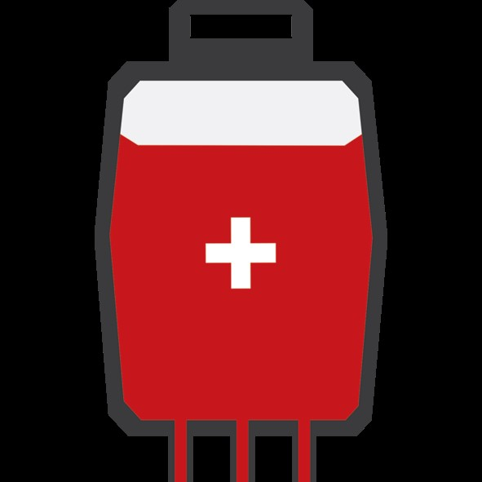  Red blood cells | 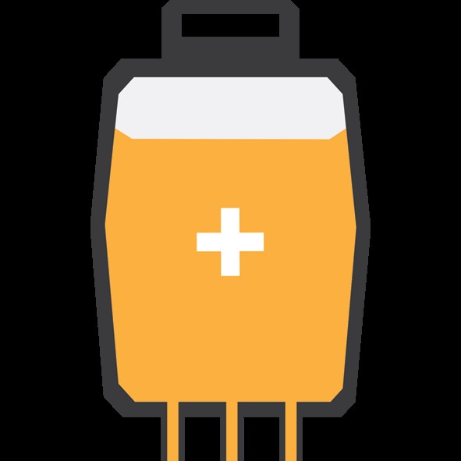  Platelets | Fresh frozen plasma and cryoprecipitate | 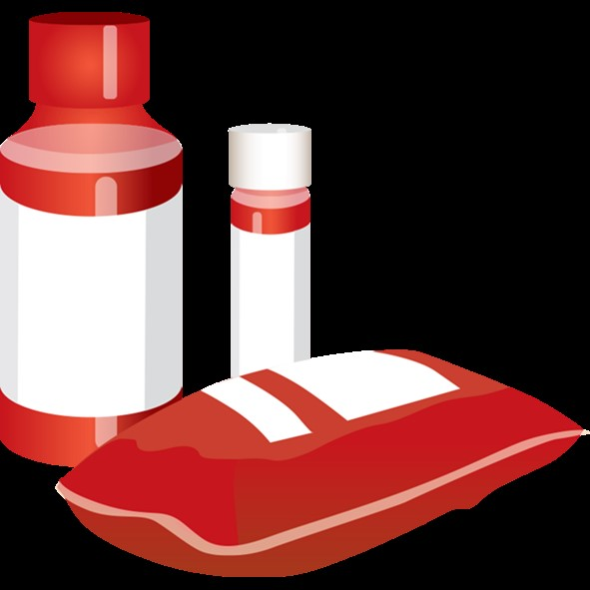  Manufactured products
Red blood cells (RBC) deliver oxygen.  You might need RBC transfusion if you lose a lot of blood.  You might also need it if you have anaemia (not enough haemoglobin or red blood cells). | Platelets are yellow.  You might need a platelet transfusion to help prevent or stop bleeding, either internal (bleeding you cannot see) or external.  You may have a low number of platelets or your platelets may not work as they should. | Fresh frozen plasma and cryoprecipitate are yellow.  They are stored frozen and are thawed before they are given to you.  These components contain clotting factors that work with platelets to seal wounds and stop bleeding. | You might need other types of manufactured blood products such as:  - Clotting factors to treat bleeding disorders  - Immunoglobulins to help fight infections  - Albumin to help maintain blood pressure.

Blood transfusion safety
Blood for transfusion in Australia is very safe. Blood is collected from healthy volunteer donors, but there can be some risks.
Risk | Description and risk reduction
  Infection | All blood is tested for disease. The risk of getting hepatitis B or C or HIV from a blood transfusion is less than one in a million.
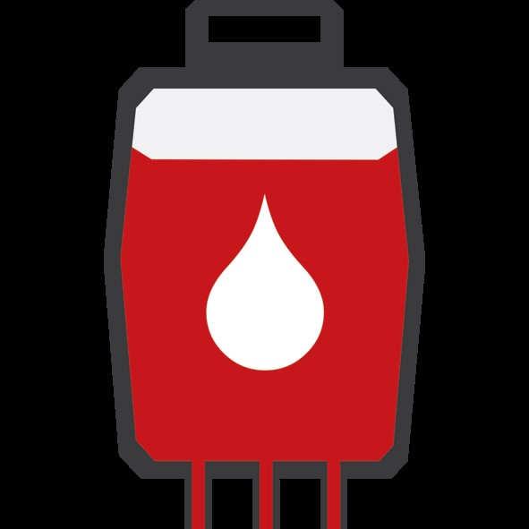  Getting the wrong blood | This is very rare. To help stop this you will be asked to say your full name and date of birth. This and other identification information is checked against your wrist band and the identification information on the blood bag. The blood transfusion can only start if all the information matches.
  Having a reaction | A mild reaction may include a rash or fever. Severe reactions are uncommon, but may include difficulty breathing, high fever, or serious allergy. Tell the nurse if you feel unwell in any way during and after the transfusion

Before the transfusion
What happens | Description
  Consent and refusal of blood transfusion | You will be asked to consent to the transfusion. Before signing the consent form it is important that you have talked to your doctor about:  - the blood component and reason the blood transfusion is needed  - the risks and expected benefits of having the blood component and the risks of not having the transfusion  - any questions you may have.  If you have any reason for not wanting a blood transfusion, it is important to discuss this with your doctor. You may be asked to sign a form confirming your choices.
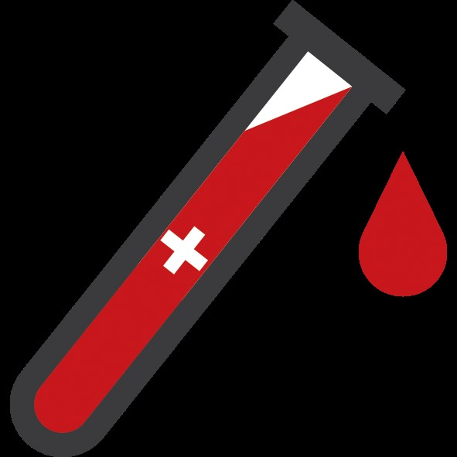  A blood test | A blood test will be taken to check and confirm your blood group. For RBC transfusion, a test called a ‘crossmatch’ is done to ensure you are given blood that is safe for you.
  Checking who you are | Before the blood test you will be asked your full name and date of birth. This is checked against your wristband and the test request along with your medical record number. You should be asked to check the name and date of birth is correct on the blood sample after the blood test has been taken. Speak up if any details are wrong!
  Get comfortable | It is a good idea to go to the toilet and make sure you have everything you need within reach before the transfusion starts.
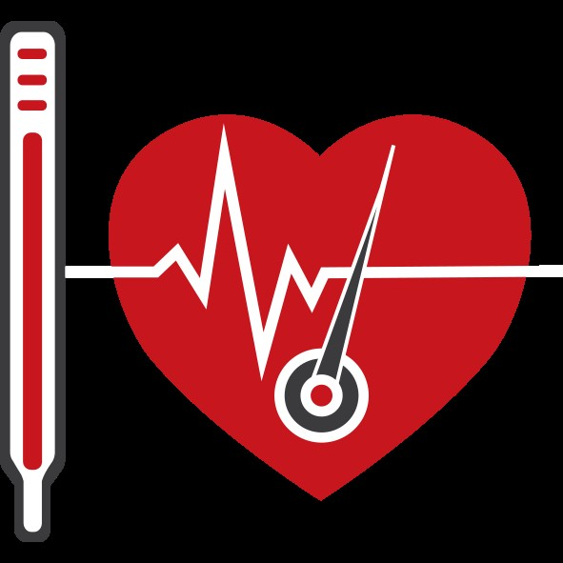  Vital signs | Your temperature, pulse, blood pressure and breathing will be checked before starting the transfusion.

Making sure you get the right blood
Before starting the transfusion, you will be asked your full name and date of birth by two nurses. This is checked against your wristband, along with your medical record number and checked on the blood prescription and bag of blood. Other details on the bag of blood will also be checked. If everything matches the transfusion can start.
Speak up if any details are wrong!

During and after the transfusion
During and after the transfusion your temperature, blood pressure, pulse and breathing will be checked and the nurse will monitor you closely. You must tell the nurse if you feel unwell in any way during or after the transfusion. A doctor may assess you if you feel unwell during the transfusion.
You might need a blood test after the transfusion to check that your blood count has improved.

To receive this document in another format, email Blood Matters <bloodmatters@redcrossblood.org.au>.
Authorised and published by the Victorian Government, 1 Treasury Place, Melbourne.
© State of Victoria, Australia, Department of Health, January 2025.
Except where otherwise indicated, the images in this document show models and illustrative settings only, and do not necessarily depict actual services, facilities or recipients of services.
ISBN 978-1-76131-739-2 (pdf/online/MS word)
Available at Blood Matters program <https://www.health.vic.gov.au/patient-care/blood-matters-program>
Consumer input provided by the Blood Matters Advisory Committee member health services consumer participants.

