
Pathway to Good Health
Service Framework
(Targeted Health Support for Children in Care program)

Service framework
January 2025

Contents
Contents 2
1. Purpose 4
2. Introduction 4
Reducing barriers to access 4
Overview of Pathway to Good Health Program 5
Service and care principles 6
3. Aboriginal children 7
Aboriginal Children in Aboriginal Care 8
4. Service model 8
Eligibility 9
5. Service components 11
Health screening, connecting and navigation 11
Multidisciplinary assessment and planning 12
Secondary consultation, support and liaison with child protection and carers 12
Health records 13
Client brokerage funding 13
Child protection and health service provider roles and responsibilities 14
6. Workforce 15
Health Navigator 15
Multidisciplinary Assessment Team 16
7. Statewide clinical leadership 16
Victorian Centre of Health Leadership for Children in Care 16
Fetal Alcohol Spectrum Disorder 16
8. Governance 17
Clinical governance 17
9. Monitoring and evaluation 17
Activity data collection and reporting 18
Evaluation 18
Appendix 1a: Child Protection and Care Services roles 19
Appendix 1b: Child Protection and Care Services roles – text version 20
Appendix 2: Health and social history information 22
Appendix 3: Consent guidance 26
Appendix 4a: Theory of Change 28
Appendix 4b: Theory of Change – text version 29
Appendix 5: Text version of figure 2: Service and care principles 30

To receive this document in another format, email pathwaytogoodhealth@health.vic.gov.au <pathwaytogoodhealth@health.vic.gov.au>.
Authorised and published by the Victorian Government, 1 Treasury Place, Melbourne.
© State of Victoria, Australia, Department of Health, April 2024.
In this document, ‘Aboriginal’ refers to both Aboriginal and Torres Strait Islander people. ‘Indigenous’ or ‘Koori/Koorie’ is retained when part of the title of a report, program or quotation.
ISBN/ISSN 978-1-76131-576-3 (online/PDF/Word)
Available at Pathway to good health for children in care <https://www.health.vic.gov.au/populations/vulnerable-children/pathway-to-good-health-for-children-in-care>

1. Purpose
This service framework (the framework) provides guidance to health services to support the development of consistent and high-quality models of care delivered to children who are entering statutory care settings through the Pathway to Good Health program. This program is funded through a recent four-year Victorian government investment for the Targeted Health Support for Children in Care initiative.
The framework describes the service components to be delivered across Victoria under the Pathway to Good Health program (program) and includes the service principles, roles and responsibilities and partnership expectations to improve access to services and health outcomes for children and young people in care (formerly ‘out of home care’).
The framework is a ‘living’ document that will be informed by the learnings of the program implementation. Updates to the framework will ensure that consistent and high-quality services are maintained while also supporting local innovation and service improvement.

2. Introduction
Children placed in statutory care are known to have poorer health outcomes than the general population, across all domains of health: physical, developmental and emotional/mental health. As of 30 June 2023, there were 9,132 children in care in Victoria (6.3 per 1,000 children) (Child Protection Australia 2022-23, AIHW). Long wait lists and the complexity in navigating health and social care systems contribute to vulnerable cohorts such as children in care being excluded from receiving the right healthcare at the right time.
Aboriginal children are significantly overrepresented in Child Protection in Victoria with Aboriginal children and young people removed and placed into care at a rate of 102.9 per 1,000 Aboriginal and Torres Strait Islander children. This is 22.5 times the rate of non-Indigenous children and almost twice that of the national average for Indigenous children.
This program aims to improve access and target services to better meet the health needs of children and young people entering care in Victoria. The 2023 -24 State Budget provided four years of funding ($37.7 million) for the program that will support early assessment and improved care planning for children and young people as they enter care with the aim of improving health outcomes and reduce avoidable downstream costs.
Building on evidence and previous projects to support this cohort of children, this program aims to provide a tiered approach to care that improves integration across the health and child protection systems, education and care services. The term “child protection system” is used throughout this document to refer to the range of programs and services delivered by or subcontracted by the Department of Families Fairness and Housing (DFFH) that support children and young people subject to statutory intervention under the Children, Youth and Families Act (2005).

Reducing barriers to access
Children in care and their carers often face a range of challenges in accessing health services. The absence of a Medicare card, lack of access to previous health records and limited referral information should not be a barrier to receiving a responsive and flexible service by health providers.
The Child Protection Manual outlines the processes that enable Child Protection practitioners to:
- Obtain a Medicare https://www.cpmanual.vic.gov.au/policies-and-procedures/out-home-care/applying-medicare-number-child-care
- Access My Health Record https://www.cpmanual.vic.gov.au/policies-and-procedures/out-home-care/my-health-record
- Payment for Medicare services where a child is not enrolled on a Medicare card https://www.cpmanual.vic.gov.au/sites/default/files/Commonwealth_protocol_appendix_2%20medicare%202810.pdf
- Share and receive information https://www.cpmanual.vic.gov.au/our-approach/information-sharing/information-sharing-child-protection-practice
There is no cost for receiving a service in the program and a General Practitioner referral is not a prerequisite for access to any health care funded through this program.
Health providers may use MBS funding where appropriate for children and young people in the program but should be mindful that the use of this funding should not create any delay or cost in receiving services. Community health services using MBS need to ensure they are compliant with s19(2) of the Health Insurance Act 1973 (Commonwealth). Lead providers are encouraged to make close connections with primary care services in their local area to ensure there are no barriers in accessing services.
As outlined in the program overview (Figure 3), this program provides health navigation and screening as well as comprehensive multidisciplinary assessments for children and young people in care with more complex needs. Services will need to establish connections that support access to primary health services including General Practice and Maternal and Child Health services to support routine age-appropriate screening as well as access to allied health therapy or interventions for children and young people.

Overview of Pathway to Good Health Program
The Pathway to Good Health is a model for the delivery of health screening, assessment and planning for all children who enter or re-enter care in Victoria. The program model aligns with the National Clinical Assessment Framework for Children and Young People in Out of Home Care (2011), https://www.health.gov.au/resources/publications/national-clinical-assessment-framework-for-children-and-young-people-in-out-of-home-care?language=en.
Services will be delivered within existing community-based health platforms such as Community Health Services (CHSs) and Aboriginal Community Controlled Health Organisations (ACCHOs). These services will leverage and expand existing service capacity and capability and utilise established connections with communities, local partnerships and services to support non-stigmatising, holistic care for children and young people.
Service delivery should be flexible, accessible and responsive to the needs of children and young people.
Services will be located in each of the seventeen Department of Families, Fairness and Housing (DFFH) Areas as shown in Figure 1 and health providers will be expected to deliver health services to all children entering and re-entering care in these Areas.

Figure 1: DFFH divisions and areas
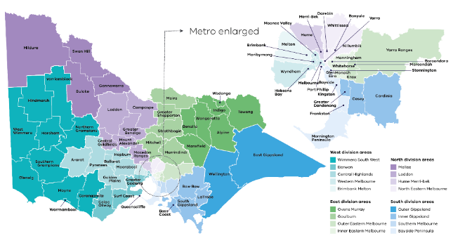

Service and care principles
The principles of “child centred care” and “culturally safe care” underpin the delivery of services and apply to all aspects of service planning, program design and service delivery for this program.
The diagram below has been adapted from the Community Health Integrated Program guidelines 2019 and the Child Health Services: Guidelines for the Community Health Program 2019. Further detail about the service principles can be found at Appendix 5.
Figure 2: Service and care principles
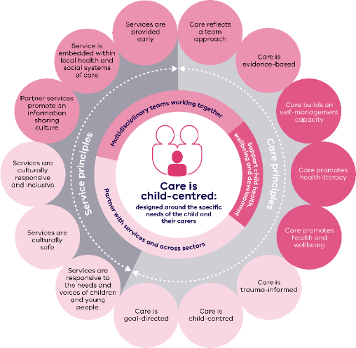

3. Aboriginal children
The program must engage in strong and respectful partnerships with Aboriginal Community Controlled Organisations to provide culturally safe healthcare for Aboriginal children and young people.
As part of this program, the Department of Health is working with the Victorian Aboriginal Community Controlled Health Organisation (VACCHO) to support self-determined demonstration models that deliver culturally safe care for Aboriginal children, young people and their carers.
Notwithstanding this work, it is expected that program health providers will work closely with their local Aboriginal communities to provide culturally safe service options that best meet the needs of Aboriginal children and young people and their carers. Further information about cultural safety can be found at VACCHO, https://www.vaccho.org.au/cultural-safety-services/#:~:text=VACCHOs%20Cultural%20Safety%20Services%20%28CSS%29%20team%20offers%20training,Australia%E2%80%99s%20First%20Peoples%2C%20Communities%20and%20Organisations%20within%20Victoria and https://www.health.vic.gov.au/health-strategies/aboriginal-and-torres-strait-islander-cultural-safety.

Aboriginal Children in Aboriginal Care
Aboriginal Children in Aboriginal Care (ACAC) is a program for Aboriginal children and families involved with the child protection system where authorised Aboriginal Community Controlled Organisations (ACCOs) provide child safety services.
The ACAC program gives authorised ACCOs, under section 18 of the Children, Youth and Families Act 2005, https://classic.austlii.edu.au/au/legis/vic/consol_act/cyafa2005252/s18.html legal responsibility for Aboriginal children or young people who have been placed on a Children’s Court protection order.
Under this program, an authorised ACCO will actively work with the child’s family, community, and other professionals to develop a case plan to address protective concerns and achieve long-term objectives in a way that is culturally appropriate and in the best interests of the child.
The ACAC program is being implemented across Victoria and further information about the program can be found at https://services.dffh.vic.gov.au/aboriginal-children-aboriginal-care.

4. Service model
Developing locally tailored models of care will be a critical part of the establishment of this program. While local models of care will be designed to support partnerships with Child Protection and leverage existing service capacity, they should also focus on the development of innovative, integrated models that can deliver tailored, flexible and responsive care to children and young people living in care including those in residential care.
Local service models should focus on:
- Creating health equity by connecting children experiencing adversity to healthcare
- Delivering accessible care through service innovation that is inclusive of cultural safety, diversity and reduces geographic barriers to care
- Supporting right care at the right time that reflects local service capability, service partnerships and pathways of care
- Holistic care that supports health, wellbeing and social care needs and reflects a locally diverse and skilled workforce
- Reflecting lived experience and the voice of children and young people in care in service design, delivery and monitoring
- Sustainable services that integrate and leverage existing local platforms and establish robust local governance and strong service partnerships.

Eligibility
Children will be eligible for services if they are:
- aged from birth up to and including 17 years; and
- currently in care (including kinship care, foster care, or residential care) as a result of a statutory court order, excluding voluntary and permanent care orders.
- the priority cohort to receive services are those children who have recently entered or re-entered care (in the last three months) either for the first or subsequent times.
An automated referral process from Child Protection ensures that basic contact information about the child and their carer is provided to the health provider. It is expected that the health provider will work with Child Protection or ACAC providers to gather all the relevant information about the child to inform the screening process.
The health provider will prioritise all children entering or re-entering care to ensure a health screening is completed at the earliest opportunity. Any child already in care who is identified as needing health support due to lack of any previous health contact can also be referred by workers in the Child Protection System, carers or other health services, noting that services for this cohort will be subject to service capacity.
Children who have been referred to Pathway to Good Health but who have returned home or are no longer on a statutory order before the screening and assessment is complete will continue to be supported with the consent of their parent.

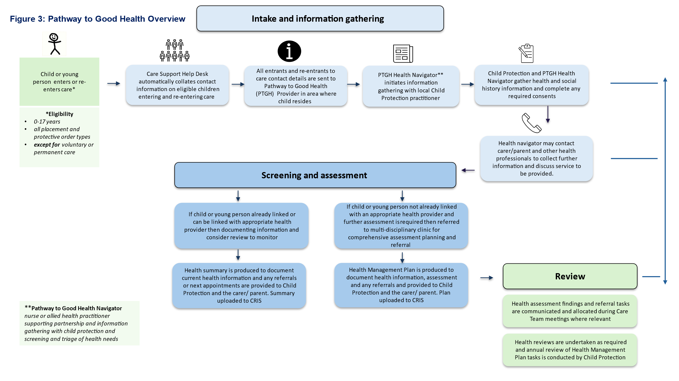

5. Service components
The local model of care in each Area will include the following service components.

Health screening, connecting and navigation
Health Navigators in the Pathway to Good Health program support initial screening for all eligible children and are pivotal in supporting the connection with Child Protection practitioners to build strong and respectful partnerships in the local Area.
Health Navigators are practitioners such as nurses or allied health workers and these clinicians support the critical early navigation and assessment phase of the program so that:
- Relevant information is provided about children and young people entering care so that carers can be engaged, culturally safety can be addressed, and any relevant referrals and health appointments are made in a timely manner.
- A health history is built for the child or young person in collaboration with Child Protection using information that is shared from CRIS (Child Protection Client Record) as well as information obtained from other health professionals, carers and family. The type of information gathered as part of the health and social history information is provided at Appendix 2.
- Opportunities for secondary consultation are maximised through co-location in Child Protection offices so that the health needs of children and young people can be quickly, accurately and sensitively assessed and prioritised
- Carers, including parents when appropriate, are supported to access and navigate the range of required health services, including primary health services, early intervention services, and specialist services such as hospitals, mental health or disability supports.
- Primary screens such as hearing, vision and dental are undertaken at the earliest opportunity and before any referral is made to a more comprehensive assessment.
- Access to the program is flexible, innovative and culturally safe using in-reach into the community such as at a carer’s home, early learning or education settings, residential care units or local Aboriginal services.
- The health needs of the child are documented using the Pathway to Good Health’s CAReHR records system and the Health Navigator develops a health summary that describes the screening process and the recommended pathway of care, which is uploaded into CRIS.
- The health information about the child or young person is shared and explained so that carers, child protection practitioners, educators and other health professionals can support the health needs that have been identified.

Multidisciplinary assessment and planning
Where children and young people in care are identified through the initial screening process as having more complex needs, they can be referred for a multidisciplinary clinical assessment. This informs the development of a comprehensive health management plan for the child.
The multidisciplinary team includes a paediatrician and appropriate allied health practitioners such as speech pathologists, occupational therapists and psychologists. This clinical team undertakes a comprehensive multidisciplinary assessment of the child or young person’s development, function and emotional wellbeing and produces a health management plan that documents the multidisciplinary assessment findings and any recommendations for further interventions for the child or young person.
Clinical services should be delivered in a way that best meets the child, young person and carer’s needs and should be flexible and employ a range of strategies in their approach to supporting attendance at assessments.
Health management plans and associated treatment recommendations are to be shared with Child Protection teams which are responsible for following through on treatment recommendations in collaboration with the health care team. Where health management plans include a review date, it is the responsibility of the health service to follow up and schedule the review in a timely manner.
Health Navigators support the multidisciplinary teams by communicating the findings of the assessment and ensuring that any recommendations from the plan are understood by child protection practitioners, carers and/or parents.

Secondary consultation, support and liaison with child protection and carers
Health services funded through this program must strengthen relationships and partnerships with local child protection and care service providers, through a range of strategies including:
- embedding a health navigator in local child protection offices to improve partnerships, referrals and foster an improved understanding of health.
- working collaboratively with children, young people and their carers and other service providers to avoid any unnecessary duplication of services or assessment and ensure that care is coordinated and tailored to the specific needs and priorities of children and young people.
- supporting carers, children and young people to build the health knowledge, skills and confidence they need to navigate the health system and access the services they need.
- advocating, sharing learnings and building partnerships between service providers that engage and support children and young people in care and their carers.
- supporting services such as child protection, schools and early years with secondary consultation to assist and link children with the right health service as early as possible.

Health records
The lack of a single coordinated and accessible health record for a child in care presents a significant challenge to coordinated healthcare for this group of children. CAReHR is a web-based software application that enables health assessments, care planning and data analysis on health needs and referrals for children in care.
The CAReHR system has been used previously by health providers for this cohort of children and health providers funded under this program will be required to use and maintain screening and assessment records for children receiving a service using this platform. The Department of Health will support the licensing and access to the CAReHR platform.
Health providers should ensure that the confidentiality and sharing of patient records is in accordance with the Victorian legislative requirements applicable to all health providers.

Client brokerage funding
Service providers receive a component of funding under this program to be used flexibly for brokerage to address barriers in accessing health services for children and young people in care, for example, out-of-pocket expenses, gap fees or transportation costs.
Where other State or Commonwealth sources of funding are available for a particular purpose this should be explored first, such as Medicare or NDIS funding. It should be noted that there are other available sources of brokerage to support the health needs of children and young people in care through Child Protection and Care Services within DFFH.
Appropriate records of brokerage expenditure (including the item or service the brokerage was used for) are to be maintained by services to ensure accountability. Details of brokerage recording requirements will be provided by the Department of Health.

Child protection and health service provider roles and responsibilities
Clear delineation of roles and responsibilities for the implementation of this service model are critical to ensuring that children and young people are referred in a timely manner and receive the health services they need. Appendix 1 provides a brief overview of some key roles in the child protection system.

Core roles and responsibilities of Child Protection and Aboriginal Children in Aboriginal Care (ACAC) providers:
- Provision of relevant information for all children entering care to the nominated CHS or ACCO delivering the service in the relevant area.
- Obtaining consent where required, to enable the exchange of relevant information and provide treatment for children and young people Appendix 3.
- Management of any urgent health concerns for children in care (e.g. facilitating an immediate primary care appointment or emergency department presentation).
- Enabling health navigators to work closely with child protection practitioners to maximise efficient and timely consultation and transfer of information.
- Receive health management plans and update the relevant information, health contacts, management plan and review date where applicable on the child or young person’s CRIS record (the Child Protection information database).
- Engaging and sharing relevant information with parents about health services children are receiving.
- Implementing recommendations of the health management plan as part of the child’s statutory case planning process.

Core roles and responsibilities of lead health service providers:
- Consult with Child Protection on all referrals received to support prioritisation of health screening.
- Enable health practitioners to work closely with local child protection offices to support connections, secondary consultation and strong working relationships.
- Maintain health record via CAReHR and share health management plans and treatment recommendations with child protection in a timely manner.
- Facilitate referrals and connection to any recommended treatment services following consultation with Child Protection and in collaboration with carers and parents where appropriate.
- Set review dates and undertake reviews of health management plans as determined by clinical need.
- Facilitate and record the expenditure of brokerage for this program.

6. Workforce
The program team needs to be able to successfully undertake a diverse range of responsibilities, including partnership work with Child Protection, screening, information-gathering, making referrals, and comprehensive multidisciplinary assessment services.
Broadly, the workforce should be supported to deliver:
- high quality and safe care overseen by strong clinical governance
- a trauma informed approach to healthcare
- collaborative and respectful professional relationships
- healthcare that is cognisant of the social determinants of health
- Culturally safe and inclusive care
The Pathway to Good Health overview in Figure 3 outlines the ‘client journey’, demonstrating the range of workforce functions required to support the health needs of children in care from screening, comprehensive assessment, referral to other health supports and clinical review.
It is expected that program teams will consist of a combination of health professionals to meet these responsibilities. Providers should engage a workforce that includes health navigators, allied health clinical team and specialist medical clinical support and relevant program administrative support and coordination to support the delivery of services. Programs should also consider engagement of specialised roles where appropriate that may include Aboriginal Health workers, youth workers, child and family nurses and mental health clinicians.
Clinicians must work within the required scope of practice and adhere to professional standards and ethics. Appropriate clinical supervision and management arrangements to ensure that staff are appropriately supported when working with clients who have experienced child abuse and neglect is critical.
Services should also look for opportunities to leverage existing fractional workforce and also identify potential graduate and training positions/placements for a range of disciplines through joint appointments across acute and community settings.

Health Navigator
Health Navigators perform a critical function in the Pathway to Good Health program to ensure all eligible children receive initial screening upon entry to the program. Health Navigators are also pivotal in supporting the connection with Child Protection practitioners to build strong and respectful partnerships in the Area.
Health Navigators are practitioners such as nurses or allied health workers and these clinicians support the critical early navigation, assessment and transition phase of the program. Health services should ensure that sufficient time fraction is dedicated to this role or roles to support the service functions and meet the demand for screening all eligible children and young people in each area.

Multidisciplinary Assessment Team
The multidisciplinary team should include a paediatrician and appropriate allied health practitioners that address the key domains of children’s needs including speech pathologist and psychologist. Other allied health team members may also be appropriate to include as part of the team where children and young people have identified health issues on screening.
This clinical team requires the skills to undertake a comprehensive multidisciplinary assessment of the child or young person’s development, function and emotional wellbeing and produce a health management plan for child protection that documents the assessment findings and any recommendations for further interventions for the child or young person.
The clinical assessment team can deliver assessments flexibly to maximise workforce expertise but are required to deliver a minimum number of assessments that are set out by the department as performance measures for the program.

7. Statewide clinical leadership
Clinical leadership will support a statewide network of clinicians working with children and young people in care. The statewide network of clinicians will also be supported through a shared Community of Practice portal hosting resources and information relevant for the delivery of the program. Access to the shared portal should be requested at pathwaytogoodhealth@health.vic.gov.au.

Victorian Centre of Health Leadership for Children in Care
The statewide clinical leadership led by the Victorian Centre of Health Leadership for Children in Care will support the following key functions over the four years of funded services:
- workforce capability building, including a Community of Practice
- clinical practice guidance
- supporting the access and enhancement of e-health systems designed for the cohort of children
- assisting the evaluation of the program.

Fetal Alcohol Spectrum Disorder
In addition to the statewide clinical leadership, additional support and secondary consultation will also be provided to service providers by the FASD Connect program This is in recognition of the significant number of children in the care system and those known to child protection who experience or are at risk of Fetal Alcohol Spectrum Disorder (FASD).
FASDConnect (delivered by Monash Health) is designed to enhance the identification, diagnosis, and support of children in care with FASD. By increasing the capacity of both Pathway to Good Health providers and child protection services, FASDConnect aims to ensure that children who have experienced prenatal alcohol exposure are identified early and receive the appropriate supports.

8. Governance
The lead provider of Pathway to Good Health services will be responsible for leading the implementation, monitoring and quality improvement of program services in each DFFH Area. Lead providers will be responsible for:
- the establishment of service partnerships with a range of relevant services in their local Area, including child protection providers, primary health services such as GPs, doctors in secondary schools, dental health services, maternal and child health services
- establishing a local steering committee or oversight governance structure that reflects the partnership between the health service and Child Protection
- designing a culturally safe model of care and service pathways with local service partners, community and people with lived experience
- management of effective and appropriate operational and clinical governance structures in accordance with Community Services Quality Governance Framework, https://www.dffh.vic.gov.au/publications/community-services-quality-governance-framework.
- maintaining record keeping in accordance with relevant policy and legislative obligations
- maintaining a health record that is accessible and can travel with the child if they change placements
- the employment and management of relevant staff
- financial and performance accountability requirements as set out in the service agreement between the department and the agency
- participation in the community of practice
- participation the evaluation of the program.

Clinical governance
Appropriate clinical governance structures should be established to ensure that services funded through this program are providing responsive, safe and high-quality care.
Services should ensure that the five domains of clinical governance as set out in the Victorian Clinical Governance Framework, https://www.safercare.vic.gov.au/publications/victorian-clinical-governance-framework are supported in the program.

9. Monitoring and evaluation
Understanding how the program is performing against the desired outcomes will inform future planning, investment and implementation. Monitoring and evaluation frameworks developed as part of the service's establishment may initially focus on shorter term process outcomes with service activity collected consistent with the current service requirements.
Over time as the model of care matures, evaluation and monitoring frameworks may include quantitative and qualitative data to measure achievement of the desired outputs, impact and outcomes for both service and child and family outcomes.
A theory of change outlines the desired outcomes and impacts for this program at Appendix 4 and this will be regularly reviewed.

Activity data collection and reporting
Service providers funded for this initiative will use their existing data collection systems to record service activity using the Community Health Minimum Data Set. https://www.health.vic.gov.au/community-health/community-health-data-reporting.
Services will also be required to provide quarterly reports on their implementation progress to the Department of Health. Details of the quarterly report and progress indicators will be provided by the department.

Evaluation
With the support and guidance of the Community of Practice and in consultation with funded service providers, child protection, children and carers, an evaluation of this initiative will seek to:
- assess how the initiative was implemented
- assess the extent to which the initiative has achieved the identified outcomes for children, carers and the service system.
- assess the extent to which the initiative has been delivered within budget
- identify successes and areas for improvement and, where relevant, inform future policy development, investment, service design and delivery for communities.

Appendix 1a: Child Protection and Care Services roles
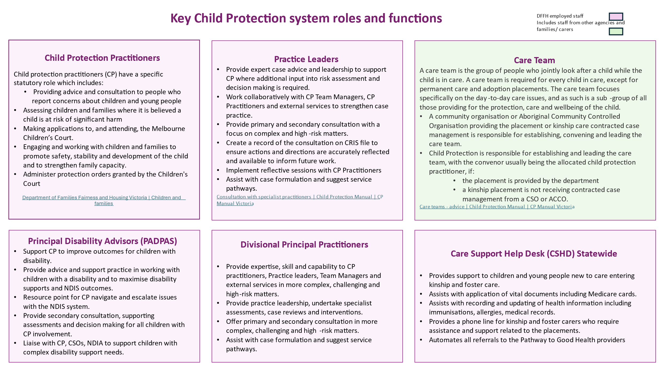
For further information regarding roles in the child protection system: https://www.cpmanual.vic.gov.au/policies-and-procedures/out-home-care

Appendix 1b: Child Protection and Care Services roles – text version
Child Protection Practitioners:
- Provide advice and consultation to people who report concerns about children and young people
- Assess children and families where it is believed a child is at risk of significant harm
- Make applications to, and attend, the Melbourne Children’s Court
- Engage and work with children and families to promote safety, stability and development of the child and to strengthen family capacity
- Administer protection orders granted by the Children's Court.

Practice leaders:
- Provide expert case advice and leadership to support CP where additional input into risk assessment and decision making is required.
- Work collaboratively with CP Team Managers, CP Practitioners and external services to strengthen case practice.
- Provide primary and secondary consultation with a focus on complex and high-risk matters.
- Create a record of the consultation on CRIS file to ensure actions and directions are accurately reflected and available to inform future work.
- Implement reflective sessions with CP Practitioners
- Assist with case formulation and suggest service pathways.

Principal Disability Advisors (PADPAS):
- Support CP to improve outcomes for children with disability.
- Provide advice and support practice in working with children with a disability and to maximise disability supports and NDIS outcomes.
- Resource point for CP navigate and escalate issues with the NDIS system.
- Provide secondary consultation, supporting assessments and decision making for all children with CP involvement.
- Liaise with CP, CSOs, NDIA to support children with complex disability support needs.

Divisional Principal Practitioners:
- Provide expertise, skill and capability to CP practitioners, Practice leaders, Team Managers and external services in more complex, challenging and high-risk matters.
- Provide practice leadership, undertake specialist assessments, case reviews and interventions.
- Offer primary and secondary consultation in more complex, challenging and high-risk matters.
- Assist with case formulation and suggest service pathways.

Care Support Help Desk (CSHD) Statewide:
- Provides support to children and young people new to care entering kinship and foster care.
- Assists with application of vital documents including Medicare cards.
- Assists with recording and updating of health information including immunisations, allergies, medical records.
- Provides a phone line for kinship and foster carers who require assistance and support related to the placements.
- Automates all referrals to the Pathway to Good Health providers.

Care Teams:
- Jointly look after a child while the child is in care.
- Are required for every child in care, except for permanent care and adoption placements.
- Focus specifically on the day-to-day care issues, and as such is a sub-group of all those providing for the protection, care and wellbeing of the child.

A community organisation or Aboriginal Community Controlled Organisation providing placement or kinship care contracted case management, is responsible for establishing, convening and leading the care team.
Child Protection is responsible for establishing and leading the care team, with the convenor usually being the allocated child protection practitioner, if:
- the placement is provided by the department.
- a kinship placement is not receiving contracted case management from a CSO or ACCO.

Appendix 2: Health and social history information

PATHWAY TO GOOD HEALTH:
HEALTH AND SOCIAL HISTORY INFORMATION

Introduction
This form is to be used to gather information about a child or young person who has entered or re-entered care to enable the Pathway to Good Health program to determine the type of assessment needed to support the child or young person’s health and wellbeing.
This form should be completed through consultation between the Child Protection practitioner and the Pathway to Good Health provider’s Health Navigator. Information from parents or carers may also be needed to answer some questions.

While some information may not be available, please complete as much information as best you can. Even an indication of what is not known, may be useful.
Child Name:
Child DOB:
Carer Name:
Carer phone number:

DFFH Child Protection Practitioner or ACAC worker:
- Phone number:
- Email:
Placement Support Worker: (if applicable)
- Agency:
- Phone number:
- Email:
Complete the following information for each child or young person and attach any additional information as required.

- Out-of-Home Care History Brief current reason for child being placed in care:
- Length of time in care
- Number, length and type of placements
- Current care arrangements
- Frequency of access contact with family – including parents and siblings

- Parental Background
- Any known cognitive challenges including any NDIS plans?
- Any known or chronic medical or mental health issues?
- Were any of these issues detected in pregnancy?
  - Hepatitis B/C, HIV, Syphilis status.
  - Drug and alcohol use
- Cultural background
  - Language spoken at home
  - Born overseas
  - First Nations

- Child’s birth
- Name of birth hospital
- Birth details:
  - Premature or term birth
  - Birth weight / length / head circumference
- Maternal Child Health attendance
  - Date and location of last visit

- Child / Young Person Medical History
- Any hospitalisations & serious illnesses including operations?
- Any chronic illness (i.e. asthma, diabetes, epilepsy)?
- Any disabilities (i.e. physical / cognitive)?
- Any accidents and injuries?
- Any soiling or bed wetting?
- Any diagnosed conditions?
  - dates and diagnosing Dr’s name and Clinic contact details if possible.
- Any current medication?
  - date and prescribing Dr’s name and Clinic contact details.
- Any known allergies?
- Is there a current General Practitioner? Name and contact details.

- Child / Young Person Psychological History
- Emotional issues (e.g. anxiety, depression)
- Risk behaviours (e.g. sexual, behavioural)
- Drug and alcohol issues
- Current involvement with counselling or mental health services (e.g. Take Two or CYMHS)

- Speech and language (under 6 years)
- Sucking, chewing, feeding ability?
- First words and sentences (0-3 yrs)
- Identification of first sounds in names
- Ability to remember and repeat songs/rhymes (3-5 yrs)

- Nutrition, exercise and sleep
- Eating habits
  - what are the child/young person’s food likes/dislikes?
  - are there concerns around food consumption
- Nutritional intake
  - does the child/young person have a balanced diet?
  - do they eat a lot of sweet or salty food/ snacks?
  - do they drink water / milk/ soft drink
- Exercise routines
  - do they play an organised sport?
  - do they do outdoor activities i.e. bike riding, swimming?
- Sleep routines
  - do they have a regular bedtime?

- Childcare/Education
- Current childcare/kinder/school:
  - Do they regularly attend?
  - Year level at school / kinder
  - How long have they been at the current school or early years setting?
- Achievement of developmental milestones and academic progress?
- Social connections established?
- Educations Needs Assessment completed
  - Date of assessment and details
- Funded under any education program for disability or inclusion?

- Other Health Services
- Optometry
  - Does the child wear glasses?
  - Date of last known vision check?
- Dental
  - Date of last known dental check?
- Audiology
  - Has the child’s hearing been checked?
  - Date of check?
- Other allied health services
  - (e.g. speech therapy, occupational therapy) – list contact details
- Victorian Forensic Paediatric Medical Service (VFPMS)
  - Has an assessment been completed (date and details)

- NDIS
- Does the child have a NDIS Plan?
  - Attach copy of the plan
- Who is the case planner?
- Referred to Early Childhood Intervention Service (ECIS)?
  - Location of ECIS service

- ANY OTHER RELEVANT INFORMATION

Date form completed / /

Appendix 3: Consent guidance

Health care consent for children in out-of-home care

Information for health care providers

Introduction
This sheet provides information for health care providers about who can provide consent to health care and treatment for a child in out-of-home care. The individual who can provide consent is dependent on the Children’s Court order the child is subject to, their permanency objective (detailed in the child’s case plan), placement type and who has parental responsibility for the child. However, generally, consent will be provided by:
- the child if they are aged 14 years or over and able to demonstrate they have the level of maturity and understanding required to make a decision (mature minor)
- the parents of the child if they retain parental responsibility
- the delegate of the Secretary, Department of Health and Human Services, if the Secretary has parental responsibility for the child, or under s597 of the Children, Youth and Families Act 2005 (the Act)
- the child’s carer if they are authorised by the child’s case planner (child protection) or by the Chief Executive Officer of a Community Service Organisation (CSO) – via a standard authorisation or child specific authorisation
- a CSO authorised under s597 of the Act. The CSO will be able to provide the relevant authorisation detailing the consent provided, and the role of the person in the CSO who has been authorised to provide consent.
- Health care and treatment consent applies to children in out-of-home care, residing with a kinship carer, foster carer or in residential care, subject to one of the following Children’s Court orders:
- interim accommodation order
- family reunification order
- care by Secretary order
- long-term care order
- therapeutic treatment (placement) order.
The consent typically provided by children and parents (verbal or implied consent) is sufficient and does not require any paperwork. If consent is provided by the delegate of the Secretary, they will be able to evidence their authority to do this by presenting a copy of a Children’s Court order, or for a CSO by way of an instrument of authorisation. If a carer has been authorised to make specified decisions for a child or have a standard authorisation, they will be able to provide a copy of the instrument of authorisation to health care professionals on request.

The authorisation of carers
The Act allows for the authorisation of carers by Child Protection, or Chief Executive Officers of CSOs to make specified decisions about a child. This can take the form of a standard authorisation, with is specific to the carer for any child in their care, or a child specific authorisation, which outlines decisions a carer can make for an individual child.
Carers are provided with an instrument of authorisation by child protection that specifies the type of decisions the carer can make in relation to a particular child. This is an A4 document that is valid while the child resides with the carer and the court order remains in force. The carer is provided with a copy of the instrument of authorisation, and a copy of the Children’s Court order to verify the authority they have to make particular decisions.

What types of health care decisions can be made?
Everyday care decisions.
Related orders – interim accommodation order, family reunification order, care by Secretary order, long-term care order and therapeutic treatment (placement) order.
Carers make many decisions about a child’s day-to-day care such as the ensuring the child has taken their Ventolin as required. They are expected to make these decisions and authorisation is not required.
Decisions of a short-term nature
Related orders – interim accommodation order, family reunification order and therapeutic treatment (placement) order
There are times when routine decisions are needed about issues of a short-term nature. Carers may be authorised to make decisions about specified issues that are more than everyday care decisions. Examples include consenting to routine medical care which includes immunisations (confirmed in section 3 Children, Youth and Families Act 2005 under the definition of ‘major long-term issue’), arranging treatment consistent with an established treatment plan for a chronic medical condition, and having a tooth filled by the dentist.
Decisions of a long-term nature
Related orders – care by Secretary order and long-term care order
Decisions about major long-term issues also need to be made from time to time and may include issues such as agreeing for the child to have a non-urgent medical procedure, or elective surgery. The delegate of the Secretary, a CSO or carer if either have been authorised, only have the ability to agree to a long-term health issue if the Secretary has exclusive parental responsibility for the child. Otherwise the agreement of the parent is also required.
Who should I contact if I have any questions?
If you have any questions, please contact the child protection practitioner or contracted case manager for the child.
Additional information regarding consent for medical examination and treatment, and the authorisation of carers can be found in the Child Protection Manual. https://www.cpmanual.vic.gov.au/advice-and-protocols/advice/health-medical/consent-medical-examination-and-treatment

Appendix 4a: Theory of Change
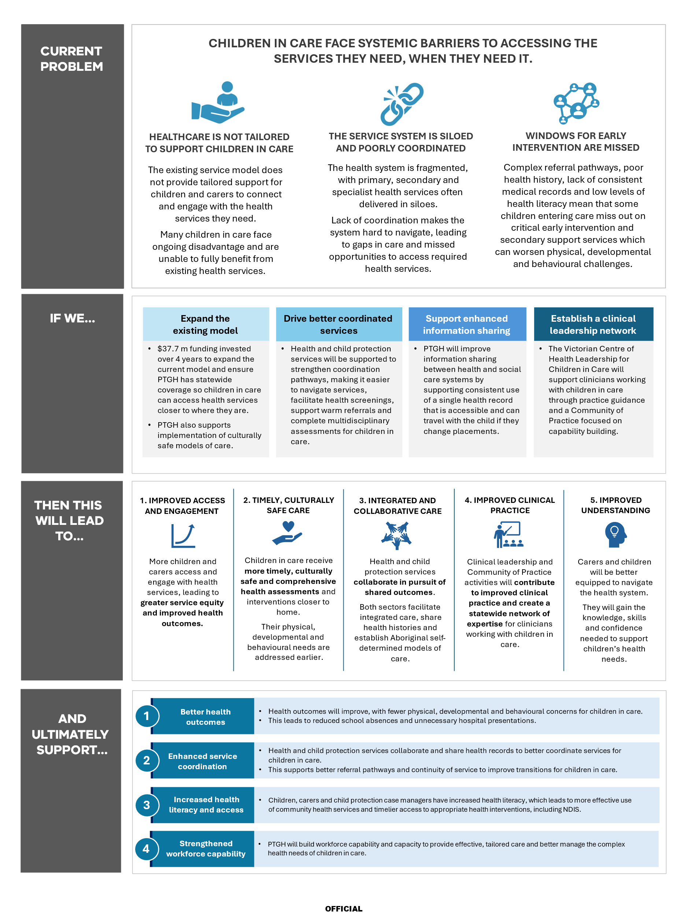

Appendix 4b: Theory of Change – text version
Current Context:
- Poor access to health services for Children in Care
- Poor Coordination and Delivery of Health Services
- Missed Opportunities for Early Intervention
- Poor health history and lack of a consistent medical record

If we:
- Expand Existing Service Model
- Coordinate Service Delivery
- Enhance Information Sharing
- Establish a Clinical Leadership Network

Then we achieve:
- Improved Access and Engagement
- Timely and Culturally Safe Care
- Integrated and Collaborative Care
- Improved Clinical Practice
- Improved Understanding

And ultimately:
- Improved Health Outcomes
- Enhanced Service Coordination and Continuity
- Increased Health Literacy and Access
- Strengthened Workforce Capability

Appendix 5: Text version of figure 2: Service and care principles
Care is child-centred: designed around the specific needs of the child and their carers.
These service and care principles guide multidisciplinary teams working together, supporting child health wellbeing and development and partnership with services and across sectors.

Service principles
Services are responsive to the needs and voices of children and young people.
- Services are culturally safe for Aboriginal people and Torres Strait Islanders, including recognition of identity and experience.
- Services are provided early to ensure that developmental delay, emotional and behavioural issues for children and young people are addressed early in life and early in illness.
- Services are culturally responsive and inclusive, with the capacity to respond to diverse cohorts of children and young people.
- Service is embedded within local health and social systems of care, building on and learning from local relationships and networks.
- Partner services promote an information sharing culture where services record and share information in a record that is accessible to health and social services.

Care principles

- Care is child-centred around the specific needs of children, young people and their carers, including recognition of and response to their voices.
- Care is trauma-informed and based on understanding how trauma affects the lives of children, young people and their needs.
- Care is goal-directed where practitioners agree on goals with children, young people and their carers based on their needs, preferences and priorities, plan how goals will be met and chart progress against them.
- Care builds on self-management capacity to empower children, young people and carers to increase control over and improve their health.
- Care promotes health literacy where children and carers can navigate, understand and use health information and services.
- Care promotes health and wellbeing, supporting children, young people and their carers to increase control over and improve their health.
- Care reflects a team approach to ensure that multidisciplinary assessment, intervention and support is developmental and relational, and tailored to the unique needs of children and young people entering care.
- Care is evidence based, using the best available evidence and expertise to plan with children, young people and their carers the best care and support for them.

Socio economic outcome area 12: Aboriginal and Torres Strait Islander children are not overrepresented in the child protection system - Dashboard | Closing the Gap Information Repository - Productivity Commission
Community Health Integrated Program (CHIP) guidelines, https://www.health.vic.gov.au/community-health/community-health-integrated-program-chip-guidelines
Child health services: Guidelines for the community health program - health.vic
young people can be deemed to be able to provide consent for their own treatment if they meet the ‘mature minor’ or ‘Gillick principle’.

