
Review of the Operation
of Victoria’s Voluntary
Assisted Dying Act 2017
October 2024

This report contains content about end of life and voluntary assisted dying, which you may find distressing.
If you are in distress and require immediate support Lifeline is available anytime by phone on 13 11 14 or by text/online chat via their website <https://www.lifeline.org.au/>. There are a number of other telephone or online services <https://www.health.vic.gov.au/mental-health-services/telephone-and-online-services>.
You may also like to speak with the Voluntary Assisted Dying Care Navigator Service. The care navigators are available to anyone in Victoria seeking information or support regarding voluntary assisted dying, including discussing the eligibility requirements or finding a medical practitioner who can assess a person for eligibility to access voluntary assisted dying. The care navigators can be contacted during business hours from anywhere in Victoria by the following methods:
- Phone: (03) 8559 5823
- Email: vadcarenavigator@petermac.org
To receive this document in another format, phone 03 9500 6894, using the National Relay Service 13 36 77 if required, or email Centre for Evaluation and Research Evidence (CERE) <CERE@Health.vic.gov.au>.
Authorised and published by the Victorian Government, 1 Treasury Place, Melbourne.
© State of Victoria, Australia, Department of Health, October 2024 (2410890)
In this document, ‘Aboriginal’ refers to both Aboriginal and Torres Strait Islander people. ‘Indigenous’ or ‘Koori/Koorie’ is retained when part of the title of a report, program or quotation.
ISBN 978-1-76131-682-1 (pdf/online/MS word)
Available at Voluntary Assisted Dying <https://www.health.vic.gov.au/patient-care/voluntary-assisted-dying>.

Acknowledgement
The Centre for Evaluation and Research Evidence (CERE) review team acknowledges everyone who provided feedback to inform this review, including people seeking voluntary assisted dying (VAD), family members, nominated contact people, health practitioners, policymakers and other stakeholders and members of the community. In particular, we thank the family members who were so open in sharing their personal and emotional experiences of supporting a family member through the end of life. We also thank the VAD Review Board Chair and members and the VAD secretariat for their work in supporting access to patient and medical practitioner data from the VAD portal.
Thank you to Karabena Consulting for their commitment to ensuring First Nations communities are given a voice in this review and in opening the dialogue on self-determination in the context of death and dying. Thank you to the Department of Health’s eHealth Division, for supporting the analysis of VAD medical practitioner availability and undertaking forecast modelling.
Finally, we would like to acknowledge the support of the Department of Health (the department) Hospital and Health Services Division who supported the CERE team throughout the review and in providing access to information and reports to complete the review.

Contents
Acknowledgement 3
Glossary 6
Executive summary 8
What is working well in the operation of VAD? 8
What operational areas of VAD could be improved? 9
Interest in legislative change 9
Recommendations 10
Introduction 11
About the VAD review 11
About VAD in Victoria 11
VAD in other jurisdictions 15
Key findings 16
VAD is generally accessible as an end-of-life choice 16
Timeliness of the VAD application process is improving 17
Families valued the compassionate care provided 18
Health and care service providers could benefit from additional policy guidance 20
The VAD measures support the safe operation of the Act 21
Further public facing information may improve awareness about VAD 22
There is a need for increased VAD-specific grief and bereavement resources and supports 23
Medical practitioner supply and distribution is challenged 24
Medical practitioner support and retention could be improved 24
The VAD medical practitioner Community of Practice is valued 25
Building on the existing training model may improve medical practitioner uptake and readiness 25
The Statewide Care Navigator Service provides extensive support 25
The Statewide Pharmacy Service is responsive and could continue to evolve 26
The restriction on the use of telehealth is a barrier to VAD access 27
Inadequate remuneration for medical practitioners presents a barrier to the provision of VAD services 27
Appendices 28
Appendix 1: Overview of Voluntary Assisted Dying (VAD) in Victoria 28
Appendix 2: Review approach and methods 31
Appendix 3: Additional tables and figures 38
Appendix 4: Summary of activity – VAD core bodies 52
Appendix 5: First Nations consultation report 54
Appendix 6: Addendum to Review of the Operation of Victoria’s Voluntary Assisted Dying Act 2017 – Stakeholder feedback regarding legislation 55
Appendix 7: Image descriptions 62

Glossary
Terms | Definition
Applicant | A person that is seeking to access voluntary assisted dying and is in the process of applying for a voluntary assisted dying permit.
Care navigator | Care navigators provide information and support to a person seeking voluntary assisted dying and health practitioners.  Care navigators can refer to individuals employed under the Statewide Care Navigator Service or local care navigators employed by health services to assist individuals and health practitioners through the process.
Consulting medical practitioner | A registered medical practitioner who accepts a referral to conduct a consulting assessment of a patient who has requested voluntary assisted dying.
Coordinating medical practitioner | A registered medical practitioner who accepts a patient’s first request for access to voluntary assisted dying.
Contact person | A person chosen by the person seeking voluntary assisted dying to take on legislated responsibilities under the Voluntary Assisted Dying Act 2017. These include returning any unused voluntary assisted dying substance following death and providing feedback to the Voluntary Assisted Dying Review Board about the person’s experience.
Health practitioner | A collective term used to define health practitioners in the health system, including nurses, allied health professionals and medical practitioners.
Medical practitioner training (may also be referred to as approved training) | Voluntary assisted dying training which provides a detailed overview of Victoria’s voluntary assisted dying legal framework.  Before assisting people seeking voluntary assisted dying, a medical practitioner must complete the approved training. On successful completion of the training medical practitioners can apply for access to the portal.
Permit | A permit means either a self-administration or practitioner administration permit issued under the Voluntary Assisted Dying Act 2017. A permit authorises the use of the voluntary assisted dying substance to bring about death.  Access to voluntary assisted dying is controlled through a permit process and a series of forms documenting the person’s eligibility under the law. VAD medical practitioners coordinate this process on the individual’s behalf. The application for a permit must be approved by the Secretary of the Department of Health before the coordinating medical practitioner can write a prescription for the substance.
Person seeking voluntary assisted dying | An individual that is seeking to access voluntary assisted dying. This term can refer to an individual who has commenced the process of accessing voluntary assisted dying, or individuals who have not yet commenced the process but are intending to make this choice.
Portal | The electronic platform used by the Department of Health to receive voluntary assisted dying forms from medical practitioners.  Voluntary assisted dying medical practitioners are given access to the portal and relevant forms following completion of the approved training.
Statewide Care Navigator Service | Commissioned by the Department of Health, the Statewide Care Navigator Service provides information and support to people seeking voluntary assisted dying, their families and support people, health practitioners and health care settings.
Statewide Pharmacy Service | Commissioned by the Department of Health and based at Alfred Health, the Statewide Pharmacy Service is responsible for importing, storing, preparing and dispensing the voluntary assisted dying substance.  Once a prescription is written by the coordinating medical practitioner, the person seeking voluntary assisted dying contacts the Statewide Pharmacy Service to organise an appointment for them to dispense the substance. The Statewide Pharmacy Service will deliver the substance to the person anywhere in Victoria.
Voluntary assisted dying (VAD) | Voluntary assisted dying refers to the administration of a substance for the purpose of causing death in accordance with the process set out under the Voluntary Assisted Dying Act 2017.
Voluntary assisted dying medical practitioner | A medical doctor, general practitioner or other specialist with appropriate experience and who has completed voluntary assisted dying training to assist a person through the process.
Voluntary assisted dying substance | A medication specified in a voluntary assisted dying permit that is used to cause death in accordance with the Voluntary Assisted Dying Act 2017.
Voluntary Assisted Dying Review Board | Established under section 92 of the Voluntary Assisted Dying Act 2017, the Voluntary Assisted Dying Review Board oversees the safe operation of the Act. The Voluntary Assisted Dying Review Board review and monitor voluntary assisted dying activities in Victoria.

Executive summary
The Voluntary Assisted Dying Act 2017 (the Act) provides a legal framework for eligible people to choose the manner and timing of their death. The Act came into effect on 19 June 2019, making Victoria the first state in Australia to pass voluntary assisted dying (VAD) legislation.
VAD means administering a substance for the purpose of causing death in accordance with the process set out in law. VAD must be voluntary and initiated by the person themselves and is usually self-administered. The law means that a person may be assisted by medical practitioners to access a substance to end their life at a time of their choosing. The process is designed to ensure the person’s decision is voluntary and enduring and provides clear guidance for how medical practitioners can lawfully support individuals in this choice.
In Victoria, VAD is available for those who face imminent death because of an incurable disease, illness or medical condition. The law provides a range of protections to ensure that VAD is safely implemented and monitored in Victoria.
This is a review of the operation of the first four years of the Act, from June 2019 to June 2023, as required under section 116 of the Act. The Department of Health’s Centre for Evaluation and Research Evidence (CERE), an independent specialist evaluation unit within the department, undertook the review between June 2023 and July 2024. This included interviews and focus groups with 119 stakeholders and analysing 303 survey responses and 257 written submissions.
The scope of the review included the systems, processes and practices that facilitate operation of the Act. The review included equity of access, the effectiveness of safeguards and protections, and reviewing the roles of the Department of Health, the VAD Review Board and other services and support programs. Suggested or required amendments to the Act were out of scope for this review.
Overall, VAD is operating as intended, providing a safe and compassionate end of life choice to eligible Victorians. Access to VAD is safe, efficiency and timeliness of processes are improving, performance monitoring and oversight mechanisms are working adequately, and most supports are effective. However, the review identified that some processes and safeguards impede access, undermining patient-centred care, and would benefit from improvement.
This report makes a series of recommendations to improve operation of the Act, including addressing gaps in community awareness, raising literacy about VAD for people and their families, supporting the workforce, and continuing to build strong leadership and accountability.

What is working well in the operation of VAD?
Access to VAD is safe. The program is working as envisioned, with no reports of ineligible individuals gaining access to the substance. Compliance with the Act has been very high, and the median time in which people can access VAD is progressively shortening.
VAD has given individuals greater autonomy and choice at the end of their lives, with many people seeking VAD while also accessing palliative care. Community acceptance and support for VAD is increasing and there is growing expectation for broader eligibility and access. Most people seeking VAD, and their families, expressed appreciation for the availability of VAD, highlighting that it provides relief and autonomy in end-of-life decisions.
Most supports for both people seeking access to VAD and health practitioners are effective. Medical practitioners who provide VAD services are highly dedicated. The Statewide Pharmacy and Care Navigator services are consistently meeting key performance indicators, and both community members and health practitioners report high levels of satisfaction with these services. Among participating medical practitioners there is a high level of satisfaction with the VAD medical practitioner Community of Practice, which is appreciated as a valuable confidential peer support network. Additionally, some health services, community groups, and non-government organisations have developed or initiated supports to assist people seeking VAD and their families.
This review found feedback, performance monitoring, oversight and accountability mechanisms are working well overall. The VAD Review Board monitors the operation of the Act. It is achieving its responsibilities to promote and ensure compliance with the Act, report to parliament, refer any issues or breaches to appropriate authorities, collect data about VAD, and provide information to the community.
The Department of Health sets policy, commissions services, and manages provider performance, while also supporting the VAD Review Board, the operation of the permit process and the VAD portal. Enhancements to the portal have addressed some administrative issues, though further portal improvements in data collection, extraction, usability, and communication would be beneficial.

What operational areas of VAD could be improved?
Access to VAD through implementation of the Act is working well. However, there is evidence that access is variable across the state. Further communication and accessible information, including in relation to grief and bereavement support, would improve the experience of those wanting to understand VAD as an option and improve equity in access. In particular, there is currently limited tailored information and support available for Aboriginal and Torres Strait Islander people, and people from multicultural communities. This impedes the ability of people in these communities to make informed choices about VAD, highlighting the need for improved engagement with Aboriginal and Torres Strait Islander communities and multicultural communities to better meet these information needs.
The VAD medical practitioner workforce is small, with a few practitioners delivering the majority of care. This workforce would benefit from more support to enable timely care and meet demand. Currently, VAD training, education activities and information would benefit from significant enhancement and expansion to better meet VAD medical practitioner needs and reach a broader segment of the health workforce.
Currently, pockets of resistance and unclear guidance for health and care organisations and individual health practitioners can delay or create a barrier to access VAD. Clearer guidance would enable services to continue to develop policies in line with their organisation’s values while also reducing the risk of unintended access barriers.
Outside of Victoria’s jurisdiction, the review identified areas to advocate for improvement with the Commonwealth Government. Adequate remuneration would reduce barriers for practitioners and patients. In addition, an outcome of restrictions imposed by the Commonwealth Criminal Code Act 1995 (Criminal Code) results in preventing the use of telehealth to support VAD access.
The recommendations provided in this report reflect an approach to continuous improvement across the VAD process.

Interest in legislative change
While assessing the VAD legislation itself was outside of the review’s scope, many contributors provided feedback about the legislation, including where certain provisions create barriers to access and timeliness. This feedback has been included in Addendum to Review of the Operation of Victoria’s Voluntary Assisted Dying Act 2017 – Stakeholder feedback regarding legislation.

Recommendations
Recommendation 1: Increase the provision of sector guidance and build on approaches to continuous improvement
    - Provide further guidance for health practitioners and health and care services to ensure patient requests and access rights to information are equitably addressed.
    - Initiate further enhancements to the VAD portal to improve functionality and processing time.
Recommendation 2: Enhance community awareness of VAD and grief and bereavement supports
    - Improve awareness of VAD as a legal end of life option through enhancement of information and resources.
    - Engage with Aboriginal and Torres Strait Islander people, as well as multicultural communities, to codesign culturally appropriate end of life information, care pathways and services to support equitable access to VAD.
    - Develop targeted resources aimed at carers supporting a person seeking VAD and investigate the need for further VAD specific grief and bereavement supports.
Recommendation 3: Support the workforce to ensure VAD is accessible, viable and sustainable
    - Monitor trends in workforce capacity to ensure the sustainability and capacity of statewide service models to meet future demand and long-term effectiveness.
    - Consider options for ensuring statewide availability of the VAD medical practitioner workforce, including hospital based and visiting medical practitioners, and specialists and GPs located in regional areas.
    - Support the psychological safety and wellbeing of the VAD workforce, including options for more consistent support, communication and improved networking across VAD practitioners.
    - Continue with the current redesign of the VAD medical practitioner training.
Recommendation 4: Consider enhancements to the statewide service models to meet anticipated future demand
    - Improve access to and promotion of support packages to aid patients, carers and families with out-of-pocket expenses.
    - Continued enhancements that improve the efficiency of the Statewide Pharmacy Service’s model should be considered.
Recommendation 5: Advocate to the Commonwealth Government for greater federal support for VAD
    - Engage with the Commonwealth Government on matters related to the Criminal Code related to the use of carriage services for VAD services.
    - Engage with the Commonwealth Government on the specific VAD funding options.

Introduction

About the VAD review

Purpose and scope of the review
This report summarises findings from a review of the operation of the first four years of the Voluntary Assisted Dying Act 2017 (the Act) from 19 June 2019 to 30 June 2023. The review included looking at how the legislation has been implemented and is operating to enable access for Victorians seeking this end-of-life choice, as well as evaluating the systems, processes and programs that support VAD (see Appendix 1 for an overview of the operation of VAD in Victoria).
The review meets the requirements of section 116 of the Act, which stipulates that:
- The Minister must cause a review of the operation of this Act to be conducted.
- The review must be conducted in the fifth year of the operation of the Act and be a review of the first four years of operation of the Act.
  - On completion, the Minister must cause a report to be tabled before each House of Parliament.
The program logic and methods for the review are in Appendix 2.

About VAD in Victoria

Overview
The Act provides a legal framework for eligible people to choose the manner and timing of their death. The Act came into effect on 19 June 2019, making Victoria the first Australian state to pass VAD legislation.
Victorians who are at the end of life and who meet the eligibility criteria can request access to VAD, which involves the administration of a substance for the purpose of causing death in keeping with process set out in law. VAD must be voluntary and be initiated by the person themselves. The legislation provides a range of protections to ensure VAD is safely implemented and monitored.
The Act outlines 10 principles to guide those who are exercising a power or performing a function or duty under the Act. These principles acknowledge that every human life has equal value; a person’s autonomy and culture, beliefs and values should be respected; and every person approaching end of life should receive quality care to minimise suffering and maximise quality of life.
The principles focus on the significance of supportive and open therapeutic relationships around treatment and care preferences to enable informed decision making which promote a person’s preferences and values, and the need to protect those who may be subject to abuse.
To be eligible for VAD a person must be aged 18 years or older and
    - be an Australian citizen or permanent resident
    - be ordinarily resident in Victoria, and at the time of making a first request, have been ordinarily resident in Victoria for at least 12 months
    - have decision-making capacity in relation to VAD
    - be diagnosed with a disease, illness or medical condition that is incurable, advanced, progressive, expected to cause death within 6 months (12 months for those with neurodegenerative conditions) and is causing suffering that cannot be relieved in a manner the person considers tolerable.
People who have lost decision-making capacity and those who have a mental illness only (without a condition that meets criterion (d) above) are not eligible for VAD.

How VAD works in Victoria
Voluntary assisted dying is an option for some people in the late stages of advanced disease. A VAD medical practitioner can prescribe a substance that will bring about their death. A person’s decision to ask for voluntary assisted dying must be:
- voluntary (the person’s own decision)
- consistent (the person makes three separate requests)
  - fully informed (the person is well-informed about their disease, treatment and palliative care options).
There are conditions and an application process. People who meet the conditions and follow the process can access the substance.
There are several steps a person needs to take to access voluntary assisted dying (Figure 1). The process makes sure people are eligible and that they are making a consistent choice. The process takes at least ten days, however, it may take several weeks to organise appointments and collect documents.
Figure 1: The voluntary assisted dying assessment and prescription process
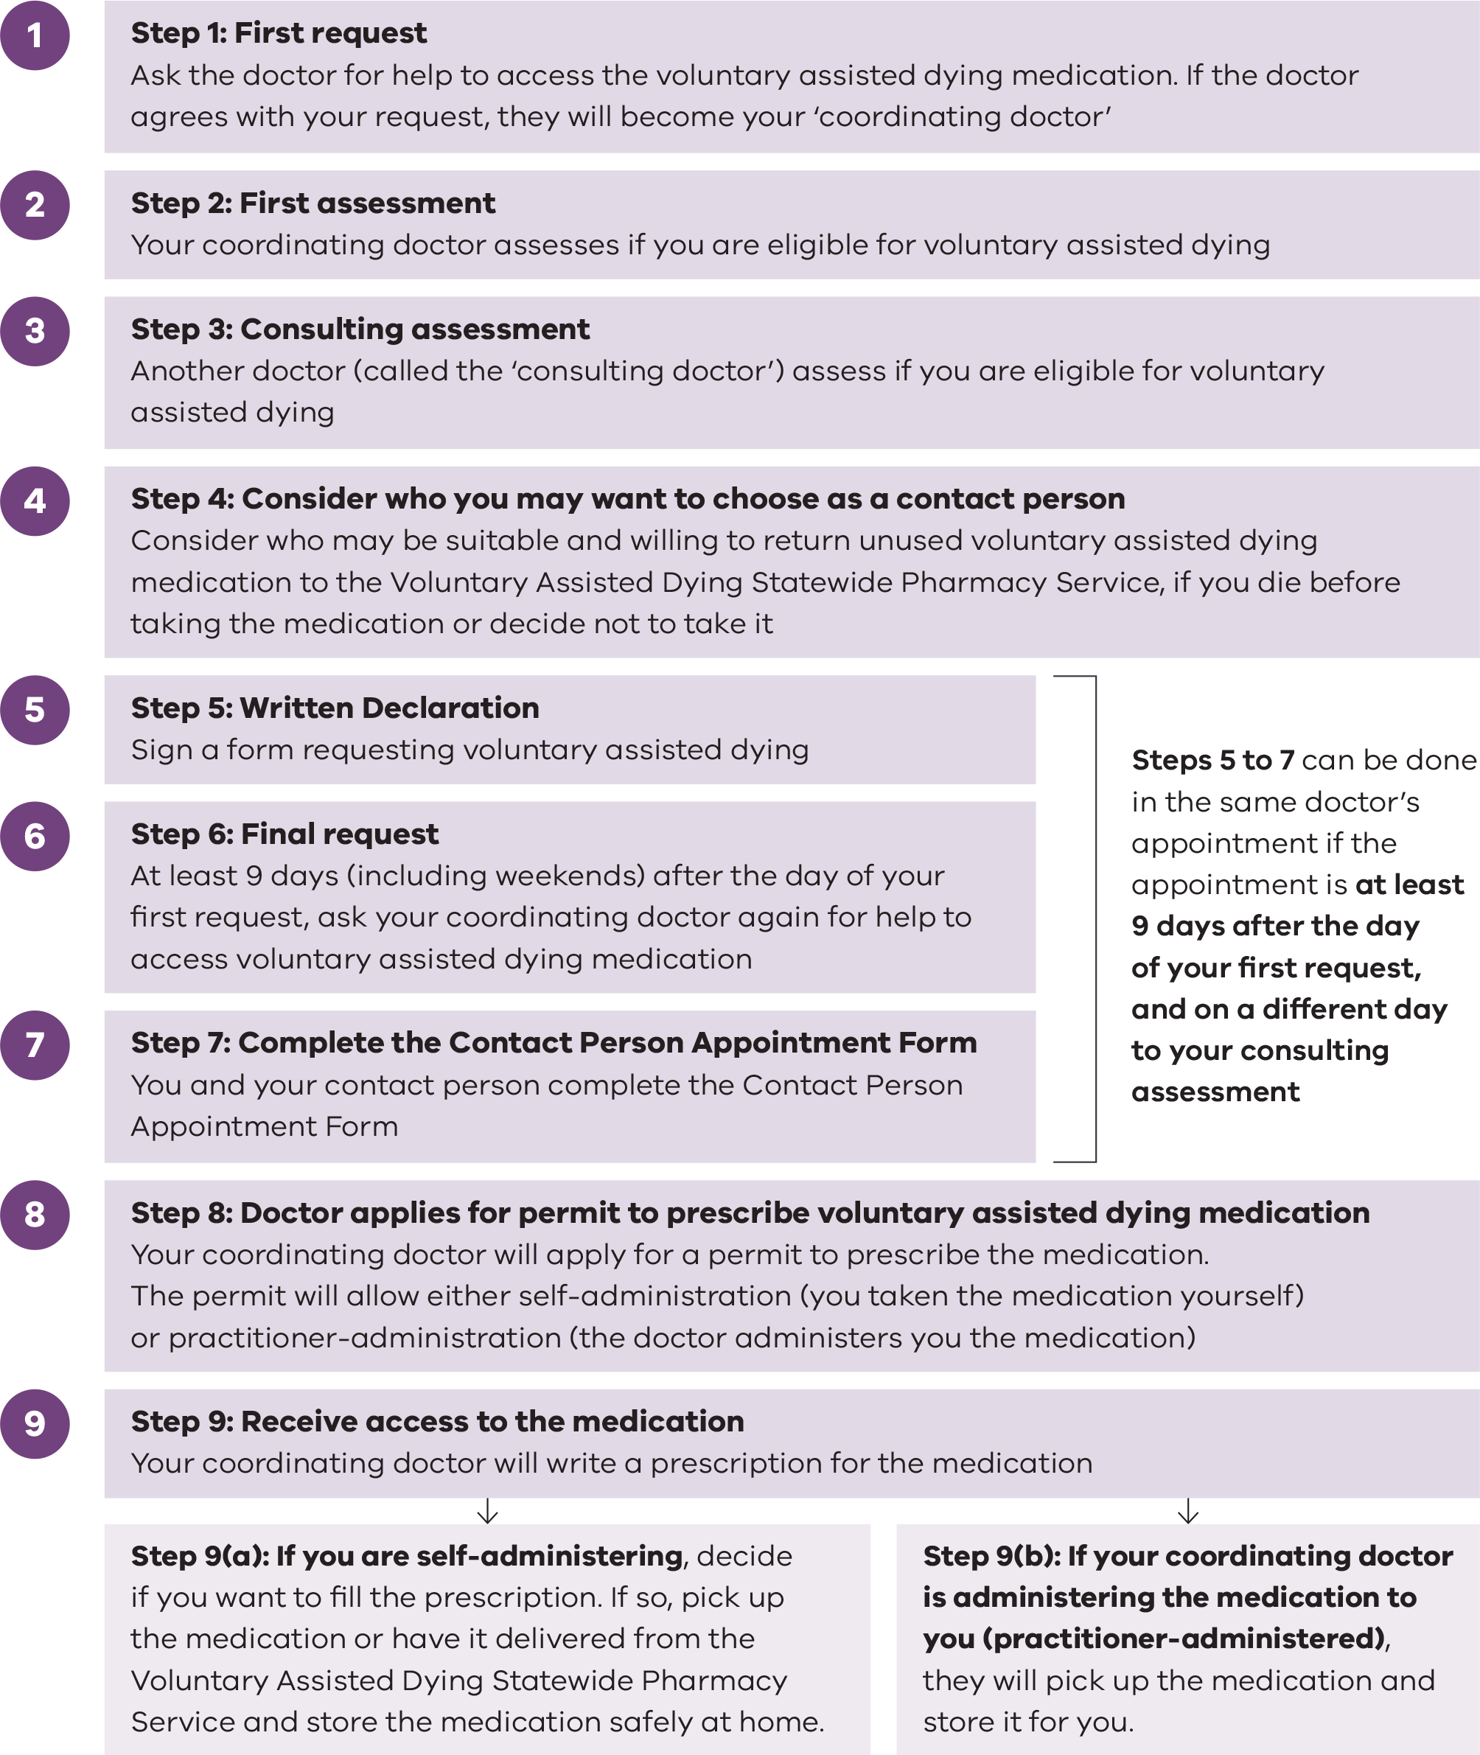
Source: Department of Health Information for people considering voluntary assisted dying <https://www.health.vic.gov.au/voluntary-assisted-dying/guide-for-people-considering-voluntary-assisted-dying>

A range of functions enable operation of the Act. These are:
    - the VAD Review Board (VADRB), which monitors the operation of the Act. Its responsibilities include promoting and ensuring compliance with the Act, reporting to parliament, referring any potential issues or breaches to appropriate authorities, collecting data about VAD, and providing information to the community. The VADRB does not provide VAD assessments or grant permits.
    - the Department of Health (the department), which delivers:
- operational support, including determining applications for a permit, data collection, and supporting the operation of the portal. This includes supporting medical practitioners to access, complete and submit all legislated forms, conducting compliance checks of submitted documentation and managing the approval process to permit.
- policy development, which involves providing advice to government, developing resources, monitoring emerging issues, and undertaking research and data analysis.
- community information, which involves developing resources for people seeking VAD, their families and carers, resources for health practitioners and care settings, maintaining the department’s website information, and responding to enquiries and correspondence.
- commissioning and performance monitoring of the Statewide Care Navigator Service, the Statewide Pharmacy Service, and the VAD medical practitioner Community of Practice.
- VAD medical practitioner training which provides a detailed overview of Victoria’s VAD legal framework. Under the Act, medical practitioners must complete the training to be eligible to provide VAD services in Victoria. Core training was initially developed and administered by the Queensland University of Technology until June 2022, after which the department assumed this role.
    - the Statewide Care Navigator Service, which provides a point of contact for the community, health practitioners, and health and care services across Victoria seeking information about or support with accessing VAD. The service is based at the Peter MacCallum Cancer Centre and integrated into five regional health services.
    - the Statewide Pharmacy Service, located at Alfred Health, is responsible for importing, storing, preparing and dispensing VAD substances. The service provides support and advice to coordinating medical practitioners about prescribing VAD substances. They also provide support and information to people accessing VAD, their families and carers, and health care services.
    - the VAD Medical Practitioner Community of Practice, a platform for VAD medical practitioners to connect, discuss questions or matters of concern, establish peer connections, enable de-identified case profile discussion, and facilitate access to key resources. The Western Victoria Primary Health Network is currently funded to deliver this service.
The medical practitioners who assess a person seeking to access voluntary assisted dying must have completed the mandatory VAD online training. The training is about the voluntary assisted dying application process. Each medical practitioner must:
- make sure that the person seeking to access VAD is fully informed about their illness or disease, and their treatment and palliative care options
- make sure that voluntary assisted dying is the person’s own choice
  - let the person know that they can change their mind about accessing voluntary assisted dying at any time.
Health and care services can decide whether or how they will support access to voluntary assisted dying, depending on whether:
- they have staff with appropriate skills and expertise
- they have the capacity to support the process
  - supporting access to voluntary assisted dying aligns with the values of the service.
Specific VAD coordinator roles have been created by some health services in metropolitan and regional areas to provide information and support to their patients.
Health services should have patient-centred policies and processes for managing requests for voluntary assisted dying. All staff should be aware of and be able to access information about the health service’s position on voluntary assisted dying. A patient who asks for information about, or access to, voluntary assisted dying should be provided with information and support. A health service or practitioner should tell the patient as soon as possible if they will not support access to VAD and refer them to another health service, medical practitioner or the Statewide Care Navigator Service for assistance. They should not obstruct or unnecessarily delay a patient’s access to voluntary assisted dying.

VAD in other jurisdictions
Victoria was the first state in Australia to legalise VAD in November 2017. However, similar legislation is now in operation, or soon will be, in all jurisdictions across Australia except for the Northern Territory.
In Australia, the broad model of VAD includes eligibility requirements that require a person to be aged 18 or over and to be terminally ill and approaching end of life. There are consistent themes across each jurisdiction regarding the need to be assessed as eligible by two medical practitioners (or one medical practitioner and one nurse practitioner in the ACT), to make at least three separate requests for VAD, including a written request, and to have decision-making capacity throughout the process.
All Australian jurisdictions with VAD legislation have mandatory training for VAD medical practitioners, and specialist pharmacy, care navigation and support services. Each jurisdiction also has an oversight body, which is intended to ensure that every case adheres to the law.

Key findings
In general, VAD is operating as intended, providing a safe and compassionate end of life choice to eligible Victorians. Evidence has emerged about things that are working well, and where there are opportunities for improvement, which has led to five recommendations.

VAD is generally accessible as an end-of-life choice
VAD has been effectively delivered to people in Victoria. Between 2019 and 2023, 1,527 permits were issued for people who were eligible to access VAD (Figure 2). Of these, 912 individuals (60%) chose to use the VAD substance, while another 400 individuals had the substance dispensed but did not use it. The number of permits issued each year has increased over time, effectively doubling between 2019–20 (237 permits) and 2022–23 (485 permits). Demand for VAD is anticipated to increase as community awareness of VAD increases, with modelling projecting that there will be about 700 applicants per year by 2028.
The rate of Victorian deaths that involved taking the VAD substance have gradually risen each year, from 4.4 VAD deaths per 1,000 deaths in 2020 to 6.1 VAD deaths per 1,000 deaths in 2022 (Table 1). The increase occurred across various demographics examined. The rate of VAD deaths was consistently higher in regional and rural Victoria compared with metropolitan areas. Portal data from VAD applicants in the first four years showed that 88% of rural and regional applicants and 83% of metropolitan applicants were accessing palliative care when they first requested VAD, suggesting that the higher rate of VAD uptake in regional and rural Victoria does not reflect difficulties accessing palliative care, and that VAD is appropriately being accessed alongside palliative care, rather than as an alternative to palliative care. Further discussion of how access to VAD can be made more equitable is provided later in this report.
Table 1: Rate of VAD deaths per 1,000 Victorian deaths by selected demographic characteristics, 2020–2022
VAD deaths per 1,000 deaths | 2020 | 2021 | 2022
All deaths | 4.4 | 5.5 | 6.1
Male deaths | 4.1 | 5.5 | 6.4
Female deaths | 4.8 | 5.6 | 5.9
Aboriginal and Torres Strait Islander deaths | Not available | Not available | 3.0
Metropolitan deaths | 4.4 | 5.2 | 5.6
Regional and Rural deaths | 4.5 | 6.3 | 7.3
Cancer deaths | 10.8 | 14.7 | 17.9
Source: VAD portal; Australian Bureau of Statistics,
Interpretation: rates show the number of VAD deaths for a specific characteristic per 1,000 deaths for that characteristic.
Note: The ABS data uses a marginally larger regional/rural area than the VAD portal data meaning that the regional/rural rates may be an underestimate and the metro rates an overestimate. The trend for higher rates of regional/rural deaths associated with VAD remain, regardless of this limitation. Deaths among Victorian Aboriginal communities (not VAD deaths) was only available for 2022.
Figure 2: Number of VAD permits issued in Victoria, 2019–20 to 2022–23
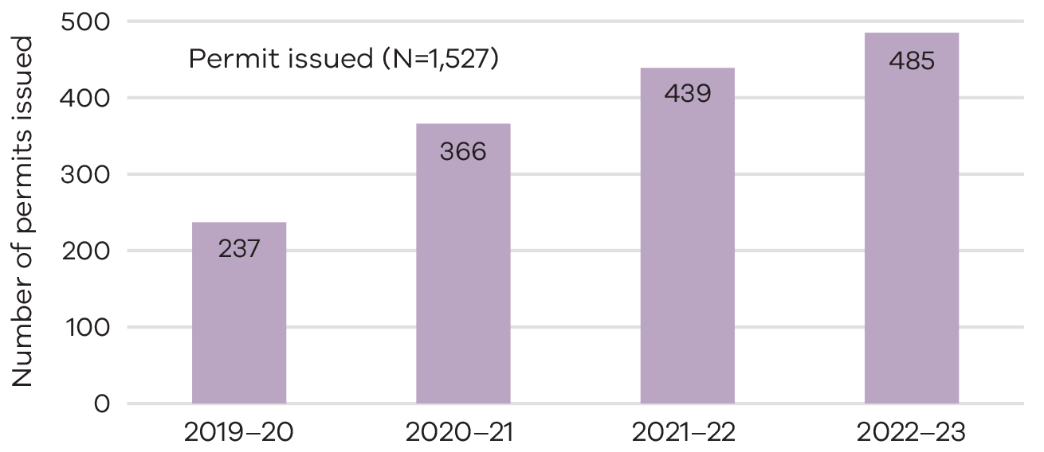
Source: VADRB 2022–23 annual report.
However, access has not been equitable and barriers remain. In particular, there was low awareness of VAD among people with lower education, those with poor health literacy, and among people who speak languages other than English. Further information about the characteristics of VAD applicants appears later in this report and in Appendix 3.
Most people seeking VAD and their families expressed appreciation for the Act, highlighting that it provides relief, autonomy, and empowerment in end-of-life decisions. VAD is a safe and compassionate end of life choice available to eligible Victorians. By integrating VAD as a choice within the broader health care system, individuals can benefit from a holistic approach to end-of-life care that aligns with their values and preferences.
In addition, the VAD workforce appreciate VAD being available as an option in the context of end-of-life care. One palliative care physician highlighted that, even with the best palliative care clinicians and excellent medication options, there can still be suffering at the end of life.

Timeliness of the VAD application process is improving
The median time taken to access VAD has decreased since the introduction of VAD in Victoria. The median time to obtain a permit has decreased from 28 days to 21 days (Figure 3), noting that for a small number of people it can take a long time to go through the VAD assessment process. The VAD application process is a comprehensive process with many steps. Evidence from stakeholder consultation suggests that some people seeking VAD could not gain access or experienced it as a slow and difficult process. Some people seeking VAD, their families and medical practitioners reported that delays in access for someone wanting to end their suffering were burdensome and distressing.
Figure 3: Median time (days) taken to obtain a permit from first request, 2019–20 to 2022–23
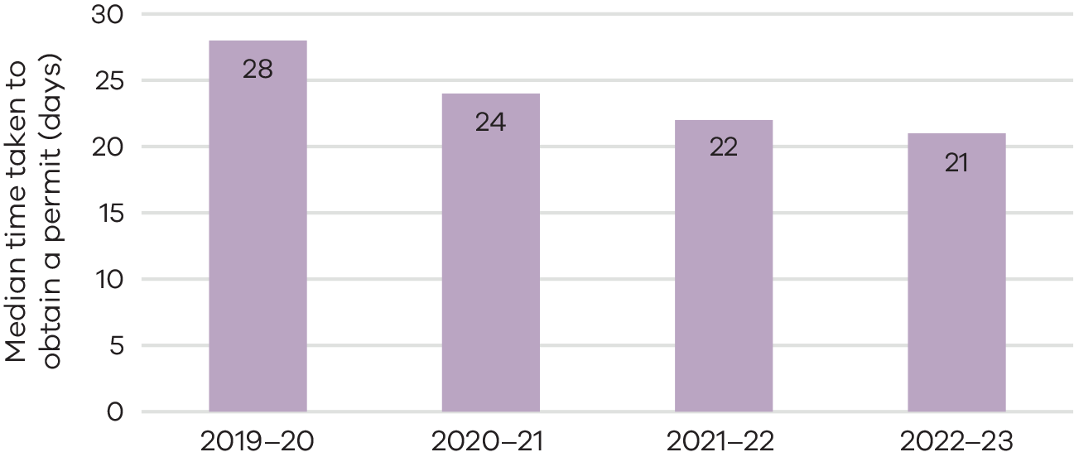
Source: VAD portal data
Note: This data also includes 12 days of the 2018–19 financial year because voluntary assisted dying became available on 19 June 2019.
The Voluntary Assisted Dying Regulations (2018) require that the Secretary, Department of Health, determine the outcome of a permit application within three business days. Of all applications, 99% were determined within this timeframe, with 95% approved within two business days.
Since commencement of the Act, 765 applications (35% of all applications) were withdrawn before the substance was dispensed. This includes 579 (26% of all applications) who died and 56 (3% of all applications) who were either too unwell or lost decision-making capacity before they could access VAD. The percentage of withdrawn applications has remained relatively stable over time. Currently, there is no way to assess the number of people who try to access VAD but are unable to commence their application.
Applications being received very close to death were evident, with 16% of all applications from people who died less than two weeks after the request that led to their first assessment. The State Coroner provided four case studies to the review where, in the investigating coroner’s opinion, the deceased appeared to meet eligibility for VAD and began engagement with the VAD process but ultimately suicided.
During the period being reviewed, the VAD Secretariat implemented enhancements to improve efficiencies and functionality, such as the introduction of a compliance officer, and improvements to the VAD portal. VAD medical practitioner feedback suggests that more enhancements to the VAD portal could deliver improved efficiency and further reduce delays in the application process.

Families valued the compassionate care provided
Feedback from families consistently highlighted that VAD medical practitioners, care navigators, and pharmacists deliver caring, respectful, and person-centred services, balancing empathy with practicality, and often involved medical practitioners working outside normal business hours to ensure timely access to VAD. This positive feedback was provided in consultations, submissions, and survey responses (see Appendix 3).
Seventy-seven percent of people seeking VAD and 93% of families/contacts reported that the process was compassionate. Qualitative data from family interviews and survey responses suggested that VAD practitioners were the primary drivers behind compassionate experiences of the VAD process, as they often devoted countless hours providing support to patients and their families.
Care navigators were also particularly valued for their role in supporting both people seeking VAD and medical practitioners. They assist in finding VAD-trained medical practitioners, facilitating difficult conversations, and supporting families with death planning and bereavement. Many family members reported that care navigators provided valuable support and information before and after a VAD death.
Currently the VAD portal does not record whether a patient has had contact with the care navigator service. As such, it is difficult to estimate how many people who undertake VAD assessment access care navigator support or are aware of the service availability. Data linkage between care navigator and portal data may assist in better understanding how the care navigator service operates.
Survey responses from VAD applicants and their families indicated high satisfaction with key VAD services, including medical practitioners (91%; Figure 4), care navigators (which could include the Statewide Care Navigator Service and/or hospital-based VAD navigators) (76%), and pharmacy services (85%).
The application was as good as it possibly could be. It was exceptionally streamlined and handled compassionately and efficiently, facilitated by the dedicated doctor and administrator at the hospital where my partner was a patient. (Family member /contact person)
The Statewide Pharmacy Service was also described as caring and compassionate:
Excellent. Excellent … the most beautiful, compassionate women and really quite efficient ... anyone that is able to actually explain the process, tell you what you need to do, do all of that, leave the room, and you can remember it all and do it, must be doing a really good job. (Daughter of a woman who took a VAD substance)
The commitment of VAD medical practitioners and the support from hospital coordinators help facilitate VAD access within health care services. Moreover, volunteers contribute by providing essential witnessing services.

Fictionalised vignette
Even before my dad was sick, he always said that he wanted to live his life and death on his terms. Choice was important to him, particularly after he saw a loved one suffer through illness. So, when he was diagnosed with cancer, just knowing that he had the option to access VAD was huge for him, even if he never ended up needing to use it. The navigators and our doctors were all incredibly helpful for us, we couldn’t have asked for more. They were so professional and compassionate, despite doing this job which must be so hard. When the time came for dad to use VAD, he was able to take control in peace, with the support of his family. It was a relief for him and for us, and I am so grateful for that.
* Fictional account based on information provided to the review
Figure 4: Proportion (%) of people seeking VAD and families/contacts who were somewhat to very much satisfied with support (n=99)
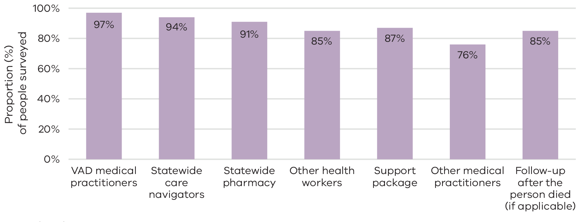
Source: Engage Victoria survey
Note: Valid percentages are shown (excluding missing data)

Health and care service providers could benefit from additional policy guidance
The department is responsible for providing policy guidance to health practitioners and to health and care services regarding VAD. The review identified that clearer guidance could support improved access.

Clarification is needed on providing information and responding to requests for VAD access
There was evidence from different stakeholder groups that organisations that did not support VAD could still meet the requirements of the Act, providing transparency in their approach while still respecting their patient’s choices and not preventing access to VAD. However, this was not consistently the experience of people accessing VAD. Many stakeholders reported that some applicants were purposefully obstructed from accessing VAD.
Departmental guidelines for health services, aged care services and health practitioners are not sufficiently clear about minimum expectations or obligations for practitioners and organisations.
A third of interviews with family members and a tenth of written submissions from people seeking VAD and their families described their experience of access barriers due to obstruction from organisations and individual practitioners. This was often, but not always, related to religious beliefs and organisational policies.
Family members reported declines in the level of support from some palliative care services once VAD was mentioned. Where palliative care services did not support VAD, families reported that open discussions about palliative care treatment and options became limited and holistic and continuous care restricted. Some families reported patients had felt forced to choose between VAD and palliative care, a contravention of the principles of the Act.
One family reported the experience of being required to put in writing that their parent would not take the substance in their residential aged care facility. Another individual who was admitted to hospital a few days prior to scheduled delivery of the VAD substance, and due to the hospital’s religious affiliation, was subsequently prevented by the hospital from being able to receive the substance. While these two examples are single events, they may provide insight into a broader issue.

Fictionalised vignette
The checks and balances are obviously critically important, but there could be better supports and structures to make the whole process faster and simpler – to make sure our patients are protected without delays. I have heard colleagues talk about the fear of getting a fine or having their registration revoked. There is an assumption that we aren’t allowed to talk about it unless a patient says the words “voluntary assisted dying”, which isn’t true, but that fear makes some of us overly cautious. With better guidance and systems, it would be so much easier to confidently have these conversations and focus our energy on supporting our patients through this really important time in their lives.
* Fictional account based on information provided to the review

More information is needed for medical practitioners who conscientiously object to VAD
Medical practitioners who conscientiously object or do not want to support VAD have a right not to provide it. However, clearer communication about their obligation to respond to a request (under section 13(1) of the Act) and accountability in relation to the provision of timely responses to requests for information or VAD access is necessary. The review heard a barrier to VAD access for many people was finding a medical practitioner who would accept or at least respond to a first request.
Obstruction or inaction from medical or health practitioners is inconsistent with person-centred care and the Act’s principle that individuals should be encouraged to openly discuss death and dying and an individual’s preferences and values should be encouraged and promoted. It is also inconsistent with the codes of conduct for medical practitioners and nurses and with the Department of Health’s expectations of government funded services.
To address these access challenges, information, guidance and sector engagement should more clearly outline minimum expectations for health practitioners and services when responding to requests for VAD.

Fictionalised vignette
The impact of not responding to requests is illustrated by the experience of an individual who requested VAD from multiple medical practitioners across 3 health and palliative care services. Their requests were never responded to, nor were they or their family provided with information about how to access the VAD care navigators. The individual died before locating a VAD medical practitioner, leaving family feeling disappointed and frustrated that services had failed to meet the individuals wishes at the end of their life.
* Fictional account based on information provided to the review

The VAD measures support the safe operation of the Act
The Act has 68 safeguards to ensure robust oversight and thorough monitoring mechanisms are in place throughout all steps of the VAD process. As a result of these legal and system controls, while groundbreaking at the time of its commencement, the Victorian model of VAD is now widely regarded as a conservative model in Australia with a strong focus on safety. Findings from this review further support this view, indicating that VAD in Victoria has been safe for patients, families and the community at large.
The VAD system has received positive feedback from within the medical community. Most health workforce survey respondents agreed that VAD is safe, with 94% of VAD registered medical practitioners and 84% of other health practitioners sharing this view. Ninety-two per cent of people seeking VAD and 95% of families/contacts reported that they felt the VAD process to be safe.

Records show compliance with the Act
The VADRB reports that there has been high compliance with the Act, with 99.3% compliance for all completed applications. Only 14 cases did not comply with the Act (0.7%), and one case (0.05%) was referred to another agency – the Australian Health Practitioners Regulation Agency (Ahpra). The case referred to Ahpra involved non-compliance with the VAD permit application process for which the medical practitioner was fined.
Half of the cases of non-compliance involved the contact person not returning the substance within 15 days of the person’s death as required in the Act. These cases were attributed to procedural delays and delays due to the fact that contacts are usually a close relative grieving the person and not able to manage the return of the substance within the specified time. There have been no reported instances of mishandling or misuse of the VAD substance.
During the conduct of the review there were no reported cases of a VAD substance failing to result in death. Surveys of contact people, collected since 2021, however, show a very small number of reports of issues with substance administration such as difficulty swallowing, having a negative reaction to the substance (pain, burning feeling, convulsions and vomiting) and the substance leading the person to fall asleep quickly but taking a longer than anticipated time to die. Further guidance and resources may help mitigate potential safety risks and ensure a smoother end-of-life experience for all involved, such as reviewing the patient information booklet, in consultation with families and practitioners involved in the delivery of VAD.

The Voluntary Assisted Dying Review Board has functioned effectively
The VADRB reviews all assessments and forms retrospectively. They do not grant or refuse applications for VAD.
Overall, the monitoring and oversight mechanisms of the VADRB are functioning effectively, and meeting obligations (see Appendix 4). The VADRB reports of operation were tabled in parliament and published on the Safer Care Victoria website for the first four years of operation of the Act. Future reports will be published on the Department of Health website. These reports illustrate that the VADRB has performed its functions.
Feedback from VADRB members indicates that their role during the first few years of the operation of the Act focused on implementation and monitoring. Now that the Act is embedded, VADRB members feel that their focus could shift towards promoting continuous improvement. Adequate visibility of information about complaints and other information about service quality and experience would assist the VADRB to further contribute to continuous improvement efforts.
Recommendation 1: Increase the provision of sector guidance and build on approaches to continuous improvement
    - Provide further guidance for health practitioners and health and care services to ensure patient requests and access rights to information are equitably addressed.
    - Initiate further enhancements to the VAD portal to improve functionality and processing time.

Further public facing information may improve awareness about VAD
Effective communication and accessible information are essential for improving awareness of VAD to ensure people can make a fully informed end of life choice. Feedback from all stakeholder groups through evaluation surveys and interviews reported a low level of community awareness about VAD.
While community awareness is crucial, raising awareness among health practitioners is also important because they deal directly with patients and can respond to requests for information or facilitate access. Low levels of awareness and lack of clear guidance can result in delays for patients initiating the VAD application process and may delay the granting of a permit to access the VAD substance.

Culturally appropriate information and engagement may enhance access for First Nations
Findings from the First Nations consultation report completed as part of the review (see Appendix 5) identified a lack of culturally appropriate resources and information as a key barrier to effective implementation and access to VAD in Aboriginal communities.
There is limited tailored information and support available for Aboriginal and Torres Strait Islander people which reduces their ability to make informed choices about VAD. This suggests a potential gap in communication and understanding, leading to confusion or exclusion. To address this, First Nations stakeholders emphasised the need for improved communication, education, resources and advocacy to empower individuals in making informed decisions about their end-of-life care. Key considerations relate to cultural needs and norms regarding death and dying, stigma associated with choices such as VAD, and use of appropriate and familiar language. Some Aboriginal stakeholders indicated that they are only familiar with the term ‘euthanasia’, not ‘Voluntary Assisted Dying’. There was also recognition of the impacts of historical and ongoing trauma and disempowerment on First Nations people about access to healthcare more broadly.
Raising community awareness among Aboriginal communities needs to be linked with creating an environment where VAD‑related discussions can occur openly, with access to appropriate information, guidance and support that respects cultural values, autonomy and self‑determination. The First Nations consultation also highlighted that family and community play a vital role in VAD related decisions, emphasising the need to extend information beyond patients to include their families and close community members. This underscores the need for VAD‑related information to be culturally appropriate and sensitive, to promote equity in information dissemination and informed decision making among Aboriginal communities.

Culturally appropriate information and engagement may enhance access for people from multicultural communities
Feedback to this review also demonstrated low awareness of VAD among multicultural communities. This is consistent with independent research conducted in Victoria that found that most people from multicultural communities are unaware of the existence of VAD as a legal option. Less than 4% of permit holders spoke a language other than English at home, compared to almost 28% of the Victorian population who reported speaking a language other than English at home according to the 2021 Census.
Information about VAD is published on the Department of Health website in 17 community languages. While this is a step at improving awareness of VAD among multicultural communities, overall access to the translated information is low. From 17 June 2019 to 17 June 2024, these pages had been accessed by 260 Victorian users. Data for each language page was available from 3 October 2022 to 17 June 2024 and shows low usage with only Chinese (62 views), Arabic (20 views) and Amharic (19 views) language pages having more than 10 views. Other forms of engagement with multicultural communities could increase awareness of VAD and improve the usability of the translated resources.

Case study
Specific efforts to engage multicultural communities led to increased VAD-related referrals. For instance, internal stakeholders heard a metropolitan hospital noted a rise in referrals after discussing VAD through a presentation at the Chinese Women’s Society, which is understood to have resulted in greater awareness and referrals among Chinese patients.

There is a need for increased VAD-specific grief and bereavement resources and supports
The review identified the need for increased grief and bereavement support for VAD applicants, their families and carers. It is important for the person seeking VAD prior to their death, and for their families and carers before and following the person’s death.
Many families members and carers did not feel prepared and supported before, during and after the VAD process. This was even more evident for those families and carers where the person who had sought VAD could not access it or died before they could access it. Families and carers often noted they struggled to find time or energy to read information, and suggested that preparatory videos (for example, featuring family members who have a lived experience of a VAD death), would help them understand what to expect and plan for the supports or resources they think will help them.
Recommendation 2: Enhance community awareness of VAD and grief and bereavement supports
    - Improve awareness of VAD as a legal end of life option through enhancement of information and resources.
    - Engage with Aboriginal and Torres Strait Islander people, as well as multicultural communities, to codesign culturally appropriate end of life information, care pathways and services to support equitable access to VAD.
    - Develop targeted resources aimed at carers supporting a person seeking VAD and investigate the need for further VAD specific grief and bereavement supports.

Medical practitioner supply and distribution is challenged
The VAD medical workforce is small and unevenly distributed across the state. Some stakeholders suggested this is potentially resulting in medical practitioner burnout, and further constraining the small workforce. Analysis of VAD portal data from 2019 to 2023 showed that after an initial period of growth in medical practitioner registrations on the VAD portal, the number of medical practitioners registering annually has plateaued at an average of 59 over the past three financial years.
The VAD portal data also showed that a small number of medical practitioners are responsible for the bulk of VAD activities. One-fifth of medical practitioners registered in the VAD portal had carried out over 80% of all completed assessments. A third had completed a single or no assessments.
In addition to being dependent on a small number of people, the VAD medical workforce is also unevenly distributed geographically and by speciality. General Practitioners (GPs) who are registered on the VAD portal are more widely available than other medical practitioners, while other specialists who are registered on the VAD portal are highly concentrated in metropolitan Melbourne. This supports the feedback received from families and workforce about the difficulties people living in regional areas face in finding VAD-registered practitioners, particularly non-GP specialists. Yet despite this, proportionately more rural and regional Victorians have accessed VAD.
Accessing a neurologist for VAD assessments was frequently cited as a barrier to access throughout stakeholder consultations. Of 199 patients with neurodegenerative conditions who sought VAD in the first four years, 64 lived in rural areas. However, only seven assessments were completed by neurologists registered outside of Melbourne, indicating that most rural patients travelled to Melbourne for their assessment, or that a neurologist travelled to them.

Medical practitioner support and retention could be improved
Even though this could not be quantified using data available for this review, retention of VAD medical practitioners was identified as an important operational issue by various stakeholders. Regional areas were reported to be especially vulnerable to workforce attrition, impacting VAD accessibility.
VAD medical practitioners and sector stakeholders raised concerns about the sufficiency of financial remuneration for VAD services. Other factors inherent to the operation of the Act are disincentives for medical practitioners to become or continue to be involved with VAD. Stakeholders reported fear of legal repercussions, insufficient time to manage VAD care alongside a normal clinical load (often resulting in VAD assessment being delivered out of hours), the complexity of the VAD application process, and the role of the coordinating VAD medical practitioner being administratively cumbersome.
Increased support is required to maintain wellbeing, such as enhanced peer support and opportunities for collaboration, and to offset the demands of the workload and the challenging nature of the work. Support as an enabler of medical practitioner retention will also help to ensure timely VAD access for people.

The VAD medical practitioner Community of Practice is valued
The VAD medical practitioner Community of Practice is a highly valued, confidential and important peer support service for medical practitioners. The number of VAD trained medical practitioner participants in the VAD medical practitioner Community of Practice has increased from 17 members in April 2020 to 63 in May 2023. As of May 2023, 64% of participants were GPs and 36% were other specialists.
Surveys conducted by the VAD medical practitioner Community of Practice reported high levels of satisfaction among participants. Consultations confirmed that the Community of Practice provided an important advisory and support role, particularly for new and more isolated VAD medical practitioners. However, some medical practitioners suggest that involvement in their dedicated Community of Practice should be an automatic process at the time of VAD registration, with the option for opting out. The current opt-in requirement means some medical practitioners may not realise it is available.

Building on the existing training model may improve medical practitioner uptake and readiness
Of medical practitioners who contributed to the review by survey, 78% indicated they were satisfied or very satisfied with the mandatory medical practitioner training.
Ensuring workforce sustainability and buy-in will continue to be important for the successful operation of VAD. Part of this is to ensure VAD training, education, and information is expanded to reach a broader segment of the workforce. Additionally, VAD medical practitioner training and information resources should be expanded to cover a range of additional topics. Key areas to consider for medical practitioner training and information resources include:
- improving the balance between legal and clinical aspects of VAD implementation, and understanding the ethical issues involved.
- training on documentation of diagnosis and prognosis.
- providing appropriate documentation on use of the VAD portal.
- understanding the role of medical practitioners in providing grief and bereavement support to families.
These changes may support increased uptake, suitability, and readiness among medical practitioners.
Recommendation 3: Support the workforce to ensure VAD is accessible, viable and sustainable
    - Monitor trends in workforce capacity to ensure the sustainability and capacity of statewide service models to meet future demand and long-term effectiveness.
    - Consider options for ensuring statewide availability of the VAD medical practitioner workforce, including hospital based and visiting medical practitioners, and specialists and GPs located in regional areas.
    - Support the psychological safety and wellbeing of the VAD workforce, including options for more consistent support, communication and improved networking across VAD practitioners.
    - Continue with the current redesign of the VAD medical practitioner training.

The Statewide Care Navigator Service provides extensive support
The Statewide Care Navigator Service provides education and support to medical practitioners and the broader health and aged care sectors about VAD. It also facilitates connections between people seeking to access VAD and medical practitioners who have completed VAD training. The Statewide Care Navigator Service also administers support packages in accordance with departmental guidelines. Support packages are typically used to cover out-of-pocket medical practitioner consultation fees and/or travel costs associated with appointments required as part of the VAD application process. The service was expanded regionally in 2019–20 as a hub and spoke model.
Care navigator annual reporting showed that in 2022–23 almost 65% of medical practitioners who completed VAD training did so via care navigator training days. Families and the VAD workforce described the navigator service as a critical part of the operation of, and experience of, the VAD process. The service may also boost the efficiency of other parts of the system – for example, reducing the administrative burden on medical practitioners by helping families find the paperwork they need to apply for a permit.
In 2023, the Statewide Care Navigator Service enhanced its data collection mechanisms to improve program and demand monitoring. Through the review, the navigator service reported service demand pressures. Between 2020–21 and 2022–23, the Statewide Care Navigator Service had contact with almost 3,000 individuals (60% patients or families; 40% health practitioners) and ran 565 workshops, information sessions and webinars for health and aged care services and practitioners.
All regional navigators work far in excess of their allocated 0.4 EFT. The role requires a very high level of diverse skills and VAD-specific expertise and all struggle to deliver and service development (for example, capacity building, doctor support and growth) beyond direct patient care within their allocated EFT. (Organisational written submission)

The Statewide Pharmacy Service is responsive and could continue to evolve
The Statewide Pharmacy Service is licensed to import, store and dispense the VAD substance and provides information and support to medical practitioners.
The majority of family participants who interacted with the Statewide Pharmacy Service provided positive reports about the support and information provided by the service. Key functions included a timely response, clear instructions, demonstrations about how to mix and administer the VAD substance and a patient information booklet with clear instructions and information.
Since inception, the Statewide Pharmacy Service has undergone several operational changes that have improved the service’s efficiency and responsiveness including:
- rostering to enable patient visits on public holidays.
- streamlined delivery of practitioner‑administration kits to experienced practitioners.
- an extended shelf-life for practitioner‑administration kits.
  - funding of an after-hours telephone service for VAD medical practitioners.
In interviews and written submissions to the review, it was suggested that there may be further opportunities for reducing duplication and/or enhancing the service model delivery of the pharmacy service. Stakeholders recommend reviewing dispensing practices, including whether it remains necessary to have two pharmacists visiting patients for dispensing, and two pharmacists delivering practitioner‑administration kits, especially in the case of experienced medical practitioners.
It was also suggested that a hub-and-spoke model for the Statewide Pharmacy Service be considered, similar to the Statewide Navigator Service.
Recommendation 4: Consider enhancements to the statewide service models to meet anticipated future demand
    - Improve access to and promotion of support packages to aid patients, carers and families with out-of-pocket expenses.
    - Continued enhancements that improve the efficiency of the Statewide Pharmacy Service’s model should be considered.

The restriction on the use of telehealth is a barrier to VAD access
Currently, under s 474.29A of the Criminal Code, it is an offence to use a carriage service (such as telephone, videoconference, email or other forms of electronic communication) to provide or share information regarding suicide. In the recent Federal Court ruling in Carr v Attorney‑General [2023], the Federal Court found VAD falls under the definition of suicide for the purposes of the Criminal Code. As such, department guidance advises avoiding the use of carriage services for VAD. This means all discussions about VAD should not take place using a carriage service, resulting in reliance on face-to-face conversations. This has disproportionate impacts on people seeking to access VAD who live in regional or rural areas, or who have mobility challenges.

Inadequate remuneration for medical practitioners presents a barrier to the provision of VAD services
VAD medical practitioners and sector stakeholders raised concerns about the sufficiency of financial remuneration for VAD services. Some stakeholders raised as a possible solution that Medicare reforms which enable wider use of the Medicare Benefits Schedule to support people to access VAD services may address this barrier.
Recommendation 5: Advocate to the Commonwealth Government for greater federal support for VAD
    - Engage with the Commonwealth Government on matter related to the Criminal Code related to the use of carriage services for VAD services.
    - Engage with the Commonwealth Government on the specific VAD funding options.

Appendices

Appendix 1: Overview of Voluntary Assisted Dying (VAD) in Victoria

Establishment of the Voluntary Assisted Dying Act and VAD operation
In June 2016 the Inquiry into End-of-Life Choices recommended legalising voluntary assisted dying (VAD) in Victoria. Following consultation led by the Ministerial Advisory Panel on Voluntary Assisted Dying, the Voluntary Assisted Dying Bill was subsequently passed by Parliament in November 2017, establishing the Voluntary Assisted Dying Act 2017. Over an 18-month implementation period (February 2018 to August 2019) key projects were conducted to establish core bodies and elements of VAD operation (outlined in Table 1.1) and to ensure sector readiness for the start of the Act, which came into force on 19 June 2019.
Table 1.1: Core bodies and elements enabling VAD operation
Body/element | Responsibilities | Administered by
VAD Review Board | The VAD Review Board (VADRB) oversees the safe operation of the Act. As outlined in s 93 of the Act, its functions and powers include:  - monitoring VAD activity  - promoting and ensuring compliance the Act  - reporting to parliament  - referring any issues or breaches to the appropriate authorities  - promoting continuous improvement  - collecting data about VAD and providing information to the community while maintaining people’s privacy.  The VADRB reviews all assessments and forms retrospectively; they do not grant or refuse applications for VAD. Terms of reference govern the VADRB and were updated in April 2023. | Safer Care Victoria  (to Jan 2024)  Department of Health (from Feb 2024)
VAD secretariat | The VAD secretariat supports the operation of the VADRB including:  - providing secretariat support for VADRB proceedings and working with the VADRB to establish and maintain operational systems to support the functions of the board  - managing the VAD portal  - conducting administrative reviews of assessment forms submitted to the VAD portal  - coordinating period reporting. | Safer Care Victoria  (to Jan 2024)  Department of Health  (from Feb 2024)
Secretary, Department of Health | As outlined in s 49, the Secretary of the Department of Health (or their delegate) must determine an application for a VAD permit. The Secretary may also amend a permit. | Department of Health
Department of Health on behalf of the Minister for Health | The Department of Health is responsible for monitoring performance of the VAD system, using Performance Monitoring Framework, including:  - monitoring risks to the Victorian government  - monitoring sustainability of the program  - managing the performance of statewide services  - reporting on performance to VADRB  - collecting data and intelligence across the sector to inform policy improvement. | Department of Health:  Permits and Licensing team  Projects, Engagement, and Policy team.
Statewide Care Navigator Service | The Statewide Care Navigator Service provides general and individualised VAD information, education and support to the Victorian community, health practitioners and health services. The service also helps to connect patients to VAD medical practitioners, provides information and access to support packages and advice on end-of-life care services. | Peter MacCallum Cancer Centre  (from Mar 2019)
Statewide Pharmacy Service | The Statewide Pharmacy Services is responsible for developing and annually updating the VAD medication protocol, supporting importation, safe storage, and dispensing of the VAD substance to those who have a VAD permit, and receiving and destroying unused medication in line with protocol. | Alfred Health
VAD medical practitioner Community of Practice | The Community of Practice (CoP) facilitate peer support among VAD medical practitioners. Funding for the CoP supports licensing the secure IT Basecamp platform to support communication, employing of administrative staff to develop and moderate the CoP and clinical input to help establish and moderate the Community of Practice. | Victorian and Tasmanian Primary Health Network Alliance (now known as Western Victorian Primary Health Network)  (initially funded for five years)
VAD medical practitioner training | All medical practitioners must complete the approved online training program (developed by Queensland University of Technology) before providing VAD services. | Queensland University of Technology  (to Jun 2022)  Department of Health  (from Jul 2022)

Accessing VAD for an individual
The VAD process begins when a person makes a request for VAD to a medical practitioner. As outlined in the Act, the practitioner must advise the person within seven days whether they will accept this request and agree to become their ‘coordinating medical practitioner’. The coordinating medical practitioner, after completing the first assessment, refers to a ‘consulting practitioner’ for a second assessment. After the coordinating and consulting medical practitioners have each conducted an independent assessment and confirmed eligibility for VAD, the person seeking VAD must complete a written declaration witnessed by two independent people (one of whom must not be a family member) in the presence of the coordinating medical practitioner. This is then followed by a final verbal request to the coordinating practitioner and appointment of a contact person who is responsible for returning any unused substance.
VAD medical practitioners apply for a VAD permit via an online portal. Applications are reviewed by the VAD secretariat and the department’s Permits and Licensing team in Regulatory Services. The departmental Secretary then determines whether to issue a self-administration permit, issue a practitioner‑administration permit, or refuse to issue a permit. If the person can swallow the VAD substance, a self-administration permit will be sought. If a person cannot self-administer or digest the substance, a practitioner‑administration permit will be sought. Once a permit has been issued, the coordinating medical practitioner is informed and provides a prescription for the VAD substance to the Statewide Pharmacy Service. They advise their patient, who can then contact the Statewide Pharmacy Service to deliver the substance in a locked box. Two pharmacists provide a patient information booklet that provides instructions on how to take the substance and talk through the instructions with the patient, answering any questions the patient, family, and/or contact person may have. For practitioner-administration, the pharmacists arrange delivery of the kit via courier or visit the medical practitioner in person to deliver the substance if it is the practitioner’s first time completing practitioner-administration. If a person is in the process of applying for a self administered permit or has received one but subsequently loses the ability to self‑administer, they must begin a new application for a practitioner-administered permit. Their coordinating practitioner must agree to undertake this role, or they will need to appoint a new coordinating practitioner. If the person has already received the VAD substance, they must return the substance before a new permit application can be submitted.
People seeking VAD can choose at any stage to withdraw from the process or not take the substance.
People seeking to access VAD must have decision-making capacity at all stages of the process.

Appendix 2: Review approach and methods

Program logic
The review approach is informed by the program logic (Figure 2.1), which articulates how VAD was intended to operate.
Figure 2.1: Program logic
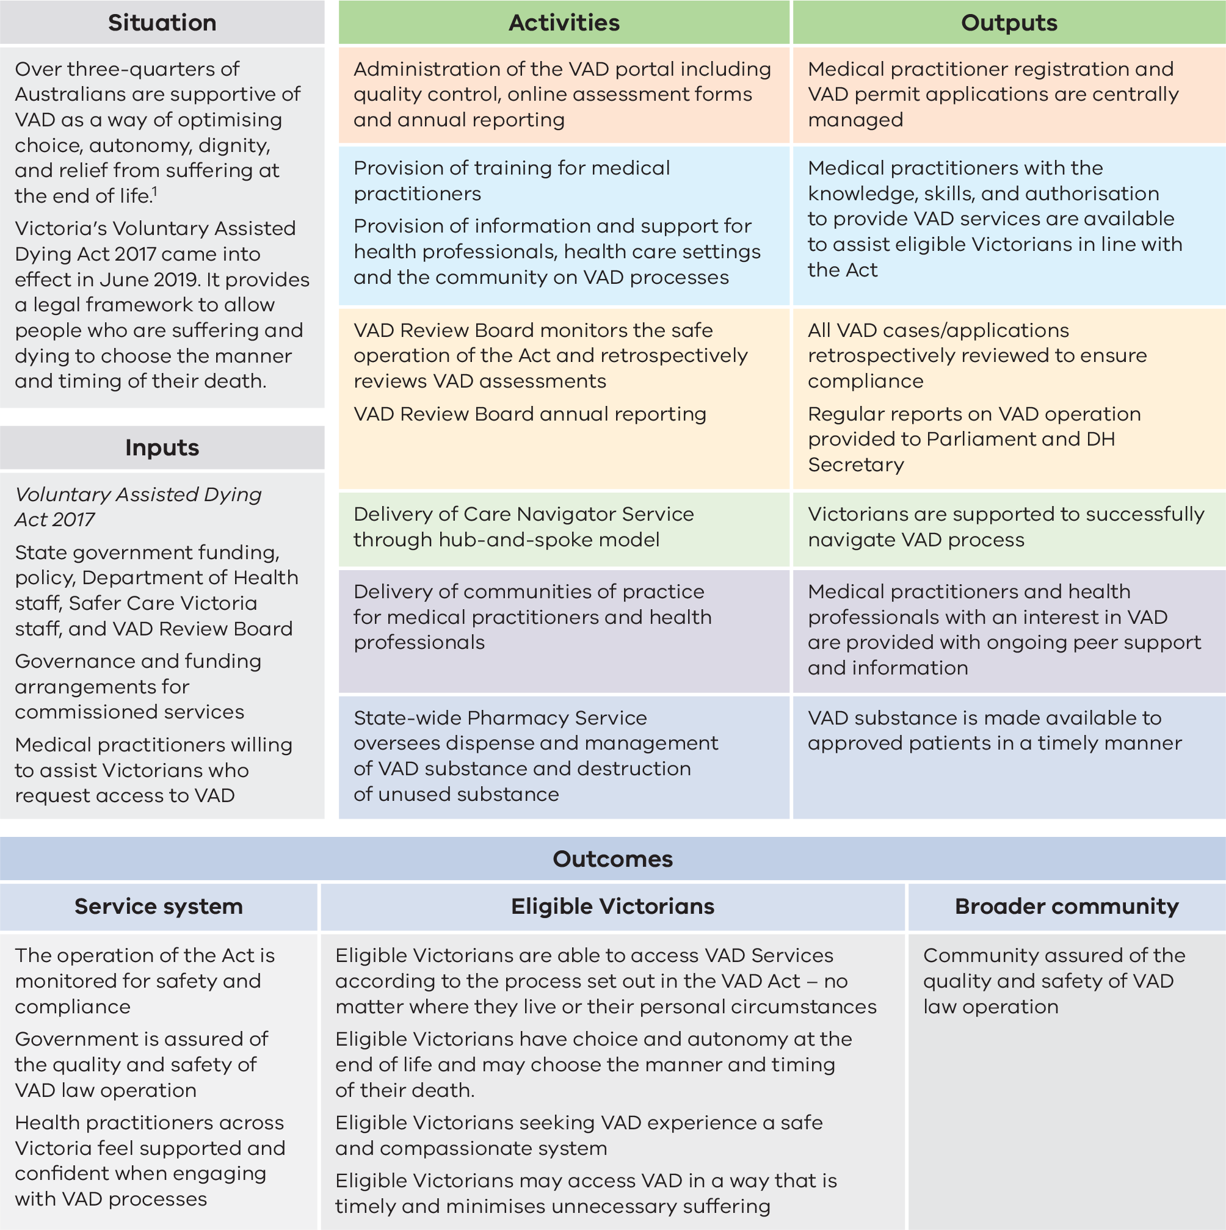
1 Kresin, T. et al. 2021, Attitudes and Arguments in the Voluntary Assisted Dying Debate in Australia: What Are They and How Have they Evolved Over Time?, Int J Environ Res Public Health, 18(23): 12327.

Assumptions associated with the effectiveness of the program
- Victorians are aware that VAD is a legal and available end-of-life choice.
- Victorians can easily access the services required to process their request for VAD.
- Safeguards and processes outlined in the law provide an appropriate balance between safety and accessibility to VAD for eligible Victorians.
- A person’s location of residence, medical condition(s) or personal circumstances are not barriers to their engagement with VAD.
- Systems and processes underpinning the operation of the Act are appropriately resourced.
- There are enough medical and health practitioners in Victoria’s health system who are willing to support eligible Victorians to engage with VAD, should they express a desire to.
  - Training and supports will provide medical practitioners and health practitioners with the necessary skills, knowledge and confidence to assist Victorians in accessing VAD.

External factors influencing the effectiveness of the program
- Across Victoria, there is broad community acceptance and support for VAD to be made available to eligible people, should they want it.
- The policy position of some medical and health peak bodies, religious and aged care health settings may prevent/dissuade support for VAD.
- The cultural and/or faith-based beliefs of some people may prevent them from considering VAD as an end of-life choice, or from being willing to support/assist people seeking information about, or a patient expressing a wish to access, VAD.
- The COVID-19 pandemic, and associated public health measures, may have impacted people’s ability to access VAD services, especially in 2020–21.
- Medical practitioners and health practitioners cannot be penalised under the Criminal Code Act (Cth) for assisting eligible Victorians to access VAD, if acting within the boundaries outlined in the Victorian Act.
- The Criminal Code Act (Cth) does not permit the use of telehealth for VAD-related consultations. This may affect access for people living in regional and rural areas.
- Economic constraints could have an impact on program resourcing.
- Chronic health workforce shortages, especially in regional or rural areas, may influence the operation of the Act in those areas.
- Lack of specific financial support (for example, VAD-specific items) in the Medicare Benefits Schedule is an issue for medical practitioners assisting patients in access VAD.
  - Amendments to the content of the Act, including eligibility criteria, are outside of the scope of this review.

Key stakeholders
In undertaking the review, CERE engaged with a broad range of stakeholders including people considering VAD and their families, carers and nominated contact people; providers of VAD services; providers of other health, palliative and aged care services; and policymakers.

Design and methods
The review design drew on process and outcome evaluation approaches to assess the implementation of the Act and the ongoing operation of the various processes and systems set up under the Act. The review examined the key questions across the evaluation domains of appropriateness, effectiveness, efficiency and impact (Table 2.1). A mixed methods approach was used, incorporating quantitative and qualitative data from multiple sources.

Table 2.1: Review questions
Domain | Questions
Appropriateness | 1.1 Did the systems, processes and practices established to facilitate access meet the needs of eligible people seeking VAD?  1.2 Did VAD systems, processes and practices meet the needs of eligible people seeking VAD and their families and carers?  1.3 Did VAD systems, processes and practices meet specific needs of various population groups?
Effectiveness | 2.1 Were VAD systems, processes and practices operating to support the Act?  2.2. What were the barriers and enablers to stakeholder compliance, understanding and operation of the Act?
Efficiency | 3.1 Have VAD systems, processes and practices had sufficient resources?  3.2 Is resourcing sufficient to implement ongoing delivery?  3.3 Could resources be allocated differently in the future? If so, how?
Impact | 4.1 Was the VAD legislative goal achieved across Victoria?  4.2 Were VAD systems, processes and practices timely, safe and compassionate?  4.3 Have VAD systems, processes and practices generated unintended consequences? If so, what are they, and how can they be addressed?

Data sources
Data was collected on the implementation and operationalisation of VAD, and stakeholders’ experiences, views and perspectives regarding VAD. Key data sources were:
- Interviews and focus group discussions, conducted with 119 people. To ensure the review considered the views and experiences of Aboriginal communities in a culturally safe and sensitive way, Karabena Consulting was contracted to undertake interviews and focus groups with Aboriginal communities (13 participants) and to make recommendations relating to their key findings.
- Surveys and written submissions, collected via the Victorian Government’s Engage Victoria platform (publicly available) over 12 weeks from 1 December 2023 to 23 February 2024. The survey was completed by 303 individuals and 257 written submissions were received.
- Data recorded in the VAD portal, obtained from the VAD secretariat,, relating to:
    - VAD medical practitioners – data obtained included the local government area of their practice, age category at VAD training, the date that they completed their training and registration, their speciality type and the number of coordinating and consulting assessments they had completed.
    - VAD applicants – data obtained included all key dates in the process (applicant’s first request, first assessment, consulting assessment, final request, permit approval date, date of death), type of permit, permit type changed, main diagnosis and demographic characteristics. Individual‑level data was provided for all applications entered on the VAD portal by VAD registered medical practitioners between 19 June 2019 and 30 June 2023.
    - Contact peoples’ experiences – 412 surveys administered by the VAD secretariat and completed by a contact person soon after an applicant’s death.
    - Medical practitioners’ experiences – feedback on 319 individual cases reported by medical practitioners.
- Reports provided to the department by the Statewide Care Navigator Service, the Statewide Pharmacy Service and the VAD medical practitioner Community of Practice moderators.
- Coronial data relating to cases involving VAD.
- Case reviews of VAD assessments from Victorian Civil and Administrative Tribunal (VCAT) and the Australian Health Practitioner Regulation Agency (Ahpra).
- CERE evaluation of VAD training conducted in 2023.
  - VAD long-term activity projection model, developed by the department’s eHealth division in August 2024.
Surveys and interview schedules were checked for clarity by departmental staff, VAD statewide care navigators, a VAD medical practitioner and the spouse of someone who had accessed VAD.

Participant engagement and representation
A range of strategies was used to raise awareness of the review and promote broad participation, including:
- Human services and aged care service managers in selected LGAs promoted surveys to local community groups such as ethnic communities, and older populations.
- Peak bodies representing diverse communities including ethnic communities, seniors’ groups, palliative care and the Cross Border Commissioner were invited to promote the review to their members and communities.
  - The Engage Victoria consultation page included links to information about VAD and the VAD review in 17 community languages and invited people to contact the review team through the Translating and Interpreting Service.
The sampling strategy developed for data collection activities undertaken by the review team aimed to recruit broad representation of participants from different demographic (e.g. geographic region, ethnicity) and service use characteristics (e.g. year of VAD access, permit type).

Recruitment and data collection – families, carers and contact people
Hearing the voice of those who had sought VAD, and their families and contacts was critical to the meaningfulness and usefulness of the review. Contacts of people who had sought VAD between February 2022 and December 2023 were invited to participate in the review by the VAD secretariat, on behalf of CERE. They were sent a link to the survey on the Engage Victoria platform and were invited to contact the CERE team if they were interested in taking part in an interview. Interviews were arranged in the format preferred by the contact – in-person, telephone or via Microsoft Teams. Analysis of demographic characteristics of survey and interview participants shows that the minimum target of five participants was reached for all categories except for First Peoples. A separate First Nations-led consultation process supplemented this to ensure appropriate representation of perspectives of First Peoples.
A distress protocol was established to minimise and manage any distress created through the conduct of the review. Interview participants were offered up to six sessions of professional grief counselling if they appeared distressed during the interview. Participants were also provided information about available support services. Family members were offered a gift voucher for their time in taking part in an interview.

Recruitment and data collection – health practitioners, policymakers and organisations
VAD medical practitioners registered as of December 2023 and medical practitioners who had registered for but not completed VAD training, were emailed by the VAD secretariat, with a link to the Engage Victoria survey and an invitation to take part in an interview. Members of the VAD medical practitioner Community of Practice were invited by moderators to take part in focus groups or interviews. CERE emailed invitations to department stakeholders, VADRB members, the VAD secretariat, statewide pharmacy and care navigators and hospital coordinators to participate in an interview or focus group. Five hundred and forty-five organisations representing Victorian health practitioners, unions, medical indemnity insurers, health, aged care and palliative care services, health service and residential aged care facility board chairs, government agencies, and advocacy, research or special interest groups were invited to provide written submissions and/or distribute to employees and/or members as relevant. Most of the interviews and focus groups were conducted using Microsoft Teams, with a small number held in person.

Data analysis
Interviews and focus groups were audio-recorded (with participant consent) and transcribed verbatim and deidentified. Written submissions received through Engage Victoria were reviewed and six submissions (2%) that were out of scope and did not address the current operation of the Act were excluded from analysis.
All qualitative data (interview and focus group transcripts and notes, written submissions and open survey responses) were thematically analysed. A matrix was created in Microsoft Excel with a row of coding for each record and columns representing the various themes in the framework. Each column was then reviewed and synthesised into key themes.
Participant characteristics, levels of service from statewide VAD services and responses to survey questions (e.g. Likert scales of satisfaction) were analysed using descriptive statistics (e.g. frequencies, percentages, cross-tabulations), with non-parametric measures (i.e. medians) reported for skewed data.
To examine availability of VAD medical practitioners, LGA data for VAD-registered medical practitioners was mapped against the total population aged older than 60 years derived from Australian Bureau of Statistics and against the total proportion of registered medical practitioners and medical practitioner age categories as recorded in the National Health Workforce Dataset for 2022.
Findings from the analysis of data from the VAD portal were reviewed by the VAD secretariat to ensure accuracy in analysis and interpretation.

Ethics and privacy
The Department of Health and Department of Families, Fairness and Housing Human Research and Ethics Committee reviewed and approved all data collection (Project ID 100702). A privacy impact assessment (PIA) was undertaken for parts of the review that involved collecting and using personal data in line with the department’s requirements and legal obligations under the Privacy and Data Protection Act 2014 and the Health Records Act 2001. The PIA was completed in conjunction with an Information Security Classification process.

Limitations of the Review
- Efforts were made to recruit people currently seeking VAD but given end of life is a difficult time for people and taking part in the review may not have been a priority, participation was limited (24 survey respondents, no interviews). To help address this, feedback was sought from family members who could provide varied and rich accounts of the experiences of accessing VAD in Victoria.
- The review team’s ability to identify and recruit people who had been unable to access VAD was limited.
- Data collection was conducted in English only, creating challenges engaging with multicultural communities; only three family members of a person who sought VAD who spoke a language other than English were included in the interview sample.
- Contacts who were invited to participate in an interview were also invited to complete the Engage Victoria survey. As survey completion was anonymous, it is not possible to calculate the number of family members who provided input into the review through both the survey and through interview.
- Approval and access processes for VAD portal data were complex and approval was not obtained until February 2024, resulting in limited time to undertake data analysis.
  - VAD portal enhancements undertaken in 2021 and 2022 impacted the availability of data and the ability to extract contact information.
Table 2.2: Number of participants by stakeholder group and method of participation¹
Stakeholder group | Individuals or organisations contacted | Interviews | Focus Groups | Surveys | Written submissions
People seeking VAD | N/A | 0 | -- | 24 | --
People formally appointed as a contact person for a VAD applicant | 1,150 | 40 | -- | 123 | 171
VAD Registered Medical practitioners (active and inactive) | 388 | 9 | 3 | 33 | --
Statewide and Regional Care Navigator Service | N/A | 0 | 1 | 0 | --
Health service-based VAD care coordinator | N/A | 1 | 1 | 0 | --
Statewide Pharmacy Service | N/A | -- | 1 | -- | 1
VAD Review Board Members and VAD Secretariat | N/A | 9 | 1 | -- | 1
Internal Department of Health teams | N/A | 5 | 3 | -- | 2
Public/private health service and residential aged care facility board chairs | 81 | -- | -- | 6 | --
Medical practitioners not registered to provide VAD | N/A | 1 | -- | 22 | --
Other health practitioners (e.g. nurse, allied health, aged care worker) | N/A | -- | -- | 95 | 26
Public and private health and residential aged care services | 352 | -- | -- | -- | 10
Community palliative care services | 12 | -- | -- | -- | 1
Registered community health services | 23 | -- | -- | -- | 0
Victorian branches of medical practitioner, nursing, pharmaceutical and/or allied health practitioner organisations/unions | 28 | -- | -- | -- | 5
Government agencies (excluding the Department of Health) | 10 | 1 | -- | -- | 0
Peak bodies (representing groups including palliative care, disability, LGAs, carers, Aboriginal communities, ethnic communities) and special interest groups | 30 | -- | 1 | -- | 15
Research institutes with interest in VAD and/or end of life in Victoria | 6 | -- | -- | -- | 3
Medical indemnity insurers | 5 | -- | -- | -- | 0
General community | N/A | -- | -- | -- | 22
Total | 2,085 | 66 | 11 | 303 | 257
1 Interviews and focus groups were the key methods of data collection for those with a direct interest in the review (e.g. family members of people who had sought VAD, VAD medical practitioners, VAD-related policy and service delivery). Other stakeholder groups primarily contributed via online surveys (health workforce) and written submissions. -- Denotes methods of data collection not targeted to this stakeholder group; N/A: Not applicable – number of individuals or organisations contacted to participate cannot be specified.
Note: 43 family members were interviewed during 40 interviews. Some family members may have provided input through multiple processes.

Appendix 3: Additional tables and figures

VAD processes and applications
Table 3.1: Number of events at each stage of the VAD process, 2019–20 to 2022–23
Event type | 2019–20 | 2020–21 | 2021–22 | 2022–23 | Total
First assessments completed1 (N) | 353 | 487 | 585 | 610 | 2,035
First assessments completed that were eligible2 (N, %) | 346 (98%) | 465 (96%) | 552 (94%) | 600 (98%) | 1,963 (97%)
Withdrawn applications3 (N) | -- | -- | -- | -- | 782
Permits issued (N) | 237 | 366 | 439 | 485 | 1,527
Self-administration permit | 207 | 323 | 379 | 403 | 1,312
Practitioner administration permit | 30 | 43 | 60 | 82 | 215
VAD substances dispensed (N) | 175 | 291 | 394 | 452 | 1,312
Deaths from administration of VAD substance (N) | 129 | 202 | 275 | 306 | 912
By self-administration | 108 | 174 | 236 | 257 | 775
By practitioner administration | 21 | 28 | 39 | 49 | 137
Source: VADRB 2022–23 annual report
1 This differs from the number of applicants referred to elsewhere in this report as not all applicant profiles created by medical practitioners receive an assessment (for example, an applicant may die before the assessment or choose not to proceed after the medical practitioner has created the profile). Some of these profiles may also have been created close to the end of the reporting period, with medical practitioners uploading their assessments after the reporting period.
2 This reflects data recorded in the VAD Portal. There may be many more assessments considered ineligible that are not recorded in the Portal by the medical practitioner at the time of assessment.
3 Withdrawn applications result from the applying dying, becoming too unwell and/or losing capacity, or choosing not to proceed. The reason for withdrawal was not recorded in all cases.
-- Annual data breakdown unavailable
Figure 3.1: Median time between key steps in VAD process and number of applicants at each stage, June 2019 to June 2023
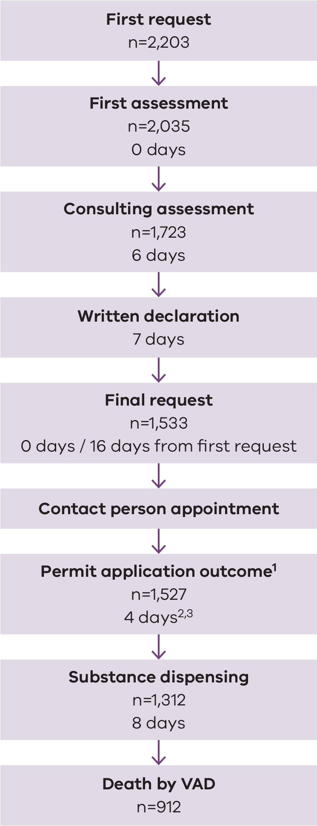
Source: VADRB 2022–23 annual report
1 There are circumstances where one applicant is issued two permits – first for self-administration and subsequently if there is a change to practitioner-administration.
2 Median time to permit approval if the applicant changed permits was 81 days; however, this includes 73 days when the person had a self-administration permit before a practitioner-administration permit was sought. The median time it took them to obtain their self-administration permit was three days and the median time to obtain the second practitioner-administration permit was 2 days
3 Median time from first request to permit approval was 22 days for self-administration permit holders and 25 days for practitioner-administration permit holders
Table 3.2: Reported barriers encountered at each stage of the VAD process, that were believed to have contributed to delays
Stage | Reported barriers
First request | - Lack of information and knowledge of VAD in the community  - Prohibition of medical practitioners raising VAD with patients  - Delays in medical practitioner responding to first request  - Access to interpreters
First assessment | - Access to VAD medical practitioners including limited availability, lack of timely response, difficulty travelling to appointment  - 6m prognosis (12m for neurological conditions) considered inappropriate by stakeholders  - Neurological conditions with 6–12month prognosis requiring a specialist opinion at first assessment  - Finding a specialist medical practitioner that meets the requirements specified in the Act
Written declaration | - Difficulty finding independent witnesses  - Organisations not allowing VAD medical practitioners on site
Final request | - Minimum of 9 days between first and final request as mandated by the Act
Permit approval outcome / switching permits | - Substantial paperwork involved  - Incorrect or insufficient data on assessments and permit applications  - VAD process impacted by weekends, public holidays, and leave  - Patient unaware a new permit is needed  - Patient is too unwell to travel for new appointments  - Requirement to return self-administration substance  - New application for practitioner-administration substance required
Substance dispensing | - Patient may be unaware they need to contact the pharmacy service  - Occasional delays in delivery of the substance
Source: Stakeholder interviews
Table 3.3: Number of referrals to specialists and reasons for referral, by timing of referral
Reason for specialist referral | Number of specialist referrals made following first assessment | Number of specialist referrals made following consulting assessment
To confirm decision-making capacity | 20 | 9
To confirm eligibility of medical condition | 93 | 33
To assess whether neurological condition is expected to cause death in 6–12 months | 120 | N/A
Source: VAD portal, June 2019 – June 2023

VAD applicants
Table 3.4: Demographic characteristics of all VAD applicants, those who obtained a VAD permit, and those who obtained a VAD permit within 21 days or less, June 2019 – June 2023
Characteristic | All VAD applicants  N=2,099  n (%) | Subset of applicants who obtained a permit  N=1,476  n (%) | Subset of applicants who obtained a permit within 21 days  N=716  n (%)
Sex – Female | 969 (46%) | 711 (48%) | 342 (48%)
Sex – Male | 1,130 (54%) | 765 (52%) | 374 (52%)
Age group – 18–69 years | 731 (35%) | 545 (37%) | 256 (36%)
Age group – 70+ years | 1,369 (54%) | 931 (63%) | 460 (64%)
Country of birth – Australia | 1,433 (72%) | 1,003 (72%) | 472 (70%)
Country of birth – Other | 564 (28%) | 396 (28%) | 198 (30%)
Language spoken at home – English | 1,941 (96%) | 1,372 (96%) | 654 (96%)
Language spoken at home – Language other than English | 79 (4%) | 51 (4%) | 30 (4%)
Aboriginal and/or Torres Strait Islander – No | 1,989 (99%) | 1,395 (99%) | 675 (100%)
Aboriginal and/or Torres Strait Islander – Yes | 11 (<1%) | 8 (<1%) | <5 (<1%)
Educational completion – End of high school or lower | 1,001 (56%) | 670 (53%) | 315 (53%)
Educational completion – Beyond high school | 793 (44%) | 585 (47%) | 276 (47%)
Location – Metropolitan Melbourne | 1,335 (64%) | 952 (65%) | 507 (71%)
Location – Regional Victoria | 756 (36%) | 524 (36%) | 209 (29%)
Main diagnosis – Cancer | 1,588 (81%) | 1,144 (80%) | 616 (89%)
Main diagnosis – Other | 371 (19%) | 278 (20%) | 75 (11%)
Accessed palliative care – Yes | 1,711 (85%) | 1,195 (85%) | 608 (90%)
Accessed palliative care – No | 299 (15%) | 216 (15%) | 71 (10%)
Source: VAD portal, June 2019 – June 2023.
Note: Valid percentages are shown (excluding missing data)
Figure 3.2: Age distribution of VAD applicants, June 2019 – June 2023 (n=2,096)
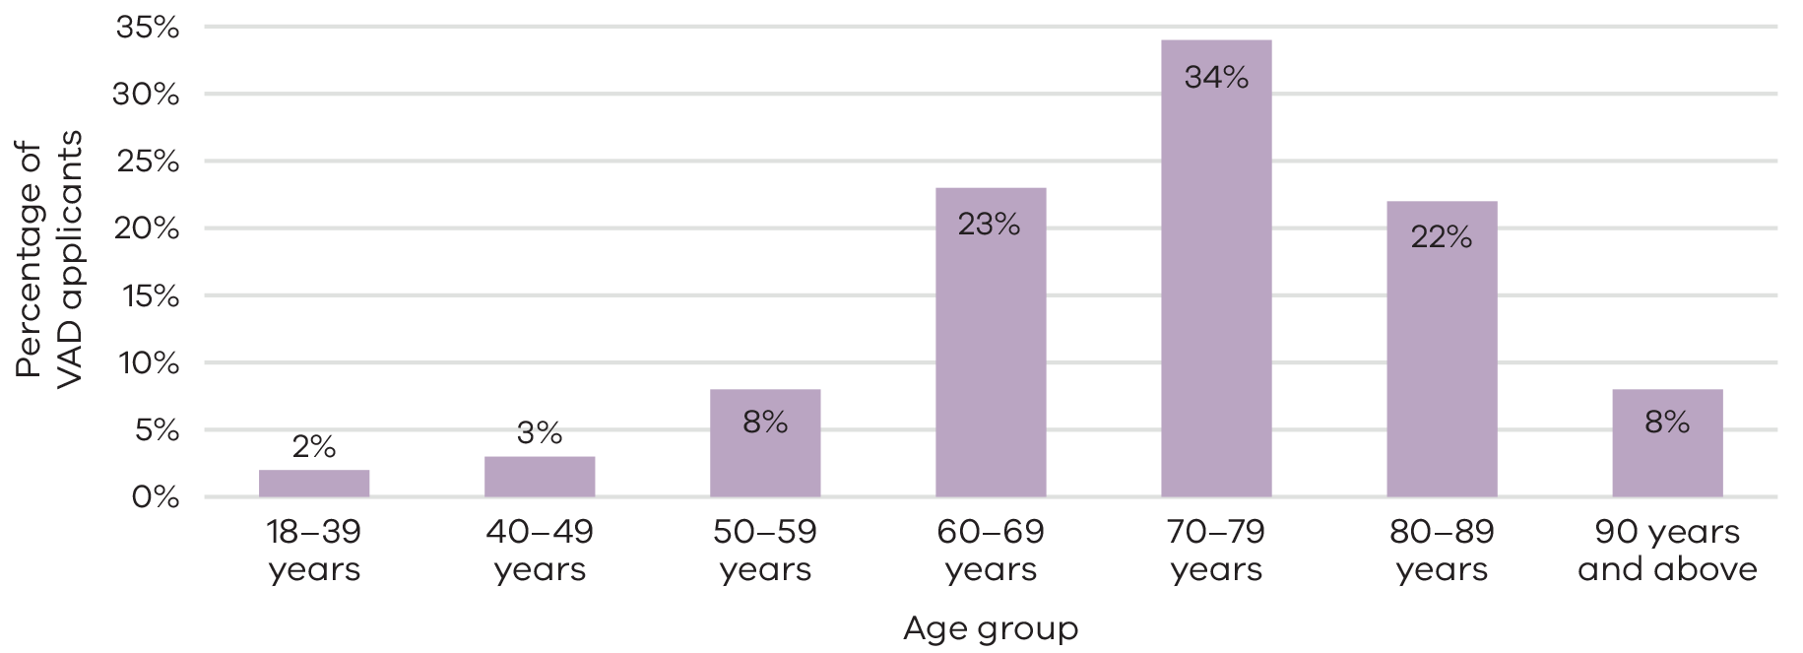
Source: VADRB 2022–23 annual report
Note: Valid percentages are shown (excluding missing data)
Figure 3.3: Life-limiting conditions of VAD applicants, June 2019 – June 2023 (n=2,100¹)
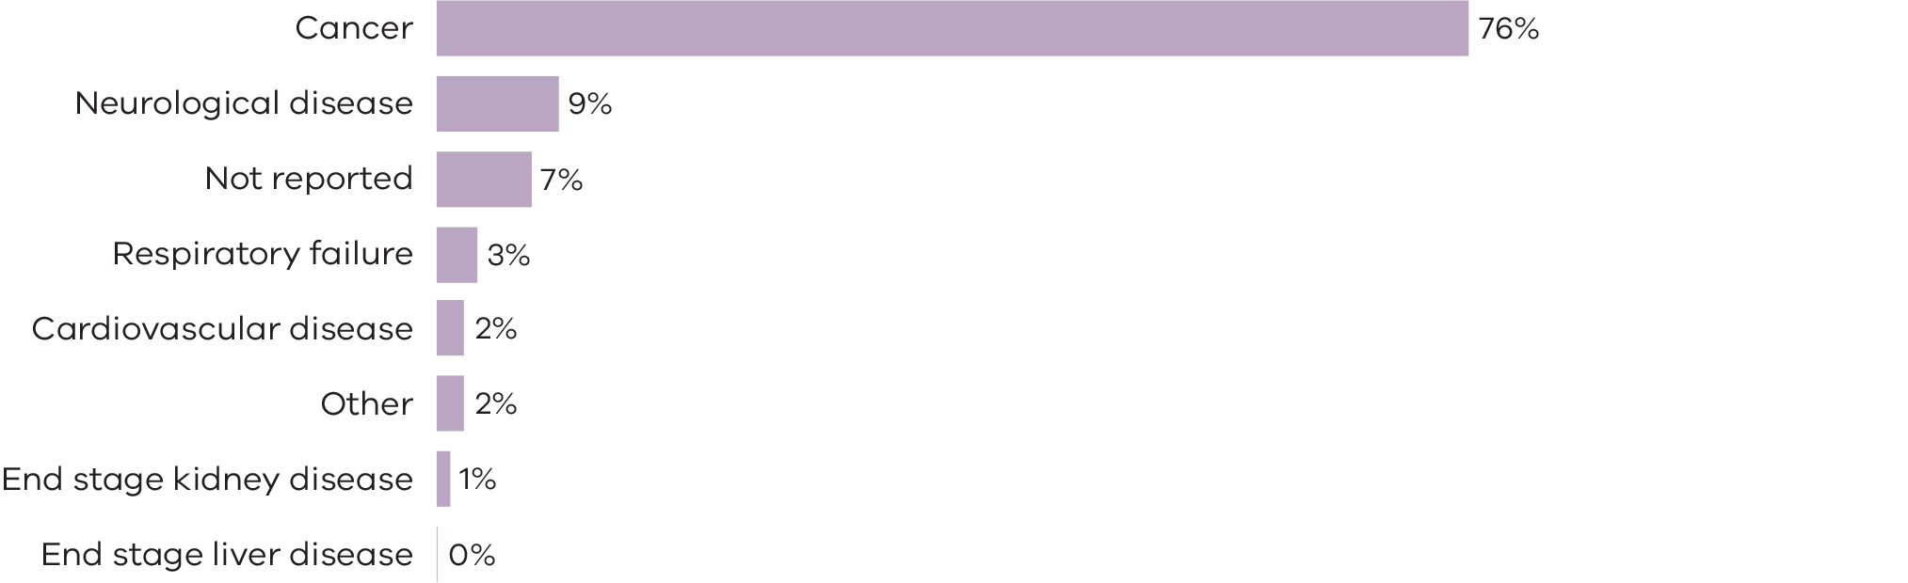
Source: VAD portal data, June 2019 – June 2023
1 Missing data occurs where the medical practitioner has not selected a condition in the online patient profile.
This profile is used for monitoring purposes; eligibility for a permit is determined through assessment).

People seeking VAD and their families/contacts
Table 3.5: Experiences of VAD processes for eligible people seeking access to VAD among people seeking VAD and their families/contacts
Variable | Applicants  N=24  n (%) | Families/contacts  N=123  n (%) | Total  N=147  n (%)
Compassionate – Very much | 6 (46%) | 83 (73%) | 89 (70%)
Compassionate – Somewhat | 4 (31%) | 18 (16%) | 22 (17%)
Compassionate – A little | 2 (15%) | 5 (4%) | 7 (6%)
Compassionate – Not at all | 1 (8%) | 8 (7%) | 9 (7%)
Safe – Very much | 8 (67%) | 96 (89%) | 104 (87%)
Safe – Somewhat | 3 (25%) | 6 (6%) | 9 (8%)
Safe – A little | 0 (0%) | 0 (0%) | 0 (0%)
Safe – Not at all | 1 (8%) | 6 (6%) | 7 (6%)
Timely – Very much | 5 (42%) | 57 (50%) | 62 (50%)
Timely – Somewhat | 1 (8%) | 24 (21%) | 25 (20%)
Timely – A little | 1 (8%) | 10 (9%) | 11 (9%)
Timely – Not at all | 5 (42%) | 22 (19%) | 27 (22%)
Applicant/family/carer wishes and needs supported – Very much | 3 (27%) | 88 (69%) | 88 (69%)
Applicant/family/carer wishes and needs supported – Somewhat | 3 (27%) | 18 (14%) | 18 (14%)
Applicant/family/carer wishes and needs supported – A little | 3 (27%) | 8 (6%) | 8 (6%)
Applicant/family/carer wishes and needs supported – Not at all | 2 (18%) | 14 (11%) | 14 (11%)
Applicant/family/carer cultural, linguistic and/or spiritual needs supported – Very much | 3 (50%) | 57 (77%) | 60 (75%)
Applicant/family/carer cultural, linguistic and/or spiritual needs supported – Somewhat | 1 (17%) | 8 (11%) | 9 (11%)
Applicant/family/carer cultural, linguistic and/or spiritual needs supported – A little | 0 (0%) | 3 (4%) | 3 (4%)
Applicant/family/carer cultural, linguistic and/or spiritual needs supported – Not at all | 2 (33%) | 6 (8%) | 8 (10%)
Source: Survey data, Engage Victoria 2024
Note: Valid percentages are shown (excluding missing data)
Table 3.6: Satisfaction with VAD systems, programs and processes among people seeking VAD and their families/contacts
System, program or process | Applicants  N=6  n (%) | Families/contacts  N=93  n (%) | Total  N=99  n (%)
VAD doctors – Very much | 2 (75%) | 82 (91%) | 84 (90%)
VAD doctors – Somewhat | 0 (0%) | 6 (7%) | 6 (7%)
VAD doctors – A little | 1 (25%) | 1 (1%) | 2 (2%)
VAD doctors – Not at all | 0 (0%) | 1 (1%) | 1 (1%)
Other doctors – Very much | 3 (75%) | 49 (56%) | 52 (57%)
Other doctors – Somewhat | 0 (0%) | 17 (20%) | 17 (19%)
Other doctors – A little | 1 (25%) | 11 (13%) | 12 (13%)
Other doctors – Not at all | 0 (0%) | 10 (11%) | 10 (11%)
Other healthcare workers – Very much | 2 (50%) | 60 (65%) | 62 (65%)
Other healthcare workers – Somewhat | 2 (50%) | 17 (19%) | 19 (20%)
Other healthcare workers – A little | 0 (0%) | 10 (11%) | 10 (10%)
Other healthcare workers – Not at all | 0 (0%) | 5 (5%) | 5 (5%)
Statewide Care Navigator Service – Very much | 2 (100%) | 66 (84%) | 68 (84%)
Statewide Care Navigator Service – Somewhat | 0 (0%) | 8 (10%) | 8 (10%)
Statewide Care Navigator Service – A little | 0 (0%) | 3 (4%) | 3 (4%)
Statewide Care Navigator Service – Not at all | 0 (0%) | 2 (2%) | 2 (2%)
Statewide Pharmacy Service – Very much | 2 (75%) | 67 (85%) | 69 (84%)
Statewide Pharmacy Service – Somewhat | 0 (0%) | 6 (8%) | 6 (7%)
Statewide Pharmacy Service – A little | 0 (0%) | 3 (4%) | 3 (4%)
Statewide Pharmacy Service – Not at all | 1 (25%) | 3 (4%) | 4 (5%)
Provision of a support package – Very much | 1 (50%) | 44 (64%) | 45 (63%)
Provision of a support package – Somewhat | 0 (0%) | 17 (25%) | 17 (24%)
Provision of a support package – A little | 0 (0%) | 1 (1%) | 1 (1%)
Provision of a support package – Not at all | 1 (50%) | 7 (10%) | 8 (11%)
Follow-up after the person died – Very much | N/A | 42 (56%) | 42 (56%)
Follow-up after the person died – Somewhat | N/A | 22 (29%) | 22 (29%)
Follow-up after the person died – A little | N/A | 3 (4%) | 3 (4%)
Follow-up after the person died – Not at all | N/A | 8 (11%) | 8 (11%)
Source: Survey data, Engage Victoria 2024
Note: Valid percentages are shown (excluding missing data). Percentages may not add up to 100% due to rounding.

VAD-registered medical practitioners
Figure 3.4: Percentage of GPs who are VAD-registered, by local government area
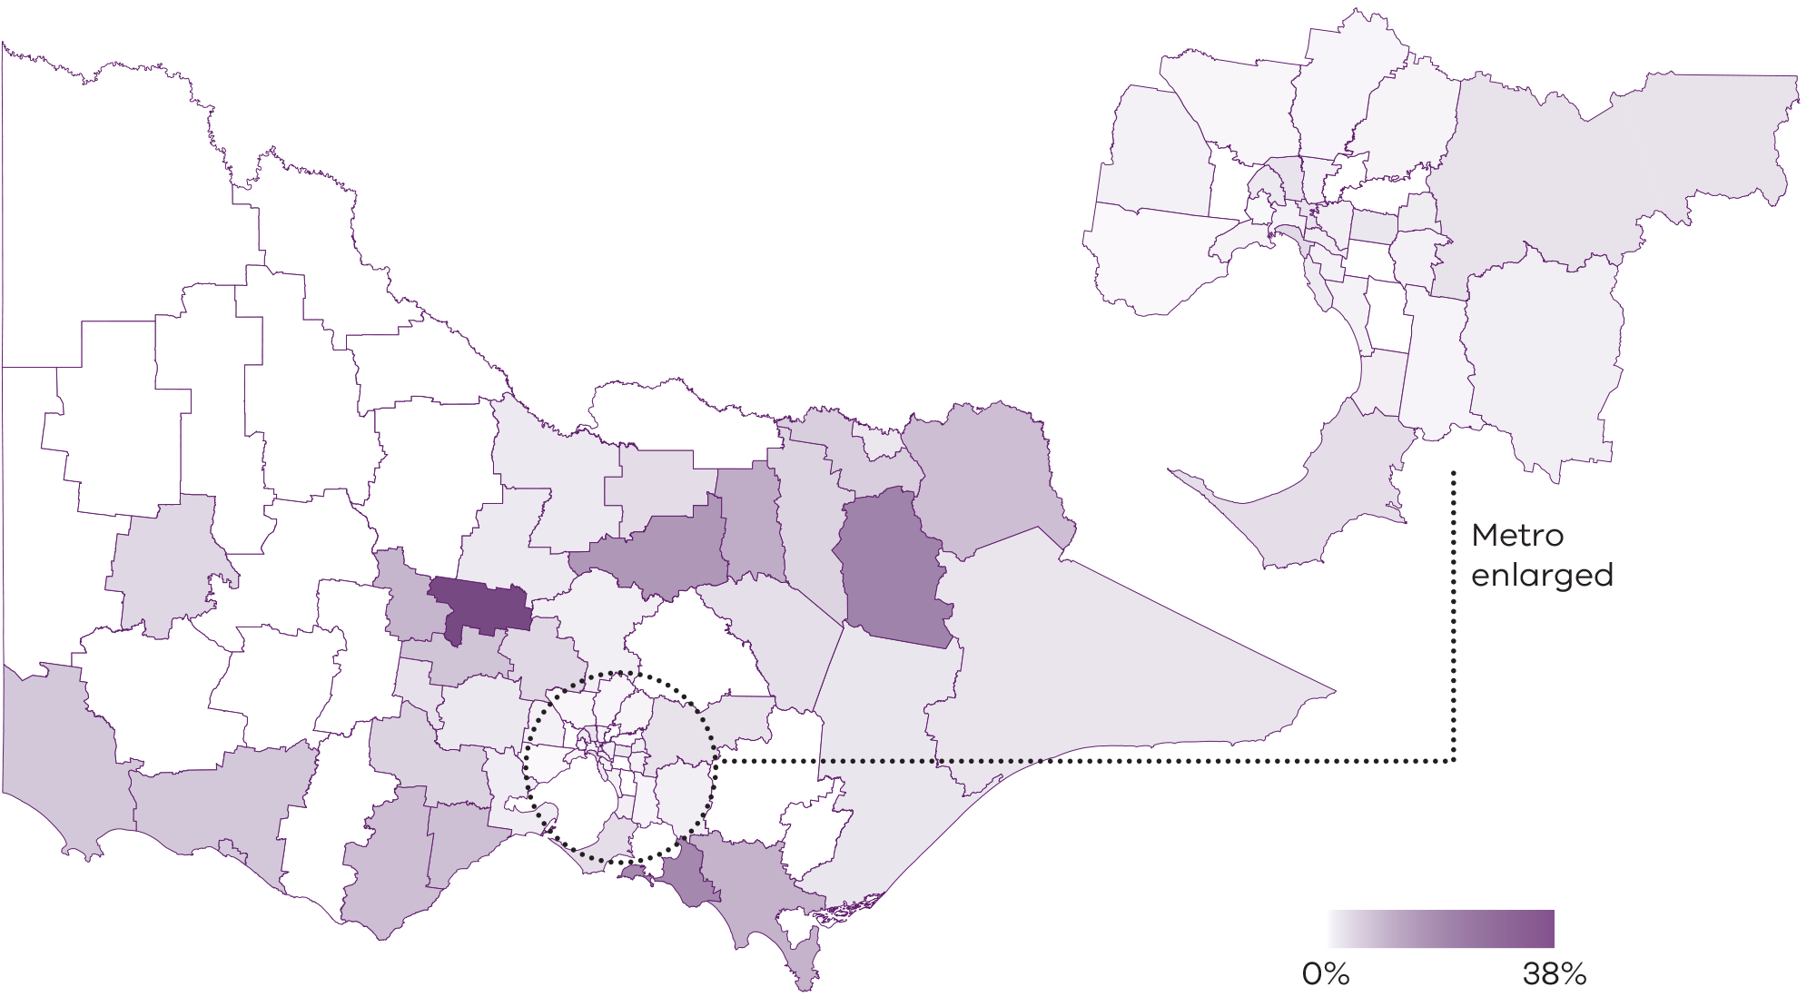
Source: VAD Portal data and National Health Workforce Dataset 2022
Figure 3.5: Rate of VAD-registered non-GP specialists per 1,000 population aged 60+ years
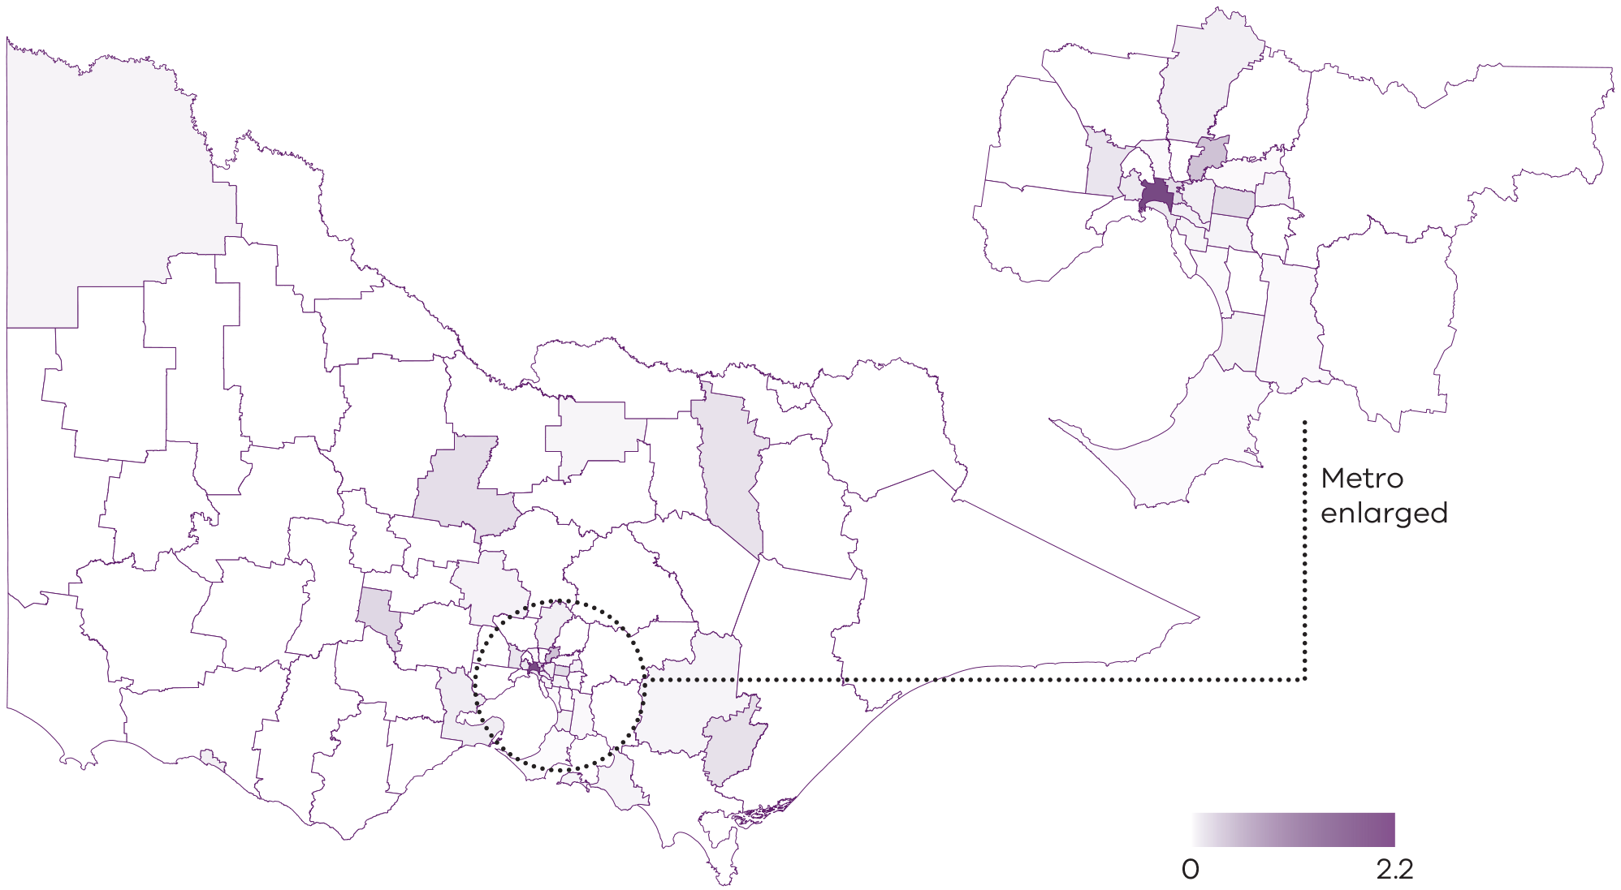
Source: VAD portal, 30 June 2023
Table 3.7: VAD medical practitioner’s perception of their and their patients’ experiences of the VAD process
Variable | Responses  N=3191  n (%)
Applicant did not experience barriers accessing VAD – Strongly agree | 101 (32%)
Applicant did not experience barriers accessing VAD – Agree | 115 (36%)
Applicant did not experience barriers accessing VAD – Neither agree nor disagree | 23 (7%)
Applicant did not experience barriers accessing VAD – Disagree | 65 (20%)
Applicant did not experience barriers accessing VAD – Strongly disagree | 15 (5%)
VAD process worked well for the applicant – Strongly agree | 119 (37%)
VAD process worked well for the applicant – Agree | 133 (42%)
VAD process worked well for the applicant – Neither agree nor disagree | 30 (9%)
VAD process worked well for the applicant – Disagree | 32 (10%)
VAD process worked well for the applicant – Strongly disagree | 5 (2%)
Coordinating medical practitioner did not experience barriers in the VAD process – Strongly agree | 121 (38%)
Coordinating medical practitioner did not experience barriers in the VAD process – Agree | 136 (43%)
Coordinating medical practitioner did not experience barriers in the VAD process – Neither agree nor disagree | 22 (7%)
Coordinating medical practitioner did not experience barriers in the VAD process Disagree | 33 (10%)
Coordinating medical practitioner did not experience barriers in the VAD process – Strongly disagree | 7 (<1%)
Coordinating medical practitioner received adequate support throughout the VAD process – Strongly agree | 160 (50%)
Coordinating medical practitioner received adequate support throughout the VAD process – Agree | 136 (43%)
Coordinating medical practitioner received adequate support throughout the VAD process – Neither agree nor disagree | 19 (6%)
Coordinating medical practitioner received adequate support throughout the VAD process – Disagree | 2 (<1%)
Coordinating medical practitioner received adequate support throughout the VAD process – Strongly disagree | 2 (<1%)
Source: VAD portal survey feedback after 319 VAD-related deaths, June 2019 – June 2023
1 Responses by medical practitioners reflecting upon 319 records of VAD-related deaths; not unique providers
Note: Valid percentages are shown (excluding missing data)

Healthcare workforce
Table 3.8: Characteristics of health practitioner survey respondents
Characteristic | Medical practitioners – VAD-registered  N=33  n (%) | Medical practitioners – Not VAD-registered  N=22  n (%) | Other health care workers  N=95  n (%)
Practice location – Metropolitan Melbourne | 22 (71%) | 13 (65%) | 55 (59%)
Practice location – Regional/rural Victoria | 9 (29%) | 7 (35%) | 39 (41%)
Job role – Nurse | N/A | N/A | 60 (65%)
Job role – Health service manager | N/A | N/A | 9 (10%)
Job role – Other | N/A | N/A | 24 (26%)
Primary setting of practice – General Practice | 12 (36%) | 5 (23%) | 6 (6%)
Primary setting of practice – Hospital | 15 (45%) | 14 (64%) | 48 (51%)
Primary setting of practice – Non-GP specialist in private practice | 4 (12%) | 2 (9%) | 0 (0%)
Primary setting of practice – Community-based palliative care | N/A | N/A | 20 (21%)
Primary setting of practice – Residential aged care | N/A | N/A | 5 (5%)
Primary setting of practice – Other | 2 (6%) | 1 (5%) | 12 (13%)
Source: Workforce survey
Note: Valid percentages are shown (excluding missing data); Data relates to people who responded to the health workforce survey and is not necessarily representative of the workforce more broadly.
Table 3.9: Involvement with VAD among medical practitioners who responded to the health practitioner survey, by training completion status (N=55)
Type of involvement with VAD | VAD training status  Trained and registered  N=33  n (%) | VAD training status  Trained but not registered  N=3  n (%) | VAD training status  Not trained  N=19  n (%)
Not yet involved in a VAD assessment | 2 (6%) | N/A | N/A
Self-administrating coordinator | 26 (79) | N/A | N/A
Practitioner-administrating coordinator | 15 (45%) | N/A | N/A
Consulting/assessment | 26 (79%) | N/A | N/A
Interested in providing VAD but have yet to do the mandatory training | N/A | N/A | 4 (21%)
Would consider providing VAD if one of my existing patients expressed a wish for it | N/A | 0 (0%) | 1 (5%)
Not opposed to VAD, but do not wish to be involved | N/A | 2 (100%) | 11 (58%)
Conscientiously object to VAD | N/A | 0 | 3 (16%)
Source: Survey data, Engage Victoria 2024
Note: Valid percentages are shown (excluding missing data); Data relates to people who responded to the health workforce survey and is not necessarily representative of the workforce more broadly.
Table 3.10: Health practitioners’ perceptions about Victoria’s current processes for eligible people to access VAD
Variable | Medical practitioners  VAD medical practitioner  N=33  n (%) | Medical practitioners  Not  VAD-registered  N=22  n (%) | Other health care workers  N=95  n (%)
Compassionate – Strongly agree | 8 (24%) | 1 (5%) | 15 (16%)
Compassionate – Agree | 14 (42%) | 8 (36%) | 48 (50%)
Compassionate – Neither agree nor disagree | 2 (6%) | 8 (36%) | 9 (10%)
Compassionate – Disagree | 3 (9%) | 3 (14%) | 12 (13%)
Compassionate – Strongly disagree | 2 (6%) | 2 (9%) | 6 (6%)
Safe – Strongly agree | 21 (64%) | 6 (27%) | 41 (43%)
Safe – Agree | 10 (30%) | 7 (32%) | 39 (41%)
Safe – Neither agree nor disagree | 0 (0%) | 3 (14%) | 6 (6%)
Safe – Disagree | 0 (0%) | 4 (18%) | 5 (5%)
Safe – Strongly disagree | 2 (6%) | 2 (9%) | 4 (4%)
Timely – Strongly agree | 3 (9%) | 1 (5%) | 7 (7%)
Timely – Agree | 11 (33%) | 4 (18%) | 24 (25%)
Timely – Neither agree nor disagree | 7 (21%) | 7 (32%) | 17 (18%)
Timely – Disagree | 11 (33%) | 6 (27%) | 29 (30%)
Timely – Strongly disagree | 1 (3%) | 4 (18%) | 16 (17%)
Enable a person’s wishes and needs to be supported – Strongly agree | 7 (21%) | 2 (9%) | 14 (15%)
Enable a person’s wishes and needs to be supported – Agree | 16 (48%) | 7 (32%) | 45 (47%)
Enable a person’s wishes and needs to be supported – Neither agree nor disagree | 5 (15%) | 8 (36%) | 12 (13%)
Enable a person’s wishes and needs to be supported – Disagree | 4 (12%) | 4 (18%) | 20 (21%)
Enable a person’s wishes and needs to be supported – Strongly disagree | 1 (3%) | 1 (5%) | 4 (4%)
Enables a persons’ cultural, linguistic and/or spiritual needs to be supported – Strongly agree | 6 (18%) | 1 (5%) | 15 (16%)
Enables a persons’ cultural, linguistic and/or spiritual needs to be supported – Agree | 15 (45%) | 4 (18%) | 38 (40%)
Enables a persons’ cultural, linguistic and/or spiritual needs to be supported – Neither agree nor disagree | 7 (21%) | 11 (50%) | 30 (32%)
Enables a persons’ cultural, linguistic and/or spiritual needs to be supported – Disagree | 3 (9%) | 3 (14%) | 9 (10%)
Enables a persons’ cultural, linguistic and/or spiritual needs to be supported – Strongly disagree | 1 (3%) | 3 (14%) | 2 (2%)
Source: Survey data, Engage Victoria 2024
Note: Valid percentages are shown (excluding missing data)
Table 3.11: Satisfaction with VAD resources or services among VAD-registered medical practitioners and other health practitioners
VAD resource/service | VAD-registered medical practitioner  N=33  n (%) | Other health practitioners  N=95  n (%)
Victoria’s mandatory VAD training – Very satisfied | 16 (50%) | N/A
Victoria’s mandatory VAD training – Satisfied | 9 (28%) | N/A
Victoria’s mandatory VAD training – Neither satisfied nor dissatisfied | 3 (9%) | N/A
Victoria’s mandatory VAD training – Dissatisfied | 3 (9%) | N/A
Victoria’s mandatory VAD training –Strongly dissatisfied | 1 (3%) | N/A
VAD portal – Very satisfied | 5 (16%) | N/A
VAD portal – Satisfied | 16 (52%) | N/A
VAD portal – Neither satisfied nor dissatisfied | 5 (16%) | N/A
VAD portal – Dissatisfied | 4 (13%) | N/A
VAD portal – Strongly dissatisfied | 1 (3%) | N/A
Information provided by the Department of Health – Very satisfied | N/A | 20 (24%)
Information provided by the Department of Health – Satisfied | N/A | 37 (45%)
Information provided by the Department of Health – Neither satisfied nor dissatisfied | N/A | 16 (20%)
Information provided by the Department of Health – Dissatisfied | N/A | 8 (10%)
Information provided by the Department of Health – Strongly dissatisfied | N/A | 1 (1%)
Statewide Care Navigator Service – Very satisfied | 26 (84%) | 43 (54%)
Statewide Care Navigator Service – Satisfied | 4 (13%) | 16 (20%)
Statewide Care Navigator Service – Neither satisfied nor dissatisfied | 1 (3%) | 15 (19%)
Statewide Care Navigator Service – Dissatisfied | 0 (0%) | 4 (5%)
Statewide Care Navigator Service – Strongly dissatisfied | 0 (0%) | 1 (1%)
Statewide Pharmacy Service – Very satisfied | 26 (84%) | 37 (52%)
Statewide Pharmacy Service – Satisfied | 4 (13%) | 16 (23%)
Statewide Pharmacy Service – Neither satisfied nor dissatisfied | 1 (3%) | 15 (21%)
Statewide Pharmacy Service – Dissatisfied | 0 (0%) | 2 (3%)
Statewide Pharmacy Service – Strongly dissatisfied | 0 (0%) | 1 (1%)
Hospital-based VAD coordinator – Very satisfied | 16 (73%) | 38 (55%)
Hospital-based VAD coordinator – Satisfied | 3 (14%) | 13 (19%)
Hospital-based VAD coordinator – Neither satisfied nor dissatisfied | 3 (14%) | 10 (14%)
Hospital-based VAD coordinator – Dissatisfied | 0 (0%) | 4 (6%)
Hospital-based VAD coordinator – Strongly dissatisfied | 0 (0%) | 4 (6%)
Community of Practice – Very satisfied | 8 (40%) | 16 (24%)
Community of Practice – Satisfied | 7 (35%) | 16 (24%)
Community of Practice – Neither satisfied nor dissatisfied | 5 (25%) | 21 (32%)
Community of Practice – Dissatisfied | 0 (0%) | 11 (16%)
Community of Practice – Strongly dissatisfied | 0 (0%) | 3 (4%)
VAD permit application process – Very easy | 3 (9%) | N/A
VAD permit application process – Easy | 8 (25%) | N/A
VAD permit application process – Neither easy nor difficult | 11 (34%) | N/A
VAD permit application process – Difficult | 9 (28%) | N/A
VAD permit application process – Very difficult | 1 (3%) | N/A
Source: Survey data, Engage Victoria 2024
Note: Valid percentages are shown (excluding missing data)

Appendix 4: Summary of activity – VAD core bodies
Table 4.1: VAD Review Board activity
Activity | 2019–20 | 2020–21 | 2021–22 | 2022–23 | Total
Annual reports to Parliament required under the Act | 6-monthly reports: 2  Establishment report  (2018–19): 1 | 6-monthly reports: 2 | Annual  reports: 1 | Annual  reports: 1 | 7
Number of noncompliant cases¹ | Medical practitioner failure to comply with procedural requirements: 1 | Delayed substance return: 2  Medical practitioner error: 5 | Delayed substance return: 3  Witness  error: 1 | Delayed substance return: 2 | 14  (0.7%)²
Number of cases referred to other agencies | Medical practitioner referred to Ahpra: 1 | 0 | 0 | 0 | 1  (0.05%)²
Source: VADRB annual reports
1 The VADRB has reviewed all VAD applications after case closure.
2 Percentage of total completed VAD applications (782 withdrawn cases plus 1,344 applicants who have died).
Table 4.2: Statewide Care Navigator Service activity
Activity | 2019–20 | 2020–21 | 2021–22 | 2022–23 | Total
Annual reports | 1 | 1 | 1 | 1 | 4
Number of people assisted with navigating VAD process | Community members: 613  Health practitioners: not reported | Total: 946 (71% patients or family; 27% health practitioners) | Total: 1,062 (60% patients or family; 40% health practitioners) | Total: 957 (49% patients or family; 51% health practitioners) | 2,965¹  (60% patients or family; 40% health practitioners
Number of workshops, information sessions, and webinars for health and aged care services / practitioners | 130 | 113 | 144 | 178 | 565
Source: VADRB annual reports
1 Excludes 2019–20 as breakdown of patients/family and health practitioners unavailable
Table 4.3: Statewide Pharmacy Service activity
Activity | 2019–20¹ | 2020–21 | 2021–22 | 2022–23 | Total
Reports to the department | Monthly | Monthly & annual | Monthly & annual | Monthly & annual | N/A
Number of prescriptions received² | - | 305 | 414 | 455 | N/A
Number of substance deliveries | 170 | 289 | 361 | 398 | 1,218
Percentage of deliveries within two business days of being requested | 100% | 100% | 96% | 99% | N/A
Source: VADRB annual reports
1 Data for 2019–20 is only available from April 2020 when request dates began to be collected.
2 Prescriptions were received either via email or during doctor visits.
Table 4.4: VAD medical practitioner community of practice activity
Activity | 2019–20 | 2020–21 | 2021–22 | 2022–23 | Total
Reports to the department | – | 1 | 2 | 2 | 5
Number of participants | 17  (Apr 20) | 37  (May 21) | 48  (Apr 22) | 63  (May 23) | 63
Number of active contributors to posts | 13  (Apr 20) | 20  (May 21) | 29  (Apr 22) | 18  (May 23) | 18
Estimated percentage of members actively participating | 77% | 54% | 62% | 29% | N/A
Source: VADRB annual reports

Appendix 5: First Nations consultation report

An accessible version of Appendix 5 is available from the Department of Health Voluntary Assisted Dying website <https://www.health.vic.gov.au/voluntary-assisted-dying/five-year-review>

Appendix 6: Addendum to Review of the Operation of Victoria’s Voluntary Assisted Dying Act 2017 – Stakeholder feedback regarding legislation

Background
The Voluntary Assisted Dying Act 2017 (the Act) provides a legal framework for eligible people in prescribed circumstances to choose the manner and timing of their death. The Act came into effect on 19 June 2019.
The Victorian Department of Health (the department) funds a range of functions to enable operation of the Act including the Voluntary Assisted Dying (VAD) Review Board, statewide services such as pharmacy and care navigator services, and VAD support programs. In July 2023, the Centre for Evaluation and Research Evidence (CERE) was commissioned to review the operation of the first four years of the Act from 19 June 2019 to 18 June 2023. The final evaluation report was completed in August 2023.
Although the scope of the review did not include the Act itself, various stakeholders consulted during the review expressed views that some elements of the legislation were resulting in unintended consequences, creating barriers to access and uptake of VAD. This addendum to the review is provided to summarise this feedback and present information for future policy consideration.

Feedback regarding legislation that may impact access to VAD

Restrictions to health practitioners initiating discussion regarding VAD
Section 8 of the Act specifies that a registered health practitioner may not initiate discussion regarding VAD and restricts health practitioners to providing information about VAD only when a patient explicitly requests assistance to end their life. Stakeholders expressed views that this restriction prevents practitioners from offering all available end-of-life options to patients, which in turn limits informed decision-making. Additionally, VAD-registered practitioners report that non-VAD medical practitioners may interpret this requirement too restrictively, particularly regarding first request. Removing this restriction would address this barrier to access. Alternatively, improved guidance could provide greater clarity on what doctors can and cannot say to patients.

Organisations and practitioners unsupportive of VAD
Section 7 of the Act allows registered health practitioners to conscientiously object to providing VAD. Although feedback to the review indicated broad support, some concerns were raised regarding s 7(a) which states that health practitioners with a conscientious objection can refuse to provide information about VAD. Family members and health practitioners indicated that some requests for VAD were blocked or ignored, resulting in the needs and wishes of patients being unmet. Further, although safeguards in the Act prevent coercion, they do not provide clear parameters to prevent health practitioners from trying to dissuade people from accessing VAD. Guidelines for health practitioners provided by the department, however, state that medical practitioners who refuse to provide information should not impede or obstruct access to VAD. The review heard cases of patients being pressured to not proceed with VAD by health practitioners who conscientiously object. This is inconsistent with the Act’s principle that ‘individuals should be encouraged to openly discuss death and dying and an individual’s preferences and values should be encouraged and promoted’ (s 5(1)(f)) and with principles of person-centred practice outlined in Ahpra codes of conduct for doctors and nurses in Australia. A minimum requirement for medical practitioners to provide contact details for the statewide care navigator service, with penalties for non‑compliance, could go some way to addressing this.
In addition to health practitioner conscientious objection, people have also experienced obstruction from organisations. This has meant that some people have had to move location in the hours or days before they take the VAD substance. This sometimes means that access to palliative care is impeded.

Requirements for coordinating and consulting medical practitioners
Section 10 of the Act specifies minimum requirements for coordinating and consulting medical practitioners, which includes that:
- Both practitioners must hold a fellowship with a specialist medical college or be vocationally registered as a general practitioner.
- One assessing practitioner must have practised as a registered medical practitioner for at least 5 years after completing a fellowship with a specialist medical college or vocational registration (as the case requires).
  - One assessing practitioner must have relevant expertise and experience in the condition expected to cause the death of the person being assessed.
Feedback to the review from medical practitioners and special interest groups is that the expertise and experience requirement is overly restrictive and open to interpretation. It can also have unintended consequences, including creating delays in the application process if decisions about whether the requirement has been satisfied need to be escalated.
Feedback also noted that the requirement for ‘relevant expertise and experience’ has typically been interpreted as needing to hold a particular fellowship or specialisation, constraining the pool of medical practitioners able to assist with VAD. For example, this could lead to situations where a medical practitioner who may otherwise hold relevant expertise and be known to the person applying for VAD – such as palliative care specialists and geriatricians – can’t assess the person if the other medical practitioner involved doesn’t satisfy the relevant expertise and experience requirement. The requirement for VAD medical practitioners to have relevant expertise and experience in the applicant’s condition was also identified as a barrier for people with rarer conditions. In these cases, some people may need to be assessed by a medical practitioner with relevant expertise and experience who is unknown to them or hasn’t provided care to the person for some time.
Removing the expertise and experience requirement would be consistent with other jurisdictions, while improving guidance for how to interpret the Act would provide more clarity for medical practitioners.

Federal prohibition of telehealth consultations
The review heard that precluding the use of telehealth has created barriers to equitable and timely access to VAD. The prohibition arises because VAD meets the definition of suicide under the Criminal Code Act 1995 (Cth), and it is a criminal offence to use a carriage service – including any form of electronic communication like videoconference, telephone or email – to provide or share information that counsels, incites or encourages suicide. The need for all appointments to be conducted in person was noted to have financial, logistical and time repercussions. This particularly disadvantaged applicants living in regional or rural Victoria (especially if they require an assessment by a specialist medical practitioner not available near their local area), people with significant mobility constraints, and people who require interpreter services. Seeking to distinguish VAD from suicide within the Criminal Code would resolve this issue.

Feedback regarding specific eligibility criteria within the Act
Section 9 of the Act specifies the eligibility criteria for access to VAD. Stakeholders provided feedback regarding eligibility criteria which they believed created barriers to VAD access and/or operational challenges.

Residency status requirements
The review heard that eligibility criteria limiting VAD access to Australian citizens and permanent residents (s 9(1)(b)(i)) prevented some applicants who would otherwise be eligible from accessing VAD. Examples provided included situations where applicants had lived in Australia for extended periods but did not have the required documents to prove citizenship or permanent residency, including New Zealand citizens and people who moved to Australia through assisted migration schemes following World War II. The time it would take to apply for new documents was too long for some applicants who only had weeks to live.
Section 9 (s 9(1)(b)(ii) and (iii)) also specifies that the applicant must ordinarily be a resident in Victoria and, at the time of making a first request, have been ordinarily a resident in Victoria for at least 12 months. Stakeholders reported that this requirement created undue stress for some applicants by delaying the application process. Removing this requirement could address this issue and may be appropriate now that nearly all Australian jurisdictions have implemented or are currently implementing VAD.
The requirement that the applicant must ordinarily reside in Victoria creates inequity for individuals based in border communities and for those who move to access health care, aged care and family support. The increased care needs of someone with a terminal condition means that some people relocate interstate to be nearer to family who can provide support. This can make the individual ineligible in both the jurisdiction where they lived previously and in Victoria until twelve months after relocation.

The requirement for a six-month death prognosis
The review heard that the eligibility requirement in the Act for the disease, illness or medical condition to be ‘expected to cause death within weeks or months, not exceeding 6 months’ (s 9 (1)(d)(iii)) created difficulties and variability in how the Act is operationalised. Medical practitioners noted that prognosis is often imprecise, and that this requirement unintentionally creates delays in the VAD application process. The requirement to receive prognosis verification from two medical practitioners may result in discrepancies, leaving applicants uncertain as to their eligibility. The review heard that some patients delayed initiating the VAD process until clear deterioration, subsequently requiring an urgent request.
Some medical practitioners raised concerns regarding fears of getting a prognosis wrong and being held liable. Several stakeholders suggested that in the absence of legislative change, this concern could partly be addressed by providing operational guidance to medical practitioners to clarify that the Act states that death is ‘expected’ within this timeframe and there are no legal ramifications if they underestimate their prognosis.

The requirement for those with neurodegenerative conditions to obtain another opinion for a six-to-12-month prognosis
The Act requires that when a VAD coordinating medical practitioner assesses a VAD applicant as having a neurological condition that is expected to cause death between six and 12 months, they must refer the patient to another specialist with appropriate skills in that disease, illness or medical condition to confirm the prognosis (s 18(4) and (5)). Although this medical practitioner does not need to be VAD‑registered, it does create further delays having to make an additional face-to-face appointment with another neurologist. Some feedback queried why a written prognosis of less than 12 months completed by a neurologist before the first VAD assessment was not considered enough evidence to remove the need for the coordinating practitioner to refer the patient to another neurologist.
Although the Act does not specifically exclude people with dementia, the requirement for a 12 month prognosis is likely to occur after the person has lost decision-making capacity in relation to VAD, meaning they would be ineligible. There were submissions to the review, mainly from people living with dementia and their families, requesting eligibility requirements be expanded for people with dementia. Advance care directives were proposed as a mechanism for supporting people living with dementia to access VAD.

Other feedback related to legislation

The default permit for self-administration of the VAD substance
Sections 47 and 53 of the Act specify that self-administration of the VAD substance is the default method and practitioner‑administration is permitted only if the patient is physically unable to self administer or ingest the VAD substance. The review heard feedback that although the self administration default emphasises the voluntary nature of VAD, it unintentionally results in a lack of flexibility that can compromise timely and compassionate access to VAD. Feedback indicated that delays can occur in instances where a practitioner-administration permit needs to be applied for when a previously able patient loses capacity to self-administer the substance. This is exacerbated if neither the coordinating nor consulting practitioner are willing to administer the VAD substance, in which case a new application is needed with a new practitioner who is willing to provide practitioner‑administration. Delays were also reported to occur when a self-administration substance had been dispensed as this is required to be returned before a permit change is allowed. There is a need to offer patients the choice between self-administration and practitioner administration, rather than defaulting to self-administration. It is understood that many patients would opt for practitioner-administration if this option were available. Additionally, providing enhanced support for families is crucial to ensure both patient and family safety, as well as emotional wellbeing, in these situations.
Table 6.1: Relevant sections of legislation
Concern raised | Relevant legislation
Restrictions to health practitioners initiating discussion regarding VAD limits informed decision making | 8. Voluntary assisted dying must not be initiated by registered health practitioner  (1) A registered health practitioner who provides health services or professional care services to a person must not, in the course of providing those services to the person—  (a) initiate discussion with that person that is in substance about voluntary assisted dying; or  (b) in substance, suggest voluntary assisted dying to that person.  (2) Nothing in subsection (1) prevents a registered health practitioner providing information about voluntary assisted dying to a person at that person’s request.  (3) A contravention of subsection (1) is to be regarded as unprofessional conduct within the meaning and for the purposes of the Health Practitioner Regulation National Law.
People being cared for by organisations and practitioners unsupportive of VAD may not have their needs and wishes met | 7. Conscientious objection of registered health practitioners  A registered health practitioner who has a conscientious objection to voluntary assisted dying has the right to refuse to do any of the following—  (a) to provide information about voluntary assisted dying;  (b) to participate in the request and assessment process;  (c) to apply for a voluntary assisted dying permit;  (d) to supply, prescribe or administer a voluntary assisted dying substance;  (e) to be present at the time of administration of a voluntary assisted dying substance;  (f) to dispense a prescription for a voluntary assisted dying substance.  5. Principles  (1) A person exercising a power or performing a function or duty under this Act must have regard to the following principles—  (a) every human life has equal value;  (b) a person’s autonomy should be respected;  (c) a person has the right to be supported in making informed decisions about the person’s medical treatment, and should be given, in a manner the person understands, information about medical treatment options including comfort and palliative care;  (d) every person approaching the end of life should be provided with quality care to minimise the person’s suffering and maximise the person’s quality of life;  (e) a therapeutic relationship between a person and the person’s health practitioner should, wherever possible, be supported and maintained;  (f) individuals should be encouraged to openly discuss death and dying and an individual’s preferences and values should be encouraged and promoted;  (g) individuals should be supported in conversations with the individual’s health practitioners, family and carers and community about treatment and care preferences;  (h) individuals are entitled to genuine choices regarding their treatment and care;  (i) there is a need to protect individuals who may be subject to abuse;  (j) all persons, including health practitioners, have the right to be shown respect for their culture, beliefs, values and personal characteristics.
Requirements for coordinating and consulting medical practitioners are overly restrictive | 10. Minimum requirements for co-ordinating medical practitioners and consulting medical practitioners  (1) Each co-ordinating medical practitioner and consulting medical practitioner must—  (a) hold a fellowship with a specialist medical college; or  (b) be a vocationally registered general practitioner.  (2) Either the co-ordinating medical practitioner or each consulting medical practitioner must have practised as a registered medical practitioner for at least 5 years after completing a fellowship with a specialist medical college or vocational registration (as the case requires).  (3) Either the co-ordinating medical practitioner or each consulting medical practitioner must have relevant expertise and experience in the disease, illness or medical condition expected to cause the death of the person being assessed.
Residency status requirements prevented some applicants who would otherwise be eligible from accessing VAD  The six-month death prognosis is challenging to operationalise and creates delays in the VAD application process. | 9. Eligibility criteria for access to voluntary assisted dying  (1) For a person to be eligible for access to voluntary assisted dying—  (a) the person must be aged 18 years or more; and  (b) the person must—  (i) be an Australian citizen or permanent resident; and  (ii) be ordinarily resident in Victoria; and  (iii) at the time of making a first request, have been ordinarily resident in Victoria for at least 12 months; and  (c) the person must have decision-making capacity in relation to voluntary assisted dying; and  (d) the person must be diagnosed with a disease, illness or medical condition that—  (i) is incurable; and  (ii) is advanced, progressive and will cause death; and  (iii) is expected to cause death within weeks or months, not exceeding 6 months; and  (iv) is causing suffering to the person that cannot be relieved in a manner that the person considers tolerable.  (2) A person is not eligible for access to voluntary assisted dying only because the person is diagnosed with a mental illness, within the meaning of the Mental Health and Wellbeing Act 2022.  (3) A person is not eligible for access to voluntary assisted dying only because the person has a disability, within the meaning of section 3(1) of the Disability Act 2006.  (4) Despite subsection (1)(d)(iii), if the person is diagnosed with a disease, illness or medical condition that is neurodegenerative, that disease, illness or medical condition must be expected to cause death within weeks or months, not exceeding 12 months.
The default permit for self-administration of the VAD substance compromises timely and compassionate access | 47. Application for self-administration permit  (1) Subject to subsection (3), the co-ordinating medical practitioner for a person may apply to the Secretary for a self-administration permit in respect of the person if the person is physically able to self-administer and digest the poison or controlled substance or the drug of dependence proposed to be specified in the permit for the purpose of causing the person’s death.  (2) An application for a self-administration permit must—  (a) be in the prescribed form; and  (b) identify the person in respect of whom the permit is sought; and  (c) specify the poison or controlled substance or the drug of dependence the applicant seeks to prescribe or supply in a sufficient dose to the person, for the purpose of self-administration to cause the person’s death; and  (d) specify the contact person in respect of the person; and  (e) be accompanied by a copy of the completed final review form and all forms referred to in section 41(1)(a); and  (f) be accompanied by a statement that the applicant is satisfied of the matters specified in subsection (3).  (3) The co-ordinating medical practitioner must not apply for a self-administration permit unless the co-ordinating medical practitioner is satisfied that—  (a) the person has decision-making capacity in relation to voluntary assisted dying; and  (b) the person’s request for access to voluntary assisted dying is enduring.  53. Person may request co-ordinating medical practitioner apply for a practitioner administration permit  (1) A person may request the co-ordinating medical practitioner for the person to apply for a practitioner administration permit if—  (a) the person is the subject of a self-administration permit; and  (b) the person has lost the physical capacity to self-administer or digest the voluntary assisted dying substance specified in the permit.  (2) The person must make the request personally.  (3) The person may make the request verbally or by gestures or other means of communication available to the person.
Table 6.2: Jurisdictional comparisons
The following considerations for change to the Victorian VAD Act are compared with States/Territories that have a similar approach to the proposed changes.
Considerations for change | VIC | NSW | QLD | SA | TAS | WA | ACT
Allow conscientious objection and organisational non-participation but require provision of information and/or referral. |  | Yes | Yes | Yes |  |  | Yes
Allow VAD to be raised as part of end-of-life planning. |  | Yes | Yes |  | Yes | Yes | Yes
Make residency requirements more inclusive. |  | Yes | Yes |  | Yes |  | Yes
Extend admissible period of death prognostication to 12 months for all conditions. |  |  | Yes |  |  |  | Yes
Reduce requirements for specialist assessments. |  | Yes | Yes |  |  |  | Yes
Allow nurse practitioners to be involved in VAD as an administering practitioner. |  | Yes | Yes |  | Yes | Yes | Yes
Enable issuance of a single permit, allowing clinical indication and patient choice to inform route of substance administration. |  | Yes | Yes |  | Yes | Yes | Yes
Broaden the types of interpreters able to assist |  |  | Yes |  |  |  | Yes
Remove forms to enable future adjustments without legislative change. |  | Yes | Yes | Yes | Yes | Yes | Yes
Note 1: This table provides a simplified overview of differences in legislation between jurisdictions in Australia with VAD legislation. There are complex differences between states and territory legislation that have not been reflected in this table.
Note 2: The ACT VAD Act does not specify a prognosis timeframe.

Appendix 7: Image descriptions
Figure 1: The voluntary assisted dying assessment and prescription process
Step in the process | Description of step
Step 1: First request | Ask the doctor for help to access the voluntary assisted dying medication. If the doctor agrees with your request, they will become your ‘coordinating doctor’
Step 2: First assessment | Your coordinating doctor assesses if you are eligible for voluntary assisted dying
Step 3: Consulting assessment | Another doctor (called the ‘consulting doctor’) assess if you are eligible for voluntary assisted dying
Step 4: Consider who you may want to choose as a contact person | Consider who may be suitable and willing to return unused voluntary assisted dying medication to the Voluntary Assisted Dying Statewide Pharmacy Service, if you die before taking the medication or decide not to take it
Step 5: Written Declaration | Sign a form requesting voluntary assisted dying
Step 6: Final request | At least 9 days (including weekends) after the day of your first request, ask your coordinating doctor again for help to access voluntary assisted dying medication
Step 7: Complete the Contact Person Appointment Form | You and your contact person complete the Contact Person Appointment Form
Step 8: Doctor applies for permit to prescribe voluntary assisted dying medication | Your coordinating doctor will apply for a permit to prescribe the medication. The permit will allow either self-administration (you taken the medication yourself) or practitioner-administration (the doctor administers you the medication)
Step 9: Receive access to the medication | Your coordinating doctor will write a prescription for the medication
Step 9(a): If you are self-administering | Decide if you want to fill the prescription. If so, pick up the medication or have it delivered from the Voluntary Assisted Dying Statewide Pharmacy Service and store the medication safely at home.
Step 9(b): If your coordinating doctor is administering the medication to you (practitioner-administered) | They will pick up the medication and store it for you
Note: Steps 5 to 7 can be done in the same doctor’s appointment if the appointment is at least 9 days after the day of your first request, and on a different day to your consulting assessment.
Figure 4: Proportion (%) of people seeking VAD and families/contacts who were somewhat to very much satisfied with support (n=99)
Supports | Proportion of people seeking VAD and families/contacts who were somewhat to very much satisfied with support (n=99)
VAD medical practitioners | 97%
Statewide care navigators | 94%
Statewide pharmacy | 91%
Other health workers | 85%
Support package | 87%
Other medical practitioners | 76%
Follow-up after the person died (if applicable) | 85%
Source: Engage Victoria survey
Note: Valid percentages are shown (excluding missing data)
Figure 2.1: Program logic
Situation | Inputs | Activities | Outputs | Outcomes
Over three-quarters of Australians are supportive of VAD as a way of optimising choice, autonomy, dignity, and relief from suffering at the end of life.  Victoria’s Voluntary Assisted Dying Act 2017 came into effect in June 2019. It provides a legal framework to allow people who are suffering and dying to choose the manner and timing of their death. | Voluntary Assisted Dying Act 2017  State government funding, policy, Department of Health staff, Safer Care Victoria staff, and VAD Review Board  Governance and funding arrangements for commissioned services  Medical practitioners willing to assist Victorians who request access to VAD | Administration of the VAD portal including quality control, online assessment forms and annual reporting  Provision of training for medical practitioners  Provision of information and support for health professionals, health care settings and the community on VAD processes  VAD Review Board monitors the safe operation of the Act and retrospectively reviews VAD assessments  VAD Review Board annual reporting  Delivery of Care Navigator Service through hub-and-spoke model  Delivery of communities of practice for medical practitioners and health professionals  State-wide Pharmacy Service oversees dispense and management of VAD substance and destruction of unused substance | Medical practitioner registration and VAD permit applications are centrally managed  Medical practitioners with the knowledge, skills, and authorisation to provide VAD services are available to assist eligible Victorians in line with the Act  All VAD cases/applications retrospectively reviewed to ensure compliance  Regular reports on VAD operation provided to Parliament and DH Secretary  Victorians are supported to successfully navigate VAD process  Medical practitioners and health professionals with an interest in VAD are provided with ongoing peer support and information  VAD substance is made available to approved patients in a timely manner | Service system  The operation of the Act is monitored for safety and compliance  Government is assured of the quality and safety of VAD law operation  Health practitioners across Victoria feel supported and confident when engaging with VAD processes  Eligible Victorians  Eligible Victorians are able to access VAD Services according to the process set out in the VAD Act – no matter where they live or their personal circumstances  Eligible Victorians have choice and autonomy at the end of life and may choose the manner and timing of their death.  Eligible Victorians seeking VAD experience a safe and compassionate system  Eligible Victorians may access VAD in a way that is timely and minimises unnecessary suffering  Community assured of the quality and safety of VAD law operation  Broader community  Community assured of the quality and safety of VAD law operation
Figure 3.1: Median time between key steps in VAD process and number of applicants at each stage, June 2019 to June 2023
Steps within the VAD process and the number of applicants | Median time taken to implement
First request (n=2,203)
First assessment (n=2,035) | 0 days
Consulting assessment (n=1,723) | 6 days
Written declaration | 7 days
Final request (n=1,533) | 0 days / 16 days from first request
Contact Person Appointment
Permit application outcome (1,527) | 4 days
Substance dispending (n=1312) | 8 days
Death by VAD (n = 912)
Source: VADRB 2022–23 annual report
1 There are circumstances where one applicant is issued two permits – first for self-administration and subsequently if there is a change to practitioner-administration.
2 Median time to permit approval if the applicant changed permits was 81 days; however, this includes 73 days when the person had a self-administration permit before a practitioner-administration permit was sought. The median time it took them to obtain their self-administration permit was three days and the median time to obtain the second practitioner-administration permit was 2 days
3 Median time from first request to permit approval was 22 days for self-administration permit holders and 25 days for practitioner-administration permit holders

The 30 June 2023 date makes the review scope slightly longer than the four years required in the Act. This date was used instead of 19 June 2023 to align with secondary data reporting that was available on a financial-year basis. Primary data collection was conducted from November 2023 to February 2024.
Between 2019 and 2024, all other Australian states and territories (except the Northern Territory) enacted VAD legislation.
More detailed information on the process is available on the Better Health Channel and the department’s website. <https://www.betterhealth.vic.gov.au/health/servicesandsupport/voluntary-assisted-dying> <https://www.health.vic.gov.au/voluntary-assisted-dying/community-and-consumer-information>
‘Doctor’ means ‘medical practitioner’.
VAD operations and the secretariat support of the VADRB were located within Safer Care Victoria during the period of the review. In early 2024, these functions moved into the department.
The recently revised Victorian Health Services Performance Monitoring Framework outlines how the department oversees the performance of health services.
This training was available from April 2019 and updated July 2021. It was evaluated by the CERE in 2023.
The VAD mandatory online training is hosted by the department <https://vicvadlearninghub.com/>
The number of permits issued is not the same as the number of people issued a permit. There are circumstances where one applicant may be issued with two permits, including if they changed from self-administration to practitioner administration. Withdrawn cases can include: the applicant dying before the substance was dispensed; the applicant withdrawing their application at any point during the request, application or permit approval phase, or where duplicate applications were created in error for a single applicant.
Unused substance in the community is monitored. The nominated contact person is legally obliged to return any unused substance to the Statewide Pharmacy Service within 14 days of the permit holder’s death.
Australian Bureau of Statistics. Deaths, Australia: Statistics about deaths and mortality rates for Australia, states and territories, and sub-state regions. 2023.
Australian Bureau of Statistics. Causes of Death, Australia: Statistics on the number of deaths, by sex, selected age groups, and cause of death classified to the International Classification of Diseases (ICD). 2023.
Voluntary Assisted Dying Regulations 2018, s 3.
VADRB annual report 2022–23. See also Appendix 3, Table 3.1.
Data provided pertains to cases identified by the Coroner’s Court of Victoria as being relevant to the scope of this review; it does not include open cases and should not be interpreted as describing the entire relevant population of Victorian deaths.
Voluntary Assisted Dying Act 2017, ss 5(1)(f).
Ahpra Medical Board, 2020; Ahpra Nursing and Midwifery Board of Australia, 2022
Survey data, Engage Victoria 2024. See Appendix 3, Table 3.10.
White BP, Jeanneret R, Willmott L. Barriers to connecting with the voluntary assisted dying system in Victoria, Australia: A qualitative mixed method study. Health Expectations. 2023.
Data supplied by the Digital Content team, Department of Health.
Survey data, Engage Victoria 2024. See Appendix 3, Table 3.11.
Each year, substance delivery has occurred within two business days for at least 96% of requests. See Appendix 4, Table 4.3.
Parliament of Victoria Legislative Council Legal and Social Issues Committee. Inquiry into end of life choices: Final Report. 2016. <https://www.parliament.vic.gov.au/get-involved/inquiries/inquiry-into-end-of-life-choices/reports>
Identifiable information such as names, addresses and date of birth were removed before individual-level data was securely provided to the review team for analysis
It took considerable time to access the data (including ethics, VADRB approvals, data extraction and data cleaning), meaning that data was not provided to the review team until February 2024
Refer to <https://www.health.vic.gov.au/voluntary-assisted-dying/about#in-your-language-and-easy-english>
Prior to portal enhancements, email addresses for contacts were not recorded in the portal.
Two participants did not consent to being recorded but agreed to extensive notes being taken instead.
The term applicant refers to a person that is seeking to access voluntary assisted dying and is in the process of applying for a voluntary assisted dying permit.
Reported outcomes for patients who experienced obstruction to VAD included: delays throughout the VAD application process leading to patients not pursuing their application or dying before securing a permit, distressing experiences trying to obtain verification of death or certification, and having to move institutions in the last days or hours of life to take the VAD substance within a service that was supportive of VAD. Where palliative care services did not support VAD, some family members reported that open discussions about palliative care treatment and options became limited, and holistic and continuous care restricted.
Australian Health Practitioner Regulation Agency, <https://www.ahpra.gov.au/Resources/Code-of-conduct.aspx>
Kresin, T. et al. 2021, Attitudes and Arguments in the Voluntary Assisted Dying Debate in Australia: What Are They and How Have they Evolved Over Time?, Int J Environ Res Public Health, 18(23): 12327

