
Secondary School Immunisation Program
Key messages for schools to distribute to parents/guardians in Term 1, 2025
OFFICIAL

What is the Secondary School Immunisation Program?
The National Immunisation Program <https://www.health.gov.au/topics/immunisation/when-to-get-vaccinated/national-immunisation-program-schedule?language=und> aims to protect the community from vaccine preventable diseases. As part of the program, free vaccines are offered to Year 7 and Year 10 secondary school students.
The following vaccines are recommended:
Year 7
- Diphtheria, tetanus, and whooping cough (pertussis) vaccine
- Human papillomavirus (HPV) vaccine
Year 10
- Meningococcal ACWY vaccine

Key messages for parents/guardians
- Parents/guardians of students in Year 7 and Year 10 should look out for vaccine and consent information coming home from school with your child or via newsletters.
- Read the vaccine information, complete and return the signed consent information by [insert date].
- Return the consent information even if you don’t want your child to be vaccinated.
- Vaccines given as part of the Secondary School Immunisation Program are delivered at school by nurse immunisers from the local council immunisation service.
- For further information contact the local council immunisation service [insert details].
- To learn more about the Secondary School Immunisation Program in Victoria visit: www.betterhealth.vic.gov.au/health/healthyliving/immunisation-in-secondary-schools

Image for use in school communications Term 1, 2025

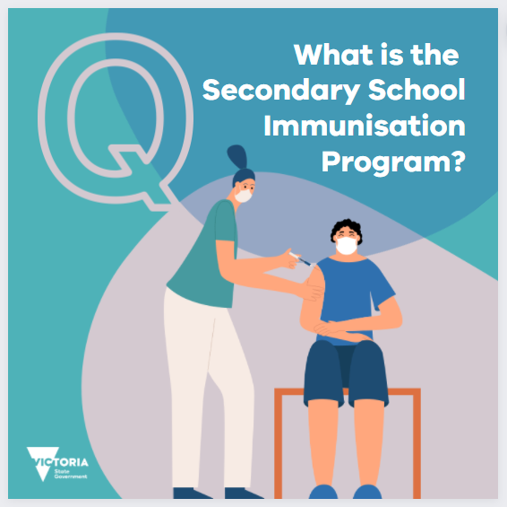

To receive this document in another format, email the Immunisation Program <immunisation@health.vic.gov.au>
Authorised and published by the Victorian Government, 1 Treasury Place, Melbourne. © State of Victoria, Australia, Department of Health, January 2025.

