

Social Media Pack 2025
Secondary School Immunisation Program
OFFICIAL

The purpose of this social media pack is to support Victorian secondary schools and local council immunisation providers to communicate to parents/guardians and secondary school students on the importance of receiving their immunisations under the Secondary School Immunisations Program (SSIP).
The Victorian Department of Health provides resources to deliver the SSIP at Secondary school immunisation program - Information for secondary schools and councils <https://www.health.vic.gov.au/vaccination-for-adolescents/secondary-school-immunisation-program>. This includes information for adolescents who may need to receive catch-up immunisation outside of school Adolescent vaccinations outside of school and catch-up immunisation <https://www.health.vic.gov.au/immunisation/adolescent-vaccinations-outside-of-school-and-catch-up-immunisation>.
Students can learn more about the immunisations they need and why they are important at the Better Health Channel <https://www.betterhealth.vic.gov.au/health/healthyliving/immunisation-in-secondary-schools>.

Post text | Accompanying asset  (use attached jpeg)
Year 7 and Year 10 secondary school students can receive free immunisations as part of the National Immunisation Program.  Vaccines given as part of the Secondary School Immunisation Program are delivered in school settings by nurse immunisers from local council immunisation providers.  You will receive information about providing or declining your consent for your child to be immunised. You might be asked to do this online, such as through your local council’s immunisation portal, or by filling in a consent form.  Your child can also receive immunisations at your GP, a local council immunisation service and at some pharmacies.  Learn more about the Secondary School Immunisation Program in Victoria at: https://go.vic.gov.au/3Culz8k | 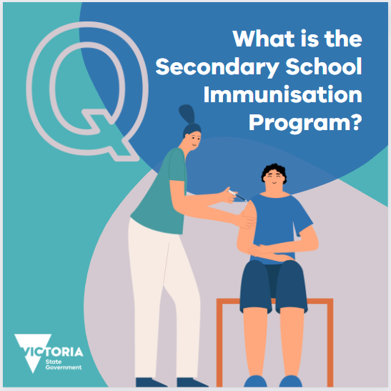  What is the Secondary School Immunisation Program?
Immunisation saves lives and is a proven and safe way to protect against diseases.  The protection provided by some childhood immunisations fades over time and needs to be boosted in adolescence.  Secondary school students are at an age when some vaccines will be most effective and provide protection before possible exposure to a disease.  Making sure your child receives their secondary school immunisations will help to keep them healthy and well through secondary school and into adulthood.  Local councils provide the Secondary School Immunisation Program. For adolescents not attending school, vaccinations are available from your local GP, pharmacy or other immunisation provider.  Learn more:  https://go.vic.gov.au/3Culz8k | 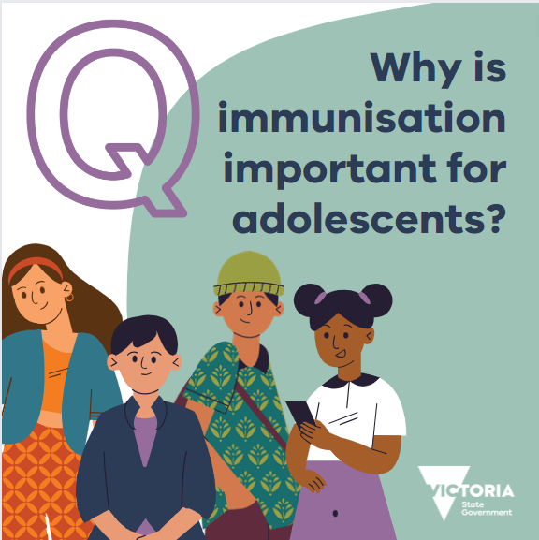  Why is immunisation important for adolescents?
Some immunisations are routinely provided free of charge to all Victorian secondary school students.  Students in Year 7 (or aged 12 to 13) receive the human papillomavirus (HPV) vaccine and the diphtheria, tetanus and pertussis (whooping cough) combined vaccine.  Students in Year 10 (or aged 14 to 16) receive the Meningococcal ACWY vaccine.  Your child’s school will support your local council to deliver these important immunisations, as part of the Secondary School Immunisation Program They will communicate with you about upcoming immunisation sessions.  You will receive information about providing or declining your consent for your child to be immunised. You might be asked to do this online, such as through the Central Immunisation Records Victoria (CIRV) portal, or by filling in a consent form.  Learn more: https://go.vic.gov.au/3Culz8k | 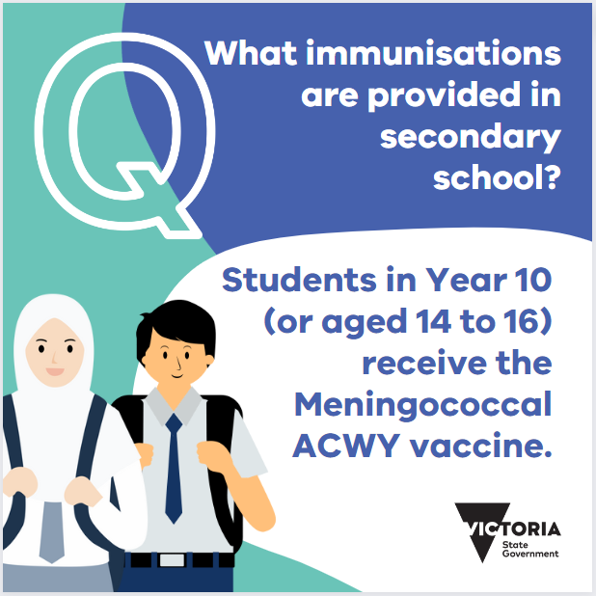  What immunisations are provided in secondary school?  Students in Year 10 (or aged 14 to 16) receive the Meningococcal ACWY vaccine.  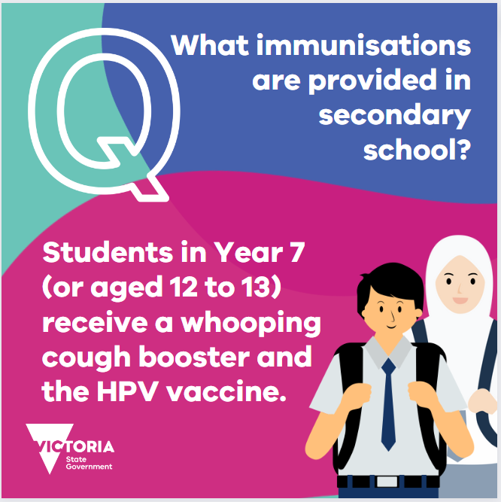  What immunisations are provided in secondary school?  Students in Year 7 (or aged 12 to 13) receive a whooping cough booster and the HPV vaccine.
Consent via printed consent forms  If you have a child in Year 7 or Year 10 at secondary school in 2025, look out for immunisation information and consent information coming home with your child.  Parents or guardians must complete the consent section on the consent form for your child to receive immunisation.  You can say no to the offer of free, secondary school-based immunisation for your child. If you wish to do so, you should still return the consent section of the form to the school, marked as 'declined'.  When your child brings the information and consent form home, take time to talk with your child about vaccination – why it’s important and how you both feel about it. If you have any questions that are not answered by the information provided within the consent form, contact your GP or your local council immunisation service.  Learn more: https://go.vic.gov.au/3Culz8k | 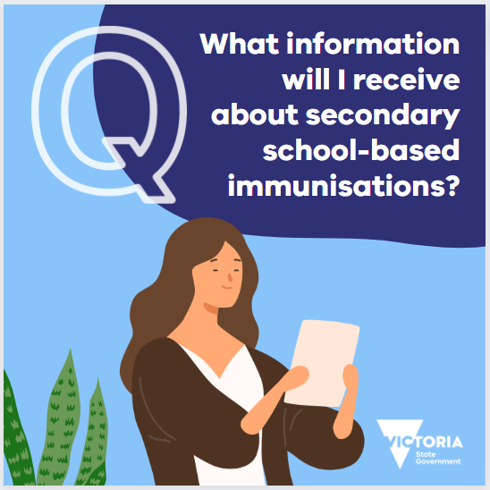  What information will I receive about secondary school-based immunisations?
Online consent  If you have a child in Year 7 or Year 10 at secondary school in 2025, look out for immunisation information and consent information that is sent to you.  Parents or guardians must complete the consent section on the relevant online portal (such as the Central Immunisation Records Victoria portal, or CIRV) for their child to receive immunisation.  You can say no to the offer of free, secondary school-based immunisation for your child. If you wish to do so, you should decline your consent online.  When you receive the information, take time to talk with your child about vaccination – why it’s important and how you both feel about it. If you have any questions that are not answered by the information provided with the consent form, contact your GP or your local council immunisation service.  Learn more: https://go.vic.gov.au/3Culz8k | 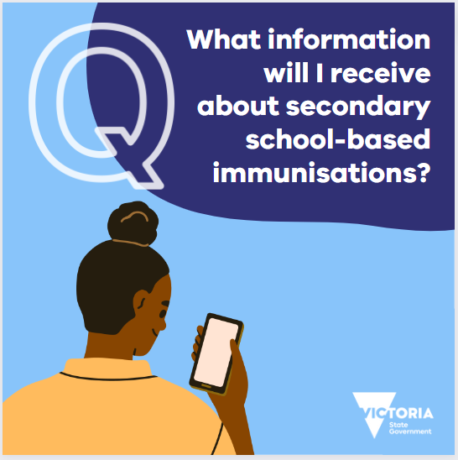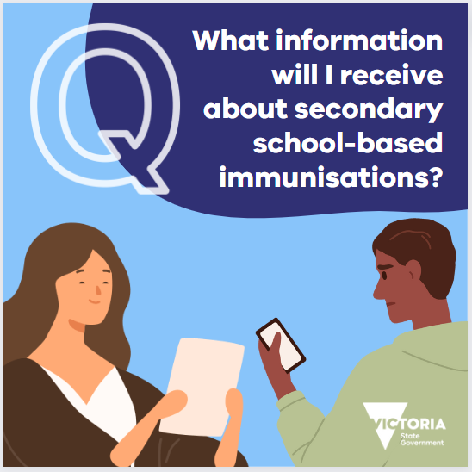  What information will I receive about secondary school-based immunisations?
Yes, vaccines are safe. The vaccine development process is very thorough. All vaccines used in Australia are rigorously tested by the Therapeutic Goods Administration before and after they are approved.  Even once vaccines are in use they continue to be monitored for safety and effectiveness.  Immunisations are the best way to keep your child safe from harmful diseases. When you protect your child from these diseases, you also protect others in your family and community who cannot be immunised, by limiting the spread of disease.  At secondary school-based immunisation sessions, students are vaccinated by immunisation nurses who are specially qualified to provide this service. Your local council works with your child’s school to provide a safe environment for students, staff and the immunisation team.  More information: https://go.vic.gov.au/3Culz8k | 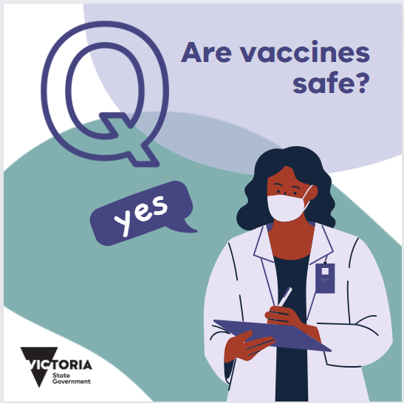  Are vaccines safe?
If your child has missed any of their secondary school-based immunisations, speak to your school, GP, pharmacy, or local council immunisation service about how they can catch up. Many community pharmacies offer free immunisations to eligible adolescents.  To see if your child is due for any immunisations, check your child’s immunisation history statement on the Australian Immunisation Register using your MyGov account. If your child is over 14 years old, they will need to access their immunisation history statement themselves through their own MyGov account or the Medicare mobile app.  Learn more about missed immunisations: https://www.health.vic.gov.au/immunisation/adolescent-vaccinations-outside-of-school-and-catch-up-immunisation | 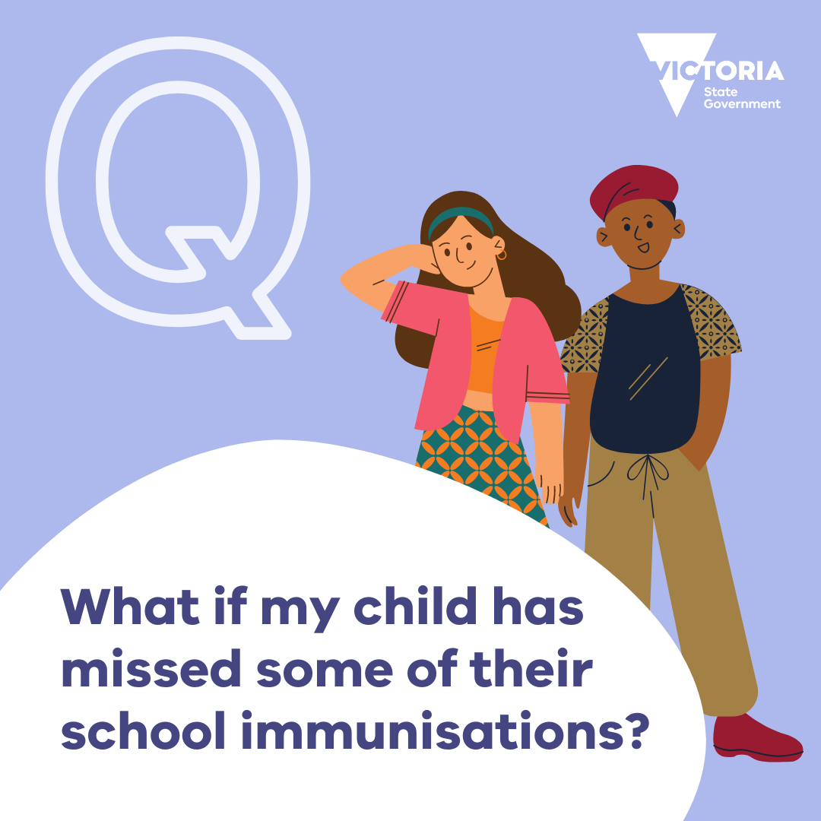  What if my child has missed some of their school immunisations?

