
Victorian guideline on carbapenemase-producing organisms
For residential care facilities
Version 1.1
OFFICIAL

Version History
Version number | Comment | Date of approval
Version 1.0 | New guideline released that supersedes the Victorian guideline on carbapenemase-producing Enterobacteriaceae for long term residential care facilities. New guideline includes additional CPO made notifiable. | 27 October 2023
Version 1.1 | - References to and links to new online CPO surveillance form.  - Communicable Disease Prevention and Control Unit updated to Communicable Disease Section to reflect updated Department of Health structure.  - Timeframe for diagnostic laboratories to report a suspected or confirmed CPO updated from one to within five business days of detection.  - Determining close contacts information updated.  - Added reference to new Aged Care IPC guide. | 15 April 2025

To receive this publication in an accessible format phone Communicable Disease Section on 1300 651 160, using the National Relay Service 13 36 77 if required, or email <infectious.diseases@health.vic.gov.au>.
Authorised and published by the Victorian Government, 1 Treasury Place, Melbourne.
© State of Victoria, Australia, Department of Health, April 2025.
Available on the Department of Health Infection Control Guidelines website <www.health.vic.gov.au/infection-control>.

Acknowledgements
This guideline was developed by the Communicable Diseases Section of the Department of Health. Recommendations were derived from existing best practice documents, literature review and expert opinion.
We gratefully acknowledge the feedback received from the members of the Victorian AMR Incident Management Team and residential care facility and health service infection prevention and control units or leads.
This guideline will remain open to continued review. The experience of residential care facilities in applying this guidance will be invaluable as we go forward.

Contents
Forward 3
Acronyms and abbreviations 6
Glossary 7
Section 1: Background 9
Purpose of the Victorian CPO guidelines for RCFs 9
Scope of the Victorian CPO Guidelines 9
Who should use this guideline? 9
What are the facts about CPO? 9
What’s the situation with CPO locally? 10
Section 2: Governance 12
Requirements for management plans for CPO 12
Roles and responsibilities 12
Where to seek further advice re CPO 14
Section 3: Screening, detection and investigation of CPO 15
Who to screen? 15
Choice of screening specimens 15
When a new CPO case is identified 16
Clearance of cases 17
Staff screening 17
Environmental screening 18
Section 4: Management and control of CPO 19
Prevention of CPO acquisition 19
Treatment of CPO infection 19
Preventing the spread of CPO 20
General measures to prevent the transmission of CPO 20
Specific measures to use for residents with CPO 22
Communication 24
Requirements for reporting 25
Audits and monitoring 26
Section 5: Actions for an outbreak of CPO 27
Data collection when an outbreak is suspected 27
Transmission Risk Area (TRA) 27
Communication of TRA to public and private health services and RCFs 27
Screening 28
Communication 29
Transmission-based precautions 30
Clearance of contacts 30
Limiting activity and unit/facility closure 30
Residents’ movement within the RCF 30
Staff, resident and equipment cohorting 30
Cleaning and disinfection 31
Use of indwelling devices 31
Audits of infection control processes 31
Requirements for reporting 31
Appendices 32
Appendix A: Contact precautions signage 32
Appendix B: Example of transfer letter for residents with CPO 33
Appendix C: Example CPO management self-audit checklist for RCFs 34

Acronyms and abbreviations
ABHR alcohol-based hand rub
AMS antimicrobial stewardship
CPA carbapenemase-producing Acinetobacter spp.
CPE carbapenemase-producing Enterobacterales
CPO carbapenemase-producing organism
CPP carbapenemase-producing Pseudomonas spp.
ELR electronic laboratory reporting
FIMT Facility Incident Management Team
IPC infection prevention and control
LPHU local public health unit
MDU PHL Microbiological Diagnostic Unit Public Health Laboratory
PPE personal protective equipment
RCF residential care facility
TBP transmission-based precautions
the department Department of Health
TRA transmission risk area
AMR-IMT Victorian Antimicrobial Resistance Incident Management Team
VASRU Victorian Antimicrobial Resistance Surveillance and Response Unit
VICNISS Victorian Healthcare Associated Infection Surveillance Coordinating Centre

Glossary
Carbapenemase-producing Acinetobacter (CPA) | The term CPA refers to bacteria that are members of the Acinetobacter genus that have been identified to carry a gene that makes them resistant to the carbapenem group of antibiotics.
Carbapenemase-producing Enterobacterales (CPE) | The term CPE refers to bacteria that are members of the order Enterobacterales that have been identified to carry a gene that makes them resistant to the carbapenem group of antibiotics.
Carbapenemase-producing organism (CPO) | For the purpose of this guideline, the term CPO is a collective term that refers to Enterobacterales, Acinetobacter spp. and Pseudomonas spp. that have been identified to carry a gene that makes them resistant to the carbapenem group of antibiotics. Carbapenemase-producing organisms that are not Enterobacterales, Acinetobacter or Pseudomonas are outside the scope of these guidelines.
Carbapenemase-producing Pseudomonas (CPP) | The term CPP refers to bacteria that are members of the genus Pseudomonas that have been identified to carry a gene that makes them resistant to the carbapenem group of antibiotics
Carbapenem group of antibiotics | The most common antibiotic in the carbapenem group is meropenem.
Case | A person that has had a clinical or screening specimen that has tested positive for a CPA, CPE or CPP.
Casual Contact | A casual contact is any other resident in the facility not classified as a close contact.  If a facility has an area, building or otherwise separated section of residents who have NO CONTACT (including for group activities) with residents in the affected area then they are not considered contacts for the purpose of these guidelines.
Close contact | Some criteria for determining close contacts include:  - Sharing a room and/or toilet, permanently or long-term.  - Resident friend who spends significant time with a case daily or near daily in the case’s room.  - Other regular contact with case. This applies especially if contact is diabetic; has an indwelling medical device; or functional impairment affecting hygiene practices.  Close contacts can be determined by the facility clinical services or IPC lead. If the facility requires assistance with this the LPHU or investigating team from VASRU may be consulted.
Colonisation | The term colonisation describes when a bacteria is present on a person without causing signs or symptoms of infection. Someone who is colonised still has the potential to spread the bacteria to others.
Frequently touched surfaces | As per national guidelines, surfaces can be divided into two groups – those with minimal hand contact (for example, floors and ceilings) and those with frequent hand contact (‘frequently touched’ or ‘high-risk’ surfaces). Frequently touched surfaces include doorknobs, bedrails, over-bed tables, light switches, tabletops and wall areas around the toilet in the patient’s room.
Infection | The term infection is used when microorganisms, such as bacteria invade the body’s tissues, causing damage to the tissues with subsequent signs and symptoms of infection.
Outbreak | An outbreak is defined as: two or more confirmed cases of CPO that are of the same type and with a possible link (such as a shared room), without an alternative explanation.
Transmission risk area (TRA) | A TRA is an area in which local transmission is occurring or is suspected to have occurred. In this case, CPO has spread from one person to another or from the environment to a person in a residential facility in Victoria.

Section 1: Background
Residential care facilities (RCFs) are different from other healthcare settings, such as acute care hospitals, in that people, often the elderly who are at increased risk for infection, are brought together in one setting and remain in the facility for extended periods of time. For most people in a RCF it is their home. Residents share common eating and living areas and participate in various group activities. Since residents interact freely with each other, controlling transmission of carbapenemase-producing organisms (CPOs) in this setting is challenging. When a patient with CPO is in an acute care hospital they are generally restricted to their room; however, in an RCF there is a need to balance the health and wellbeing needs of individuals and their community when considering prevention and control measures for CPO.

Purpose of the Victorian CPO guidelines for RCFs
The purpose of the Victorian CPO guidelines for RCFs is to:
- provide information on CPO and the associated risks
- provide a template for development of management plans for CPO
- outline recommendations on the assessment and screening for CPO
- provide advice on measures to manage CPO cases
- provide advice for actions required if CPO transmission occurs.

Scope of the Victorian CPO Guidelines
This guideline applies to all residential care facilities (RCFs) in Victoria. This refers to any public or private aged care, disability services or other congruent accommodation setting in Victoria where temporary or permanent residents are provided with personal care or health care by facility staff.
This guideline does NOT extend to other carbapenem resistant organisms that show resistance to carbapenem antibiotics by other mechanisms.

Who should use this guideline?
This guideline has recommendations that are relevant for a wide range of health professionals, including medical staff, nursing and allied health staff, personal care assistants and disability support staff.

What are the facts about CPO?

What are CPOs?
CPOs are bacteria that have developed resistance to a number of first-line antibiotics as well as carbapenems which are considered ‘last resort’ antibiotics for the treatment of serious infections. These bacteria have become resistant to carbapenems because they have acquired an enzyme (carbapenemase) which breaks down the antibiotic.
These bacteria are part of the normal flora of the gastrointestinal tract but have the potential to develop and spread antimicrobial resistance which can lead to serious infections such as bloodstream infections, pneumonia, urinary tract and wound infections.

Who is most at risk of getting CPO?
In Australia, CPO infections are not common. Risk factors for acquiring CPO include a recent history of medical care overseas, particularly in some areas of Europe, North America, the Middle East and Asia. Other people at risk of acquiring CPO are those who have had prolonged antibiotic exposure or have shared a room and/or bathroom with another person with CPO.
Most healthy people do not usually get CPO infections. However, it is important to know that some people may carry CPO in their body, such as in the bowel or a wound, without symptoms. This is called ‘colonisation’ (see Glossary). People who carry CPO are at risk of getting a CPO infection if they have an operation, especially on the prostate, or receive treatment involving medical devices and instruments such as ventilators, catheters, or intravenous drips.

How is CPO spread?
CPO can be found in multiple sites of the body such as the sputum, urine, wounds and skin lesions. CPE is usually found in the bowels. CPOs are usually spread person to person through contact with someone who is infected or colonised. CPOs may also be spread through contact with equipment or environmental surfaces contaminated with CPO.

How is CPO diagnosed?
CPO infections are diagnosed through laboratory testing which identify the bacteria and its antibiotic resistance. It is important for testing to occur in an appropriate and timely manner for appropriate treatment and to prevent onward spread.

What is the treatment for CPO?
There are limited options for treating CPO infections because the bacteria are usually resistant to many commonly used or recommended antibiotics. The few antibiotics which are effective tend to have multiple or major side-effects and are more expensive. As such, it is very important that people try to prevent an infection occurring in the first place.
People who carry CPO bacteria without having any symptoms do not require antibiotic treatment.

What does it mean to have a CPO?
People who are colonised may not know that they are carrying a CPO and may never develop serious infection. However, in some people, CPO can become a serious problem and may cause serious infections which can sometimes result in death.

What’s the situation with CPO locally?

In Australia
Australia has not recorded high levels of CPO cases (infection or colonisation) compared to Europe, North America, the Middle East and Asia. This may be in part due to its geographic isolation. This creates an opportunity for proactive measures to prevent, detect and contain CPOs and thereby limit their impact on human health.

In Victoria
Since 2012, an increasing number of CPOs have been identified in patients in Victoria. While many of these patients had a history of being admitted to an overseas healthcare facility, some patients likely acquired CPO from local transmission in Victorian health services. This presents an opportunity to implement targeted control measures. To better understand what is happening with CPOs in Victoria and to be able to implement appropriate risk mitigation strategies as required, CPE was made a notifiable condition in 2017 and CPP and CPA in 2019.
Most of the patients who have acquired a CPO locally have had several hospital admissions and episodes in sub-acute care (for example, rehabilitation facilities). A number of these patients are elderly, have multiple medical co-morbidities and it is likely that some patients have had time in RCFs. There has been little screening for CPO in such settings however, so the real extent of the problem is unknown. International reports tell us that there is a risk of CPO being carried among residents in RCFs. The risk of outbreaks is higher if individual cases or single transmissions are not identified and appropriate measures implemented to prevent further spread.

Section 2: Governance

Requirements for management plans for CPO
RCFs have a responsibility for the following actions in preventing and managing CPO.
- Minimise the risk of local transmission through prompt identification and management of CPO cases and the routine application of standard and transmission-based precautions.
- Maintain excellent communication when transferring residents to, and receiving residents from, health services.
- Provide a coordinated, transparent, accountable and collaborative response to any CPO case.
- Maintain high levels of staff awareness, competence and confidence in preventing and managing CPO cases.

Principles of management plans for CPO
Plans should incorporate the following principles:
- strategies for the prevention, detection and management of CPO
- compliance with recommended infection prevention and control (IPC) measures by facility personnel to limit local transmission of CPO
- education of staff (including induction for new staff) on CPO and IPC.

Content of management plans for CPO
Management plans for CPO should include all the essential areas which are covered in these guidelines.
Any facility staff member managing a suspected or confirmed case of CPO should be familiar with the required actions, how to check that these are in place and know who to contact for assistance.
Specifically, the following areas should be covered in any management plans for CPO:
- governance and communication
- awareness and prevention of CPO
- screening and detection of CPO
- IPC measures.

Roles and responsibilities

Victorian Department of Health (the department)
The department will be the first point of contact for reporting suspected or confirmed CPO cases and will maintain the database for all information collected during the investigation of cases.

Microbiological Diagnostic Unit Public Health Laboratory (MDU PHL)
MDU PHL is Victoria’s bacterial public health reference laboratory. They receive all isolates of suspected CPO and undertake confirmatory testing. Where required, they also undertake other testing and data analysis to establish local transmission and to support the Victorian Antimicrobial Resistance Incident Management Team (see below).

Local public health unit (LPHU)
LPHUs have responsibility for public health actions in response to CPO in their catchments. This includes liaising with health services, RCFs and clinicians to collect additional data required for each newly diagnosed CPO case.

Victorian AMR Response and Surveillance Unit (VASRU)
The VASRU is a term that describes the joint work of the department, MDU PHL and LPHUs in assessing and responding to CPO in Victoria.

RCFs
RCFs need to implement this guideline. They have a number of specific roles and responsibilities as outlined in each chapter of this guideline.

Diagnostic laboratories
The role of diagnostic laboratories is to identify suspected CPO, and to report suspected CPO results to the department. The diagnostic laboratory should notify the doctor who requested the original microbiological test of any suspected or confirmed CPO isolates.
Laboratories should refer to Section 5 of the Victorian guideline on CPO for health services V1.2. <https://www.health.vic.gov.au/infectious-diseases/victorian-guideline-on-cpo-for-health-services> for laboratory methods and reporting requirements.

Victorian AMR Incident Management Team (AMR-IMT)
The AMR-IMT supports and oversees all aspects of the public health, health service and RCF response to key antimicrobial resistant organisms, including CPO. It will oversee a range of actions, including coordinating a risk assessment, undertaking appropriate investigations, and determining control measures and actions required.
The AMR-IMT is chaired by the Victorian Chief Health Officer or delegate and will provide advice and guidance on required control measures based on the authority of the Public Health and Wellbeing Act 2008. The membership of the AMR-IMT will include expertise in public health medicine, microbiology, infectious diseases, epidemiology, IPC, and communications. A member from a Facility Incident Management Team (FIMT) (see below) may be invited to join the AMR-IMT. The AMR-IMT will be supported in its functions by MDU PHL, VICNISS and other agencies, who will perform roles such as assisting in collection of information and provision of advice and guidance.

Facility Incident Management Team (FIMT)
An FIMT should be established when transmission of CPO has been identified. An FIMT can provide best practice governance and oversight for a response to transmission of CPO within a facility.
An FIMT will be activated at the discretion of the RCF operator. Membership could include representatives from: the executive management (chair); the facility IPC lead (nurse); a personal care attendant (PCA) lead; and environmental services (cleaner).
External assistance may be provided through membership from a local acute care health service, for example: Infectious Diseases (Doctor); IPC Consultant; and Laboratory (Specialist Microbiologist or Microbiology Scientist). The LPHU in which the facility is located, may also be able to provide assistance with an FMIT.
The FIMT should ensure there is timely communication with the LPHU and/or department; all required data is collected and provided; and all control measures and actions as specified by the AMR-IMT are implemented, including audits.

Where to seek further advice re CPO
Further advice regarding the implementation of this guideline or general queries about the management of residents with CPO can be sought from the LPHU in which the facility is located or the department (phone: 1300 651 160 or email <amr.secretariat@health.vic.gov.au>).

Section 3: Screening, detection and investigation of CPO

Who to screen?

New Residents
It is recommended that all new residents to a RCF be assessed for the need to have CPO screening tests or to ascertain if they have been told that they had a CPO (infection or colonisation) in the past. This should be done by discussion with the resident and/or their family, their health practitioner or through review of any healthcare paperwork.
Consider the need for CPO screening tests in any new resident who has received care in an overseas healthcare or residential care facility in the past 12 months.
For residents who are being transferred directly from a health service (or another RCF), enquire about whether any CPO transmission is known to have occurred on the ward or unit during their admission or stay. The transferring service should inform the receiving RCF if the resident is suspected or confirmed has having CPO (or any other multi-resistant organisms) and advise on IPC precautions (and testing) if required.
Timely screening, transport of sample(s) to pathology and follow-up of results is important to ensure IPC precautions can be removed as soon as possible, where appropriate. Once screening is undertaken, results are usually available within 3-5 days upon receipt of sample(s) by the pathology service.
Flowchart 1: Recommended CPO screening for new residents
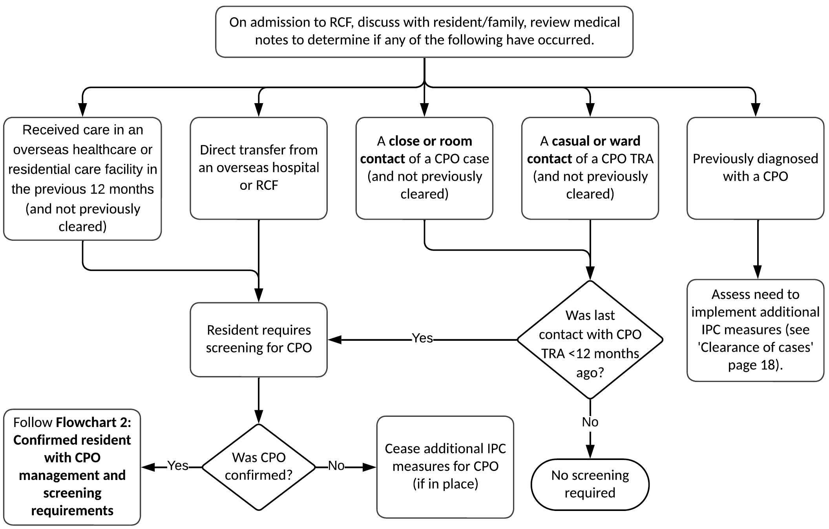

Transfer of residents undergoing screening from health services to RCFs
When a RCF is receiving a resident requiring CPO screening from a health service, the transferring service should undertake the screening, unless otherwise negotiated with the receiving RCF. If testing was not conducted prior to transfer, the receiving RCF should complete the testing.
While RCFs should ideally have a screening result before receiving residents, a result, however, is not needed for a transfer to take place.
RCFs should not refuse or delay the transfer of a resident who is being screened for CPO. Transfer can occur while CPO screening results are pending.
Where practicable, residents who are awaiting CPO screening results should be cared for in contact precautions (see Section 4) until a negative result is received.

Choice of screening specimens
Screening specimens for CPE, CPA and CPP are not always the same. For all three CPOs there are different requirements dependent on the clinical picture as indicated in Table 1 below. Recommended screening samples have been standardised to facilitate screening for additional multi-resistant organisms (MRO) which is often required, for example, when screening patients who have been in overseas hospitals. If unsure which samples to take, particularly if screening for multiple MROs, consult with your diagnostic microbiology laboratory.
Table1: Recommended screening samples
 | CPE | CPA and CPP
Recommended | Preferred options in order:  - Faeces  - Rectal swab* plus inguinal swab  - Rectal swab*  - Peri-anal* (should only be used for neutropenic patients) | Preferred options in order:  - Faeces plus an axilla/groin swab  - Rectal swab* plus an axilla/groin swab  Consider addition of:  - Buccal mucosa swab during TRA/outbreaks.
Consider obtaining these screening samples if devices or a wound are present | - endotracheal tube => collect swab or sputum  - enterostomy => collect swab  - urinary catheter (indwelling or suprapubic) => collect urine  - wound => collect swab | - endotracheal tube => collect swab or sputum  - urinary catheter (indwelling or suprapubic) => collect urine  - wound => collect swab
* The quality of rectal and perianal swabs is variable, particularly if samples are self-collected, therefore, faeces is always preferred. In all cases, follow appropriate collection, storage and transport methods as directed by your pathology service for the sample type(s) taken.

When a new CPO case is identified

Data collection for a case of CPO
Diagnostic laboratories refer all isolates of suspected or confirmed CPO to MDU PHL for confirmation and typing. Doctors who care for persons in RCFs are not required to report suspected or confirmed cases to the department. This is a laboratory requirement only.
If the isolate is confirmed as CPO, MDU PHL will notify the diagnostic laboratory. It is the responsibility of the diagnostic laboratory to advise the clinician who requested the specimen of the result.
The doctor who ordered the specimen will be contacted by the relevant LPHU to collect further information about the resident. Occasionally, the LPHU may need to contact the RCF directly to gather this information.
Completed CPO Surveillance Forms must be returned to the department either via the secure online form <https://forms.business.gov.au/smartforms/servlet/SmartForm.html?formCode=cd_cpos&tmFormVersion> or fax (1300 651 170) within two business days. Both versions of the form are available on the department’s website <https://www.health.vic.gov.au/infectious-diseases/carbapenemase-producing-enterobacteriaceae-surveillance-and-isolate-referral>.

Implement additional IPC measures
When an RCF is advised that a resident has been diagnosed with a CPO, additional IPC measures should be implemented to mitigate the risk of transmission within the facility. See Section 4 for further details.

Contact tracing
A key step in the risk assessment and management of CPO is identifying and screening close contacts of a newly identified resident with CPO. Some considerations for determining who may be considered a close contact are:
- Sharing a room and/or toilet, permanently or long-term.
- Resident friend who spends significant time with case daily or near daily in the case’s room.
- Other contact spending time with case regularly. This applies especially if contact is diabetic; has an indwelling medical device; or functional impairment affecting hygiene practices.
A person identified as a close contact should be screened and have IPC precautions and other recommendations applied until ‘clearance criteria’ are met (see clearance of close contacts).
Close contacts can be determined by the facility clinical services or IPC lead. If the facility requires assistance with this the LPHU or investigating team from VASRU may be consulted.

Clearance of close contacts
A close contact is considered cleared when two suitable specimens taken more than 48 hours apart are found to be negative for the same CPO as the case. Both specimens must have been taken more than seven days after the last date of sharing a room with a case or being classified as a close contact with the case (that is, after implementation of contact precautions for the case).
Flowchart 2: Confirmed CPO case management and follow up requirements
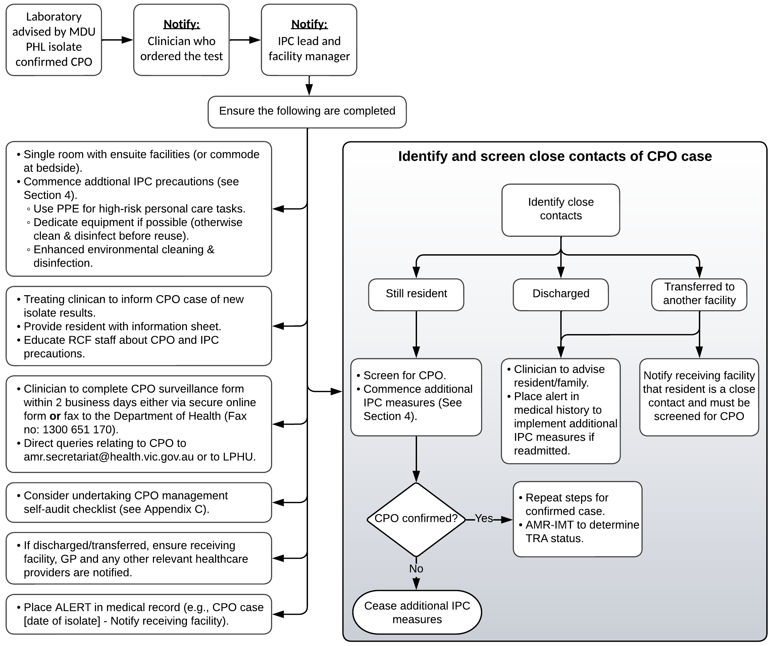

Clearance of cases
A person with CPO, whether colonised or infected, can excrete CPO intermittently for many months in their faeces and sometimes considerably longer, particularly with ongoing or repeated healthcare contact and/or antibiotic use. Generally, once a person is identified as a case of CPO, they should be considered potentially able to spread the bacteria indefinitely. Usually, the bacteria may remain present and able to be transmitted to other people, without the resident experiencing any signs or symptoms of a CPO infection (this is known as “colonisation”). While such residents can return negative screening results at times, CPO may remain in their body in small numbers, unable to be detected by current screening methods. However, when conditions in the body change, for example if the resident takes antibiotics, CPO bacteria may increase in number causing infection and/or transmission to other people.
While ‘clearance’ screening of cases may be undertaken, such screening should not be undertaken within 12 months of the most recent positive result. Clearance screening samples should include specimens as outlined in Table 1 above and should be repeated at least once 2-3 days after the first set have been taken. Consideration to ceasing additional IPC measures may be given if all samples return a negative result. Note: the final decision to cease IPC measures should be made in consultation with the facility’s IPC lead.
Regardless of clearance screening results which may indicate CPO has reduced to an undetectable level or been cleared, if a resident who has previously been diagnosed with CPO is transferred to hospital, the hospital must be advised of their past positive result. The hospital will need to undertake their own risk assessment to determine if the resident will need to be placed into a single room with contact precautions.

Staff screening
Staff do not routinely require to be screened for CPOs.

Environmental screening
Generally, environmental screening is not recommended. The AMR-IMT may recommend environmental screening if there is evidence of ongoing transmission in the facility despite implementation of recommended IPC measures. See Section 5 for further information regarding environmental screening.

Section 4: Management and control of CPO
As noted previously, RCFs are different from other healthcare settings. It is important to recognise that RCFs are also places of primary residence and community.
When a patient with CPO is in an acute care hospital they are generally restricted to their room; however, in a RCF there is a need to balance psychosocial needs with IPC needs. A person with CPO colonisation or infection should have the risk of transmission to others regularly reviewed by the IPC lead, and the least restrictive approaches applied to mitigate any ongoing risk.
Spread of CPO in RCFs can occur through person-to-person spread, contact with contaminated objects including shared resident equipment such as medical device/equipment and the facility environment. The measures to prevent and control transmission are therefore focused on these transmission pathways.

Prevention of CPO acquisition

Antimicrobial stewardship (AMS)
AMS is a crucial aspect in the prevention of CPO. National standards provide guidance in this space and future developments are likely in relation to the recent publication of the Australian Antimicrobial Resistance Strategy <www.amr.gov.au/australias-response/national-amr-strategy>.
AMS is equally important in the RCF setting and steps should be undertaken by all RCFs to implement an AMS program. For further advice regarding implementing an AMS program in your facility and/or participating in the Aged Care National Antimicrobial Prescribing Survey (acNAPS), see the National Centre for Antimicrobial Stewardship website <www.ncas-australia.org/aged-care>.

Use of indwelling devices
In accordance with good IPC practices, RCFs should regularly review the need for all indwelling medical devices (for example, urinary catheters) and check if they can be removed if no longer required.

Treatment of CPO infection
Treatment of residents with a clinical infection involving CPO must always be undertaken under the advice of an infectious diseases physician. The resident’s GP will need to work with an infectious diseases physician to manage care.
At the time of writing there are no proven ways to treat colonisation or to lead to clearance of CPO.
An information sheet for clinicians (called CPO – information for clinicians) is available on the department’s website <https://www.health.vic.gov.au/infectious-diseases/victorian-guideline-on-cpe-for-long-term-residential-care-facilities-version-11>.

Preventing the spread of CPO

How CPOs are spread
CPOs may also be spread through contact with hands or equipment with CPO on them or from contaminated environmental surfaces.
Specific resident-risk factors associated with a higher risk of spreading CPOs include:
- diarrhoea
- faecal incontinence
- colostomy or ileostomy
- copious or uncontained respiratory secretions or drainage from a wound/abscess
- presence of a urinary catheter
- residents who have difficulty understanding or require support with IPC precautions.
To help prevent the spread of CPO there are basic IPC precautions that all staff should always use for all residents. These are called standard precautions. Sometimes additional measures are required to prevent the spread of an infection or organism, these are called transmission-based precautions. The transmission-based precautions generally required to prevent the spread of CPOs are often called contact precautions.

General measures to prevent the transmission of CPO
The use of standard precautions is an essential IPC strategy for the successful prevention and minimisation of transmission of all infections between residents. Standard precautions will also protect staff from transmission of infections as well. Standard precautions include the elements outlined below.
For further IPC guidance, refer to the Australian Guidelines for the Prevention and Control of Infection in Healthcare (2019) <https://www.nhmrc.gov.au/about-us/publications/australian-guidelines-prevention-and-control-infection-healthcare-2019> or The Aged Care Infection Prevention and Control Guide (2024) <https://www.safetyandquality.gov.au/publications-and-resources/resource-library/aged-care-infection-prevention-and-control-guide>.

Hand hygiene
Hand washing with soap and water or using an alcohol-based hand rub (ABHR) is one of the most important IPC measures for preventing the spread of infectious organisms, particularly multi-resistant organisms. Emphasis should be placed on the importance of hand hygiene for staff, residents and visitors.
Facilities should have adequate hand washing facilities and maintain adequate stock of soap, paper towel and ABHR. Handbasins for staff should, wherever possible, be hands-free (for example, elbow operated) to facilitate appropriate hand hygiene practices and prevent recontamination of hands when turning off taps.

Staff
Hand hygiene should be performed before and after providing care for residents, particularly after toileting residents, contact with colonised/infected wounds/sites or contact with devices (for example, urinary catheter). The use of gloves does not remove the need for appropriate hand hygiene. Hand hygiene should be attended to before gloves are put on and immediately after they have been removed.
Staff should be made aware of proper hand hygiene techniques and rationale; when, where and how, known as the “5 moments for hand hygiene”. For more information about hand hygiene and promotional materials see the National Hand Hygiene Initiative website <https://www.safetyandquality.gov.au/our-work/infection-prevention-and-control/national-hand-hygiene-initiative>.
Note: ABHR can be used for most hand hygiene opportunities except for when hands are visibly soiled. Hands must be washed with soap and water when visibly soiled.

Residents
Residents should perform hand hygiene after toileting, before eating, prior to communal activities and when leaving their room. Staff should assist residents who are unable to perform hand hygiene by themselves due to physical, cognitive or other impairments.

Visitors
Remind visitors that they should perform hand hygiene before and after visiting any resident.

Aseptic technique
Appropriate aseptic non-touch technique should be used for all clinical procedures, such as wound dressings or emptying or changing urinary catheter bags.

Wound management
Ensure discharging wounds are covered with an appropriate dressing to protect the wound and contain discharges.

Personal protective equipment (PPE)
Wear appropriate PPE when it is anticipated that you may have contact with a resident’s blood or body fluids, mucous membranes, non-intact skin or other potentially infectious material or equipment. Depending on the activity or procedure being undertaken PPE required to prevent CPO transmission may include gown or apron, and gloves. Always perform hand hygiene before putting on PPE and immediately after removal of PPE.

Cleaning shared equipment
Shared equipment (for example, lifting machine, commode, thermometer) should be appropriately cleaned and disinfected or reprocessed between use by residents.
Where possible, items such as slings should be dedicated to one resident’s use and must be laundered before use for another resident.
Anything labelled as ‘single use’ must be discarded after use and not reprocessed or used on another resident. Items labelled ‘single-patient use’ may be cleaned (and disinfected if required) as per manufacturers’ instructions only for reuse on the same resident.

Routine environmental cleaning
Environmental surfaces should be adequately cleaned daily. Frequently touched surfaces, such as door handles and bed rails may require more frequent cleaning compared to other surfaces.
Further information about environmental cleaning principles, and the process and product selection for routine environmental cleaning can be found on the Australian Commission on Safety and Quality in Health Care (ACSQHC) website <www.safetyandquality.gov.au/our-work/infection-prevention-and-control/environmental-cleaning-and-infection-prevention-and-control-resources>. Note, while these resources are aimed at “health services” the principles outlined and guidance provided are applicable to RCFs.

Appropriate handling of linen and laundry items
No additional precautions are required for the management of linen and clothing items from residents with CPO. However, it is recommended that staff handle, transport, and process used linen or items requiring laundering (for example, clothing) in a manner that avoids contamination of surfaces and persons.
If linen or resident clothing is laundered onsite compliance with the Australian Standard for Laundry Practice AS/NZS 4146:2000 is required.

Waste management
Ensure waste is appropriately segregated into the different waste streams, for example, general, recyclable, or clinical and related waste. Storage and handling of all waste must meet the Environment Protection Authority (EPA) Victoria legislative requirements. For more information refer to EPA Victoria’s Clinical and Related Waste – Operational Guidance <www.epa.vic.gov.au/for-business/find-a-topic/manage-clinical-and-related-waste>.

Specific measures to use for residents with CPO
The measures outlined in this section are recommended to be implemented for residents with a CPO. In certain situations, additional IPC measures, or transmission-based precautions, are required to prevent the spread of CPO from residents suspected or confirmed as having CPO (colonised or infected).
Appropriate IPC precautions (to be used in addition to the standard precautions listed above) include the following elements.

Resident placement
Residents with a CPO should be placed in single rooms with an ensuite wherever possible, with highest priority given to residents who have conditions that may increase the risk of transmission of CPOs, for example, incontinence.
When single rooms are not available or sharing a room is unavoidable, consider the following.
- Resident who shares a room with a CPO case should not be incontinent or have indwelling medical devices or open wounds.
- Regularly screen roommate(s) for CPO (for example every 3–6 months).
- If roommate is transferred to a health care facility, notify the facility that the resident shares a room with a CPO case.
Residents with the same strain of CPO can be cohorted in the same room. When cohorting is not possible you will need to consider lesser alternatives to reduce the risk of transmission, for example, shared room but dedicated bathroom facilities, shared room and resident with CPO uses a dedicated commode etc.

Additional PPE
Gowns and gloves are not required for low-risk activities, for example, entering the resident’s room without engaging in prolonged close physical contact or resident personal care. Other examples of low-risk activities where gown/apron and gloves are not required include taking observations, delivering meal trays, or escorting a resident to a communal area.
When performing high–risk tasks that involve anticipated contact with bodily fluids, wounds, or medical devices use a gown or apron and gloves. Examples of high-risk activities include toileting, assisted showering, changing wound dressings or continence pads.
Gowns may be either disposable or reusable isolation gowns composed of polyester and polyester-cotton fabrics. Disposable aprons/gowns are single use and must be removed and disposed of appropriately after use. Fabric/reusable gowns must be laundered after each use and not hung up and used again. Always remove gowns/aprons and gloves before exiting the resident’s room and perform hand hygiene before and after all glove use.
If residents are sharing a room, PPE must be changed (and hand hygiene performed) between residents.
Visitors do not need to use gowns/aprons and gloves when visiting a resident in contact precautions unless they will be participating in personal care such as showering or toileting.

Equipment and instruments/devices
Dedicate use of non-disposable equipment to any residents with a CPO (for example, commode). If equipment must be shared (for example, lifting machine/hoist) between multiple residents, ensure the equipment has been cleaned and disinfected before use on another resident. In the case of shared hoists, either a dedicated resident sling is required, or the sling must be laundered before it can be used for another resident.

Environmental cleaning
When residents with a CPO are suspected or known to be present, routine cleaning should be intensified. Rooms of residents with CPOs should be prioritised with a weekly full clean. Daily cleaning and disinfection of the CPO case’s bathroom, frequently touched surfaces (for example, bed rails, overbed table, commode, toilet surfaces in resident bathrooms, doorknobs) and equipment in the immediate vicinity of the resident should be instituted.
When considering selection of a hard-surface disinfectant product, the agent should be effective against the vast majority of organisms that cause healthcare associated infections and for practical purposes have a fast kill time (or contact time). This will enable killing of organisms before the solution can dry, be removed or before the resident or staff are likely to re-touch the surface. Further information about the principles of product selection can be found on the Australian Commission on Safety and Quality in Health Care (ACSQHC) website <www.safetyandquality.gov.au/our-work/infection-prevention-and-control/environmental-cleaning-and-infection-prevention-and-control-resources>.
If facilities use an alternative method for cleaning and disinfection, the method must be validated to be equivalent to the above.
If using a no-touch method of surface disinfection as part of your environmental hygiene program (for example ultraviolet [UV-C] or hydrogen peroxide vapour) prior cleaning is required. Follow the manufacturer’s instructions when using the selected disinfectant (that is, correct amount, dilution, contact time, safe use and disposal) or no-touch method of surface disinfection.
A more thorough discharge clean (also known as a terminal clean) should take place when a resident is discharged, transferred or moved to another room according to the same recommendations above.

Participation in group activities and attending communal areas
It is extremely important to maintain a resident’s ability to socialise and have access to rehabilitation opportunities. Residents with a CPO can continue to participate in group activities unless they are unwell (for example, diarrhoea). Any oozing wounds should be covered with a dressing that contains the wound ooze. Residents with faecal incontinence can participate in group activities provided they are dressed and wearing a fresh continence pad.
For cases and uncleared close contacts:
- Avoid use of toilets outside of their room. Residents should be toileted in their own toilet to minimise potential contamination outside their room. If the toileting of a resident does need to occur outside their own room the toilet must be cleaned immediately after its use or use a commode and ensure it is cleaned as well.
- The resident should perform hand hygiene prior to participation in a group session. If using equipment as part of a group session, clean and disinfect equipment after use. Staff may need to assist residents with their hand hygiene.
Residents can attend a shared dining area and use regular dishes and cutlery. Dishes and cutlery used by residents with a CPO can be processed in the usual manner (for example, dishwasher) and do not need to be separated.

Staff and resident cohorting
Staff and resident cohorting is generally not applicable if there is no evidence of an outbreak.
If there are multiple residents with unrelated CPOs (not an outbreak), then consider managing these cases in a single area (for example, end of wing or floor) with dedicated personal care assistant staff.

Communication

Communication with residents and their families
It is important to communicate openly and effectively with residents who have been diagnosed with a CPO and their families. The issue of multi-resistant organisms (or “superbugs” as they are commonly referred to in the media) can be a source of real anxiety for residents and cause inappropriate stigmatisation and excessive actions.
Resident confidentiality must be maintained. A finding of a CPO in a resident’s sample is confidential resident information. Make sure the CPO case or guardian has told you who can be informed of the finding of CPO.
It is important to listen to expressed concerns and speak realistically about risk. Involve family and friends if the resident consents and ensure that there is a good understanding of what has been explained. Ask them to repeat back to you their understanding of the issue and correct any misconceptions.
A CPO Factsheet has been developed for residents and their families and is available on the department’s website <https://www.health.vic.gov.au/infectious-diseases/victorian-guideline-on-cpe-for-long-term-residential-care-facilities-version-11>. The factsheet can be used to form the basis of discussions with residents, family, and carers.

Staff education and communication
Educate staff about the emerging threat of CPOs and stress the importance of IPC precautions, that is, interviewing of new residents, hand hygiene, use of gowns and gloves, cleaning and disinfection of equipment and the environment. Ensure there is a mechanism to notify all staff that a resident requires additional IPC precautions, for example, signage visible on the resident’s door (note: any signage used should not disclose the resident’s confirmed or suspected diagnosis). An example of a “Contact Precautions” poster is in Appendix A, although such a poster may need to be adapted as PPE does not need to be put on every time staff enter the room, only when they provide close personal care.
Conduct in-service education on the affected ward or unit, covering all nursing staff or personal care attendants who may provide care to affected resident/s and to all cleaning staff. In addition, key medical, allied health and other relevant staff for that unit should receive education.

Communication to other facilities
If the resident is transferred to another facility, for example, an acute care hospital; provide clear documentation that the resident has a CPO (or had CPO in the past if clearance screening has been undertaken) and may require a single room with own ensuite, and additional IPC precautions. See Appendix B for an example of a transfer letter for residents with a CPO.

Resident alert and flagging systems
If the RCF can place alerts in a resident’s history the following alerts should be used.

CPO case
Alerts for cases of CPO are essential given the frequency of admissions in residents at high risk of acquisition. Even if a patient is cleared from requiring contact precautions, alerts for CPO cases should remain for life. This is primarily to alert health facilities should the resident be transferred when ill. These should be recorded in residents’ records and electronically wherever available.

Close contact
Alerts for close contacts should be recorded in the resident’s record until clearance criteria have been achieved.

Requirements for reporting
RCFs are not required to report suspected or confirmed cases to the department. Reporting is a laboratory requirement only (see Section 2, Diagnostic laboratories). Results should be reported by the laboratory regardless of whether these have arisen as sporadic cases or as part of a recognised local outbreak.
The department or LPHU may liaise with your facility to collect further information about the resident. The CPO surveillance form must be completed either via the secure online form<https://forms.business.gov.au/smartforms/servlet/SmartForm.html?formCode=cd_cpos&tmFormVersion> or returned to the department via fax (1300 651 170) within two business days. Both versions of the form are available on the department’s website <https://www.health.vic.gov.au/infectious-diseases/carbapenemase-producing-enterobacteriaceae-surveillance-and-isolate-referral>.
All queries regarding CPOs should be directed to the department by email <amr.secretariat@health.vic.gov.au> or the LPHU in which the facility is located.

Audits and monitoring
Compliance with IPC principles is vital in preventing the spread of CPOs and other significant bacteria. RCFs are encouraged to routinely audit IPC practices, for example, hand hygiene compliance, PPE use and environmental cleaning. An example audit tool can be found in Appendix C.
Further information regarding auditing/monitoring IPC practices can be found in the Australian Guidelines for the Prevention and Control of Infection in Healthcare (2019) <www.nhmrc.gov.au/about-us/publications/australian-guidelines-prevention-and-control-infection-healthcare-2019> or The Aged Care Infection Prevention and Control Guide (2024) <https://www.safetyandquality.gov.au/publications-and-resources/resource-library/aged-care-infection-prevention-and-control-guide>.

Section 5: Actions for an outbreak of CPO

Data collection when an outbreak is suspected
When there is evidence of local transmission (see definition of outbreak) in an RCF, the LPHU in which the facility is located will coordinate collection of any additional information that may be required by the AMR-IMT.
During an outbreak, the LPHU may also collect information on IPC measures used by the RCF to assess the effectiveness of the response.

Transmission Risk Area (TRA)
When there is evidence that local transmission has occurred within an RCF, the AMR-IMT may declare the facility or part of the facility a TRA. A TRA is defined as an area (a distinct geographical area or unit) where the following criteria are deemed to have been met by the AMR-IMT:
- two or more confirmed cases of genetically related CPO as determined by MDU PHL AND
- at least one case is a locally acquired case AND
- there is a plausible epidemiological connection between the two cases, either through geographic proximity or shared staff, equipment or other exposures in the healthcare setting as determined by the AMR-IMT
OR
- where acquisition from an environmental source is hypothesised, clustering in time and place without a direct patient to patient epidemiological link will also be considered.
If the AMR-IMT cannot reach a consensus regarding a TRA, the Victorian Chief Health Officer or delegate will have the final determination.
When an area is determined to be a TRA there will be additional screening requirements and other actions as specified by the AMR-IMT. The RCF should convene an FIMT as described in Section 2 of this guideline.

TRA actions
Using information collected via the CPO Surveillance Form and provided by the RCF, the AMR-IMT will determine the following:
- the period of risk of transmission of CPO to other residents (used to determine close and casual contacts)
- the TRA timeframe (start and end) dates
- screening requirements for the facility, for example, a once off screen of residents or weekly screening for a period until no further cases are found.
- any additional screening (for example, environmental screening) or IPC actions required to be implemented.

Communication of TRA to public and private health services and RCFs
Outcomes and recommendations of the AMR-IMT meetings will be communicated directly to the affected RCF. This communication will only be emailed to the:
- RCF executive
- facility manager
- IPC lead.
The department’s media unit will work with the facility management to coordinate communication. The spokesperson for the department must agree to any media messaging in advance of any external communications should this be required.
All other unaffected public and private health services will receive an email alert from the department directing them to refer to the restricted Victorian Healthcare Associated Infection Surveillance System (VICNISS) website <https://www.vicniss.org.au/> for status updates on Victorian TRAs.
Under the direction of the department, VICNISS maintains an up-to-date list of all active TRAs within a secure online portal. TRA information will remain listed within the portal until 12 months has lapsed since the end of the TRA. Access to this information is restricted to relevant health professionals from Victorian public and private health services and RCFs. Portal access can be granted to relevant staff required to view TRA information such as quality managers, infectious diseases clinicians, IPC consultants/leads and chief executives but not to the general public. Login access to the restricted area is at the discretion of the IPC coordinator or equivalent at each facility and/or VICNISS. For any enquiries regarding access/registration contact VICNISS via phone on (03) 9342 9333 or email <vicniss@mh.org.au>.

Screening

Resident Screening
When a new CPO case is identified, screening of contacts is a key step in the risk assessment to determine the extent of ongoing transmission (see Flowchart 2, page 18).
When an area has been designated a TRA, CPO screening of close contacts may be extended to include casual contacts or the entire facility (see Flowchart 3 below). Which residents will require screening will be determined by the AMR-IMT. Some of the factors used to determine which residents will require screening are the location of the TRA within a facility and how much other residents and staff interact with residents from the TRA.
Following designation of a TRA, the first round of screening should take place within 1 week. The results from this round of screening will determine the need for further screening (for example, if there is evidence of ongoing transmission weekly screening may be required).

Choice of screening specimen(s) for residents
For choice of screening samples see Table 1, page 16. Further advice can be obtained from VASRU; email <amr.secretariat@health.vic.gov.au>.
Flowchart 3: Local transmission/outbreak response requirements
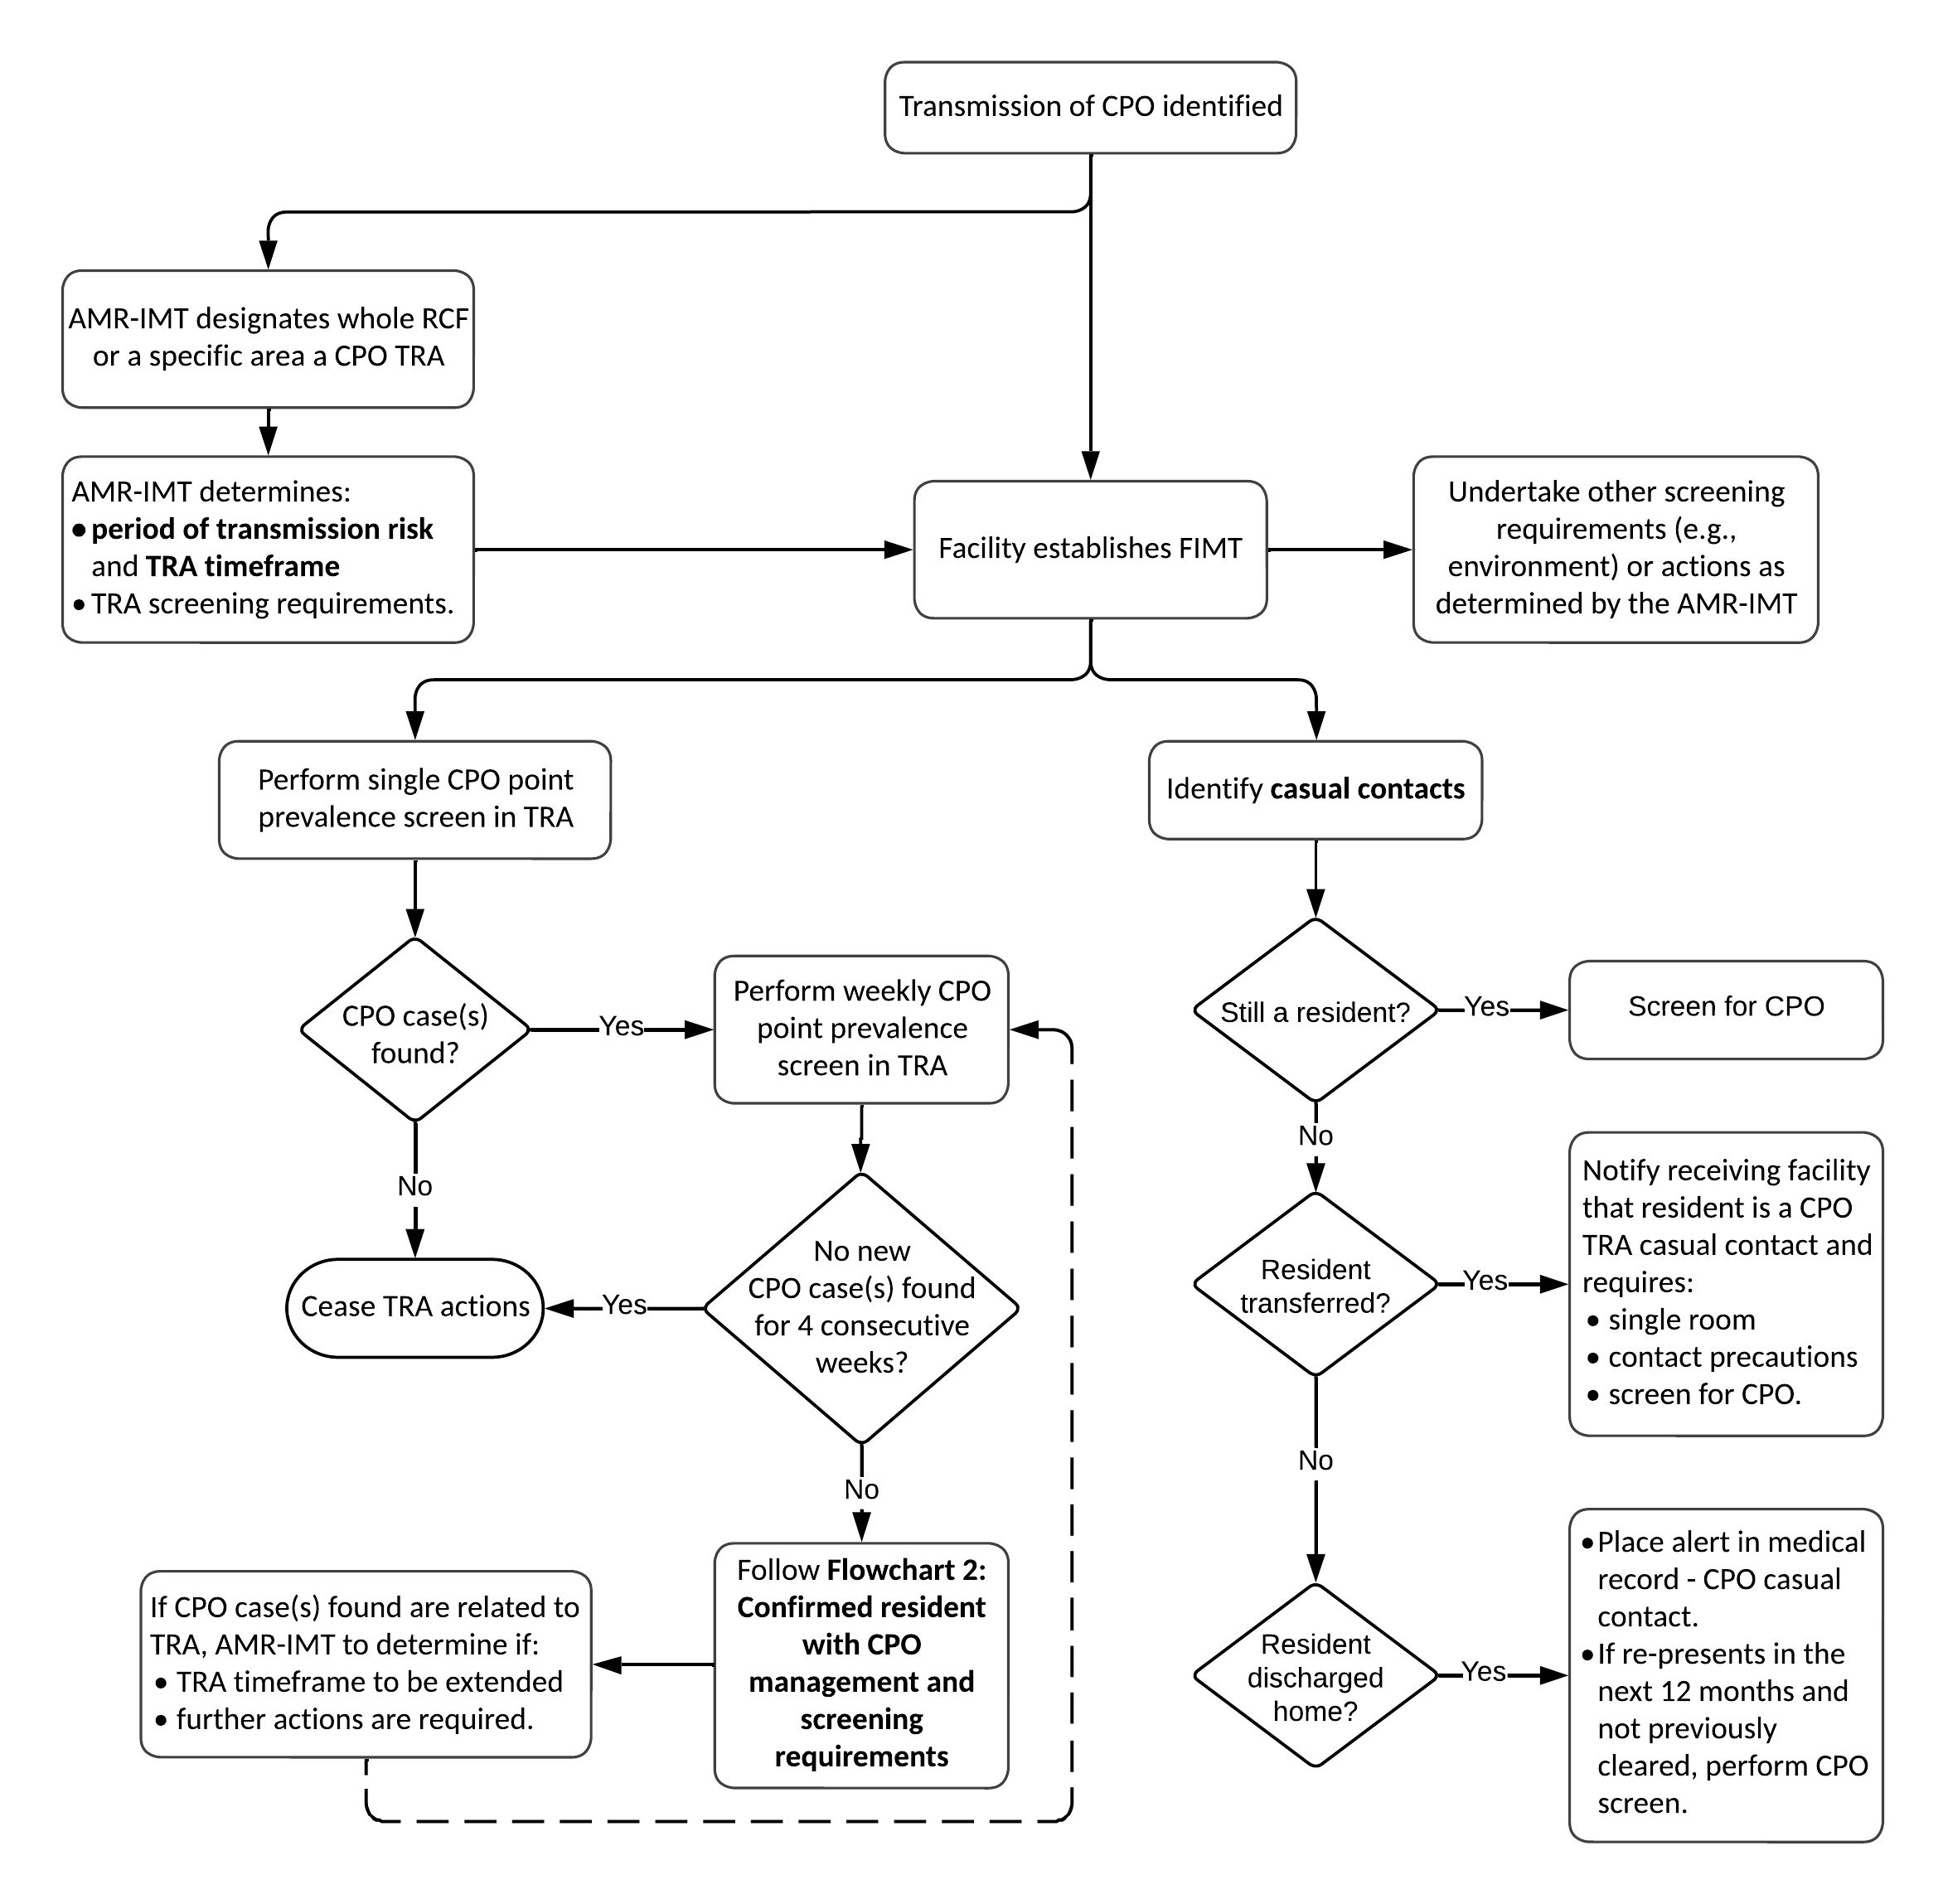

Environmental Screening
A facility will be advised by the AMR-IMT as to whether environmental screening is recommended. Generally, environmental screening is not recommended unless there is evidence of ongoing transmission and all other IPC measures are being complied with.
If activated, environmental screening may be considered for:
- toilets and surrounds
- hand basins or sinks
- shared resident equipment (for example, commode chair or lift machine)
- frequently touched surfaces, for example, call buttons, mattresses, beds, bedrails, bedside tables, tables, chairs, armchairs, windowsills, computers on wheels.
The method of specimen collection may vary slightly depending on the nature and shape of the surface/article to be tested. The Victorian guideline on environmental sampling for CPE (2018) outlines recommended sampling and laboratory methods for the isolation of CPE from the environment. This guideline can be found on the department’s website <https://www.health.vic.gov.au/infectious-diseases/victorian-guideline-on-environmental-sampling-for-cpe>. Further advice regarding environmental screening can be obtained from VASRU; email <amr.secretariat@health.vic.gov.au>.

Staff screening
Generally, screening of staff is not recommended unless there is evidence of ongoing transmission, all IPC measures are being complied with and evidence of an environmental source has been ruled out.

Communication

Communication with residents and carers
It is very important to communicate with residents and their families openly and accurately when there is evidence of transmission of CPO within a facility. Consent will need to be obtained from residents when screening for a CPO and as such information provided to them will need to address concerns the resident and their families may have.
An information sheet for residents and their families regarding screening (Screening for CPOs – Information for residents) is available on the department’s website <https://www.health.vic.gov.au/infectious-diseases/victorian-guideline-on-cpe-for-long-term-residential-care-facilities-version-11>.

Staff education and communication
Conduct in-service education across the entire facility, covering all nursing staff or personal care assistants who may provide care to affected resident/s and to all cleaning staff. In addition, key medical, allied health and other relevant staff should receive education. Staff may also require further information regarding the screening process and its relevance to them.
An information sheet for staff regarding screening (Screening for CPOs – Information for staff) is available on the department’s website <https://www.health.vic.gov.au/infectious-diseases/victorian-guideline-on-cpe-for-long-term-residential-care-facilities-version-11>.

Communication to other facilities
If a resident with a CPO is transferred to another facility, for example, an acute care hospital; provide clear documentation that the resident has a CPO, requires a single room with own ensuite, and additional IPC precautions, usually contact precautions. See Appendix B for an example of a transfer letter for residents with CPO.
During the initial phase of screening within the RCF, receiving facilities and health services will need to be notified when CPO contacts (close and casual) are transferred, and clearance criteria have not been met. Receiving facilities should place the resident into a single room with contact precautions and screen for CPO.

Transmission-based precautions

For CPO cases (infection or colonisation)
Contact precautions to be applied as for single cases in Section 4.

For close contacts
Contact precautions should be used as above until screening is completed and resident meets clearance criteria (see below).

For casual contacts
For practical reasons, it is not feasible to place all casual contacts into contact precautions. However, if a casual contact who has not yet received a negative result from screening is transferred to a health service or other RCF, the receiving facility must be advised the resident is a casual contact (similar to a ward contact definition from health services CPO guideline). As such, contact precautions should be applied until the casual contact has had appropriate CPO screening and is cleared.

Clearance of contacts
A close contact is considered cleared when two suitable specimens taken more than 48 hours apart are found to be negative for CPO. Both specimens must have been taken more than seven days after the last date of sharing a room with a case or being classified as a close contact with the case (that is, after implementation of contact precautions for the case).
A casual contact is considered cleared after one suitable specimen is found to be negative for CPO at any point in time.

Limiting activity and unit/facility closure
If after initial control measures for example screening, additional IPC measures such as contact precautions and enhanced environmental cleaning, there is ongoing transmission, then the AMR-IMT may consider closure of an affected TRA to new admissions.

Residents’ movement within the RCF
During the initial phase of screening within the RCF, all resident movement between the TRA and other residential areas within the facility should be minimised until advised by the AMR-IMT. This should also include group sessions such as the gym or hydrotherapy.

Staff, resident and equipment cohorting
Cohorting applies to the practice of grouping residents infected or colonised with a CPO together to confine their care to one area and prevent contact with susceptible residents (cohorting residents). During outbreaks, staff may also be assigned to a cohort of residents to further limit opportunities for transmission (cohorting staff).
When there is an outbreak with two cases at a particular time, risk assessment by the FIMT should take place to provide advice regarding the value of staff and resident cohorting.
When there is an outbreak involving several cases at a particular time, resident cohorting should be considered. Staff cohorting should be activated when there are sufficient cases, and it is advised by the FIMT. When staff cohorting is activated, priority should be given to cohorting personal care assistants, nursing staff, and allied health professionals.
When there is ongoing transmission despite recommended measures, the AMR-IMT will help decide on additional measures. This may include help to design and monitor a dedicated cohorting area in the facility or arranging for transfer of residents to an acute care ward designed for this purpose.
Equipment should wherever possible be dedicated to individual residents who require additional IPC measures such as contact precautions.

Cleaning and disinfection
Cleaning and disinfection is the same as for individual cases in Section 4.

Use of indwelling devices
When there is local transmission, review of use of all indwelling devices should be considered daily as part of routine practice.

Audits of infection control processes
In addition to regular local audits and staff education conducted by the facility, the LPHU may initiate an audit of the adequacy of adherence to these guidelines or – especially if transmission is ongoing – establish regular performance reviews.

Requirements for reporting
- Regular communication (daily in the acute phase) should occur between facility leadership and appropriate staff regarding the progress of the outbreak.
- Establish and maintain communication with VASRU. This will usually be done through a representative of the LPHU.

Appendices

Appendix A: Contact precautions signage
Ref: Australian Commission on safety and Quality in Health Care, Infection Prevention and Control Poster – Contact precautions poster (2022) <www.safetyandquality.gov.au/publications-and-resources/resource-library/infection-prevention-and-control-poster-contact-precautions-poster>

Appendix B: Example of transfer letter for residents with CPO
Dear Doctor

Re: CPO Case –Infection prevention and control precautions required

Thank you for your ongoing care of <name of Resident>.
This letter is to alert you that the above-named resident has been identified as having a multi-resistant organism known as carbapenemase-producing organism (CPO).
Date isolated: ____________________________________
Organism: ____________________________________
Specimen: ____________________________________
CPOs are resistant to carbapenem antibiotics by means of an acquired carbapenemase gene. These organisms pose a greater risk of transmission to other patients. This may lead to health service outbreaks or establishment of endemicity in Victoria. CPOs are endemic in some areas of Europe, North America, the Middle East and Asia and is an emerging risk in Australia. The Victorian guideline on CPO for health services (2023) outlines the proactive measures Victoria is implementing to prevent, detect and contain CPOs.
A person with CPO, whether colonised or infected, can excrete CPO intermittently for many months and some considerably longer, particularly with ongoing or repeated healthcare contact and/or antibiotic use. Generally, once a person is identified as a case of CPO, they should be considered potentially infectious indefinitely.
The Department of Health requires the health facility admitting this individual to undertake an assessment to determine the need for this resident/patient to be placed into a single room with contact precautions. This will need to take into account such aspects as the type of CPO the patient has been diagnosed with and the treatment plan, for example will antibiotics be commenced.
Contact your facility’s Infection Prevention and Control Consultant and/or Infectious Diseases Physician to discuss the infection prevention and control precautions required of this patient.
Further information regarding management of CPO cases in an acute hospital access the Victorian guideline on CPO for health services available on the department’s website <www.health.vic.gov.au/infection-control>.

Yours sincerely,

Appendix C: Example CPO management self-audit checklist for RCFs
Date / Time: _____________________________________
Person conducting audit: _______________________________________________
- Staff Training
1.1 | Do staff regularly attend in-service training on infection prevention and control? (If No, got to Q1.2) | Yes / No
 | Is this training compulsory? | Yes / No
 | How often is training provided? _______________________________________
1.2 | Are infection prevention and control training programs part of the orientation program for new employees? | Yes / No
- Hand hygiene
2.1 | Hand hygiene stations are easily accessible for staff near residents’ rooms? | Yes / No
2.2 | Does each hand hygiene station have:
 | - Hand basin with hands-free taps (for example elbow operated) | Yes / No
 | - Soap dispenser | Yes / No
 | - Paper towel | Yes / No
 | - Plastic-lined bin for waste disposal | Yes / No
2.3 | Are soap dispensers disposable and not refillable? (If Yes, go to Q2.4) | Yes / No
 | If refillable, are dispensers washed and dried before refilling? | Yes / No
2.4 | Does the facility provide 60-80% Alcohol-based hand rub (ABHR) | Yes / No
2.5 | Is ABHR and/or a hand hygiene station available in each residents’ room? | Yes / No
2.6 | Do the following communal areas have ABHR and/or a hand hygiene station available for residents and staff to use?
 | - Dining room | Yes / No
 | - Sitting room/television area | Yes / No
 | - Gymnasium | Yes / No
2.7 | Is ABHR and/or a hand hygiene station available near the entrance to the facility for visitors to use? | Yes / No
2.8 | Is appropriate signage visible for visitors advising them about the need for hand hygiene when visiting? | Yes / No
2.9 | Do staff receive training on how to wash their hands correctly and use an ABHR? (If No, go to Q2.10) | Yes / No
 | Is this training compulsory? | Yes / No
 | How often is training provided? _______________________________________
2.10 | Have staff received education about the 5 moments of hand hygiene? | Yes / No
2.11 | Has auditing of staff’s hand hygiene compliance been conducted in the facility? (If No, go to Q2.12) | Yes / No
 | What was the date and result of the last hand hygiene compliance audit? ____________________________________________
2.12 | Are all residents reminded or assisted to perform hand hygiene:
 | - before each meal | Yes / No
 | - after toileting | Yes / No
 | - before communal activities? | Yes / No
- Personal protective equipment (PPE)
3.1 | Are gloves available to staff and easily accessible for staff to wear when there is a risk of exposure to blood or body fluids /substances? | Yes / No
3.2 | Are gloves used once only and then discarded? | Yes / No
3.3 | Are disposable gowns/aprons disposed of after each use (that is not reused multiple times)? | Yes / No
3.4 | Do staff receive training on how to put on and take off PPE? (If No, go to Q3.5) | Yes / No
 | Is this training compulsory? | Yes / No
 | How often is training provided? __________________________________________
3.5 | Has an audit of PPE use been conducted? (If No, go to Q3.6) | Yes / No
 | What was the date and result of the last PPE audit? ___________________________________________________
3.6 | Are bins for disposal of PPE immediately inside the resident’s room? | Yes / No
- Cleaning of the environment and shared equipment
4.1 | Have cleaning staff received specific education about how to clean? (If No, go to 4.2) | Yes / No
 | Is this training compulsory? | Yes / No
 | How often is training provided? __________________________________________
4.2 | Is shared equipment (for example commode chair, lifting machine) cleaned after use/prior to use on another resident? | Yes / No
4.3 | Is shared group activity equipment (for example balls, hand weights) cleaned after each session? | Yes / No
4.4 | Have any cleaning audits been conducted? (If No, go to Q5.1) | Yes / No
 | What type of cleaning audit(s) are conducted?
 | - Observational assessment of cleanliness | Yes / No
 | - Objective assessment of cleaning (for example, fluorescent marker) | Yes / No
 | What was the result and date of the last cleaning audit? __________________________________________________
 | How frequently are cleaning audits conducted? _________________________________________________________
- Specific infection control measures for care of residents with CPO (Note: You may not be able to answer all questions if there are no CPO cases in your RCF)
5.1 | Does the facility have a guideline/protocol regarding the management of residents with multi-resistant organisms, including CPOs? | Yes / No
5.2 | Have all staff received specific education regarding CPOs? (If No, go to Q 5.3) | Yes / No
 | Is this training compulsory? | Yes / No
 | How often is training provided? __________________________________________
 | Do staff have access to written information pertaining to CPOs? | Yes / No
5.3 | Do all residents with a CPO have a single room with their own ensuite? (If Yes, go to Q5.4) | Yes / No
 | If No, are residents with a CPO assigned a dedicated bathroom? | Yes / No
5.4 | Are residents with a CPO always toileted in their own bathroom? (If Yes, go to Q5.5) | Yes / No
 | If No, are any toilets used by residents with a CPO outside their own room cleaned and disinfected immediately after use? | Yes / No
5.5 | Is there an alert mechanism (for example, signage in room) in use to alert staff to the need for contact precautions for residents with a CPO? | Yes / No
5.6 | Are gowns/aprons and gloves easily accessible for staff to wear when attending to close personal care of residents with a CPO? | Yes / No
5.7 | Do all staff use gown/apron and gloves for all close personal care (for example toileting) of residents with a CPO? | Yes / No
5.8 | Do the rooms of residents with a CPO receive a weekly full clean and disinfection? | Yes / No
5.9 | Are the following areas of the rooms of residents with a CPO cleaned and disinfected daily?
 | - Bathrooms | Yes / No
 | - Frequently touched surfaces | Yes / No
 | - Equipment/furniture in the immediate vicinity of the resident | Yes / No
5.10 | Is a TGA listed or registered disinfectant used to disinfect environmental surfaces in rooms of residents with CPO? (If Yes, go to Q5.11) | Yes / No
 | If No, what alternative method for cleaning/disinfection is used? _________________________________________________
5.11 | Is all equipment (for example, commode chair, lifting machine) used for residents with a CPO dedicated to their use? (If Yes, go to Q5.12) | Yes / No
 | List shared equipment: ____________________________________________________________________________________
 | Are these items cleaned and disinfected after use/prior to use on another resident? | Yes / No
5.12 | Is shared equipment used by residents with CPO in group activities cleaned and disinfected prior to use by other residents? | Yes / No
5.13 | Are other RCFs or health facilities (for example, acute-care hospital) advised when a resident with a CPO is transferred to them? | Yes / No
 | If Yes, is a template letter of transfer used to document all necessary information | Yes / No
If you wish to discuss results of this audit tool or seek further advice regarding CPO management, contact your LPHU or email the AMR Secretariat <amr.secretariat@health.vic.gov.au>.

