
Victorian guideline on carbapenemase-producing organisms
For health services
Version 1.2
OFFICIAL

Version History
Version number | Comment | Date of approval
Version 1.0 | New guideline released which supersedes the Victorian guideline on carbapenemase-producing Enterobacterales for health services. New guideline includes additional CPO made notifiable. | 15 August 2023
Version 1.1 | Changes to reflect integration of CPO to LPHUs. | 20 October 2023
Version 1.2 | - References to and links to new online CPO surveillance form.  - Communicable Disease Prevention and Control Unit updated to Communicable Disease Section to reflect updated Department of Health structure.  - Timeframe for diagnostic laboratories to report a suspected or confirmed CPO updated from one to within five business days of detection.  - ‘Management of a suspected case’ updated to reflect steps in flowchart 2 | 15 April 2025

To receive this publication in an accessible format phone Communicable Disease Section on 1300 651 160, using the National Relay Service 13 36 77 if required, or email <infectious.diseases@health.vic.gov.au>.
Authorised and published by the Victorian Government, 1 Treasury Place, Melbourne.
© State of Victoria, Australia, Department of Health, April 2025.
Available on the Department of Health Infection Control Guidelines website <www.health.vic.gov.au/infection-control>.

Acknowledgements
This guideline was developed by the Communicable Diseases Section of the Department of Health. Recommendations were derived from existing best practice documents, literature review and expert opinion.
We gratefully acknowledge the feedback received from the members of the Victorian AMR Incident Management Team, health service infectious diseases and infection prevention and control units, and public health and diagnostic laboratories.
This guideline will remain open to continued review. The experience of health services in applying this guidance will be invaluable as we go forward.
Contents
Acknowledgements iii
Acronyms and abbreviations 5
Glossary 6
Section 1: Background 12
Carbapenemase-producing organisms 12
Scope of the Victorian CPO guideline 12
Epidemiology of CPO 14
Section 2: Governance 15
Roles and responsibilities of all agencies 15
Section 3: Screening, detection, and investigation 19
Surveillance strategy 19
Choice of screening specimen(s) for patients 19
Screening requirements for all facilities 20
Actions when a single case of CPO is detected 23
Actions when local transmission of CPO is identified 28
Environmental screening 31
Section 4: Laboratory methods and reporting requirements 32
Methods for detecting suspected or confirmed CPO 32
Referral criteria for suspected CPO isolates 32
Requirements for primary diagnostic laboratories to report cases 36
Role of the reference laboratory 36
Environmental sample testing 36
Section 5: Management and control of cases 37
Medical therapy 37
Antimicrobial stewardship 37
Standard and transmission-based precautions 37
Additional measures for consideration 38
Subacute or rehabilitation healthcare setting 39
Ambulatory healthcare settings 41
Hydrotherapy 41
Appendices 43
Appendix A: Guide to microbiological testing and data collection 43
Appendix B: Reference documents and web addresses 45

Acronyms and abbreviations
AMR antimicrobial resistance
AMR-IMT Victorian Antimicrobial Resistance Incident Management Team
AST antimicrobial susceptibility testing
CDS calibrated dichotomous sensitivity test
CIM carbapenemase inactivation method
CLSI Clinical Laboratory Standards Institute
CPA carbapenemase-producing Acinetobacter spp.
CPE carbapenemase-producing Enterobacterales
CPO carbapenemase-producing organism
CPP carbapenemase-producing Pseudomonas spp.
CRE carbapenem-resistant Enterobacterales
CRO carbapenem-resistant organism
ELR electronic laboratory reporting
EUCAST European Committee on Antimicrobial Susceptibility Testing
HSIMT health service incident management team
IPC infection prevention and control
MDU PHL Microbiological Diagnostic Unit Public Health Laboratory
MIC minimal inhibitory concentration
MRO multi-resistant organism
NATA National Association of Testing Authorities, Australia
PCR polymerase chain reaction
PPS point prevalence screen
PRIS patients requiring pre-emptive isolation and screening
RCF residential care facility
the department Victorian Department of Health
TRA transmission risk area
VASRU Victorian Antimicrobial Resistance Surveillance and Response Unit
VICNISS Victorian Healthcare Associated Infection Surveillance Coordinating Centre

Glossary
Carbapenemase-producing Acinetobacter (CPA) | The term CPA refers bacteria that are members of the Acinetobacter genus that have been identified to carry an acquired (non-intrinsic) carbapenemase gene.
Carbapenemase-producing Enterobacterales (CPE) | The term CPE refers to bacteria that are members of the order Enterobacterales that have been identified to carry an acquired (non-intrinsic) carbapenemase gene.
Carbapenemase-producing organism (CPO) | For the purpose of this guideline, the term CPO is a collective term that refers to any organisms of the order Enterobacterales and genera Acinetobacter and Pseudomonas that have been identified to carry an acquired (non-intrinsic) carbapenemase gene. Carbapenemase-producing organisms that are not Enterobacterales, Acinetobacter or Pseudomonas are outside the scope of these guidelines.
Carbapenemase-producing Pseudomonas (CPP) | The term CPP refers bacteria that are members of the genus Pseudomonas that have been identified to carry an acquired (non-intrinsic) carbapenemase gene.
Carbapenem-resistant Enterobacterales (CRE) | The term CRE refers to bacteria that are members of the order Enterobacterales that have been found to have resistance to carbapenem antibiotics by any mechanism including carbapenemase gene acquisition.
Carbapenem-resistant organism (CRO) | The term CRO refers to any bacteria that have been found to have resistance to carbapenem antibiotics by any mechanism including carbapenemase gene acquisition.
Case | Case definitions:  Suspected case of CPE  A suspected case requires a species of Enterobacterales to be isolated from routine clinical or screening specimens (infection or colonisation), with any one of the following:  - meropenem minimum inhibitory concentrations (MIC) ≥ 0.5 mg/L  - meropenem disc diffusion zone < 28 mm by EUCAST or CLSI methods  - if disc zone < 25 mm always refer  - if disc zone 25-27 mm, only refer if piperacillin-tazobactam is also resistant  - meropenem disc diffusion zone < 6 mm by CDS method  - phenotypic resistance to any carbapenem where the MIC is above the clinical breakpoint as defined by CLSI or EUCAST or zone diameter suggests resistance by CDS  - positive colorimetric test for carbapenemase (for example, CarbaNP or Blue-Carba)  - positive or equivocal carbapenemase inactivation method (CIM) test (or accepted modified CIM method)  - positive carbapenemase gene PCR.  Note: The definition of a suspected case will capture patients who are colonised or infected with bacteria that are more likely to be either CRE or CPE. Infection prevention and control (IPC) actions should begin at the initial point of suspicion prior to confirming whether the bacterium is a CPE.
Confirmed case of CPE
A confirmed case requires a carbapenemase gene to be detected in a sample or isolate (for example, KPC-2-producing Klebsiella pneumoniae).
The term ‘confirmed case’ is intended to refer to a person who is either colonised or infected with a species of CPE.
Case (cont’) | Suspected case of CPA  A suspected case requires a species of Acinetobacter (typically Acinetobacter baumannii) to be isolated from routine clinical or screening specimens (infection or colonisation), with any one of the following:  - meropenem MIC > 8 mg/L  - meropenem disc diffusion zone < 15 mm by EUCAST, or ≤ 14 mm by CLSI methods, or < 6 mm by CDS method  - positive or equivocal colorimetric test for carbapenemase (for example, CarbaNP or Blue-Carba)  - positive or equivocal CIM test (or accepted modified CIM method)  - positive carbapenemase gene PCR.  Note: False negatives are common with CarbaNP, and to a lesser degree, CIM testing. Isolates with meropenem MIC > 8 mg/L should still be referred to MDU, regardless of other test results.  The definition of a suspected case will capture patients who are colonised or infected with bacteria that are more likely to be either CRA or CPA. IPC actions should begin at the initial point of suspicion prior to confirming whether the bacteria is a CPA.
Confirmed case of CPA
A confirmed case requires a carbapenemase gene to be detected in a sample or isolate (for example, OXA-23-producing Acinetobacter baumannii).
The term ‘confirmed case’ is intended to refer to a person who is either colonised or infected with a CPA.
Note: Isolates with intrinsic carbapenemases, for example, OXA-51, are excluded.
Case(cont’) | Suspected case of CPP  A suspected case requires a species of Pseudomonas to be isolated from routine clinical or screening specimens (infection or colonisation), with any one of the following:  - evidence of reduced susceptibility to meropenem AND piperacillin-tazobactam:  - meropenem MIC ≥ 4 mg/L, or disc diffusion zone < 24 mm by EUCAST, or < 19 mm by CLSI methods, or < 6 mm by CDS AND  - piperacillin-tazobactam MIC ≥ 32 mg/L, or disc diffusion zone < 18 mm by EUCAST methods, or ≤ 20 mm by CLSI methods, or < 6 mm CDS method  - positive colorimetric test for carbapenemase (for example, CarbaNP or Blue-Carba)  - positive or equivocal CIM test (or accepted modified CIM method)  - positive carbapenemase gene PCR.  Note: The definition of a suspected case will capture patients who are colonised or infected with bacteria that are more likely to be either CRP or CPP. IPC actions should begin at the initial point of suspicion prior to confirming whether the bacteria is a CPP.
Confirmed case of CPP
A confirmed case requires a carbapenemase gene to be detected in a sample or isolate (for example, VIM-4-producing Pseudomonas aeruginosa).
The term ‘confirmed case’ is intended to refer to a person who is either colonised or infected with a CPP.
Note: Isolates with intrinsic carbapenemases are excluded, for example, POM-1 in Pseudomonas otitidis.
Clearance | In this guideline clearance is a term that refers to applying criteria to determine that an individual no longer requires infection control precautions in relation to a risk of transmission of CPO. Further details are in Section 3.
Contact | An individual who is exposed to a person (a case) colonised or infected with a CPO in a manner that might allow transmission to occur or is exposed to a CPO-contaminated environment where there is an increased risk of acquisition of CPO. For the purposes of this guideline, two categories of contact are referred to – room contact and ward contact.  If a person meets the criteria for being considered a case of CPO (suspected or confirmed), they should be managed as a case of CPO and not as a CPO contact. Further details are in Section 3.  Room contact  A room contact is a person who shared a room in a health service with a case for ≥ 24 hours during the case’s period of transmission risk or was in a different room but shared a bathroom with a case for ≥ 24 hours.  Ward contact  A ward contact is any person who has been on a ward for ≥ 24 hours in the time period that the ward has been designated as a transmission risk area (TRA) (see TRA definition below).
Genome | An organism’s complete set of genetic material.
Genotype | Usually refers to the type (allele or variant) of a particular gene or genetic location, for example, a carbapenemase gene. Genotype contributes to phenotype.
Local transmission / outbreak | Local transmission is defined as:  - two or more confirmed cases, OR  - a confirmed case and an environmental isolate,  of genetically closely related CPO with a plausible epidemiological link, without an alternative explanation.  The definition is deliberately inclusive.
Period of transmission risk | The period of transmission risk is the time when a CPO case could potentially transmit CPO to another patient. The period is from the date of likely acquisition until the time that the case is placed into contact precautions (or discharged or transferred). The period of transmission risk is used for determining room contacts only.
Phenotype | The observable characteristics of an organism that result from the interaction of its genotype (total genetic inheritance) with the environment.
Point prevalence screen (PPS) | A PPS is when a point in time is chosen to screen a cohort of patients (for example, all patients on a ward on a particular date) at risk of being infected or colonised with a particular CPO.
Transmission risk area (TRA) | A TRA is an area (a distinct geographical area or ward) in which local transmission has been determined to have occurred by the Victorian Antimicrobial Resistance Incident Management Team (AMR-IMT). The timeframe for the TRA is the period when transmission may have occurred plus either four consecutive weeks of negative PPS or four weeks after the final patient involved in the transmission was discharged. The timeframe for the TRA is different from the period of transmission risk. These concepts are explained further in Section 3.

Section 1: Background

Carbapenemase-producing organisms
CPO are bacteria that have developed resistance to both first-line antibiotics and carbapenems, which are considered ‘last resort’ antibiotics for the treatment of serious infections. Carbapenemase genes encode enzymes that degrade carbapenem antibiotics. CPO most commonly include carbapenemase-producing Enterobacterales (CPE) which comprise the largest group of gram-negative bacteria causing human infection and includes common pathogens such as Escherichia coli, Klebsiella and Enterobacter species (see Box 1 below). These organisms are normal flora of the gastrointestinal tract but have the potential to cause infections such as bacteraemia, pneumonia, urinary tract, and wound infections; and disseminate antimicrobial resistance. CPO also include other less common organisms such as CPP (typically Pseudomonas aeruginosa) and CPA (typically Acinetobacter baumannii).

Scope of the Victorian CPO guideline

Victorian health services
This guideline applies to all paediatric and adult health services in Victoria. For the purpose of this guideline, the term ‘health service’ refers to public and private health services, hospitals and denominational hospitals that admit patients overnight. Where there are multiple campuses within a health service, each campus is referred to as a healthcare facility.
The guidance also applies to all satellite haemodialysis units and day oncology units, due to the nature of the patients treated and the risk of transmission of serious infections. Surgical day procedure centres are not within the scope of this guideline. If a known CPO case is admitted to a surgical day procedure centre, appropriate standard and transmission-based IPC precautions should be implemented.
Recommendations in this guideline supplant all other state and national IPC guidelines related to the management of CPO. They are relevant for all health professionals, including general and specialist clinical staff, allied health, microbiology laboratory staff and general practitioners.
Any isolation of a suspected or confirmed CPO (as defined in the glossary of this guideline) from clinical, screening, or environmental samples are in scope.

Victorian residential care facilities (RCF)
The Department of Health (the department) has developed a separate document for more specific guidance on CPO management within RCFs in Victoria. This document can be found on the department’s website <www.health.vic.gov.au/infectious-diseases/carbapenemase-producing-enterobacteriaceae-management-guidelines>.

Microbiological scope
This guideline provides recommendations around the detection and response to CPO (see Box 1 below). Carbapenemase gene families that have so far been detected in Enterobacterales, Pseudomonas species and Acinetobacter species in Australia include ACT, FRI, GES, IMI, IMP, KPC, NDM, NMC, OXA, SHV, SME and VIM.
Box 1: List of CPO
Enterobacterales include the following species:
Cedecea spp.  Citrobacter spp.  Cronobacter spp.  Edwardsiella spp.  Enterobacter spp.  Escherichia spp.  Ewingella spp. | Hafnia alvei  Klebsiella spp.  Kluyvera spp.  Leclercia spp.  Morganella spp.  Pantoea spp.  Plesiomonas spp. | Proteus spp.  Providencia spp.  Raoultella spp.  Salmonella spp.  Serratia spp.  Shigella spp.  Yersinia spp.
Non-Enterobacterales CPO include:
- carbapenemase-producing Pseudomonas spp., typically Pseudomonas aeruginosa
- carbapenemase-producing Acinetobacter spp., typically Acinetobacter baumannii.
Suspected CPO are isolates of Enterobacterales, Pseudomonas or Acinetobacter with phenotypic characteristics suggestive of carbapenemase gene presence, but not yet confirmed. Confirmed CPO are organisms from the list above where presence of an acquired carbapenemase-encoding gene has been confirmed by polymerase chain reaction (PCR) or genomic sequencing. Isolates from clinical, screening, or environmental samples are included in the scope of this guideline. Definitions of suspected and confirmed CPE, CPA and CPP cases are outlined in the Glossary.
The microbiological scope of this guideline is consistent with the Australian Commission on Safety and Quality in Health Care 2021 Recommendations for the control of CPE <https://www.safetyandquality.gov.au/our-work/infection-prevention-and-control/carbapenemase-producing-enterobacterales>. This reflects the greater risk that CPE carries for local transmission, including health service outbreaks and potential multi-jurisdictional spread.
The scope of this guideline does NOT extend to non-carbapenemase-producing CRO that are phenotypically resistant to carbapenems by mechanisms other than carbapenemase production. Although non-carbapenemase producing CRO pose a lower risk of transmission, it is important to note they are still clinically significant and may require precautionary infection and prevention control (IPC) actions similar to those described here for CPO (see Section 4). The necessary control actions are similar to those required for a variety of multi-resistant organisms, and are specified in the Australian Guidelines for the Prevention and Control of Infection in Healthcare <www.nhmrc.gov.au/about-us/publications/australian-guidelines-prevention-and-control-infection-healthcare-2019> and the Victorian Patient-centred risk management strategy for multi-resistant organisms <www.health.vic.gov.au/infectious-diseases/patient-centred-risk-management-strategy-for-multi-resistant-organisms>.

Epidemiology of CPO
The general burden of CPO in Australia is lower than that observed in some areas of Europe, North America, the Middle East and Asia. Regulation of antimicrobial usage and geographical isolation may have contributed to keeping national rates of CPO low.
Prior to 2012, identification of CPO in Victoria was limited to patients with recent overseas hospitalisation in high burden countries and low-level transmission of IMP producing bacteria in patients with long-term hospitalisation within Australia.
An increase in one particular carbapenemase, Klebsiella pneumonia carbapenemase (KPC), was observed throughout Victoria between 2012 and 2015. Many affected patients reported no recent travel. In 2015, an investigation concluded that KPC transmission in Victoria was driven by discrete healthcare associated outbreaks in a small number of healthcare facilities. In line with previous international recommendations, a statewide epidemiological and laboratory surveillance system for CPE in Victoria was commenced in 2015.
Systematic surveillance in Victoria has since detected a wide variety of carbapenemase genes. Data from 2016 to end of June 2022 highlight specific genes more likely to be associated with either local clusters and outbreaks or with overseas acquisition. IMP genes have dominated among local clusters and outbreaks (67%) followed by NDM genes (18%), KPC genes (10%) and a smaller number of other genes (approx. 4%). Carbapenemase genes most likely to be acquired overseas include NDM (57%), OXA-181 (14%), OXA-48 (10%), OXA-232 (5%), KPC (5%) and other genes (approx. 8%). Local transmission within and between Victorian health services has also occurred, enabling focussed control measures. Endemic spread of CPE in Victoria has not been observed outside these networks.
Carbapenemase genes may be transmitted between bacterial species on mobile genetic elements, such as plasmids. This means multi-species (or multi-clonal) outbreaks may occur, which were not captured as transmission events under the previous CPE guidelines.
In Victoria, NDM carbapenemase genes have historically been identified in people hospitalised in high burden countries, most commonly India, Greece and Thailand. However, since 2019, an increasing number of CPE cases in Victoria carrying the NDM-1 gene without travel history have been observed, indicating local acquisition. However, most of the non-travel associated cases have appeared in unique species, MLST, and/or phylogenetic groupings and possible transmission events could not be investigated or declared under the previous CPE guidelines. The rapid increase in case numbers and concentration in a small number of health services suggests non-clonal transmission of the NDM-1 gene may be occurring through dissemination of the NDM-1 containing plasmid or other mobile genetic elements, resulting in a potential multi-species outbreak. Further genomic analysis of the isolates is being undertaken, as well as systematic epidemiological data collection and analysis.
Central to this document is an acknowledgment of the time-limited opportunity for control afforded by Australia’s currently low rates of CPO, and that a public health approach beyond a single healthcare facility is essential to containment. These approaches are therefore focused on prevention and, where identified, timely elimination of local transmission.

Section 2: Governance

Roles and responsibilities of all agencies

Department of Health
The department is the lead agency for the statewide strategic response to CPO. The department engages with the Microbiological Diagnostic Unit Public Health Laboratory (MDU PHL) and Local Public Health Units (LPHUs) to assist with the surveillance and response to CPO in Victoria.
All suspected or confirmed CPO cases are notified to the department. The department also maintains the database for all information collected during the investigation of cases.
The relevant roles for the department include:
- maintaining a notifiable conditions surveillance and response capability and capacity
- providing oversight of quality and safety in Victorian health services
- activating and maintaining the AMR-IMT when required.

MDU PHL
MDU PHL is a surveillance partner of the department. MDU PHL undertakes work in assessing and responding to CPO in Victoria on behalf of the department. It is based at the Peter Doherty Institute for Infection and Immunity.
MDU PHL is Victoria’s bacterial public health reference laboratory. All reports and isolates of suspected and confirmed CPO are sent to MDU PHL. They perform further tests to confirm, characterise and sequence CPO isolates. Whole genome sequencing and bioinformatic analysis are used to determine how closely related certain isolates are to one another.
The combined MDU PHL and department information is used to establish whether local CPO transmission has occurred and supports the AMR-IMT in their response to transmissions.

LPHUs
LPHUs are responsible for data collection and implementing local CPO prevention and control measures. LPHUs liaise with IPC teams and/or clinicians (for example, general practitioners) to ensure CPO surveillance forms are completed in a timely manner and provide assistance with implementation of control measures when required.

Victorian AMR Response and Surveillance Unit (VASRU)
VASRU is a surveillance collaboration of the department, MDU PHL and LPHUs focussing on prevention and, where identified, timely elimination of local CPO transmission.

AMR-IMT
The role of the AMR-IMT is to support and oversee the public health and health service response to CPO. The AMR-IMT is activated at the discretion of the department in response to the identification of possible or confirmed local transmission of CPO within Victoria and will remain activated as long as coordination of risk assessment and management is required.
The AMR-IMT reports to the Victorian Chief Health Officer and will provide advice and guidance on required control measures based on the authority of the Public Health and Wellbeing Act 2008. Members of the AMR-IMT have expertise in:
- public health medicine
- microbiology
- infectious diseases
- epidemiology
- IPC
- communications
Appointment to these roles is at the discretion of the Victorian Chief Health Officer or delegate and may comprise internal and/or external participants.
A member from a health service incident management team (HSIMT) (see below) will be invited to join the AMR-IMT. The AMR-IMT will be supported in its functions by MDU PHL, and other agencies, who will perform roles such as assisting in collection of information and provision of advice and guidance.
The AMR-IMT oversees a range of actions, including coordinating a risk assessment, undertaking an epidemiological and microbiological investigation, determining the requirement for control measures and coordinating risk communication activities.
The key decisions that the AMR-IMT has the authority to make include:
- determining if transmission has occurred within a health service
- determining and communicating actions required of the health service to address the transmission
- determining any other investigation, control action or communication required
- audits of IPC measures and compliance with these measures by the affected health service.
The need for a coordinated response to the threat of CPO means that on occasion, there may be different views formed by individual professionals, healthcare facilities, a health service incident management team or the department relating to the CPO control actions and risk communication. The AMR-IMT will retain the responsibility via the chairperson for final decisions on any matter of assessment, control, or communication when there is not unanimous agreement as to the required approach.
Outcomes and recommendations of AMR-IMT meetings and decisions will be communicated directly to the affected health services. This communication will only be emailed to the:
- health service chief executive
- medical lead for IPC (if none, director of medicine)
- nursing manager or lead for IPC.
At the direction of the department, the Victorian Healthcare Associated Infection Surveillance System (VICNISS) will notify all other unaffected public and private health services via an email alert directing them to refer to the restricted VICNISS website for status updates on Victorian TRAs. On behalf of the department, VICNISS maintains an up-to-date list of all active TRAs (CPOs and Candida auris) within a secure online portal. TRA information will remain listed within the portal until 12 months has lapsed since the end of the TRA timeframe.

Access to this information is restricted to relevant health professionals from Victorian public and private health services and RCFs. Portal access can be granted to relevant staff required to view TRA information such as quality managers, infectious diseases clinicians, infection control practitioners and chief executives but not to the public. Login access to the restricted area is at the discretion of the IPC coordinator or equivalent at each facility and/or VICNISS. For any enquiries regarding access/registration phone VICNISS on 9342 9333 or email VICNISS <vicniss@mh.org.au>.

Health services
Health services must implement this guideline and have a number of specific roles and responsibilities as outlined within each chapter.

Management plans for CPO
All health services should develop plans for the prevention, detection and management of CPO. Early diagnosis of CPO colonisation or infection and implementation of the steps described in this guideline will allow for timely identification of patients most at risk of subsequent infection and enable timely implementation of IPC measures in health services to prevent transmission to other patients and the hospital environment.
This guideline is intended to provide a template to assist health services in the development of individual management plans.
Any health service staff member managing a suspected or confirmed case of CPO should be familiar with the required actions, how to check that these are in place, and who to contact for assistance. Non-laboratory clinicians are not required to report suspected of confirmed cases to the department. Reporting is a laboratory requirement only.
The following areas should be covered in any health services plan:
- governance and communication
- awareness and prevention of CPO
- screening and detection of CPO
- IPC measures.

Health Service Incident Management Team
An HSIMT is an approach that can provide best practice governance for a response to transmission of CPO within a healthcare facility. An HSIMT should be established when there is confirmation of local transmission of CPO.
An HSIMT will be activated at the discretion of the relevant lead at a health service. Membership could include representatives from:
- the health service executive
- the affected ward/unit – for example nurse unit manager, medical lead
- infectious diseases
- IPC
- microbiology
- environmental services
- communications/media.

The HSIMT should ensure that:
- there is timely notification of suspected cases
- all required data is collected and provided to the AMR-IMT
- all control measures recommended in this guideline or by the AMR-IMT are implemented
- any media and risk communication are undertaken in agreement with the department.

Staff communication and education
All health services should provide education to staff covering issues of high-risk patient identification and isolation, screening and transmission-based precautions. This education can be ‘bundled’ into regular hand hygiene or personal protective equipment education sessions.
When single (sporadic) cases or transmissions are identified, the affected ward or unit should receive further education, covering all staff who may provide care to the affected patients, and who may be involved in the environmental response (that is, cleaning).

Compliance with national standards and guidelines
All health services must comply with the Australian national standards and guidelines around IPC and ensure that compliance is monitored in accordance with the current iteration of Standard 3 of the National Safety and Quality Health Service (NSQHS) Standards <www.safetyandquality.gov.au/our-work/assessment-to-the-nsqhs-standards/>.
Local audits of CPO management are not required to be submitted to the department. In some circumstances, the department may initiate an audit of healthcare facility preparedness and response arrangements. This will be communicated in writing should it be required.

Diagnostic microbiology laboratories
The role of diagnostic laboratories is to identify suspected CPO, and to report suspected or confirmed CPO results to the department by fax (1300 651 170) or by electronic laboratory reporting (ELR) within five business days of detection. All clinical, screening and environmental isolates must be sent to MDU PHL for characterisation. After confirmation, the diagnostic laboratory should notify the healthcare facility IPC lead and executive as agreed locally.
For information on detailed actions and timelines, see Appendix A.

Section 3: Screening, detection, and investigation

Surveillance strategy
In Victoria, the surveillance strategy for CPO aims to detect all cases using a precautionary approach in order to understand the extent of the problem and to ensure IPC measures and outbreak management processes are applied whenever necessary.
The guideline supports these aims by describing the minimum requirements of health services for screening of patients for CPO. Based on an understanding of risk factors for acquisition, onwards transmission and increased risk for severity of illness (see Boxes 2, 3 and 4 below), the recommendations in this guideline describe the minimum frequency and extent of screening for different cohorts of patients.
The World Health Organization recommends surveillance of CPO infections as essential. This includes, clinical monitoring of signs and symptoms of infection, as well as laboratory testing and identification of carbapenem resistance among potential CPO isolates from clinical samples.
Surveillance cultures are also required to detect CPE colonisation. This should be guided by local epidemiology and risk assessment to include patients with a history of previous CPE, contacts of CPE cases, patients with a history of recent hospitalisation in endemic CPE settings/outbreaks, as well as patients with an increased risk of CPE acquisition and infection (for example, those admitted to intensive care units). This recommendation is based on global evidence that colonisation with CPE usually precedes or is co-existent with CPE infection. Early detection of CPE colonisation identifies patients most at-risk of subsequent CPE infection and facilitates timely implementation of IPC measures to prevent CPE transmission.
Active surveillance for CPA and CPP may not be as beneficial as for CPE but is certainly recommended during outbreak situations and follow-up of contacts of cases.
Surveillance cultures should be performed and processed as soon as possible after hospital admission or risk exposure, to minimise the risk of further transmission.
This section describes the minimum requirements for healthcare facilities in relation to contact tracing and screening. A healthcare facility may choose to undertake more extensive contact tracing based on a local risk assessment. This should be undertaken or overseen by an IPC professional or equivalent.

Choice of screening specimen(s) for patients
Screening specimens for CPE, CPA and CPP are not always the same. For all three CPOs there are different requirements dependent on the clinical picture as indicated in Table 1 below. Recommended screening samples have been somewhat standardised to facilitate screening for additional multi-resistant organisms (MRO) which is often required, for example, when screening patients who have been in overseas hospitals. If unsure which samples to take, particularly if screening for multiple MROs, consult with your diagnostic microbiology laboratory.

Table1: Recommended screening samples
 | CPE | CPA and CPP
Recommended | Options in order of preference:  - Faeces  - Rectal swab* plus inguinal swab  - Rectal swab*  - Peri-anal* (should only be used when clinically indicated, for example neutropenic patient) | Preferred options in order:  - Faeces plus an axilla/groin swab  - Rectal swab* plus an axilla/groin swab  Consider addition of:  - Buccal mucosa swab during TRA/outbreaks.
Consider obtaining screening samples if present or clinically relevant | - endotracheal tube  - enterostomy  - urinary catheter (intermittent or indwelling)  - wound | - endotracheal tube  - sputum  - urinary catheter (intermittent or indwelling)  - wound
* The quality of rectal and perianal swabs is an important consideration if choosing to use these samples, particularly if samples are self-collected.
In all cases, follow appropriate referenced collection methods for the sample type(s) taken.

Screening requirements for all facilities
In Australia, the current major risk factor for CPE acquisition is overseas travel, particularly when there is a history of contact with an overseas healthcare facility. However, there have been numerous CPE cases in which overseas travel was not an identified exposure route. Other risk factors associated with an increased risk of CPE acquisition include: extended hospitalisation, dialysis or chemotherapy in the previous 12 months, multiple and/or recent exposure to different antibiotic agents (including extended-spectrum penicillins, cephalosporins, fluoroquinolones and carbapenems), indwelling medical devices (such as central venous catheters, urinary catheters, biliary catheters or wound drains), organ or stem cell transplant recipients, mechanical ventilation, admission to an intensive care unit, diabetes mellitus, prior vancomycin-resistant Enterococcus (VRE) colonisation, and recent hospitalisation in a hospital with a known CPE outbreak or endemic transmission.
Depending on the individual risk assessment, pre-emptive isolation and the use of contact precautions is necessary until the results of screening cultures are available. This is a particularly important consideration for patients with a history of recent hospitalisation in regions with an increased risk of CPO acquisition.
The following patients are at significant risk of being infected or colonised with a CPO. The in-patient admission process should include relevant questions to identify patients requiring pre-emptive isolation and screening (PRIS) as indicated in Box 2.

Box 2: Patients requiring pre-emptive isolation and screening (PRIS)
- Direct transfer from an overseas hospital.
- Received care in an overseas healthcare facility or RCF in the previous 12 months.
- A room contact of a CPO case who has not achieved clearance criteria (see Clearance criteria for room contacts).
- A ward contact of a CPO case where transmission has occurred who has not achieved clearance criteria (see Clearance criteria for ward contacts).
On admission, these patients will require a single room (for patient placement recommendations see Section 5: Management and control of cases - Patient placement), contact precautions and screening. Health services may consider PRIS for additional high-risk patients as determined by individual risk assessment.
Those who are being screened based on an exposure event or other risk factors can be taken out of isolation once they have achieved appropriate clearance criteria for their category of risk, that is, room contacts (see Clearance criteria for room contacts), ward contacts (see Clearance criteria ward contacts) or overseas healthcare facility contacts (see below).
Flowchart 1: CPO screening requirements for all facilities
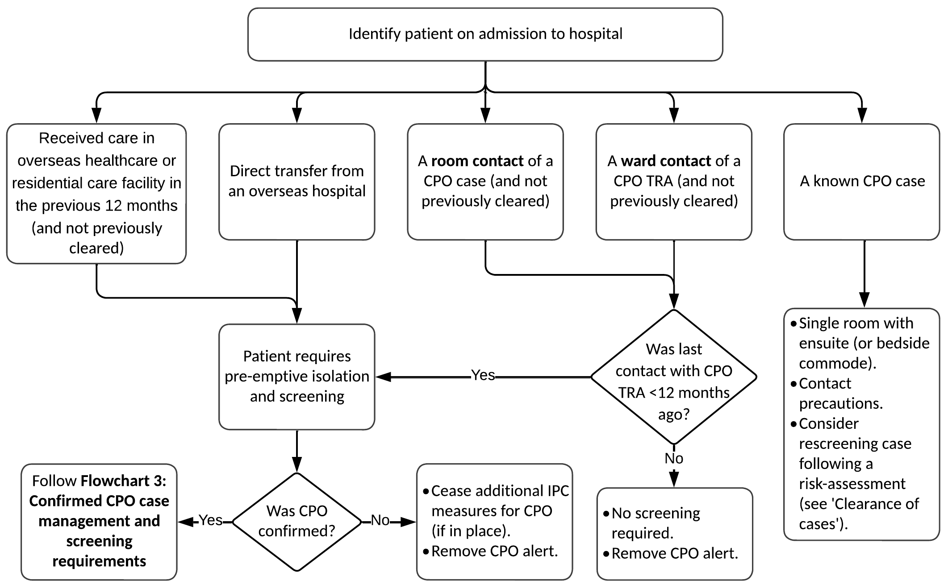

Clearance criteria for overseas healthcare facility contact
Patients who have received care in an overseas healthcare facility or RCF in the last 12 months do not need to be isolated and screened each time they are admitted as long as the following criteria have been met.
- All screening specimens were taken more than seven days after the patient’s most recent contact with an overseas facility.
- A faeces sample has been screened and the result is negative.
- All other relevant sites (for example wounds, urine if indwelling catheter) present at time of first admission have been screened following the most recent contact with an overseas facility.

Higher-risk patients – consider screening based on local risk assessment
Health services are encouraged to undertake hospital wide or high-risk ward PPS based on local risk assessments. The AMR-IMT may request the results of voluntary screening results as part of investigations into cases.
There are two types of high-risk patients that health services may consider screening: those who are at higher risk for acquiring CPO (see Box 3 below), and those at higher risk of developing severe illness due to CPO (see Box 4 below). Health services may decide to increase screening frequency of some or all these patients at their own discretion.
Box 3: Factors contributing to a higher risk of acquiring a CPO
- Prolonged hospital stay, for example, geriatric evaluation and management units.
- Multiple and/or recent exposures to different antibiotic agents, including extended-spectrum penicillins, cephalosporins, fluoroquinolones and carbapenems.
- An indwelling medical device, such as a central venous catheter, urinary catheter, biliary catheter or wound drain.
- An organ or stem-cell transplant recipient.
- Burns patients
- Respiratory patients on long-term antimicrobials (for example, people with cystic fibrosis)
- Admission to an intensive care unit.
- Received mechanical ventilation.
Box 4: Patients at higher risk for developing severe illness due to a CPO
- Patients with organ or stem-cell transplants.
- Patients admitted to an intensive care unit.
- Haematology patients.

Actions when a single case of CPO is detected

Management of the case

Suspected CPO cases
Upon identification of a suspected or confirmed CPO isolate, the primary laboratory should:
- Immediately notify IPC staff (or after-hours management staff) and treating clinicians of suspected or confirmed CPO cases so that appropriate IPC measures and necessary alerts can be implemented (see Section 5).
- Report all suspected and confirmed cases/isolates of CPO from clinical, screening and environmental samples to the department by sending the microbiological reports to Communicable Disease Section by fax (1300 651 170) or ELR within five business days of detection. Results should be reported regardless of whether these have arisen from sporadic cases or as part of a recognised local outbreak.
- Ensure the isolate is referred immediately to MDU PHL for further confirmation and typing along with the CPO isolate referral form. Download the form (FM2458) from the department’s website <www.health.vic.gov.au/infectious-diseases/carbapenemase-producing-enterobacteriaceae-management-guidelines> or the MDU PHL website <http://biomedicalsciences.unimelb.edu.au/departments/microbiology-Immunology/research/services/microbiological-diagnostic-unit-public-health-laboratory#services>.
If a suspected case is rejected by MDU PHL (that is, a carbapenemase gene has not been detected), a revision of IPC measures required for the case should occur as per the Australian Guidelines for the Prevention and Control of Infection in Healthcare <https://www.nhmrc.gov.au/about-us/publications/australian-guidelines-prevention-and-control-infection-healthcare-2019> and the Victorian Patient-centred risk management strategy for multi-resistant organisms <www.health.vic.gov.au/infectious-diseases/patient-centred-risk-management-strategy-for-multi-resistant-organisms>.
Flowchart 2: Suspected CPO case reporting and management requirements
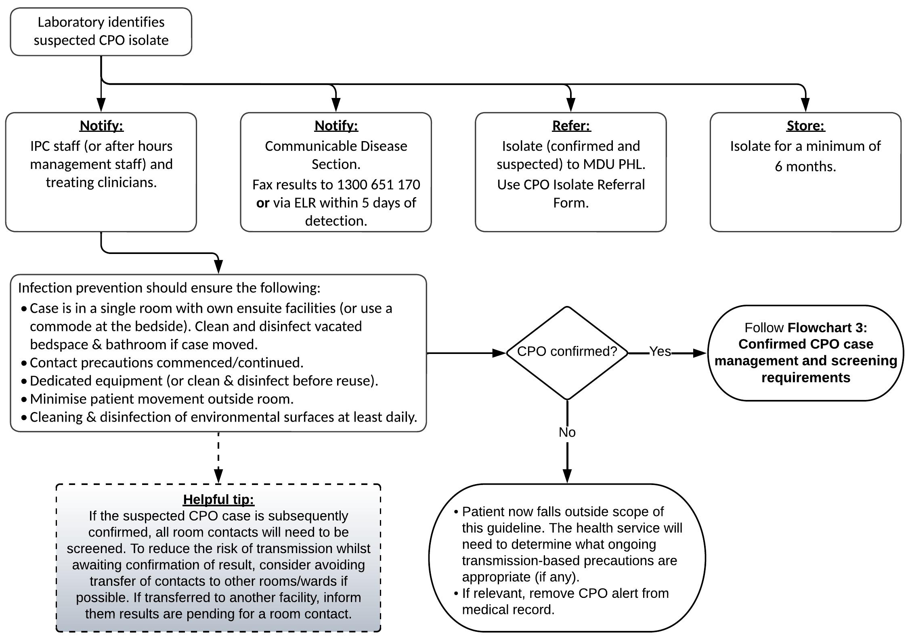

Confirmed CPO cases
- Ensure the patient, and/or their carer is notified and counselled appropriately regarding the diagnosis. An information sheet for patients with CPO can be found on the department’s website <www.health.vic.gov.au/infectious-diseases/victorian-guideline-on-cpo-for-health-services>.
- Commence or continue additional IPC measures (see Section 5).
- Ensure the patient’s local doctor is informed of the case confirmation upon discharge. An example template letter and information sheet for clinicians can be found on the department’s website <www.health.vic.gov.au/infectious-diseases/victorian-guideline-on-cpo-for-health-services>.
- Ensure other healthcare providers are alerted to the patient’s CPO status, and the requirement for isolation and/or additional IPC measures should they be transferred to another healthcare facility or RCF.
- Complete the CPO surveillance form, either via the secure online form <https://forms.business.gov.au/smartforms/servlet/SmartForm.html?formCode=cd_cpos&tmFormVersion> or return the completed PDF version via fax (1300 651 170) to the department within two business days. Both versions of the form can be found on the department’s website <https://www.health.vic.gov.au/infectious-diseases/carbapenemase-producing-enterobacteriaceae-surveillance-and-isolate-referral>. All queries regarding CPOs should be directed to the department by email <amr.secretariat@health.vic.gov.au> or to the LPHU in which the health service is located.
- Place an alert in the hard-copy and/or electronic patient records.
- Identify (where possible) and document the date of likely acquisition and period of transmission risk. This is required to determine which patients are room contacts of the case.
  - The date of likely acquisition depends on epidemiological factors, such as:
      - when contact first occurred with a known case with the same strain
      - an overseas hospital admission in the absence of local risks
  - any previous negative screening results.
The final determination of the date of likely acquisition will be made by the AMR-IMT.
  - The period of transmission risk is from the date of likely acquisition until the time that the case is placed in contact precautions.
  - If the date of likely acquisition is unable to be determined, the period of transmission risk is usually considered to be one month prior to the date of CPO isolation (the date the screen or test was taken) until the time that the case is placed in contact precautions.

Clearance of cases

CPE
Most CPE patients remain colonised for at least 6 to 12 months and some considerably longer, particularly with ongoing or repeated healthcare contact and/or antibiotic use. It is acknowledged that the requirement for a single room and contact precautions for every subsequent admission to a healthcare facility may be onerous for the patient and not always the best use of healthcare resources.
While it is still a requirement that an alert remain in the patient’s medical record noting that CPE has been isolated, an assessment must be made at each subsequent admission to determine if additional IPC measures are warranted using the following risk-based approach to determine ‘clearance criteria’.
- Patients who have had a positive result for CPE in the previous 12 months should remain in contact precautions if readmitted, regardless of subsequent negative screens during that time.
- Patients whose last positive CPE result was more than 12 months prior should have a risk assessment conducted to determine if they may still pose a risk of being colonised. For example, have they had a course of antibiotics since their last admission, or will they be placed on a treatment course during this admission? If not, then they may be screened to ‘clear’ them for that admission. Such admission clearance should include screening three CPE screening samples (each taken at least 24 hours apart), with at least one of those being a faeces sample. If all samples collected are negative, all additional IPC measures may be ceased for that admission.
- If a course of antibiotics is commenced during the admission (or known to have occurred since last screened negative), consideration should be given to rescreening the patient or delaying initial screening until several days after commencing the course of antibiotics.
Note: The final decision to cease IPC measures should be made in consultation with the healthcare facility’s IPC coordinator, infectious diseases and/or medical microbiology experts.

CPA and CPP
Although an alert should remain in the patient’s medical record, patients with a history of CPA or CPP may not require implementation of additional IPC precautions at each admission. A risk assessment should be conducted at each admission, considering factors such as which ward or unit they are to be admitted to (for example, admission to ICU would be a high risk in the case of a previously colonised CPA patient), reason for admission (for example, treatment of a current infection) or other patient risk factors (for example, chronic respiratory condition and colonised with CPP in past). If additional IPC precautions are not implemented at the time of admission, these cases should still be monitored for signs and symptoms of infection, and immediate laboratory investigations undertaken to identify possible carbapenem resistance if infection is suspected.
Particular precaution should be taken for patients with cystic fibrosis or other chronic lung diseases and a history of CPP colonisation or infection as the risk of relapse is high in these patients. Once again, a local risk assessment should be undertaken to ascertain the need for additional IPC measures at each admission, although it is recommended that these patients be screened at each readmission.

Management of contacts

Purpose of contact tracing
The purpose of contact tracing is to identify potentially infected or colonised patients and to manage the risk of onwards transmission from these patients. This occurs by identifying which patients should be screened and over what time period. It may also involve pre-emptive isolation until a person is cleared.
No contact tracing is required until the case has been confirmed.

Room contacts
A room contact is any person who shared a room or a bathroom with a case for ≥ 24 hours in a health service during the case’s period of transmission risk. Patients discharged prior to the case being diagnosed, and who meet the room contact criteria are included in the required actions.
Room contacts should have IPC precautions and other recommendations applied until clearance criteria are met.
On confirmation of a case of CPO, the following actions must be taken for all room contacts:
- Room contacts who are still inpatients:
  - Pre-emptively isolate and screen for CPO
  - Implement contact precautions until clearance criteria (see below) have been met.
- Room contacts who have been discharged prior to diagnosis and/or who have not met clearance criteria prior to discharge:
  - Give or send the room contact written advice of their room contact status. An example room contact letter can be found on the department’s website <www.health.vic.gov.au/infectious-diseases/victorian-guideline-on-cpo-for-health-services>.
  - Place an alert on their hard-copy and/or electronic hospital records so that they are placed into a single room with contact precautions and screened if readmitted before clearance criteria are met in the 12 months following last contact with the CPO case. This includes room contacts who have refused to be screened. (Alerts in hospital records may be removed after 12 months if screening has not occurred.)

Clearance criteria for room contacts
A room contact is considered cleared when two suitable specimens taken > 48 hours apart are negative for CPO. Both specimens must be taken more than seven days after cessation of room contact with a case of CPO. See Table 1 for recommended screening samples.

Further screening following confirmation of a case of CPO
A ward contact, as previously defined, is any person who has been on a ward for ≥ 24 hours in the period that the ward has been designated as a TRA. Therefore, when there has been no local transmission, there are no ward contacts for the purposes of this guideline. Further actions are required if transmission is identified (see Actions when local transmission of CPO is identified).
Some cases, however, are considered high-risk for onwards transmission (Box 5 below). Health services may conduct their own risk assessment regarding these patients and consider performing further screening on some or all the other patients on that ward. Further advice can be sought from the VASRU (email <amr.secretariat@health.vic.gov.au>) if a health service requires guidance or assistance in responding to complex cases.
Box 5: Risk factors that contribute to a higher risk of onwards transmission
- Copious or uncontained drainage from wounds or abscesses.
- Faecal incontinence, diarrhoea, intestinal stoma or history of recent colorectal procedure.
- Copious or uncontained respiratory secretions
- Urinary incontinence or indwelling urinary catheter.
- Difficulty complying with hygiene and self-care, for example patients living with dementia and exhibiting wandering behaviours.
- High acuity patients, for example those admitted to ICU, patients with burns or malignant haematology.

Healthcare workers, household and casual contacts
Screening is generally not recommended for healthcare workers who care for and manage CPO cases.
Household and community contacts do not require contact tracing or screening.
Screening of healthcare workers or household contacts may be undertaken at the discretion of the AMR-IMT, however given the lack of current evidence regarding the risk for transmission to these groups, this is unlikely and would only occur in an extreme circumstance.
Flowchart 3: Confirmed CPO case management and screening requirements
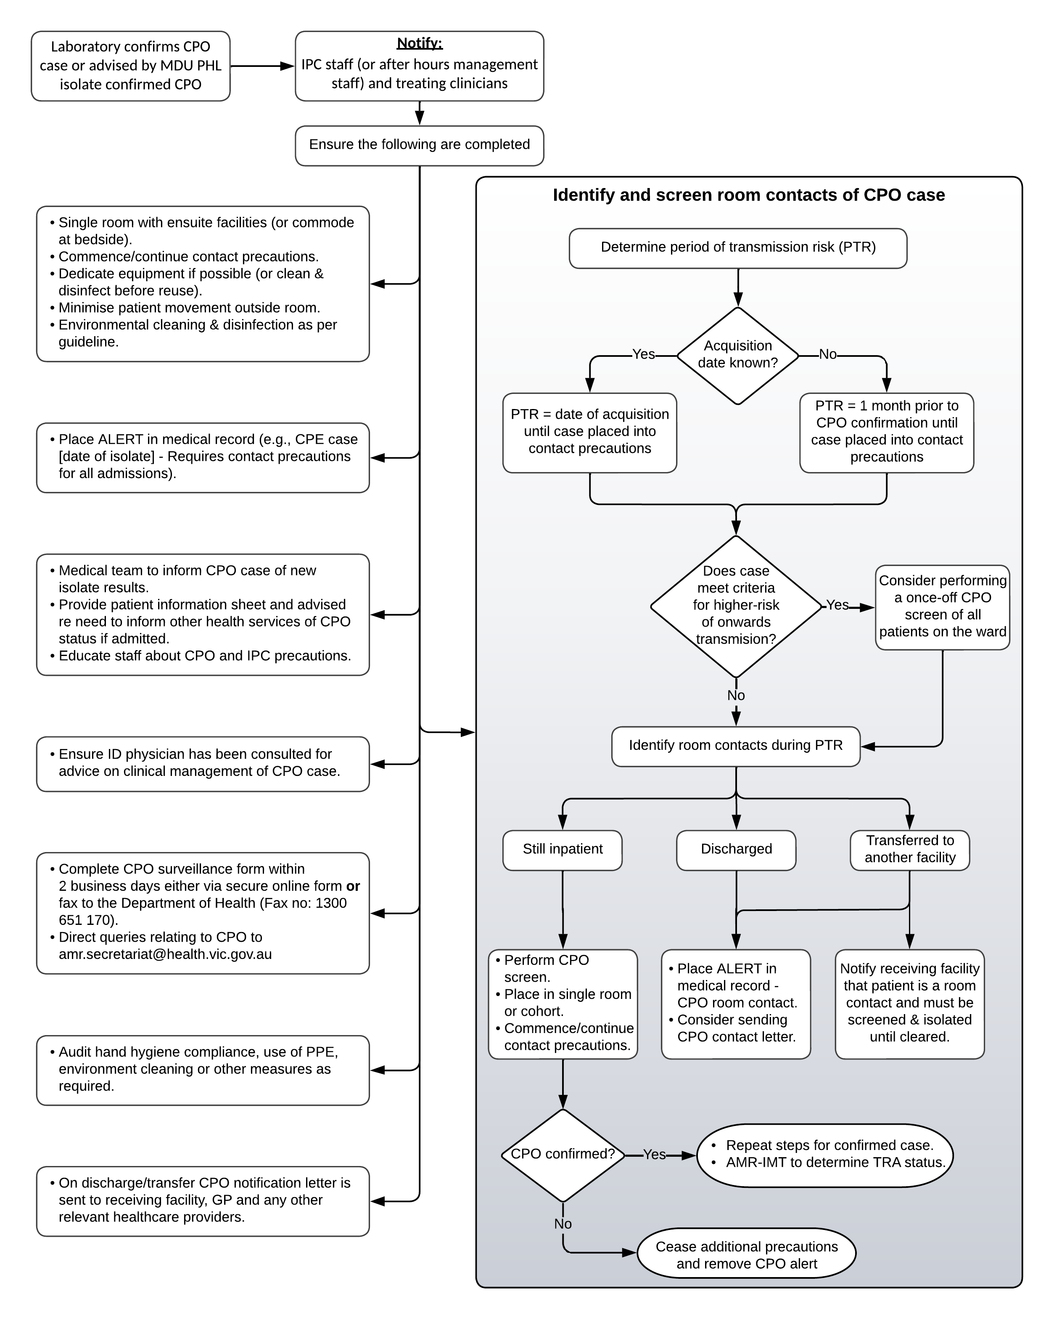

Actions when local transmission of CPO is identified
When transmission of CPO is suspected, the VASRU will prepare a risk assessment for the AMR-IMT. The AMR-IMT will review the information and determine if transmission has occurred. If transmission has occurred, the ward (or a specified geographical area in the health service) will be designated as a TRA. It is not necessary to delay the commencement of contact screening and other IPC actions while awaiting formal recommendations from the AMR-IMT.

TRA – overview
A TRA is an area (a distinct geographical area or ward) in which local transmission has been determined by the AMR-IMT to have occurred. The following criteria are used by the AMR-IMT:
- two or more confirmed cases of genetically related CPO as determined by MDU PHL AND
- at least one case is a locally acquired case AND
- there is a plausible epidemiological connection between the two cases, either through geographic proximity or shared staff, equipment or other exposures in the healthcare setting as determined by the AMR-IMT.
OR
- where acquisition from an environmental source is hypothesised, clustering in time and place without a direct patient to patient epidemiological link will also be considered.
If the AMR-IMT cannot reach a consensus regarding a TRA, the Victorian Chief Health Officer or delegate will have the final determination.

Health facility actions
- Determine and document the timeframe for the TRA
This will be done formally by the AMR-IMT. The facility should also make a preliminary determination at the time a transmission is identified in order to commence contact tracing activities without delay.
    - If one or more of the patients remains an inpatient or was discharged within the past four weeks from the ward/s identified as a TRA: generally, the TRA will apply from the day that the first CPO positive patient involved in the transmission was admitted, until there have been four consecutive weeks of negative ward screens.
    - If all the patients involved in the transmission have been discharged for longer than four weeks from the ward/s identified as a TRA: generally, the TRA will apply from the time that the first patient involved in the transmission was admitted to four weeks after the final patient involved in the transmission was discharged.
    - For an hypothesised environmental source, the timeframe will apply until appropriate environmental cleaning or other risk mitigation strategy has been implemented. Re-establishment or extension of the TRA timeframe will occur if there is evidence of further clustering of cases.
- Identify, notify and place alerts on room contacts as previously described

- Commence screening programs
    - If one or more of the patients remains an inpatient, or were discharged within the past four weeks, perform a weekly PPS for CPO on ward patients until there have been four consecutive weeks of negative screens.
    - If all the patients involved in the transmission have been discharged for longer than four weeks, perform a single PPS on the ward.
    - Where an environmental source is implicated in the TRA, the AMR-IMT may recommend environmental screening in addition to patient screening requirements outlined above.
- Identify, notify and place alerts on ward contacts
A ward contact is any person who has been on a ward for ≥ 24 hours during the period that the ward has been designated as a TRA.
    - Ensure that all ward contacts discharged before clearance criteria are met have alerts placed on their medical record (see below for further information on clearance criteria). This is to ensure they are placed into contact precautions and screened if readmitted prior to meeting clearance criteria within 12 months of their last contact with the TRA. (Alerts in hospital records may be removed after 12 months if screening has not occurred.)
    - Notify any healthcare facility or RCF where TRA ward contacts have been transferred prior to clearance, to enable the receiving facility to place alerts and consider further action if required.
- Enact patient transfer procedures for ward contacts (if the TRA is active)
When transferring patients from a TRA to another ward or healthcare facility:
    - Ensure that all ward contacts are screened on discharge or within the 24 hours prior to transfer to another ward or healthcare facility.
    - Inform the receiving ward or facility in writing that the patient is a ward contact and that the patient must be placed in contact precautions until cleared.
When transferring patients to RCFs:
    - Ensure that all ward contacts are screened on discharge or within the 24 hours prior to transfer to a RCF.
    - If the result will be available within 24 hours, it is ideal (but not mandatory) to wait for the result prior to transferring the patient.
    - RCFs should not refuse transfer of a patient awaiting a screening result.
    - RCFs should manage any cases of CPO as per the Victorian guideline on CPO for RCFs V1.1 <https://www.health.vic.gov.au/infectious-diseases/carbapenemase-producing-enterobacteriaceae-management-guidelines>.

Clearance criteria for ward contacts
A ward contact is considered cleared when:
- a suitable specimen is negative for CPO at any time after discharge or transfer out of the TRA
OR
- a suitable specimen taken within 24 hours of discharge or transfer out of the TRA is negative for CPO.
See Table 1 for recommended screening samples.
If a patient remains in contact with a TRA, they should be screened weekly as per the TRA requirements.
Flowchart 4: Local transmission/outbreak response requirements
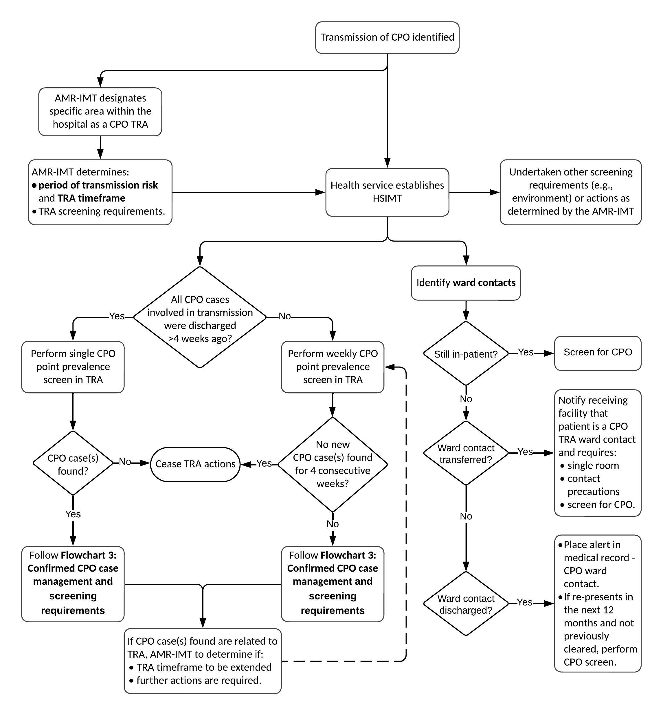

Environmental screening
Environmental contamination with CPO is commonly associated with increased rates of patient colonisation and infection with these pathogens, particularly carbapenemase-producing Acinetobacter and Pseudomonas. Thus, as part of IPC measures, environmental surveillance cultures for CPA and CPP should be considered during a TRA or outbreak investigation to monitor the efficacy of hospital cleaning and disinfection measures or to investigate a possible environmental source should an outbreak be ongoing.
Environmental screening for CPE in non-outbreak situations is however generally not required.
In the case of evidence of local CPO transmission, environmental samples taken before comprehensive cleaning can be a valuable part of an investigation to determine if an environmental reservoir is the source of persistent cases of CPO in a healthcare setting. Screening of the environment after comprehensive cleaning can enable a healthcare facility to target specific problem areas or reservoirs effectively.
Sites that may be sampled for CPO can be categorised into wet or dry surfaces. In general, CPO are isolated from wet or moist environments more frequently than dry surfaces, although this is also dependent on the organism. CPO outbreaks have also been associated with point source acquisition (for example contaminated ultrasound gel; contaminated endoscopes). Where epidemiological evidence exists for such acquisition, sampling sites should be extended to include these possibilities.
The AMR-IMT may direct a health service to undertake environmental screening as part of the required responses for managing a TRA. Choice and number of sampling sites is to be determined in consultation with the AMR-IMT.
The Victorian guideline on environmental sampling for CPE (2018) outlines recommended sampling and laboratory methods for the isolation of CPE from the environment. This guideline can be found on the department’s website <https://www.health.vic.gov.au/infectious-diseases/victorian-guideline-on-environmental-sampling-for-cpe>.

Screening endoscopes
Endoscopes should be screened / microbiologically tested if more than one patient with confirmed CPO is found to have had a common exposure to an endoscope. Such screening should be conducted in addition to routine microbiological sampling as laid out in the current edition of the Gastroenterological Society of Australia (GESA) Infection Prevention and Control in Endoscopy (2021). Refer to sections ‘Chapter 10: Microbiological surveillance cultures’ and ‘Chapter 11: Response to possible endoscopy-related infection transmission’. This document can be found on the GESA website <https://www.gesa.org.au/education/clinical-information/>.

Section 4: Laboratory methods and reporting requirements

Methods for detecting suspected or confirmed CPO
All isolates of Enterobacterales, Pseudomonas and Acinetobacter should undergo routine antimicrobial susceptibility testing (AST) using the usual method undertaken by the laboratory. It is not necessary to introduce new methods of testing, although some laboratories may choose to use additional methods (for example, phenotypic assays for carbapenemase activity, or multiplex PCR testing for carbapenemase gene) according to local requirements and capacities. As a minimum standard, laboratories should test meropenem susceptibility.
Laboratories using phenotypic assays for carbapenemase activity, such as the CIM (or accepted modified CIM method) or colorimetric tests such as CarbaNP or BlueCarba, should ensure that they are adhering to documented methods and using appropriate quality control strains. Any queries about the performance of these assays may be directed to MDU PHL for further assistance.
The CIM test, in particular, has a high negative predictive value for the presence of carbapenemases in Enterobacterales and Pseudomonas. A negative CIM test can effectively rule out carbapenemase production in these species. As such, these isolates do not need to be referred to MDU PHL, unless there are other indications for testing.
For laboratories that perform multiplex PCR carbapenemase assays, please note that a negative PCR result does not completely exclude the presence of a carbapenemase, as these assays only cover the most common carbapenemase genes. Isolates that meet the phenotypic criteria for referral but are negative on a multiplex PCR screen must still be referred to MDU PHL for testing.

Referral criteria for suspected CPO isolates
The referral criteria are aligned with the National Alert System for Critical Antimicrobial Resistances (CARAlert) criteria (with additional detailed advice), and hence may change with updates to the CARAlert Laboratory Testing Handbook <https://www.safetyandquality.gov.au/publications-and-resources/resource-library/caralert-laboratory-handbook-0>.

CPE
Isolates meeting any of the following screening criteria are considered suspected CPE and must be referred to MDU PHL for confirmatory testing:
- meropenem MIC ≥ 0.5 mg/L
- meropenem disk diffusion zone < 28 mm (EUCAST or CLSI methods)
  - if disk zone < 25mm, always refer
  - if disk zone 25–27mm, only refer if piperacillin-tazobactam is also resistant
- meropenem disc diffusion zone < 6 mm (CDS)
- phenotypic resistance to any carbapenem where the MIC is above the clinical breakpoint as defined by CLSI or EUCAST or zone diameter suggests resistance by CDS
- positive colorimetric test for carbapenemase (for example, CarbaNP or Blue-Carba)
- positive or equivocal CIM test (or accepted modified CIM method)
- positive carbapenemase gene PCR.
Notes:
- Isolates that meet the criteria above but test negative on multiplex carbapenemase PCR testing must still be referred to MDU PHL for testing.
- Isolates with elevated meropenem MICs or reduced disc diffusion zones (as above) but test negative by CIM test do not need to be referred to MDU PHL for further testing. Isolates may still be referred for other reasons, for example, extended antimicrobial susceptibility testing, if clinically indicated.

Referral criteria for suspected CPA
Isolates meeting any of the following screening criteria are considered suspected CPA and must be referred to MDU PHL for confirmatory testing and genomic analysis:
- meropenem MIC > 8 mg/L
- meropenem disk diffusion zone < 15 mm (EUCAST) or ≤ 14 mm (CLSI)
- meropenem disc diffusion zone < 6 mm (CDS)
- positive or equivocal colorimetric test for carbapenemase (for example, CarbaNP or Blue-Carba)
- positive or equivocal CIM test (or accepted modified CIM method)
- positive carbapenemase gene PCR.
Notes:
- Isolates that meet the criteria above but test negative on multiplex carbapenemase PCR testing must still be referred to MDU PHL for testing.
- Phenotypic assays for carbapenemase activity (CarbaNP and, to a lesser extent, CIM testing) do not perform as well in Acinetobacter as in CPE or CPP, due to the predominance of OXA genes with weak carbapenemase activity. Isolates with elevated meropenem MICs or reduced disc diffusion zones (as above) but test negative by CIM test must still be referred to MDU PHL for further testing.

Referral criteria for suspected CPP
Isolates meeting any of the following screening criteria are considered suspected CPP and must be referred to MDU PHL for confirmatory testing and genomic analysis:
- Evidence of reduced susceptibility to meropenem AND piperacillin-tazobactam:
  - meropenem MIC ≥ 4 mg/L, or disc diffusion zone < 24 mm (EUCAST) or < 19 mm (CLSI) or < 6 mm (CDS) AND
  - piperacillin-tazobactam MIC ≥ 32 mg/L, or disc diffusion zone < 18 mm (EUCAST) or ≤ 20 mm (CLSI), or < 6 mm (CDS)
- positive colorimetric test for carbapenemase (for example, CarbaNP or Blue-Carba)
- positive or equivocal CIM test (or accepted modified CIM method)
- positive carbapenemase gene PCR.
Notes:
- Isolates that meet the criteria above but test negative on multiplex carbapenemase PCR testing must still be referred to MDU PHL for testing.
- Isolates where the colorimetric test (for example, CarbaNP) is negative or equivocal but meets the MIC criteria must still be referred.
- Isolates with elevated meropenem MICs or reduced disc diffusion zones (as above) but test negative by CIM test do not need to be referred to MDU PHL for further testing. Isolates may still be referred for other reasons, for example, extended antimicrobial susceptibility testing, if clinically indicated.
See Table 2 for a summary of the above screening criteria for determining when to refer a CPO isolate.

Table 2: Summary of screening criteria for referral of suspected or confirmed CPO to MDU PHL
Criteria | CPE | CPA | CPP
Meropenem susceptibility test | - MIC ≥ 0.5 mg/L  - Disc diffusion zone < 28 mm (EUCAST or CLSI)  - if disk zone < 25mm, always refer  - if disk zone 25-27mm, only refer if piperacillin-tazobactam is also resistant  - Disc diffusion zone < 6 mm (CDS) | - MIC > 8 mg/L  - Disc diffusion zone < 15 mm (EUCAST) or ≤ 14 mm (CLSI) or < 6 mm (CDS) | Must have evidence of reduced susceptibility meropenem AND piperacillin-tazobactam  Meropenem:  - MIC ≥ 4 mg/L  - Disc diffusion zone ≤ 24 mm (EUCAST) or < 19 mm (CLSI) or < 6 mm (CDS)  AND  Piperacillin-Tazobactam:  - MIC ≥ 32 mg/L  - Disc diffusion zone < 18 mm (EUCAST) or ≤ 20 mm (CLSI) or < 6 mm (CDS)
Resistance to carbapenem (other than meropenem) | Where the MIC is above the clinical breakpoint as defined by CLSI or EUCAST or zone diameter suggests resistance by CDS. | N/A | N/A
Positive colorimetric test for carbapenemase (e.g., CarbaNP or BlueCarba) | Yes | Yes (including equivocal result) | Yes
Positive CIM (or accepted modified CIM method) | Yes (including equivocal result)  Note: Isolates with elevated meropenem MICs or reduced disc diffusion zones (as above) BUT test negative by CIM test do not need to be referred. | Yes (including equivocal result)  Note: Isolates with elevated meropenem MICs or reduced disc diffusion zones (as above) BUT test negative by CIM test must still be referred. | Yes (including equivocal result)  Note: Isolates with elevated meropenem MICs or reduced disc diffusion zones (as above) BUT test negative by CIM test do not need to be referred.
Positive carbapenemase gene PCR | Yes  Note: Isolates that meet other criteria BUT are PCR negative must still be referred. | Yes  Note: Isolates that meet other criteria BUT are PCR negative must still be referred. | Yes  Note: Isolates that meet other criteria BUT are PCR negative must still be referred.

Requirements for primary diagnostic laboratories to report cases
- Immediately notify IPC staff (or after hours, management staff) and treating clinicians of suspected or confirmed CPO cases so that appropriate precautions and necessary alerts can be implemented.
- Report all suspected and confirmed cases/isolates of CPO from clinical, screening and environmental samples to the department by sending the microbiological reports to the Communicable Disease Section by fax (1300 651 170) or ELR within five business days of detection. Results should be reported regardless of whether these have arisen from sporadic cases or as part of a recognised local outbreak.
- Refer all isolates of suspected or confirmed CPO to MDU PHL for further confirmation and typing. Isolates are to be accompanied by a completed laboratory CPO isolate referral form. Forms for human (FM2458) or environmental (FM2699) isolates can be found on the department’s website <https://www.health.vic.gov.au/infectious-diseases/carbapenemase-producing-enterobacteriaceae-surveillance-and-isolate-referral> and MDU PHL website <http://biomedicalsciences.unimelb.edu.au/departments/microbiology-Immunology/research/services/microbiological-diagnostic-unit-public-health-laboratory#services>. The form has provision for including the names of any infectious disease personnel that require a copy of the report.
- Store all suspected CPO isolates at the testing laboratory for six months.

Role of the reference laboratory
All suspected and confirmed CPO isolates should be referred to MDU PHL for further testing, unless excluded above. This testing includes:
- extended antimicrobial susceptibility testing
- molecular and genomic characterisation to determine carbapenemase gene presence
- phylogenetic analysis and inference of transmission pathways, where applicable.
MDU PHL is also available to provide advice to primary laboratories regarding laboratory techniques, and other technical aspects for the isolation and identification of CPOs. Contact details are:
Website: <https://biomedicalsciences.unimelb.edu.au/departments/microbiology-Immunology/research/services/microbiological-diagnostic-unit-public-health-laboratory>
Email: mdu-general@unimelb.edu.au
Phone: +61 3 8344 5701 / 8344 5713

Environmental sample testing
The Victorian guideline on environmental sampling for CPE (2018) outlines recommended sampling and laboratory methods for the isolation of CPE from the environment. Download this guideline from the department’s website <https://www.health.vic.gov.au/infectious-diseases/victorian-guideline-on-environmental-sampling-for-cpe>.
If you require assistance with environmental sampling contact MDU PHL.

Section 5: Management and control of cases
Health services should ensure that their routine admission processes reliably identify PRIS patients (see Box 2). Each patient should be assessed on admission and re-admission to the healthcare facility as well as any transfer from another healthcare facility.
Transmission pathways for CPO in healthcare settings are most commonly via contamination of healthcare workers’ hands, shared patient equipment and the healthcare environment. Interventions recommended in this guideline to control transmission are therefore focused on these transmission pathways.

Medical therapy
Treatment of patients with a CPO infection should be managed in consultation with an infectious diseases physician. Wherever possible, health services should have a local protocol for management of CPOs. This may include, how to access restricted antimicrobials and an antibiogram where appropriate.
For colonised patients, an infectious diseases physician should be consulted to provide advice on the use of antimicrobials in situations such as prophylaxis for planned invasive procedures or when a patient is unwell with sepsis or is significantly immunosuppressed.
Currently, there are no known proven interventions for decolonisation for CPOs.

Antimicrobial stewardship
Antimicrobial stewardship is a crucial aspect of the prevention of all multi-resistant organisms. Australia’s National Antimicrobial Resistance Strategy – 2020 & Beyond published in March 2020 outlines priority areas for action. This document is available on the Australian Government’s website <www.amr.gov.au/resources/australias-national-antimicrobial-resistance-strategy-2020-and-beyond>.
All healthcare facilities must have an antimicrobial stewardship program that is appropriately monitored.

Standard and transmission-based precautions
CPO require targeted interventions to prevent ongoing transmission in health services. Health services should have localised specific policies and procedures for the management of CPOs. General IPC measures are outlined below but will need to be contextualised for specific facilities considering such things as aims of care, for example, acute care vs rehabilitation, and resources, such as access to single rooms with own ensuites vs shared bedrooms and bathrooms.
Measures covered in CPO case management policies and procedures should include:
- patient placement
- use of personal protective equipment
- environmental cleaning and disinfection
- management of shared patient equipment
- communication of CPO status upon transfer or discharge
- contact identification and management.

The use of standard precautions is an essential IPC strategy for the successful minimisation of transmission of infections, including multi-resistant organisms. Adherence to standard precautions, in particular hand hygiene and cleaning of shared patient equipment, minimises the risk of transmission from patients unknown to be colonised with a multi-resistant organism.
Transmission-based precautions implemented for CPO cases should be based on the best available evidence of transmission pathways. The current version of the Australian Guidelines for the Prevention and Control of Infection in Healthcare outlines such measures required. This guideline can be found on the National Health and Medical Research website <www.nhmrc.gov.au/about-us/publications/australian-guidelines-prevention-and-control-infection-healthcare-2019>.
CPO are primarily transmitted by direct or indirect contact. A risk assessment should be undertaken to determine if other transmission-based precautions are required, such as droplet precautions for a patient whose has copious sputum and their sputum is colonised with a CPO. At a minimum, contact precautions are required for the following patients:
- suspected CPO cases
- confirmed CPO cases
- room contacts until clearance criteria have been met
- PRIS patients until clearance criteria have been met.
Contact precautions apply to all healthcare settings except where specified below, usually lower acuity settings including subacute, rehabilitation and ambulatory care.
Note: Standard precautions are adequate for linen management, crockery and cutlery.

Additional measures for consideration

Patient placement
Preferably, patients with a CPO should be placed in a single room with their own ensuite. If this is not possible, highest priority for a single room should be given to CPO cases who have higher-risk factors for onwards transmission (see Box 5).
When a single room is not available patient placement should be prioritised as below.
- Single room with separate dedicated bathroom facilities.
- Single room with dedicated commode, but shared showering facilities.
- Shared room with dedicated commode and shared showering facilities.
Patients with the same strain of CPO can be cohorted in the same room unless one of them has any other MRO or infectious disease that require precautions. For example, vancomycin resistant Enterococcus (VRE) or an acute respiratory illness would be considered another MRO or infectious disease. It is preferable that patients with the same organism but different resistance genes should not be cohorted either.
Clear signage should be visible to alert healthcare workers of required precautions before entering the room or patient zone.

Cohorting of patients and/or staff
When there is local transmission, a risk assessment by the HSIMT should consider the value of staff and patient cohorting. If staff cohorting is enacted, priority should be given to cohorting nursing staff, allied health professionals and patient care attendants. If considering patient cohorting, only patients with the same strain of CPO should be cohorted together. This is only recommended when there are insufficient single rooms for instance in the case of endemic situations or where cohorting of patients colonised with the same strain is necessary for more efficient use of hospital rooms and resources.

Movement of patients
Patients with a CPO should be strongly encouraged to stay within their room. If it is necessary to attend other clinical areas for diagnostic tests or procedures transmission-based precautions must be maintained and schedule their procedure last in the day where feasible without compromising patient care. Clinical areas receiving patients for procedures or investigations should be advised well in advance of patient arrival to enable adequate preparation to manage a CPO case, for example, to allow enough time to perform environmental cleaning and disinfection before the next patient.
Patients should avoid using toilets outside their room however, if necessary, staff should ensure cleaning and disinfection occurs after toilet use or that a commode is used where possible which must also be cleaned and disinfected afterwards.

Environmental cleaning and disinfection
Healthcare facilities should have environmental cleaning and disinfection policies and procedures that include guidance for environmental management of rooms of patients with a CPO. Guidance should include:
- product selection and use
- frequency of cleaning and disinfection for the patient’s room and bathroom, including frequently touched surfaces
- discharge cleaning and disinfection requirements.
If using a no-touch method of surface disinfection (for example, ultraviolet [UV-C] or hydrogen peroxide vapour) prior cleaning is required. When there is ongoing transmission, healthcare facilities should strongly consider the use of no-touch methods for discharge disinfection.

Limiting ward activity and ward closure
If, after implementation of initial control measures, there is ongoing transmission consideration may need to be given to closure of an affected ward to new admissions.

Subacute or rehabilitation healthcare setting
Patient care activities in the subacute or rehabilitation healthcare setting are different from those in the acute healthcare setting. Patients are generally more ambulant and frequently participate in group activities or attend communal areas such as gymnasiums. In this lower acuity setting the application of some of the above IPC precautions can be modified to allow CPO cases to participate in rehabilitation activities as indicated below.

PPE
At a minimum, staff should use a gown or apron and gloves when attending to a patient’s personal care, such as showering and toileting. Each facility should conduct their own risk assessment to determine if they require staff to always wear a gown/apron and gloves whenever entering the patient’s room. The risk assessment should be based on the following factors.
- Acuity of the patients within the facility.
- Location of the ward or facility (for example, stand-alone rehabilitation facility vs rehabilitation ward co-located with acute care wards).
- Individual risk factors of the CPO case (for example, patient has risk factors for onwards transmission).
When there is ongoing transmission a long-sleeved gown and gloves must be worn by staff whenever entering the patient’s room.
Visitors are not required to wear a gown and gloves unless assisting with patient care for example showering, toileting. After exiting the room, visitors should be discouraged from visiting other patients in the health service.

Use of PPE during activities outside the patient’s room
Staff conducting group activities or one-to-one sessions (for example, a physiotherapist) where minimal physical contact occurs do not need to wear additional PPE, unless providing close personal care, such as toileting, where clothes may become contaminated.

Movement of patients/participation in group activities
Unless a patient is unwell (for example, has diarrhoea) or there are other complicating risk factors (for example, the patient has uncontainable faecal incontinence) they may freely attend shared areas such as the dining room, and group activities. Patients should be educated to perform hand hygiene whenever they leave their room and when entering a communal area. If a patient is unable to adequately perform hand hygiene staff should assist. Patients’ personal hygiene should be maintained, and clean clothes worn when outside their room. Ensure wounds are covered with a dressing that contains any ooze.
Avoid using toilets outside the patient’s room however if it is necessary, ensure cleaning and disinfection occurs after toilet use, or use a commode where possible which must also be cleaned and disinfected afterwards.

Equipment and instruments/devices
Equipment used in groups activities (for example, gymnasium equipment, weights) should be wiped over with a detergent/disinfectant wipe after use by each patient.

Environmental cleaning
Environmental cleaning and disinfection of communal areas, such as gymnasiums, should also be increased when there is ongoing local transmission.

Ambulatory healthcare settings
For the purpose of this guideline, ambulatory healthcare settings include haemodialysis and day oncology units but does not include outpatient clinics. Patients are generally only admitted for a few hours and access to single rooms is often limited. In this setting, the application of some of the above IPC precautions noted for acute-care settings may be difficult and require modification.

Patient placement
The principles of patient placement outlined previously should be applied wherever possible. If none of these options are available then patients with a CPO should be placed away from other patients (for example, at the end of the row) and a toilet or commode should be dedicated to the patient for the duration of their day admission. Any toilets and/or equipment dedicated for their use during their admission must be cleaned and disinfected prior to reuse.

PPE
A gown or apron and gloves should be worn when undertaking procedures or assisting a patient to toilet. Staff should remember to always remove the gown/apron and gloves before exiting the immediate patient care area. Gloves must also be changed during patient care episodes in accordance with the five moments of hand hygiene, as well as between caring for different patients.

Hydrotherapy
Patients with a CPO may be required to access hydrotherapy pools as part of their rehabilitation program. Such patients should be permitted to attend a hydrotherapy pool and not be excluded merely because they are colonised or infected with a CPO. A risk assessment of patients should be conducted prior to their use of the hydrotherapy pool. This should include assessment of continence and presence of wounds. At times, a patient’s access to the pool may need to be deferred, for example, when they are incontinent of faeces.
Aquatic facilities, such as hydrotherapy pools, must comply with the Public Health and Wellbeing Regulations 2019. All facilities must have a water quality risk management plan. Further information about aquatic facility requirements can be found on the department’s website <www.health.vic.gov.au/water/aquatic-facilities>.
Further information about infection control precautions for hydrotherapy pools and management of patients can be found in the Australian Physiotherapy Association Australian guidelines for aquatic physiotherapists working in and/or managing hydrotherapy pools, second edition, 2015. Download this document from the APA website <https://australian.physio/sites/default/files/tools/Aquatic_Physiotherapy_Guidelines.pdf>.

Management and risk assessment of patients
- A risk assessment of all patients should be undertaken prior to hydrotherapy to determine their suitability. A risk assessment should include, but not be limited to, whether the patient is continent of urine or faeces, has an active infection or is colonised and if they have any wounds present.
- All patients should shower (including washing their bottom) before entering the pool.
- Patients with uncontrolled faecal incontinence should be deferred from using the pool until this has either ceased or can be managed with appropriate devices (for example, incontinence aids).
- Patients should inform the facility if they have had loose bowel motions or been unwell. Hydrotherapy may need to be deferred for a period (for example, a period of two weeks after diarrhoea ceases).

Equipment and instruments/devices
Where possible, dedicate the use of equipment to one patient. If equipment must be shared between patients, ensure the equipment has been cleaned and disinfected before use on another patient. If a sling is used to transfer the patient in and out of the pool, the sling should preferably be dedicated to the use of that patient for the duration of their rehabilitation. Following use, the sling will need to be laundered prior to use on another patient.

Appendices

Appendix A: Guide to microbiological testing and data collection
Agency | Action | When to initiate
Diagnostic microbiology laboratory | Process clinical and screening samples referred for CPO testing as per CPO guideline (Section 4). | The day the samples arrive in the laboratory
Diagnostic microbiology laboratory | Report suspected or confirmed CPO to the referring clinician and an IPC representative in the healthcare facility. | Same day that the suspected or confirmed result is available
Diagnostic microbiology laboratory | Report suspected or confirmed CPO isolates to the Communicable Disease Section by faxing the initial result to 1300 651 170 or by ELR. | Within five business days of detection
Diagnostic microbiology laboratory | Refer suspected or confirmed CPO isolates to MDU PHL using a completed CPO isolate referral form available on the department’s website <www.health.vic.gov.au/infectious-diseases/carbapenemase-producing-enterobacteriaceae-surveillance-and-isolate-referral> or MDU PHL website <http://biomedicalsciences.unimelb.edu.au/departments/microbiology-Immunology/research/services/microbiological-diagnostic-unit-public-health-laboratory#services>. | Within two business days of isolation
Healthcare facility | When CPO is confirmed IPC lead or delegate must complete the CPO surveillance form either via secure online form or via fax to the department (Fax no: 1300 651 160). Both versions of the form are available here <https://www.health.vic.gov.au/infectious-diseases/carbapenemase-producing-enterobacteriaceae-surveillance-and-isolate-referral>. | Within two business days of receiving confirmation of CPO result
Healthcare facility | Refer all screening samples to your clinical diagnostic microbiology laboratory for testing. Ensure the pathology request form is clearly marked for CPO screening. | When screening samples collected
MDU PHL | Confirm phenotypic resistance and perform PCR testing for carbapenem resistance genes on suspected or confirmed CPO isolates submitted by clinical diagnostic laboratories when deemed necessary. | Within two business days of receiving the isolate
MDU PHL | Report results to referring laboratory. | Same day that the result is available
MDU PHL | Perform genetic sequencing on all CPO isolates when deemed necessary. | Within five to seven business days of confirming CPO
MDU PHL | Review and collate epidemiology data from all CPO cases and collaborate with the department to determine if a new case is sporadic or suggests local transmission. | Each time a CPO case is reported

Agency | Action | When to initiate
MDU PHL  (cont’) | Notify the VASRU if samples suggest local transmission. | When two or more epidemiologically linked cases of CPO are identified, and genomic analysis is consistent with potential transmission
Department of Health | Coordinate AMR-IMT and VASRU. | As required
Department of Health | Coordinate correspondence re designation of TRA which includes the following:  - Draft letter (and screening report template) to relevant health service CEO re designation of TRA.  - Notify VICNISS when letter has been sent to health service CEO for TRA to be added to the VICNISS secure portal.  Receive TRA screening results from TRA health service, enter results into PHESS and report them to the AMR-IMT. | As required
LPHUs | Coordinate data collection, that is, completion of CPO surveillance forms. | As required
LPHUs | Provide IPC advice to health services re management of CPOs and assist with implementation of control measures. | As required
VICNISS | Add or remove TRAs from the VICNISS secure portal when advised and email Victorian Infection Control Professionals when these updates are made. | As directed by AMR-IMT

Appendix B: Reference documents and web addresses
Reference document/web page | Web address
Australian Commission on Safety and Quality in Health Care | www.safetyandquality.gov.au
Australian Guidelines for the Prevention and Control of Infection in Healthcare | www.nhmrc.gov.au/about-us/publications/australian-guidelines-prevention-and-control-infection-healthcare-2019
National Safety and Quality Health Service (NSQHS) Standards | www.safetyandquality.gov.au/standards/nsqhs-standards
Department of Health website | www.health.vic.gov.au
Infection Control in Endoscopy | www.gesa.org.au/education/clinical-information/
MDU PHL website | https://biomedicalsciences.unimelb.edu.au/departments/microbiology-Immunology/research/services/microbiological-diagnostic-unit-public-health-laboratory
Victorian CPO surveillance forms, templates, and resources | www.health.vic.gov.au/infection-control
Victorian Guideline on carbapenemase-producing organisms for residential care facilities | https://www.health.vic.gov.au/infectious-diseases/carbapenemase-producing-enterobacteriaceae-management-guidelines
Victorian guideline on environmental sampling for carbapenemase-producing Enterobacteriaceae | https://www.health.vic.gov.au/infectious-diseases/carbapenemase-producing-enterobacteriaceae-management-guidelines
VICNISS website | www.vicniss.org.au

