
Burial depth requirements
Guidance for cemetery trusts
OFFICIAL

Regulation 36
This factsheet summarises the minimum depth for burials in Victorian public cemeteries in accordance with Regulation 36 of the Cemeteries and Crematoria Regulations 2025.

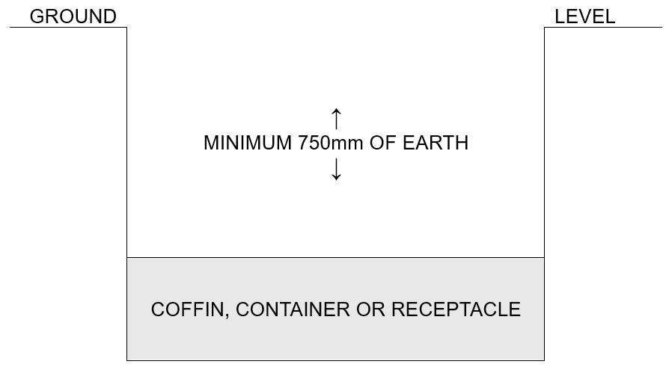
Unsealed
If bodily remains or body parts are interred in an unsealed place of interment in a public cemetery, the cemetery trust responsible for that cemetery must ensure there is at least 750mm of earth between the coffin, container, receptacle or those remains and normal ground level.
Penalty: 10 penalty units

Sealed cap
A sealed cap is a substantial layer of concrete or similar solid material that is installed over a coffin, container, receptacle or human remains to seal the place of interment.
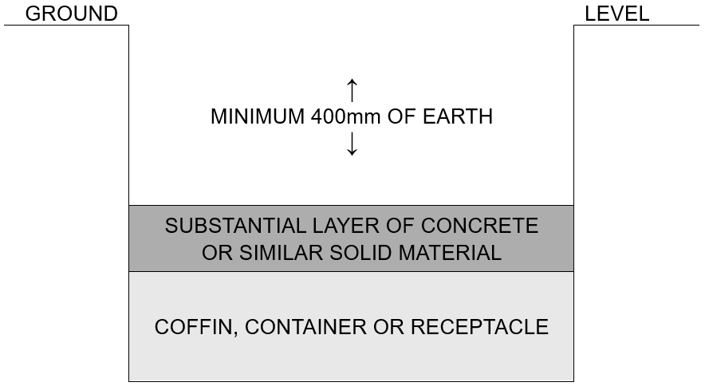
Where a sealed cap is to be installed over bodily remains or body parts interred in a place of interment in a public cemetery, the cemetery trust responsible for that cemetery must ensure there is at least 400mm of earth between the sealed cap and normal ground level.
The sealed cap is to be installed as soon as practicable after the interment.
Penalty: 10 penalty units

Sealed cap and sides
If an interment has taken place at least once before 28 July 1998 in a place of interment, bodily remains or body parts may be interred in that place of interment if:
- the place of interment is resealed with a sealed cap as soon as practicable after the interment, and
- the sides of the place of interment above the sealed cap are lined with brick, stone, concrete or other similar material, and
- there is at least 300mm of earth between the sealed cap and normal ground level.
Penalty: 10 penalty units

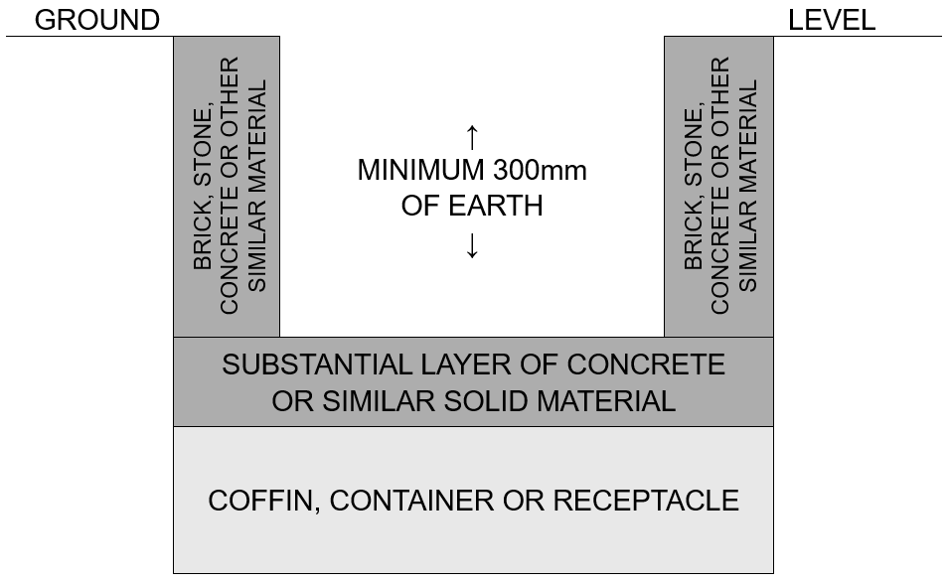

To receive this document in another format, phone 1800 034 280, using the National Relay Service 13 36 77 if required, or email the department <cemeteries@health.vic.gov.au>.
Authorised and published by the Victorian Government, 1 Treasury Place, Melbourne.
© State of Victoria, Australia, Department of Health, June 2025.
Available at health.vic <https://www.health.vic.gov.au/cemeteries-and-crematoria/cemeteries-burial-depth>.

