Victorian Integrated Non-Admitted Health Minimum Data Set (VINAH MDS) manual 2025-26
Section 2 - Concepts and derived items
20th edition, July 2025
Version 1.0
OFFICIAL

To receive this publication in an accessible format email HDSS helpdesk <hdss.helpdesk@health.vic.gov.au>.
Authorised and published by the Victorian Government, 1 Treasury Place, Melbourne.
© State of Victoria, Australia, Department of Health, July 2025.
Except where otherwise indicated, the images in this document show models and illustrative settings only, and do not necessarily depict actual services, facilities or recipients of services. This document may contain images of deceased Aboriginal and Torres Strait Islander peoples.
In this document, ‘Aboriginal’ refers to both Aboriginal and Torres Strait Islander people. ‘Indigenous’ or ‘Koori/Koorie’ is retained when part of the title of a report, program or quotation.

ISBN 978-1-76131-792-7 (pdf/online/MS word)
Available at VINAH minimum data set <https://www.health.vic.gov.au/data-reporting/victorian-integrated-non-admitted-health-vinah-dataset>.

Contents
Introduction 1
Concepts 1
Campus 1
Complex Care (FCP) 2
Conservative Management 2
Contact 3
Contracted Care 7
Early Parenting Centres (EPC) 7
Episode 8
Geriatric Evaluation and Management (GEM) 9
Group sessions 10
Home Based Dialysis (HBD) 10
Home Enteral Nutrition (HEN) 11
Hospital Admission Risk Program (HARP) 11
Infusion Therapy (IT) 12
Medicare eligibility status 13
Medi-Hotel 14
Palliative Care (PC) 14
Palliative Care Consultancy (HBPCCT) 15
Patient/Client 15
Post Acute Care (PAC) 16
Program 17
Programs reporting to the VINAH MDS 18
Referral process 19
Residential In-Reach (RIR) 20
Specialist Clinics (Outpatients) (OP) 21
Stream 22
Subacute Ambulatory Care Services (SACS) 23
Total Parenteral Nutrition (TPN) 23
Transition Care Program (TCP) 24
Victorian Artificial Limb Program (VALP) 25
Victorian HIV and Sexual Health Services (VHS) 25
Victorian Respiratory Support Service (VRSS) 26
Derived items 27
Age 27
Case 27
Case end date 27
Case start date 28
Contact count 28
Contact duration 28
Group session count 29
Service events 30
Generic process diagrams 31
Generic process (concepts only): One episode per case 31
Generic process (concepts and data elements): One episode per case 32
Generic process (concepts only): Two episodes per case 33
Generic process (concepts and data elements): Two episodes per case 34
Generic process (concepts only): Referral not resulting in an episode 35
Generic process (concepts and data elements): Referral not resulting in an episode 35
Generic process (concepts and data elements): Community palliative care referral – not accepted 36
Generic process (concepts and data elements): Community palliative care referral – accepted 37

Introduction
This section lists concept definitions relating to data items reported to the VINAH MDS, and in some cases provides a guide for their use. There is also reference to the VINAH MDS data items derived from data reported.
Detailed specifications for reporting data to the VINAH MDS are provided in Sections 3, 4 and 5 of this manual.

Concepts

Campus
Definition | A physically distinct site owned or occupied by a public health service/hospital, where treatment and/or care is regularly provided to patients.
Guide for use | For the purpose of reporting:  - A single campus hospital provides non-admitted patient services at one location only.  - Unless designated otherwise by the department, a multi-campus hospital has two or more locations providing non-admitted patient services, where the locations:  - are separated by land (other than public road) not owned, leased or used by that hospital  - have the same management at the public health service/hospital level  - each has overnight stay facilities. A separate location (see first dot point) providing day only services, such as a satellite dialysis unit, is considered to be part of a campus  - are not private homes. Private homes where hospital services are provided are considered to be part of a campus.  Episode Campus Code  The campus responsible for delivering the service to the patient is described by the Episode Campus Code data element. The code list of campuses is found in Section 9 and the table identifier HL70115. The campus responsible for delivering the service may be the same as, or different to, the campus providing the service.  Contact Campus Code  The campus where the contact was provided. The code list of campuses is found in Section 9 and the table identifier HL70115.  Contact Provider  A campus of a hospital or health service that provides the service to the patient is described by the Contact Provider data element. The code list of providers is found in Section 9 and the table identifier 990012. A Contact Provider may also be an organisation which is not a campus of a health service or hospital.  Local Identifier Assigning Authority  A campus of a hospital or health service that has assigned the Patient Identifier for the patient is described by the Local Identifier Assigning Authority (LAA) data element. The code list of LAA’s is found in Section 9 and the table identifier HL70300. Note: if the Patient Identifier is common across the organisation, LAA can be reported as a code from the Organisation Identifier table.
Refer to | Section 3: Contact campus code  Section 3: Contact provider  Section 3: Episode campus code  Section 3: Local identifier assigning authority

Complex Care (FCP)
Definition | The Complex Care (FCP) program, previously known as the Family Choice Program, is a state-wide program which provides home based support to families of children (0-17) with high levels of complex ongoing medical care needs. The support provided is flexible and tailored to the needs of the child and family, based on a care plan, to support the high level of ongoing medical care in the home.
Guide for use | Activity for patient/clients enrolled in the FCP program may be collected at either the episode or contact level depending on the FCP stream.  For patients receiving home-based ventilation, an episode is to be opened for the period that the patient/client is responsible for their administration of the treatment and the episode is to be closed when the patient/client ceases home self-administration of their treatment. The department will count one non-admitted service event per calendar month for episodes that have been active during the month. No contacts should be reported in this episode.  FCP funded contacts should be reported under an appropriate FCP stream (other than home based ventilation).  Non FCP funded contacts should be reported separately to the FCP episode to the appropriate program/stream.  For example, if a patient has a consultation with a physiotherapist in an outpatient clinic, this should be reported under the ‘OP’ program.
Refer to | Section 2: Contact  Section 2: Program  Section 2: Programs reporting to the VINAH MDS  Section 2: Stream  Section 3: Episode program/stream  Section 3: Referral in program/stream

Conservative Management
Definition | Conservative management refers to non-surgical treatment aimed at preserving or improving function, with the intent of delaying or avoiding the need for invasive procedures. It does not refer to the avoidance of invasive procedures as part of palliative care.
Guide for use | Conservative management approaches are a priority for the department alongside the rollout of Safer Care Victoria’s Best Care policy. Reporting conservative management allows the department to monitor referrals to conservative management in line with the Best Care policy.
Refer to | Section 3: Contact purpose  Safer Care Victoria’s Best care: guidance for non-urgent elective-surgery available at <https://www.safercare.vic.gov.au/best-care-guidance-for-non-urgent-elective-surgery>.

Contact
Definition | A contact between a patient/client or other relevant person (in scope), and a professional associated with a program reporting via the VINAH MDS that results in a dated entry being made in the patient/client record.
Guide for use | A contact must meet all of the following criteria:  - Clinically significant in nature;  - Provided (or brokered) by an agency funded by a program area that requires reporting via the VINAH MDS;  - For a patient/client who has provided consent (either implied or explicit);  - Requires a dated entry in the clinical record of the patient/client (or a reference to a clinical record held by the brokered service).  For some programs, the following criteria must also be met:  - Have the patient/client directly participating, or  - Have a patient/client’s family member/carer directly participating, or  - Other external healthcare professional directly participating.  The availability of individual code values to a program/stream does not inherently mean that a contact that uses that code value is appropriate to be reported to the VINAH MDS. For example, Contact Delivery Mode has a code for ‘Written’ modes of service delivery. In order to report a contact using this code, the contact must meet all of the criteria listed above or it cannot be reported as a direct contact.  Contacts must be reported according to the VINAH MDS business rules, and within the scope of the VINAH MDS, and not according to the end use of the data. For example, the derivation of service events may be different for activity based funding than for reporting purposes. Therefore, services should ensure they report according to the definitions and business rules of the VINAH MDS and the department will derive data appropriately for the given purpose.  There are different types of contacts, and each program reporting via the VINAH MDS defines which types of contacts are to be reported for that program. Each type of contact is defined below.

Contact type and reporting requirements by program
 | Contact type (service) |  | EPC | FCP | HARP | HBD | HBPCCT | HEN | IT | Medi-Hotel | OP |  | PC |  | PAC |  | RIR |  | SACS | TCP | TPN | VALP | VHS |  | VRSS
 | Direct
 | - Attended |  | Y | Y | Y | N | Y | N | Y | Y | Y | Y |  | Y |  | Y |  | Y |  | Y | N | Y |  | Y |  | Y
 | - Non-attended |  | Y | Y | Y | N | Y | N | Y | Y | Y | N |  | Y |  | Y |  | Y |  | Y | N | Y |  | Y |  | Y
 | - Screening |  | N | N | N | N | N | N | N | N | N | Y |  | N |  | N |  | N |  | N | N | N |  | N |  | N
 | Indirect
 | - Indirect |  | N | N | N | N | N | N | N | N | N | Y |  | N |  | N |  | N |  | N | N | N |  | N |  | N
 | - Indirect-MDCC patient not present |  | Y | Y | Y | N | N | N | N | N | Y | Y |  | Y |  | Y |  | Y |  | N | N | Y |  | Y |  | Y
 | - Screening |  | N | N | N | N | N | N | N | N | N | Y |  | N |  | N |  | N |  | N | N | N |  | N |  | N
 | Administrative |  | N
Each contact:
- may be delivered in a variety of settings (for example, home–based or centre–based), and via a number of delivery modes (for example, face to face or by telephone)
- may be delivered to a patient/client in either an individual or a group context
- may be delivered when the patient/client is not present for the interaction, but their carer or family is
- is delivered by one or more health professionals
- may be aggregated to provide a count of client service events.
Separate data elements included in the VINAH MDS enable the delivery mode, setting and other attributes of a contact to be reported.
Each patient/client who attends a group session should be reported as having received a contact, independent of the number of patients/clients who participated in the group activity.
Service contacts
Service contacts would either be with a patient/client, carer or family member or another professional involved in providing care and do not include contacts of an administrative nature.
Service contacts may be differentiated from administrative and other types of contacts by the need to record data in the clinical record. However, there may be instances where notes are made in the patient/client record that have not been prompted by a service contact with a patient/client (for example, noting receipt of test results that require no further action). These instances would not be regarded as a service contact.
For contacts that relate to brokered services, a contact may be able to be reported if the contact provider is not a healthcare professional. Providing that all other criteria of a direct service contact are met, a contact may be recorded. In these instances, the Contact Professional Group must be recorded as a ‘non-professional healthcare provider’.
Service contacts can be further categorised:
- Direct contacts: those contacts involving the patient/client and/or the patient/client’s family or carer(s).
- Contacts that are scheduled but not attended
All programs require reporting of direct contacts that occur.
Contacts that are scheduled but not attended are reported using the following values:
- Contact Client Present Status: 32 Patient/Client/Carer(s)/Relative(s) not present: scheduled appointment not attended;
- Contact Delivery Mode: 9 not applicable;
- Contact Delivery Setting: 98 not applicable - Patient/Client not present.
Note: the following data elements should be reported as scheduled, even though the contact did not occur:
- Contact End Date/Time
- Contact Main Purpose
- Contact Professional Group
- Contact Session Type
- Contact Start Date/Time.
Indirect contacts
Those contacts not involving the patient/client and/or the patient/client’s family or carer(s) but are still clinical in nature. This type of contact may include contact with another professional who may provide additional advice/information about the patient/client.
Only the Palliative Care program requires reporting of indirect contacts. This is done through reporting the following values:
- Contact Client Present Status: 31 Client/Carer(s)/Relative(s) not present: indirect contact
- Contact Delivery Setting: 98 not applicable – Patient/Client not present
- Contact Session Type: 3 not applicable – indirect contact type.
Administrative contacts
Administrative contacts are not to be reported to the VINAH MDS. They include activities such as, but not limited to:
- allocation meetings
- appointment scheduling
- administrative tasks
- clinically related administrative work (such as reading or researching patient notes for any purpose)
- clinical supervision
- organisation of brokered services
- record keeping
- report writing or reviewing
- research on any topic for any purpose
- travel time.
Screening contacts
Screening contacts determine if the referred person (potential client) is appropriate for the service and the urgency of their care needs. They do not include contacts of an administrative nature (such as receipt of test results).
Screening contacts can be direct or indirect in nature.
- Includes activity such as gathering sufficient clinical information from the referrer, other health professionals and the referred person and their carer/families. Depending upon the complexity, this may be completed by a single clinician or require a multi-disciplinary approach.
- Includes communication with other health professionals and will generally occur over the phone or may involve either phone or face-to-face contact with potential client’s and/or their carers/families.
Excluded from reporting are contacts with client’s and their carers/families for administrative purposes e.g. arranging an appointment, updating client’s record with laboratory results.
Refer to |  | METEOR Identifier 583996 Non-admitted patient service event  Section 2: Contact count (derived item)  Section 2: Group session count (derived item)  Section 2: Patient/Client  Section 2: Service event (derived item)  Section 3: Contact client present status  Section 3: Contact end date/time  Section 3: Contact delivery mode  Section 3: Contact delivery setting  Section 3: Contact inpatient flag  Section 3: Contact main purpose  Section 3: Contact professional group  Section 3: Contact provider  Section 3: Contact session type  Section 3: Contact start date/time  Section 3: Contact specialist palliative care provider  Section 3: Message visit indicator code (transmission data element)

Contracted Care
Definition | Contracted hospital care is provided to a patient under an agreement between a purchaser of hospital care (contracting hospital or external purchaser) and a provider of a non-admitted service (contracted hospital/facility).  Contracted care can also involve brokerage. Brokerage occurs when an organisation that is funded by the department to deliver services that are in scope for VINAH MDS reporting pays a third-party organisation, that is not a public health service, to assist with service delivery.  A contract agreement can be formal or informal, written or verbal.
Guide for use | To be in scope, contracted care must involve all of the following:  - a purchaser, which can be a public health service/agency, or a health authority (Department of Health or a Health Region) or another external purchaser,  - a contracted health service/agency,  - the purchaser making full payment to the contracted health service/agency for the contracted service,  - the patient being present for the provision of the contracted service.  Non-admitted activity provided under a contracted care arrangement is reported by the health service/agency paying for the service, using the contracted health service/agency’s contact provider code or the contact provider code of BROKER when the third party organisation is not a public health service. Refer section 3: data definitions - contact provider and section 9: code list.  Accurate recording of contracted care is essential because:  - Details of contracted public patients are required to be reported under the National Health Reform Agreement.  - Unidentified duplication in the reporting of referrals, episodes of care and contacts must be avoided to enable accurate analyses as required for funding, resource use and epidemiological purposes.
Refer to | Section 3: Contact provider

Early Parenting Centres (EPC)
Definition | Victorian state-funded Early Parenting Centres (EPCs) are dedicated facilities that support parents and their children aged up to 4 years of age by providing specialised, flexible early parenting services. The services enhance the parent-child relationship and support parents with strategies to achieve their parenting goals in areas such as sleep and settling, child behaviour, parent-child attachment, and parent and child health and wellbeing.
Guide for use | EPCs provide a family-centred, multidisciplinary model of care supported by flexible service delivery. The majority of supports are delivered at an EPC facility, including through residential stay and day stay programs. Home-based care programs and outreach supports can also be provided by EPC service providers.
Refer to | Section 2: Contact  Section 2: Program  Section 2: Programs reporting to the VINAH MDS  Section 2: Stream  Section 3: Contact program/stream  Section 3: Episode program/stream  Section 3: Referral in program/stream

Episode
Definition | An episode is the period during which a patient/client receives services within a defined program and stream.
Guide for use | An episode:  - is opened when an organisation first accepts responsibility for a patient/client. This occurs in response to a referral when it is determined that the referral was appropriate.  - will generally contain one or more contacts. However, there may be some situations where cases will be opened and then closed without containing any contacts. For example, the patient/client may die or move away before they can receive a contact or contact with the patient/client may otherwise be lost. A patient/client might also decline the services offered.  - is one of the building blocks from which a case is derived.  - is closed when the criteria for keeping the patient/client in the program is no longer met (this may differ between programs).  The department will, for some accountability purposes, 'roll-up' multiple episodes for a patient where more than one episode is open for the same program stream at the same time. This 'roll-up' is an example of the 'Case' derivation.  When rolling up overlapping episodes, values of data elements will usually take either the value from the episode with the earliest Episode Start Date or the value from the episode with the latest Episode End Date.  The following data elements will take their value from the episode with the earliest Episode Start Date:  - Episode Campus Code  - Episode Care Plan Documented Date  - Episode First Appointment Booked Date  - Episode Health Conditions.  - Episode Hospital Discharge Date  - Episode Identifier  - Episode Impairment Onset Date  - Episode Patient/Client Notified of First Appointment Date  - Episode Start Date  - Referral In Elements  Note: Episode Health Condition(s) with Observation Sequence Number 1 will be taken as the main Episode (Case) Health Condition. All other Episode Health Condition(s) values will be assigned an unspecified sequence within the data element, following removal of any duplicate values.  The following data elements will take their value from the episode with the latest Episode End Date:  - Episode End Date  - Episode Proposed Treatment Plan Completion.  It is important to note that the department will report back to the health services about cases after the episode roll-up functionality has been applied, thus there may be differences in data within health services' internal systems and the case data reported for accountability purposes. Further, this case data may change over time as overlapping episodes are closed. Consequently, health services may wish to consider developing internal reporting to duplicate the above roll-up rules.
Refer to | Section 2: Case (derived item)  Section 2: Case end date (derived item)  Section 2: Case start date (derived item)  Section 2: Program  Section 2: Referral process  Section 3: Episode end date  Section 3: Episode program/stream  Section 3: Episode start date  Section 3: Message visit indicator code (transmission data element)

Geriatric Evaluation and Management (GEM)
Definition | The GEM stream involves the care of chronic or complex conditions associated with ageing, cognitive dysfunction, chronic illness or disability. These conditions may require review, treatment and/or management by a geriatrician and multi-disciplinary team for a defined episode of care.  The GEM client group is usually older people with complex, chronic or multiple health care conditions requiring treatment and stabilisation of those conditions and/or medical review for future treatment options or service planning.
Guide for use | The GEM stream is only reported when services are provided by a geriatrician and multi-disciplinary team.
Refer to | Section 2: Program  Section 2: Programs reporting to the VINAH MDS  Section 2: Stream  Section 3: Episode program/stream  Section 3: Referral in program/stream

Group sessions
Definition | A group session is defined as two or more patients/clients receiving services as part of a group program or group individual program that occurs on the same date from the same clinician/s at the same location.
Guide for use | In practice, this should be interpreted to mean that patients/clients are receiving precisely the same services, for example, a movement class or a chronic disease education class, where all participants are following the same intervention on the same date and/or where the group nature of the activity is conceived as part of the benefit to the patient/client.  In situations where a clinician/s is working one-on-one with several different patients/clients at the same location, the same date and each patient/client is following their own personalised program (for example, in a physiotherapy gym in a Community Rehabilitation Centre (CRC)), each of these clients should be coded as having a Contact Session Type of ‘4 – Group Individual Program’ as the services provided to each patient/client are not the ‘same’ but rather individualised programs.  Note that providing care to a patient/client can encompass the provision of services (for example, counselling, education) to the patient/client’s carer(s) and family, whether or not the patient/client is present when these services are delivered. The carer/family member is not, in these situations, considered to be a patient/client in their own right. Thus, for example, if a single patient/client and several members of their family were the only attendees at a centre-based contact, the Contact Session Type coded for that contact would still be '1- Individual'.  Only one Contact Session Type can be reported for a single contact.  Should a patient/client receive care in both individual and group settings within a single attendance, this must be reported as two separate contacts. That is, one contact for ‘Group – group program’ and one contact for ‘Group –individual program’. Multiple session types cannot be reported within a single contact.
Refer to | Section 2: Group session count (derived item)  Section 2: Patient/Client  Section 3: Contact end date/time  Section 3: Contact start date/time  Section 3: Contact session type

Home Based Dialysis (HBD)
Definition | Dialysis undertaken by patients in their own homes for the treatment of end stage kidney disease. There are two modalities used: home haemodialysis (HHD) and home peritoneal dialysis (HPD).  HBD is performed by the patient or carer in their home.
Guide for use | Activity for patient/clients enrolled in the HBD program will be collected at the episode level. An episode is to be opened for the period during which the patient/client is responsible for the administration of home dialysis, the HBD episode stream indicates the mode of dialysis the patient is administering. The episode is to be closed when the patient/client ceases home self-administration of the dialysis mode. No contacts should be reported in this episode.  The department will count one non-admitted service event per calendar month for episodes that have been active during the month.  Contacts provided to support the patient/client’s HBD activity should be reported under the Specialist Clinics (Outpatients) program.  For example, if a patient has a consultation with a renal consultant in an outpatient clinic, this should be reported under the ‘OP’ program.
Refer to | Section 2: Program  Section 2: Programs reporting to the VINAH MDS  Section 2: Stream  Section 3: Episode program/stream  Section 3: Referral in program/stream

Home Enteral Nutrition (HEN)
Definition | The administration of nutrition either orally or by feeding tube directly into the gastrointestinal tract self-administered by the patient or carer.  HEN is performed by the patient or carer in their home.
Guide for use | Activity for patient/clients enrolled in the HEN program will be collected at the episode level. An episode is to be opened for the period during which the patient/client is responsible for their administration of the treatment and the episode is to be closed when the patient/client ceases home self-administration of their treatment. No contacts should be reported in this episode.  The department will count one non-admitted service event per calendar month for episodes that have been active during the month.  Contacts provided to support the patient/client’s HEN activity should be reported under the Specialist Clinics (Outpatients) program.  For example, if a patient has a consultation with a Dietician in an outpatient clinic, this should be reported under the ‘OP’ program.
Refer to | Section 2: Program  Section 2: Programs reporting to the VINAH MDS  Section 2: Stream  Section 3: Episode program/stream  Section 3: Referral in program/stream

Hospital Admission Risk Program (HARP)
Definition | HARP services provide comprehensive and specialist assessments, care coordination, review and monitoring for people with chronic diseases, such as heart failure or children with asthma, people with complex psychosocial needs such as people who are homeless or at risk of self-harm and people with complex needs such as multiple co-morbidities or older people who are frail. In particular, HARP tries to provide more appropriate community services to people who frequently use hospitals or who are at imminent risk of hospitalisation.
Guide for use | HARP services are governed by a Local Alliance that shares responsibility for decision-making, risk and responsibility. While health services are the fund-holders, most HARP alliances include one or more community agencies.  HARP services will be provided directly by the health service and by other members of the Local Alliance (as documented in Service Level Agreements). HARP services may also be provided by others through brokerage arrangements.  Responsibility for reporting HARP activity lies with the health service as fund-holder, regardless of how a given service is provided, or by which provider.  Further information on the Hospital Admission Risk Program is available at health independence program <https://www.health.vic.gov.au/patient-care/health-independence-program>.
Refer to | Section 2: Contact  Section 2: Program  Section 2: Programs reporting to the VINAH MDS  Section 2: Stream  Section 3: Episode program/stream  Section 3: Referral In program/stream

Infusion Therapy (IT)
Definition | The administration of infusion therapy self-administered by the patient or carer. This includes subcutaneous immunoglobulin (SCIg) infusion therapy performed by the patient or carer in their home.
Guide for use | SCIg infusion therapy is reported within the Infusion Therapy (IT) Program/Stream. Activity for patient/clients enrolled in the IT program will be collected at the contact level. An episode is to be opened for the period during which the patient/client is responsible for their administration of the treatment and the episode is to be closed when the patient/client ceases home self-administration of their treatment. Health services that only dispense SCIg and do not provide specialist clinician support or consumables and equipment do not report this activity.  Contacts are to be reported for each occasion that a patient performs SCIg infusion therapy in their own home with each procedure documented in the patient’s medical record. The Contact Professional Group is not required to be reported in the contact.  Where clinical staff attend to assist the patient with the administration of the SCIg infusion therapy this is reported as one contact.  For example, a patient’s hand dexterity worsens requiring assistance to perform the SCIg infusion therapy. A division 1 nurse makes a home visit to assist the patient perform the SCIg infusion therapy and the procedure is documented in the patient’s medical record. This is reported as one contact, a Contact Professional Group code of 254400 – Nurse – Division 1 may be reported.  Contacts provided to support the patient/client’s infusion therapy activity should be reported under the Specialist Clinics (Outpatients) program.  For example, if a patient has a consultation with a Dietician in an outpatient clinic, this should be reported under the ‘OP’ program.  Further information on the SCIg access program is available at SCIg access program <https://www.health.vic.gov.au/patient-care/subcutaneous-immunoglobulin-scig-access-program> and Policy and Funding Guidelines <https://www.health.vic.gov.au/policy-and-funding-guidelines-for-health-services>.
Refer to | Section 2: Contact  Section 2: Program  Section 2: Programs reporting to the VINAH MDS  Section 2: Stream  Section 3: Episode program/stream  Section 3: Referral in program/stream

Medicare eligibility status
Definition | The patient’s eligibility for Medicare as specified under the Commonwealth Health Insurance Act 1973.
Guide for use | An eligible person includes a person who resides in Australia and is:  - An Australian citizen.  - A permanent resident.  - A New Zealand citizen.  - A temporary resident who has applied for a permanent visa and who has either  - an authority to work in Australia or  - can prove relationship to an Australian citizen (other requirements may apply).  Other persons who are eligible for Medicare in certain circumstances include visitors to Australia from a country that has a Reciprocal Health Care Agreement.  In practice, the primary method for ascertaining Medicare eligibility is sighting the patient’s current Medicare card.  Further information regarding Medicare eligibility is available at Australian Government - Services Australia <https://www.servicesaustralia.gov.au/individuals/services/medicare/medicare-card>.
Refer to | Section 3: Contact account class  Section 3: Contact Medicare number  Section 3: Contact Medicare suffix

Medi-Hotel
Definition | Provision of a non-ward residential service maintained and/or paid for by the hospital for the purpose of accommodating patients, as a substitute for traditional hospital ward accommodation.
Guide for use | Non-ward accommodation provided by the hospital, excluding the Hospital In The Home (HITH) program. Unlike HITH, no clinical services are provided. Thus, a significant decline in medical condition would always necessitate return from Medi-Hotel to the hospital’s Emergency Department or a ward.  The Medi-Hotel facility may or may not be on hospital property. Where it is on hospital property, this may be co-located in the same building as traditional wards.  Patients may be accommodated in a Medi-Hotel when receiving outpatient care and this activity should be reported to the VINAH MDS.  A public hospital must be registered in its Health Service Agreement and/or Statement of Priorities to provide a Medi-Hotel service. The use of a Medi-Hotel is voluntary for the patient.
Refer to | Section 2: Program  Section 2: Programs reporting to the VINAH MDS  Section 2: Stream  Section 3: Episode program/stream  Section 3: Referral in program/stream

Palliative Care (PC)
Definition | Care in which the clinical intent or treatment goal is primarily quality of life for a patient with an active, progressive disease with little or no prospect of cure. It is usually evidenced by an interdisciplinary assessment and/or management of the physical, psychological, emotional and spiritual needs of the patient; and grief and bereavement support service for the patient and their carers/family.
Guide for use | Palliative care (WHO definition):  - provides relief from pain and other distressing symptoms  - affirms life and regards dying as a normal process  - intends neither to hasten or postpone death  - integrates the psychological and spiritual aspects of patient care  - offers a support system to help patients live as actively as possible until death  - offers a support system to help the family cope during the patient's illness and in their own bereavement  - uses a team approach to address the needs of patients and their families, including bereavement counselling, if indicated  - will enhance quality of life, and may also positively influence the course of illness  - is applicable early in the course of illness, in conjunction with other therapies that are intended to prolong life, such as chemotherapy or radiation therapy, and includes those investigations needed to better understand and manage distressing clinical complications.  Community palliative care services provide a range of services to clients in their home including: nursing, liaison with medical practitioners, counselling for the client and their family, allied health services, complementary therapies and coordination with other services. Services comprise multidisciplinary specialist assessment and intervention for pain, symptom control or prevention whilst being treated for a disease that cannot be cured. Emotional, social, spiritual, cultural and physical aspects are considered in the provision of practical support to the patient, carers and family.  Further information on the Palliative Care program is available at Palliative Care Program <https://www.health.vic.gov.au/patient-care/palliative-care-program>.
Refer to | Section 2: Contact  Section 2: Program  Section 2: Programs reporting to the VINAH MDS  Section 2: Stream  Section 3: Episode program/stream  Section 3: Referral in program/stream

Palliative Care Consultancy (HBPCCT)
Definition | HBPCCT are interdisciplinary services funded by the department; providing medical, nursing and allied health advice and support to treating teams in hospitals and community palliative care services in order to support people with end of life needs in their care. Consultancy teams also provide direct care for people with very complex end of life care needs and provide education and training about palliative care to other clinicians.
Guide for use | Further information on the Palliative Care Consultancy program is available at Accessing palliative care <https://www.health.vic.gov.au/patient-care/accessing-palliative-care> and Palliative Care Program <https://www.health.vic.gov.au/patient-care/palliative-care-program>.
Refer to | Section 2: Contact  Section 2: Program  Section 2: Programs reporting to the VINAH MDS  Section 2: Stream  Section 3: Episode program/stream  Section 3: Referral program/stream

Patient/Client
Definition | A patient/client is a person for whom an organisation accepts responsibility for providing treatment and/or care delivered in programs reporting to the VINAH MDS.
Guide for use | Services provided to the patient/client’s carer(s) and/or family (for example, counselling, education) may be reported on the patient/client’s episode, whether or not the patient/client is present when these services are delivered. The carer is not, in these situations, considered to be a patient/client in their own right, even if the patient/client is deceased (which may be the case for the Palliative Care program).
Refer to | Section 2: Service event (derived item)  Section 2: Contact  Section 2: Group sessions  Section 3: Contact client present status

Post Acute Care (PAC)
Definition | PAC provides services to people following discharge from a public hospital (acute or subacute) inpatient stay or following an emergency department presentation. The services provided are based on a person’s individually assessed needs and delivered via a brokerage service model with the core function being care coordination.
Guide for use | The PAC program was established with the objective of supporting recuperation after hospitalisation by providing an appropriate package of community-based supports to facilitate safe and timely discharge, and at the same time aims to prevent hospital readmission.  PAC delivers flexible service delivery and works in conjunction with, but does not replace, the services provided by other programs such as: Home and Community Care (HACC), Subacute Ambulatory Care Services (SACS), and Hospital Admission Risk Program (HARP). PAC offers short-term support to clients following hospitalisation and will continue to provide the support until the client is linked into ongoing community supports if required. The Department of Veterans’ Affairs and Transport Accident Commission clients can also access PAC services.  The most common services provided by PAC include:  - community nursing  - personal care  - home care services arranged by PAC are provided for the duration of the recuperative period and are generally of a short-term nature.  Care co-ordination, rapid response to short time frames, flexibility to deliver tailored packages and service interface between hospital and community sectors are core features of PAC that enable the delivery of its objectives.
Refer to | Section 2: Contact  Section 2: Program  Section 2: Programs reporting to the VINAH MDS  Section 2: Stream  Section 3: Episode program/stream  Section 3: Referral in program/stream

Program
Definition | A grouping of services or patients/clients within an agreed framework, generally along departmental funding lines. Each program has particular attributes, such as policy, objectives, eligibility and assessment/monitoring criteria.
Guide for use | A program:  - is usually equivalent to a line of department funding, and/or  - usually has a unit within the department which is responsible for activities such as policy development and liaison with organisations, in relation to this service.  Some programs are further broken down into streams.
Refer to | Section 2: Complex Care (FCP)  Section 2: Early Parenting Centres (ECP)  Section 2: Home Based Dialysis (HBD)  Section 2: Home Enteral Nutrition (HEN)  Section 2: Hospital Admission Risk Program (HARP)  Section 2: Infusion Therapy (IT)  Section 2: Medi-Hotel  Section 2: Palliative Care (PC)  Section 2: Palliative Care Consultancy (HBPCCT)  Section 2: Post Acute Care (PAC)  Section 2: Program  Section 2: Residential In-Reach (RIR)  Section 2: Stream  Section 2: Specialist Clinics (Outpatients)  Section 2: Subacute Ambulatory Care Services (SACS)  Section 2: Total Parental Nutrition (TPN)  Section 2: Transition Care Program (TCP)  Section 2: Victorian Artificial Limb Program (VALP)  Section 2: Victorian HIV and Sexual Health Services (VHS)  Section 2: Victorian Respiratory Support Service (VRSS)  Section 3: Contact program/stream  Section 3: Episode program/stream  Section 3: Referral in program/stream

Programs reporting to the VINAH MDS
Definition | For 2024-25 the following programs report to the department via the VINAH MDS:  - Complex Care (FCP)  - Early Parenting Centres (EPC)  - Home Based Dialysis (HBD)  - Home Enteral Nutrition (HEN)  - Hospital Admission Risk Program (HARP)  - Infusion Therapy (IT)  - Medi-Hotel  - Palliative Care (PC)  - Palliative Care Consultancy (HBPCCT)  - Post Acute Care (PAC)  - Residential In-Reach (RIR)  - Specialist Clinics (Outpatients) (OP)  - Subacute Ambulatory Care Services (SACS)  - Total Parenteral Nutrition (TPN)  - Transition Care Program (TCP)  - Victorian Artificial Limb Program (VALP)  - Victorian HIV and Sexual Health Services (VHS)  - Victorian Respiratory Support Service (VRSS)
Guide for use | All contacts funded by these programs must be reported to the VINAH MDS according to the specifications in this manual.
Refer to | Other program specific documents, including policy documentation.  Section 2: Complex Care (FCP)  Section 2: Early Parenting Centres (EPC)  Section 2: Home Based Dialysis (HBD)  Section 2: Home Enteral Nutrition (HEN)  Section 2: Hospital Admission Risk Program (HARP)  Section 2: Infusion Therapy (IT)  Section 2: Medi-Hotel  Section 2: Palliative Care (PC)  Section 2: Palliative Care Consultancy (HBPCCT)  Section 2: Post Acute Care (PAC)  Section 2: Program  Section 2: Residential In-Reach (RIR)  Section 2: Stream  Section 2: Specialist Clinics (Outpatients)  Section 2: Subacute Ambulatory Care Services (SACS)  Section 2: Total Parental Nutrition (TPN)  Section 2: Transition Care Program (TCP)  Section 2: Victorian Artificial Limb Program (VALP)  Section 2: Victorian HIV and Sexual Health Services (VHS)  Section 2: Victorian Respiratory Support Service (VRSS)  Section 3: Contact program/stream  Section 3: Episode program/stream  Section 3: Referral In program/stream

Referral process
Definition | The process by which a referral is received, assessed, accepted, prioritised and processed.
Guide for use | Conceptually this process includes the following steps:  - Receipt of referral.  - Decision to accept or reject referral.  - Direction to the most appropriate service.  - Assign clinical prioritisation category.  - Patient/client consent to participate in care provision.  Programs and/or organisations may apply different business processes that may lead to the four steps of the referral process being undertaken with different timing within eight working days.  There are data elements that capture key dates in the referral process. These are respectively:  - Referral In Clinical Referral Date  - Referral In Received Date  - Referral In Receipt Acknowledgement Date  - Referral In Outcome Date  - Episode Start Date (where Referral In Outcome code is 010, 020, 50, 1 or 3).  These may be the same or different dates, depending on the workflow in an organisation.  The final step is required in order to schedule the first contact; however, this date does not need to be reported to the VINAH MDS.  Each episode must be linked to a Referral. However, one Referral may generate more than one Episode; that is, one Referral may result in more than one program/stream providing services to the patient/client.  Note: The Referral In Clinical Referral Date is not the date that the referral validity commences. Referral validity periods commence from the date the first service is provided.
Refer to | Section 2: Episode  Section 3: Episode program/stream  Section 3: Episode start date  Section 3: Referral in clinical referral date  Section 3: Referral in outcome  Section 3: Referral in outcome date  Section 3: Referral in program/stream  Section 3: Referral in reason  Section 3: Referral in receipt acknowledgement date  Section 3: Referral in received date  Section 3: Referral in service type  Section 3: Referral out date  Section 3: Referral out service type

Residential In-Reach (RIR)
Definition | RIR services provide an alternative to the emergency department (ED), where appropriate and safe, for people living in residential aged care services (RACS). Specifically, RIR services provide assessment and management (in appropriate circumstances) of residents with an acute medical condition/s, which would otherwise result in a resident of a RACS unnecessarily presenting to an ED or being admitted to hospital.
Guide for use | RIR services provide a person-centred model of care supported by flexible service delivery in RACS. Health services providing RIR services have a dedicated telephone number(s) for receiving referrals.  The support provided by health services includes:  - telephone consultation and liaison with RACS staff, GPs and other providers  - assessment and management of the resident’s acute medical condition at the aged care facility in collaboration with the resident and their representatives (RACS staff and the resident’s GP).  RIR services aim to:  - reduce the need for residents of RACS to be transferred to an ED in circumstances where appropriate and safe care can be provided within the RACS  - improve communication between RACS and health services.  Communication with the residents’ general practitioner is essential. RIR services are not intended to replace or substitute for the care provided by the resident’s doctor or RACS.
Refer to | Section 2: Contact  Section 2: Program  Section 2: Programs reporting to the VINAH MDS  Section 2: Stream  Section 3: Episode program/stream  Section 3: Referral in program/stream

Specialist Clinics (Outpatients) (OP)
Definition | Services provided to non-admitted, non-emergency department patients registered for care by specialist outpatient clinics of public hospitals classified as principal referral and specialist women’s and children’s hospitals and large hospitals (Peer Group A or B).
Guide for use | Hospitals use the term ‘clinic’ to describe various arrangements under which they deliver specialist outpatient services to non-admitted non-emergency department patients. For the purpose of this collection, an outpatient clinic is a specialty unit or organisational arrangement under which a hospital provides outpatient clinic services. The nature of the service provided by the clinic is classified by ‘clinic type’. All outpatient clinic types are included, except specialised mental health and alcohol and other drug treatment services.  Outpatient clinic services should be interpreted as encompassing services provided through specific organisational units staffed to administer and provide a certain range of outpatient care:  - in defined locations  - at regular or irregular times  - where one or more medical, surgical, allied health or nursing specialist providers deliver care to booked patients.  Generally, in such clinics, a booking system is administered and patient records are maintained to document patient attendances and care provided.  Included in scope are:  - all arrangements made to deliver specialist care to non-admitted, non-emergency department patients whose treatment has been funded or managed through the hospital, regardless of the source from which the hospital derives these funds.  Excluded from scope are:  - stand-alone diagnostic clinics (Tier 2 classes 30.01 – 30.09).  - services funded by another program reporting to the VINAH MDS (for example, Health Independence Programs)  - services which are not funded through the hospital and/or which deliver non-clinical care (activities such as home cleaning, meals on wheels, home maintenance)  - community-based services.  - all services covered by data collections for:  - admitted patient care  - admitted patient mental health care  - alcohol and other drug treatment services  - community mental health care  - non-admitted patient emergency department  Services provided to admitted patients may be reported providing the Contact Inpatient Flag is reported as ‘I – Yes (Inpatient/Admitted)’.
Refer to | Section 2: Contact  Section 2: Program  Section 2: Programs reporting to the VINAH MDS  Section 2: Stream  Section 3: Contact inpatient flag  Section 3: Contact program/stream  Section 3: Episode program/stream  Section 3: Referral In program/stream

Stream
Definition | A sub-grouping, usually clinical, within a program.
Guide for use | A stream is a layer below the program; streams are usually based on the clinical attributes of patients/clients and/or the services/resources the patient/client receives. Not all programs are split into streams.
Refer to | Section 2: Complex Care (FCP)  Section 2: Early Parenting Centres (EPC)  Section 2: Home Based Dialysis (HBD)  Section 2: Home Enteral Nutrition (HEN)  Section 2: Hospital Admission Risk Program (HARP)  Section 2: Infusion Therapy (IT)  Section 2: Medi-Hotel  Section 2: Palliative Care (PC)  Section 2: Palliative Care Consultancy (HBPCCT)  Section 2: Post Acute Care (PAC)  Section 2: Program  Section 2: Residential In-Reach (RIR)  Section 2: Stream  Section 2: Specialist Clinics (Outpatients)  Section 2: Subacute Ambulatory Care Services (SACS)  Section 2: Total Parental Nutrition (TPN)  Section 2: Transition Care Program (TCP)  Section 2: Victorian Artificial Limb Program (VALP)  Section 2: Victorian HIV and Sexual Health Services (VHS)  Section 2: Victorian Respiratory Support Service (VRSS)  Section 3: Contact program/stream  Section 3: Episode program/stream  Section 3: Referral in program/stream

Subacute Ambulatory Care Services (SACS)
Definition | SACS comprise non-admitted rehabilitation services that are complex, multidisciplinary, and/or interdisciplinary, as well as a suite of specialist assessment and management services. Rehabilitation services can be centre based, for example they may be provided through a Community Rehabilitation Centre (CRC) or may be provided in a client’s home.
Guide for use | SACS provide a person-and family-centred, interdisciplinary model of care supported by flexible service delivery in a range of settings, directed at improving and maintaining a person’s functional capacity and maximising their independence. While the majority of SACS clients are older people, services for children and younger adults are currently being developed and expanded.  The aims of SACS are to:  - improve, restore and/or maintain a person’s functional capacity to achieve the highest possible level of independence physically, psychologically, socially and economically  - provide a coordinated and integrated service that delivers the appropriate care, in a timely manner, in the most appropriate setting and at the most appropriate cost.  SACS play a key role in supporting people to get safely home from hospital as soon as possible (for example after a stroke, hip replacement, or major trauma), and in helping them optimise their functional status and maintain their health independence. SACS also have a major role in preventing and diverting hospital admissions, by ensuring that multidisciplinary therapy and assessment services are available in non-admitted settings.  Further information on the Subacute Ambulatory Care Service program is available at health independence program <https://www.health.vic.gov.au/patient-care/health-independence-program>.
Refer to | Section 2: Contact  Section 2: Program  Section 2: Programs reporting to the VINAH MDS  Section 2: Stream  Section 3: Episode program/stream  Section 3: Referral In program/stream

Total Parenteral Nutrition (TPN)
Definition | The administration of nutrition by means of an infusion of an intravenous nutrition formula self-administered by the patient. TPN is generally only used when it is not possible to meet a patient’s nutrition requirements through an oral or enteral route.  TPN is performed by the patient or carer in their home.
Guide for use | Activity for patient/clients enrolled in the TPN program will be collected at the episode level. An episode is to be opened for the period during which the patient/client is responsible for their administration of the treatment and the episode is to be closed when the patient/client ceases home self-administration of their treatment. No contacts should be reported in this episode.  The department will count one non admitted service event per calendar month for episodes that have been active during the month.  Contacts provided to support the patient/client’s TPN activity should be reported under the Specialist Clinics (Outpatients) program (OP).  For example, if a patient has a consultation with a Dietician in an outpatient clinic, this should be reported under the ‘OP’ program.
Refer to | Section 2: Program  Section 2: Programs reporting to the VINAH MDS  Section 2: Stream  Section 3: Episode program/stream  Section 3: Referral in program/stream

Transition Care Program (TCP)
Definition | The TCP is a national program that is jointly funded by the Australian and State/Territory Governments to assist older people complete their restorative process following their hospital episode of care with a package of services that includes low intensity therapy. The services are delivered by a multidisciplinary team with medical oversight by a general practitioner and geriatrician where appropriate. The client also has a designated case manager, who assists the client to prepare for, or access, suitable long term care arrangements. The program is flexible in its service delivery as it can be provided in the individual’s usual place of residence (that is, home based) or in an approved residential care facility (that is, bed based).
Guide for use | The TCP is located at the interface of the acute, subacute, residential aged care and community care sectors. The TCP provides a time-limited, goal oriented and therapy-focused program safeguarding older people from remaining in hospital unnecessarily for an extended period of time and entering residential care prematurely. It is person and family centred and flexible in its care delivery. It is considered a specialist service as it is supported by a multidisciplinary team with aged care expertise and is focused on maintaining or improving the client’s physical, cognitive and psychosocial functioning and their capacity for independent living. The primary function of the TCP is therapeutic and not administrative. The case manager will assist the client and their family to access the required information so that they may make an informed decision and finalise long term care arrangements in a timely manner.  Access to the TCP requires an initial approval by the Aged Care Assessment Service (ACAS). As all TCP clients are discharged from hospital, they may access the Pharmaceutical Benefits Scheme (PBS) and the Medicare Benefits Schedule (MBS). A client can also move between the two care settings (that is, the community or residential arm of the program) within the one episode of care, as deemed appropriate to their care needs.  Further information about the Transition Care Program is available at transition care program <https://www.health.vic.gov.au/patient-care/transition-care-program>
Refer to | Section 2: Contact  Section 2: Program  Section 2: Programs reporting to the VINAH MDS  Section 2: Stream  Section 3: Episode program/stream  Section 3: Referral in program/stream

Victorian Artificial Limb Program (VALP)
Definition | The VALP is an artificial limb service consisting of provision of primary prosthesis, socket assessment and labour for public eligible patients. Ongoing management, assessment and replacement of parts and prostheses are also provided.
Guide for use | VINAH MDS contacts are reported for all clinical consultations associated with the VALP. Time spent in production or adjustment of limbs is not reported to the VINAH MDS as this does not meet the criteria for reporting a contact.
Refer to | Section 2: Contact  Section 2: Program  Section 2: Programs reporting to the VINAH MDS  Section 2: Stream  Section 3: Episode program/stream  Section 3: Referral In program/stream

Victorian HIV and Sexual Health Services (VHS)
Definition | VHS provides services to people living with or at risk of HIV or sexual health conditions. This ranges from acute, subacute care and chronic illness management to health maintenance, prevention and health promotion. The services provided are based on individually assessed needs and delivered through in-hospital, outpatient and community care services.
Guide for use | The VHS was established by the State Government to provide comprehensive care for Victorians affected by or infected with HIV or sexual health conditions.  Services are delivered by Alfred Health and include:  - HIV complex care services – inpatients, community outreach (medical, nursing and social work)  - HIV outpatient clinics  - HIV specialist state-wide outpatient clinics – infections disease (drug and alcohol, complex metabolic, HIV/Hep C coinfection, neurocognitive clinic)  - Non-Occupational Post-Exposure Prophylaxis (NPEP) service  - Pre-Exposure Prophylaxis (PEP) service  - Sexual health service  - State-wide specialist HIV support to community pharmacies  - Training and education  - Victorian HIV mental health service  VHS supports other health services across Victoria to support people living with HIV and sexual health conditions in their community.  Responsibility for reporting VHS activities lies with the health service as fundholder.
Refer to | Section 2: Contact  Section 2: Program  Section 2: Programs reporting to the VINAH MDS  Section 2: Stream  Section 3: Episode program/stream  Section 3: Referral in program/stream

Victorian Respiratory Support Service (VRSS)
Definition | The Victorian Respiratory Support Service (VRSS) is a state-wide specialist program providing a range of services to adults with chronic respiratory failure who need to use a ventilator.
Guide for use | Activity for patient/clients enrolled in the VRSS program may be collected at either the episode or contact level depending on the VRSS stream.  For patients receiving home-based ventilation, an episode is to be opened for the period that the patient/client is responsible for their administration of the treatment and the episode is to be closed when the patient/client ceases home self-administration of their treatment. The department will count one non-admitted service event per calendar month for episodes that have been active during the month. No contacts should be reported in this episode.  VRSS funded contacts should be reported under an appropriate VRSS stream (other than home based ventilation).  Non VRSS funded contacts should be reported separately to the VRSS episode to the appropriate program/stream.  For example, if a patient has a consultation with a physiotherapist in an outpatient clinic, this should be reported under the ‘OP’ program.
Refer to | Section 2: Contact  Section 2: Program.  Section 2: Programs reporting to the VINAH MDS.  Section 2: Stream.  Section 3: Episode program/stream.  Section 3: Referral in program/stream.

Derived items

Age
Definition | The patient’s age at the time of episode start.
Guide for use | Age is calculated as:  Episode Start Date minus Patient/Client Birth Date  Age is:  Used in analysis of data for service planning purposes.
Refer to | Section 3: Patient/Client birth date  Section 3: Episode start date

Case
Definition | The case:  - is opened when an organisation first accepts responsibility for a patient/client, which results in an episode starting  - will contain at least one episode, and may contain two or more episodes where they overlap with each other, or are broken in time only by a referral received prior to all episodes closing, which results in another program/stream accepting the patient/client  - is closed when the patient/client has no open episodes or referrals without outcomes.  Case data may be used for retrospective analysis of patterns of service activity to contribute to policy development and service planning.
Refer to | Section 2: Case end date (derived item)  Section 2: Case start date (derived item)  Section 2: Episode  Section 3: Episode end date  Section 3: Episode start date

Case end date
Definition | The date the case for one patient/client at one organisation ends.
Guide for use | The case end date will be the date of:  - the Episode End Date when there is only one episode for a patient/client, or the latest Episode End Date, when there are two or more overlapping episodes, and  - there are no (incoming) referrals for a program/stream (Referral In Received Date) that do not have a Referral In Outcome.
Refer to | Section 2: Case (derived item)  Section 2: Case start date (derived item)  Section 2: Episode  Section 3: Episode end date  Section 3: Referral in outcome  Section 3: Referral in received date

Case start date
Definition | The date the case for one patient/client at one organisation begins.
Guide for use | The case start date will be the Episode Start Date of the first episode (of possibly several overlapping episodes and referrals).  The case will continue when:  - the episode remains open (Episode Start Date present without a corresponding Episode End Date), or  - there are additional episodes that overlap in Episode Start Date and Episode End Date, or  - there is at least one (incoming) referral for a program/stream (Referral In Received Date) that does not have a Referral In Outcome.
Refer to | Section 2: Case (derived item)  Section 2: Case end date (derived item)  Section 2: Episode  Section 3: Episode end date  Section 3: Episode start date  Section 3: Referral in outcome  Section 3: Referral in received date

Contact count
Definition | The count of non-admitted contacts delivered to a patient/client by an organisation within a given time period.
Guide for use | Any contact that occurs between a patient/client and a professional associated with a program reporting to the VINAH MDS. Contacts are not aggregated.
Refer to | Section 2: Contact

Contact duration
Definition | The time between the contact start date/time and the contact end date/time.
Guide for use | The purpose of capturing duration is to identify the actual time spent providing treatment for patients.  Time spent reviewing files, test results etc, immediately prior to a consultation with a patient can be included when determining the start time of a contact. Similarly, time spent writing patient notes directly after the patient contact can be included when determining the end time of a contact. Health services should use their own judgement to determine what activities to include when determining the start and end time of a contact.  Where the entire contact is administrative in nature it should not be reported.
Refer to | Section 2: Contact  Section 3: Contact end date/time  Section 3: Contact start date/time

Group session count
Definition | The number of group sessions delivered by an organisation within a given time period.
Guide for use | For reporting purposes for some program areas, counts of group sessions will be aggregated as described below.  A count of one group session will be made for all contacts/client service events within an organisation where Contact Session Type is “2 – Group” and the following data elements have the same value:  - Contact End Date/Time  - Contact Professional Group  - Contact Provider  - Contact Start Date/Time  - Message Visit Indicator Code.  Therefore, it is important that if multiple group sessions are being delivered by the same mix of professionals, at the same provider organisation, at the same time, that a minor differentiation be made in the Contact Date/Time (for example: by reporting them 1 second apart).  Equally, all patients/clients participating in the same group session must have exactly the same Contact Date/Time reported in order for the correct Group Session Count to be derived.  The inclusion of a Message Visit Indicator Code means that all contacts and client service events that contribute to a single group session must be reported as either all contacts or all client service events, not a mix of the two.
Refer to | Section 2: Service event (derived item)  Section 2: Contact  Section 2: Group sessions  Section 3: Contact end date/time  Section 3: Contact start date/time  Section 3: Contact professional group  Section 3: Contact provider  Section 3: Message visit indicator code

Service events
Definition | A contact or series of contacts, between a patient/client or other person in scope, and a professional associated with a program reporting via the VINAH MDS, that is intended to be unbroken in time, and that result in a dated entry being made in the patient/client record.
Guide for use | The VINAH MDS collects information about services provided to non-admitted patients at the lowest, contact, level. Multiple contacts for one patient that take place on the same day can be derived into ‘service events’.  Depending on the intended use of the data, the rules used in the derivation of service events may vary.  For other purposes, such as reporting of the Non-admitted Patient NBEDS, the derivation may vary according to the specifications of the dataset. Further detail is available at National Funding Model implementation resources <https://www.health.vic.gov.au/data-reporting/national-funding-model-implementation-resources>.
Refer to | METEOR Identifier 583996 Non-admitted patient service event  Section 2: Contact  Section 3: Contact account class  Section 3: Contact date/time  Section 3: Contact delivery mode  Section 3: Contact delivery setting  Section 3: Contact provider  Section 3: Contact session type

Generic process diagrams

Generic process (concepts only): One episode per case
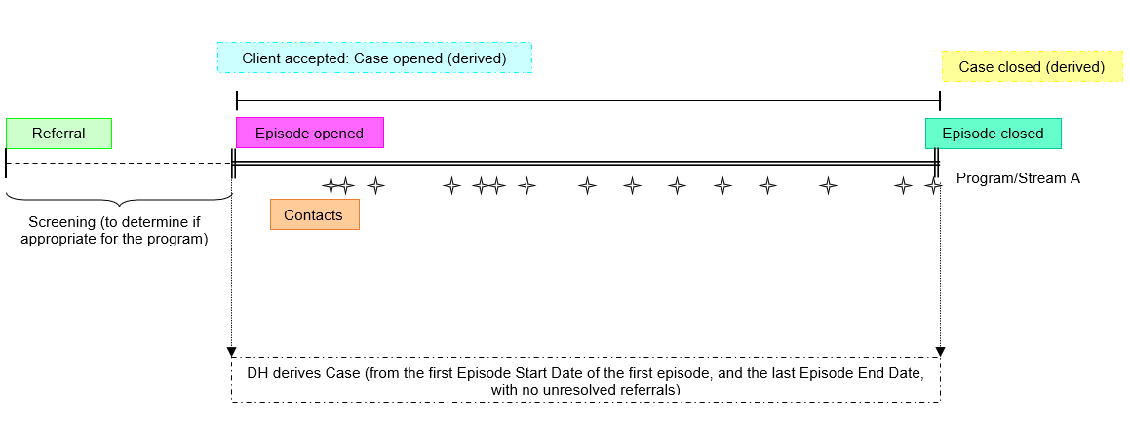

Generic process (concepts and data elements): One episode per case

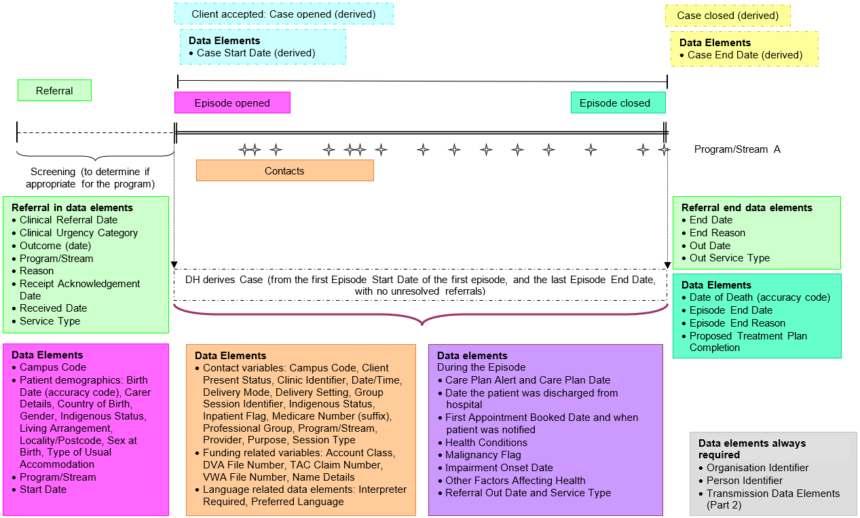

Generic process (concepts only): Two episodes per case

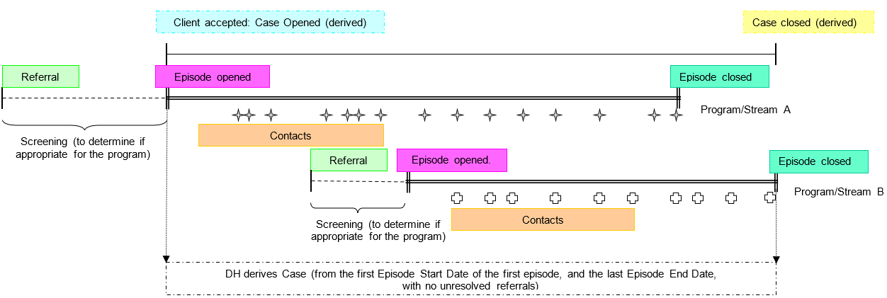

Generic process (concepts and data elements): Two episodes per case

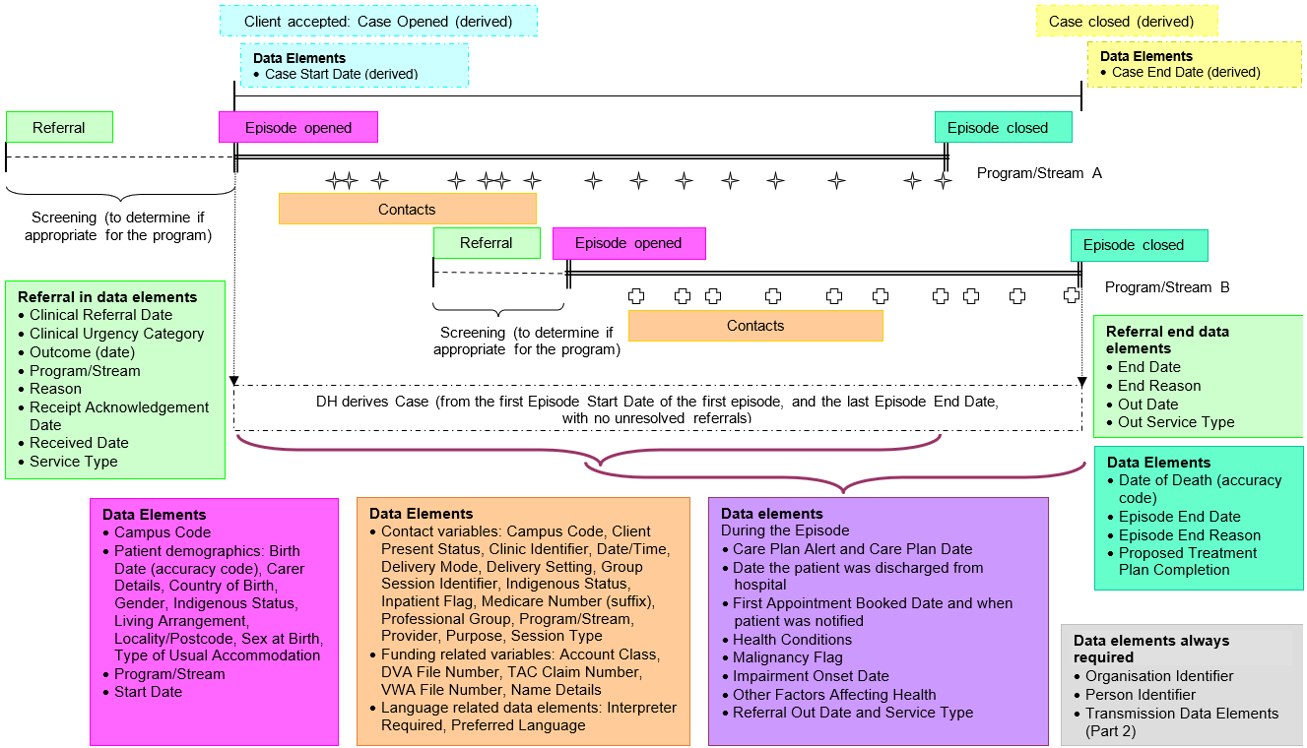

Generic process (concepts only): Referral not resulting in an episode

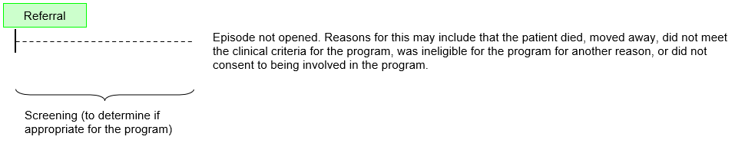

Generic process (concepts and data elements): Referral not resulting in an episode

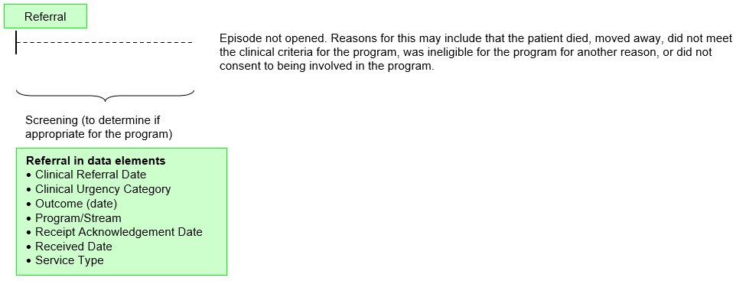

Generic process (concepts and data elements): Community palliative care referral – not accepted

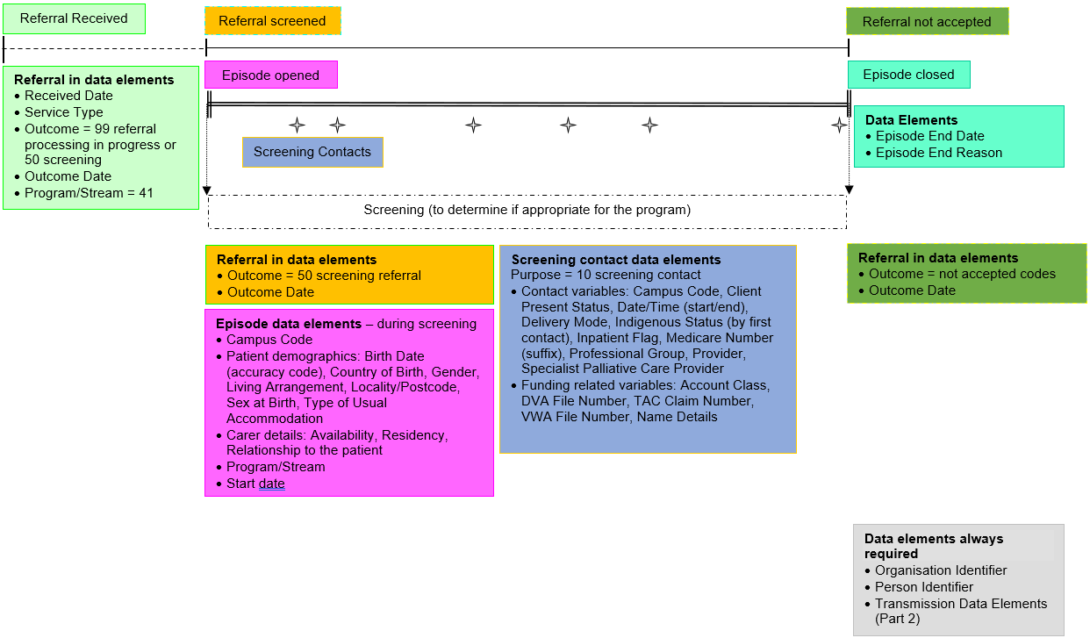

Generic process (concepts and data elements): Community palliative care referral – accepted

