
2025 Influenza vaccination program toolkit
Guidance for immunisation providers
March 2025
OFFICIAL

Contents
Key points 3
Influenza vaccine strains 3
Egg-based influenza vaccines 3
Cell-based influenza vaccines 3
2025 NIP Influenza vaccines 4
Pre-season preparation 5
Update your practice software 5
Identify NIP eligible patients 5
Children aged 6 months to less than 5 years 5
Aboriginal and Torres Strait Islander People aged 6 months and over 6
Pregnant women 6
Medically at-risk 6
Aged 65 years and over 6
Ordering vaccines 6
Vaccine storage and cold chain management 7
Professional development 7
Vaccine administration 7
Intramuscular injection 7
Vaccine choice 8
Schedule 8
Coadministration 8
After vaccination 8
Reporting to the AIR 8
Vaccine Safety 9
Contraindications and precautions 9
Adverse events following immunisation 9
Vaccine errors 9
Key reference documents 10
Appendix 1 11
Appendix 2 - 2025 NIP funded influenza vaccines 12
Appendix 3 - Influenza vaccine storage labels 13

Key points
The Victorian Department of Health (the department) has developed this toolkit to assist immunisation providers to manage the timely roll-out and safe implementation of the influenza vaccination program in 2025. Refer to Appendix 1 for a seasonal activity timeline.
- Annual vaccination is the most important measure to prevent influenza and its complications and is recommended for all people aged 6 months and older.
- The National Immunisation Program (NIP) provides free influenza vaccines for people most at risk of complications from influenza.
- Influenza vaccination is particularly important for those most at risk, with the need to improve uptake in children under 5, pregnant women and Aboriginal and Torres Strait Islander people. A recommendation from a healthcare professional plays an important role in improving vaccination uptake.
- Identify your eligible patients. Consider local initiatives to improve vaccine uptake in those most at-risk including children aged 6 months to under 5 years, pregnant women and Aboriginal and Torres Strait Islander people aged 6 months and over.
- Influenza vaccines are recommended for pregnant women in every pregnancy, at any stage of pregnancy. They can be co-administered with pertussis (20 to 32 weeks), maternal RSV (28 to 36 weeks), COVID-19 (if required) and other vaccines indicated during pregnancy.
- Ensure your vaccine Cold Chain Management policy and practices are up to date.

Influenza vaccine strains
The composition of influenza vaccines for the Southern Hemisphere is reviewed by the World Health Organization annually, and then subsequently determined by the Australian Influenza Vaccine Committee (AIVC). The AIVC recommendation for the composition of influenza vaccines for Australia in 2025 differs from the 2024 southern hemisphere and 2024/25 northern hemisphere recommendations. The southern hemisphere 2025 vaccine will contain one new strain for the Influenza A(H3N2) subtype virus component.
For the 2025 season, Quadrivalent Influenza Vaccine (QIVs) are the only influenza vaccines available in Australia.

Egg-based influenza vaccines
- an A/Victoria/4897/2022 (H1N1) pdm09-like virus
- an A/Croatia/10136RV/2023 (H3N2)-like virus
- a B/Austria/1359417/2021 (B/Victoria lineage)-like virus
- a B/Phuket/3073/2013 (B/Yamagata lineage)- like virus

Cell-based influenza vaccines
- an A/Wisconsin/67/2022 (H1N1) pdm09-like virus
- an A//District of Columbia/27/2023 (H3N2)-like virus
- a B/Austria/1359417/2021 (B/Victoria lineage)-like virus
- a B/Phuket/3073/2013 (B/Yamagata lineage)-like virus

2025 NIP Influenza vaccines
The Australian Government, through the NIP, provides free seasonal influenza vaccine to the following groups at higher risk of complications from influenza:
- children aged six months to less than five years
- Aboriginal and Torres Strait Islander people aged 6 months and over
- pregnant women, at any stage of pregnancy
- people aged 6 months and over with certain medical risk conditions for severe influenza disease
- people aged 65 years and older.

Table 1. 2025 NIP-funded influenza vaccines
Make sure you administer the correct influenza vaccine for age
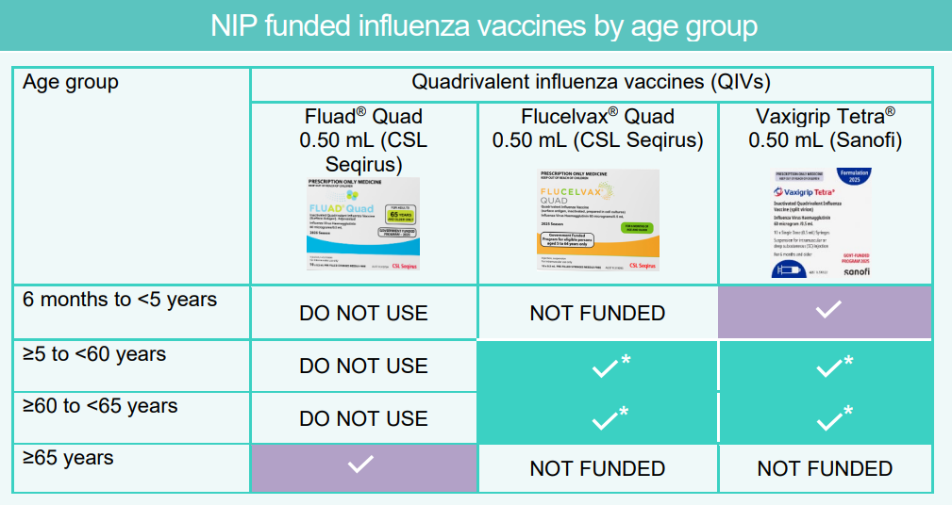
Note: Ticks indicate vaccines that are NIP funded. Asterisks (*) indicate funding only for Aboriginal and Torres Strait Islander people, pregnant women and people who have certain medical conditions. Other influenza vaccines that are not NIP-funded are available in 2025.
For further information regarding NIP-funded Influenza vaccines refer to
- ATAGI Statement on the administration of seasonal influenza vaccines in 2025 <https://www.health.gov.au/resources/publications/atagi-statement-on-the-administration-of-seasonal-influenza-vaccines-in-2025?language=en>
- 2025 Influenza vaccination – Program advice for health professionals <https://www.health.gov.au/resources/publications/2025-influenza-vaccination-program-advice-for-health-professionals?language=en>
- Australian Immunisation Handbook – Influenza (flu) <https://immunisationhandbook.health.gov.au/contents/vaccine-preventable-diseases/influenza-flu>

Pre-season preparation
Annual vaccination should ideally occur before the onset of each influenza season. Immune responses take about 2 weeks to fully develop after vaccination. The period of peak influenza circulation is typically June to September in most parts of Australia. Advanced preparation is vital for a successful influenza vaccination program. See Appendix 1 for a timeline of recommended actions.

Update your practice software
Check you have updated your medical practice software with the latest version. This will ensure the correct vaccine brand and fields are accurately reported to the Australian Immunisation Register (AIR). Report using the new antenatal indicator for influenza vaccine given in pregnancy.

Identify NIP eligible patients
Review your patient cohort in your health service and assess how many patients are:
- children aged six months to less than five years
- Aboriginal and Torres Strait Islander people aged 6 months and over
- pregnant women, at any stage of pregnancy
- people aged 6 months and over with certain medical risk conditions for severe influenza disease
- people aged 65 years and older.

Send a personalised invitation for vaccination to your clients before the end of March. Know your target audience and tailor your communication methods to suit the needs of patients. Phone calls and text messages can be more effective than emails.
Offer to provide resources about vaccination to remind patients why we vaccinate against influenza and the effectiveness of vaccination against severe disease.
Patients aged 5 to 64 years who are not eligible for NIP-funded vaccine should be advised that they can purchase private influenza vaccine. Promote opportunistic vaccination where possible.

Children aged 6 months to less than 5 years
Key messages | NIP funded vaccine brand
Recommended for people from 6 months of age.  Children aged 6 months to less than 9 years receiving influenza vaccine for the first time need 2 doses given at least 4 weeks apart.  Influenza vaccine can be co-administered (given at the same day) as routine childhood vaccines. | Vaxigrip Tetra®

Aboriginal and Torres Strait Islander People aged 6 months and over
Key messages | NIP funded vaccine brands
Recommended for all Aboriginal and Torres Strait Islander people from 6 months of age. | Vaxigrip Tetra® | 6 months to 64 years
 | Flucelvax® Quad | 5 years to 64 years
 | Fluad® Quad | 65 years and over

Pregnant women
Key messages | NIP funded vaccine brands
Recommended for pregnant women in every pregnancy and at any stage of pregnancy.  Vaccination in pregnancy protects both pregnant women and their babies from influenza and its complications. | Vaxigrip Tetra®  Flucelvax® Quad

Medically at-risk
Key message | NIP funded vaccine brands
Recommended for people aged 5 years and over with medical risk conditions such as severe asthma, chronic kidney disease, chronic neurological disease, lung, or heart disease, low immunity or diabetes. | Vaxigrip Tetra®  Flucelvax® Quad
Refer to the Australian Immunisation Handbook Influenza (flu) for further details.

Aged 65 years and over
Key messages | NIP funded vaccine brand
Vaccination is important for people from the age of 65 years as they are at high risk of complications from influenza.  The adjuvanted influenza vaccine is preferentially recommended over standard quadrivalent vaccine for adults aged 65 years and over. | Fluad® Quad

Ordering vaccines
Use your Onelink account to order seasonal influenza vaccines online. The department will advise government vaccine account holders when ordering commences.
The department will allow weekly ordering during April, May and June 2025 to assist you in managing the NIP influenza program. Orders must be separated by 7 days. You should combine orders for influenza and all other government funded vaccines into one and refrain from placing another order until the previous order has been delivered.
Aim to have no more than a month’s stock in your vaccine refrigerator to reduce the risk of stock loss through cold chain breaches or expiry before use.
Order limits may be restricted to assist with equitable and timely distribution of vaccines.

Vaccine storage and cold chain management
All influenza vaccines must be stored in a purpose-built vaccine refrigerator, in the cold chain range (+2 to +8°C). Store vaccines in their original boxes and do not overcrowd shelves in the vaccine refrigerator. For further details, refer to the National Vaccine Storage Guidelines – ‘Strive for 5’ . <https://www.health.gov.au/resources/publications/national-vaccine-storage-guidelines-strive-for-5?language=en>
Ensure your service’s Vaccine Coordinator and back up person have completed the Victorian Cold Chain eLearning module <https://vic-immunisation-learning.com/immunisation/>.
To avoid vaccine administration error, label and store different influenza vaccine brands separately. Refer to the template examples in Appendix 3.

Professional development
Refresh your knowledge of influenza disease and 2025 influenza vaccines:
- Visit the department’s Seasonal influenza vaccine web page, and review all updated influenza vaccine resources.
<https://www.health.vic.gov.au/immunisation/seasonal-influenza-vaccine>
- Review the Australian Government Department of Health and Aged Care Getting vaccinated against influenza – Resource collection for resources, fact sheets and posters for your patients and your health service.
< https://www.health.gov.au/resources/collections/getting-vaccinated-against-influenza-resource-collection?language=en%3E>
- Visit the Sharing Knowledge About Immunisation (SKAI) webpage to prepare for conversations with your patients, parents and carers.
<https://skai.org.au/>
- Be aware of any age limitations and conditions associated with your Secretary Approval as a Nurse Immuniser, Pharmacist Immuniser or Aboriginal and Torres Strait Islander health practitioner immuniser and/or scope of practice for health professionals.
<https://www.health.vic.gov.au/immunisation/nurse-immunisers>
<https://www.health.vic.gov.au/immunisation/pharmacist-immunisers>
< https://www.health.vic.gov.au/immunisation/aboriginal-and-torres-strait-islander-health-practitioner-immunisers>

Vaccine administration

Intramuscular injection
Influenza vaccines are preferably given via the intramuscular route.
- Review the Melbourne Vaccine Education Centre (MVEC) Vaccine administration web page for information on injection techniques and anatomical markers for persons of different ages.
<https://mvec.mcri.edu.au/references/vaccine-administration/>
- Refer to practical guidance to ensure correct injection technique - Avoiding shoulder injury related to vaccine administration fact sheet (SIRVA) <https://immunisationhandbook.health.gov.au/resources/publications/avoiding-shoulder-injury-related-to-vaccine-administration>
- Complete the MVEC Shoulder Injury Related to Vaccine Administration (SIRVA) eLearning module to learn how to prevent injury relating to incorrect injection technique.
<https://education-mvec.mcri.edu.au/courses/shoulder-injury-related-to-vaccine-administration-sirva/>

Vaccine choice
- Always CHECK you are using correct vaccine for age. Refer to Table 1.
- Influenza vaccines come in pre-filled syringes of 0.5 mL. Administer the full content as this is required for the optimal immune response.
- Fluad® Quad (an adjuvanted influenza vaccine) is preferentially recommended for adults aged 65 years and over only. The adjuvant boosts the immune system’s response to the vaccine and provides better protection for people aged 65 years and over.
- If a person had a 2024 influenza vaccine in late 2024 or early 2025, they are still recommended to receive a 2025 vaccine when available, at least 4 weeks apart.

Schedule
- Children aged 6 months to less than 9 years receiving influenza vaccine for the first time need 2 doses given at least 4 weeks apart. This maximises the immune response to the vaccine strains.
- People aged 9 years and over need 1 dose of influenza vaccine every year.

Coadministration
Influenza vaccines can be given at the same time as, or at any interval before or after, other vaccines. This includes dTpa, respiratory syncytial virus (RSV), pneumococcal and COVID-19 vaccines. Shingrix can be co-administered with any Influenza vaccines.
Refer to the Australian Immunisation Handbook | Influenza (flu) for further details.

After vaccination
Keep the person under observation for at least 15 minutes to ensure that they do not experience an immediate adverse event, and to provide rapid medical care if needed.
Inform the vaccinated person or their parent/carer, preferably in writing, of any expected adverse events following immunisation.

Reporting to the AIR
It is mandatory to report the administration of influenza vaccines, COVID-19 vaccines and all other NIP vaccines to the AIR. Use the current AIR vaccine code formats; refer to the Services Australia air vaccine code formats <https://www.servicesaustralia.gov.au/air-vaccine-code-formats?context=22796>.
Ensure use of the antenatal indicator for Influenza vaccines given in pregnancy. <https://www.servicesaustralia.gov.au/manage-immunisation-records-air?context=20#accordion3>

Vaccine Safety

Contraindications and precautions
The only contraindications to influenza vaccines are:
- Anaphylaxis following a previous dose of any influenza vaccine
- Anaphylaxis following any vaccine component (excluding eggs).
Egg allergy is not a contraindication to influenza vaccines. If there is significant parental or health professional concern, the vaccine may be administered in a primary care setting with a longer waiting period of 30 minutes.
Latex allergy: All influenza vaccines available under the NIP in 2025 are latex free and people with a latex allergy can safely be vaccinated.

Adverse events following immunisation
An adverse event following immunisation (AEFI) is any negative reaction that follows vaccination. It does not necessarily have a causal relationship with the vaccine. AEFIs also include conditions that may occur following the incorrect handling or administration of a vaccine.
Refer to the Australian Immunisation Handbook for a list of common local and systemic adverse events relating to influenza vaccines. <https://immunisationhandbook.health.gov.au/contents/vaccine-preventable-diseases/influenza-flu>
Serious or unexpected AEFI and vaccine errors require notification to SAEFVIC, Victoria’s Safety Surveillance service.
- via SAEFVAC reporting online <https://www.safevac.org.au/Home/Info/VIC>
- Ph: 1300 882 924 (option 1)
- For hours of operation please refer to the SAEFVIC website.

Vaccine errors
Vaccine administration errors can occur when a vaccine is incorrectly stored, prepared or given outside the current clinical guidelines, potentially resulting in an AEFI.
Review the department’s Vaccine error management web page to learn how to prevent and manage vaccine administration errors.
<https://www.health.vic.gov.au/immunisation/vaccine-error-management>

Key reference documents
Resource | Description
Victorian Department of Health | Up to date information and resources about the 2025 Seasonal influenza vaccination program.  <https://www.health.vic.gov.au/immunisation/seasonal-influenza-vaccine>
The Australian Immunisation Handbook | Clinical guidance developed by the Australian Technical Advisory Group on Immunisation (ATAGI) for health professionals on all influenza vaccines.  <https://immunisationhandbook.health.gov.au/contents/vaccine-preventable-diseases/influenza-flu>
Australian Technical Advisory Group on Immunisation | ATAGI Statement on the administration of seasonal influenza vaccines in 2025.  <https://www.health.gov.au/resources/publications/atagi-statement-on-the-administration-of-seasonal-influenza-vaccines-in-2025?language=en>
Australian Government Department of Health and Aged Care | Influenza vaccination resource collection. Resources, fact sheets and posters for your patients and your health service.  <https://www.health.gov.au/resources/collections/getting-vaccinated-against-influenza-resource-collection?language=und>
Australian Government Department of Health and Aged Care | National Vaccine Storage Guidelines – Strive for 5.  <https://www.health.gov.au/resources/publications/national-vaccine-storage-guidelines-strive-for-5?language=en>
Victorian Department of Health | Practical guidance on mandatory vaccine storage and cold chain management requirements in Victoria.  <https://www.health.vic.gov.au/immunisation/cold-chain-management>
Victorian Department of Health | Practical guidance on preventing and managing vaccine administration errors in Victoria.  <https://www.health.vic.gov.au/immunisation/vaccine-error-management>
Victorian Department of Health | How to register for a Onelink vaccine account and order government funded vaccines.  <https://www.health.vic.gov.au/immunisation/ordering-vaccines>
Victorian Department of Health | Information about nurse, pharmacist and Aboriginal and Torres Strait Islander health practitioner immunisers in Victoria.  <https://www.health.vic.gov.au/immunisation/immunisers-in-victoria>
SAEFVIC | SAEFVIC is Victoria’s vaccine safety service.  Report serious AEFI and vaccine error to SAEFVIC. <https://www.safevac.org.au/Home/Info/VIC>
Services Australia  (AIR) | Influenza vaccine code formats for reporting to the AIR  <https://www.servicesaustralia.gov.au/air-vaccine-code-formats?context=22796>
Appendix 1 - Influenza vaccination program timeline 2025
Date | Action
March | Discard previous year (2024) influenza vaccine stock.
 | Identify all children 6 months to < 5 years and at-risk patients eligible for NIP influenza vaccine.
 | Check your vaccine refrigerator capacity to ensure you can store the number of vaccines you will need.
Check for emails (including junk folder) regularly. The department will notify government vaccine account holders when influenza vaccine ordering is open.

(a) Check your pre-allocation offer (for providers identified by the department). Acknowledge your pre-allocation order offer using the online form emailed to you.
(b) Order on the Onelink online ordering system for all other providers.

Contact the Immunisation Program via email immunisation@health.vic.gov.au for advice.

 | Check that all staff are trained in vaccine cold chain management (including receipt of vaccine deliveries). The department’s Cold Chain Management eLearning should be used to facilitate staff education to effectively manage the cold chain.
April | Send communications to all patients reminding them of the importance of influenza vaccination from April.
 | Promote influenza vaccination in your service using resources. posters and social media.
Only order enough stock for use in a maximum 4-week period.
Check software to confirm the correct batch numbers correspond with batch numbers for vaccines received.
 | Advise patients that influenza vaccines can be given at the same time as, or at any interval before or after, other vaccines.
 | Send reminder messages to pre-identified patients advising of the influenza vaccination arrangements.
Mid-April | Commence influenza vaccination clinics  Report all vaccinations to the AIR  Report all AEFI to SAEFVIC <https://www.safevac.org.au/Home/Info/VIC>
Mid-May | Review patient vaccine uptake – send reminders to patients who have not attended for vaccination.
 | Reorder vaccines according to stock on hand and residual demand, taking into consideration the amount of 2024 expired stock that you discarded at the end of last season. If demand for the vaccine exceeds your last order, create a wait list for patients, so they know they can be vaccinated when you receive your next delivery.

Appendix 2 - 2025 NIP funded influenza vaccines
All infants and children - aged 6 months to under 5 years
Vaccine brand | Packaging image
Vaxigrip Tetra®  0.5 mL (Sanofi)  - Do not split doses, give 0.5mL  - Latex free | 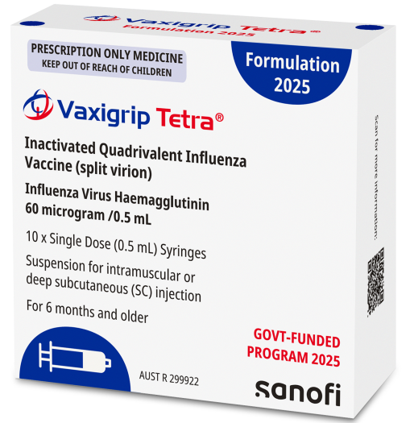
Children aged 6 months to less than 9 years receiving influenza vaccine for the first time need 2 doses given at least 4 weeks apart.
Aged 5 years to 64 years – medical risk conditions
Vaccine brand | Packaging
Flucelvax® Quad  0.5 mL (Seqirus)  - Do not split doses, give 0.5mL  - Latex free  NIP funded 5 to 64 years only | 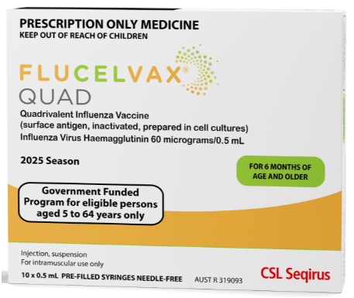
Aboriginal and Torres Strait Islander people, pregnant women, people with medical risk conditions
Vaxigrip Tetra® may also be provided to this cohort.
Aged 65 years and over
Vaccine brand | Packaging
Fluad® Quad  0.5mL (Seqirus)  - Milky white suspension  - Do not give to people ˂ 65 years | 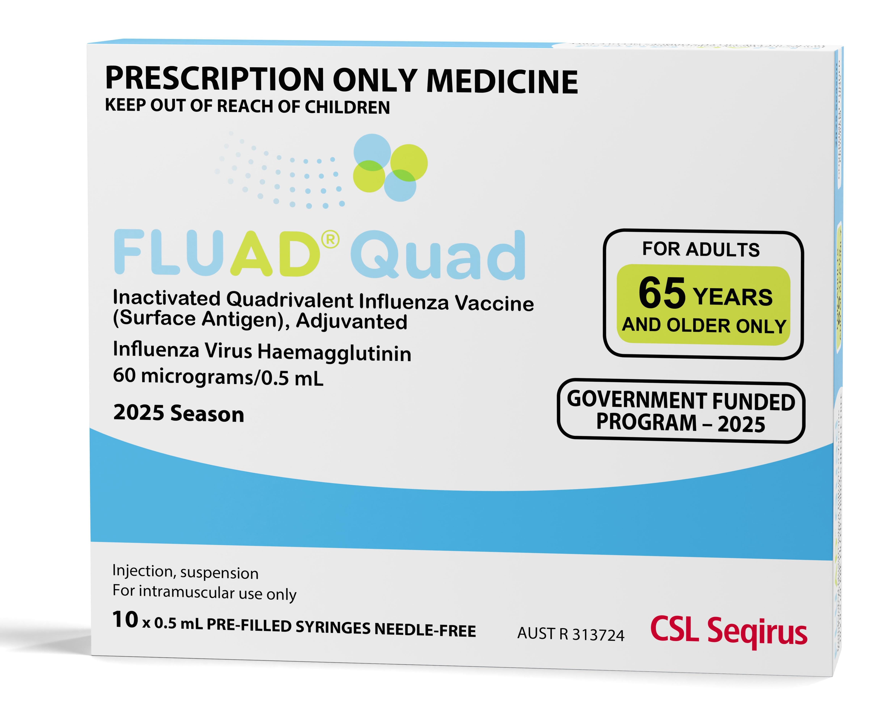
Preferred over other quadrivalent vaccines for people aged 65 years and older.

Appendix 3 - Influenza vaccine storage labels
2025 NIP influenza vaccine
Cohort - 6 months to <5years
Brand - Vaxigrip Tetra®

2025 NIP influenza vaccine  Cohort - 5 to 64 years at risk  Brand - Vaxigrip Tetra® | 2025 NIP influenza vaccine  Cohort - 5 to 64 years at risk  Brand – Flucelvax® Quad
2025 Influenza vaccine  PRIVATE STOCK | 2025 Influenza vaccine  PRIVATE STOCK  2025 NIP influenza vaccine  Cohort - 65 years and above  Brand – Fluad® Quad

This document can be downloaded from the Seasonal Influenza vaccine webpage <https://www.health.vic.gov.au/immunisation/seasonal-influenza-vaccine>.
To receive this publication in an accessible email the Immunisation Program <immunisation@health.vic.gov.au>.
ISBN 978-1-76131-754-5 (pdf/online/MS word)
While the information contained in this resource has been researched, reviewed and presented with all due care, the content is for use by a doctor or qualified immunisation provider only.
All information contained in this publication is accurate at the time of publication. Authorised and published by the Victorian Government, 1 Treasury Place, Melbourne © State of Victoria, Department of Health, March 2025.

