
Respiratory Syncytial Virus Mother and Infant Protection Program (RSV-MIPP)
2025 Toolkit for immunisation providers (V2.1)
OFFICIAL

Contents
Introduction 4
Background 4
Respiratory Syncytial Virus 4
RSV Mother and Infant Protection Program (RSV-MIPP) 4
Eligibility for nirsevimab 5
Neonate dose 5
Catch up – first RSV season 6
Second RSV season 6
Interchangeability of RSV immunisation products 6
Ordering nirsevimab 7
Product information 7
Presentation 7
Storage and cold chain management 7
Administration 8
Dosing recommendations 8
Consent 8
Administration route 8
Co-administration with other vaccines 9
Contraindications and precautions 10
Adverse events following immunisation 10
Reporting to the AIR 11
Immunisation providers 11
Key resources 12

Introduction
This resource has been developed to support the implementation of the 2025 Respiratory Syncytial Virus Mother and Infant Protection Program (RSV-MIPP) to reduce RSV-associated infections and hospitalisations in infants and young children.
The guide is intended for immunisation providers who will order and/or administer Beyfortus™ (nirsevimab) monoclonal antibody (mAB) in Victorian hospitals, general practices (GPs), Aboriginal health services, community health centres and local council immunisation services.

Background

Respiratory Syncytial Virus
Respiratory syncytial virus (RSV) is a common virus that can result in mild colds to severe conditions such as bronchiolitis (in infants) and pneumonia. Primary infection with RSV, often seen in infants and young children aged 0-2 years, is generally more severe than subsequent infections at older ages. RSV infection can cause severe disease, particularly in very young infants and those with underlying health conditions that make them at risk of severe RSV disease.
The RSV-associated hospitalisation rate is highest in infants under 6 months of age and declines sharply with age from early childhood. Aboriginal and Torres Strait Islander infants and young children aged 2 years and under are hospitalised with RSV at a rate around two times higher than the rest of the population.
Seasonal outbreaks in most regions in Australia occur during autumn and winter, usually between April and September.

RSV Mother and Infant Protection Program (RSV-MIPP)
In 2025, the Commonwealth and jurisdictions will introduce initiatives to protect infants against severe RSV through maternal vaccination and passive immunisation for at risk infants.
- Abrysvo® RSV vaccine will be included in the National Immunisation Program (NIP) from February 2025. It is the only RSV vaccine approved for use in pregnancy and is recommended as a single dose from 28 to 36 weeks’ gestation.
- Abrysvo® RSV vaccine is administered to protect newborn infants by transplacental transfer of RSV-specific antibodies from the mother to the foetus during pregnancy.
- The Victorian Government will fund an infant RSV immunisation program using Beyfortus™(nirsevimab) monoclonal antibody (mAB) for defined cohorts. The program will run from 1 April to 30 September 2025.
Beyfortus™ (nirsevimab), is a long-acting mAB approved for use in neonates and infants in Australia. It has a minimum duration of effect of 5-months. In October 2024, RANZCOG updated their pre-pregnancy and pregnancy-related vaccination guidelines to include Abrysvo® and nirsevimab.

Eligibility for nirsevimab
The eligibility criteria for nirsevimab monoclonal antibody and decision aides are available at the Victorian Department of Health (department) Respiratory Syncytial Virus (RSV) webpage <https://www.health.vic.gov.au/immunisation/respiratory-syncytial-virus-immunisation>.

Neonate dose
Offered to infants born between 1 April 2025 - 30 September 2025:
- to mothers who did not receive Abrysvo® RSV vaccine during pregnancy or born within 2 weeks of receiving maternal Abrysvo® RSV vaccine
- high risk infants (Figure 1) regardless of maternal vaccination, after assessment by their treating doctor to confirm potential clinical benefit.

Figure 1. Flowchart to guide which infants should receive nirsevimab in their 1st RSV season
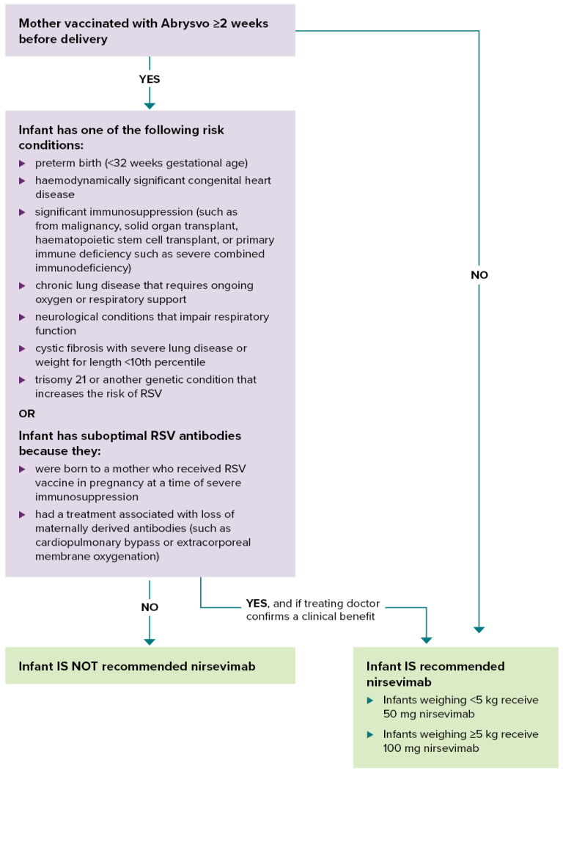

Catch up – first RSV season
Infants born from 1 October 2024 to 31 March 2025, entering their first RSV season in 2025:
- to mothers who did not receive Abrysvo® RSV vaccine during pregnancy or were born within 2 weeks of receiving Abrysvo® RSV vaccine (up to 8 months of age) and
- high risk infants (Figure 1) regardless of maternal vaccination, after assessment by their treating doctor to confirm potential clinical benefit.

Second RSV season
Young children born on or after 1 October 2023 (up to 24 months of chronological age) who remain vulnerable to severe RSV throughout their second RSV season in 2025. This is regardless of whether these at-risk children received a dose of RSV-specific monoclonal antibody in their first RSV season or were born to a mother who received RSV vaccine during pregnancy.
- Aboriginal Torres Strait Islander infants
- Young children with conditions associated with increased risk of severe RSV disease.
A minimum interval of 6 months is recommended between a 1st and 2nd season dose of nirsevimab.
Conditions associated with increased risk of severe RSV disease in infants and young children
- Preterm birth <32 weeks gestational age
- Haemodynamically significant congenital heart disease
- Significant immunosuppression, such as from solid organ transplant, haematopoietic stem cell transplant, or primary immune deficiencies such as severe combined immunodeficiency (SCID)
- Chronic lung disease requiring ongoing oxygen or respiratory support
- Neurological conditions that impair respiratory function
- Cystic fibrosis with severe lung disease or weight for length <10th percentile
- Trisomy 21 or another genetic condition that increases the risk of severe RSV disease

Previous RSV infection
Previous infection with RSV can provide some immunity, but this protection is not long term. Eligible infants and young children less than 24 months old who have previously had an RSV infection are recommended to receive RSV-specific monoclonal antibodies during the RSV season, once recovered.

Interchangeability of RSV immunisation products
Infants who have already received palivizumab (mAB), and who meet the above eligibility criteria, can receive Beyfortus™ (nirsevimab) 28 days later, instead of their next palivizumab dose. Palivizumab should then be discontinued.

Ordering nirsevimab
Nirsevimab will be made available to order through the Victorian government account portal Onelink online. Immunisation providers are required to have a Onelink government vaccine account to order vaccines <https://www.health.vic.gov.au/immunisation/ordering-vaccines>.
Nirsevimab is available to order in the following formulations from Onelink:
- 50 mg in 0.5mL solution (prefilled syringe) for infants less than 5kg
- 100 mg in 1mL solution (prefilled syringe) for infants 5kg and over.
Community based immunisation providers should consider client cohorts and order nirsevimab on demand only, to prevent stockpiling and product wastage. Distribution will be managed to ensure fair and equitable access to the product for those most at risk.

Product information
Beyfortus (nirsevimab) is a clear to opalescent colourless to yellow solution in a prefilled syringe.
- Each prefilled syringe contains 0.5 mL or 1 mL solution.
- Pack size: 1 single use prefilled syringe without needle.

Presentation
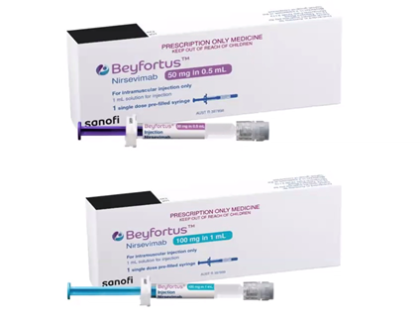 | - 50mg solution for injection is in a prefilled syringe with a purple plunger rod: each prefilled syringe contains 50mg of nirsevimab in 0.5mL.  - 100mg solution for injection is in prefilled syringe with a light blue plunger rod: each pre-filled syringe contains 100mg of nirsevimab in 1mL.

Storage and cold chain management
Nirsevimab must be stored at +2°C to +8°C in original packaging and always protected from light.
All immunisation providers responsible for ordering, storing, receiving, and administering nirsevimab must understand the principles of vaccine storage. The National Vaccine Storage Guidelines: Strive for 5 provide best practice guidelines for storing vaccines and therapeutic products to manage the cold chain.
Refer to the department’s Cold Chain Management Protocols <https://www.health.vic.gov.au/immunisation/cold-chain-management>, including requirements for facilities with automated temperature monitoring and back to base systems, and Cold Chain Breach Reporting <https://www.health.vic.gov.au/immunisation/cold-chain-management>.

Administration

Dosing recommendations
The recommended dose for infants and young children is weight and age dependant. The dosing weight refers to an infant’s or young child’s weight at the time of administration, not their birth weight. Immunisation providers should weigh all infants or young children prior to administration if they do not have a recent weight recorded.

Timing
The recommended dosage of Beyfortus® (nirsevimab) in neonates and infants during or entering the RSV season as per the Australian Immunisation Handbook <immunisationhandbook.health.gov.au>.

Dosage

RSV season | Body weight | Formulation / dose
Newborns | less than 5 kg | 50mg purple plunger rod
Newborns | 5kg and greater | 100mg blue plunger rod
Catch up - first RSV season | less than 5 kg | 50mg purple plunger rod
Catch up - first RSV season | 5kg and greater | 100mg blue plunger rod
Second RSV season  (risk as per program criteria) | Not applicable | 200mg at the same visit  2 x 100mg blue plunger rod

Confirm eligibility
- Check The Australian Immunisation Register (AIR), electronic medical record, or Victorian maternal record for evidence of timely maternal Abrysvo® RSV vaccination (Vaccine code ABRSV).
- Check eligibility criteria for risk factors for neonates and infant catch up doses.

Consent
Beyfortus® (nirsevimab) is registered for use in Australia by the TGA and use in the RSV-MIPP in accordance with the indications and clinical guidance in the Australian Immunisation Handbook.
Standard processes for obtaining consent from a parent or guardian for infant and child immunisation should be followed. Further information about consenting is available in The Australian Immunisation Handbook.

Administration route
Nirsevimab is administered by intramuscular injection. The recommended injection site for infants under 12 months is the anterolateral thigh.
The recommended injection site for infants aged 12 months (2nd RSV season) and older is the deltoid muscle. Different sites for each injection should be used or separate by at least 2.5cm.
Table 1. Needle size and type
Age and size of infant | Needle type | Angle of needle insertion
Infant and young child | 22–25 gauge, 25 mm long | 90° to skin plane
Preterm infant (<37 weeks gestation) up to 2 months of age, and/or very small infant | 23–25 gauge, 16 mm long | 90° to skin plane

Recommended injection sites
Infants aged under 12 months  The recommended injection site is the anterolateral thigh region.  See Australian Immunisation Handbook figure. Vastus lateralis injection site on the anterolateral thigh. | 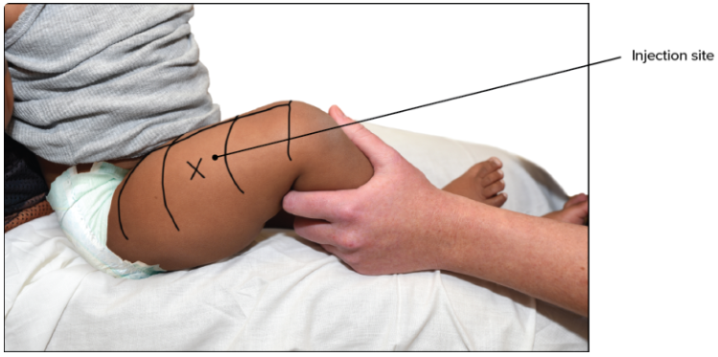
Children aged over 12 months  The recommended injection site is the deltoid (upper arm).  See Australian Immunisation Handbook figure. Anatomical markers used to identify deltoid site injection site. | 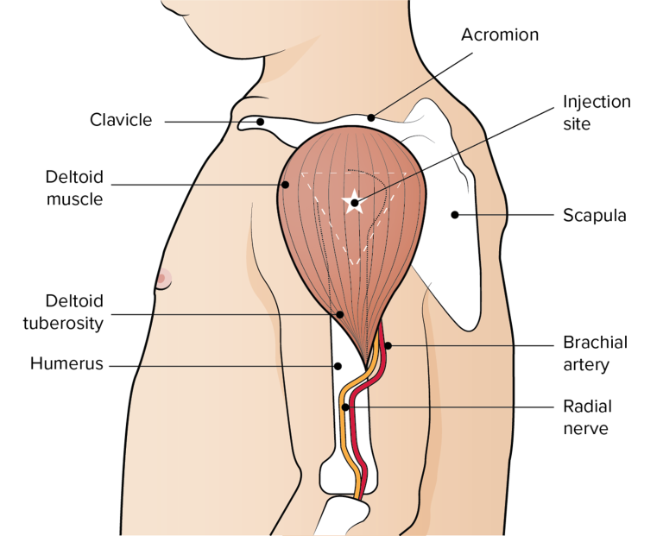

Co-administration with other vaccines
Eligible infants and children can receive nirsevimab at the same time, or separate to, routine infant and childhood vaccines and medicines, including birth dose hepatitis B and vitamin K injection. Because monoclonal antibodies target specific antigens, there is unlikely to be any interference with other disease antigens from vaccines.
Refer to the Australian Immunisation Handbook for more information <https://immunisationhandbook.health.gov.au/contents/vaccine-preventable-diseases/respiratory-syncytial-virus-rsv#infants-and-children-1>.

Contraindications and precautions
The only absolute contraindications to nirsevimab are:
- anaphylaxis after a previous dose of nirsevimab
- anaphylaxis after any component of nirsevimab.
Nirsevimab solution for injection contains the excipients: histidine, histidine hydrochloride monohydrate, arginine hydrochloride, sucrose, polysorbate 80 and water for injections.

Precautions for use
History of hypersensitivity including anaphylaxis.
- Monitor for at least 15 minutes post administration of nirsevimab.
- Serious hypersensitivity reactions, including anaphylaxis, have been observed with monoclonal antibodies. If signs and symptoms of a clinically significant hypersensitivity reaction or anaphylaxis occur, immediately discontinue administration, and initiate appropriate medical treatment.
Clinically significant bleeding disorders.
- As with any other intramuscular injections, nirsevimab should be given with caution to infants with thrombocytopenia or any coagulation disorders.
Should individual clinical advice be required, immunisation providers may contact the Specialist Hospital Immunisation Services for advice:
- Royal Children’s Hospital - 1300 882 924 option 3
- Monash Health - 1300 882 924 option 5.

Blood transfusion
If a pregnant woman receives Abrysvo® RSV vaccine and the infant is born of ABO incompatibility, and subsequently receives a blood transfusion, this does not change the RSV immunisation recommendations for an infant.
Risk criteria for neonate and infant doses of nirsevimab are listed in the Australian Immunisation Handbook <https://immunisationhandbook.health.gov.au/contents/vaccine-preventable-diseases/respiratory-syncytial-virus-rsv#infants-and-children-1>.

Expected adverse side effects following immunisation (AEFI)
- Mild injection site reactions such as pain and redness.
- Rash, fever.
Serious side effects, such as a severe allergic reaction, are rare. No difference in AEFI or serious AEFI has been identified when compared to placebo or palivizumab in clinical trials aged from birth <24 months⁷.

Adverse events following immunisation
An adverse event following immunisation (AEFI) is defined as “any untoward medical occurrence that follows immunisation. It does not necessarily have a causal relationship with the vaccine.”
All AEFI notifications are required to be reported to the to SAEFVIC, Victoria’s vaccine safety surveillance partner. AEFIs can be reported via the SAEFVIC webpage 24 hours a day, 7 days a week < https://www.saefvic.org.au/>. Alternatively, you can call SAEFVIC on 1300 882 924 (Option 1). For hours of operation please refer to the SAEFVIC website.

Vaccine administration errors
Vaccine administration errors can occur when a vaccine is incorrectly stored, prepared, or given outside the current clinical guidelines, potentially resulting in an AEFI. Vaccine administration errors should be reported to your health service medication incident management system and to SAEFVIC.
For guidance on preparing your practice to prevent vaccine administration errors, refer to Vaccine error management <https://www.health.vic.gov.au/immunisation/vaccine-error-management>.

Reporting to the AIR
The Australian Immunisation Register (AIR) has been updated to accept records of Beyfortus™ (nirsevimab). Vaccination encounters should be reported to the AIR and will show on the child’s immunisation history record.
Children aged 8 months and older (regardless of weight) will require a dosage of 200mg (2x100mg doses). When reporting to AIR, this must be entered as a single dose, using only one batch number.
Vaccine brand name | Vaccine code | Program code
Beyfortus | BFRSV | Other
Check to see if your practice software is integrated with the AIR to automatically report the immunisation encounter to the AIR. If not, ensure your service has manual processes in place to make sure the encounter is reported to the AIR.
Please ensure you have updated your practice software in early 2025 to ensure the option to record and report Beyfortus® (nirsevimab) to the AIR. For further support, refer to:
- Uploading to the AIR Fact Sheet for providers <https://www.health.vic.gov.au/immunisation/respiratory-syncytial-virus-immunisation>.
- AIR Tip – 20 July 2023 | NCIRS to report immunisation encounters for infants not yet enrolled in Medicare <https://ncirs.org.au/air-tip-20-july-2023>.

Immunisation providers
Medical practitioners, nurse practitioners and authorised midwives can administer RSV immunisation products without the need for additional authorisation.
Nurse immunisers and Aboriginal and Torres Strait Islander health practitioner (ATSIHP) immunisers in Victoria are authorised under Secretary Approvals to administer Beyfortus® (nirsevimab) in accordance with the Victorian eligibility and as recommended in the Australian Immunisation Handbook <https://immunisationhandbook.health.gov.au/contents/vaccine-preventable-diseases/respiratory-syncytial-virus-rsv>.
For further details refer to the department’s Respiratory Syncytial Virus (RSV) webpage <https://www.health.vic.gov.au/immunisation/respiratory-syncytial-virus-immunisation>.
Due to limited supply, nirsevimab will be prioritised for administration in key settings to meet the needs of infants most at risk. This includes maternity services, GPs, Specialist Hospital Immunisation Services, nurse practitioners, paediatricians, regional health services, Aboriginal Community Controlled Health Organisations, and some local councils.

Key resources
Resource | Description
Australian Immunisation Handbook Respiratory Syncytial Virus (RSV) | <https://immunisationhandbook.health.gov.au/contents/vaccine-preventable-diseases/respiratory-syncytial-virus-rs>
Victorian Department of Health RSV webpage | Respiratory Syncytial Virus (RSV) immunisation and RSV-MIPP eligibility. Information, webinars, fact sheets for health services and consumers and decision aids.  <https://www.health.vic.gov.au/immunisation/respiratory-syncytial-virus-immunisation>
Australian Government -  Immunisation for pregnancy | Immunisation for pregnancy. Includes clinical guidance, resources, fact sheets and posters for patients and health services.  <https://www.health.gov.au/topics/immunisation/when-to-get-vaccinated/immunisation-for-pregnancy>
National Centre for Immunisation Research and Surveillance (NCIRS) RSV webpage | RSV - Frequently asked questions <https://ncirs.org.au/ncirs-fact-sheets-faqs-and-other-resources/respiratory-syncytial-virus-rsv-frequently-asked>
SAEFVIC webpage | SAEFVIC Report serious AEFI and vaccine error to SAEFVIC. <https://www.safevac.org.au/Home/Info/VIC>
Victorian Department of Health webpage | Adverse events following immunisation reporting. https://www.health.vic.gov.au/immunisation/adverse-events-following-immunisation-reporting
Victorian Department of Health webpage | Practical guidance on preventing and managing vaccine administration errors in Victoria.  <https://www.health.vic.gov.au/immunisation/vaccine-error-management>
AusVaxSafety | Active vaccine safety surveillance- provider participation <https://ausvaxsafety.org.au/our-work/active-vaccine-safety-surveillance>
Australian Government | National Vaccine Storage Guidelines – Strive for 5  <https://www.health.gov.au/resources/publications/national-vaccine-storage-guidelines-strive-for-5?language=en>
Victorian Department of Health webpage | Practical guidance on mandatory vaccine storage and cold chain management requirements in Victoria.  <https://www.health.vic.gov.au/immunisation/cold-chain-management>
Victorian Department of Health | How to register for a Onelink vaccine account and order government funded vaccines.  <https://www.health.vic.gov.au/immunisation/ordering-vaccines>
Victorian Department of Health | Information about nurse, pharmacist and ATSIHP immunisers in Victoria.  <https://www.health.vic.gov.au/immunisation/immunisers-in-victoria>

To receive this document in another format, email the Immunisation Program <immunisation@health.vic.gov.au>.
Authorised and published by the Victorian Government, 1 Treasury Place, Melbourne.
ISBN 978-1-76131-796-5 (pdf/online/MS word)
© State of Victoria, Australia, Department of Health, February 2025.

Royal Australian and New Zealand College of Obstetricians and Gynaecologists (RANZCOG) 2024. Pre-pregnancy and pregnancy-related vaccinations (C-Obs 44) <https://ranzcog.edu.au/wp-content/uploads/Pre-Pregnancy-and-Pregnancy-Related-Vaccinations.pdf>
Australian Technical Advisory Group on Immunisation (ATAGI). Australian Immunisation Handbook | RSV Australian Government Department of Health and Aged Care, Canberra, 2024 <https://immunisationhandbook.health.gov.au/contents/vaccine-preventable-diseases/respiratory-syncytial-virus-rsv>
ATAGI. Australian Immunisation Handbook | RSV Australian Government Department of Health and Aged Care, Canberra, 2024 <https://immunisationhandbook.health.gov.au/contents/vaccine-preventable-diseases/respiratory-syncytial-virus-rsv>
Australian Government Department of Health 2019 The National Vaccine Storage Guidelines: Strive for 5 <https://www.health.gov.au/resources/publications/national-vaccine-storage-guidelines-strive-for-5?language=en>
ATAGI. Australian Immunisation Handbook | Preparing for vaccination, Australian Government Department of Health and Aged Care, Canberra, 2024 <https://immunisationhandbook.health.gov.au/contents/vaccination-procedures/preparing-for-vaccination>.
ATAGI. Australian Immunisation Handbook | Vaccination procedures, Australian Government Department of Health and Aged Care, Canberra, 2024 <https://immunisationhandbook.health.gov.au/contents/vaccination-procedures/administration-of-vaccines>.

